Molecular study for mitochondrial gene (MT) mutation in diabetes patients in Karbala province

Yasmin kadhier kalf
Biology dep./ college of education for pure sciences/ Karbala university
dr2011dr2011@yahoo.com
Abstract
Mutations in mitochondrial DNA (mtDNA) associated with various disease states. A few mtDNA mutations strongly associate with diabetes, such as MT gene mutation .in this study include (48) patients from T2D and T1D compared with (24) healthy ,the patient subject scanned and show mutation in MT gene (422 bp) ,appositive significant relationship between mutation and sex ,age ,family history ,duration of diabetes, marriage and another disease while non-significant relationship between relative and non-relative marriage .
Keywords :mitochondria ,diabetes ,MT gene , ATP .
الخلاصة :
الطفرات التي تحدث لـ DNA المايتوكوندريا تكون مسوؤلة عن العديد من الامراض ,عدد قليل من طفرات المايتوكوندريا لها علاقة قوية مع الاصابة بداء السكري مثل جين MT . في هذه الدراسة التي شملت (48) مصابين بالنوع الاول والثاني من داء السكري مقارنة مع (24) عينة من الاصحاء ,من خلال مسح عينات المرضى تم التأكد من وجود الطفرة في جين (MT) وكان حجم الناتج (422) زوج قاعدي واظهرت الدراسة وجود علاقة معنوية بين الجنس ,العمر ,التاريخ العائلي ,فترة الاصابة بالمرض ,الزواج والاصابة بامراض اخرى والطفرة بينما لم تكن العلاقة معنوية بين الطفرة ونوع الزواج من الاقارب اوغير الاقارب .
الكلمات المفتاحية: المايتوكوندريا، داء السكري، جين (MT)، ATP.

Introduction
Diabetes is a collection of diseases characterized by the presence of chronic hyperglycemia. Maintenance of normal glucose homeostasis involves the action of a glucose sensor in the pancreatic-cell that detects an increase in blood glucose concentration and converts that into increased secretion of insulin. Increased circulating insulin concentrations suppress hepatic glucose output and stimulate glucose uptake by muscle and adipose tissue (Maassen et al ,2005)
Mitochondria are organelles that play an important role in the energy production of a cell, and they also have extranuclear genes, which are transmitted maternally. Especially in pancreatic
b cells, mitochondria are responsible for glucose-induced insulin secretion because the exocytosis of secretory granules is triggered by changes in the intracellular ATP and ADP concentrations and subsequent increase in the ATP/ADP ratio as a result of oxidative phosphorylation in the mitochondria caused by glucose metabolism (Nunnari and Suomalainen ,2012) . Mutations in mitochondrial genes may lead to disorders in ATP production, and thereby impair the glucose-induced insulin secretion (ADA ,2013) Mitochondrial diabetes was initially described as maternally inherited diabetes and deafness syndrome The origin of MIDD is primary defects in mitochondria(MIDD). mutation with dysfunction. The clinical presentation of MIDD is similar to that of type 1 or type 2 diabetes but accompany with hearing impairment, poor vision, and seizure disorders (Maassen et al ,2005 ). The clinical phenotype of MIDD is heterogeneous, even within the same family. Some patients may present with isolated diabetes or impaired glucose tolerance but no overt hearing loss, whereas others have early-onset diabetes and deafness and yet others have MELAS syndrome (mitochondrial encephalopathy, lactic acidosis, and stroke-like episodes). This phenotypic variability has been ascribed in part to differences in the amount of mutant mitochondria deoxyribonucleic acid (mtDNA) relative to wild-typeType 2 diabetes is following with progressive decrease in ß-cell mass due to marked increase beta cell apoptosis (Marchetti,2010). It’s well known that mitochondria play a pivotal role in regulating cell apoptotic death (Orrenius,2004). Proapoptotic stimulating agents are released from mitochondrial cytochrome c into the cytoplasm. By the way, cytochrome c participates in apoptosome formation which can conduct a series of caspase reaction and subsequent activation then demolished the cell apoptosis. Insulin resistance was defined as a diminished responsive ability of cells or tissues in normal physiological insulin concentrations. Genetic and environmental factors, including aging, obesity, lack of exercise, and stress are considered to causes of insulin resistance. The molecular and cellular mechanisms of insulin resistance are relevant to the pathogenesis of type 2 diabetes (Morino et al ,2006 ) .

Material and methods :
Patient and control :
Peripheral blood was obtained from (68) patients (33) type 2 diabetes patient and (15) type 1 diabetes compared with (24) apparent healthy people, DNA extracted by promega kit and store in 4c° until working .
Primers for mitochondrial gene MT1(5-CGTTTGTTCAACGATTAAAG-3)as forward and MT2 (5-AGCGAAGGGTTGTAGTAGCC-3) as revers and primer prepared according to instructions supplement by bionner company. Polymerase chain reaction The DNA was initially denatured at 94 °C for 5 min and subjected to30 PCR cycles of 94 °C for 1 min, 55 °C for 1 min, and72 °C for 1 min. The PCR products were electrophoresed on 2% agarose gel and stained with ethidium bromide.
Results and discussion:
The PCR product amplified by the primers MT1 and MT2 was 422 bp in length as showed in figure (1). The result of present study figure (2) showed significantly increase (0.05) in mutation percentage in female rather than male, Due to the maternal pattern of mitochondrial inheritance, males with a mitochondrial disease are not considered to be at risk for transmitting the disorder to their offspring (Song et al,2010) . It's important to remember that there are many mitochondria within a cell, each with its own mtDNA and potential mutations. Thus, when discussing mitochondrial mutations, it is necessary to think of mutations present across the entire mitochondrial population rather than in a single mitochondrion (Wang et al , 2004).
mothers can have mitochondrial populations that are homoplasmic for a given mitochondrial mutation; in this case, the majority of their mitochondrial genome would harbor the mutation. Homoplasmic mitochondrial mutations will be transmitted to all maternal offspring; however, due to the complex interplay between the mitochondrial and nuclear genomes, it is often difficult to predict disease outcomes, even with homoplasmic mitochondrial populations (Muravchick, 2008) and this agree with the present study .the results showed figure (2) also that percentage of mutation significantly increase (0.05) in older age in type 2 diabetes and this agree with (Shin et al ,2006 ) suggested that mutation of patients to undergo mtDNA analysis,see mutation in older patients rather than younger , this is accounted for by the early age of aminoglycoside exposure. The causes for defects in ß-oxidation are thought to be spontaneous mtDNA mutations that accumulate upon ageing (Michikawa et al , 1999 ).
The result showed significant (0.05) relationship between family history and mutation ,percentage was high (37.50 %) in type 2 diabetes rather than type 1 ( 6.25 % ) , we share our mitochondrial DNA sequence with our mothers, brothers, sisters, maternal grandmothers, maternal aunts and uncles, and other maternal relatives. Due to the high mutation rates associated with mitochondrial DNA (Kazak et a ,2012) significant variability exists in mitochondrial DNA sequences among unrelated individuals. However, the mitochondrial DNA sequences of maternally related individuals, such as a grandmother and her grandson or granddaughter, are very similar and can be easily matched (McCarthy et al ,2001) . Mitochondrial DNA sequence data has proved extremely useful in human rights cases, as it is a great a tool for establishing the identity of individuals who have been separated from their families. This approach has been very successful for the following reasons (Owens et al., 2002; Schubert, 2003): person's mitochondrial DNA sequence is shared with all of his or her maternal relatives, allowing a genetic match even with few surviving relatives. Mitochondrial DNA varies greatly between unrelated families, but it should be nearly identical among closely related individuals. A given cell contains many more copies of its mitochondrial DNA than its nuclear DNA, which allows researchers to more easily obtain and analyze mitochondrial DNA samples from deceased relatives. Figure (5) showed that significant increase of percentage of mutation with long duration of diabetes , (Bacman et al ,2009) say The reliable detection of mitochondrial DNA mutations in T2DM Requires long duration based samples are needed to provide an epidemiological context and to characterize susceptible genes. sequencing of isolated mitochondrial proteins may provide evidence as to whether alterations in the primary structure are, indeed, involved in the pathogenesis of MIDD (Ingman ,2000). there was clear maternal transmission of diabetes in each pedigree. Our comprehensive search for mtDNA defects, therefore, allows us to conclude that mechanisms other than inherited defects of mtDNA must maternal transmission (Wahid et al ,2006 ).

15 14 13 12 11 10 9 8 7 6 5 4 3 2 1 M
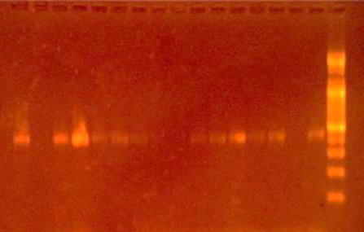
422 bp
200 bp
300bp
100 bp
400 bp
Figure ( 1 ) gel electrophoresis ethidium bromid on 2% agaros for amplified 422 bp segment of MT gene in T2D and T1D .
M: DNA marker
Lan1 : T1D patient
Lan2,3,4,5,6,7 : T2D patient
Lan 8, 9 : control
Lan 10, 11 , 12:T1D
Lan 13. 14, 15,16 : T2D patient

There is appositive significant (0.05 ) relationship between marriage and MT mutation as showed in figure ( 6) , strid et al ,2003 say that height percent of mitochondrial gene mutation in in type two diabetes in marriage patient rather than single ,this agree with present study .
The results showed figure (7) significant (0.05) relationship between mutation and another disease in T2D percentage (37.50%), Mitochondrial dysfunction is at the core of a surprising range of very common illnesses and conditions, and represents a promising new avenue for their treatment. As the mitochondria are responsible for producing energy, any illness that has an energy problem could be related to the mitochondria (Suomalainen, 2011).
mitochondria in type 2 diabetes are suspected to be involved in numerous aspects of disease pathogenesis as well as responsible for some downstream effects after onset (Lowell et al,2005 ). By classical definition, the core function of the mitochondrion is to act as the metabolic hub of the cell Indeed, when mitochondrial respiratory activity becomes impaired, symptoms are visible on a systemic level (Patti and Corvera ,2010 ) .
However, recent research has found that mitochondria are involved in many other additional processes, which also have the ability to influence mitochondrial function and dynamics and therefore may give rise to disease. New treatments and therapies for mitochondrial-associated diseases are now under development; and while much work remains, the identification of new executors of metabolic disease has renewed attention in developing treatments for many of these disorders) Schon et al ,2010 ) .

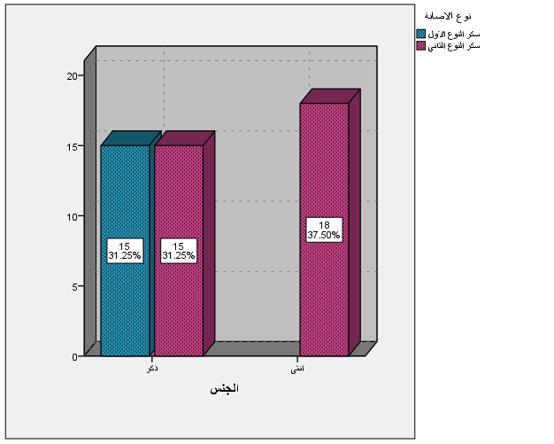

Figure (2): relationship between mutation in (MT) gene and sex in diabetes patient

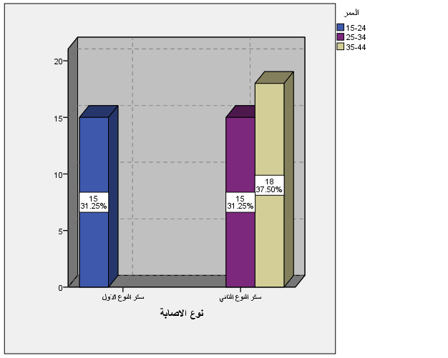

Figure (3): relationship between mutation in (MT) gene and age in diabetes patient

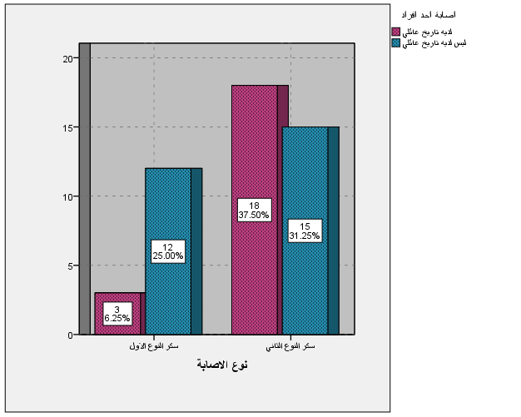

Figure (4) : relationship between mutation in (MT) gene and family history in diabetes patient

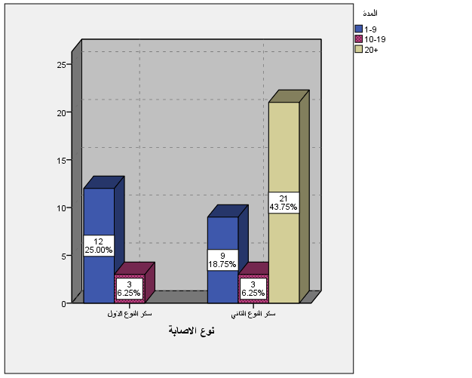

Figure (5) : relationship between mutation in (MT) gene and duration of diabetes in diabetic patient

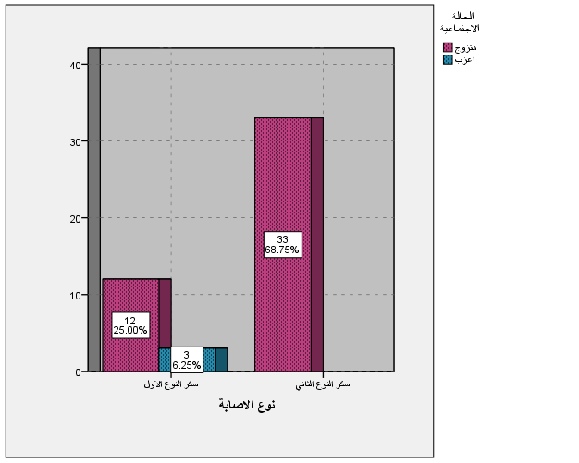

Figure (6) :Relationship between marriage and mutation mutation in (MT) gene according to the type of diabetes

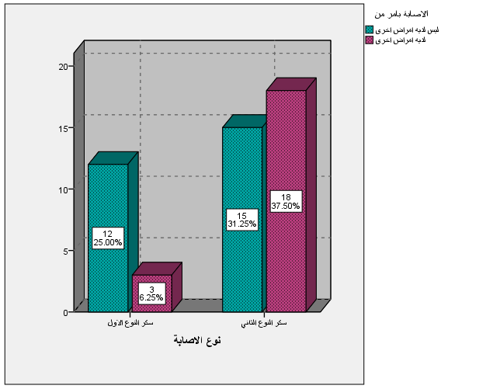

Figure ( 7) :relationship between mutation in (MT) gene and another disease in diabetes patient

References
American Diabetes Association ( 2013):Diagnosis and classification of diabetes mellitus.Diabetes Care.36: S11-S66.
Bacman SR, Williams SL, Moraes CT. (2009): Intra- and inter-molecular recombination Of mitochondrial DNA after in vivo induction of multiple double-strand breaksNucleic Acids Res, 37:4218–4226.
Ingman, M. (2000) : Mitochondrial genome variation and the origin of modern humans. Nature 408, 708-713.
Kazak L, Reyes A, Holt IJ. (2012): Minimizing the damage: repair pathways keep mitochondrial DNA intact. Nat Rev Mol Cell Biol. 13:659–671.
Lowell BB, Shulman GI .( 2005 ): Mitochondrial dysfunction and type 2 diabetes.Science .307:384–387.
Maassen JA, Janssen GM, ‘t Hart LM.(2005) : Molecular mechanisms of mitochondrialdiabetes (MIDD). Ann Med.37:213-21.
Marchetti P, Lupi ,R. and Del Guerra, S. (2010) : The beta cell in human type 2 diabetes. Adv Exp Med Biol;654:501-14.
McCarthy, MI, Hattersley AT. (2001) : Molecular diagnostics in monogenic and multifactorial forms of type 2 diabetes. Expert Rev Mol Diagn 1:403–412.
Michikawa Y, Mazzucchelli F, Bresolin N, Scarlato G, Attardi G.(1999): Agingdependent large accumulation of point mutations in the human mtDNA control region for replication. Science, 286:774–779.
Morino K, Petersen KF, Shulman GI. (2005) : Molecular mechanisms of insulin resistance in humans and their potential links with mitochondrial dysfunction. Diabetes; 55:S9-S15.
Muravchick S. (2008) :Clinical implications of mitochondrial disease. Adv Drug Deliv Rev. 60:1553-60
Nunnari, J. and Suomalainen, A. (2012 ): Mitochondria: in sickness and in health. Cell, 148:1145–1159.
Orrenius S. (2004 ): Mitochondrial regulation of apoptotic cell death. Toxicol Lett 2004; 149:19-23.
Owens, K. N. (2002 ):Genomic sequencing in the service of human rights. International Journal of Epidemiology 31, 53-58 .
Patti M-E, Corvera S.(2010): The role of mitochondria in the pathogenesis of type 2 diabetes. Endocr Rev .31:364–395.
Saltiel AR, Kahn CR.(2001): Insulin signaling and the regulation of glucose and lipid metabolism. Nature.414:799-806.
Schon EA, DiMauro S, Hirano M, Gilkerson RW.(2010): Therapeutic prospects for mitochondrial disease. Trends Mol Med . 16:268–276.
shin. Rolo, Carlos M. Palmeira.(2006): Diabetes and mitochondrial function: Role of hyperglycemia and oxidative stress. Toxicology and Applied Pharmacology 212:167-78.
Song ,A.,Suomalainen A, Isohanni P . ( 2010 ): Mitochondrial DNA depletion syndromes–many genes, common mechanisms. Neuromuscul Disord, 20:429–437.
Suomalainen ,A.( 2011 ): Therapy for mitochondrial disorders: little proof, high research activity, some promise. Semin Fetal Neonatal Med .16:236–240.
Wahid M, Naveed AK, Hussain I. ( 2006 ): Insulin and glucagon ratio in the pathophysiology of diabetic ketoacidosis and hyperosmolar hyperglycemic non-ketotic diabetes. J Coll Physicians Surg Pak .16(1):11–4.
Wang JJ, Hu G, Lappalainen J,. ( 2005 ) :Changes in features of the metabolic syndrome and incident impaired glucose regulation or type 2 diabetes in a Chinese population. Diabetes Care .28:448–50.

