Chest X-Ray Findings of Foreign Body Aspiration and Their Relation With Type and Site of Impaction
Hayder Sabeeh Nsaif Rehab Faisal Laftah
College of Medicine, Babylon University
Abutalib20033@gmail.com rehab.faisal@yahoo.com
Abstract
Objectives: Foreign body (FB) aspiration is still one of the most common emergencies in daily practice with great dependency of diagnosis on the history and radiological exam. Our work is to analyze the role of chest x-ray exam (CXR) in the management of FB aspiration trying to reach the most common radiological findings and how can such findings be affected by type and site of impaction of FB.
Methods: A retrospective study (descriptive study) of FB aspiration at Hilla General Teaching Hospital. CXR findings were analyzed in 53 positive cases, identifying the common patterns of such exam, then we tried to identify any possible effect of the type of FB and their site of impactions upon such CXR findings.
Results: Organic FB most commonly impacted at right bronchi and presented with complications specially emphysema, while inorganic metallic foreign bodies most commonly impacted at left bronchi, being radiopaque with no obvious radiological complications.
Conclusions: CXR findings will be affected by the type and site of impaction of FB.
Key words:foreign body aspiration , Tracheobronchial , CXR findings
الخلاصة:
ألهدف استنشاق الاجسام الغريبة في القصبة الهوائية ما يزال واحدا من الحالات الطارئة التي نواجهها باستمرار في حياتنا العملية مع اعتمادية كبيرة لتشخيص هذا المرض على تاريخ الحالة المرضية و مظاهر اشعة الصدر السينية. الهدف من دراستنا هو تحديد الدور الذي تلعبه اشعة الصدر السينية في تشخيص هذا المرض وعلاجه بصورة عامة وصولا لتحديد المظاهر الاكثر شيوعا وكيفية تاثر المظاهر الشعاعية المختلفة بنوع الجسم الغريب ومكان استقراره في القصبات الهوائية
ألطريقة دراسة استرجاعية وصفية اجريت لمرضى حالات استنشاق الاجسام الغريبة في مستشفى الحلة التعليمي العام. تم تحليل مظاهر اشعة الصدر السينية لثلاثة وخمسين مريضا كانت اصابتهم بهذه الحالة موجبة ومن خلال هذا التحليل تم التعرف على المظاهر الشائعة من الاقل شيوعا مع محاولة التعرف على تأثير نوع الاجسام الغريبة ومحل استقرارها في القصبات الهوائية على شيوع هذه المظاهر من عدمها.
ألنتائج الاجسام الغريبة العضوية شائعة الانحسار في القصبات اليمنى وتتمظهر شعاعيا على شكل مضاعفات الحالة المرضية بينما الاجسام الغريبة اللاعضوية (واغلبها اجسام معدنية معتمة) تنحسر غالبا في القصبات اليسرى وتتمظهر شعاعيا على شكل اجسام غريبة بعينها مع ندرة في حصول مضاعفات للمرض وقت الاستشارة الطبية
ألاستنتاجات المظاهر الشعاعية لأشعة الصدر السينية المجراة لمرضى استنشاق الاجسام الغريبة ستتأثر بنوع ومكان استقرار الاجسام الغريبة في القصبات الهوائية
الكلمات المفتاحية : استنشاق الاجسام الغريبة , الرغامي والقصبات , مظاهر الاشعة الصدرية
Introduction
The first systematic or elaborate study of FB in the airway was attempted by Gross in 1854 [Gross SD 1854]. He emphasized the importance of clinical history, specially the first paroxysm, notably cough and a severe suffocation which occurred with the aspiration of foreign objects[Yadav , 2007].
Although there has been a decrease in childhood deaths from asphyxiation by ingested objects, the incidence of FB aspiration has not changed significantly [Laure D 1410].Tracheobronchial FB is one of the most serious life threatening emergency, in USA, 90% of patients are less than four years, the maximum prevalence is between one and two years, it is the fourth leading cause of accidental death in children under five years of age, accounting for about 8% of such deaths [Mu L, 1991, Steen ,1990]. In the middle east, the prevalence of foreign body aspiration is high, and the puzzles involved in the diagnosis and the problems in their management are many[Abdulmajid ,1976, Al-Ani ;1978, Elhassani ,1978, Thabet ,1986].
Patients who have inhaled foreign bodies are typically asymptomatic at the time of initial exposure unless the particle is large enough to occlude the tracheobronchial tree, in such cases, as often seen in children, the diagnosis is made by history and confirmed by chest radiography and, if needed, diagnosed as well as treated via bronchoscopy [Suborto Paul 2005]. Bronchitis and pneumonic infiltration may develop after foreign body aspiration as a result of local irritation or possible post stenotic dystelectasis. Non radiopaque foreign bodies can often be recognized by indirect signs [Lars Kamper, 2007].
FB can be classified as either inorganic or organic. Inorganic materials are typically plastic or metal, common examples include beads and small parts from toys. These materials are often asymptomatic and may be discovered incidentally. Organic foreign bodies, including food, rubber, wood, and sponge, tend to be more irritating to the nasal mucosa and thus may produce earlier symptoms [François ,1998].
The right main bronchus has a predilection for foreign body impaction because it is wider than the left, the carina is slightly to the left of the midline and the right main bronchus has more direct extension of the trachea than the left main bronchus [James ,1991].
Killian was the first person to remove a foreign body from an air passage in 1898, later on, Einhorn, Jackson, Ingels and Mashu improved the instrumentation and brought it to it’s present high state of perfection [Clerf ,1952]. In children, suspected FB aspiration can be excluded with flexible fiberoptic bronchoscope, but it is recommended that foreign body extraction should be performed with the rigid bronchoscope, while in adults, flexible fiberoptic bronchoscope can be used in the removal of a foreign body but it is best done under general anesthesia, the rigid bronchoscope is preferred [Martinot ,1997, Richard Burr McElvein, 1996].
Patients and Methods
During the period from 28/10/2008 to 25/5/2012, 53 cases , ages ranging from 8 months to 62 years, were proved to be with definitive FB aspiration after rigid bronchoscopic exam for a number of a suspected cases at Hilla General Teaching Hospital . CXR PA view was the main investigation to be requested prior to bronchoscopy. During bronchoscopy, we precisely document the site of impaction and types of foreign bodies extracted according to the well known two major categories which are organic and inorganic types. The CXR findings were analyzed retrospectively (descriptive study) in relation with such different sites of impaction and types of FB trying to identify any effects on CXR findings.
Results
- CXR finding: positive FB was the most common finding (fig.1) which occurred in 18 cases (33.96%), emphysema (fig.2) being next occurring in 16 (30.18%), other findings with less percentages, as in 9 cases (16.98%) there were infection, 4 cases (7.54%) with collapse (fig.3), 1 case (1.88%) with pneumothorax, and 5 cases (9.43%) were normal. Figure 4 summarizes these findings.

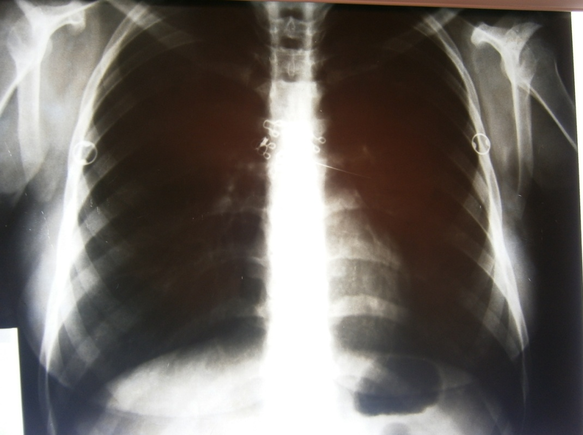
Figure 1: CXR with metallic FB at left main bronchus
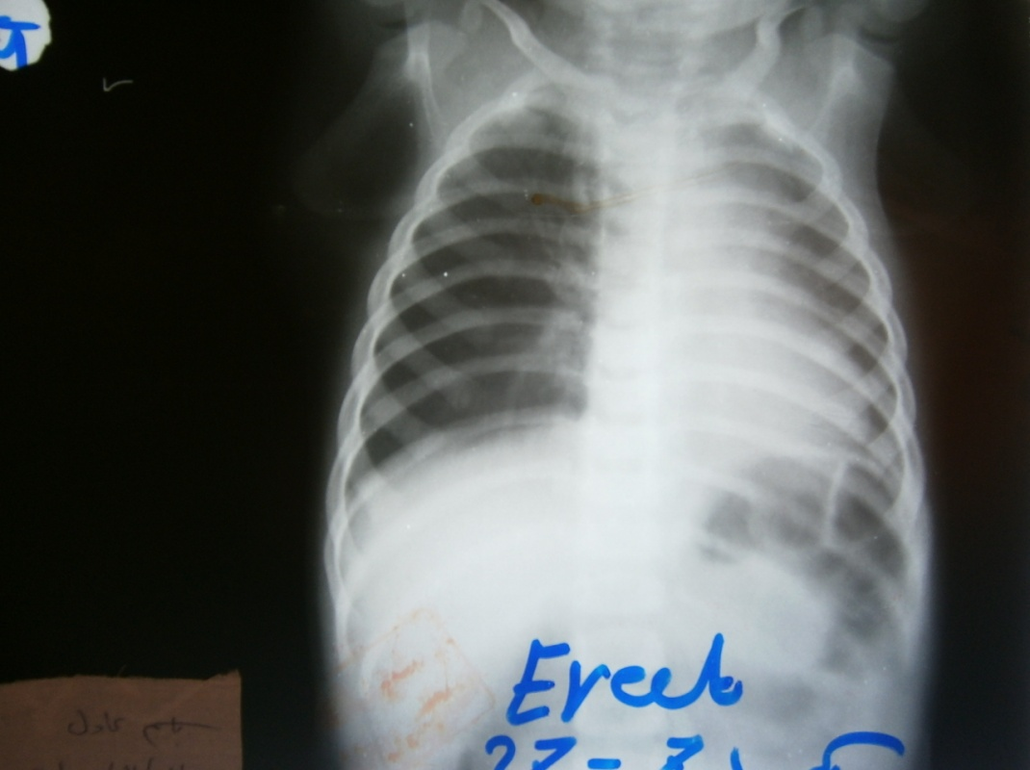
Figure 2: CXR with right sided emphysema

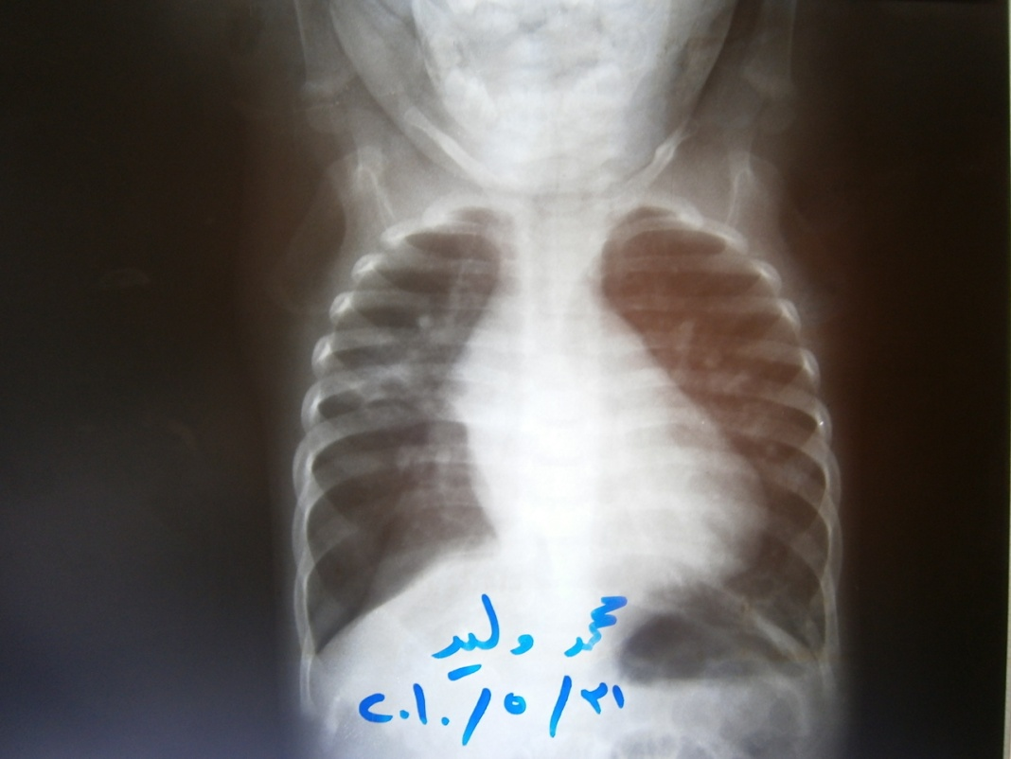
Figure 3: CXR with collapse
18
1
5
9
16
4
number
20
15
10
5
0
finding
Positive FB
Pneumothorax
Normal
Infection
Emphysema
Collapse
Figure 4: CXR findings
- All the positive cases for FB were without other findings except one which was associated with Bronchiectasis wrongly treated for many years as TB infection as shown in figure 5.
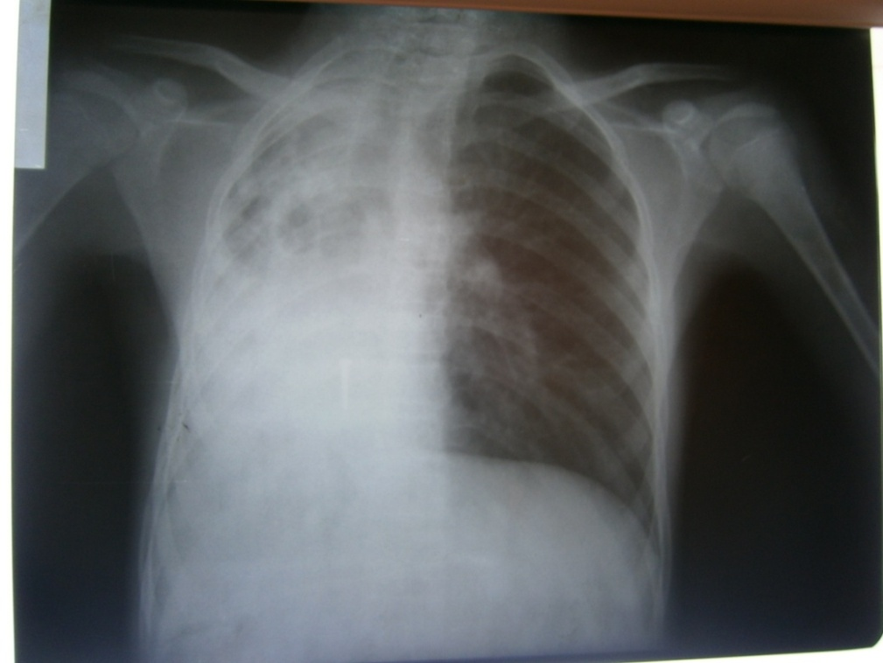
Figure 5: CXR with right lung bronchiectasis and metallic FB
- Anatomical Sites of impaction: 23 cases (43.39%) in the right bronchi, 17 cases (32.07%) in the trachea, 12 cases (22.64%) in the left bronchi, while in 1case (1.88%) the foreign body was bilateral as it is summarized in figure 6.
17
23
12
1
number
25
20
15
10
5
0
Site of Impaction
Trachea
Right bronchus
Left bronchus
Bilateral
Figure 6: site of impaction
- Types and sites of impaction of foreign bodies: Organic FB are more common (32/53) , and these are mainly non radiopaque (31/32), but can be radiopaque (1/32) with predilection for right bronchial impaction (15/32) , while inorganic FB are less common (21/53), being mainly radiopaque (17/21), and can be non radiopaque (4/21) with predilection for left bronchial impaction of the radiopaque (metallic) types (8/17). Table 1 presents these findings.
Table. 1: Types and sites of impaction of FB
Type of foreign bodies | No. | % | subtypes | Site of impaction
 |  |  |  | Right bronchi |  | Left bronchi |  | Trachea |  | Bilateral
 |  |  |  | No. | % | No. | % | No. | % | no. | %
organic | 32 | 60.37 | opaque |  | 65.23 |  | 33.33 | 1 | 70.58 |  | 100
organic | 32 | 60.37 | nonopaque | 15 | 65.23 | 4 | 33.33 | 11 | 70.58 | 1 | 100
inorganic | 21 | 39.62 | opaque | 4 | 34.78 | 8 | 66.66 | 5 | 29.41
inorganic | 21 | 39.62 | nonopque | 4 | 34.78 |  | 66.66 |  | 29.41
Total | 53 | 100% |  | 23 | 100% | 12 | 100% | 17 | 100% | 1 | 100%

- CXR findings according to site of impaction: emphysema was the most common finding of the total and right bronchial FB comprising 16/53 (30.18%), and 9/23 (39.13%) respectively, while positive FB was the most common finding in left bronchial and tracheal FB comprising 8/12 (66.66%), and 6/17 (35.29%) respectively. Table 2 presents these findings.

Table. 2: radiological findings according to site of impaction
finding | total |  | Right bronchi |  | Left bronchi |  | trachea |  | bilateral
finding | No. | % | no | % | No. | % | No. | % | No. | %
emphysema | 16 | 30.18 | 9 | 39.13 | 2 | 16.66 | 5 | 29.41 | - | -
normal | 5 | 9.43 | 4 | 17.39 | - | - | - | - | 1 | 100
infection | 9 | 16.98 | 3 | 13.04 | 1 | 8.33 | 5 | 29.41 | - | -
positive | 18 | 33.96 | 4 | 17.39 | 8 | 66.66 | 6 | 35.29 | - | -
collapse | 4 | 7.54 | 2 | 8.69 | 1 | 8.33 | 1 | 5.88 | - | -
pneumothorax | 1 | 1.88 | 1 | 4.34 | - | - | - | - | - | -
total | 53 | 100% | 23 | 100% | 12 | 100% | 17 | 100% | 1 | 100%
Discussion
Radiologically, it is well known that radiopaque foreign bodies will be found in the tracheobronchial tree directly, while radiolucent foreign bodies will be found by indirect signs where in 75% of cases they cause emphysema, in 15% obstructive atelectasis, and in 10% the CXR might be normal [Lars Kamper, 2007], so whether to find a foreign body directly or indirectly will be greately affected by the incidence of both radiopaque or radiolucent foreign bodies, and hence the incidence of non organic and organic foreign bodies because needless to say that radiopaque foreign bodies are mainly belong to the group of non organic foreign bodies, while radiolucent foreign bodies are mainly organic [Salcedo ,1998], although we found that there are 1/32 (3.12%) of organic foreign bodies can be radiopaque and 4/21 (19.04%) of non organic FB can be radiolucent.
The majority of aspirated objects are organic in nature, with the aspirated radiopaque foreign bodies being less than 20% [Midulla ,2005, Raos ,2000, Tsolov Ts 1999, Emir, 2001], or even less as we see in the great work of Nazar B. Elhassani where a radiopaque FB was found in only 63/1800 (3.50%) of cases[Nazar, Elhassani ,1988]. In our work, the aspirated organic foreign bodies are still the majority but occupying only 32/53 (65.23%) with increasing percentage of non organic FB to be 21/53 (34.78%) and specially the radiopaque objects to be 17/53 (32.07%), this is definitely due to increase incidence of (pins) aspiration due to changing cultural and social factors in the community at the last years and increasing number and decreasing age of veiled females who were used to hold pins at their mouth while wearing their shawl and talking or laughing with sisters or friends.
The single case with bilateral foreign body and that presented with pneumothorax clearly reveal the importance to anticipate whatever possible in FB aspiration cases, and honestly I found no mention to such occurrence in the available data specially the great and important work of Nazar B. Elhassani which can be regarded, proudly, one of the most important regarding the problem in the world [Nazar. Elhassani, 1988]. also The single case with Bronchiectasis clearly demonstrate the high morbidity of such problem on long term, although the screw was obvious upon presentation to us, but it was hard(but not impossible) to be observed Radiologically some months earlier. This child received a full anti TB course without benefit, which clearly reveal that keeping high index of suspicion is the only way to precisely diagnose and manage this common problem.
There is great discrepancy among literatures regarding the most common site of impaction [Rashid ,1999, Farooqi ,1999, Black ,1994, Yeh ,1998 ] , although they are realizing that there are two main presentation with the right bronchus is the most common and the left one is the second, or the reverse status is the most common. At our study, we found that the tracheal FB are second to the expected most common right sided FB leaving the left bronchial FB last. this distribution will carry no effect on the radiological findings if the types of foreign bodies were evenly distributed among anatomical sites, but we found that the more the metallic and sharp the FB, the more chance to be lodged in the left bronchi or trachea (table 1), that’s why emphysema and other signs of non radiopaque FB were very common with right sided FB9/23 (40.90%), then tracheal FB 5/17(27.77%), and last left sided FB 2/12(9.09%) because of more organic FB to be lodged in the right bronchial tree 15/23, and the reverse is true since positive FB were more common finding in left sided 8/12(72.72%) and tracheal foreign bodies 6/17(33.33%) when the type of foreign body was nonorganic in nature 8/12. These findings point to the importance of history taking in the way that CXR findings will, and better to be, anticipated and related with the type of possibly aspirated FB.
Conclusions
CXR findings will be affected by the type and site of impaction of foreign body in the way that The more the organic the FB, the more the right sided impaction and the more the radiological complications, while the more the metallic the FB, the more the left sided impaction and the less the radiological complications.
References
Abdulmajid OA, Ebied AM, Mutaweh MM, 1976 Kleibo IS. Aspirated foreign bodies in tracheobronchial tree: Report of 250 cases. Thorax; 31: 365-40.
Al-Ani MS, Elhassani NB. 1978 Study of intrabronchial foreign bodies in Iraq. In: proceedings of the first world congress in bronchoscopy. Tokyo: 151-3.
Black RE, Johnson DG, 1994 Matlak ME. Bronchoscopic removal of aspirated foreign bodies in children . J Padiatr Surg; 29(5): 682-4.
Clerf LH. 1952 Historical aspects of foreign bodies in the air and food passages. Ann Otol Rhinol Laryngol; 61: 5-17.
Elhassani NB. 1978 Aspirated tracheobronchial foreign bodies in infants. J R Coll Surg Edin; 23: 310-4.
Emir H, Tekant G, Beşik C, Eliçevik M, 2001 Senyüz OF, Büyükünal C, Sarimurat N, Yeker D. Bronchoscopic removal of tracheobronchial foreign bodies: value of patient history and timing. Pediatr Surg Int Mar; 17(2-3):85-7.
Farooqi T, Hussain M, Pasha HK, Bokhari K, Hassan S. 1999 Foreign body aspiration in children: an experience at Nishtar hospital Multan. Pak J Paed Surg;1-2:16-24.
François M, Hamrioui R, Narcy P. 1998; Nasal foreign bodies in children. Eur Arch Otorhinolaryngol 255(3):132-4.
Gross SD. 1854.A practical treatise on foreign bodies in the air passages. Philadelphia: Blanchard and Lea,
James B, Snow JR. Bronchology. 1991 In: disease of the nose, throat, ear, head and neck, volume 2, 14th ED; 1278-1296.
Lars Kamper, Matthias Hofer. Foreign bodies. 2007 The Chest X- Ray: a systematic teaching atlas; 9: 179
Laure D. Holinger. 2004 Foreign bodies of the airways. Nelson textbook of pediatrics; 373: 1410.
Martinot A, Closset M, Marquette CH, 1997 et al. Indications for flexible versus rigid bronchoscopy in children with suspected foreign body aspiration. A J Respir Crit Care Med; 156: 1017-19.
Midulla F, Guidi R, Barbato A, Capocaccia P, Forenza N, 2005 Marseglia G, Pifferi M, Moretti C, Bonci E, De Benedictis FM. Foreign body aspiration in children. Pediatr Int Dec; 47(6): 663-8.
Mu L, He P, Sun D. 1991 Inhalations of foreign bodies in Chinese children: a review of 400 cases. Laryngoscope; 101: 657-60.
Nazar B. Elhassani: 1988 Tracheobronchial foreign bodies in the Middle East :a Baghdad study. Journal of thoracic and cardiovascular surgery: volume 96, number 4,; 621-25.
Raos M, Klancir SB, Dodig S, Koncul I. 2000 Foreign bodies in the airways in children. Lijec Vjesn Mar; 122(3-4): 66-9.
Rashid D, Ahmed B, Muhammed S, Hydri AS, Anwar K. 1999 Foreign body: tracheobronchial tree. Pak Armed Forces Med J; 49(2):114-6.
Richard Burr McElvein, Bronchoscopy. 1996 Glenn’s Thoracic and Cardiovascular Surgery; 10: 174.
Salcedo L. Foreign body aspiration. Anesthesiol Clin North Am1998;16:885–92.
Steen KH, Zimmermann T. 1990 Tracheobronchial aspiration of foreign bodies in children: a study of 94 cases. Laryngoscope; 100(5): 525-30.
Suborto Paul, Yolonda L. 2005 Colson. Interstitial Lung Diseases. Sabiston and Spencer Surgery of the Chest;11: 152.
Thabet JH. 1986 Mismanagement of inhaled foreign bodies in the Middle East. Saudi Med J;7: 255-60.
Tsolov Ts, Melnicharov M, Perinovska P, Krutilin F. 1999 Foreign bodies in the upper airways of children: problems relating to diagnosis and treatment. Khirurgiia (Sofiia); 55(5):33-4.
Yadav S P S, Singh J, Aggarwal N, Goel A. 2007 Airway foreign bodies in children: experience of 132 cases. Singapore Med J; 48 (9) :850.
Yeh LC, Li HY, Huang TS. 1998 Foreign bodies in tracheobronchial tree in children : a review of cases over a twenty- year period. Changgeng Yi Xue Za Zhi; 21(1):44-9.

