Blood Pressure and Atrial Natriuretic Peptide (ANP) Levels in Patients with Autosomal Dominant Polycystic Kidney Disease.
Rafie Shakir Al-Khafaji* Ali Hmood Al-Saadi** Haider Kamil Zaidan**
* Faculty of Science/University of Kufa. ** Faculty of Science/University of Babylon.
*Email: rafie.alkhafaji@uokufa.edu.iq **Email: haider_kamil@yahoo.com
Abstract
Autosomal dominant polycystic kidney disease (ADPKD) is the most common life threatening hereditary disease of the kidney. It is a systemic disease characterized by multiple, bilateral renal cysts that result in massive renal enlargement and progressive functional impairment. Patients with ADPKD often develop hypertension before any abnormalities in renal function are detected clinically. In particular, hypertension is insidious and remains a continuous problem that evolves during the course of the disease. Atrial natriuretic peptide (ANP) possess bioactive on blood pressure. This study dealt with two groups of patients with ADPKD; the first included the patients with renal failure while the other included the patients without renal failure, as well as healthy control group. The results found prevalence of hypertension in patients with ADPKD, reached 75%. Blood pressure was significant increase (P≤0.05) in ADPKD patients without renal failure than control, where reached to 137.14/85 mmHg compared with 123.93/80.71 mmHg respectively. The ANP levels were significant increase (P≤0.05) in ADPKD patients with renal failure compared with ADPKD patients without renal failure and control groups, which reached (106.5 pg/ml), (79.2 pg/ml) and (24.4 pg/ml) respectively.
Key words: Autosomal Dominant Polycystic Kidney Disease, hypertension, Atrial Natriuretic Peptide.
الخلاصة
مرض الكلية عديدة الاكياس السائد ADPKD هو المرض الوراثي الاكثر شيوعا في تهديد الحياة. هو مرض شامل يتصف بوجود اكياس كلوية متعددة تؤدي الى توسع كلوي هائل وضعف وظيفي متفاقم. مرضى ADPKD غالبا ما يعانون من ارتفاع ضغط الدم, قبل ان يتم الكشف سريريا عن اي اضطرابات في وظيفة الكلى, الذي يبقى المشكلة المستمرة التي تتطور خلال تقدم المرض.ANP هرمون له فعالية حيوية على ضغط الدم. الدراسة الحالية تناولت مجموعتين من مرضى ADPKD ,تضمنت احداهما المرضى بالفشل الكلوي بينما الاخرى تضمنت المرضى بدون فشل كلوي, فضلا عن مجموعة السيطرة. بينت النتائج نسبة انتشار ارتفاع ضغط الدم في عموم المرضى كانت 75% . واظهرت ان معدل ضغط الدم كان أعلى في المرضى بدون فشل كلوي مما في السيطرة,حيث بلغ 137.14/85 ملم زئبق مقارنة مع 123.93/80.71 ملم زئبق على التوالي. ان مستويات هرمون ANP كانت أعلى في المرضى بالفشل الكلوي منها في المرضى بدون فشل كلوي اللذين بدورهم كان لهم مستوى هرمونANP أعلى من مجموعة السيطرة حيث بلغت 106.5 بيكوغرام/مل و 79.2 بيكوغرام/مل و 24.4 بيكوغرام/مل على التوالي.
الكلمات الدالة: مرض الكلية متعددة الاكياس السائد الجسمي،ارتفاع ضغط الدم،ببتيد البيلة الصوديومية الاذيني.
Introduction
Autosomal dominant polycystic kidney disease (ADPKD) is the most common monogenic disorder of the kidney, affected all ethnic groups worldwide with frequency of 1:400 to 1:1000 persons and accounts for 5-10% of cases of chronic renal failure (Ong and Harris,2005). The disease may arise from mutations in two genes, which are known as PKD1 and PKD2. Mutations in PKD1, which is located on the short arm of chromosome 16 and encodes the protein polycystin-1, account for about 85% of cases. Mutations in PKD2, which is located on the long arm of chromosome 4 and encodes the protein polycystin-2, are responsible for approximately 15% of cases (Katabathina et al.,2010).
ADPKD is characterized by progressive formation and enlargement of renal cysts, typically resulting in end-stage renal disease (ESRD) by late middle life. Although the kidneys are the major sites of clinical disease, the prevalence of extrarenal manifestations in ADPKD is high. These extrarenal manifestations include cyst formation in other ductal organs and various cardiovascular abnormalities (Torres et al.,2007). From a clinical perspective, it is important to identify treatable risk factors associated with early progression in the course of the disease. Several factors that predict a more rapid deterioration of renal function include age, male gender, gross hematuria, proteinuria, type of caused gene, and hypertension (Kelleher et al.,2004). Of these risk factors for renal dysfunction in ADPKD, hypertension is the only treatable condition identified to date. Moreover, hypertension in patients with ADPKD is associated with a high incidence of left ventricular hypertrophy. Left ventricular hypertrophy (LVH) is a known risk factor for cardiovascular complications, which are now the most common cause of death in patients with ADPKD. The aggressive control of blood pressure (BP) in patients with ADPKD was associated with reversal of LVH to greater extent than the patients who had chronic hypertension (Helal et al.,2013).
Atrial natriuretic peptide (ANP), hormone release from heart atria stimulated for stretch in myocardium or volume overload, has potentially important interactions with the renin-angiotensin-aldosterone system (RAAS) and then, it has a role in homeostatic control of BP as well as of extracellular fluid volume. Although there is a high prevalence of cardiovascular diseases (CVD) in patients with chronic kidney disease (CKD) and ESRD (Suresh and Farrington,2005; Briccaa and Lantelme,2011). Therefore, evaluation of ANP levels in patients with ADPKD as an indicator of presence of heart diseases may be associated with those patients. Early identification of patients with CKD at risk of premature cardiovascular events has become a major public health issue given the emergence of even mild renal dysfunction as an independent risk factor for cardiovascular events (Mark et al.,2006).
Materials and methods
The current study included twenty four patients with ADPKD (15 males and 9 females) who were diagnosed by ultrasonography according to Ravine criteria (Ravine et al., 1994). These patients were receiving treatment in Al-Hakeem General Hospital and Al-Sadr Medical City in Al-Najaf Provence. The patients were divided into two groups, the patients with renal failure (10 patients) and the patients without renal failure (14 patients), as well as fifteen healthy peoples as a control group. Diastolic and systolic blood pressure (BP) was measured by mercury sphygmomanometer in all groups. Blood samples were collected from all groups by about 5 ml per person. Serum was separated for estimating of ANP levels by enzyme linked immune-sorbent assay (ELISA). ANP levels were estimated in virology laboratory in Al-Sadr Medical City according to manufacturer's procedure (USCN life Co. USA). Statistical analysis of the results was performed by using megastat program (version 10.12) for excel 2007; t-test and one way ANOVA test were used to comparison between the groups.

Results
The mean of hypertension prevalence was 75% from all patients with ADPKD and 100% in ADPKD patients with renal failure alone. Figure (1) revealed to a significant increase (P≤ 0.05) in both systolic and diastolic BP in the ADPKD patients (147.5 ± 3.17) mmHg and (87.5 ± 1.9) mmHg comparison with control group (123.93 ± 1.83) mmHg and (80.71 ± 0.49) mmHg respectively.
Figure (2) revealed to a significant increase (P≤ 0.05) in systolic and diastolic BP in the patients with renal failure (162 ± 2) mmHg and (91 ± 1) mmHg than the patients without renal failure (137.14 ± 2.95) mmHg and (85 ± 1.39) mmHg as well as control group, while the patients without renal failure were significant increase (P≤ 0.05) in comparing with control group.

Figure (1): Systolic and diastolic BP in the ADPKD patients and control group.
(*): significant differences (P≤ 0.05).

Figure (2): systolic and diastolic BP in the ADPKD patients with and without renal failure. (a,b,c):significant differences (P≤ 0.05).

Figure (3) indicated a significant increase (P≤ 0.05) in ANP level in ADPKD patients in comparing with control group. Figure (4) revealed a significant increase in the patients with renal failure than the patients without renal failure. The patients without renal failure have significant increasing (P≤ 0.05) of ANP compared with control group.
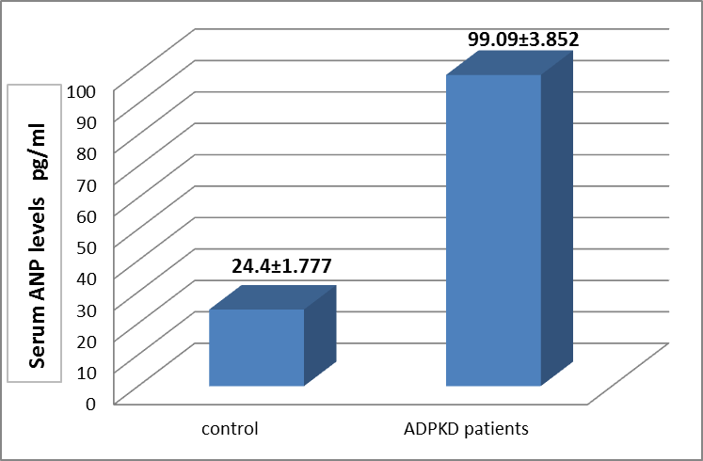
*
Figure (3): Serum ANP levels in ADPKD patients and control.
(*): significant differences (P≤ 0.05).

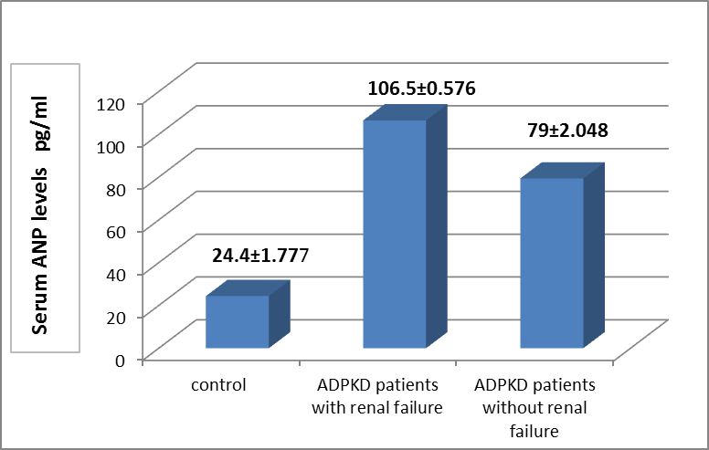
a
b
c
Figure (4): Serum ANP levels in ADPKD patients with and without renal failure. (a,b,c): significant differences (P≤0.05).
Discussion
Hypertension is the most common manifestation of ADPKD and a major contributor to renal disease progression and cardiovascular morbidity and mortality (Torres and Harris,2009). It is responsible for the diagnosis of ADPKD in approximately 30% of patients, and early manifestation occurs in more than 60% of affected individuals before decline or any substantial reduction in glomerular filtration rate (GFR) (Chapman et al.,2010a). There are several mechanisms which can be involved hypertension in ADPKD, include:
- Activation of Renin-Angiotensin-Aldosterone System (RAAS).
- Sympathetic nervous system (SNS): The chronic intra-renal ischemia and capsular stretch caused by cyst growth theoretically activates the renal sympathetic nervous system, potentially contributing to hypertension (Ratnam and Nauli,2010).
- Endothelial Dysfunction: abnormal polycystin proteins, products of PKD genes, in the vasculature may also play a role in the early development of hypertension and renal vascular remodeling in the ADPKD (Qian et al.,2007;Chapman et al.,2010b).
The association between ANP levels and renal function is complex. Ecder and Schrier (2001) were mentioned that the plasma ANP concentration increased in ADPKD patients with reduced renal function and this was interpreted as a compensatory change secondary to decreased renal capacity to elimination of sodium with decline glomerular filtration rate (GFR) and extracellular fluid volume expansion. Patients with renal dysfunction tend to have higher atrial pressure, systemic high pressure, and ventricular mass, all of which could lead to higher ANP levels in plasma, or they might have increased ANP levels due to decreased renal dysfunction (Daniels and Maisel,2007).
Increased ANP levels in the ADPKD patients with renal failure in comparing with the patients without renal failure (figure 4), may be caused by fluid overload in the patients with renal failure (Aziz,2005;Surech and Farrington,2005). ANP is a potent diuretic, vasorelaxant hormone which responded to intra volume expansion and blood pressure (BP) elevation. It controls sodium-water balance and exerts inhibitory effects (antagonist) on the renin-angiotensin-aldosterone system (RAAS) and other vasoactive components, including vasopressin and catecholamines, thereby acting as an antihypertensive hormone (Kato et al.,2000). Because the study patients were suffering from hypertension, so it may be another reason for the high levels of ANP. In general, many of studies indicated presence higher ANP levels in hypertensive patients than normotensive persons (Ahmed et al.,2012;Helal et al.,2013). The increased plasma ANP has found to be associated with hypertension in ADPKD patients, which confirms that the relationship between BP and ANP, some studies have been reported that genetic mutations affecting the ANP pathway may contribute to hypertension and heart diseases in human (Zhou et al.,2009). There are results were showed that higher levels of serum ANP in the ADPKD patients with renal failure than the ADPKD patients without renal failure, may also be due to occult cardiovascular defect the patients with hypertension (Helal et al.,2013).
Because great majority of the study patients received antihypertensive medications and diuretics control of hypertension and avoid disease complications, these drugs may be other cause for elevate of ANP concentrations. The antihypertensive medications received by the patients ADPKD who had hypertension may contribute significantly to elevating ANP levels. Where confirmed the studies on this topic that some of antihypertensive drugs (for example: Beta-blockers, angiotensin converted enzyme (ACE) inhibitors, calcium-channel blockers and NEP inhibitors) and some of diuretics (such as furosemide and acetazolamide) lead to rising of ANP levels (Liu et al., 2007; Divya et al.,2011).

Conclusions
Hypertension occurs early in ADPKD patients and before impairment of renal function. Hypertension is associated with a faster progression to ESRD and represents the most important potentially treatable factor in ADPKD. ANP levels increased with progression of ADPKD. ANP may be a good indicator to overload volume of body fluids in the patients with renal failure.

References
Ahmed,F;Tabassum,N and Rasool,S.(2012).Regulation of atrial natriuretic peptide (ANP) and its role in blood pressure. Int.Curr. Pharma. 1(7): 176-179.
Aziz, A.A. (2005). Atrial natriuretic peptide in chronic renal failure on maintenance hemodialysis: effect of heart failure.Ann. Coll. Med. Mosul.,31(1):32-36.
Briccaa, G. and Lantelme, P. (2011). Natriuretic peptides: Ready for prime-time in hypertension? Archives of Cardiovascular Diseases, 104:403-409.
Chapman,A., Rahbari-Oskoui,F., Errboe,S. and Rizk,D.(2010a). Hypertension in autosomal dominant polycystic kidney disease. US Nephrology,5(1): 54-59.
Chapman,A.B.,Stepniakowski,K. and Rahbari-Oskoui,F.(2010b). Hypertension in autosomal dominant polycystic kidney disease. Adv.Chroni Kidney Dis.,17(2): 153-163.
Daniels,L.B. and Maisel,A.S. (2007). Natriuretic Peptides. J Am Coll Cardiol.,50(25):2357-68.
Divya,S., Bhavya,N.,Kumar,K.P.,Keerthi,K.S. and Dhanaraju,M.D. (2011). New Era of Antihypertensive Agents-Vasopeptidase Inhibitors. World J. Med. Sci., 6 (4):193-201.
Ecder,T. and Schrier,R.W. (2001). Hypertension in Autosomal-Dominant Polycystic Kidney Disease: Early Occurrence and Unique Aspects. J Am Soc Nephrol.,12:194-200.
Helal,I.; Gorsane,I.; Harzallah,A.; Zaziri,F.; Elgaied,H.; Aouadia,R. and Kheder,A. (2013). Approach of Hypertension in Autosomal Dominant Polycystic Kidney Disease. Ann Clin Exp Hypertension 1(1): 1002.
Katabathina,V.S.; Kota,G.; Dasyam,A.K.; Shanbhogue,A.K. and Prasad, S.R. (2010). Adult Renal Cystic Disease: A Genetic, Biological, and Developmental Primer. RadioGraphics,30:1509-1523.
Kato,N., Sugiyama,T.,Morita,H., Nabika,T Kurihara,H., Yamori,Y. and Yazaki,Y.(2000). Genetic analysis of the atrial natriuretic peptide gene in essential hypertension. Clinical Science,98:251-258.
Kelleher,C.L.; McFann,K.K.; Johnson,A.M. and Schrier,R.W. (2004). Characteristics of Hypertension in Young Adults With Autosomal Dominant Polycystic Kidney Disease Compared With the General U.S. Population. Am J Hypertension.,17:1029-1034.
Liu, C., Liu,G., Zhou,C., Ji,Z.,Zhen,Y., Liu,K. (2007). Potent diuretic effects of prednisone in heart failure patients with refractory diuretic resistance. Can J Cardiol.,23(11):865-868.
Mark,P.B.; Stewart,G.A.; Gansevoort,R.T.; Petrie,C.J.; McDonagh, T.A.; Dargie,H.J.; Rodger,R.S. and Jardine,A.G.(2006). Diagnostic potential of circulating natriuretic peptides in chronic kidney disease. Nephrol. Dial. Transplant., 21: 402-410.
Ong,A.C. and Harris,P.C. (2005). Molecular pathogenesis of ADPKD: the polycystin complex gets complex. Kidney Int. 67:1234-1247.
Qian,Q.; Hunter,L.W.; Du,H.; Ren,Q.; Han,Y. and Sieck,G.C. (2007). Pkd2⁺/ˉ Vascular smooth muscles develop exaggerated vasocontraction in response to phenylephrine stimulation. J Am Soc Nephrol., 18:485-493.
Ratnam, S. and Nauli, S.M. (2010). Hypertension in Autosomal Dominant Polycystic Kidney Disease: A Clinical and Basic Science Perspective. Int. J Nephrol. Urol.,2(2):294-308.
Ravine,D.; Gibson,R.N.; Walker,R.G.; Sheffield,L.J.; Kincaid-Smith, P. and Danks,D.M. (1994). Evaluation of ultrasonographic diagnostic criteria for autosomal dominant polycystic kidney disease 1. Lancet, 343(8901):824-7.
Suresh,M. and Farrington,K. (2005). Natriuretic Peptides and the Dialysis Patient.Seminars in Dialysis,18(5):409-419.
Torres, V.E. and Harris, P. C. (2009). Autosomal dominant polycystic kidney disease: the last 3 years. Kidney Int.,76:149-168.
Torres,V.E.; Harris,P.C. and Pirson,Y. (2007). Autosomal dominant polycystic kidney disease. Lancet, 369:1287-301.
Zhou,Y., Jiang,J., Cui,Y. and Wu,Q. (2009). Corin, atrial natriuretic peptide and hypertension. Nephrol Dial Transplant.24(4): 1071–1073.

