Effect of Irradiation on the Properties of Bi₂ Sr_{2-x} Li_{x} Ca₂ Cu₃O_{y} Superconductor

M. A. Hapeep
Babylon University, College of Education, Department of Physics

Abstract
High temperature superconductor Bi₂ Sr_{2-x}Li_{x} Ca₂Cu₃O_{y} was prepared by a solid state reaction method, with firing temperature 800 ºC for 24 hours and sintering temperature 850 ºC for 140 hours. Superconductor properties were studied before and after irradiation, critical temperature and oxygen content increase by increasing the ratio of Li (Li=0.1, 0.2, 0.3), but they decrease after irradiation.
X-ray diffraction analysis showed that the compounds have two phases: high-T_{c} phase (2223) and low-T_{c} phase(2212) in addition to impurity phase, also irradiation leads to a decrease of volume fraction of high-T_{c} phase (2223) and the appearance of new peaks.
Scanning electron microscope has been used to investigate the morphology of the superconductor phases. Grain size increases by increasing of Li concentration and these grains take a square-shape, but after irradiation grain size becomes smaller and the square -shape disappears.

الخلاصة
حضرت نماذج من ألمركبBi₂ Sr_{2-x}Li_{x} Ca₂Cu₃O_{y} ألفائق ألتوصيل بطريقة تفاعل ألحاله ألصلبه وبدرجة حرارة حرقºC 800 لمدة 24 ساعة وبدرجة حرارة تلبيد ºC850 لمدة 140 ساعة، درست خواص ألموصل ألفائق قبل وبعد ألتشعيع، وقد وجد ان درجة الحرارة الحرجة ومحتوى الأوكسجين يزداد بزيادة نسبة الليثيوم (Li=0.1, 0.2, 0.3) لكنها تقل بعد التشعيع. أظهرت تحليلات ألاشعه ألسينيه إن ألمركب يمتلك طورين: ألطور فائق ألتوصيل ألعالي (2223) والطور فائق التوصيل الواطئ (2212) بالإضافة إلى طور الشوائب، كذلك وجد أن ألتشعيع يؤدي إلى تقليل النسبة ألحجميه للطور فائق التوصيل العالي (2223) وظهور قمم جديدة.
لقد استخدم المجهر الالكتروني الماسح لدراسة تشكيلة الأطوار فائقة التوصيل وقد وجد ان الحجم الحبيبي يزداد بزيادة تركيز ألليثيوم وهذه الحبيبات تكون مربعة الشكل ولكن بعد التشعيع يصبح الحجم الحبيبي اصغر ويختفي الشكل المربع للحبيبات.
Introduction
Superconductors are materials whose resistance is zero below a certain temperature, called the critical temperature(T_{c}) (Maqsood and Maqsood,1996), these materials include simple elements, metallic alloys and certain ceramic compounds, these compounds are known as the cuprate high temperate superconductor (Hott et al., 2004).
Based on the number of CuO₂ planes in the characteristic multilayer blocks, the high critical temperature cuprate superconductors can be classified into: single layer materials [e.g.,Bi₂Sr₂CuO_{6+δ}(Bi2201)], bilayer materials [e.g.,Bi₂Sr₂Ca-Cu₂O_{8+δ} (Bi2212)] and trilayer materials [e.g.,Bi₂Sr₂Ca₂Cu₃O_{10+δ} (Bi2223)] (Damascelli et al., 2002). This structural characteristic has a direct correlation with the superconducting properties: within each family of cuprates, the super-conducting phase transition temperature (T_{c}) first increases with the layer number (n) (Bernhard et al., 2004). Because of the highest critical temperature, the (2223) phase of the compound has attracted greater interest and many workers have spent much effort to obtain the pure phase of the compound in the bulk, this phase has unstable structure (Ertan and Necdet, 2001). Intergrowth of multiple phases in crystal grain has posed difficulties in preparing single phase crystals (Shaoyan and Michal, 1998).
These compounds are very important in the practical applications, therefore we suggested that study of the effect of gamma radiation on the superconductor properties.

Experimental Procedure
The samples were prepared by standard solid state reaction from the starting materials Bi₂O₃, Sr(No₃)₂, LiCo₃, CaCo₃ and CuO. These were mixed and the mixture was thoroughly ground in an agate mortar and then calcined at 800 ºC for 24 hours in a furnace to remove CO₂ and NO₂ gases from the mixture.
The calcined powder was reground again, pressed to pellets with (1.2cm) in diameter under a hydrostatic pressure about (0.5Gpa).The pellets were sintered at 850 ºC for 140 hours. The pellets were examined by Miessner effect to evaluate the superconducting state.
Oxygen content in the samples was determined by idometric titration method, this method includes: weighting (45mg) of sample and placed inside a conical flaks on the magnetic stirrer, adding (2.5ml) of KI solution and (1.25ml) of HCl solution together to the samples powder, the liquid in the flask turns dark brown, the solution of Na₂S₂O₃ is added to the liquid from the burette when the liquid becomes pale brown, a few drops of starch were added. The liquid turns dark blue, further addition of the Na₂S₂O₃ solution with more slowly will turn the liquid to yellow. Stopping the titration and measuring the volume of the titrated Na₂S₂O₃ solution, and the oxygen content (δ) could be found from equation (Swinnea et al., 1987).
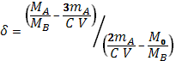 (1)

where M_{A} is the molar mass of the sample, M_{B} is the molar masses of Na₂S₂O₃ .5H₂O, m_{A} is the mass of the sample, C is the concentration of the Na₂S₂O₃, V is the volume of Na₂S₂O₃ used in titration and M₀ is the atomic weight of oxygen.
The phase compositions of samples were analyzed by X-ray diffraction analysis using Cu-Kα radiation. The electrical properties were measure by four-point probe method, in the temperature intervals of (77-300) K and direct current from 0.5mA to 15mA was admitted throw the sample. The resistivity could be found from the relation (Sorab, 1968).

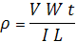 (2)

where I is the current passing throw the sample, V is the voltage drop across the
electrodes, W is the width of the sample, t is the thickness of the sample and L is the effective length between the electrodes. The microstructure of the sample was observed using a scanning electron microscopy (SEM); the observation was performed on the surface of the samples.
Samples have been irradiated by gamma ray at room temperature by using Co⁶⁰, the test samples were irradiated by a dose 23MRad, all these samples have been examined before and after irradiation.
Results and Discussion
The values of excess oxygen content are shown in Table (1). It could be noted that the value of excess oxygen content (δ) of the specimens doped with lithium gradually increases because of that the doping introduces additional oxygen into the Li/Sr-O planes. After irradiation the amount of oxygen decreases because irradiation acts to damage the bonds in the CuO planes and causes defects, these defects decrease the number of holes in the lattice (Bodi et al., 2001).

Table (1). Oxygen content of Bi₂Sr_{2-x}Li_{x}Ca₂Cu₃O_{Y} before and after irradiation.

Oxygen content |  | x
After irradiation | Before irradiation | x
0.184 | 0.213 | 0.1
0.215 | 0.259 | 0.2
0.273 | 0.324 | 0.3

On the other hand, the critical temperature of the prepared samples increases by increasing of lithium concentration (T_{c}=102,110,120)K when (x=0.1,0.2,0.3) respectively, as shown in figure (1) before irradiation, apparently it is due to the fact that, for small hetrovalent replacement of 2-valent copper cation by 1-valent lithium ion, the concentration of Cu⁺³ holes in the CuO₂ layers increases (Meretliev et al., 2000).The critical temperature of the samples decreases after irradiation, where the take the values (T_{c}=93,102,109)K when (x=0.1,0.2,0.3) respectively, see figure (2), due to change in oxygen stoichemetry, also this may be attributed to the fact that the radiation induce damage of weak links which result in poor grain conductivity in Bi-2223 compound (Borisenko et al.,2006).
Figure (3) shows x-ray diffraction spectra of the prepared samples before irradiation, we can seen from the spectra that there are two phases in all samples: high-T_{c} phase (2223), low-T_{c} phase and a small amount of impurity phases. The substitution of Sr by Li may well relax the modulation by influencing the charge balance oxygen content and structure of the relevant layers (Mazaki et al., 2005).From these figure it can be noticed that the high rate of (2223) phase appears with increasing Li content and slightly change in the intensity. Figure (4) shows x-ray diffraction spectra of irradiated samples, from this figure one can observe the volume fraction of high-T_{c} phase decreases and the irradiation causes a shift of peaks, as well as some oxide impurities were found to be developed peaks corresponding to another oxide impurities which may be attributed to the absent of some oxygen atoms due to irradiation (Kivelson, 2006).
Figure (5) shows SEM photographs of samples before irradiation. It can be observed from figure (5a) plate-link grains which consist of 2212 phase and grain boundaries are very clear. From figure (5b) we can see that some small particles are seen on the edge of the plate-like, the size and amount of particle increase and the shape of these particles is square (figure (5c)) (Guo, et al., 2000).
Figure (6) shows SEM of irradiated samples, from this figure we can see that these particles become smaller and less continuous and the square shaped particles disappeare (Ramesh, 2005).

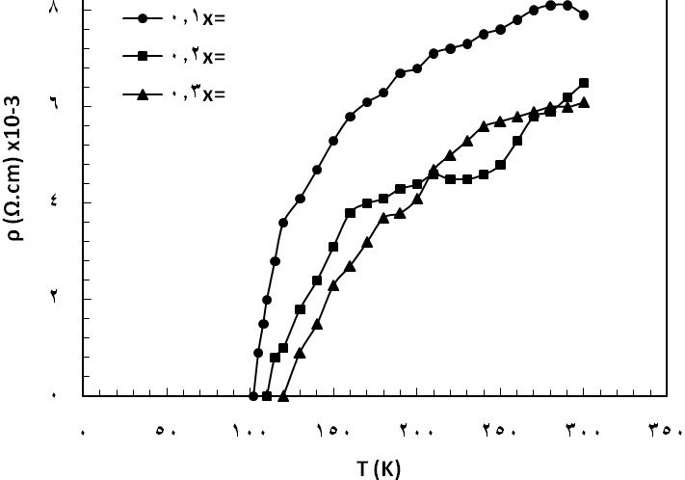

Figure (1). Temperature dependence of resistivity of Bi₂Sr_{2-x}Li_{x}Ca₂Cu₃O_{Y} before irradiation

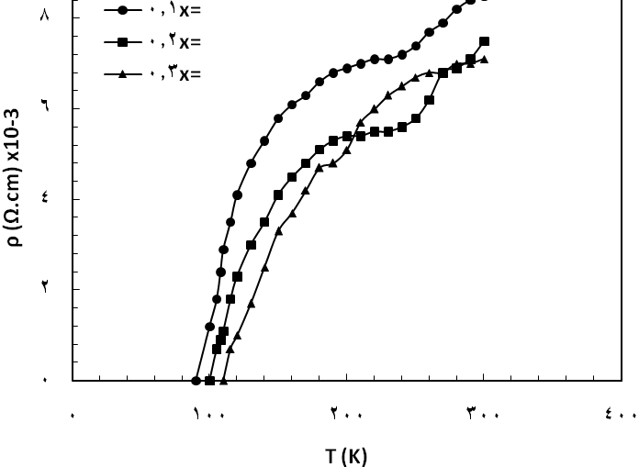

Figure (2). Temperature dependence of resistivity of Bi₂Sr_{2-x}Li_{x}Ca₂Cu₃O_{Y} after irradiation 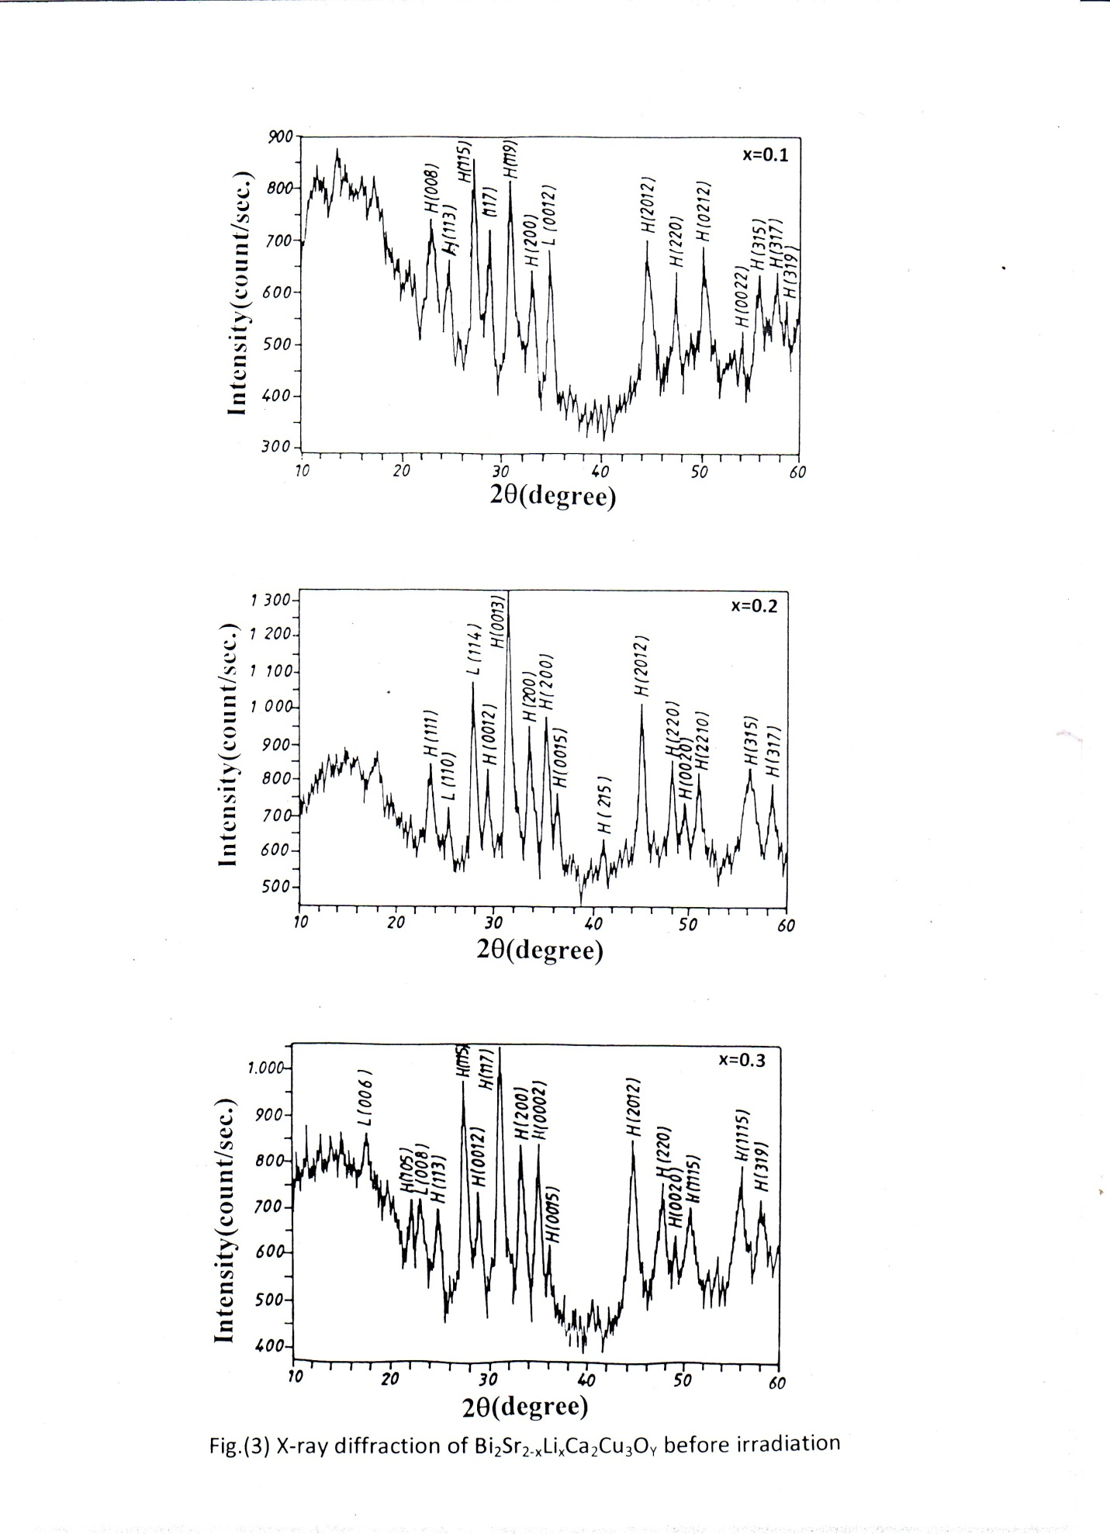

Figure (3). X-ray diffraction of Bi₂Sr_{2-x}Li_{x}Ca₂Cu₃O_{Y} before irradiation.
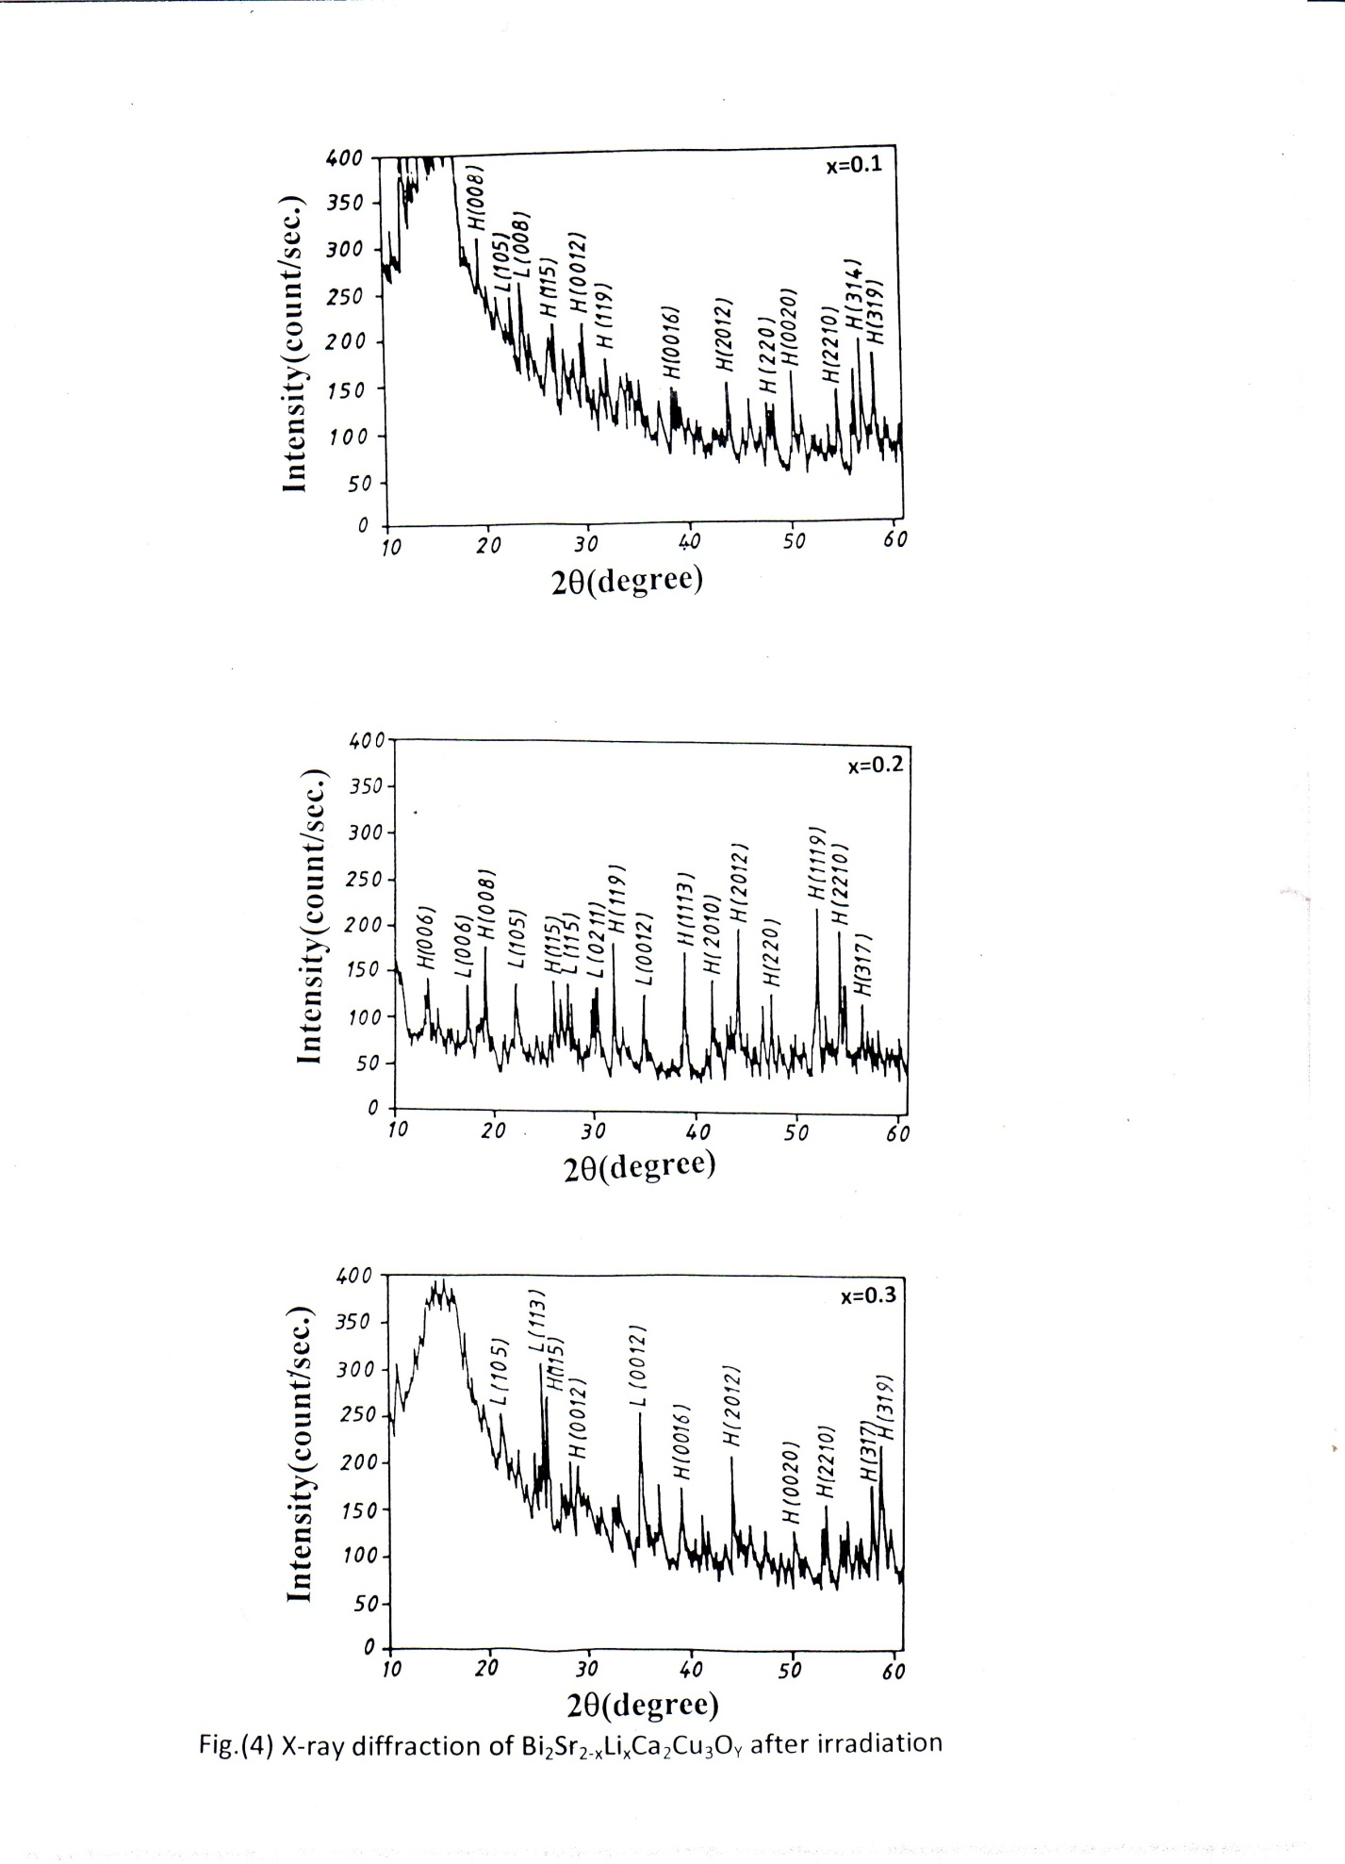

Figure (4). X-ray diffraction of Bi₂Sr_{2-x}Li_{x}Ca₂Cu₃O_{Y} after irradiation.
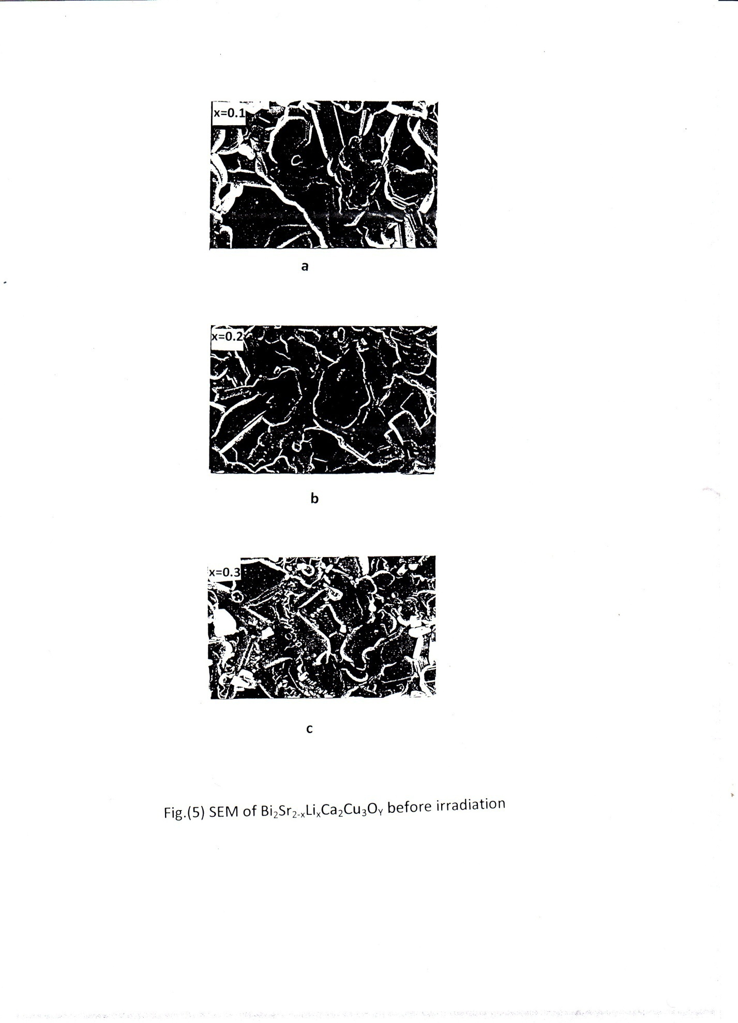

Figure(5). SEM of Bi₂Sr_{2-x}Li_{x}Ca₂Cu₃O_{Y} before irradiation.

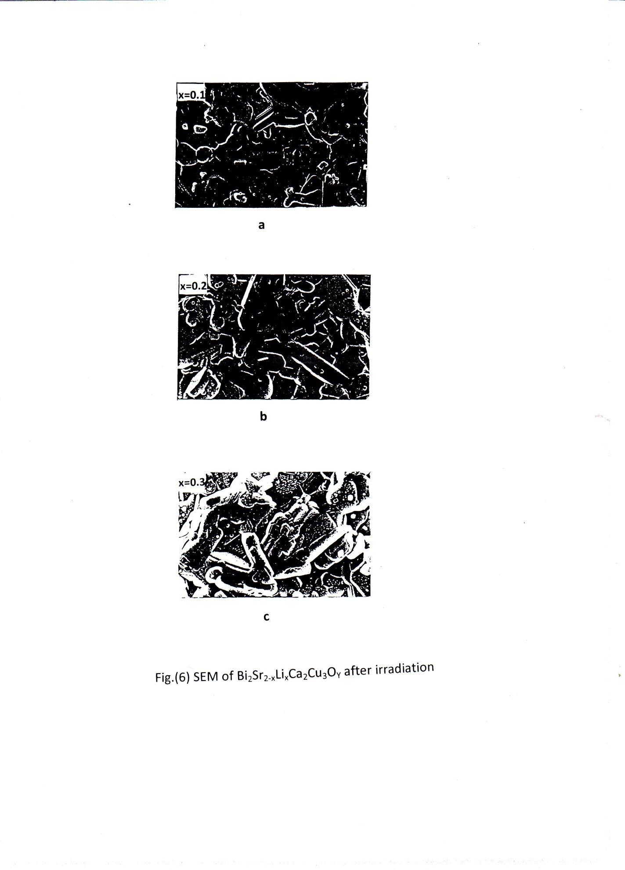

Figure(6). SEM of Bi₂Sr_{2-x}Li_{x}Ca₂Cu₃O_{Y} after irradiation.

Conclusions
The critical temperature increases by increasing of Li, also excess oxygen content, while it decreases for irradiated samples, as well as irradiation leads to a decrease in volume fraction of high-T_{c} phase with appearing of new peaks of impurity oxide phases. Scanning electron microscope displays plate-like grains which consist of (2212) phase and the shape of particles is square but these particles become small and the square-shaped particles faded after irradiation.
References
Bernhard, C., Liang,B., Wolf, Th., and Lin, C.T., 2004, "Supercond. Sci. Techn.", Vol.17, PP. 731-738.
Bodi, A.C., Sika, J.C., and Trager, T., 2001, "Physica C.411", Vol.85, P.331.
Borisenko, S.V., Kordyuk, A.A., Kim, T.K. and Nenkov, K.A., 2006, "J. App. Phys.", Vol.27, P.18.
Damascelli, A., Feng, D. L., Shen, K. M, Motoyarma, N., Lu, D. H., Roning, F., Kishio, K., and Kaneko, N., 2002, "Physical Review Letters", Vol.88, N.10, P.10701.
Ertan, N. and Necedet, A., 2001, "Turk. J. Phys.", Vol.25, P.257.
Guo, Y.C., Liu, H.K., and Dou, S.X., 2000, "J. Am. Ceram. Soc.", Vol.83, P.1675.
Hott, R., Kleiner, Wolf, Th., and Zwicknagi, G., 2004, "Superconducting Materials-A topical Overview", Spring Verlag, Berlin, P.5.
Kivelelson, S.A, 2006, "Physica B.318", Vol.61, PP.3451-3459.
Maqsood, A., and Maqsood, M., 1996, "Condens. Matt. Phys.", Vol.1, PP.77-110
Mazaki, H., Yamamoto, O. and Kitaguchi, H., 2005,"Jpn. J. App. Phys.", Vol.29, N.4, L 372.
Meretliev, Sh., Sadykov, K.B. and Berkelief, A., 2000, "Turk. J. Phys.", Vol.24, PP.39-48.
Ramesh, R., 2005, "Phys. Rev. B.38", P.7090.
Shaoyan, C.H., and Michal, E.M., 1998, "Journal of Material Research", Vol.13, N.3, P.75.
Sorab, K., 1968, "Theory and Practice of Microelectronics", John Willy & Sons, P.133.
Swinnea, J.S., Manthiram, A.M., Sui, Z.T., Steinfink, H. and Goodenough, J.B., 1987,"J. Am. Chem. Soc.", Vol.11, N.22, P.6667.

