Effect of Hermaphrodite on some Hematological and Biochemical Parameters in Goats

Asmaa Sh. Aliawy
Dept. of Theriogenology, College of Veterinary Medicine Univ. of Basra,
Nawras A. Alwan
Dept. of physiology and Chemistry , College of Veterinary Medicine Univ. of Basra
Azal N. Alnusear
Dept. of anatomy & Histology , College of Veterinary Medicine Univ. of Basra

Abstract
In this study hermaphrodite in goat were taken. For this purpose three infertile goat at age of 3.5-5 month culled from a herd managed at Basra provenience .A similar number of healthy goat were taken as a control group. The weight of each an animal were recorded, while the length of each organ taken after slaughtering of the animal of both group. The aim of study is to evaluate the properties and serum activity of Alkaline phosphatase(ALP),serum Glutamic oxaloacetic tran samines (SGOT),serum Glutamic pyruvate transaminas(SGPT) and serum cholesterol. In addition to calculate the volume of packed cell volume (PCV) and hemoglobin(HB). Blood samples for PCV and HB as wall as for serum were collected from jugular vein. A significant reduce in packed cell volume (PCV) and hemoglobin ( HB) of hermaphrodite goat from that of normal one (control group) Similar finding with the values of SGOT and SGPT concentration .However the concentration of serum cholesterol in hermaphrodite were mach higher that that of serum cholesterol in control group while the concentration of Alkaline phosphates were lower than that of control group.Therefore it seem to be so important to carry on the study to create abase for wide characterization of the syndrome in domestic goat .

الخلاصة
في هذه الدراسة تناول ثلاث حالات للمعز المصابة بالخناثة والتي تتراوح أعمارها من 3,5-5 أشهر خلال تقييم فعالية الأنزيم الأكالين فوسفتيز ALP وكلوتامك اوكزالو أستك ترانسمنس SGOT وكذلك أنزيم كلوتامك بايروفيت ترانسمنس SGPT في مصل المعز انخفاض معنوي عن المجموعة الطبيعية وكذلك الكولسترول في الحيوان المصاب اكثر من المجموعة الطبيعة .وبعد ذلك تم قياس كريات الدم المرصوصة والهيموغلوبين الدم في الحيوان المصاب بالخناثة ولوحظ ايضآ انخفاضا معنوي مقارنتاً بالمجموعة الطبيعة للحالة وتمت عن طريق سحب الدم من الوريد الوداجي .
Introduction
Hermaphrodite is a condition occurring in twins of different sexes where an imperfect masaulinised seriate female twin is born with a male. The syndrome has been mostly reported for cattle and sheep(Allard et al., 2000; Antonov, 1979). The clinical signs of the hermaphrodite at age of three to six weeks are the Absence of the external os, preventing development of cervix and Vagina in the female fetus(Azab and Abdel-Maksoud, 1999).
No traces of cervix or uterus were present and the vagina was represented in its caudal part only .High alkaline phosphates activity was detected in cervix and vagina.(Cole, 2003) showed that while a testis placed near the genital duct of a female could support development of the wolffian duct and induce regression of the Mullerian duct. The fetal testis produces a substance capable of inhibiting mullerian duct development in vitro this substance, which appears to be of large molecular protein (Josso et al., 1975).. In hermaphrodite the cervix was absent but the vestibule and the uterine horns were present showed(Rajakoski & Hafez, 2005).

Material and Methods
Three infertile goat at age 3.5-5 months culled from a herd managed at Basra province were take for this study .Along with three healthy goat as a control group. All the goats were kept under standard condition (Housing and feeding).
Blood sample were collected from each and every goat from jugular vein using about 5 µl Ethylene diamine tetra acetic acid (EDTA) as anti coagulant. In a tube then centrifuged at 3000 r.p.m for 15 min .Blood serum was drown out from the tube with the help of syringe and transferred into a plastic tube and kept at 20cº .However for packed cell volume measurement the drown blood is kept in capillary tube of microhaematocrit .Then centrifuged at 10000 r.p.m for 5 min .The reading were taken by using microhaematocrit reader but to determine hemoglobin content according to (Cribin & Chaffaux, 1990) as hemoglobin react with hydrochloric acid to from heamatin which could be measured by sahil Haemometer (Howksly comp. England).While the method used for Biochemical analysis of blood for the fallowing parameter (a total serum cholesterol determination (b) Effect serum enzymatic activity SGOT and SGPT and Alkaline phosphates activity were mentioned separately the determination of weigh and length of internal organ in addition to histochemical studies techniques .
A-Total serum cholesterol Determination.
Serum cholesterol was enzymatically measured by using a linear chemical kit (BIOLABOS.A.\CHOD-PAP, France)).The principle of this method is presented (2,24).Were the intensity of the pink\red color formed is proportional to cholesterol concentration. The test tubes were incubated for 5 minutes at37°C And then absorbance of sample and against the reagent blank at 500nm wave length were measured. The total concentration was calculated by using the fallowing formula:
Reading of sample
Reading of standard ×n =µg\100µL of blood
N=200µg\100µL concentration of standard solution.
B-Effect serum enzymatic activity:
For revealing the changes in the activity of some enzymes in hermaphrodite goats 1µl of blood were drown from jugular vein of each an every goats .Blood samples were Left to clot, then centrifuged at 1500 r.p.m for 10 minutes and the obtained sera were subjected to study the activity of serum glutamic oxaloacetic transaminas (SGOT) and serum glutamic pyruvate trnsaminase (SGPT ).These enzymes were determined by photometrically method which described by (Reitmans, 1957) .
C-Mesurment of ALP activity:
According to method utilizes P-nitrophenyl phosphate that is hydrohyzed by ALP into a yellow colored product at PH mater 10. 5 .This assay equilibrate reagents to room temperature or as37°C as well as product phenyl measuring .Found Amino-4-antipyrine riche sand potassium .Uses Arsenate sodium stop enzyme reaction then read absorbance by spectrophotometer on wave length 510 nm .Then measure activity enzyme by units Kind \King \100µl calculation ALP activity Calculation ALP activity of the serum sample Units King- Kind are amount enzyme which product 1µg from phenyl 37c° temperature for (15 min ) under experimental.
Measurements of Weights and Length of internal organs
Weight taking and length measurement of hermaphrodite internal reproductive system (female-type and male–type) of organs Vesitibull,Cervix, ,bulbo urethral gland and cystic dilatation and Mullerian duct as well as taken by mean Length theirs them.

Histochemical:
A-Preparation of tissue and staining method (Naphthol phosphate methods for alkaline phosphates 10 specimens from, mullerian duct of hermaphrodite were taken and immediately washed with cold normal saline . Content from each specimens were gently pressed out by cold 0.1M phosphate buffer (PH 7.5) .Frozen sections were prepared by cryostat microtome and serial sections of (8mm) thickness were processed as described by(Gomori, 1952).
B-Incubation Medium :
Consist of 0.05M Tris hydroxyl methyl amino methane PH 10(10µl, sodium naphthyl phosphate)(sodium salt)10gm,Magesium chloride (MgCL² H2O)10µg. fast blue RR salt 10µg.The final PH of the incubating medium should be between 9.0-9.4 .
The dissolved sodium d-naphthyl phosphate was well mixed and then filtered and used immediately (Gomori 1952).
C-Incubating Method:
The frozen section after mounted on the slides was incubates in solution (B) at37°Cfor 60min to 2hr. Then transferred to water for 5min then to counter stain in 2% methyl green for 5 min .After that the sections were rinsed in distilled water and covered with mounting medium like (glycerin jelly) as described by (Garleton & Leach, 1938).
D-Heamatoxyline and Eosin:
Tissue samples were processed for paraffin sections. First it should be fixed with formalin for 72hrs embedded in paraffin and cut to 4to5µm section Plus slides (Menzel Glaser, Germany).
Statistical analysis:
The obtained data were presented as means ±Standard deviation (SD) means were compared by one –Way analysis of variance (ANOVA) .Significance levels were established at P values of P<0.05 (Snedecor & Cochraan, 1980).
Results
Enzyme Activity:-
The results obtained in this study presented in table (1) where the concentration of SGOT U\L in hermaphrodite reduced from the normal values at significantly (P<0.005) where the value of SGOT in hermaphrodite is (6.66±4.25) and that of control group (10.0± 2.78) .Similarly the concentration of SGPT in hermaphrodite is (2.50±0.005) while that of control group (4.06±1.15). However the concentration of cholesterol is (41.76±4.11) higher than that of control group which is (19.36±8.91). But Alkaline phosphates (ALP) concentration in hermaphrodite (7.84±4.52) which is lowest then that in control group(12.70±1.06).

Table (1) concentration of enzyme in serum hermaphrodite goats
Concentration control Mean±S.D | Concentration Hermaphrodite Mean±S.D | Checking Biochemistry
10.0 ±2.78 | 6.66* ±4.25 | GOT U\L
4.06±1.15 | 2.50* ± 0.005 | GPT U\L
19.36*± 8.91 | 41.76± 4.11 | Cholesterol µg\100µL
12.70± 1.06 | 7.84* ± 4.52 | ALP 100µL\KAU

Measurement of PCV and Hb :
A Significant value of (P<0.05) are the difference between Hb value of hermaphrodite which is(8.0 ±5.66±6.02%) and a control (10.66±1.15).The numerical difference between both values were 2gm/100UL. PCV values hermaphrodite (11.33±2.5 %) lesser then of control group which higher than 25.66+6.02 (%)

Table (2) Effect Hermaphrodite case on concentration Blood Goats.

Mean± S.D control | Mean± S.D Hermaphrodite | Count Blood
10.66±1.15 | 8.0*±2.0 | Hb g\100µL
25.66±6.02 % | 11.33*±2.5 % | PCV %

Effect of Alkaline phosphates activities on mullerian duct:
Alkaline phosphates ALP on Mullerian duct were presented in figure (1).Where hermaphrodite slide shows the distribution of ALP activity measured by precipitation technique(Gomori) inform accumulation of ALP in surrounding serosa of mullerian duct. But it is less in its internal layer of duct .Also a distribution for ALP in the secretion.
Measurement of genital system:
All animals were Weighed and Length after slaughtering and immediately taken of the some from genital system including measurement of (vestibule, cervix, bulb urethral gland, mulleriane duct and cystic dilatation) reduced from the normal values at significantly (P<0.05). Table (3) shows the measurements of male –type which was Lower (P<0.05) than control measurements .also undifferentiated –type measurements were Lower than those of control .vestibule weight in the control was higher (11.30 ±1.05)g than in male –type (10.17 ±1.50 )g and in undifferentiated –type was (4.90±1.30 )g .These results indicate that the Length and weight increased as compared to male –type and undifferentiated-type hermaphrodite . The bulbo urethral gland Length was highest in control (2.46 ±0.45 )cm than male –type (1.03±0.41 ) cm and bulbo urethral gland Length of the undifferentiated-type was (0.60 ±0.30)cm and the Lowest than control (2.46 ±0.45) cm .bulbo urethral gland weight was the highest in control (2.65 ±0.78 )g than male-type (2.54 ±1.03)g and undifferentiated-type (2.21±1.48)g .The mullerian duct Length in control (2.33±o.152)cm than Length in male-type (0.67±0.45)cm and the undifferentiated –type was(0.51±0.11)cm.as well as mullerian duct weight in control higher (1.53±0.35) g than in male-type (0.24±0.176) g and in undifferentiated –type was (0.810±0.180).

Table (3)Post mortem finding in male-type and undifferentiated-type of hermaphrodite goats (Mean ±S.D)

control | Undifferentiated-type | Male-type | Characters of organs (cm&g)
6.96 ±0.50 cm  11.30 ±1.05 g | 2.20 ±0.70  4.90±1.30 | 2.23±0.75 cm  10.17*±1.50 g | Vestibule Length (cm) Wight(g)
15.73±1.96 cm  5.13 ±0.70 g | 1.36*±0.47 cm  3.73*±1.56 g | 0.70* ±0.52 cm  2.93*± 1.20 g | Cervix Length(cm)  Wight (g)
2.46±0.45 cm  2.65*±0.78 g | 0.60*±0.30 cm  2.21*± 1.48 g | 1.03 ±0.41 cm  2.54 ±1.03 | Bulbo urthral gland  Length(cm) Wight(g)
2.33±0.152 cm  1.53±0.35 g | 0.51 ±0.11 cm  0.810±0.180 g | 0.67*±0.45 cm  0.24±0.176 g | Mullerian duct  Length(cm) Wight(g)
--------------- | 2.66±1.00 cm  23.63 ±9.04 g | ------------- | Cystic dilation  Length(cm) Wight (g)
*the mean difference is significant at 0.05 Level

Histological examination:
The histological changes found in hermaphrodite Haematoxyline-Eosin Mullerian ducts arise in 10mm goat's embryos as a cleft lined by the coelomic epithelium, between the gonad and mesonephric parts of the urogenital ridge. This coelomic opening will later constitute the abdominal ostium of the Fallopian tube. The cleft is closed caudally by a solid bud of epithelial cells, which burrows in the mesenchyme lateral to the Wolffian ducts and then travels caudally inside their basal lamina, in its downward course and entered its basal membrane. For a while, the two Mullerian ducts are in intimate contact, then they fuse, giving rise to the uterovaginal canal as show in(Fig. 4), which makes contact with the posterior wall of the urogenital sinus, causing an elevation, the Mullerian tubercle, flanked on both sides by the opening of the Wolffian ducts (Fig 4).
Fig.5 shows Mullerian regression Once initiated the regression of the Mlluerian duct extends caudally as well as cranially, sparing the cranial tip which becomes the Morgagni hydatid, and the caudal end, which participates in the organogenesis of the prostatic utricle.The Mullerian regression of the cranial part of the Mullerian duct begins while the duct is still growing caudally towards the urogenital sinus .Shortly afterwards, the peri-Mullerian mesenchyme condenses to form a fibrous whorl, which progressively strangles the Mullerian duct and finally remains the only witness of its former existence. Mesenchymal changes are preceded by the dissolution of the basement membrane, which precipitates apoptosis and allows extrusion of epithelial cells and their transformation into mesenchymal cells.
Mullerian ducts persist and develop into the uterus and Fallopian tubes. Tubal differentiation involves formation of fimbriae and folds in the ampullary region (Fig. 3) and acquisition of cilia and secretor activity by the high columnar epithelium.
Discussion:
Although ALP is present in many tissues and organs throughout the body, only those listed above produce enough ALP to increase plasma or serum ALP activity (Stockham & Scott, 2002).
This isoenzyme may cause increased serum or plasma ALP activity during late term pregnancy(Bain, 2003). This fact is evident in the high values observed for serum total protein when compared with Red Sokoto goats(Tambuwal et al., 2002) and WAD sheep (Mishina et al., 1995). The present study showed a wide variation in the concentrations of both alkaline phosphates and the transeminases (SGPT and SGOT). The comparative value of ALP in both sexes is in contrast to the findings of (Tambuwal et al., 2002) for goats. Although ALP level can be influenced by pregnancy, blood pH of hermaphrodite(Kelly, 1974), the animals in this study were apparently healthy, non-pregnant, and these parameters could not have been influenced by these factors.
Obation the Redre Sokoto goats (Tambuwal et al., 2002). Earlier reports in Baladi goats (Azab & Abdel-Maksoud, 1999) and Red Sokoto goats(Tambuwal et al., 2002) show a PCV value of 27.25+0.59 and 25.7+3.1. This suggested that PCV is beneficial in assessing the protein status and possibly forecasting the degree of protein supplementation in goats at different physiological states. HB in this study fell within the range of high values obtained for goats (Tambuwal et al., 2002). West African Dwarf goats seem to possess relatively high HB values, and this is an advantage in terms of the oxygen carrying capacity of the blood.
Who reported that high alkaline phosphates activity was detected in cervix and mullerian duct and disodium _a naphyl phosphate was broken up at the highest rate by cervix and mullerian duct alkaline phosphates(Roberts et al., 1999). Again reported that hermaphrodite goats can be differentiated on the basis of Length of the vagina and presence or absence of a cervix (Heikkila et al., 2001).
These results were in agreement with the finding of (Guioli et al., 2007) who reported that Mullerian ducts flanked on both sides of epithelial cells wollffian ducts.
The Mullerian regression of the cranial part of the Mullerian duct begins while the duct is still growing caudally towards the urogenital sinus from the finding of (Picon, 1969). and is characterized by a wave of apoptosis spreading along the Mullerian duct (Roberts et al., 1999; Allard et al., 2000).
Mesenchymal changes are preceded by the dissolution of the basement membrane, which precipitates apoptosis and allows extrusion of epithelial cells and their transformation into mesenchymal cells (Trelstad et al., 1982; Allard et al., 2000). Epithelial-mesenchymal transformation is an important factor of epithelial cell loss during mullerian regression.
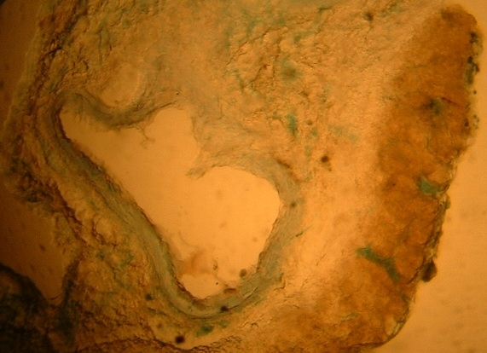
Figure(1) Show Mullerian duct (hermaphrodite) the distribution of alkaline phosphates activity by precipitation technique (Gomori)40X

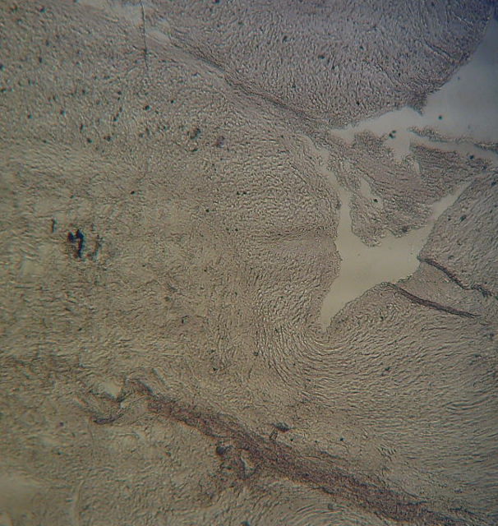
Figure (2) Show normal mullerian duct the distribution of alkaline phosphates activity by precipitation technique(Gomori) 10X.
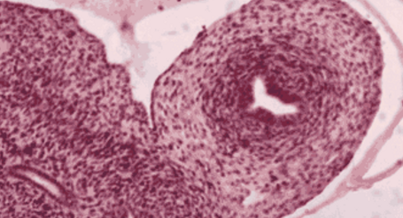

Figure ( 3). Mullerian ducts develop into the uterus and Fallopian tubes(Haematoxylin-Eosin 10x).

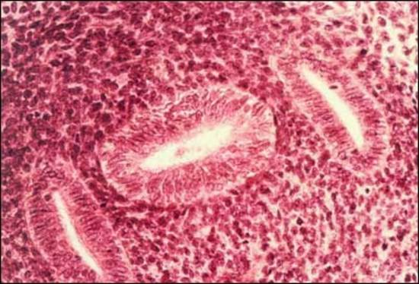
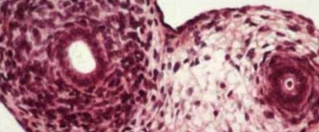.
Figure ( 4. )Fused Mullerian ducts flanked by Wolffan ducts in the lower reproductive tract of female fetus.(Haematoxyline-Eosin 10x)
Figure (5.) Regressing Mullerian duct in male fetus. Note the fibroblastic ring surrounding the epithelium(Haematoxyline Eosin 40x)

References
Allain, CC.; Poon, LS.; Chan, C.S.; Richmond ,W. and Fu, P.C. 1974 Enzymatic determination of total serum cholesterol .Clin. Chem.,20:470-475.
Allard S, Adin P, Gouédard L, di Clemente N, Josso N, Orgebin - Crist MC, Picard JY, Xavier F 2000 Molecular mechanisms of hormone- mediated Mulleria duct regression : involvement of beta-catenin Development 127:3349-3360.
Antonov, S.1979 Alkaline phosphatase activity and properties in the organs of cattle and sheep .Vet Med Nauki16(10):41-7.
Azab, M. E. and Abdel - Maksoud H A 1999 Changes in some haematological and biochemical parameters during pre-partum and post-partum periods in female Baladi goats. Small Ruminant Research, 34, 77-85.
Bain, P.J, 2003: Liver. In: Latimer KS, Mahaffey EA, Prasse KW: Duncanand Prasse's Veterinary Laboratory Medicine: Clinical Pathology,4th ed.Ames, Iowa Stata Press, pp.193-214.
Cole, J; Broad well and Rogers 1997 Intersexuality in a charolaris herifer. Vet.Rec.,141(25):656-7
Coles, E.H 1986 Veterinary clinical pathology .4th Ed., W.B. Saunders company, Philadelphia, Lpndon.P.16,102.
Cribin, E.P .and chaffaux, S 1990 Intersexuality in domestic mammals.Reprod-Nuter-Dev, supp 11:51-61
Durlinger AL, Kramer P, Karels B, de Jong FH, Uilenbroek JT, Grootegoed JA, Themmen AP 1999 Control of primordial follicle recruitment by anti-Mullerian hormone in the goats ovary. Endocrinology 140:5789-5796.
Garleton, H.M. and Leach, E.H 1938 Histological techniques 2nded., London : oxford university Press. Guioli ,S, Sekido R, Lovell-Badge R 2007 The origin of the Mullerian duct in goats and mouse. Dev Biol 302:389-398.
Gomori, G 1952 Alkaline phosphatase microscopic photochemistry. Chicago university Press.P-P:231-241.
Heikkila, M, PeHoketo H, Vainio S.2001 Wnt and the female reproductive system. J. Exp Zool.290:616-623.
Josso, N., M.G. Forest, and J.V.Picard1975 Mullerian-inhibiting activity of calf fetal testes : Relationship to testosterone and protein synthesis.Biol.Reprod.13:163.
Jost, A 1947Recherches surla differenciation sexualle delembryon de lapin. Archs . Ana t. microsc morph Exp 36:271-315.
Kelly, W R 1974 Veterinary Clinical Diagnosis. 2nd edition Macmillan Publisher, London. pp. 204-294.
Mishina, Y, Suzuki A, Ueno N, Behringer RR 1995 Bmpr encodes a type I bone morphogenetic protein receptor that is essential for astrulation during mouse embryogenesis. Genes Dev 9:3027-3037.
Olusanya ,S K, Edewor E and Health E 1976 Studies on the blood chemistry and other haematological parameters of Buffaloes in a Ranch in Nigeria. Nigerian Veterinary Journal 5 (1), 27-31.
Picon, R .1969 Action du testicule foetal sur le développement in vitro des canaux de Muller chez le rat. Arch Anat Microsc Morph Exp 58:1-19.
Pryse-Davies J, Dewhurst CJ 1971 The development of the ovary and uterus in the foetus, newborn and infant : a morphological and enzyme histochemical study. J Pathol 103:5-25.
Rajakoski, E., Hafez. H.S.E 2005 Dervatives of cortical cords in adult hermaphrodite gonods of bovine quintuplets. The anatomical Record, 457-467.
Reitmans., Frankels., Am. J. Clin .Path.1957,28-56.
Richmond, W. 1973 Preparation and properties of cholesterol oxidase from Nocardia sp .and it's application to the enzymatic assay of total cholesterol serum.Clin.Chem.,19:1350-1356.
Roberts ,L.M, Hirokawa Y, Nachtigal MW, Ingraham HA 1999 Paracrine-mediated apoptosis in reproductive tract development. Dev Biol 208:110-122.
Schonherr, H. Zobisch H, Kolb FE 1978 properties and isozymes of acid and attealine phosphatase in cattle cervix and mullerian duct. Arch Exp Veterinarmed 32(1):93-103.
Snedecor, G.W. and Cochraan, W. 1980 Statistical methods. 7th edition, Lowa state University Press, Ames.
Stockham, S.L Scott MA. Fundamentals of Veterinary Clinical Pathology. Ames, Iowa State Press, 2002, pp. 438, 446-450.

Tambuwal, F. M, Agale B M and Bangana A 2002 Haematological and Biochemical values of apparently healthy Red Sokoto goats. Proceeding of 27th Annual Conference Nigerian Society of Animal Production (NSAP), March, 17-21, 2002, FUTA, Akure, Nigeria. pp. 50-53.
Trelstad, R.L, Hayashi A, Hayashi K, Donahoe PK 1982 The epithelial mesenchymal interface of the male rat Mullerian duct : loss of basement membrane integrity and ductal regression. Dev Biol 92:27-40.

