Drying Shrinkage Behavior Of Base Restrained High Strength Concrete Walls

Ghalib M. Habeeb Mahdi S. Essa Mohammad Jassam AL- Tai
Babylon University

Abstract
In this study, reduced scale wall models (which are believed to resemble as much as possible field conditions) were used to study the shrinkage behavior of high strength concrete base restrained walls. Two sets of base restrained HSC walls were cast; Winter set which consists eight walls in different length/height ratios with and without reinforcement and Summer set which consists two reinforced walls in two length/height ratios. These walls were base restrained by steel base frame to hinder the shrinkage movement in the concrete base.The mechanical properties of high strength concrete investigated were; compressive strength between ( 50 – 90 ) MPa, splitting tensile strength between ( 5.5 – 7) MPa, flexural tensile strength ( 6 – 8.6) MPa, static modulus of elasticity ( 32 – 44 ) GPa. Based on the observations of this work, it was found that the cracks did not develop in the reinforced and unreinforced high strength concrete walls with L/H (1,2,4 and 6) during 90 days period of drying conditions. Also, the shrinkage values increase toward the edges.Based on the results of this work, the increasing in maximum shrinkage values in Summer were (73٪, 61٪) of the maximum shrinkage values in Winter for length/height ratios (4,6) respectively. The use of horizontal reinforcement (0.2٪) led to reduce in the maximum shrinkage values with increasing of length/height ratio where this reduction ratios were (12 ٪,14٪,20٪,28٪) of the maximum shrinkage values in the unreinforced walls for length/height ratios (1,2,4,6) respectively. The experimental observation in end restrained beams showed that the Summer free shrinkage(at date of cracking) was higher than of Winter free shrinkage by about (27٪), the Summer tensile strain capacity(at date of cracking) was higher than of Winter by about (30٪), the Summer elastic tensile strain capacity(at date of cracking) was higher than the Winter elastic tensile strain capacity by about (44٪).

Key words : High Strength Concrete, Drying Shrinkage , Maximum Shrinkage Values and Location in the Wall Base Restraint.
الخلاصة
في هذا البحث تم استخدام نماذج بحث مصغرة يعتقد بأنها توفر ظروفا مشابهة للظروف الطبيعية الموقعية لدراسة سلوك الانكماش للجدران المصنوعة من خرسانة عالية المقاومة وعلى وجبتين: شتوية بعدد ثمانية جدران لنسب مختلفة من الطول/الارتفاع بوجود وعدم وجود حديد التسليح والوجبة الصيفية تحوي على جدارين مسلحَين وبنسبتين من الطول/الارتفاع. تم تقييد تلك الجدران بواسطة أساس حديدي للتخلص من تأثير الانكماش الذي يحدث في الأساس الكونكريتي. الخواص الميكانيكية للخرسانة التي تضمنها البحث ، مقاومة الانضغاط ، مقاومة الشد ( الانشطار) ،مقاومة الشد (الانحناء)٬ معامل المرونة , تراوحت القيم بالنسبة للخرسانة عالية المقاومة ، مقاومة الانضغاط ( ٥٠-٩٠ ) ميكاباسكال ، مقاومة الشد بالانشطار (٥٫٥ -٧) ميكا باسكال ، مقاومة الشد بالكسر( ٦ ـ ٨٫٦) ميكاباسكال ، ومعامل المرونة ( ٣٢-٤٤) كيكا باسكال. لقد تبين من خلال المراقبة إن جميع هذه الجدران المسلحة وغير المسلحة ولهذه النسب من الطول/الارتفاع (٦٬٤٬٢٬١) لا تبدي تشققا خلال فترة تعرض للجفاف قدرها (٩٠) يوم. وكانت قيم الانكماش غالبا ما تزداد كلما اتجهنا نحو نهايات الجدار الجانبية والعليا. وكانت نسب الزيادة في القيم العظمى للانكماش في الصيف بحوالي (٧٣٪ ٬ ٦١٪) من القيمة العظمى للانكماش في الشتاء عند عمر ٩٠ يوم لنسب الطول إلى الارتفاع (٤ ٬ ٦) على التوالي. كما أدى استخدام حديد التسليح الأفقي بنسبة ٠٫٢٪ إلى نقصان في قيم الانكماش العظمى بزيادة نسبة الطول/الارتفاع حيث كانت نسب النقصان حوالي (١٢٪٬ ١٤٪٬ ٢٠٪٬ ٢٨٪) عن قيم الانكماش العظمى للجدران الغير مسلحة ولنسب الطول/الارتفاع (٦٬٤٬٢٬١( على التوالي. وقد بينت النتائج المختبرية للعتبات الخرسانية المقيدة من النهايتين إن الانكماش الحر في وقت حدوث الشق أعلى في فصل الصيف مما هو عليه في الشتاء بحوالي(٢٧٪)٬ انفعال الشد الأقصى في الصيف أعلى مما هو عليه في الشتاء بحوالي (٣٠٪) وانفعال الشد المرن في الصيف أعلى مما هو عليه في الشتاء بحوالي (٤٤٪).
Introduction
High strength concrete (HSC) have a simple definition would be" concrete with a compressive strength above the present existing limits in national cods about 40 MPa and up to 130 MPa[ACI Committee 363,2006].This concrete was available at only few locations. However, in recent years, the applications of high-strength concrete have increased, and high-strength concrete has now been used in many parts of the world. The growth has been possible as a result of recent developments in material technology and a demand for higher-strength concrete.High strength concrete (HSC) has been advantageously used for columns, shear walls of high rise buildings elevated structures, bridges, tunnels, precast and prestressed products, and in construction where durability is a function of compressive strength. Such concrete is being specified where reduced weight is important or where architectural considerations require more slender vertical load carrying elements[Yogendran et.al,1987].
Shrinkage is the decrease of concrete volume with time. This decrease is due to changes in the moisture content of the concrete and physicochemical changes ,which occur without stress attributable to actions external to the concrete. There are different types of concrete shrinkage; Plastic shrinkage is associated with moisture loss from freshly poured concrete into the surrounding environment, within the first few hours after it has been placed, Autogenous shrinkage is the early shrinkage of concrete caused by the loss of water from capillary pores due to the hydration of cementitious materials, without the loss of water into the surrounding environment, carbonation shrinkage is caused by the reaction between carbon dioxide(CO₂) present in the atmosphere and calcium hydroxide (CaOH₂) present in the cement paste and drying shrinkage refers to the reduction in concrete volume resulting from the loss of capillary water by evaporation. The amount of shrinkage depends on many factors, Troxell et al.[1968] concluded that shrinkage of low heat cement (type IV) is greater than that of (typeI). This is believed to be due to high (C2S) content in (type IV) cement, which exhibits high shrinkage. The stiffness of the coarse aggregate concrete, with higher aggregate content and higher modulus of elasticity exhibits smaller shrinkage ,aggregate with rougher surfaces is more resistant to the shrinkage process. Powers[1959] reported that prolonged moist curing delays the initiate of shrinkage but the curing effect on the shrinkage magnitude is small, though rather complex. Carlson [1979] reported that a decrease of water content of concrete by 15 percent causes a decrease in shrinkage of about 30 percent. A high temperature and a low relative humidity of the ambient environment accelerate the diffusion of the adsorbed water and capillary water[Mehta and Monteiro, 1993]. Effect varies from admixture to admixture .Chemical admixtures will tend to increase shrinkage unless they are used in such a way as to reduce the evaporable water content of the mix , in which case the shrinkage will be reduced.
Research Significance
Many researchers studied base restrained shrinkage of walls on the normal concrete. However, no work was done on shrinkage cracking of high strength concrete walls with base restraint. The main aims of this study are the effect of base restraint on the shrinkage cracking behavior (crack width, crack spacing and crack length) of high strength concrete walls and studying the shrinkage strain values and its distribution and location of maximum shrinkage value.

Shrinkage Induce Cracking
Concrete is always under some degree of restraint, either externally (by the foundation or by another part of the structure) or internally (by reinforcing steel embedded in concrete and the rigidity of the concrete aggregate) in structures during its contraction due to exposure to the environment of temperature and humidity variation conditions. So, the tendency of the concrete to contract upon drying and the restraint which resists action will develop tensile stresses within the concrete. These stresses increase with time, but the rate of this increase will decrease due to the decreased shrinkage rate and due to the relaxation of stresses in concrete. Relaxation takes place and may prevent the development of cracking when the shrinkage develops slowly. If the tensile stress produced by the restrained shrinkage and reduced by the relaxation exceeds the tensile strength of concrete, which is a function of time, the cracking will occur.
Factors Influencing Cracking Resistance
Creep of Concrete
Creep is a slow increase of strain (due to stress) under a sustained load. According to Neville [1995], if the restraints are such that a stressed concrete specimen is subjected to constant strain, creep will be expressed as a progressive decrease in stress with time known as (relaxation). Al-Rawi [1985] measured creep under shrinkage cracking conditions, he assumed creep to be the difference between tensile strain capacity and elastic tensile strain capacity.
Tensile Strain Capacity
Tensile strain capacity " amount of strain which is instantly relived due to elastic recovery of restrained concrete upon cracking. Tensile strain capacity is influenced by some factors such as moisture condition , riches of the mix and volume and type of aggregate and age. There is some contradiction regarding, the effect of age on tensile strain capacity does not show the same agreement , some researchers found the tensile strain capacity increases with increase in age whilst others do not .
Experimental Work
Materials
Alqaseem ordinary Portland cement (OPC) manufactured in Saudia Arabia was used in this work. The fine aggregate used was Al-Ekhaider natural sand with Specific gravity(2.65). Crushed gravel used throughout this work of maximum size(14)mm,Specific gravity (2.6). This aggregate was washed , then stored in air to dry and sieved into different particle sizes , then these sizes were remixed again. Super plasticizer (high range water reducing)called Glenium 51 was used. Apercentage of (0.8%)of SP addition was chosen, the superplasticizer was added to mixing water before addition to the mix.
Mix Proportions
A one design strength of 80 MPa was used in this work.The proportions of the concrete mix are summarized in Table (1).
Table (1): Mix Proportions
Weight proportion  Cement : Sand : Gravel | W/C  ratio | Mix proportion kg/m3  Cement :Sand :Gravel: Water | Superplasticizer  (liter/100kg cement) | Slump  mm
1.0 : 1.2 : 1.8 | 0.3 | 550 : 660 : 990 : 165 | 0.8 | 200

Molds : The molds used in this work were as follows :
1-( 100 ×100×100 ) mm cubes to obtain concrete specimens for compressive strength test .
2- ( 100 × 200 ) mm cylinders to obtain concrete specimens for splitting tensile strength test .
3- ( 150 × 300 ) mm cylinders to obtain concrete for static modulus of elasticity test .
4-(100 ×100×400) mm prisms to obtain concrete specimens for flexural tensile strength test.
5- End restraint molds having a channel section with a necking at the mid-span with the dimensions shown in Figure ( 1 ). This mould was used to determine free shrinkage and elastic tensile strain capacity.
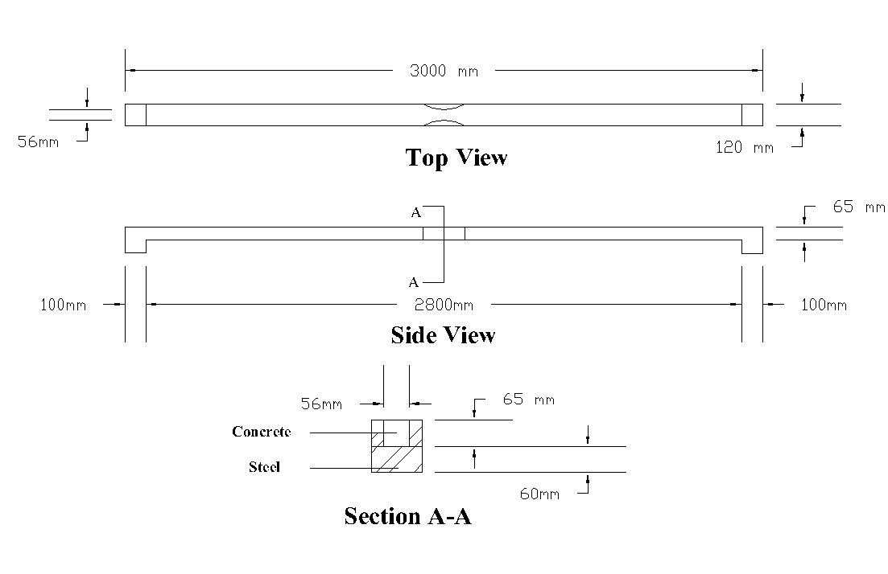
Figure ( 1 ) : Schematic Diagram of the End Restrained Beam.

Restraining Steel Rigid Base:
The base restraint was provided by two welded steel channel sections(127×64mm) have properties as shown in Table(2).
Table(2) The properties of channel section used.
Serial size  (mm) | Mass per metre  (kg) | Depth  (mm) | Width  (mm) | Thickness  (mm)  Web Flang |  | Area of Section  (mm²)
127×64 | 14.9 | 127 | 63.5 | 6.4 | 9.2 | 1898

The roughness of base was taken from welding reinforcement bars along the top surface of base. The dowels were welded on the top surface of base at 200mm distance. Fig.(2) shows the base, dowels and roughness of the restraining base.
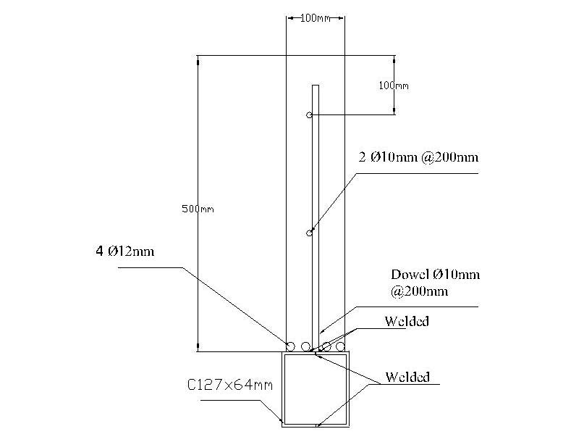
Fig.( 2) The schematic diagram of the steel restraining base with welded dowels and roughness of the base.
Wall Notation:
Two sets of concrete walls were cast .The first set was cast in Winter season which contains four unreinforced concrete walls(WP1,0 ,WP2,0 ,WP4,0 and WP6,0) and four reinforced concrete walls(WP1,2 ,WP2,2 ,WP4,2 and WP6,2) with deformed steel bars(10mm diameter) distributed horizontally with steel ratio (ρ=0.2%). Whilist the second set was cast in Summer season which contains two reinforced concrete walls(SP4,2 and SP6,2) with deformed steel bars(10mm diameter) distributed horizontally with steel ratio (ρ=0.2%).The characteristics of the eight reduced scale reinforced and plain high strength concrete walls are shown in Table ( 3).
Table(3) Walls characteristics.
Wall Notation | Length  mm | Width  mm | L/H  Ratio | Horizontal Reinf.(ρ٪)
WP1,2٭ | 1000 | 1000 | 1 | 0.2
WP1,0 | 1000 | 1000 | 1 | 0
WP2,2 | 2000 | 1000 | 2 | 0.2
WP2,0 | 2000 | 1000 | 2 | 0
WP4,2 | 2000 | 500 | 4 | 0.2
WP4,0 | 2000 | 500 | 4 | 0
WP6,2 | 3000 | 500 | 6 | 0.2
WP6,0 | 3000 | 500 | 6 | 0
SP4,2 | 2000 | 500 | 4 | 0.2
SP6,2 | 3000 | 500 | 6 | 0.2
WP1,2٭ : W:Winter set. P:Panel. 1: L/H ratio. ,2: Reinforcement ratio(0.2٪).

Mixing and Casting
The concrete was mixed using an electrical drum type mixer with a maximum capacity of 0.1m³. The interior surface of the mixer was cleaned and moistened before placing the materials.Materials were put in the pan of the mixer, firstly coarse and fine aggregates were mixed together with amount of mixing water(1/4 mixing water without superplacticizer) for 1 minute. Meanwhile the superplacticizer was mixed with the remaining water (3/4 of mixing water). Half of cement and half mixing water (with superplacticizer) were added as mixing proceeded for 4 minutes to make a homogeneous mix. Finally, the remaining (cement and water) were added to the mix as mixing proceeds for other 2 minutes. The total mixing time from the time of adding water was about 7 min.Then the concrete mix was cast into the plywood formwork of the wall in three layers, compaction was achieved using a portable mechanical vibrator.
Curing and Exposure:
To prevent plastic shrinkage cracking due to rapid evaporation from the upper surface of the wall. Wetted hessian sheets and polythene sheets were used to cover the walls after lifting the formwork (about 24 hrs from the casting. The hessain sheets were wetted evry day during 7days of curing period.The same curing procedure was adopted to cubes,cylinders and beams. Temperature and relative humidity variation in the laboratory were measured and recorded during the period of work. Table (3-11) gives these ambient conditions.
Table (4) Temperature and relative humidity during measurement period. *
Month | Temperature ( av. )  Cْ | Relative humidity  ( av . ) %
Febreuary | 27 | 44
March | 30 | 48
April | 35.5 | 36
May | 36.5 | 31
June | 39.5 | 26
July | 48 | 28
Augest | 45.5 | 31
September | 41.8 | 35
(*) From Center of Weather Forecast in Babylon.

Results and Discussions
Restrained Shrinkage of The walls
The measurement of longitudinal movement of the walls was carried out to investigate the effect of base restraint of the walls on the cracking behavior (cracking age, cracking sequence, crack spacing, crack width, crack length and location of maximum crack width). These measurements were conducted for a drying period of 3 months for the first set( in Winter) and 3 months for the second set( in Summer).
Figures (3 to 12) and Table (4) show the restrained shrinkage strain development with age at 3 rows of ( 25, 150 and 450 mm distance from the base) for the walls which have 500mm height and 4 rows of (25,150,500and 950 mm distance from the base) for the walls which have 1000mm height.
Table(5) The maximum restrained shrinkage strains and loss of restraint of the walls.
Wall Notation | L/H  Ratio | Max. Shrinkage Strain Value (Microstrain) | Loss of Restraint  L.O.R  (Microstrain)
WP1,2 | 1 | 350 | 70
WP1,0 | 1 | 400 | 60
WP2,2 | 2 | 300 | 77
WP2,0 | 2 | 350 | 72
WP4,2 | 4 | 200 | 75
WP4,0 | 4 | 250 | 68
WP6,2 | 6 | 250 | 83
WP6,0 | 6 | 350 | 78
SP4,2 | 4 | 750 | 85
SP6,2 | 6 | 650 | 91
W:Winter set. S:Summer set.

From Table (4), it can be noticed the followings:
1- The maximum shrinkage strains were found to be decreasing with increasing in L/H ratios in Summer and Winter sets. This may be attributed to that the action of restraint is increasing with the increasing of L/H ratio.
2- The maximum shrinkage strain was found in all the casted walls at the upper row(95cm from base for 1m wall height and 45cm from base for 0.5m wall height). This is due to the base restraint decreasing toward the upper row.
3- There is increasing in maximum shrinkage values in Summer about (66٪, 46٪) of the maximum shrinkage values in Winter for walls with length/height ratio (4,6) respectively. This can be attributed to the shrinkage in hot weather is more intensive than in cold weather.
4- The values of loss of restraint (L.O.R) in the present work (60-90 microstrain) was found to be higher than its values in the [Al-Mashhdi, 1989] and [Kheder,1986] which may indicate stiffer restraint.
5- The loss of restraint (L.O.R) in the Summer set was found to be higher than in Winter set. This is due to high shrinkage rates which occur in Summer set.

From Figures (3 to 12), it can be noticed the followings:
1- The shrinkage strains in reinforced walls were found to be less than in unreinforced walls. This is due to the action of internal restraint which comes from the reinforcement.
2- The shrinkage strains in the exterior columns were found to be more than the shrinkage strains in the interior columns of most walls. This may be attributed to the large surface area which is subjected to the drying conditions.
3- There is a continuous increasing in the shrinkage strains with age. This gives an indication to no crack occurrence.
4- There are certain values in the row 2.5cm from the base in all walls although its position is very close to the base. This is may be due to some slippage which occurs between base and wall and dua to loss of restraint which comes from contraction of the base.

Fig.(3) Strain development history for reinforced HSC base restrained wall(WP1,2).

Fig.(4) Strain development history for plain HSC base restrained wall(WP1,0).

Fig.(5) Strain development history for reinforced HSC base restrained wall(WP2,2).

Fig.(6) Strain development history for plain HSC base restrained wall(WP2,0).

Fig.(7) Strain development history for reinforced HSC base restrained wall(WP4,2).

Fig.(8) Strain development history for plain HSC base restrained wall(WP4,0).

Fig.(9) Strain development history for reinforced HSC base restrained wall(WP6,2).

Fig.(10) Strain development history for plain HSC base restrained
wall(WP6,0).

Fig.(11) Strain development history for reinforced HSC base restrained wall(SP4,2).

Fig.(12) Strain development history for reinforced HSC base restrained wall(SP6,2).

Cracking of The Walls:
Theoretically, the first crack must occur at the centre of the wall starting from base, this can be attributed to the value of the degree of restraint being the highest at this position [ACI 207,2007]. Assuming no weak region occurring over the wall height ,the crack must originate near the wall bottom and propagate toward the wall top [Stoffer,1978]. In spite of the long observation period (90 days) of all walls, no crack occurrence at this region or any other place was observed except there were some plastic shrinkage cracks in the top surface of the Summer set. This observation is compatible with the study carried out by [Bloom and Bentur,1995]. There is no study about high strength concrete base restrained walls to make comparison with this study, but it can be compared with normal concrete base restrained concrete walls that have lower compressive and tensile strength. For example, the walls that have L/H=1, 2 and 4 , the vertical steel ratio=1٪, horizontal steel ratio=0.2٪ was found not cracked, but there is one secondary crack in the wall which has L/H=8 with 0.05mm crack width [Kheder,1986]. For L/H=2.0, the crack width was found 0.1mm for two horizontal steel ratios (0.2٪ and 0.0٪) and vertical steel ratio=1٪ for the two walls[Al-Mashhadi, 1989]. For L/H=4, the wall was found not cracked with the same vertical and horizontal steel ratios of this study(1٪and0.2٪ respectively),but there is one secondary crack in the wall which has L/H=8[Al-Tamimi,1987].
Free Shrinkage of HSC End- Restrained Beams:
The free shrinkage strain of HSC was measured under the same indoor and outdoor exposure conditions for the two sets(Winter and Summer) of the restrained walls as shown in Table (5). Figure (13) shows the free shrinkage strain development of the concrete of the two sets with drying period. It can be seen from the results that the free shrinkage increases with the age progress for the two sets, but with different rates where the free shrinkage of Summer set is higher than the free shrinkage of Winter set (36٪,42٪ and 41٪ at ages 7,28 and 60days respectively). This may be due to the difference in the temperature degrees and relative humidity and consequently different evaporation intensity between Winter and Summer seasons.
It is clear from the results that there is a high initial rate of shrinkage. The reason of this behavior can be expected from the diffusion theory of drying that is the shrinkage is influenced strongly by the moisture loss. The moisture will be evaporated initially from the surface and near the surface with a high rate. In the Winter set , there was a contraction (25 microstrain) due to the drop of the concrete temperature from its peak temperature (due to heat of hydration) to its temperature when the first demec reading was taken, which was carried out early in the morning.

Table (5): Shrinkage properties of HSC in end restrained beams.

 | Date of  Crack in Beam  (day) | Free Shrinkage at cracking  date  (×10⁻⁶) | Loss of  restraint  (×10⁻⁶) | Tensile strain  capacity  (×10⁻⁶) | Elastic tensile strain  capacity  (×10⁻⁶) | Creep  (×10⁻⁶) | Width of  crack  (mm)
Winter | 40 | 250 | 60 | 190 | 54 | 136 | 0.15
Summer | 19 | 345 | 75 | 270 | 96 | 174 | 0.27

Summer
Winter
Fig.(13) Free shrinkage development of the HSC beam models in Winter and Summer .

Elastic Tensile Strain Capacity of HSC Beam Models:
Elastic tensile strain capacity of the HSC beam models was obtained directly by measuring the immediate movement after cracking of concrete in the end restrained beams in two seasons(Winter and Summer),the results are summarized in Table(5). The elastic tensile strain capacity was also calculated indirectly by determination of flexural tensile strength divided by the modulus of elasticity. The results are illustrated in Table (6) and plotted in Figures (14).

Table (6): Results of the calculated elastic tensile strain capacity of the HSC beam models in Winter and Summer ( indirect method ).
 | Elastic tensile strain capacity ×10⁻⁶
 | 7 days | 28 days | 60 days | 90 days
Winter | 187.5 | 191.4 | 192.3 | 195
Summer | 189.5 | 192.7 | 195.2 | 195.5

Figure (14 ) :Development of elastic tensile strain of the HSC beam models in Winter and Summer ( indirect method ).

Tensile Strain Capacity of HSC Beam Models:
The determination of tensile strain capacity was based on the end restrained shrinkage beam model. Table (5) shows the values of tensile strain capacity at date of cracking obtained in the present work. It can be observed from the results that the tensile strain capacity in Summer season (270 microstrain) is more than the tensile strain capacity in Winter season (190 microstrain) although the crack date in Summer (19 day) is less than the crack date in Winter (40 day).
Creep of HSC Beam Models:
Creep strain of HSC subjected to the end restrained shrinkage was calculated as the difference between the tensile strain capacity and the elastic tensile strain capacity. Table (5) shows that the creep strain for HSC end restrained beam specimen at cracking in Winter and Summer seasons is (136 and 174 ×10⁻⁶) respectively.
Cracking Time of HSC Beam Models:
Cracking time is the time required for first crack to occur . From Table (5), it can be observed that the cracking time of HSC in Winter is 40 days, while it decreases in Summer to 19 days.

Conclusions:
Based on the test results and theoretical analysis of the present work, the following conclusions can be drawn: -
- The experimental observation clearly indicates that the cracking did not developed in reinforced and plain HSC base restrained walls with L/H ( 1, 2 , 4 and 6) during 90 days period of drying.
- The maximum shrinkage values increased toward the edges and top of the most walls.
- The maximum shrinkage is found to be always at the upper row(95cm from base for 1m height walls and 45cm from base for 0.5m height walls).
- The maximum shrinkage strains in Summer walls was found more than for Winter walls about (66٪, 46٪ ) for L/H (4 and 6)respectively.
- The use of horizontal reinforcement (0.2٪) led to reduction in the maximum shrinkage values with increasing of length/height ratio where this reduction ratios were (12 ٪,14٪,20٪,28٪) of the maximum shrinkage values in the unreinforced concrete walls with length/height ratio (1,2,4,6) respectively.
- It was found from the end-restrained beam specimens results that the drying shrinkage is less for high strength concrete than for normal strength concrete. Also the following conclusions were drawn from the results of the same beam specimens.
- The Summer free shrinkage at date of cracking is higher than the Winter free shrinkage by about (27٪) in end restrained beams.
- The Summer tensile strain capacity at date of cracking is higher than of Winter about (30)٪ . On the other hand, the Summer elastic tensile strain capacity at date of cracking is higher than the Winter elastic tensile strain capacity by about (44٪).
- Elastic tensile strain capacity calculated by indirect method ( flexural tensile strength divided by the modulus of elasticity ) is higher than that of direct method ( elastic tensile strain capacity of concrte was obtained directly by measuring the immediate movement after cracking of concrete in end restrained beams ) by about ( 72 and 50)٪ in Winter and Summer respectively.
References
ACI Committee 363 (2006). "State–of– the Art Report on High–Strength Concrete" "Journal of American concrete Institute.
ACI Committee 207, (2007)." Effect of Restraint, Volume Change and Reinforcement on Cracking of Massive Concrete ", American Concrete Institute, Detroit.
ACI Committee 207.2R, (2007). "Effect of Restraint, Volume Change and Reinforcement on Cracking of Massive Concrete", Journal of American concrete Institute.
Al- Rawi , R.S, (1985)."New Method of Determination of Tensile Strain Capacity and Related Properties of Concrete Subjected to Restrained Shrinkage", ACI symp . Singapore , Aug.
Al -Taee, M.J., (2008). "Drying Shrinkage of High Strength Concrete Walls With Different Restraints,", MSc thesis, University of Babylon.
Al Timmimi, A.A., (1987)."Control of Cracking due to Volume Change in Reinforced Concret,", MSc thesis, University of Baghdad
Al-Mashhedi, S.A.,(1989). "Control of Secondary Shrinkage Cracks in Reinforced Concrete Walls ", M.Sc Thesis, University of Baghdad, College of Engineering, Sep.
Bloom, R. and Bentur, A (1995). "Free and Restrained Shrinkage of Normal and High – Strength Concretes ", ACI Materials Journal, V. 92,No. 2,March – April.
Carlson , R.W., Houghton , D.L. and Polivka , M., (1979)." Causes and Control of Cracking in Unreinforced Mass Concrete", ACI Journal , V. 76 ,No.7 , July .
Carlsward, J. (2006). "Shrinkage Cracking of Steel Fibre Reinforced Self Compacting Concrete Overlays", Ph.D. Thesis, Department of Civil and Environmental Engineering, Lulea University of Technology, Sweden.
Kheder, G.F., (1986). " Control of Shrinkage Cracking in Reinforced Concrete Walls ", M.Sc. Thesis, University of Baghdad, College of Engineering, Jan.
Kheder, G.F., (1997). "A New Look at the Control of Base Restrained Concrete Walls ", ACI – Structural Journal , V.94, No.3, May-June.
Mehta P.K., and Monteiro P.J.M., (1993). "Concrete Structures, Properties and Materials", Second Edition, Prentice Hall, Englewood Cliffs, New Jersey.
Neville, A.M., (2000). "Properties of Concrete", Fourth and Final Edition , Wiley , New York and Longman , London.
Powers T.C., (1995). "Causes and Control of Volume Change", Portland Cement Association Research and Development Laboratories Vol.1, No.1, pp. 29-39 (Jan.).(Cited by Neville ).
Tarun, R.N., Yoon, M.C., Rudolph, N.K.,(2006). "Reducing Shrinkage Cracking of Structural Concrete Through The Use of Admixtures", Final Report, Department of Civil Engineering and Mechanics, University of Wisconsin-Milwaukee.
Troxell G.E., Davis H.E., and Kelly J.W.,(1968). “Composition and Properties of Concrete”, Mc Graw Hill, Second Edition.
Yogendran,V., Langan, B.W., Haque, M.N. and Ward, M .A. (1987). "Silica Fume in High –Strength Concrete" ACI Materials Journal, March-April, pp.124-129.

