Corrosion Behavior of Cast Iron in
Different Aqueous Salt Solutions

Ali Hubi Haleem. Firas Jabar, Newal Mohammed.
Babylon University,College of Materials Engineering

Abstract
The corrosion behavior of cast iron in different aqueous salt solutions has been studied. Samples of cast iron were exposed in the salt solutions media for 40 days and corrosion rates evaluated, using total immersion test and Tafel extrapolation curves. The concentration of salts taken is 5 g/liter. The total immersion test parameters vise weight loss; corrosion rate as well as Tafel extrapolation parameters, I_{corr.,} corrosion potential , corrosion rate have been calculated. Besides these terms, the pH and electrical conductivity have been calculated by standard methods.
It was observed that NaCl solutions was most corrosive to cast iron because of the nature of chlorine ions followed by KCl ,Na₂SO₄ ,CaCl₂ , MgSO₄, MnSO_{4,} NaNO_{3,} KBr, CaCO₃, KI, NaHCO₃, and lastly, Pb (NO₃)₂. The types of salt solution and exposure time affected the corrosion of the cast iron.

Key words: Cast iron, Aqueous salt solution, Corrosion rate, Immersion test.

الخلاصة تم في هذا البحث دراسة سلوك التآكل لحديد الزهر في محاليل ملحية مختلفة كما تم قياس معدل التآكل باعتماد طريقة الغمر الكلي للنماذج لمدة أربعون يوما ومنحنيات استكمال تافل. حضرت المحاليل الملحية بتركيز ( 5 g/liter). إن معاملات اختبار الغمر الكلي والتي تشمل الوزن المفقود وكذلك معاملات استكمال تافل, تيار التآكل, جهد التآكل تم حسابها. بالإضافة إلى ذلك تم قياس الأس الهيدروجيني pH والموصلية الكهربائية للمحاليل.
أظهرت النتائج إن محلول كلوريد الصوديوم أكثر الأوساط أكالة بسبب طبيعة ايون الكلور أما تأثير بقية الأملاح فتترتب تنازليا وحسب التسلسل الآتي:
KCL >Na₂SO₄ >CaCl₂ > MgSO₄> MnSO₄>NaNO₃ > KBr > CaCO₃ > KI> NaHCO₃> Pb (NO₃)₂.
الكلمات الرئيسية: حديد الزهر, محاليل ملحية مائية, معدل التآكل, اختبار الغمر.
1. Introduction
Cast iron is a generic term that identifies a large family of ferrous alloys. Cast irons are primarily alloys of iron that contain more than 2% carbon and 1% or more silicon with a wide variety of properties. Cast irons are complex materials with stable and meta-stable phases and have elements in the solution which influence the extent and stability of the desirable properties not obtained by other alloys. Cast irons are intended to be cast to shape rather than formed in the solid state. Cast irons have low melting temperature, high fluidity when molten, don't form undesirable surface film when poured due to less reactivity with molten materials and have slight to moderate shrinkage during solidification and cooling. However, cast irons have relatively low impact resistance and ductility which may limit their use (Henkel and Pense, 2002).
Mechanical properties of cast irons like strength, ductility, and modulus of elasticity depend strongly on structure and distribution of micro structural constituents. Physical properties such as thermal conductivity and damping capacity are strongly influenced by microstructure. Cast irons popularity stems from an ability to cast complex shapes at relatively low cost and the wide range of properties that can be achieved by careful control over composition and cooling rate without radical changes in production methods (Milekhine, 2003).
Alloying elements can play a dominant role in the susceptibility of cast irons to corrosion attack. Silicon is the most important alloying element used to improve the corrosion resistance of cast irons. Silicon is generally not considered an alloying element in cast irons until levels exceed 3%. Silicon levels between 3 and 14% offer some increase in corrosion resistance to the alloy, but above about 14% Si, the corrosion resistance of the cast iron increases dramatically (Rana et. al., 2001).
Carbon in cast iron can exist in two forms, namely as free graphite or combined with some of the iron to form iron carbide (cementite). Due to existing form of carbon, cast irons can be defined as; a family of alloys which contain carbon at a level which will cause precipitation of graphite or iron carbide (Fe₃C) during the final phase of solidification(Loper Jr, 2002). Since high carbon contents tend to make cast irons very brittle, other metallic and non-metallic alloying elements are, therefore added to control and vary the microstructure and mechanical properties (Sinha, 2003). Cast Iron has, for hundreds of years, been the preferred piping material throughout the world for drain, waste, and vent plumbing applications and water distribution. Gray iron can be cast in the form of pipe at low cost and has excellent strength properties. Unique corrosion resistance characteristics make cast iron soil pipe ideally suited for plumbing applications (Zhang et. al., 2001).
Cast iron and steel corrode; however, because of the free graphite content of cast iron (3% - 4% by weight or about 10% by volume), an insoluble graphitic layer of corrosion products is left behind in the process of corrosion. These corrosion products are very dense, adherent, have considerable strength, and form a barrier against further corrosion. Because of the absence of free graphite in steel, the corrosion products have little or no strength or adherence and flake off as they are formed, thus presenting fresh surfaces for further corrosion. In tests of severely corroded cast iron pipe, the graphitic corrosion products have withstood pressures of several hundred pounds per square inch although corrosion had actually penetrated the pipe wall (Fredric, T., 2004).
Various studies have been carried out for determination of corrosive behavior of cast iron in acid and basic mediums (Osarolube et. al., 2008) but it is corrosion resistance in salt aqueous solutions at high concentration of salts is a little bit limited. Corrosive behavior of metals in aqueous solutions is mainly determined by dissolved salts and oxygen (Ibrahim, 2005). In order to minimize corrosion problem in water supply system its important to identify the mechanism of corrosion rate of ions with cast iron , the extent to which they contribute to corrosion in potable water as well as threshold limiting values to which the corrosion rate should be minimize in order to provide excellent corrosion resistance (Essam and Hussein, 2005).
This work examines the corrosion behavior of cast iron when exposed to different types of salts solutions. The corrosion rates in these media are also calculated to study their stability when similar industrial environments are encountered.
2. Experimental details
The discs of diameter 25 mm and thickness of 4 mm analyzed cast iron samples were used. The samples were cast in the die by appropriate casting procedure. Analysis of these samples was carried out using (spectrometer DV. 4) in Al-Nasser company. The chemical composition of ingots used for the cast iron is shown in Table 1.
After casting, the surfaces were smoothened. To ensure satisfactory service life, the surface condition of cast iron must be given carefully attention. Smooth surface, plus freedom from surface imperfection, blemishes and all traces of scale and other foreign material reduce the probability of corrosion. Generally, a smooth, highly polished reflective surface has greater resistance to corrosion. Rough surfaces are more likely to catch dust, salts, and moisture, which tend to localize corrosion attack.
Acetone was used to remove oil and grease. Surface contamination may be caused by mechanical operation. Small particles of metal from tools become embedded in the cast iron surface and, unless removed, may cause localized galvanic corrosion.
Small hole of 2 mm diameter was drilled in each sample for holding. All surfaces, including the edges were wet ground using 120, 220, 320, 600, 800, 1000, and 1200 grit silicon carbide papers. These samples were then cleaned with water, and then ultrasonically cleaned for 30 minutes using ethanol as a medium. After drying, the samples were stored in polyethylene zip- lock bags. The dimensions of all samples were measured in three places along the length to a precision ± 0.0l mm using calibrated micrometer. Measured dimensions were averaged to provide the sample diameter, and thickness to be used in surface area calculation. The weight of each sample was measured using Sartorius electronic balance with an accuracy of ± 0.1 mg. prior to weighing, all samples were held overnight in glass dessicator in order to eliminate any effect of humidity on the sample weight determination.
Because actual service conditions are difficult or impossible to reproduce in standard laboratory tests, results of such tests usually can serve only as a guide. Chemical conditions, temperature should parallel those in the process; therefore, field tests in existing equipment in a comparable process should be used wherever possible, in order to duplicate anticipated conditions.
Previously weighed samples were immersed in beakers containing 200 ml of test solutions maintained at room temperature. The samples were retrieved at 5 day intervals progressively for 40 days. The difference in weight was noted as the weight loss in grams. The procedure for weight loss determination was similar to that reported previously (Osarolube et al., 2008; Abiola and Oforka, 2005).
Result of weight loss measurement for corrosive mediums have been carried out for NaCl , KCl, Na₂SO₄, CaCO₃, CaCl₂, MgSO₄ , NaNO₃ , MnSO₄ ,Pb (NO₃)₂ , KBr , and KI salts using (5g /liter ) for each salt, in order to determine the average contribution of each salt to the corrosion rate. Distilled water was used in the preparation of all test solution. All chemical used were of analytical grade.
Experimental set up for polarization measurements consisted of potentiostat / galvanostat, with a sweep generator type PRT 10-0.5 volt which supplied DC current at the range (0- 500 mA). Saturated calomel electrode type (Tagussel Ca- F 10/ 15 bridged by laggin- Haber Probe) was used as reference electrode. The variation of the cast iron electrode potential under open circuit conditions in the tested solution were also determined after definite period of time and subsequently anodic and cathodic potentiostatic polarization curves were drawn. All electro-chemical experiments were carried out at 30 ºC and in each experiment 500 ml of test solution was employed. Fig. 1 illustrates Tafel extrapolation apparatus which used to measure corrosion currents in this work.
Results of Tafel extrapolation and weight loss measurement for corrosive medium have been carried out for different salt solutions, which expected to be found in potable water have been discussed.
pH and electrical conductivity for test solutions were measured. pH values were measured by pH meter type Beckman model (A1 Tex), whereas electrical conductivity values were obtained by digital conductivity meter type Bisschof model (L11).

3. Results and Discussion
Light optical microscopy of cast iron before immersing in salt solution is shown in Fig. 2. The corrosion rate of cast iron in the test solutions is calculated from decrease in weight observed in samples in weight loss tests using following formula (Orubite and Oforka, 2004):
Corrosion rate (mpy) = 534 w/ DAT ………………. (1)

Where: mpy: mils penetration per Year, 1 mils 10⁻³ inch
W= weight loss (mg)
D= density of sample g/cm³
A= area of sample (inch²)
T= exposure time (hrs.)

For Tafel extrapolation measurement potentiostatic parameters I_{corr}, E_{corr} were obtained from the slopes of linear polarization curves and corrosion rate was calculated using the following expression (Mehra and Soni, 2001):
Corrosion rate (mpy) = 0.129*I_{corr.}*EW/ DA……… (2)

Where I_{corr.} is corrosion current (A), EW the equivalent weight of metal (g), A the exposed area of sample (cm²), D the density of metal (g / cm³).
Fig. 3 shows the results of samples specific weight loose obtained by corrosion test for cast iron for different durations of exposure in different aqueous salt solutions. An increase in value of loss in weight was observed. Whereas Table 2 listed the corrosion rate values from weight loss data (mpy) of cast iron in various aqueous salt solutions are in the order of NaCl >KCl >Na₂SO₄ >CaCl₂ > NaNO₃> MgSO₄> CaCO₃> MnSO₄> KI> NaHCO₃> Pb (NO₃)₂> KBr for 40 day.
It is also seen from Fig. 3 that the corrosion of cast iron in different salts solution was not a simple homogeneous process, but a heterogeneous one. It consists of intermediate steps as revealed by the no uniformity of the plots.
The two anions that are found to have a significant influence on the corrosion characteristics of cast iron are chloride and sulphate ions. It is clear from Fig .3 and Table 2 that metal loss increases progressively with immersion time in salt solutions but corrosion rate dose not follow a definite trend for all test solutions and is not proportional with time. The corrosion rate of cast iron in salt solutions increase continuously with immersion period. The relative increase in halide ions salts is found to be more than other ions because of corrosive nature of halide ions than sulphate and nitrate ions (Roberge, 2000).
Although chloride is known to be the primary agent of pitting attack, it is not possible to establish a single critical chloride limit for each grade. The corrosively of a particular concentration of chloride solution can be profoundly affected by the presence or absence of various other chemical species that may accelerate or inhibit corrosion. Chloride concentration may increase where evaporation or deposits occur. Because of the nature of pitting attack- rapid penetration with little total weight loss –it is rare that any significant amount of pitting will be acceptable in particular applications (Abiola, and Oforka, 2002).
Halogen salts, especially chlorides easily penetrate this passive film and will allow corrosive attack to occur. Chlorides are one of the most common elements in nature and if that is not bad enough, they are also soluble, active ions; the basic for good electrolytes, the best conditions for corrosion or chemical attack (Talbot and Lames, 1998).
Fig. 4 shows the surface appearance of cast iron sample after 40 day of immersion in NaCl solution. This figure indicates that scale surface becomes rougher with large increase in scale layer thickness compared to that immersed in other salt solutions. However heights density of corrosion pitting and notches are the main characteristics on the metal surface, further un uniform corrosion appeared on the metal surface. The occurring of high pitting density leads to high corrosion rate on the metal surface.
Its noticed that scale layer formed on cast iron surface after immersed in KCl solution for 40 day period is still adherent, thick, and continuous (Fig. 5). Further corrosion occurred as pitting and notches but a little bit smaller than in NaCl solution case where the portion of area damage was smaller besides of non-uniform corrosion.
Fig. 6 shows the corroded cross section of the cast iron sample in Na₂SO₄ solution. In this test, the scale looks less adherent and reddish in color. At 40 day period of corrosion the surface under spalled region become more reddish and some area red to black color with high roughness scale. Scale morphology shows no distinct difference inside the scale.
Fig. 7 shows transverse section image of the cast iron sample immersed in NaNO₃ solution. This image illustrates an increase in scale layer thickness with discontinuity and it looks uniform dark gray scale tending to rougher surface. Further the corrosion pitting appeared on the metal surface with different densities.
Except for halide salts, the corrosively of a salt is based primarily on its oxidizing strength and on whether it hydrolyzes to an acid or a base. For example, materials, that are resistant to nitric acid most likely are resistant to nitrates, include both sodium nitrate and ferric nitrate. These nitrate salts have high oxidizing strength and will readily hydrolyze to form nitric acid (Even, 1997).
Fig. 8 illustrates corroded surface after 40 day immersed in CaCO₃ solution which shows little or no increase in scale layer thickness. The outer layer is the thinner layer and continuous. Further the inner and outer layers are interconnected and no obvious limit between each other.
A cross section view of cast iron sample corroded at NaHCO₃ solution for 40 day is shown in Fig. 9. The scale formed in the NaNO₃ solution is less thick than for that of previous salt solutions. The scale layer looks more adherent, continuous and shows very small indication of spallation at longer period.
The samples immersed in the different test solutions develop the corrosion potential as - 550 mV for NaCl, - 496 mV for KCl, -390 mV for Na₂SO₄, -342 mV for CaCl₂, -312 mV for MgSO₄, -297 mV for MnSO_{4,} -280 mV for NaNO_{3,} -271 mV for KBr, -253 mV for CaCO₃, -220 mV for KI, -192 mV for NaHCO₃, -156 mV for Pb (NO₃)₂.
Anodic and catholic polarization plots for cast iron in 5 g / liter of KI, NaHCO₃, and Pb (NO₃)₂ test solutions are shown in figures 4, 5, and 6 respectively. The values of I_{corr.} and corrosion potential for various test solutions calculated from Tafel extrapolation curves have been given in Table 3. The trend of corrosion rates for cast iron in different test solutions observed by weight loss and Tafel extrapolation curves is in a good agreement but the corrosion rate calculated from Tafel extrapolation method are higher than calculated from weight loss method. This is expected since corrosion rate is maximum in the beginning and decreases when equilibrium value is attained.
Table 4 listed electrical conductivity and pH values of test solutions at room temperature. Electric conductivity values indicate to the ability of the electrolyte mediums to transfer electrical current. Generally all salts which tend to form ions in their aqueous solutions have good electrical conductivity values. For example, NaCl solution has higher electrical conductivity values, because of smallness of chlorine ions, and this tends to make the transmitted and diffusivity of ions easy. Whereas the low conductivity of salt solutions belongs to low ability of solutions to be in ionic conditions, and to lower movement of ions. However the electrical conductivity depends on many factors like ions size, ions weight, ions charges, and solution test temperature (Roberge, 2000). The values of electrical conductivity of salt test solutions listed in Table 4 are consistent with corrosion rates values listed in Table 2 and the values of I_{corr.} and corrosion potential for cast iron in different test solutions.
4. Conclusions
From the above results it is clear that anions play a decisive role in determining the ease with which cast iron undergoes dissolution upon application of some anodic current density. The order of corrosion in various salt solutions is: NaCl>KCl>Na₂SO₄>CaCl₂>MgSO₄>MnSO₄>NaNO₃>KBr>CaCO₃>NaHCO₃>
Pb (NO₃)₂ for 40 day, i.e. halide ions contribute significantly to the corrosion rate of cast iron in potable water, sulphate and nitrate ions have intermediate effect and carbonate and bicarbonate have minimum contribution to corrosion of cast iron in potable water.
5. References
.
Abiola OK, and Oforka N. C., (2005). Organic Corrosion Inhibitors for steel and aluminum in acid systems, J. corr. Sci. Tech. 3: pp.113-117.
Abiola, O. K., and Oforka, N. C., 2002, Corrosion Science and Engineering, http:// www.umist.au.uk.
Essam Hussein and Hussein A., 2005, Erosion – Corrosion of Duplex Cast iron Under Kuwait Marine Condition, Kuwait Collage of Technological Studies, Automotive and Marine Engineering Department, www. elsevier. com/ locate/desal.
Even, J., 1997, Corrosion in Cast iron, in: Advanced Materials Technology, vol. 151, No. 4.
Fredric, T., 2004, High Temperature Corrosion of Cast Irons and Steels , Chalmers University of Technology.
Hand Book of Material Selection, 2002, Edited by Myer Kutz, Associates, Inc Copyright by John Wiley &Sons, New York.
Henkel and Pense, 2002, Structure and Properties, of Engineering Materials, Mc Graw- Hill Higher Education,.
Ibrahim Saeed L., 2005, Corrosion of Boiler Steel Pipes Under Given Operating Conditions in Presence and Absence of Some O₂ Scavengers , College of Engineering , University of Baghdad , Chemical Engineering Department.
Loper Jr, C. R., 2002, Cast Irons – Essential Alloys for the Future, Proceeding of the 65th World Foundry Congress, Korea.
Mehra R. and Soni, A., 2001, J. Indian Council Chemist, Vol. 18, No. 22.
Milekhine, V., 2003, High Performance Cast Irons, Norwegian University of Science and Technology.
Orubite; Okorosaye, K, and Oforka, N. C.; 2004, Corrosion Inhibition of zinc on HCL using Nypa fruticans Wurmb extract and 1, 5 Diphenel carbazone, J.appl. Sci.; Vol. 8; No.1; pp. 57-61.
Osarolube, E.; Owate, I. O.; and Oforka, N. C.; 2008, Corrosion behavior of mild and high carbon steels in various acidic media, Scientific Research and Essay, Vol. 33(6),pp. 224-228.
Rana, A. M.; Khan, A.; Amjad, S. and Abbas, T., 2001, Microstructural Evalution in Heat-Treated Cast Irons, Journal of Research (Science), Bahauddin Zakariya University, Multan, Pakistan. Vol.12, No.1, , pp. 65-71.
Roberge, P. R., 2000, Hand Book of Corrosion Engineering, McGraw-Hill.
Sinha, A. K., 2003, Physical Metallurgy, McGraw Hill.
Talbot, D. and Lames T., 1998, Corrosion Science and Technology, CRC Press LLC.
Zhang, M. X.; Kelly, P. M., and Gates, J. D., 2001, The Effect of Heat Treatment on the Toughness, Hardness and Microstructure of Low Carbon White Cast Irons”, Journal of Materials Science, vol. 36, No. 3865.

Table 1: Chemical composition of cast iron produced.
C % | Si % | Mn% | S % | P % | Ni % | Mo% | Cu %
3.9 | 2.1 | 0.33 | 0.05 | 0.09 | 0.05 | 0.004 | 0.05

Table (2) corrosion rate from weight loss data (mpy) of cast iron in different salt solutions with concentration of (5g/liter) at room temperature for 40 days as immersion time.
Corrosion rate (mpy) | Salt Solution
3.03 | NaCl
2.86 | KCl
2.72 | Na₂SO₄
2.71 | CaCl₂
2.44 | MgSO₄
2.42 | MnSO₄
2.39 | NaNO₃
2.18 | KBr
1.94 | CaCO₃
1.71 | KI
1.44 | NaHCO₃
1.30 | Pb(NO₃)₂

Table (3) Tafel extrapolation parameters for cast iron in different salt solutions with concentration of (5g/liter) at room temperature.

Test Salt Solution | Corrosion Potential  (- mV) | I_{corr.} (μA/ cm²) | Corrosion Rate from Tafel Extrapolation data (mpy)
NaCl | --724 | 0.528 | 3.20
KCl | -713 | 0.497 | 3.01
Na₂SO₄ | -697 | 0.490 | 2.97
CaCl₂ | -689 | 0.477 | 2.89
MgSO₄ | -673 | 0.452 | 2.74
MnSO₄ | -661 | 0.441 | 2.68
NaNO₃ | -652 | 0.425 | 2.57
KBr | -604 | 0.400 | 2.43
CaCO₃ | -591 | 0.351 | 2.13
KI | -585 | 0.300 | 1.81
NaHCO₃ | -575 | 0.280 | 1.69
Pb(NO₃)₂ | -570 | 0.260 | 1.57

Table (4) Electrical Conductivity and pH values for cast iron in different salt solutions with concentration of (5g/liter) at room temperature.

Test Salt Solution | Electrical Conductivity  (μS m⁻¹) | pH
NaCl | 6.45 | 7.03
KCl | 6.30 | 7.25
Na₂SO₄ | 4.23 | 6.94
CaCl₂ | 4.12 | 7.12
MgSO₄ | 6.86 | 7.45
MnSO₄ | 5.77 | 6.81
NaNO₃ | 5.62 | 7.16
KBr | 6.33 | 6.93
CaCO₃ | 6.77 | 7.80
KI | 6.30 | 7.23
NaHCO₃ | 7.52 | 8.13
Pb(NO₃)₂ | 4.50 | 5.56

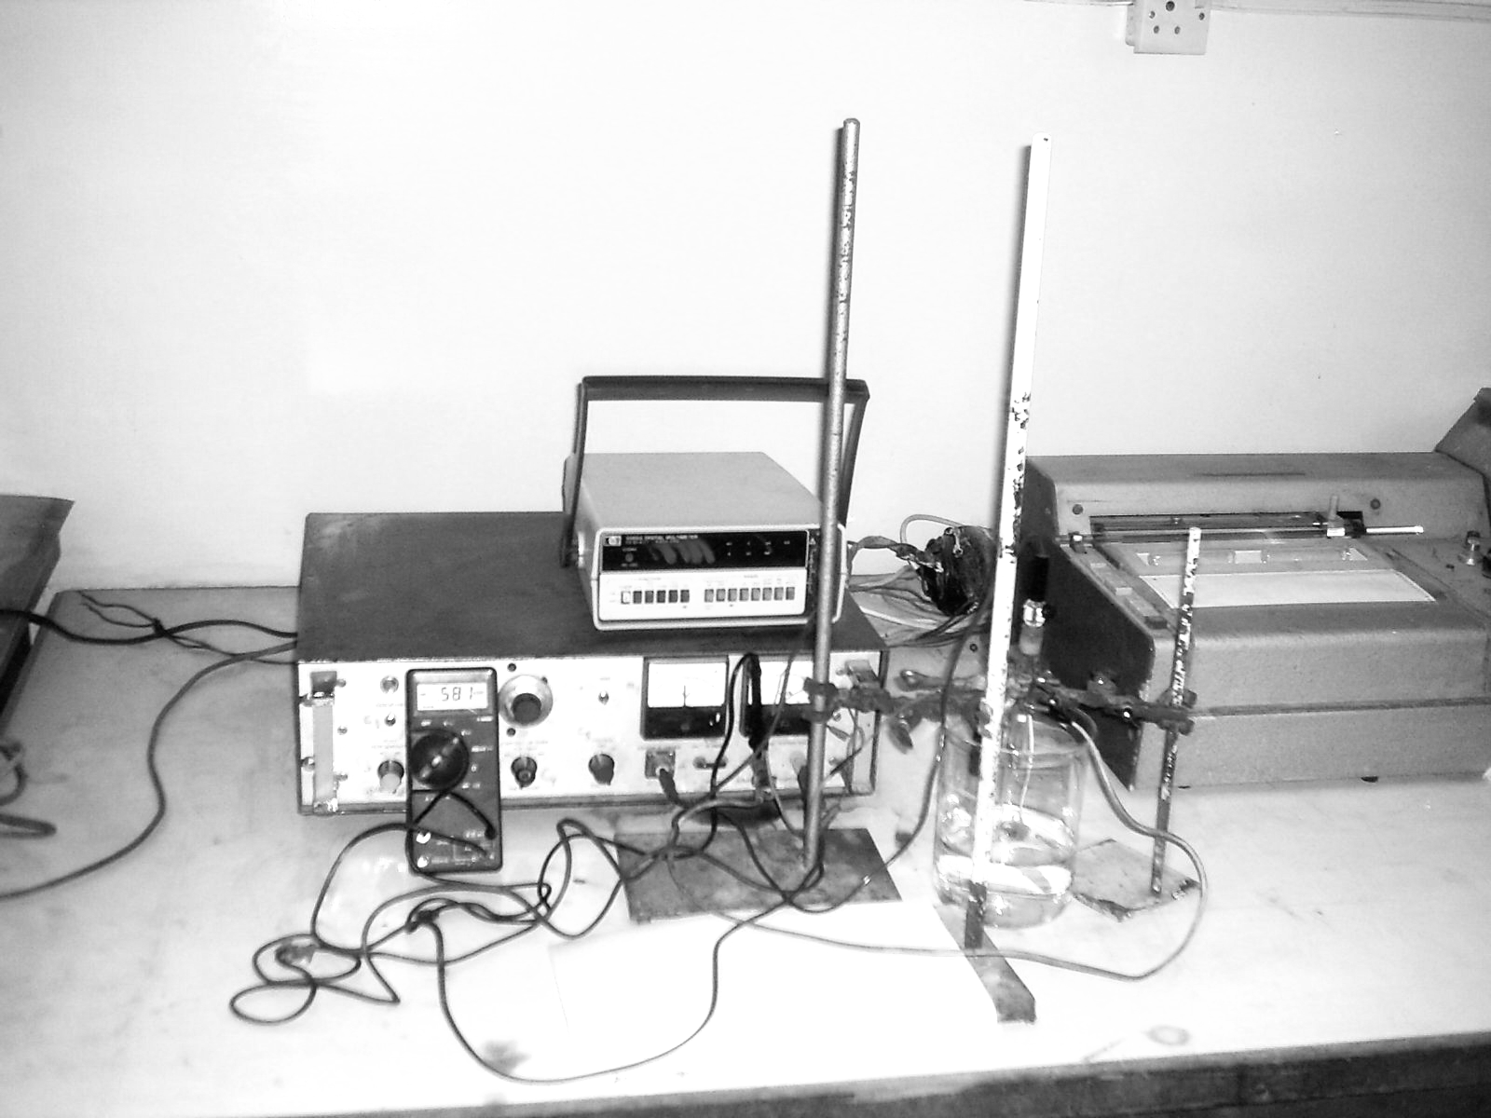

Fig. 1: Tafel extrapolation apparatus for electrochemical tests.

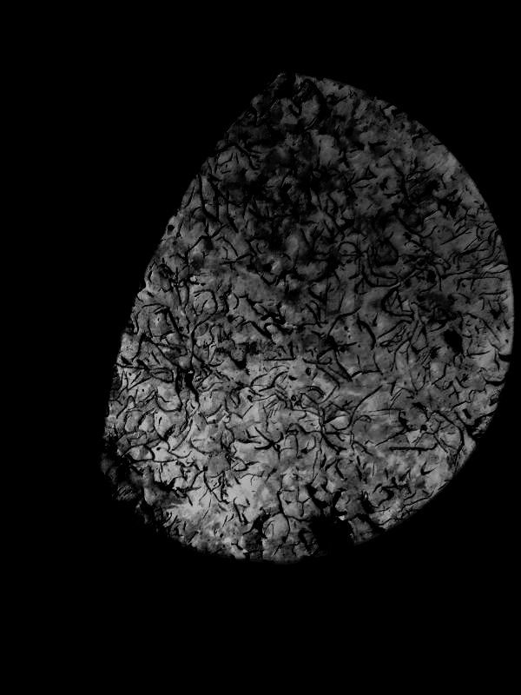

Fig. 2: Light Optical microscopy of cast iron before immersing in salt solution (Magnification 250X).

Fig. 3: Variation of specific weight loose of (g /cm² ) with time (days) cast iron in different salt solutions at concentration of 5 g/liter.

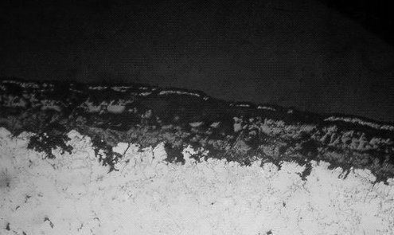
Scale
Substrate

Fig.4: Cross section image of LOM of cast iron after corroded in NaCl test solution for 40 day (Magnification 300X).

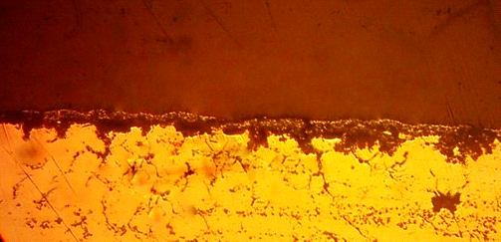
Scale
Substrate

Fig. 5: Cross section image of LOM of cast iron after corroded in KCl
test solution for 40 day (Magnification 300X).

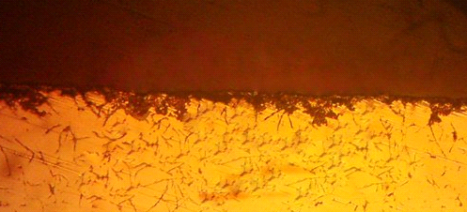
Substrate
Scale

Fig. 6: Cross section image of LOM of cast iron after corroded in Na₂SO₄
test solution for 40 day (Magnification 300X).

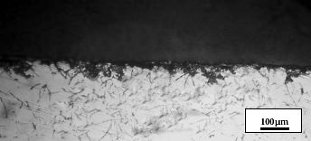
Substrate
Scale

Fig. 7: Cross section image of LOM of cast iron after corroded in NaNO₃
test solution for 40 day (Magnification 300X).
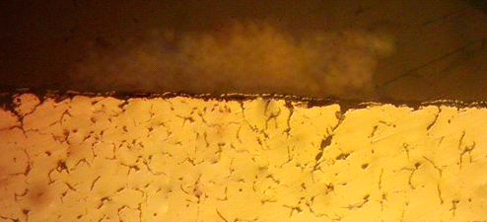
Substrate
Scale

Fig. 8: Cross section image of LOM of cast iron after corroded in CaCO₃
test solution for 40 day (Magnification 300X).

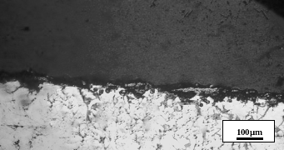
Substrate
Scale

Fig. 9: Cross section image of LOM of cast iron after corroded in NaHCO₃
test solution for 40 day (Magnification 300X).

E_{corr} = -585mV
I _{corr} =3 x 10 ⁻¹ μA/cm ²

μ

Fig. 10: Tafel extrapolation curve for cast iron in 5 g/ liter KI solution.

E_{corr} = -575 mV
I _{corr} =2.8x 10 ⁻¹ μA/cm ²

μ

Fig. 11: Tafel extrapolation curve for cast iron in 5 g/ liter NaHCO₃ solution.

E_{corr} = -570 mV
I _{corr} =2.6x 10 ⁻¹ μA/cm ²

μ

Fig. 12: Tafel extrapolation curve for cast iron in 5 g/ liter Pb (NO₃₎₂ solution.

