Environmental Impact Assessment
And Its Application To The Middle Euphrates Region
Mohammad A. Muslem Jabar Homod
Huda Mohammad Selman
Abstract
Environmental impact assessment (EIA) is a process that requires consideration of the environment and public participation in the decision- making process of project development. There are mainly three methods used to quantify the impact assessment, Leopold matrix, Map overlay, and Battelly impact evaluation. The Leopold matrix was applied for the middle Euphrates region to evaluate its air and water environment that polluted by the industrial activities. The types and no. of industrial activities that chosen in this research are: textile factories (9), chemical industries factory (1), grain mill factories (4), bricks factories (10), cement factories (4), lime factory (1), soft drink factories (3), power station (1), rubber products factory (1), dairy products factories (7) and asphalt factories (4).
الخلاصة
تقييم الاثر البيئي هو عملية تتطلب اشتراك البيئة والصحة في اتخاذ القرار لاي مشروع متطور.توجد ثلاث طرق لتقييم الاثر البيئي هي: مصفوفة ليبولد, خرائط ميدانية و تقييم الاثر بواسطة الخبراء.مصفوفة ليبولد طبقت لمنطقة الفرات الأوسط لتقييم البيئة المائية والهوائية. إن أنواع وأعداد الأنشطة الصناعية التي اختيرت في هذا البحث هي: معامل النسيج (9), معمل الصناعات الكيمياوية(1), معامل الطحين (4), معامل الطابوق (10), معامل السمنت(4), معمل النورة(1), معامل المشروبات الغازية (3), محطة توليد الطاقة الكهربائية(1), معمل المنتجات المطاطية (1), معامل منتجات الألبان(7) ومعامل الإسفلت(4).
1. Introduction:
Environmental Impact Assessment (EIA) is a process that requires consideration of the environment and public participation in the decision- making process of project development. Environmental Impact Statement (EIS) is a review document prepared for assessment in the EIA process. In some countries, EIA is direct legal requirement, while in others it is enforced indirectly under general planning, health or pollution control powers.
The National environmental Policy Act (NEPA) was introduced in the U.S in 1969 and required environmental statements to be prepared for federally funded or supported projects that were likely to have impacts on the environment. In 1973, the U.S Council of Environmental Quality (CEQ) has developed and published standard procedures for environmental statement. In 1978,the CEQ published regulations under the act which were directed towards streamlining the process, making the output more useful to planners and decision markers , encouraging public involvement and ensuring that the agencies follow up on their responsibilities after the approval of the EIS. in 2000, the Environmental Impact Assessment act was issued as a legal regulation .^{[ 6]}.
In 1972, environmental assessment was accepted in principle at the United Nation conference on the human environment at Stockholm when the framework of modern environmental international and national policy was laid down.
(Lohani: 1997), in his description of the prediction and assessment of impacts on the environment, provides specific guidance on and examples of how to assess significance for: 1) air; 2) surface water; 3) soil and groundwater; 4) noise; 5) biological environment; 6) cultural (architectural, historical and archaeological) environment; 7) visual environment; and 8) socioeconomic environment. ^{[10]}
The Rijeka - Zagreb motorway Project involves completion of the 148.45 km motorway between Zagreb and Rijeka. Two separate EIA were commissioned the Croatian road authority and prepared by the croatian Civil Engineering Institute, as follows:
1- Preliminary study on the Environmental Impact.
2- Environmental Protection Study; and by this study the construction of the project has already begun. ^{[7]}
(Faisal Aslam; 2006) evaluates environmental system in Pakistan and environmental impact assessment laws and their effectiveness in comparison to European Union rules and regulations. ^{[8]}
2. Procedure Description:
The main objects of EIA are:
- An assessment of the environmental impact of the project is carried out to ensure that, before consent is granted for a project which may, due to its location, the activities which it will involve, its nature or extent, have significant effects on the environment.
- Encourage co-operation of parties with interests at stake and concerned parties with regard to a project, which affects the environment.
- Acquaint the public with information on the environmental impact of the project which may involve significant environmental effects and on mitigating measures to deal with them and give the public the opportunity to comment and contribute information before a ruling on the environmental impact assessment of a project is issued.
The EIA consists mainly of four stages ^{[9]}. The stages include the following:
- Screening, to decide which project should be subjected to environmental assessment. Criteria used include threshold, size of project and sensitivity of the environment.
- Scoping is the process, which defines the key issues that should be included in the environmental assessment. Many early EIAs were criticized because they were encyclopedic and included irrelevant information.
- EIS preparation is the scientific and objective analysis of the scale, significant and importance of impacts identified. Various methods have been developed to assist this task.
- Review, As environmental assessments are normally produced by the project proponent, it is usual for a review to be undertaken by a government agency or an independent review panel. The review panel guides the study and then advises the decision-makers.
3. EIA Methodology
In order to quantify the impact through sensible values or numbers, three approaches were mainly selected these are: ^{[2]}.
- Leopold matrix
- Overlays
- Battelle environmental evaluation
Although, the last method seems powerful in obtaining reasonable ranking for the projects been assessed, the first method (Leopold matrix) will be applied in this research due to the following reasons:
- The method is applied extensively in the reports issued by the UNEP. So that, using this method will coincide with the structural view of the national reports.
- This method is simple to follow up, and a comparison among different projects can be clarified easily.
- The method is comprehensive in covering physical, biological and socio-economic environment.
- The method can be modified to (Battelle) method, when there is enough skilled data to count the environmental quality index, by applying the weights for each environmental characteristic. Thus obtaining a sum that reflects the overall assessment of the impact.
The constructions for using Leopold matrix are as follow: ^{[2]}.
- Identify all actions (located across the top of the matrix) that are part of the proposed project.
- Under each of the proposed actions, place a slash at the intersection with each item on the side of the matrix if an item impact is possible.
- Having completed the matrix, in the upper left-hand corner of each box with a slash, place number which indicates the MAGNITUDE of the possible impact. In the lower right-hand corner of the box place a number from 0 to 5 which indicates the IMPORTANCE of the possible impact,
0 = no impact, 1 = minimal impact,
2 = small impact, 3 = moderate impact,
4 = significant impact, 5 = severe impact.
The magnitude of the impacts(b) was calculated from division concentration of any element (in working state) on standard limits (concentration) from research 1, If there is no guideline for any element the magnitude of the impacts was calculated from division concentration of the element (in working state) on concentration of the element (in design state) while importance of the impacts(a) was estimated between 0 – 5.These calculations based on research no.1.
- The text, which accompanies the matrix, should be a discussion of the significant impact, those columns and rows with large numbers of boxes marked and individual boxes with the larger numbers. Fig.. (1) shows the Leopold Matrix.
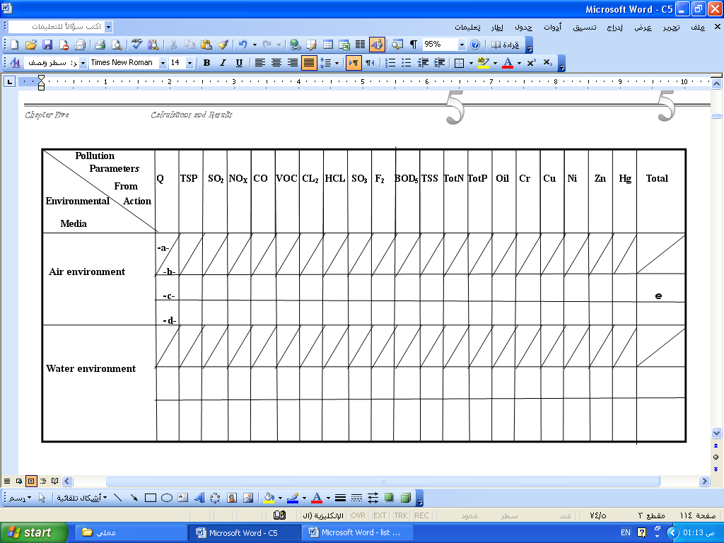

-a- Importance (0-5),
-b- Magnitude (calculating),
-c- Impact = a * b
-d- Ratio of parameter from total = c / e
-e- Total

Fig. (1): Shape of the Leopold Matrix

4.EIA Application to the Middle Euphrates Region
The middle Euphrates region includes Baghdad, Babylon, Al-Najaf, Kerbela and Al-Qadisia cities. It lies in the middle of the lower half section of Iraq. It is total area around 18,975 km². Populations are 10,379,375 million capita ^{[3,4,5]}. The industrial pollution in the middle Euphrates region (Babylon, Al-Najaf and Kerbela) was studied. The matrices (1-45 ) represent matrix for each industrial activities in the middle Euphrates region. The magnitude of the impacts (b) was calculated by division concentration of any element (in working state) on standard limits (concentration), If there is no guideline for any parameter the magnitude of the impacts was calculated from division concentration of the element (in working state) on concentration of the element (in design state) while importance of the impacts (a) was selected between (0–5). Tables (1 – 8) represent the impact of Q, TSP, SO₂, NO_{X}, CO, VOC, F₂, CL₂, HCL, and SO₃ on the air environment. While tables (9 – 19) represent the impact of Q, BOD₅, TSS, TotN, TotP, Oil, Cr, Cu, Ni, Zn and Hg on the water environment.

Table (1): Impact of Total Suspended Particle on the Air Environment for the Factories that Produce Air Pollution in the Middle Euphrates Region
b≤1 (accepted impact) |  |  |  | b>1(unaccepted impact)
Factory Name | Value of b | Value of c | Rank of Sever Impact | Factory Name | Value of b | Value of c | Rank of Sever Impact
معمل إسفلت آشور |  | 3 | 1 | معمل إسفلت الجنائن |  | 3.6 | 17
zمعمل إسفلت بابل |  | 2.1 | 3 | معمل طابوق الاعتماد |  | 594 | 3
معمل إسفلت قاسم |  | 2.4 | 2 | معمل طابوق جبران |  | 59.4 | 6
 |  |  |  | معمل طابوق الرافدبن |  | 76.5 | 4
 |  |  |  | معمل طابوق السلام |  | 102.9 | 2
 |  |  |  | معمل طابوق صابر التميمي |  | 59.4 | 6
 |  |  |  | معمل طابوق الفرات |  | 63.6 | 5
 |  |  |  | معمل طابوق الفيحاء |  | 53.1 | 7
 |  |  |  | معمل طابوق المحاويل |  | 12 | 10
 |  |  |  | معمل طابوق النيل |  | 44.7 | 8
 |  |  |  | معمل طابوق الهاشمية |  | 133.5 | 1
 |  |  |  | معمل النورة - كربلاء |  | 3.9 | 16
 |  |  |  | معمل سمنت السدة |  | 7.5 | 13
 |  |  |  | معمل سمنت كربلاء |  | 10.8 | 11
 |  |  |  | معمل سمنت الكوفة |  | 15.3 | 9
 |  |  |  | معمل سمنت النجف الاشرف |  | 8.4 | 12
 |  |  |  | الشركة العامة للصناعات الكيمياوية / معمل حرير السدة |  | 4.2 | 15
 |  |  |  | معمل طحين الإخلاص |  | 4.2 | 15
 |  |  |  | معمل طحين بابل |  | 4.2 | 15
 |  |  |  | معمل طحين طارق |  | 5.7 | 14
محطة كهرباء المسيب الحرارية |  | 0.3 | 1 | شركة الفرات لطحن الحبوب |  | 3.9 | 16
Table (2): Impact of Sulfur Dioxide on the Air Environment for the Factories that Produce Air Pollution in the Middle Euphrates Region
b≤1 (accepted impact) |  |  | b>1(unaccepted impact)
Factory Name | Value of c | Rank of Sever Impact | Factory Name | Value of c | Rank of Sever Impact
كل معامل الإسفلت | 0 | 4 | معمل طابوق الاعتماد | 123 | 1
معمل طابوق المحاويل | 1.5 | 3 | معمل طابوق جبران | 12.5 | 5
معمل طابوق النيل | 4.5 | 1 | معمل طابوق الرافدبن | 16 | 3
معمل النورة - كربلاء | 4 | 2 | معمل طابوق السلام | 13.5 | 4
كل معامل السمنت | 0 | 4 | معمل طابوق صابر التميمي | 12.5 | 5
كل معامل الطحين | 0 | 4 | معمل طابوق الفرات | 13 | 6
 |  |  | معمل طابوق الفيحاء | 1.1 | 8
 |  |  | معمل طابوق الهاشمية | 18.5 | 2
 |  |  | الشركة العامة للصناعات الكيمياوية / معمل حرير السدة | 6 | 6
 |  |  | محطة كهرباء المسيب الحرارية | 5.5 | 7
Table (3): Impact of Nitrogen Oxide on the Air Environment for the Factories that Produce Air Pollution in the Middle Euphrates Region
b≤1 (accepted impact) |  |  | b>1(unaccepted impact)
Factory Name | Value of c | Rank of Sever Impact | Factory Name | Value of c | Rank of Sever Impact
كل معامل الإسفلت | 0 | 7 | معمل طابوق الاعتماد | 7 | 1
معمل طابوق جبران | 2 | 1
معمل طابوق الرافدبن | 1 | 2
معمل طابوق السلام | 1 | 2
معمل طابوق صابر التميمي | 0.7 | 3
معمل طابوق الفرات | 1 | 2
معمل طابوق الفيحاء | 0.65 | 4
معمل طابوق المحاويل | 0.1 | 6
معمل طابوق النيل | 0.5 | 5
معمل طابوق الهاشمية | 1 | 2
معمل النورة - كربلاء | 0 | 7
معمل سمنت السدة, كربلاء, النجف الاشرف | 0 | 7
معمل سمنت الكوفة | 0.5 | 5
الشركة العامة للصناعات الكيمياوية / معمل حرير السدة | 0 | 7
كل معامل الطحين | 0 | 7
محطة كهرباء المسيب الحرارية | 0.5 | 5

Table (4): Impact of Volatile Organic Compound on the Air Environment for the Factories that Produce Air Pollution in the Middle Euphrates Region
b≤1 (accepted impact) |  |  | b>1(unaccepted impact)
Factory Name | Value of c | Rank of Sever Impact | Factory Name | Value of c | Rank of Sever Impact
كل معامل الإسفلت | 0 | 5 | معمل طابوق الاعتماد | 660 | 1
معمل طابوق الهاشمية, جبران, الرافدبن, السلام, الفرات | 0.6 | 3 | معمل طابوق الفيحاء | 60 | 2
معمل طابوق صابر التميمي | 1.2 | 2 | معمل طابوق المحاويل | 3.2 | 3
معمل طابوق النيل | 0.4 | 4
معمل النورة - كربلاء | 0 | 5
كل معامل السمنت | 0 | 5
كل معامل الطحين | 0 | 5
الشركة العامة للصناعات الكيمياوية / معمل حرير السدة | 0 | 5
محطة كهرباء المسيب الحرارية | 1.6 | 1

Table (5): Impact of Chloride on the Air Environment for the Factories that Produce Air Pollution in the Middle Euphrates Region
b≤1 (accepted impact) |  |  | b>1(unaccepted impact)
Factory Name | Value of c | Rank of Sever Impact | Factory Name | Value of c | Rank of Sever Impact
بقية المعامل | 0 | 1 | الشركة العامة للصناعات الكيمياوية / معمل حرير السدة | 4.4 | 1

Table (6): Impact of Hydrogen Chloride on the Air Environment for the Factories that Produce Air Pollution in the Middle Euphrates Region
b≤1 (accepted impact) |  |  | b>1(unaccepted impact)
Factory Name | Value of c | Rank of Sever Impact | Factory Name | Value of c | Rank of Sever Impact
الشركة العامة للصناعات الكيمياوية / معمل حرير السدة | 0.6 | 1
بقية المعامل | 0 | 2

Table (7): Impact of Sulfur Trioxide on the Air Environment for the Factories that Produce Air Pollution in the Middle Euphrates Region
b≤1 (accepted impact) |  |  | b>1(unaccepted impact)
Factory Name | Value of c | Rank of Sever Impact | Factory Name | Value of c | Rank of Sever Impact
بقية المعامل | 0 | 1 | الشركة العامة للصناعات الكيمياوية / معمل حرير السدة | 4.5 | 1
 |  |  | محطة كهرباء المسيب الحرارية | 4.2 | 2

Table (8): Impact of Fluoride on the Air Environment for the Factories that Produce Air Pollution in the Middle Euphrates Region
b≤1 (accepted impact) |  |  | b>1(unaccepted impact)
Factory Name | Value of c | Rank of Sever Impact | Factory Name | Value of c | Rank of Sever Impact
بقية المعامل | 0 | 1 | معمل طابوق الاعتماد | 876 | 1
 |  |  | معمل طابوق جبران | 87.2 | 8
 |  |  | معمل طابوق الرافدبن | 112.8 | 5
 |  |  | معمل طابوق السلام | 152 | 3
 |  |  | معمل طابوق صابر التميمي | 262 | 2
 |  |  | معمل طابوق الفرات | 93.2 | 7
 |  |  | معمل طابوق الفيحاء | 94.4 | 6
 |  |  | معمل طابوق المحاويل | 18 | 10
 |  |  | معمل طابوق النيل | 66 | 9
 |  |  | معمل طابوق الهاشمية | 131.2 | 4

Table (9): Impact of Flow Rate on the Water Environment for the Factories that Produce Water Pollution in the Middle Euphrates Region
b≤1 (accepted impact) |  |  | b>1(unaccepted impact)
Factory Name | Value of c | Rank of Sever Impact | Factory Name | Value of c | Rank of Sever Impact
الشركة العامة للصناعات الكيمياوية / معمل حرير السدة | 1 | 2 | معمل البان بابل | 9.2 | 10
محطة كهرباء المسيب الحرارية | 0 | 5 | معمل البان الطيب | 7.6 | 11
معمل ألبان (جمعة عبادي ,السهل, الفيحاء, الرفق) | 1.6 | 1 | معمل نسيج الحلة | 103.6 | 9
معمل البان الوسام | 0.8 | 3 | معمل نسيج ابو زيد | 772 | 4
معمل المنتجات المطاطية | 0.4 | 4 | معمل نسيج الاخوان | 7048 | 1
معمل بابل للمشروبات الغازية | 0.4 | 4 | معمل نسيج الامل | 804 | 3
معمل نور كربلاء للمشروبات الغازية | 0 | 5 | معمل نسيج الحسن | 616 | 6
معمل الكوفة للمشروبات الغازية | 0.4 | 4 | معمل نسيج الكوثر | 704 | 5
 |  |  | معمل نسيج الهادي | 524 | 7
 |  |  | معمل نسيج الهدى | 5036 | 2
 |  |  | معمل نسيج الوطن العربي | 316 | 8

Table (10): Impact of Biological Oxygen Demand on the Water Environment for the Factories that Produce Water Pollution in the Middle Euphrates Region
b≤1 (accepted impact) |  |  | b>1(unaccepted impact)
Factory Name | Value of c | Rank of Sever Impact | Factory Name | Value of c | Rank of Sever Impact
الشركة العامة للصناعات الكيمياوية / معمل حرير السدة | 0 | 2 | محطة كهرباء المسيب الحرارية | 36.5 | 2
معمل المنتجات المطاطية | 0 | 2 | معمل ألبان (جمعة عبادي ,السهل, الفيحاء) | 27 | 6
معمل نسيج الاخوان , الهدى | 1.5 | 1 | معمل البان بابل | 29 | 4
 |  |  | معمل البان الطيب | 5.5 | 13
 |  |  | معمل البان الرفق | 18 | 7
 |  |  | معمل البان الوسام | 48.5 | 1
 |  |  | معمل بابل للمشروبات الغازية | 6 | 12
 |  |  | معمل نور كربلاء للمشروبات الغازية | 30 | 3
 |  |  | معمل الكوفة للمشروبات الغازية | 12 | 11
 |  |  | معمل نسيج الحلة | 27.5 | 5
 |  |  | معمل نسيج أبو زيد | 16 | 9
 |  |  | معمل نسيج الأمل , الحسن , الكوثر, الهادي | 15.5 | 10
 |  |  | معمل نسيج الوطن العربي | 16.5 | 8

Table (11): Impact of Total Suspended Solids on the Water Environment for the Factories that Produce Water Pollution in the Middle Euphrates Region
b≤1 (accepted impact) |  |  | b>1(unaccepted impact)
Factory Name | Value of c | Rank of Sever Impact | Factory Name | Value of c | Rank of Sever Impact
الشركة العامة للصناعات الكيمياوية / معمل حرير السدة | 3.36 | 2 | محطة كهرباء المسيب الحرارية | 5084 | 1
معمل البان الطيب | 1.2 | 5 | معمل ألبان (جمعة عبادي ,السهل, الفيحاء) | 5.2 | 11
معمل البان الرفق | 3.6 | 1 | معمل البان بابل | 6 | 10
معمل المنتجات المطاطية | 0.4 | 6 | معمل البان الوسام | 9.6 | 9
معمل بابل للمشروبات الغازية | 1.2 | 5 | معمل نور كربلاء للمشروبات الغازية | 10.8 | 8
معمل نسيج الاخوان | 2.8 | 4 | معمل الكوفة للمشروبات الغازية | 6 | 10
معمل نسيج الهدى | 3.2 | 3 | معمل نسيج الحلة | 13.2 | 7
 |  |  | معمل نسيج أبو زيد | 31.6 | 3
 |  |  | معمل نسيج الأمل , الحسن | 30 | 6
 |  |  | معمل نسيج الكوثر | 31.2 | 4
 |  |  | معمل نسيج الهادي | 30.4 | 5
 |  |  | معمل نسيج الوطن العربي | 32 | 2

Table (12): Impact of Tot N (Nitrogen) on the Water Environment for the Factories that Produce Water Pollution in the Middle Euphrates Region
b≤1 (accepted impact) |  |  | b>1(unaccepted impact)
Factory Name | Value of c | Rank of Sever Impact | Factory Name | Value of c | Rank of Sever Impact
الشركة العامة للصناعات الكيمياوية / معمل حرير السدة | 0 | 2 | معمل ألبان (جمعة عبادي ,السهل, الفيحاء) | 10.4 | 3
معمل البان الطيب | 2 | 1 | معمل البان بابل | 12.4 | 2
محطة كهرباء المسيب الحرارية | 0 | 2 | معمل البان الرفق | 9.2 | 4
معمل المنتجات المطاطية | 0 | 2 | معمل البان الوسام | 18.8 | 1
كل معامل المشروبات الغازية | 0 | 2
كل معامل النسيج | 0 | 2

Table (13): Impact of Tot P (Phosphors) on the Water Environment for the Factories that Produce Water Pollution in the Middle Euphrates Region
b≤1 (accepted impact) |  |  | b>1(unaccepted impact)
Factory Name | Value of c | Rank of Sever Impact | Factory Name | Value of c | Rank of Sever Impact
الشركة العامة للصناعات الكيمياوية / معمل حرير السدة | 0 | 2 | معمل ألبان (جمعة عبادي ,السهل, الفيحاء) | 13.2 | 4
معمل البان الطيب | 2.8 | 1 | معمل البان بابل | 15.2 | 3
معمل المنتجات المطاطية | 0 | 2 | معمل البان الرفق | 11.2 | 5
كل معامل المشروبات الغازية | 0 | 2 | معمل البان الوسام | 24 | 2
كل معامل النسيج | 0 | 2 | محطة كهرباء المسيب الحرارية | 1670 | 1

Table (14): Impact of Oil on the Water Environment for the Factories that Produce Water Pollution in the Middle Euphrates Region
b≤1 (accepted impact) |  |  | b>1(unaccepted impact)
Factory Name | Value of c | Rank of Sever Impact | Factory Name | Value of c | Rank of Sever Impact
بقية المعامل | 0 | 1 | محطة كهرباء المسيب الحرارية | 1570 | 1
 |  |  | معمل المنتجات المطاطية | 20 | 2

Table (15): Impact of Chromium on the Water Environment for the Factories that Produce Water Pollution in the Middle Euphrates Region
b≤1 (accepted impact) |  |  | b>1(unaccepted impact)
Factory Name | Value of c | Rank of Sever Impact | Factory Name | Value of c | Rank of Sever Impact
بقية المعامل | 0 | 1 | محطة كهرباء المسيب الحرارية | 1000 | 1

Table (16): Impact of Copper on the Water Environment for the Factories that Produce Water Pollution in the Middle Euphrates Region
b≤1 (accepted impact) |  |  | b>1(unaccepted impact)
Factory Name | Value of c | Rank of Sever Impact | Factory Name | Value of c | Rank of Sever Impact
بقية المعامل | 0 | 1 | محطة كهرباء المسيب الحرارية | 1275 | 1

Table (17): Impact of Nickel (Ni) on the Water Environment for the Factories that Produce Water Pollution in the Middle Euphrates Region
b≤1 (accepted impact) |  |  | b>1(unaccepted impact)
Factory Name | Value of c | Rank of Sever Impact | Factory Name | Value of c | Rank of Sever Impact
بقية المعامل | 0 | 1 | محطة كهرباء المسيب الحرارية | 4710 | 1

Table (18): Impact of Zinc on the Water Environment for the Factories that Produce Water Pollution in the Middle Euphrates Region
b≤1 (accepted impact) |  |  | b>1(unaccepted impact)
Factory Name | Value of c | Rank of Sever Impact | Factory Name | Value of c | Rank of Sever Impact
بقية المعامل | 0 | 1 | محطة كهرباء المسيب الحرارية | 1612 | 1

Table (19): Impact of Mercury on the Water Environment for the Factories that Produce Water Pollution in the Middle Euphrates Region
b≤1 (accepted impact) |  |  | b>1(unaccepted impact)
Factory Name | Value of c | Rank of Sever Impact | Factory Name | Value of c | Rank of Sever Impact
بقية المعامل | 0 | 1 | الشركة العامة للصناعات الكيمياوية / معمل حرير السدة | 180000 | 1
- Conclusion:
The Leopold matrix method is of little value for evaluating impacts because there is no standardized way of assessing the scores, nor is there a means of assigning weight to different impacts to determine relative importance ^{[2]}. For this reason, the scoring values in the matrix present the author’s opinion. Experts committees increase the value of this matrix after confirming its information. From EIA all factories that produced air pollution in the middle Euphrates region unaccepted impact in TSP except Ashur, Babylon, Qasim, asphalt factory and power station. All factory of bricks unaccepted impact in SO₂ except Al-Mahawil and Al-hashimia bricks factory. All factories unaccepted impact in BOD₅ except general company for chemical industries, rubber product factory, Al-Ehwan and Al-Huda textile factories and all factories unaccepted impact in TSS except general company for chemical industries, rubber product factory, Al-Ehwan and Al-Huda textile factories, Al-Teeb and Al-Rifiq dairy product factory and Babylon soft drink factory.
References
Al-Hinnawi, E., 1999 “Guidelines for the Identification of Environmental Impacts of Industries in the Arab Region”, Cairo,.
Barrow, C.J., 1997 “Environmental and Social Impact Assessment” John Wiely and Sons Inc., USA,.
Environmental Directorate of Al-Najef, 2006 reports and special forms of industrial activities in Al-Najef governorate,.(In Arabic)
Environmental Directorate of Babylon, 2006 reports and special forms of industrial activities in Babylon governorate, (In Arabic)
Environmental Directorate of Kerbalaa, 2006 reports and special forms of industrial activities in Kerbalaa governorate,.(In Arabic)
“Environmental Impact Assessment Act”, http://www.skipulag is/ htdocs/ English/ acts/ manual.html.
“Environmental Impact Assessment of the Rijika-Zagreb Motorway Project”, Source: Internet.
Faisal Aslam, June 2006 “Environmental Impact Assessment in Pakistan–Overview, Implementation and Effectiveness”, TRITA LWR Masters Thesis 0624,.
Gerard Kiely, 1997.
“Environmental Engineering”, MCGLAW-Hill International Company ,UK,
Lohani, B., J.W. Evans, H. Ludwig, R.R. Everitt, Richard A. Carpenter, and S.L. Tu. “Environmental Impact Assessment for Developing Countries in Asia”. 1997, Volume 1 - Overview. 356 pp..

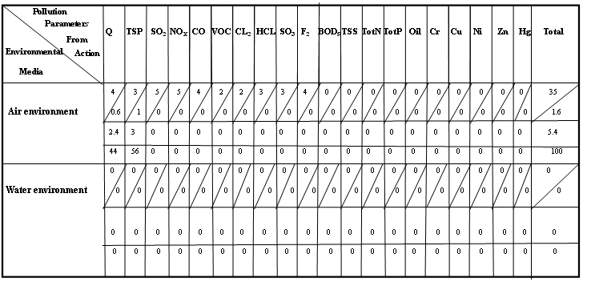

Matrix (1): Leopold Matrix of Asphalt Manufacturing (معمل إسفلت شركة آشور)

Matrix (2): Leopold Matrix of Asphalt Manufacturing (معمل إسفلت بابل)

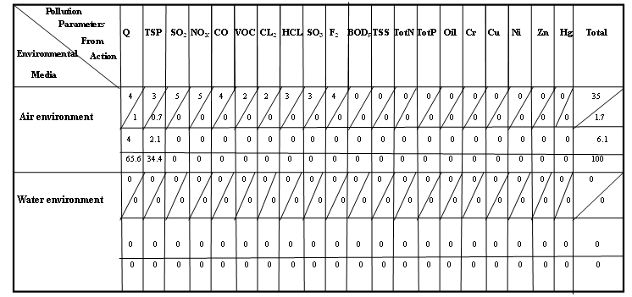

Matrix (3): Leopold Matrix of Asphalt Manufacturing (معمل إسفلت الجنائن)

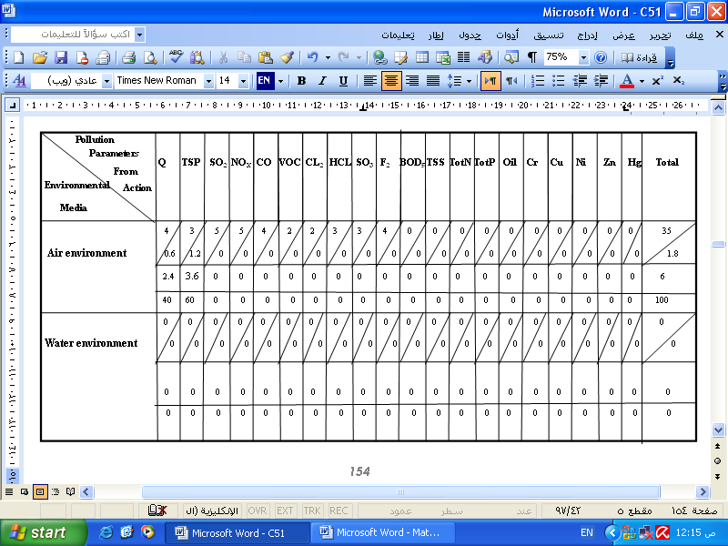

Matrix (4): Leopold Matrix of Asphalt Manufacturing (معمل إسفلت قاسم)

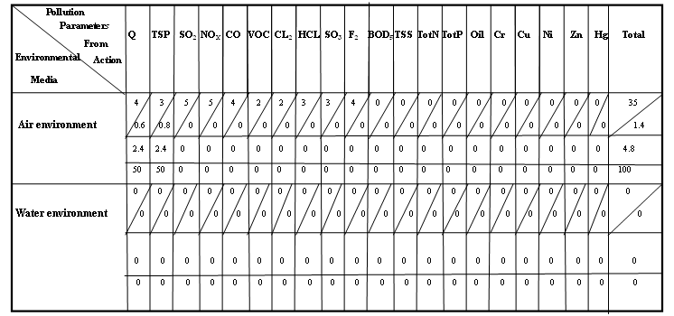

Matrix (5): Leopold Matrix of Bricks Manufacturing (معمل طابوق الاعتماد)

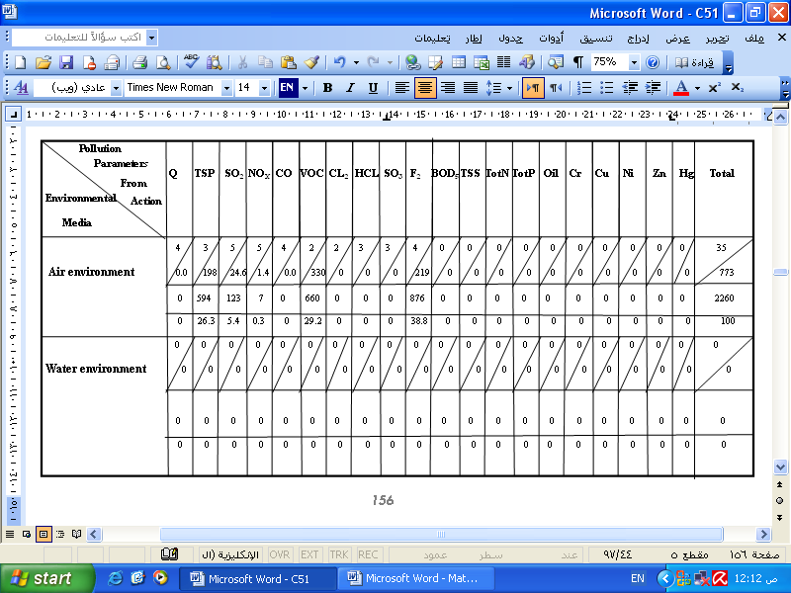

Matrix (6): Leopold Matrix of Bricks Manufacturing (معمل طابوق جبران)

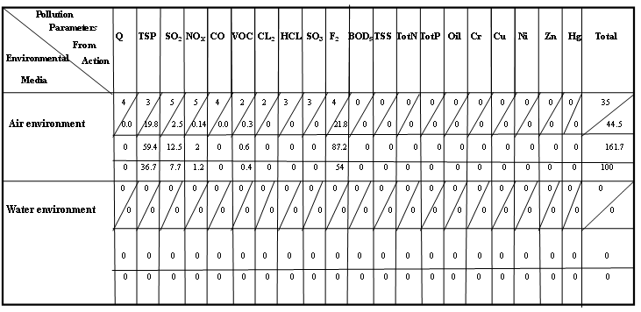

Matrix (7): Leopold Matrix of Bricks Manufacturing (معمل طابوق الرافدين)

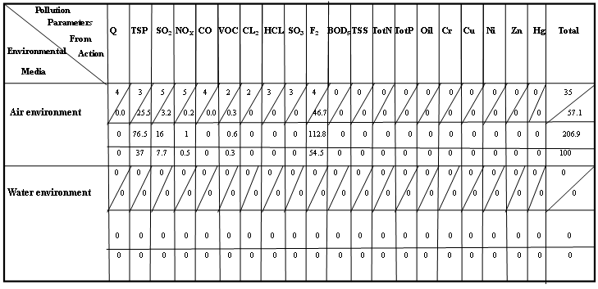

Matrix (8): Leopold Matrix of Bricks Manufacturing (معمل طابوق السلام)

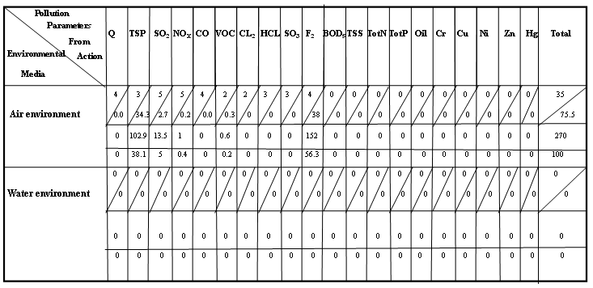

Matrix (9): Leopold Matrix of Bricks Manufacturing (معمل طابوق صابر التميمي)

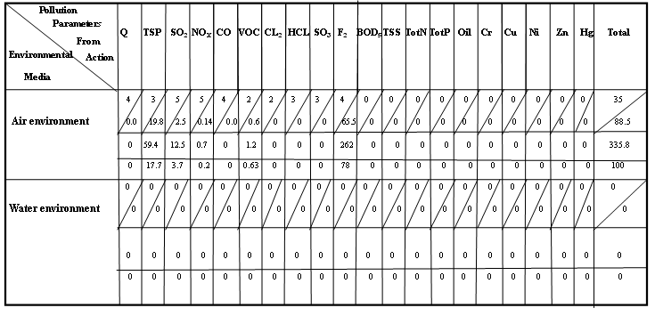

Matrix (10): Leopold Matrix of Bricks Manufacturing (معمل طابوق الفرات)

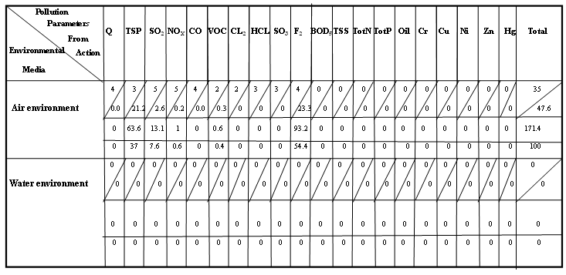

Matrix (11): Leopold Matrix of Bricks Manufacturing (معمل طابوق الفيحاء)

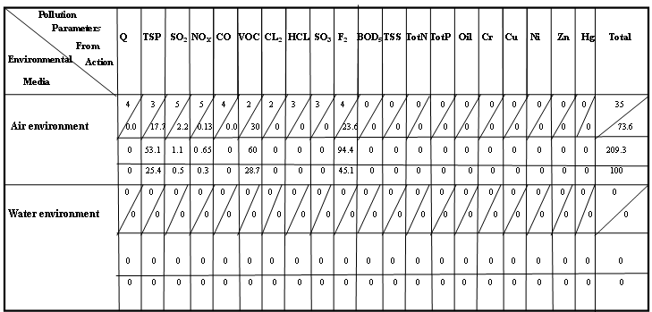

Matrix (12): Leopold Matrix of Bricks Manufacturing (معمل طابوق المحاويل)

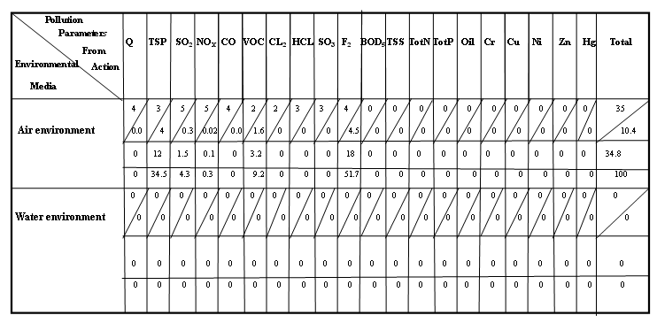

Matrix (13): Leopold Matrix of Bricks Manufacturing (معمل طابوق النيل)

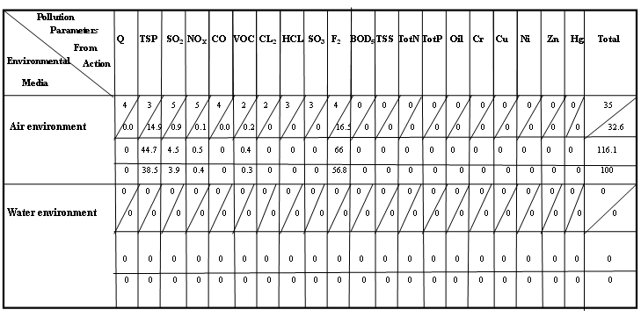

Matrix (14): Leopold Matrix of Bricks Manufacturing (معمل طابوق الهاشمية)

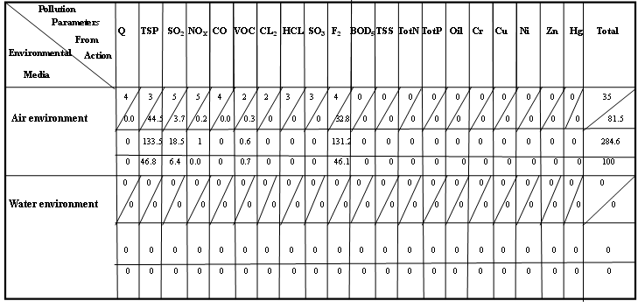

Matrix (15): Leopold Matrix of Lime Manufacturing (معمل النورة- كربلاء)

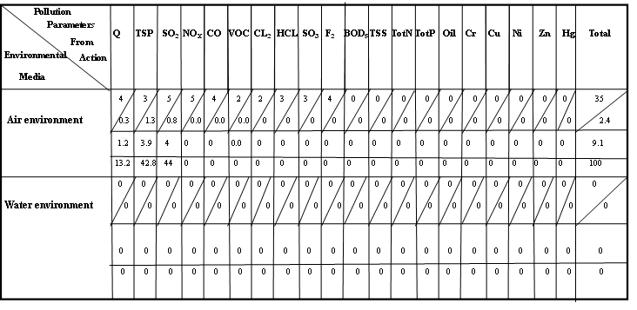

Matrix (16): Leopold Matrix of Cement Manufacturing (معمل سمنت السدة)

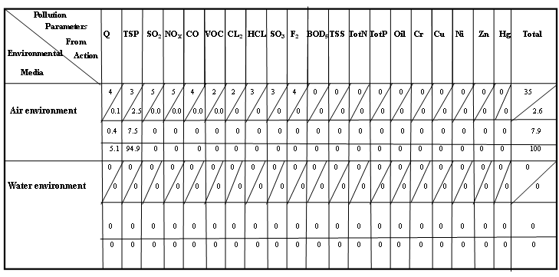

Matrix (17): Leopold Matrix of Cement Manufacturing (معمل سمنت كربلاء)

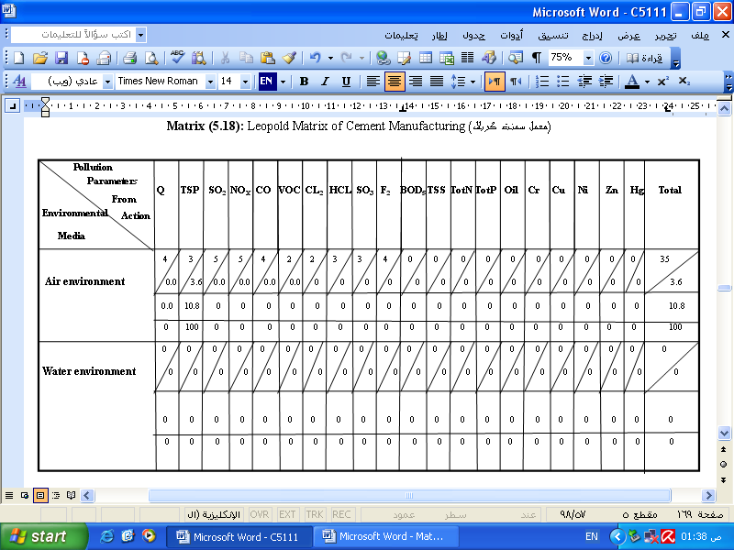
Matrix (18): Leopold Matrix of Cement Manufacturing (معمل سمنت الكوفة)
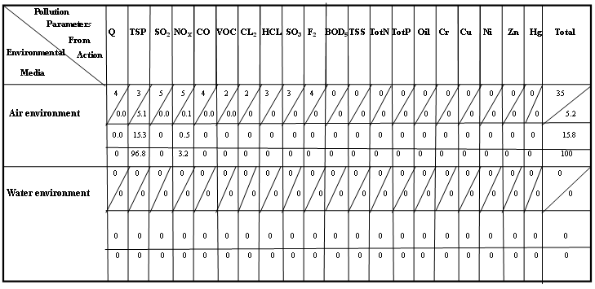

Matrix (19): Leopold Matrix of Cement Manufacturing (معمل سمنت النجف الاشرف)

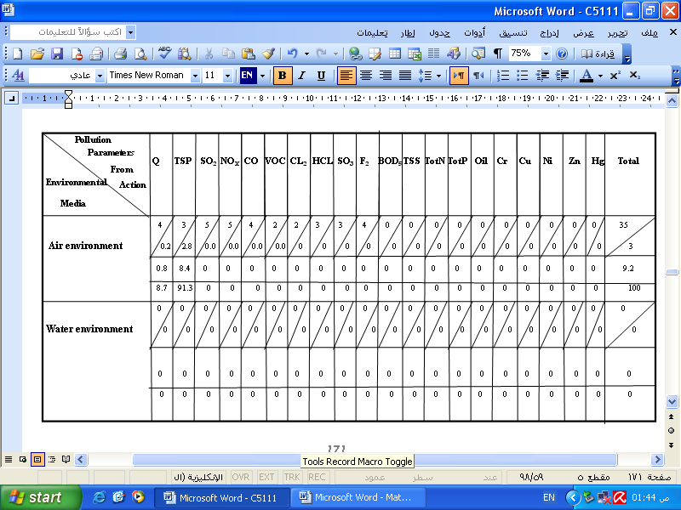

Matrix (20): Leopold Matrix of Chemical Industries

(الشركة العامة للصناعات الكيمياوية/معمل حرير السدة)

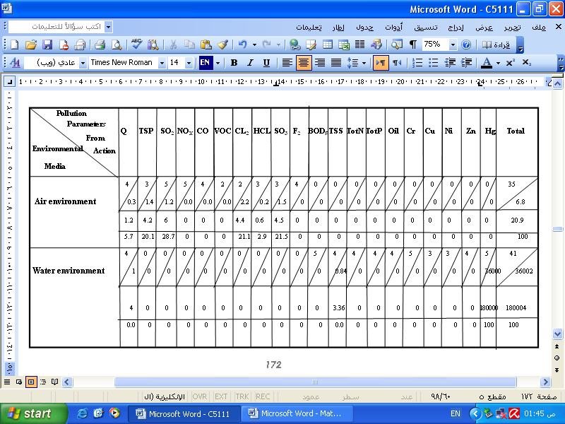

Matrix (21): Leopold Matrix of Grain Mill (معمل طحين الإخلاص)
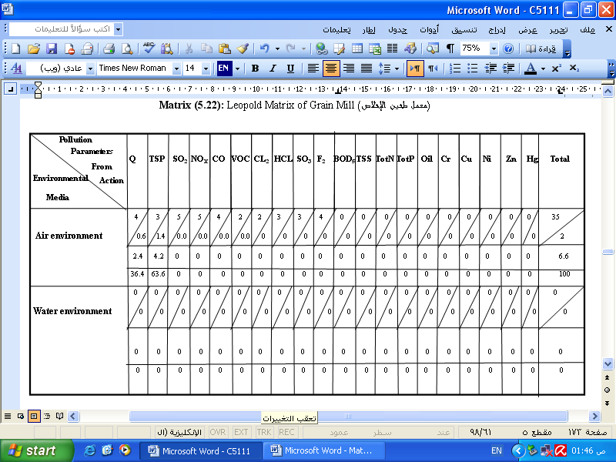

Matrix (22): Leopold Matrix of Grain Mill (معمل طحين بابل)
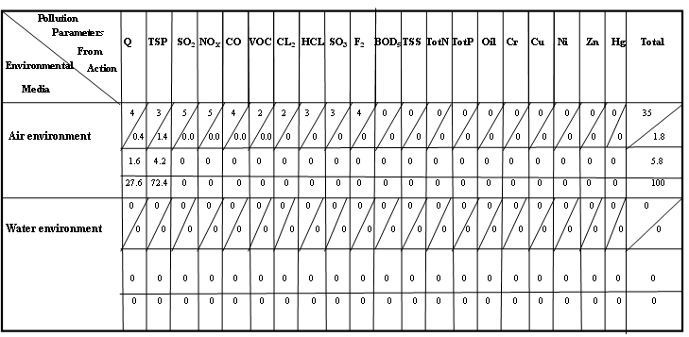

Matrix (23): Leopold Matrix of Grain Mill (معمل طحين طارق)

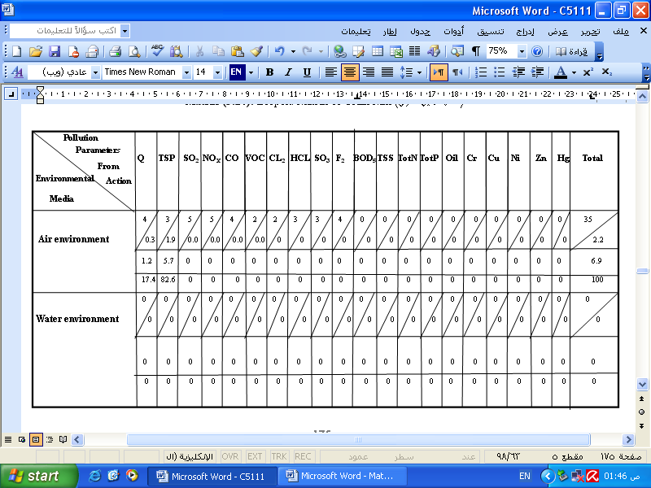

Matrix (24): Leopold Matrix of Grain Mill (شركة الفرات لطحن الحبوب)

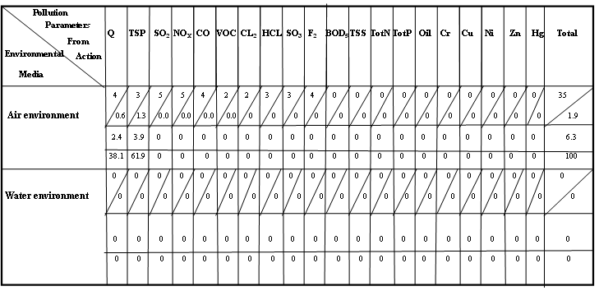
Matrix (25): Leopold Matrix of Power Station (محطة كهرباء المسيب الحرارية)

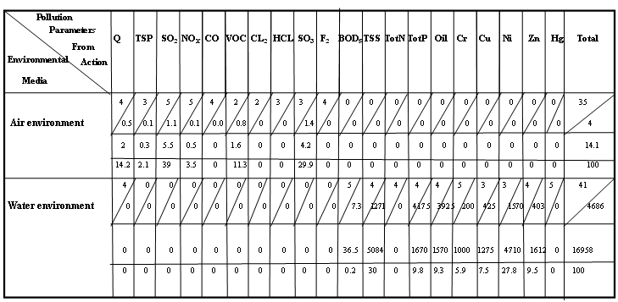

Matrix (26): Leopold Matrix of Dairy Products (معمل ألبان أولاد جمعة عبادي سلمان)

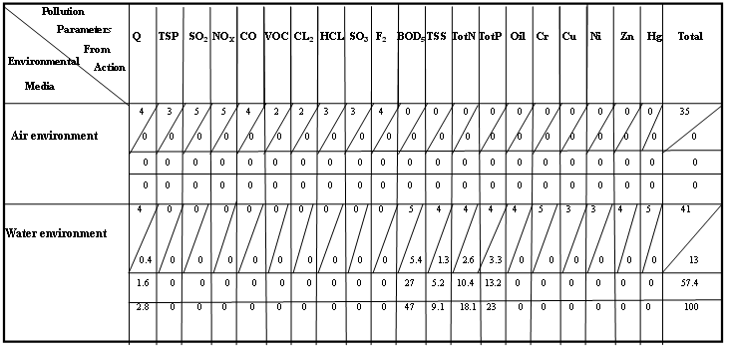

Matrix (27): Leopold Matrix of Dairy Products (معمل ألبان بابل)

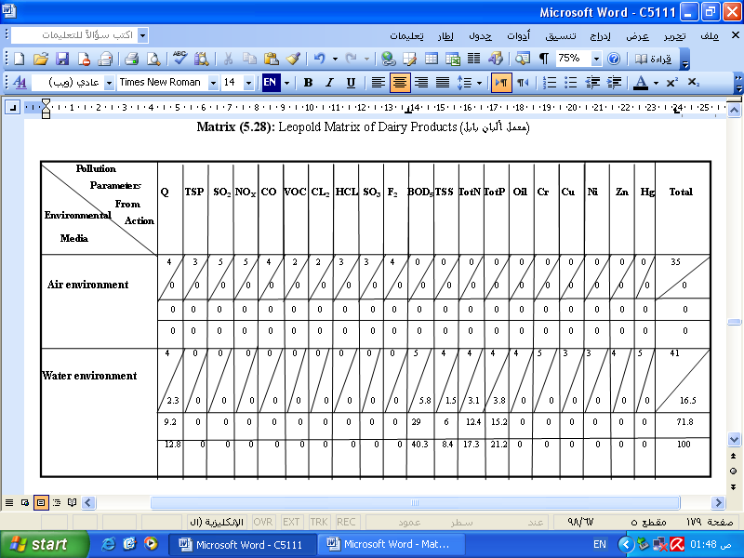

Matrix (28): Leopold Matrix of Dairy Products (معمل ألبان السهل)

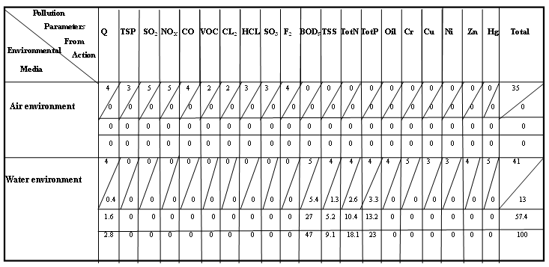

Matrix (29): Leopold Matrix of Dairy Products (معمل ألبان الفيحاء)

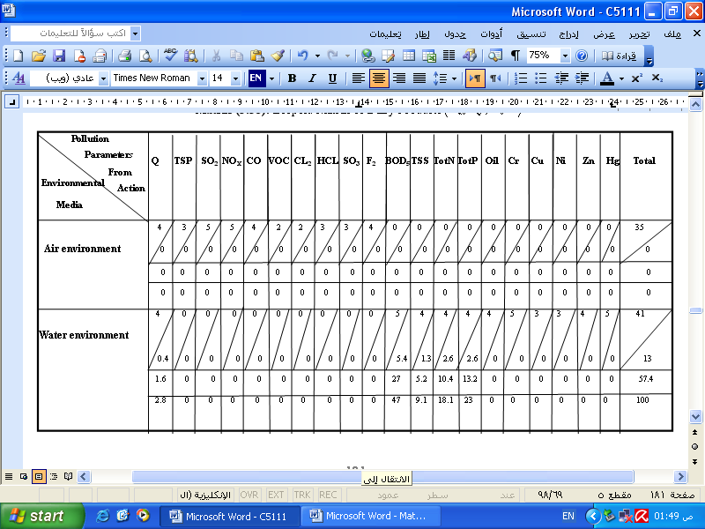

Matrix (30): Leopold Matrix of Dairy Products (معمل ألبان الطيب)

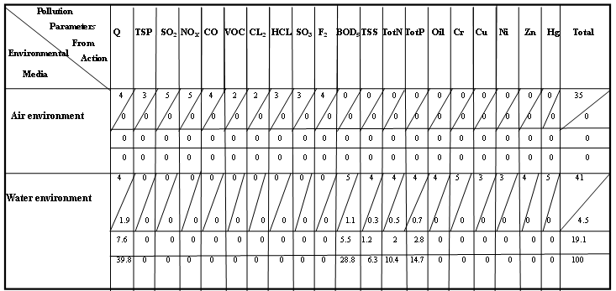

Matrix (31): Leopold Matrix of Dairy Products (معمل ألبان الرفق)

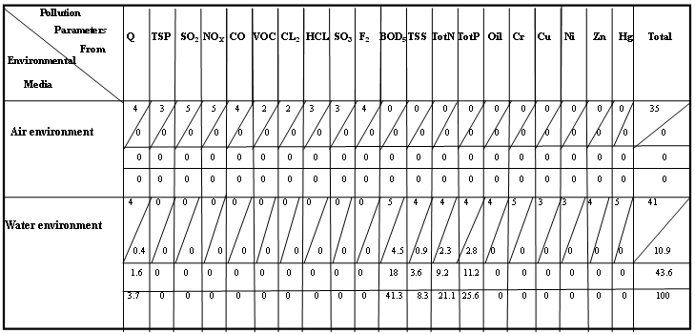

Matrix (32): Leopold Matrix of Dairy Products (شركة الوسام للمنتجات الغذائية)

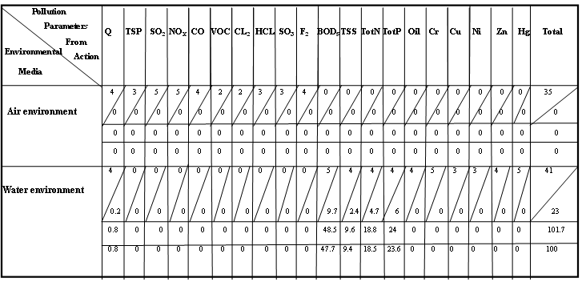

Matrix (33): Leopold Matrix of Tire Products (معمل المنتجات المطاطية)

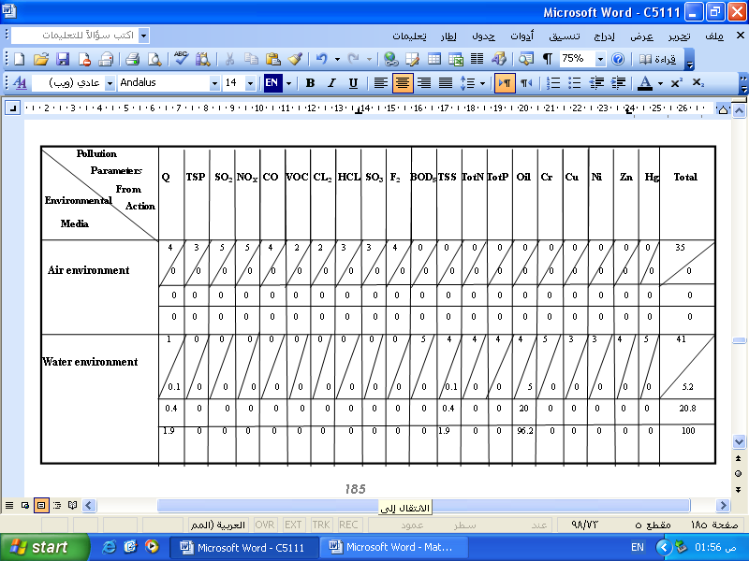

Matrix (34): Leopold Matrix of Soft Drinks (شركة بابل للمشروبات الغازية)

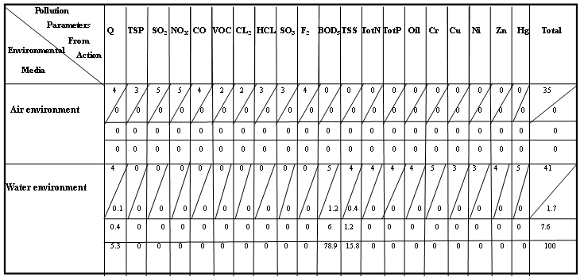

Matrix (35): Leopold Matrix of Soft Drinks (شركة نور كربلاء للمشروبات الغازية)

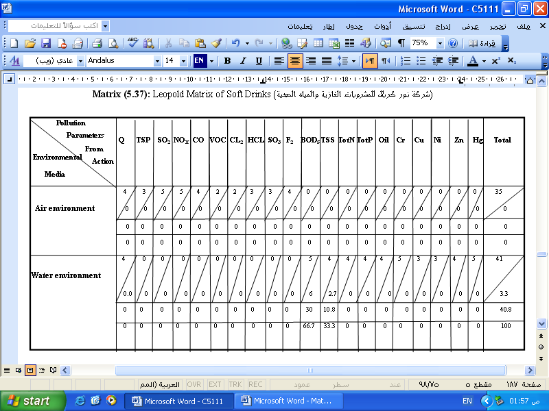

Matrix (36): Leopold Matrix of Soft Drinks (معمل الكوفة للمشروبات الغازية)

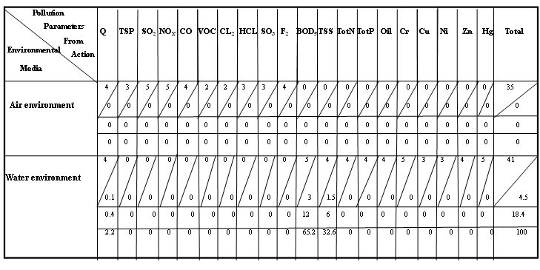

Matrix (37): Leopold Matrix of Textile Manufacturing (الشركة العامة للصناعات النسيجية /معمل نسيج الحلة)

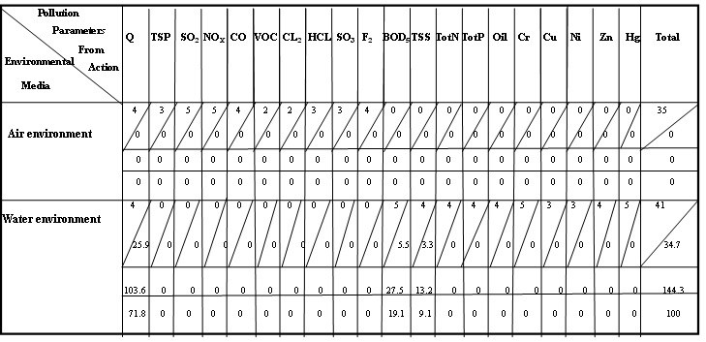

Matrix (38): Leopold Matrix of Textile Manufacturing (معمل نسيج أبو زيد)

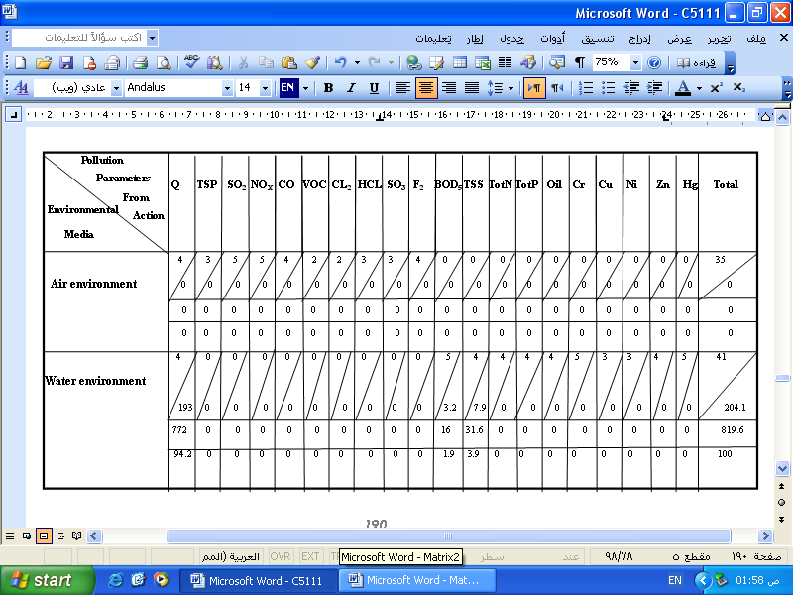

Matrix (39): Leopold Matrix of Textile Manufacturing (معمل نسيج الإخوان)

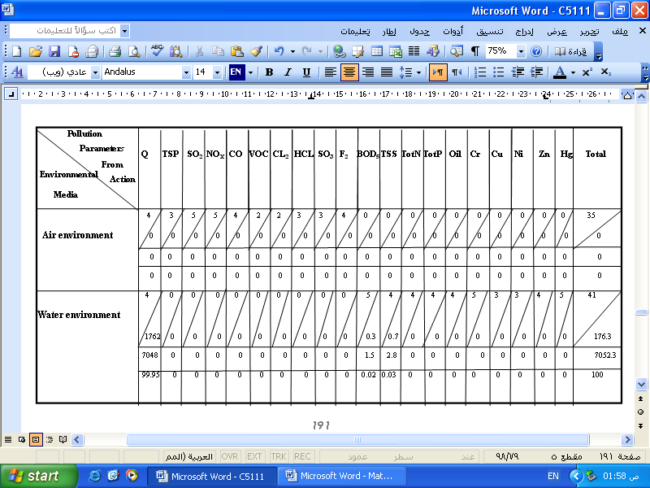

Matrix (40): Leopold Matrix of Textile Manufacturing (معمل نسيج الأمل)

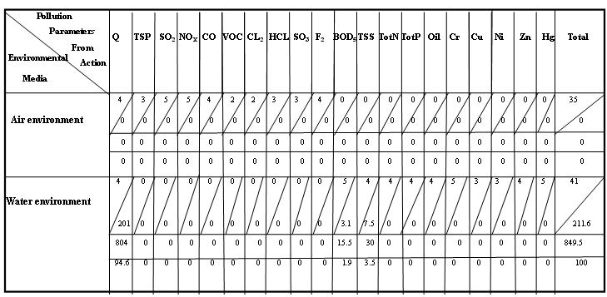

Matrix (41): Leopold Matrix of Textile Manufacturing (معمل نسيج الحسن)

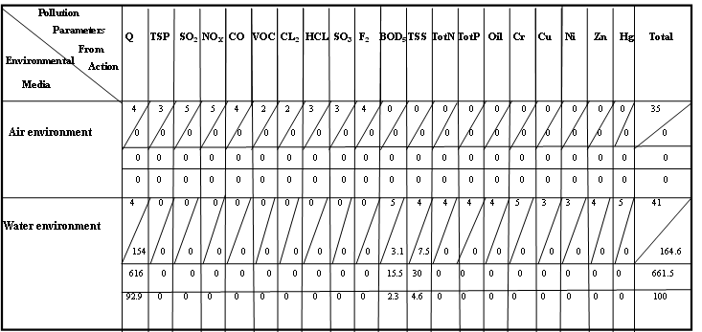

Matrix (42): Leopold Matrix of Textile Manufacturing (معمل نسيج الكوثر)

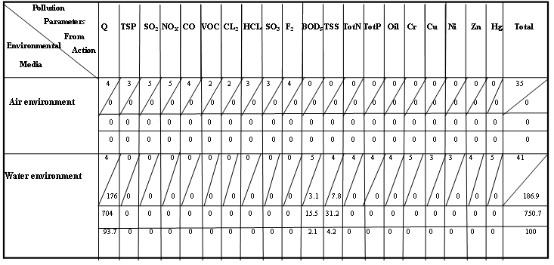

Matrix (43): Leopold Matrix of Textile Manufacturing (معمل نسيج الهادي)

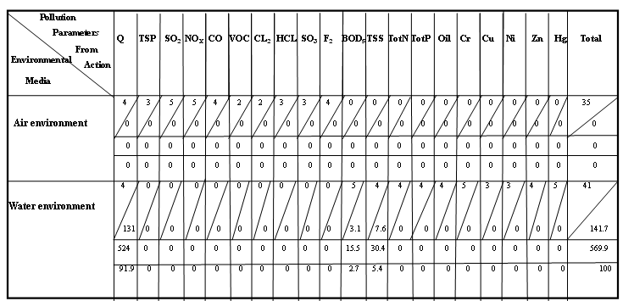

Matrix (44): Leopold Matrix of Textile Manufacturing (معمل نسيج الهدى)

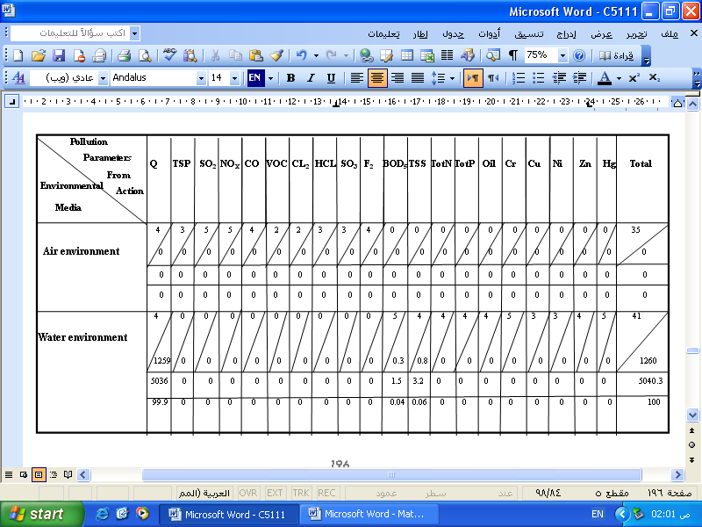

Matrix (45): Leopold Matrix of Textile Manufacturing (معمل نسيج الوطن العربي)
