Antimicrobial Activity of Local Imported Yoghurts Against Candida Albicans

Abdulelah A. Al-Mayah , Eiman A. Saeed
Tamadir H. Wadi , Huda Sh. Farhan
University of Basra College of Pharmacy Department of Clinical Laboratory Sciences
abdulelah.suhain@gmail.com
Abstract
Twelve types of imported traditional yogurts and home-made yogurts are studied for antimicrobial activity against Candida albicans. The investigation showed that the presence of lactobacillus spp. in some types of used yoghurts, while lack in others. Antimicrobial activity of yoghurts with presence of Lactobacillus was established against Candida albicans. The metabolites produced by Lactobacillus were inhibited Candida albicans growth. Water solutions with different pH values (5, 7, 8) were used to cultivate Candida albicans, the results showed there is no effect of pH values on the growth of Candida albicans, while the presence of Lactobacillus and their secondary metabolites exhibited notable inhibitory effect against Candida albicans growth.
key wrds: antimicrobials , yoyurts , yeast , lacto bacllus , candida
الخلاصة
أستخدم أثنا عشر نوع من الألبان التجارية المستوردة من مصادر مختلفة وكذلك البان منزلية الصنع، لدراسة فعاليتها ضد المبيضات Candida albicans. أظهرت الدراسة أن الألبان المستوردة وكذلك اللبن منزلي الصنع يحتوي على العصيات اللبنية Lactobacillus، وخلت الأنواع الأخرى من الألبان من هذه العصيات.
أثبتت الدراسة الحالية وجود تأثير مثبط للنواتج الأيضية للعصيات اللبنية على نمو المبيضات، أذ تم أنماء المبيضات في محاليل مائية مختلفة الأس الهيدروجيني (5، 7،8) ولوحظ عدم وجود أي تأثير تثبيطي لقيم الأس الهيدروجيني المختلفة على نمو المبيضات، في حين أظهر تواجد العصيات اللبنية ونواتجها الأيضية في الوسط تأثير تثبيطي واضح ضد المبيضات.
الكلمات المفتاحية : مضادات الميكروبات . المبيضات albicans candida
INTRODUCTION
Probiotic bacteria defined as live microorganisms which when administered in adequate amounts confer a health benefit on the host like lactic acid bacteria (Meurman & Stamatova, 2007; Twetman & Stecksen-Blicks, 2008), such health promoting bacteria are added to different commercial dairy products such as milk, cheese and yoghurt. Possible action of probiotic bacteria in production of antimicrobial substances and activation and regulation of the immune response (Parvez et al., 2006; Allaker & Douglas, 2009). Bacterial antagonism may occur when growth of one bacterial species is hampered by components produced by another species. Lactic acid bacteria produce antimicrobial and some have the ability to produce hydrogen peroxide (H₂O₂) that can be toxic to organisms producing little or no H₂O₂ (Onwehand, 1998; Becker et al., 2002; Meurman, 2005). Another important characteristic of lactobacilluss is production of proteinaceous bacterial substances which have intraspecies antagonistic effects. These substances have been known as bacteriocins (Vanderhoof & Rosemary, 2002; Reid, 2010).
Bacteriocin – like substances which normally have a broad spectrum of antimicrobial activity than bacteriocins can inhibit a wide range of Gram – positive, Gram – negative bacteria and Candida albicans (McGroarty, 1993; Birdsall, 1997; Vanderhoof & Rosemary, 2002).
The aim of the present study was to investigate the antibacterial effect of metabolites produced by Lactobacillus in yoghurt against growth of C. albicans.
MATERIALS AND METHODS
Samples of yoghurts
Twelve types of yoghurts used in the present study; 10 origins of commercial from local market in Basra city and 2 origins of home-made.
Yeast isolates
Candida albicans isolated from pulmonary infection patients, obtained from Research Laboratory in Clinical laboratory Sciences Department / College of Pharmacy.
First screening of Lactobacillus
Each type of yoghurt with amount of 0.01ml inoculated on MRS (deMan, Rogosa and Sharpe) agar medium with replications, samples then incubated under anaerobic conditions at 37◦C for (24-48)hr.
- Ten ml from each used yoghurts dispensed in screw capped bottles, then inoculated 0.01ml of 10⁶ cfu/ml (according to McFarland standard scale) from yeast suspension of C. albicans, then incubated at 37◦C for 48hr. Control samples performed by inoculating 0.01ml of C. albicans suspension onto SDA (Sabouraud Dextrose Agar), incubated at 37◦C for 48hr.
- About 0.01ml from yoghurts inoculated with Candida suspension were cultured onto MRS agar and SDA plates, then incubated at 37◦C for 48hr (Harrigan & McCane, 1976).
- Gram's staining and biochemical tests used to identify Lactobacillus spp. (Holt et al., 1994) and Saccharomyces yeast (Koneman et al., 1978).
Effect of pH on growth of C. albicans in yoghurts
1. The pH of all yoghurts was measured, and were found acidic (pH=5). From each type of yoghurts, 10 ml was dispensed in screw capped bottles, then inoculated with 0.01ml of 10⁶cfu/ml from yeast suspension of C. albicans according to Mcfarland standard scale (Collee et al., 1996), then screw capped bottles incubated at 37ºC for 48hr.
2. From yoghurts that inoculated with yeast suspension of C. albicans, 0.01ml was inoculated onto the surface of MRS agar and SDA plates, then incubated at 37ºC for 48hr. Control plates performed by streaking 0.01ml from yeast suspension of C. albicans on SDA plates.
3. In another step, 10ml from each type of yoghurts suspended in screw capped bottles, then the pH of all used yoghurts was adjusted to pH 7 by adding drops of 10% NaOH, after that yoghurts inoculated with 0.01ml of 10⁶ cfu/ml from yeast suspension
of C. albicans and incubated at 37ºC for 48hr.
4. About 0.01ml taken from each type of yoghurts (that pH=7 and inoculated with yeast suspension) streaked onto MRS agar and SDA plates, incubated at 37ºC for 48hr. (Awan & Rahman, 2005).
pH effects on the growth of C . albicans in water solution
1. The pH adjusted to (acidic=5), (neutral=7), (alkaline=8) to three equal samples (10 ml) from sterilized distilled water that dispensed in screw capped bottles. Water samples then inoculated with 0.01 ml of 10⁶ cfu/ml yeast suspension of C. albicans, all samples incubated at 37ºC for 48hr.
2. About 0.01ml from inoculated water samples with yeast suspension streaked on SDA plates then incubated at 37ºC for 48hr.

Lactobacillus spp. production of metabolites
- MRS broth dispensed in screw capped bottles (10ml each) with replications in three equal groups, then inoculated with pure Lactobacillus isolates and incubated an aerobically at 37◦C in water bath-shaker for 7 days (Schillinger & Luke, 1989).
- After incubation period, pH of three equal groups from the broth was adjusted to 5, 7, and 8 and inoculated with 0.01ml from yeast suspension, control samples performed by inoculating C. albicans suspension (without Lactobacillus metabolites) to broth samples, then incubated at 37◦C for 48hr.
- About 0.01ml from broth samples that inoculated with C. albicans inoculated onto SDA, the results recorded after 48hr. at 37◦C.
RESULTS AND DISCUSSION
First screening of yoghurts
The results exhibited the presence of Lactobacillus as Gram positive long bacilli associated with Saccharomyces yeast in some types of yoghurts (Table 1), Fig.(1) and (2) while the other types lack the presence of two microorganisms and this may be related to pasteurization process.

Table (1). First screening of used yoghurts for bacterial and yeast presence
Types of yoghurts | The origin | Microbial contents
1. Kala | Iran | Lactobacillus
2. Avisa | Iran | Lactobacillus
3. Enas | Turkey | Lactobacillus, Saccharomyces
4. (Home-made)a | Iraq | Lactobacillus, Saccharomyces
5. (Home-made)b | Iraq | Lactobacillus, Saccharomyces
6. Activia | Saudi Arabia | Gr+ rods, Saccharomyces
7. Al-Safi | Saudi Arabia | Saccharomyces
8. Mac | Iran | Saccharomyces
9. Manizan | Iran | Saccharomyces
10. Mast | Iran | (-)
11. Pacah Faris | Iran | (-)
12. Al-Wafrah | Kuwait | (-)

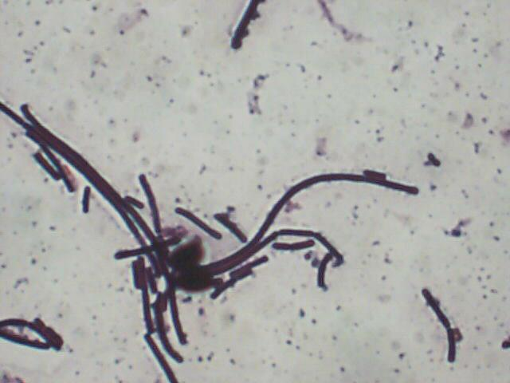


Fig. (1), (2): showed Lactobacillus isolates

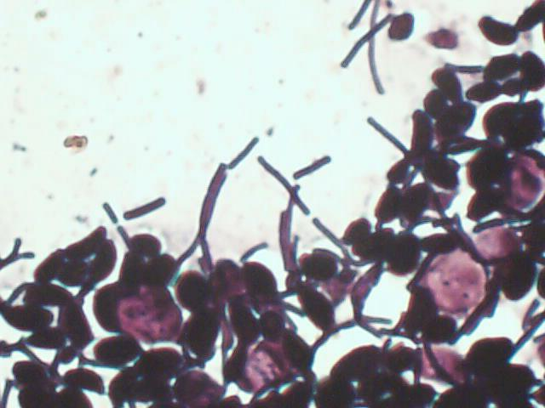
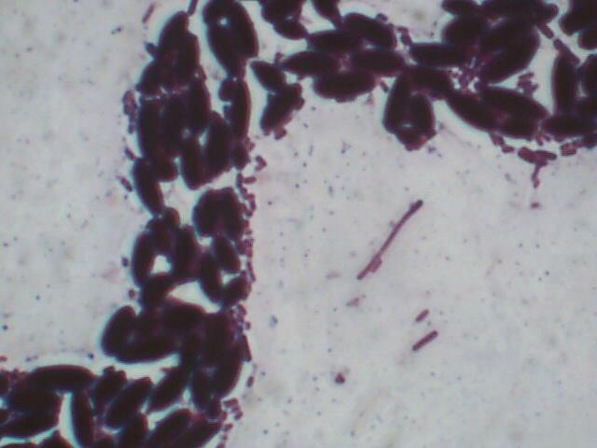

Fig. (3), (4): showed Saccharomyces yeast associated with Lactobacillus isolates

Biological activity of yoghurts against C. albicans
The results of inoculating yoghurts with C. albicans exhibited that yoghurts (type 1, 2, 3, 4, 5) contain Lactobacillus inhibit the growth of C. albicans and have the ability to eliminate it from the culture. While the other types of yoghurts (7, 8, 9, 10, 11, 12) that do not contain Lactobacillus have no effect on C. albicans, indicated by heavy growth of C. albicans on SDA culture medium. In type 6 of yoghurts, results showed the absence of growth of Candida in spite of it lack Lactobacillus, this may be related to the presence of Bifidiobacterium which have effective action on C. albicans growth Table (2). Yoghurts that contain non pathogenic bacteria like L. acidophilus help to fight yeast infection symptoms, have capability to stop them before it begin to growth, so yoghurts help to control C. albicans, not allow to over populate and turn into a yeast infection (Hilton et al., 1992; Shalev et al., 1996). Studies have shown that the daily ingestion of 150ml of yoghurt enriched with live L. acidophilus is associated with an increased colonization of friendly bacteria in the body. Lactobacillus have been used to treat or prevent infection of intestinal and uro-genital tract, also yoghurts often used by women with chronic vaginal Candida infection (Reid & Bruce, 2006).

pH effect on C. albicans in water solution
The results of cultivation of C. albicans suspended in distilled water (in pH 5, 7, 8) exhibited a good growth of Candida on SDA medium in acidic, neutral, and alkaline pH. This result indicate that the acidity of yoghurts do not have any affect on the growth of C. albicans.
Table (2). Biological activity of yoghurts against C. albicans
Yoghurts types | Yoghurts pH before adjustment | Microbial contents
Yoghurts types | Yoghurts pH before adjustment | MRS agar medium | SDA medium
1 | 5 | Lactobacillus | No growth
2 | 5 | Lactobacillus | No growth
3 | 5 | Lactobacillus, Saccharomyces | Saccharomyces
4 (a) | 5 | Lactobacillus, Saccharomyces | Saccharomyces
5 (b) | 5 | Lactobacilli, Saccharomyces | Saccharomyces
6 | 5 | Gv+ rods, Saccharomyces | Saccharomyces
7 | 5 | Saccharomyces | Saccharomyces, C. albicans
8 | 5 | Saccharomyces | Saccharomyces, C. albicans
9 | 5 | Saccharomyces | Saccharomyces, C. albicans
10 | 5 | No growth | C. albicans
11 | 5 | No growth | C. albicans
12 | 5 | No growth | C. albicans

Effect of Lactobacillus metabolites on the growth of C. albicans
The results revealed that secondary metabolites of Lactobacillus isolate have an inhibitory action against the growth of C. albicans in different pH values (5, 7, 8) in comparison with control samples (lack the presence of Lactobacillus metabolites) in which C. albicans showed heavy growth in acidic, neutral, and alkaline pH medium, this may be related to secondary metabolites that produced by Lactobacillus to the medium which inhibit the growth of C. albicans Table (3). These results compatible with other studies (Lowe & Arendt, 2004; Hatakka et al., 2007; Slacanac et al., 2010).

Table (3). Inhibitory effect of Lactobacillus metabolites on C. albicans
C. albicans | In presence of Lactobacillus metabolites |  |  | In absence of Lactobacillus  metabolites
C. albicans | pH = 5 | pH = 7 | pH = 8 | pH = 5 | pH = 7 | pH = 8
C. albicans | No growth | No growth | No growth | Heavy growth | Heavy growth | Heavy growth

CONCLUSIONS
The present study showed :-
- Lactobacilli isolated from yoghurts could produce metabolites have ability to inhibit growth of C. albicans in vitro.
- Yoghurts acidity do not have a noticeable effect on C. albicans growth.
RECOMMENDATIONS
Further studies to be done to investigate the type of metabolites produced by Lactobacillus that found in yoghurts or other dairy products.
References
Allaker, R. P. and Douglas, C. W. (2009). Novel anti-microbial therapies for dental plaque-related disease. Int. J. Antimicrob. Agents., 33:8-13.
Awan, J. A. and Rahman, S. U. (2005). Microbiology Manual. Unitech Communications, Faisalabad, Pakistan, pp: 49-51.
Becker, M. R. ; Paster, B. J. ; Leyes, E. J. ; Moeschberger, M. L. ; Kenoyon, S. G.; Galvin, J. L. ; Boches, S. K. ; Dewhirst, F. E. and Griffin, A. L. (2002). Molecular analysis of bacterial species associated with childhood caries. J. Clin. Microbiol, 40:1001-1009.
Birdsall, T.C. (1997). Gastrointestinal candidiasis: fact or fiction? Alternative Medicine Review 2:346-354.
Collee, J. G.; Fraser, A. G.; Marmion, B. P. and Simon, A. (1996). Mackie and McCartney Practical Medical Microbiology. 14thed. Churchill Livingstone. New York. pp. 978.
Harrigan, W. F. and McCane, M. E. (1976). Laboratory Methods in Food and Dairy Microbiology, Academic Press, London, UK. Pp. 19-20.
Hatakka, K. ; Ahola, A. J. ; Yli-Knuuttila, H. ; Richardson, M. ; Poussa, T. ; Meurman,
J. H. and korpela, R. (2007). Probiotics reduce the prevalence of oral Candida in the elderly-a randomized controlled trail. J. Dent. Res., 86: 125-130.
Hilton, E. ; Isenberg, H. D. ; Alperstein, P. ; France, K. and Borenstein, M. T. (1992). Ingestion of yoghurt containing Lactobacillus acidophilus as prophylaxis for candidal vaginitis. Ann. Intern. Med., 116:353-357.
Holt, J. G., Krieg, N. R., Sneath, P. H. A., Staley, J. T. and Williams, S.T. (1994): Bergey’s manual of Systematic Bacteriology. 9th ed. Williams and Williams. Baltimore. pp. 566.
Koneman, E. W.; Robert, G. D. and Wright, S. E. (1978). Practical Laboratory Mycology. 2nded. The Willims and Wilkins Co. Baltimore, U. S. A. pp. 153.
Lowe, D. P. and Arendt, E. K. (2004). The use and effect of lactic acid bacteria in malting and brewing with their relationships to antifungal activity, mycotoxins and gushing: A review. J. Inst. Brew., 110:163-180.
McGroarty, J. A. (1993). Probiotic use of lactobacilli in the human female urogenital tract .FEMS Immun. Med. Microbiol. 6:251-264.
Meurman, J. H. (2005). Probiotics : Do they have a role in oral medicine and dentistry . Eur. J. Oral. Sci., 113:188-196.
Meurman, J. H. and Stamatova, I. (2007). Probiotics: contributions to oral health. Oral Dis., 13:443-451.
Ouwehand, A. C. (1998). Antimicrobial components from lactic acid bacteria. In: Lactic acid bacteria Microbiology and Functional aspects. 2nd ed .Edited by Salminen, S. and von Wright, A. New York. Pp. 139-160.
Parvez, S.; Malik, K. A. ; Ahkang , S. and Kim , H.Y.(2006). Probiotics and their fermented food products are beneficial for health. J. Appl. Microbiol., 100: 1171-1185.
Reid, G. and Bruce, A. W. (2006). Probiotics to prevent urinary tract infections : the rationale and evidence .Wor. J. Uro. 24:28-32.
Reid, G. (2010). Probiotics and prebiotics – progress and chalanges. Int. Dair. J., 18:969-975.
Schillinger, V. and Luke, S. K. (1989). Antimicrobial activity of Lactobacillus Sakei isolated from meat. Appl. Environ. Microbiol., 55:1901-1906.
Shalev, E.; Battino, S.; Weiner, E. ; Colodner, R. and Keness, Y. (1996). Ingestion of yoghurt containing Lactobacillus acidophilus compared with pasteurized yoghurt as prophylaxis for recurrent candidal vaginitis and bacterial vaginosis. Arch. Fam. Med., 5:593-596.
Slacanac, V. ; Hardi, J. ; Lucan, M. ; Bozanic, R. ; Galic, S. and Koceva-Komlenic, D. (2010). Prevention of uro-genital infections by oral administration of probiotics Lactobacilli. Mljekarstvo, 60:156-165.
Twetman, S. and Stecksen-Blicks, C. (2008). Probiotics and oral health effects in children.Int. J. Paediatr. Dent., 18:3-10.
Vanderhoof, J. A. and Rosemary, J. Y. (2002). Probiotics in pediatrics. Pediatrics 109:956-958.

