Evaluation of mung bean seed viability after exposing to accelerating ageing conditions

Farah A. Abass Abdulla I. Shaheed
Department of Biology, College of Science, University of Babylon.
Babil – Iraq.

Abstract
The current study has bean curried out by exposing Mung bean (Phaseolus aureus Roxb.) seeds to accelerating ageing conditions (45± °C and 100% relative humidity) for 2,4,8 and 14 days.Evaluation of seed vigor was obtained by comparing acceleratedaly aged seeds to un-aged seeds (control). The results were revealed that, accelerating ageing of mung bean seeds had significant inhibition of germination percentage ,up to 4 days .Mean-while, a progressive decline in germination % with increasing ageing period (from 100% in control to 36% after 14 days). However,reduction of germination % was coincided with the reduction of most tested parameters : Germination seed index , seed vigor index , seedling length , seedling fresh and dry wight (shoot and root systems).Althought, accelerating ageing causes increase in moisture content and soluble leakage of seed , but it has no deteriorative effect on membrane integrity in terms of electrical conductivity (permeability perturbation ) at least within the first 4 day. As aconclusion , accelerated ageing caused diminishing of mung bean seed viability according to the above results.
Introduction
Seed seldom planted immediately aftar harvesting,it is stord for certain period of time before sowing (Iqbal,2002).There are many factor affected seed quality and vigor such as temperature ,moisture,drought ,salinity,fungi , insect and other (Chhetri,2009).
The two most important environmental factors influencing on the life of seeds are relative humidity of the air, which controls seed moisture content, and the temperature (McDonald, 1999). Most crop seeds loss their viability with high temperature and high retative humidity, lead to ageing and seed deterioration.Seed deterioration can be define as the loss of quality,vaiablity and vigor either due to ageing or effect of adverse environmental factors. The rate of deterioration rapidly increases with increasing of either seed moisture content or temperature of storage (Ellis et al, 1985).
Free fatty acid content and free radicals are,the main causes of seed ageing and deterioration(Iqbal,2002),free fatty acid can damage lipid bilayer especially of mitochondria leading to reduce energy production (Booth and Bai, 1999). Most enzyme activity decrease in seed ageing such as superoxide dismutase , catalyase ,peroxidase and other.protein also declines with seed ageing while amino acid content increase .
Ageing lead to decrease DNA synthesis, increase DNA degredation and increase memberane permeability associated wih increase seed deterioration (MacDonald and Kwong ,2005).Recently Hussein (2012) was found adecrease in enzyme activity (Glutathione Reductase and Peroxidase) in sunflower seeds were exposure to accelerating ageing conditions.
The process of seed deterioration and ageing can be understood by accelerating ageing (AA) test (Delouche and Baskin, 1973). Accelerating ageing test is one of most of vigor seed tests widely used to determine the quality of seed lots and important procedure for understanding the events that lead to the loss of seed viability (Thant et al,2010).
Most of the methods of accelerated ageing are based on the precepts of Roberts (1973) that seeds in prcsencc of high moisture and high temperature during storage gradually deteriorate and eventually lose viability .AA is physiological stress test that permits controlling deterioration of seed (Begnami and cortelazzo, 1996) due to exposure to high temperature and to high relative humidity (greater than%90 ) (ISTA, 1995).
The AA is one of the most popular seed vigor test due to it is simplicity, ease of standrazatiom (Tekrony ,1995) and applicability to wide range of crops (MacDonald ,1995) and it is standrized and correlats with field emergence under avariety of seedbad condition (Egli and Tekrony,1996). The aim of the present research was to investigate the possible effects of accelerated ageing upon physiological changes of mungbean seeds.
Material and Methods
Plant materials
Experiments were performed on Iraqi cultivar ( Phaseolus aureus Roxb.) local variety . The seed materials were obtained from the field of Babil governorate at the season of (2011-2012); Seeds were surface sterilized using 5% sodium hypochlorite solution for 5 minutes and rinsed thoroughly in distilled water. The seeds were dried at 25°C for 24 hours in the laboratory, as described for pea by (Khan et al., 2003). Seed materials were stored in dark plastic containers at 4C° until use.
Accelerated aging treatment
Seeds were aged acceleratedly at 45 ±1C° and 100% relative humidity for 14days. Seeds were aged in glass desiccators containing at the bottom distilled water, seeds spread as a single layer on a metallic net to avoid contact with water. The desiccators were covered and maintained in an incubator at 45±1ºC for2,4,8 and 14 days of ageing treatments. Following the accelerated aging treatment, moisture content was determined and the seeds were air dried at 25°. The seed material was stored at 4°C under the dark until use (Khan et al., 2003).
Moisture content
Carried out in an oven at 105±3°C/72h, using three samples of 4.0 g of seeds, for each lot. Results were expressed as mean percentages for each lot (fresh weight basis) (Woltz & Tekrony, 2001).
Germination test
Germination test was conducted using between paper (BP) method of germination 25 seed per 3 replication were sown on paper towel. Seeds were placed on the surface of double sheets of towel paper which were moistened with distilled water. The seeds were covered with an another sheet of paper towel. The sheets were rolled and placed vertically in a plastic beaker, covered with a plastic bag at 25Cº in a germinator (ISTA, 1993).
Solute leachate test
Twenty five seeds were weighed and placed in 100 ml beaker containing 30 ml of distilled water. Beaker were covered and left undisturbed for overnight. The Elute was collected and the final volume was made to 50 mL with distilled water and measured by pH meter (Simon and Rajaharun, 1972). The conductivity measurements were expressed in (µs\cm\25 seed).

germination speed index (GI)
The germination index (GI) was calculated as described in the Association of Official Seed Analysts (AOSA, 1983) by following formula:
GI = 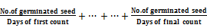

Seedling vigor index (SVI)
Seedling vigor index (SVI) was calculated following modified formula of (Abdul-Baki and Anderson 1973):
SVI = [seedling length (cm) × germination percentage]/100
Growth analysis: (Relative Growth Rate)
Seedlings of mung bean were transplanted into plastic trays filled with clean sawdust .Water was topped after 3 days of planting, seedlings were harvested from trays.their length in addition to root and shoot were separated, fresh and dry weights were determined, their length in addition to (AL-Maskri, et al, 2002).
Statistical test:
All treatments were determined by three replicates. Data were subjected to an analysis of variance, a completely randomized and LSD (least significant difference) were calculated at P
Results
1-Moisture content:
A significant increase was observed in moisture content after aging for (2,4,8and 14 day) compared to control. Under accelerated aging condition,moisture content increased from 9.33% (in control) to12.66 25.3%,40% and 42.6 at (2,4,8and 14 day of aging respectively) as shown in (fig 1).
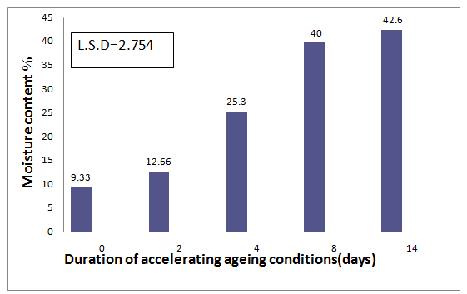
Fig(1) Effect of accelerated aging conditions on moisture content (%)of mung bean seeds
2-Standard germination test
Figure (2) shows that accelerated aging had no significant effect on germination during the first 2 days.However, after four days of aging there was significant reduction in germination percentage(7%). Further increase in aging period a suppressive effect on germination percentage at14 days (reduction = 64%).
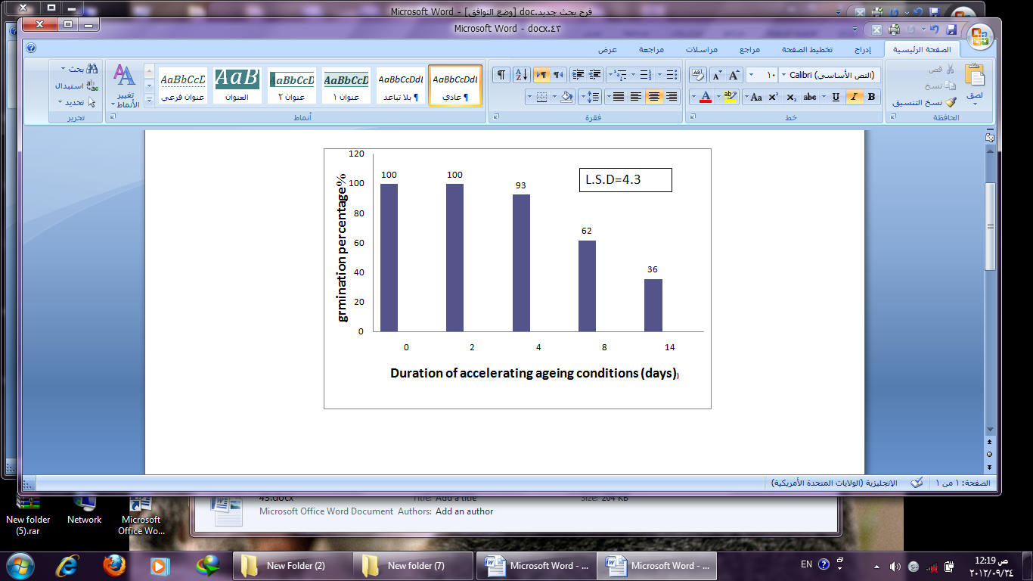

Fig (2) Effect of accelerated aging conditions on germination percentage (%)of mung bean seeds.
3-Germination speed index (GI):
Germination speed is a direct measure of seed vigor. Accelerated ageing also decreased the germination speed index of seeds. fastest germination speed was observed in control (25) compared to the lowest (9) at 14 days of ageing treatment (Fig.3).
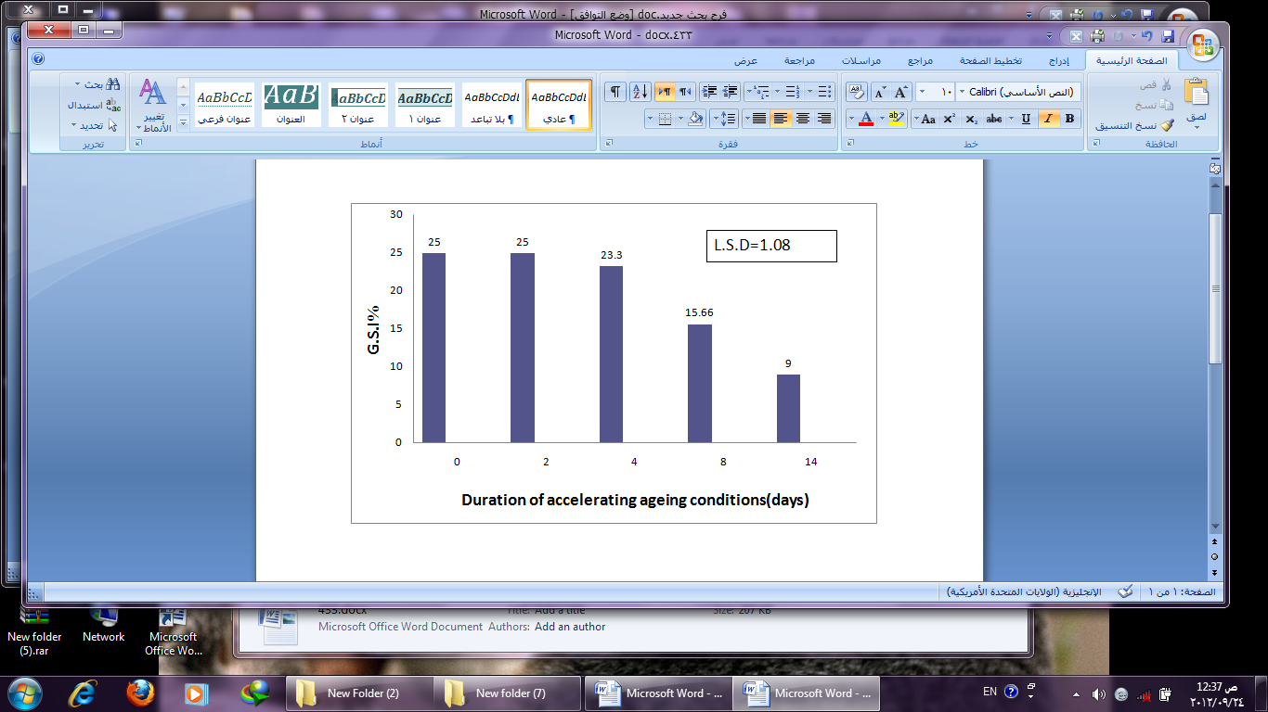
Fig (3) Effect of accelerated aging conditions on germination speed index (GSI) of mung bean seeds.
4-Electrolyte Leakage:
Accelerating ageing condition,increased permeability perturbation in terms of Solute leakage( electrical conductivity). significantly after 4, 8,and 14 days(161.6 ,308.3, 402.6).Mean-while,it has no significant effect after 2 days compard to control (unaged seed) (fig.4).

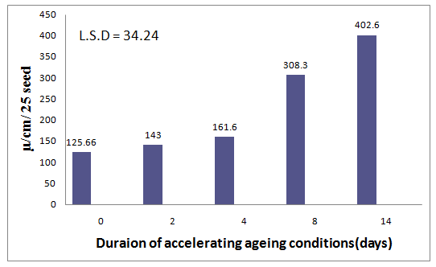

Fig (4) Effect of accelerated aging conditions on membrane permeability in term of electrical conductivity (µs\cm\25 seed) of mungbean seeds.
5-Seedling vigor index (SVI):
Besides the decrease in germination percentage and germination seed index the seedling vigor index also showed a decline pattern during accelerated aging (Fig 5). vigor index decreased from (18.83 in control) to (8.55 and 4.74 ) aftar 8 and 14 days of accelerated aging treatments respectively.
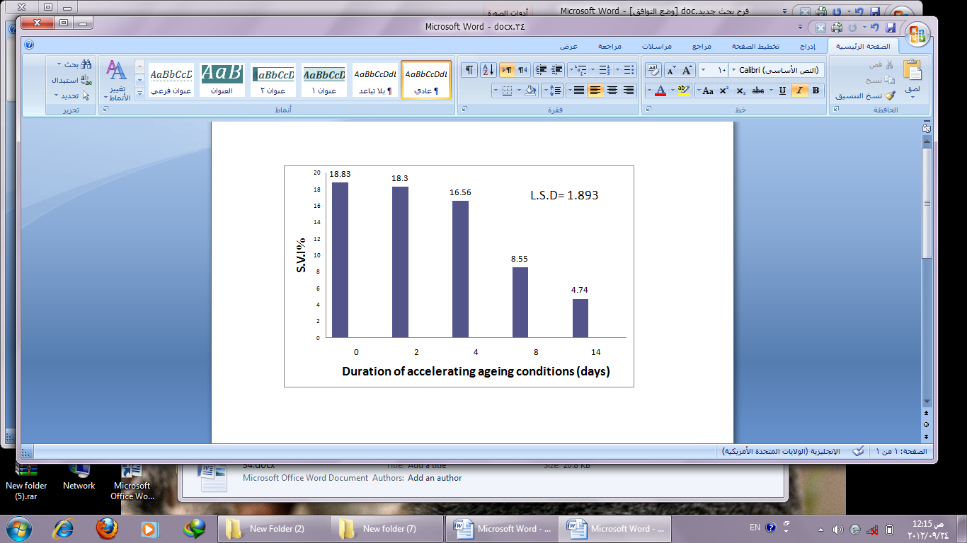
Fig (5) Effect of accelerated aging conditions on seedling vigor index of mung bean seed
6-Seedling length:
Accelerated aging significantly inhibited seedling growth (Fig 6). Ageing up to 4,8 and 14 days produced statistically different seedling length compared to control
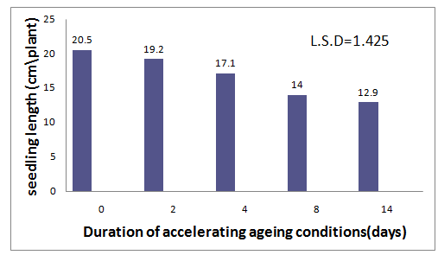

Fig (6) Effect of accelerated aging conditions on 10-day-old of mungbean seedlings length (cm\plant).

Growth analysis (Relative Growth Rate):
Shoot and Root length also elicited a significant decline compared to control seeds (Fig 7, 8) after accelerated aging treatments.
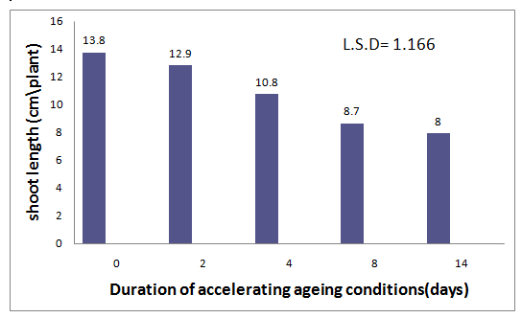
Fig (7) Effect of accelerated aging conditions on shoot length (cm\plant) of mung bean seedlings.

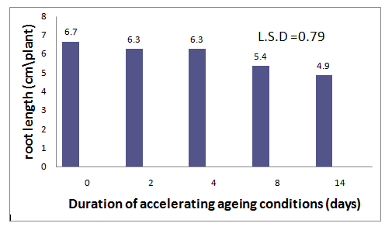
fig (8) Effect of accelerated aging conditions on root length (cm\plant) of mung bean seedlings.

In addition, accelerated aging conditions showed significant decline on fresh and dry weight of shoot (Fig 9, 10) particularly after 8, and14 days.
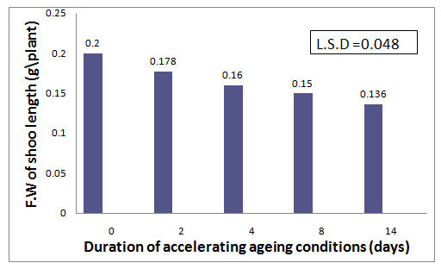
Fig (9) Effect of accelerated aging conditions on fresh weight of shoot (g\plant) of 10- days -old mung bean seedlings.

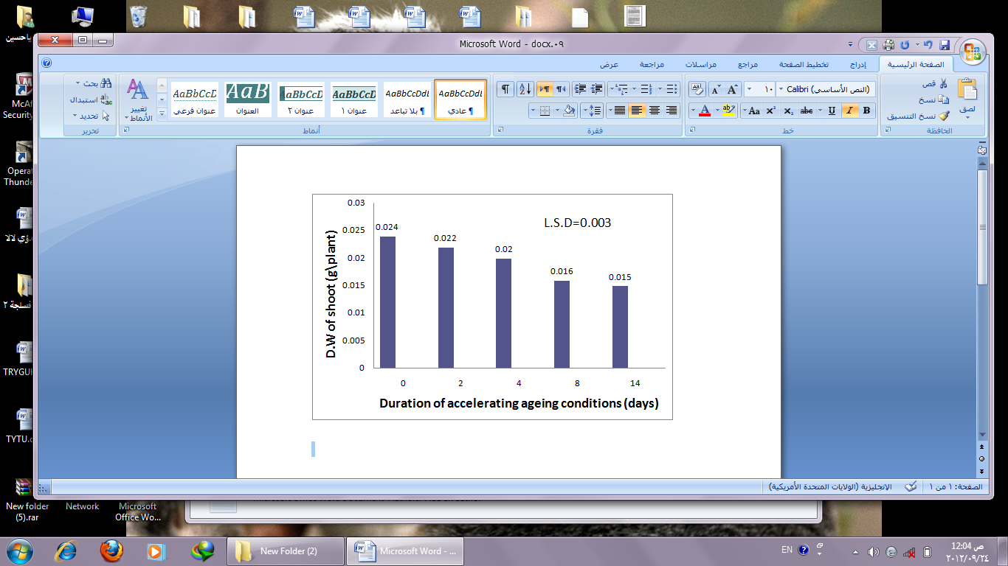

Fig (10) Effect of accelerated aging conditions on effect dry weight of shoot (g\plant) mung bean seedlings.
Moreover accelerated aging conditios also exhibited no a significant effect on fresh and dry weight of seedling root compared to control (Fig 11, 12) except the decline in fresh weight at (8,14 days) and in dry weight at 14 day only.
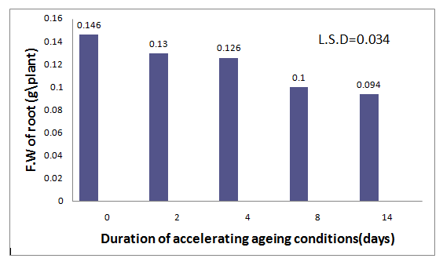

fig (11) Effect of accelerated aging conditions on fresh weight of root(g\plant) of mung bean seedlings.

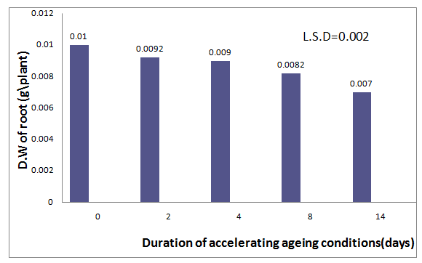
Fig (12) Effect of accelerated aging conditions on dry weight of root(g\plant) of mung bean seedlings.

Discussion
Relative humidity and temperature are the two most important factors determining rate (level of) seed deterioration. Relative humidity is important because it directly influences the moisture content of seeds in storage as they come to equilibrium with the amount of gaseous water surrounding them. Temperature is important because it: (i) determines the amount of moisture of air can hold – higher temperatures holding more water than lower temperatures; and (ii) enhances the rate of deteriorative reactions occurring in seeds as temperature increases (McDonald & Kwong, 2005).
A significant increased were observed in moisture content after accelerated ging at all periods of aging. (Fig1).The increase could explain by increase in imbibe water due to the disorgnazation of the cell membrane during ageing .However, similar result were reported by (Ellis, et al. 1985 )
Accelerated aging resulted in progressively loss of seed viability and vigor. Seeds of mung bean were exhibited an initial 100% germination which declined progressively wih increasing peroid of artificial ageing (Fig2).Reduction in germination is due to degradation of mitochondrial membrane, leading to reduction in energy supply necessary for germination(Gidrol,et al.1998). Accelerated aging also caused decreased caused in seedling vigor index; germination speed index, seedling length, and seedling shoot and root length.(Fig 4, 5, 6, 7 and 8). The possible reason of this reduction might be the lowering of biochemical activities in seeds. Ageing have damaging effect on enzymes that are necessary to convert reserve food in the embryo to usable form and ultimately production of normal seedling (Iqbal, et al. 2002).Similar results were reported in peanut (Sung & Jeng, 1994) in cotton seed (Iqbal, et al. 2002) in chickpea (Kapoor, 2010) and in Rice (Kapoor, et al. 2011).The decline in shoot length, root length and seedling vigor index might be attributed to DNA degradation with aging which leads to impaired transcription causing incomplete or faulty enzyme synthesis essential for earlier stages of germination (Kapoor, 2010) and also effect the lipid peroxidation on the protein content important for seedling growth.with decrease in germination percentage and seedling length, lead to decrease in vigor index.Aceelerating ageing also increase electrolyte leakage after 8 days and deterioration in membrane integrity of mung bean seeds (Fig.3), that reflect permeability perturbation. Similar results were reported in sun flower seed (Hussein, 2011). The loss in membrane integraty and the leakage of electrolytes are the first symptoms of seed deterioration (McDonalald, 1999).

References
- Abdul Baki, A.A. & Anderson, J.D. (1973). Vigor determinations in soybean seed multiple criteria. Crop Sci. 13: 630-633.
- Aiazzi, M.T; J.A. Aregullo; A. Perez; J. Rienzo & C.A. Guzman. (1996). Deterioration in Atriplex cordobensis (Gandoger et sucker) seed: Natural & accelerated aging. Seed Sci. Technol. 25: 147-155.
- Al-Maskri, A; M.M. Khan; O. Al-Manthery and K. Al-Habsi (2002). Effect of accelerated aging on lipid peroxidation, leakage and seedling vigor (RGR) in cucumber (Cucumis sativus L.) seeds. Pakistan J.Agri. Sci., 39: 330–337.
- Association of Official Seed Analysts(AOSA).(1983). Seed vigor testing handbook. Contribution 32, Handbook on Seed Testing, AOSA, Lincoln, NE, USA.
- Begnami, C.N. and A.L. Cortelazzo. (1996). Cellular alterations during acceleratedaging of french bean seeds. Seed Sci. & Technol. 24: 295-3
- Booth,D.T. and Y.Bai,(1999). Imbibitions temperature affects on seedling vigor: in crops and shrubs.J.Range Manage.,52:534-8.
- Chhetri,S . (2009). Identification of accelerating ageing condition for seed vigor test in rice (Oryza sativa L.). Thesis Submitted in Suranaree University of Technology.pp: 8-18.
- Delouche, J.C. and C.C. Baskin. (1973). Accelerated aging techniques for predicting therelative storability of seed lots. Seed Sci. &
  - Technol. 1: 427-452 .
- Egli, D.B. and D.M. Tekrony,(1996). Seedbed condition and prediction of field emergence of soybean seed. J . prod. Agri., 9:365-70.
- Ellis, R.H; T.D. Hong & E.H. Roberts .(1985). Handbook of seed technologies for Gene Banks. Vol. 1 TBPGR ROME, P.P.
  - 518-537.
- Gidrol, X; A. Noubhani; B. Mocquot; A. Fournier & A. Pradet .(1998). Effect of Accelerated Aging on Protein Synthesis in Two Legume seeds. Plant Physio. Biochem. 26: 281-288.
- Hussein,H.J.( 2011). Effect of Accelerated Aging Conditions on Viability
  - of Sunflower(Helianthus annus L.)Seeds. Euphrates J.of Agri. Sci-3 (3): 1-9.
- Hussein, J.H.; Yasser, O. M. ;, Shaheed A. I.& Abidi, A.B.(2012). Effect of Accelerated Ageing Conditions on Physiological and Biochemical Changes of Sunflower (Helianthus annus L.) Seeds. Adv. Life Sci.(in press).
- Iqbal, N; A., Shahzad M; Basra & Khalil Ur Rehman (2002). Evaluation of Vigor and Oil Quality in Cottonseed during Accelerated Aging. Int. J. Agri. Biol. 4(3): 318-322.
- International Seed Testing Association(ISTA),. (1993). International rules for seed testing. Seed sci. technol. 21:1-288.
- International Seed Testing Association. (1995). Handbook of Vigour Test Methods.3rd edition. Internaitonal Seed Testing Association Zurich. Switzerland.
- Kapoor, N; Arya, A;Siddiqui, Mohd. Asif; kumar, H. & Amir, A. (2011).Physiological & Biochemical Changes During Seed Deterioration in Aged Seeds of Rice (Oryza sativa L.).American J.of plant physiology 6(1):28-35.
- Kapoor, N; Arya, A; Siddiqui, Mohd. Asif; kumar, H. & Amir, A. (2010). Seed deterioration in chickpea (Cicer arietinum L.) under accelerated aging. Asian j. of plant sci. 9 (3): 158-162.
- Khan, M.M; M.J. Iqbal; M. Abbas and M. Usman (2003). Effect of accelerated ageing on viability, vigor and chromosomal.
- McDonald, M.B.,(1995) .standrazation of seed vigour tests .in: van de
- Venter,H.A. (ed), ISTAseed vigour testing seminar, pp:88-97.ISTA,Copenhagen.
- McDonald, M.B. (1999). Seed deterioration physiology, repair and assessment. Seed Sci. and Technol. 27: 177-237.
- McDonald, M.B. and Kwong, F.Y. (2005). Flower seeds biology and technology. CABI publishing, p.p. 176.
- Roberts, E.H. (1973).Predicting the viahility crf seeds. Seed Sci.Tech.1:499-5 14.
- Simon, E.W & R.M. Rajaharun (1972). Leakage during seed imbibition. J Exp Bot 23: 1076-1085.
- Sun,W.Q. and A.C. Leopold, (1995). The Maillard reaction and oxidative stress during seed ageing of soybean.physio.plant.94:94-104.
- Sung, J. M. and Jeng, T. L. (1994). Lipid peroxidation and peroxide-scavenging enzymes associated with accelerated aging of peanut seed. Physiologia Plantarum, 91: 51-55.
- Thant KH, Duangpatra J, Romkaew K (2010). Appropriate Temperatureand Time for an Accelerated Aging Vigor Test in Sesame (Sesamumindicum L.) Seed. J. Nat. Sci. 44: 10-16.
- Tekrony,D.M., (1995). Accelerated ageing. In :van de Venter, H.A. (ed), ISTA vigour test seminar ,pp:53-72. ISTA, Copenhagen.
- Woltz,J.M & Tekrony,D.M. (2001.) Accelerated aging test for corn seed. Seed Technology. 23:p. p.21-34.

