Developing a Chatting System by Using a Mobile Networking

Alaaddin Abbas Abdulhasen
University of Babylon, College of information technology
Information Networks Department
Abstract
Wireless communications have become an important aspect of our lives.
The Smartphone is one of mobile phone devices which are a device that provide the ability for voice communication as well as thin, smart client application and network communication.
Most of the smartphone devices now support Bluetooth wireless technology between two devices, some support WI-FI technology.
The main objective of this research is to design and implement Chatting Application as a new network application for mobile devices support series 60 version 2.0.
This new software application will give the smartphone the ability of sending and receiving transparently instant messages and client server networking free of charge independent on the availability of the mobile service provider and without affecting other mobile activities.
The complete software package was written using J2ME for the smartphones support MIDP 2.0, the design of this application based on a Server-Client mode.
1. Introduction
Mobile and wireless devices are the power to change the way business is conducted now day. It allows employees, partners, and customers to access, use shared data from almost anywhere.
Global access to data, along with increased worker productivity and effectiveness, treatment costs, heightened accuracy, and competitive advantages, is driving demand for mobile enterprise applications. As the demand continues to increase, and mobile infrastructure that make create advanced mobile applications possible mature [1]
In contrast, the concern that the development of mobile and wireless applications will include many new technologies and concepts that developers are still many companies learn to use. One of the challenges in the mobile application space is a variety of application architectures available, which can be abbreviated as follows[1]:
1. Thin Client application.
2. Smart Client application.
3. Messaging application.
1.1 Thin Client overview
Should be aware that the thin client refers to wireless Internet applications. This application is called "thin client" because no software is required on the wireless device only a small browser to a web browser. True for thin client applications, all of the application logic resides and is executed on the server platform. Thus, the client does not require a lot of processing power or memory to be able to run these types of applications, making it suitable for very small, limited resources [2].

1.2. Smart Client Application
These applications allow companies to deploy an application to a smartphone device making the user able to continue to the interaction with the application even when a wireless data connection is not available. These applications include usually a form of data storage firmware that communicates with enterprise systems using data synchronization. This combination can be applications and advanced user interfaces and high-performance data access, making it suitable for offline computing [3].
1.3. Messaging Application
Mobile and Wireless messaging available for in many formats, including e-mail, and SMS, EMS, MMS, and Instant Messaging, HDML, WAP, and application to application messaging. all those messaging options, SMS so far widely in most mobile space, although that in the future we can expect significant competition from both Instant Messaging and MMS.
In Europe in 1991 The Short Message Service (SMS) was first presented as part of the GSM Phase one standard. Since that time it has had substantial success with more than one billion messages sent around the world daily
One of the most important applications for the smartphone users is the SMS its existing interdepends on the existence of Service Provider. SMS makes it possible to send and receive short text messages to and from mobile telephones. The message can contain alphanumeric characters to a maximum length of 160 characters for Latin alphabets, including English, and 70 characters for non-Latin alphabets, such as Arabic and Chinese. It provides an easy way for the users to communicate with one another and with global systems. This service is supplied with low cost for the mobile[1].
Instant Messaging (IM) is well positioned to be the next largest application for the wireless industry. With a huge growth rate of SMS, and more than 100 million desktop users instant messaging, and wireless Instant incredible. It provides capabilities similar to other two-way communications technologies, such as SMS and e-mail, with the addition of one there is a great advantage. The existence of an element is to chat, which is often referred this type of message to the Instant Messaging and Presence Services (IMPS).
The proposed software application (Networking mobile application) suggests using the smartphone's Bluetooth device to provide wireless IM between two smartphones which is free of charge service instead of use Services Provider network, the proposed new software application can be worked even if there is no service provider for cell phone in the area.
2. The Smartphones Operating System
The smartphone is categorized as a device having the size and form factor of a normal phone, while providing, a graphics-capable color screen, value-adding applications such as messaging tools (e.g. e-mail, advanced calendar, and contacts book) and the ability to install new applications. It is devices that are always on and typically run for weeks or months without restarting. Actually, many users turn their devices off only when traveling by plane - in all other situations the silent mode is sufficient. Another issue is the nature of data and storage media used with these devices. As the users store important personal data - such as their itineraries and precious memories - loss of data simply cannot be tolerated. These set stringent requirements for the memory management in the smartphone, and a smartphone operating system must be robust and support design principles that allow other software to be reliable. Robustness of the operating system is one of the key criteria to be considered when selecting the platform for smartphones. Especially important is the performance in error conditions, and it is vital that the user data and system integrity are not compromised in any situation.
The smartphone are rated as a presence size and form factor of a regular phone, while providing, color screen capable graphics, value added services such as applications messaging tools (such as e-mail, calendar advanced, the book names f) and the ability to install new applications. And devices that is always on and usually run for a period of weeks or months without a restart. In fact, many users run their computers take off only for air travel - in all other cases enough to silent mode. Another issue is the nature of the data and the storage media used with these devices. As users store important personal data - such as tracks and precious memories - data loss simply cannot be tolerated. These must be the stringent requirements of memory management group in a smartphone, and smartphone operating system be strong design principles and support that will allow other programs to be reliable. Robustness of the operating system is one of the main criteria to be taken into consideration when choosing a platform for smart phones. Particular importance is the performance in cases of error, and it is important that data is not compromised user and the integrity of the system in any case.
The operating system of a smartphone is the most critical software component as it depicts the nature of the software development and operating principles. The most important requirements are [4]:
• Multi-tasking (with multi-threading).
• Real-time operation of the cellular software.
• Effective power management.
• Small size of the operating system itself, as well as the applications built on it.
• Ease of developing new functionality.
• Reusability.
• Modularity.
• Connectivity (i.e. interoperation with other devices and external data storage)
• Robustness.
Based on choices in the world mobile phone manufacturers with the largest share of the market (Nokia, Motorola, Samsung, Sony Ericsson and Siemens hold nearly 80% of the market), and the alternatives most important to extend the functionality of a smartphone in the phone either Symbian OS or operating system for the manufacture of property [4].
3. The Mobile and Wireless Definitions
The definition of mobile and wireless differs from one person to another and from one organization to another.in many instances, the terminology is used mobile and wireless alternately, although they are two different things. Mobile is the ability to be on the move. Mobile device is anything that can be used on the move, ranging from laptops to mobile phones. always the location is not fixed, and is mobile. Refers to wireless voice and data transmission via radio waves. It allows communication with the workers of enterprise data without the need for an actual contact to the network. Wireless devices include anything that uses a wireless network to send or receive data. Can access the same wireless network of mobile workers, as well as in fixed positions. Figure (1) portrays the relationship between the mobile and wireless area. As can be seen in most cases, wireless is a subset of the mobile, but in many cases, can be a mobile application without being wireless [1].
Figure (1) The Relationship between the mobile and the wireless [1].

4. The Proposed Software Design
The Bluetooth chat application allows two users to exchange short messages chat using Bluetooth as the communication medium. The basic design of this application based on a client-server model, one device should be act as a server and the other one act as a client. Figure (2) explains the main design for the proposed software application. First the application will ask the user to launch to the chat application before that the user can choose either to be in server mode or the client mode, the first one will start running and waits indefinitely to accept new client connection requests from remote client which is running from the other side.
So it is performed generally in four stage of design process. First stage is to design and program the server mode which is offer the service of Bluetooth Chat for establish the connection and wait for a client to connect to it. The second stage is to design and program the client mode, which is search for an active Bluetooth server offering Bluetooth Chat server to connect to it. The third stage is to design and program Send and receive procedure and make them run simultaneously by using two threads for each Send and Receive Procedures. Finally the last stage is to design and program a user interface that collects all the previous stages in one software package.

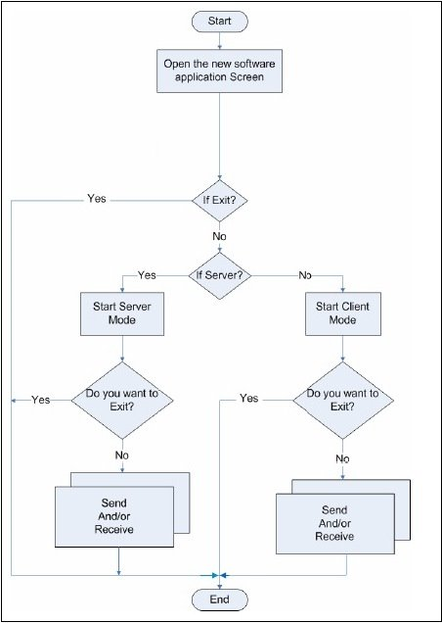
Figure (2) The Proposed Software Application Block Diagram.
4.1 The Implementation
In the implementation side of this software application we will use all the technologies mentioned in the previous chapters. This phase will contain the implementation of the new software application which was programmed using JBluilder 9 Enterprise Edition and Nokia Developer Suite 2.2 to create the application package which is instilled in two Nokia 6600 devices. The icons of the new software application can be seen in the application menu of each device and the user can choose it to start the Bluetooth chat application.
After the user start the application , a message " please select peer " will appear to the user to choose what must u should (server or client ), or can choose "Exit" to exit from the application as shown in figure (3 a & b) .
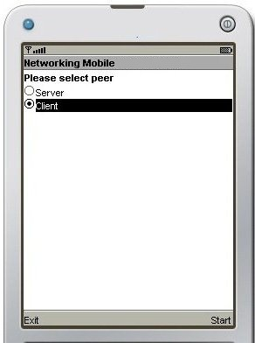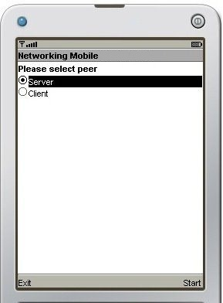
(a) (b)
Figure (3) Screenshot shows the options provide to the user

There are two peer as the following:
1. Server:
If the user select "Server" the system made an alert to the user asking the application wants to send and receive data using the network, if press "Yes" the user can be use network or if press "No" to exit as shown in figure (4)
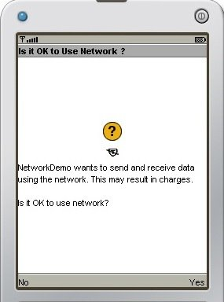
Figure (4) asking the server for permission
When the user gives the permission to the program to use network by press on “yes” bottom, the program will present a message to the user tell him/her that the server is running now and wait a request from other device (Client) to start chat as shown in figure (5).
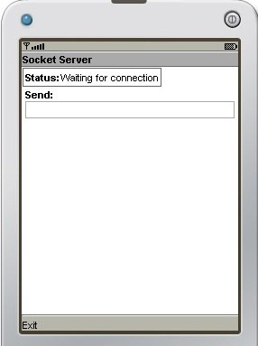
Figure (5) Status: waiting for connection
while the user connected with "client" a message "connection accepted" will appear to the user it means the server allowed to connection, this message represent the Current Status as shown in figure (6).
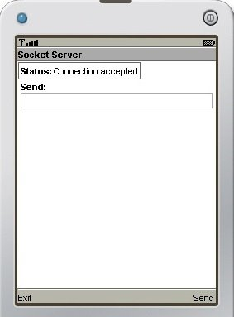
Figure (6) Status: connection accepted
2. Client:
If the user select “Client” the system made an alert to the user asking the user for permission to let the application (network demo) used Network as shown in figure (7)
Figure (7) asking the client for permission
When the user gives the permission to the program to use network by press on “yes” bottom, the program will present a message "connection accepted", to the user show him/her that the client is connected now with the server and start chat, this message represent the Current Status as shown in figure (8).

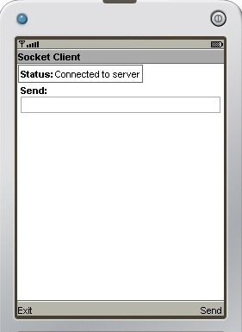
Figure (8) show the connected to Server
Then the chat screen will start automatically in both devices (server and client). As shown in figure (9 a & b) and the two users can enjoy in chat with each other free of charge and the application will not affect or effect of the other activates of the smartphone (like receiving call or SMS) .
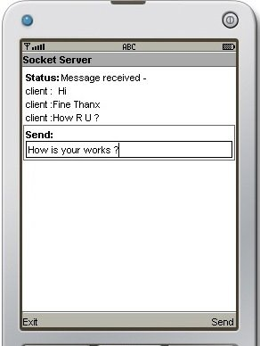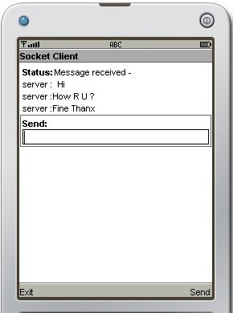
Figure (9) Start Chat between two users
4.2 Performance Operation
During the implement of the Mobile Chatting Software using both smartphone devices we get the following results:
First from the power side that needed to run this software in both devices smoothly and with no troubles we find that it will be run successfully if they have been used according to the Bluetooth range and it can be run as long as the users want, it will cause battery power down if it is run for a long time (over than one hour).
Second during the chatting operation between device “A” and device “B” if there is any interrupt just like a phone call they can obviously continue using the chatting software by sending and receiving messages while answering the phone call by making a voice conversation without any effects on the running of the mobile chat software.
Third the operation of the chatting will slow down the sending and receiving messages during using the same Bluetooth to send or receive any other object in the same time.
Fourth some time when the user search for an active Bluetooth device he get alert message that here is no active device in the range and add new option capable the user to do new search for an active Bluetooth device, this happen when one of the user forget to turn on the Bluetooth or they are far away from each other (out of Bluetooth coverage area).
Fifth this software application cannot receive Arabic messages because Arabic characters used 16-bit (Unicode UCS2) instead 7-bit for English characters and while the receive message procedure deal with English characters (7-bit) the Arabic characters will show different characters. And it needs a sophisticated processing to solve this issue.
Sixth when the users gone out of the Bluetooth range the software application will stop the program and gave the user alert message that he lost the connection with the other device.
5. Conclusions:
In this work we have designed and implement a system that allows mobile device to provide the ability of doing free of charge chatting between two smartphones.
This solution for smartphone devices is dependent upon the capabilities in the programming environment on the devices. MIDP, which is a Java programming environment for mobile phones, provides simple syntaxes support that limits.
The most important points that are concluded throughout the design and the implementations of this software are:-
1. The evaluation shows that the design consumes minimal power from the hardware.
2. This software application has been to be hardware mobile manufactured independent that means it can be run on any type of smartphone support Series 60 and MIDP 2.0.
3. It is free of charge and it can be run successfully even if there is no service provider network for cell phone in the area.
4. The programmer who uses J2ME to create new application does not need to know the tiny detail of the Symbian OS or Series 60 compared with the programmers who uses C++.
References
1. Martyn Mallick, “Mobile and Wireless Design Essentials”, John Wiley & Sons Ltd, 2003.
2. “Mobile and Wireless Application Options”, iAnywhere Solutions, Inc., 2004. (accessed 10-11-2004)
http://www.ianywhere.com/downloads/whitepapers/mobile_and_wireless_application_optionsV2.pdf
3. “A smart client architecture Making the Case for Local Database and Synchronization”. (accessed 20-6-2005)
http://www.devx.com/wireless/Article/11398/1954?pf=true
4. Digia Inc., “Programming for Series 60 Platform and Symbian OS”, John Wiley & Sons Ltd, May 2004.

