Determination of Vanadium(V) by Flow injection and sequential injection analysis
D.N.Taha Khdija Jabar Ali
Chem.dep./Science college/ Babylon university , chem.dep./Edu.for girls college/ Kufa university
dakhilfia @yahoo.com Khdija jabar @gmail.com

Abstract
Two new simple and rapid methods are reported for the accurate and precise spectrophotometric determination of Vanadium (V) using flow injection analysis(FIA) and sequential injection analysis(SIA). The methods are based on the fast oxidation of iodide ion by V(V) in acidic medium to iodine which is determined spectrophotometrically at 353 nm. The methods allow the determination of linear range ( 0.05- 1.50 ) mg /l , ( 0.02 – 4.00) mg /l at a sampling rate of 50 , 60 injections per hour , the detection limits ( 0.02 mg /l , 0.01 mg /l ) for FIA and SIA respectively. Relative standard deviation for( 1 mg / l ) ,n=3 for both methods are found ( 1.1111for FIA and 0.9523 for SIA ). Desperation coefficient is measure for the two methods.
Key word: Vanadium, sequential, determination

Introduction
The increasing demand on process monitoring has led to new analytical systems, which can work during long periods of time with little maintenance and low reagent consumption. Flow injection analysis (FIA) fulfils those requirements and its simplicity However, conventional FIA analysers have been designed as closed and dedicated systems useful to work with very well defined sample compositions[1].
In recent years, the sequential injection analysis (SIA) has become an important analytical technique, mainly for the determination of drugs in pharmaceuticals and for the determination of the environmental contaminants. SIA, developed by Ruzicka and Marshall in 1990 is based on forward, reversed, and stopped flow of the carrier stream and it has been the subject of several studies aimed to establish its theory and particularities . It offers several advantages: the instrumental set-up is very flexible, the components undergo little wear and the hydrodynamic variables can be controlled with high efficiency[2]. The “single-line” technique is based on forward and reverse movement of a piston of syringe pump, which together with amulti-position selection valve enables precise sampling of liquid chemicals into the system and propelling of the sequenced zones to the reactors and detector, Automation, speed of the analysis and low consumption of sample and reagents are the most important features that favour the SIA technique for application in many fields of analysis, primarily by more complicated operations such as sample pre-treatment, derivatization reactions or monitoring of long lasting processes[3,4] Zone penetration and dispersion are finitely controlled as these stacks passes through the holding coil to the reaction coil wherein they undergo a chemical reaction before being forwarded to the detector[5] , Sequential-injection systems enable automation of spectrophotometric reactions with low reagent consumption , this enables reduction of the toxicity and cost of the analytical procedure[6].

Chemicals
All chemicals were analytical-reagent grade, except where otherwise stated; distilled water was used to preparation of all solutions in the experiments. Standard stock solution containing 100 mg l⁻¹ of V(V) was prepared by dissolving 0.0178 g of V₂O₅ in dilute NaOH (0.5 M) solution ( standardized before using ) .Acidify the solution with sulphuric acid and dilute with water in 100 ml volumetric flask..Potassium iodide solution (0.5M) were prepared by dissolving ( 41.5000 g) in distilled water and completed to ( 500 ml) in volumetric flask. sulphric acid (1.5M) was dilute (8.28 ml) of ( 96.50 %) H₂SO₄ (sp.gr 1.840) with distilled water in a (100ml) volumetric flask. Interfering ions solutions ,all the solutions were prepared at the concentration of 100 ppm by dissolving an appropriate amount of each substance in distilled water and completed to 100 ml volumetric flask .
Apparatus
The unit consists of pump, valve (home made), Reaction coil made from glass, I.D=1 mm(home made), Spectronic SC (UV-Vis) with flow injection cell (1 cm) , Recorder( kompensonsograph C1032) and other meters used the balance (satorius,BL 2105) and pH meter ( pH 720 WTW ,Germany ).
FIA unit
The various parameters affecting the unit have been investigated and selected for a final method evaluation, the following results allow the operator to chose different operation conditions.
Chemical parameters
Effect of the potassium iodide concentration
Effect of KI concentration on the peak height( absorbance intensity) was studied at different concentrations from 0.005 to 0.3 mol. l⁻¹. Table (1) and Fig. 1 shows the effect of KI concentration on the peak height of I₂ .The maximum peak height was obtained at 0.15 mol. l⁻¹ KI. So 0.15 mol l⁻¹ KI was chosen for the further work.
Table (1):Effect of the KI concentration on the peak height of I_{2,} V(V)concentration =10ppm,R.C(reaction coil )=150 Cm,[H₃O⁺]=0.1M,sample loop (L₁)= acid loop (L₂)=20 Cm, Flow rate=2.8 ml min ⁻¹
R.S.D.% | S.D | Peak height (mV)* | Con. (M) | No.
7.204 | 1.224 | 17.00 | 0.005 | 1
3.303 | 1.172 | 35.50 | 0.010 | 2
2.249 | 1.154 | 51.33 | 0.050 | 3
0.000 | 0.000 | 72.00 | 0.100 | 4
0.776 | 1.154 | 148.66 | 0.150 | 5
1.732 | 2.309 | 133.33 | 0.200 | 6
0.000 | 0.000 | 116.00 | 0.300 | 7
Peak height average of three times*
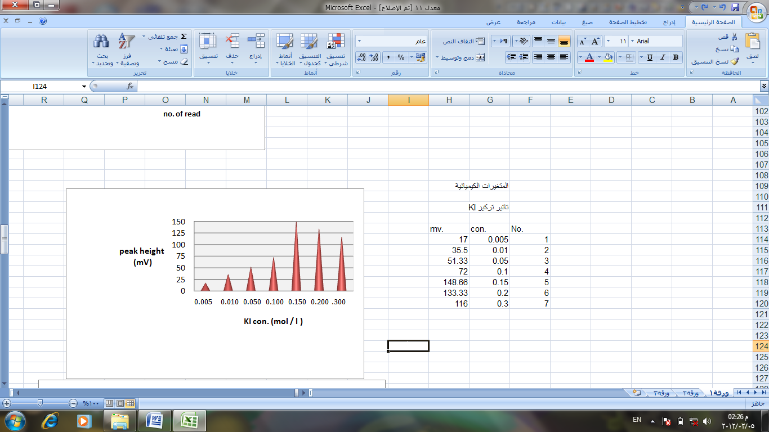

Fig.1: Change the peak height with KI concentration

Effect of the acid concentration
The sulfuric acid concentration was varied in the range 0.001–0.75 mol l⁻¹ in order to maximize the peak height. Table(2) and Fig. 2 shows the effect of sulfuric acid concentration on the peak height of the released iodine. The maximum peak height was obtained with 0.5 mol l⁻¹ sulfuric acid. Therefore, the 0.5 mol l⁻¹ sulfuric acid was chosen for further work.
Table(2):Effect of the sulfuric acid concentration on the peak height of I_{2.}
V(V)concentration =10ppm,R.C(reaction coil )=150 Cm,[KI]=0.1 5M,sample loop (L₁)= acid loop (L₂)=20 Cm, Flow rate=2.8 ml min ⁻¹

R.S.D.% | S.D | Peak height (mV)* | Con. | No.
6.250 | 1.000 | 16.00 | 0.001 | 1
2.986 | 1.154 | 38.66 | 0.005 | 2
1.946 | 1.154 | 59.33 | 0.010 | 3
1.946 | 2.309 | 118.66 | 0.050 | 4
0.776 | 1.154 | 148.66 | 0.100 | 5
0.000 | 0.000 | 228.00 | 0.500 | 6
0.000 | 0.000 | 152.00 | 0.750 | 7
Peak height average of three times*
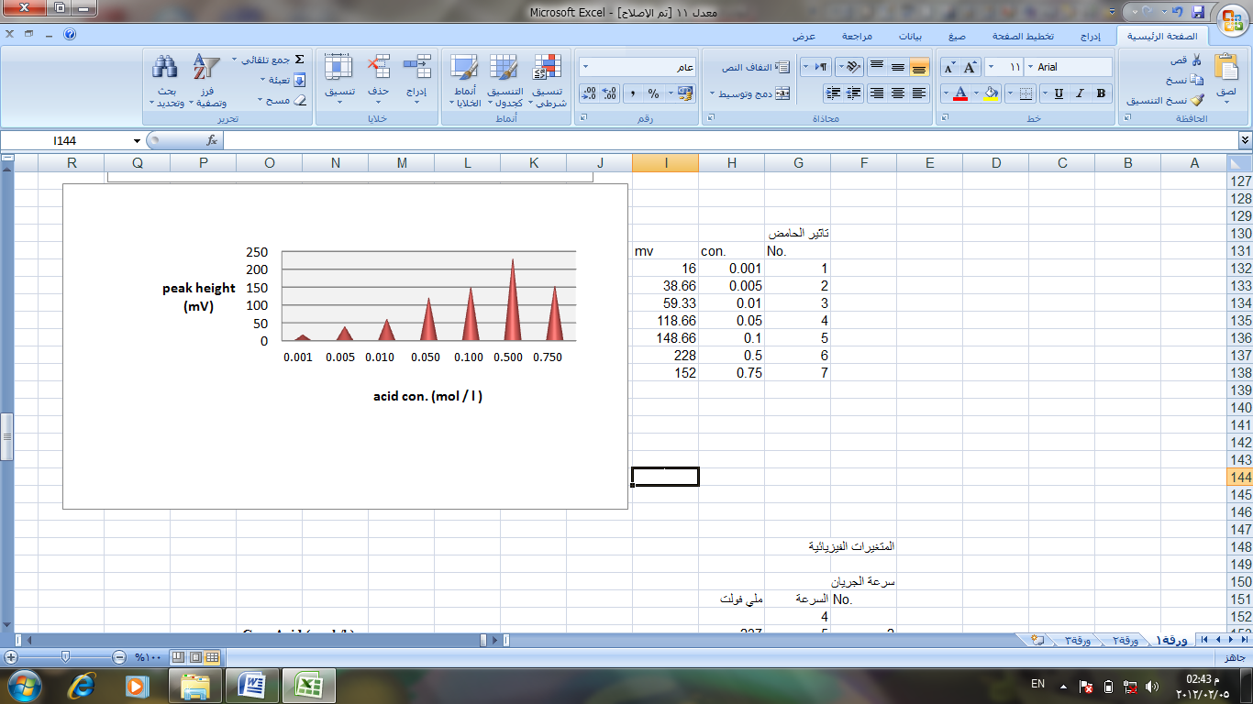
5

Fig.2: Change the peak height with acid concentration
physical parameters
Effect of the flow rate
The effect of the flow rate on the peak height was studied in the range of 0.5 -/3.9 ml min⁻¹.as in table(3) and Fig. 3 .Lower flow rate cause doublet peaks, possibly due to the fact that the carrier solution did not sufficiently disperse into the middle of the sample zone[7]. On other hand the peak height decreased with the increasing of the flow rate[8] . The decrease in sensitivity at higher flow rates could be mainly due to a shortage of time for complete oxidation of the reaction to form a product zone[9] . Taking into consideration of the stability of the pump, peak shape and sampling time, the flow rate of the carrier solution was adjusted to 2.5 ml min⁻¹. For subsequent measurement due to highest sensitivity. A sample throughout 50 sample h⁻¹ was easily achieved by using the above flow rate.

Table(3):Effect of the flow rate on the peak height of I₂
V(V)concentration =10ppm,R.C(reaction coil )=150 Cm,[KI]=0.1 5M,sample loop (L₁)= acid loop (L₂)=20 Cm, [H₃O⁺]=0.5M

R.S.D.% | S.D | Notes | Peak height (mV)* | Flow rate ml/min | No.
0.000 | 0.000 | Double peak | 356.00 | 0.5 | 1
0.561 | 2.000 | Double peak | 344.00 | 1.0 | 2
0.000 | 0.000 | Double peak | 236.00 | 1.4 | 3
1.923 | 4.000 | Double peak | 208.00 | 2.0 | 4
0.516 | 1.224 | - | 237.00 | 2.5 | 5
0.000 | 0.000 | - | 228.00 | 2.8 | 6
0.000 | 0.000 | - | 212.0 | 3.0 | 7
peak height average of three times *
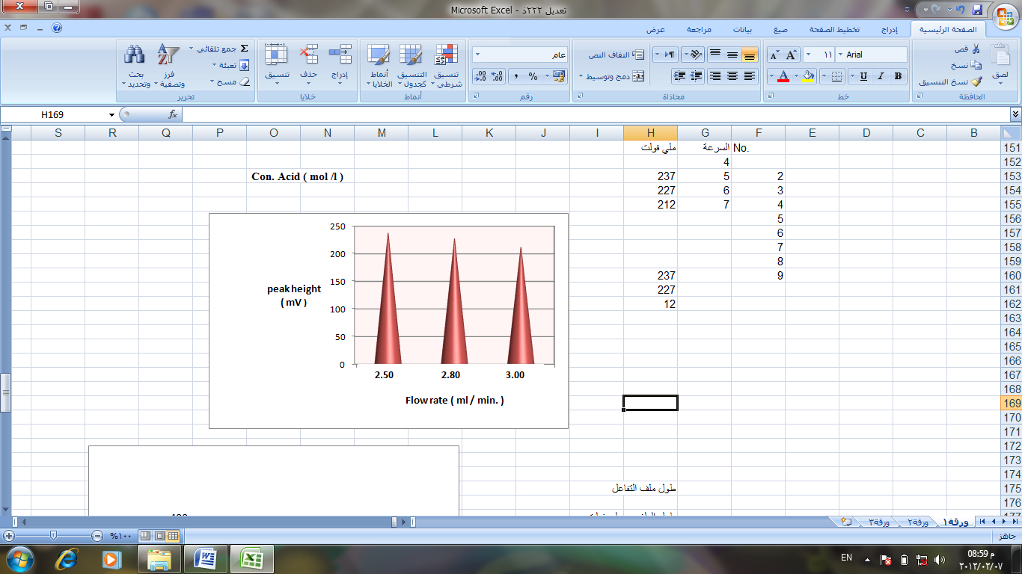

Fig.3: Change the peak height with flow rate
Effect of the reaction coil length
The absorbance as the peak height as table(4) and Fig. 4 shows effect the reaction coil length on the peak height in the range (50 – 200) cm .when the reaction coil length exceeded 100 cm the absorbance decreased due to the dispersion [10]it was seen the suitable reaction coil length 100 cm ,since it provided the greatest sensitivity.

Table (4) :Effect of the reaction coil length on the peak height of I₂.
V(V)concentration =10ppm,flow rate (2.5 ml min. ⁻¹), [H₃O⁺]=0.5M ,[KI]=0.15M,sample loop (L₁)= acid loop (L₂)=20 Cm,

R.S.D.% | S.D | Peak height (mV)* | Reaction coil length(Cm) | No.
1.595 | 4.690 | 294.00 | 50 | 1
0.707 | 2.828 | 400.00 | 100 | 2
0.516 | 1.224 | 237.00 | 150 | 3
0.000 | 0.000 | 172.00 | 200 | 4
Peak height average of three times *

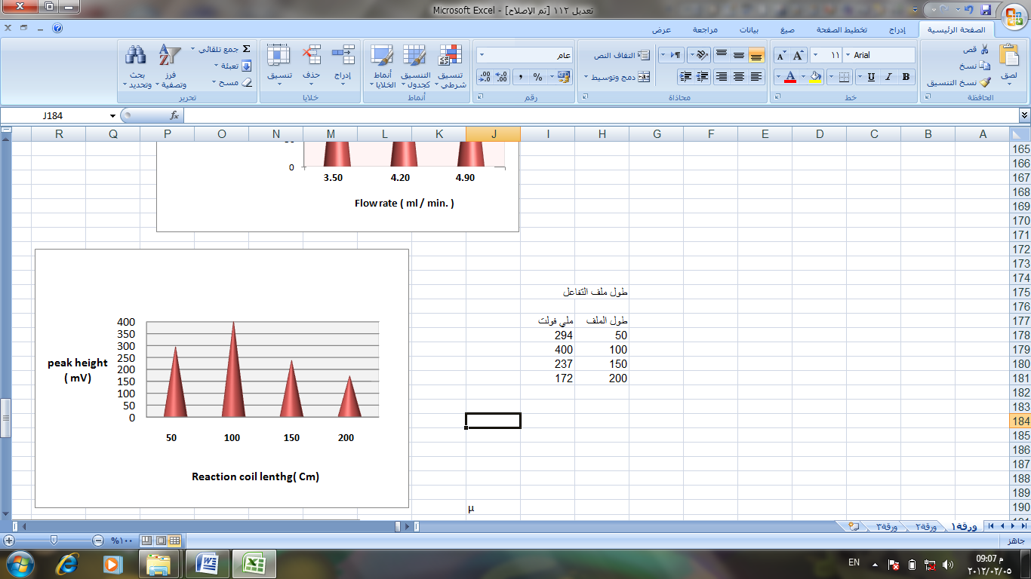

Fig.4:Change the peak height with the reaction coil length
Effect of the acid volume
The influence of the various acid volume(117 – 314) µl on the absorbance of the released iodine as (peak height) was examined . The acid volume that exhibited the greatest peak height was found to be 157 µl and was chosen as the optimum as in Fig. 5 and table(5).

Table (5) :Effect of the acid volume on the peak height of I₂.
V(V)concentration =10ppm,flow rate (2.5 ml min. ⁻¹), [H₃O⁺]=0.5M ,[KI]=0.15M,sample loop (L₁)= 20 Cm and R.c= 100 cm.
R.S.D.% | S.D | Peak height (mV)* | acid volume  ( µl) | No.
0.000 | 0.000 | 360.00 | 117 | 1
0.707 | 2.828 | 400.00 | 157 | 2
1.086 | 4.000 | 368.00 | 235 | 3
0.000 | 0.000 | 362.00 | 314 | 4
* peak height average of three times
6
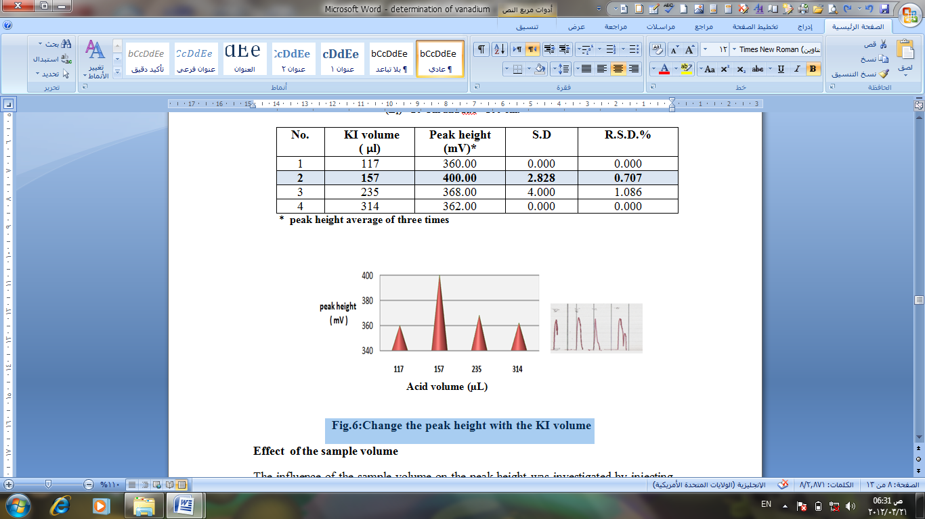

Fig.5:Change the peak height with the acid volume
Effect of the sample volume
The influence of the sample volume on the peak height was investigated by injecting different volumes (117 -392) µl of V(V) standard solutions. The peak height increased to the maximum at 235 µl after that volume the peak height decreased , so that 235 µl was chosen for further work as table(6) and Fig.6.

Table 6: Effect of the volume sample on the peak height of I_{2.}
V(V)concentration =10ppm,flow rate (2.5 ml min. ⁻¹), [H₃O⁺]=0.5M ,[KI]=0.15M, acid loop (L₂)= 20 Cm and R.c= 100 cm.
R.S.D.% | S.D | Peak height (mV)* | Sample volume  ( µl) | No.
8.069 | 18.479 | 229.00 | 117 | 1
0.707 | 2.828 | 400.0 | 157 | 2
0.000 | 0.000 | 412.00 | 235 | 3
0.671 | 2.345 | 349.00 | 314 | 4
5.357 | 12.000 | 224.00 | 392 | 5
Peak height average of three times *

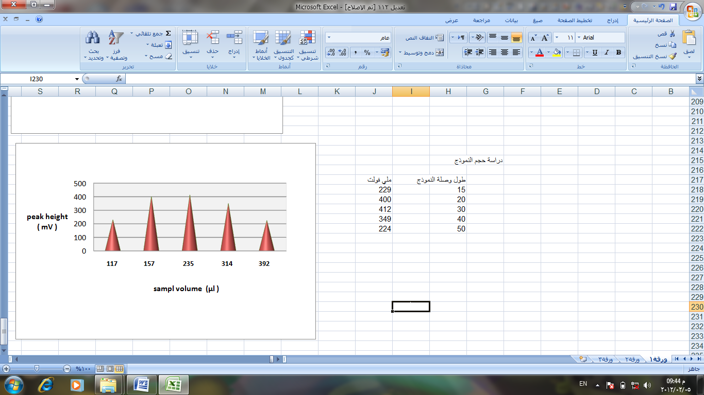

Fig .6 :Change the peak height with sample volume

Calibration curve in FIA method
A series of V(V) ion solutions of the range (0.02-10 ) mg l⁻¹ were prepared from stock solutions and under the optimum conditions of the reagent and manifold variables ,the result show in table(7)and fig.7 .The calibration curve is linear in the range of 0.05 -1.50 mg l⁻¹. The detection limit is(0.02 ) mg l⁻¹.
Table 7: Effect of the concentration V(V) ion with peak height
R.S.D.% | S.D | peak height *(mV) | (ppm)Con. | No.
2.3713 | 0.2885 | 12.160 | 0.05 | 1
0.0000 | 0.0000 | 40.000 | 0.20 | 2
1.3888 | 1.0000 | 72.000 | 0.40 | 3
0.3717 | 0.5000 | 134.400 | 0.70 | 4
1.1111 | 2.0000 | 180.000 | 1.00 | 5
0.4545 | 1.0000 | 220.000 | 1.20 | 6
0.71428 | 2.0000 | 280.000 | 1.50 | 7
peak height average of three times *

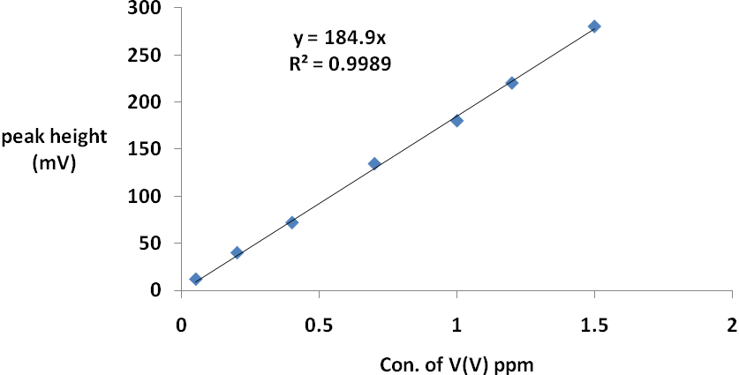
Fig.7: calibration curve of V(V) ion in FIA method

SIA unite
Comparison between SIA and FIA units using the same conditions.

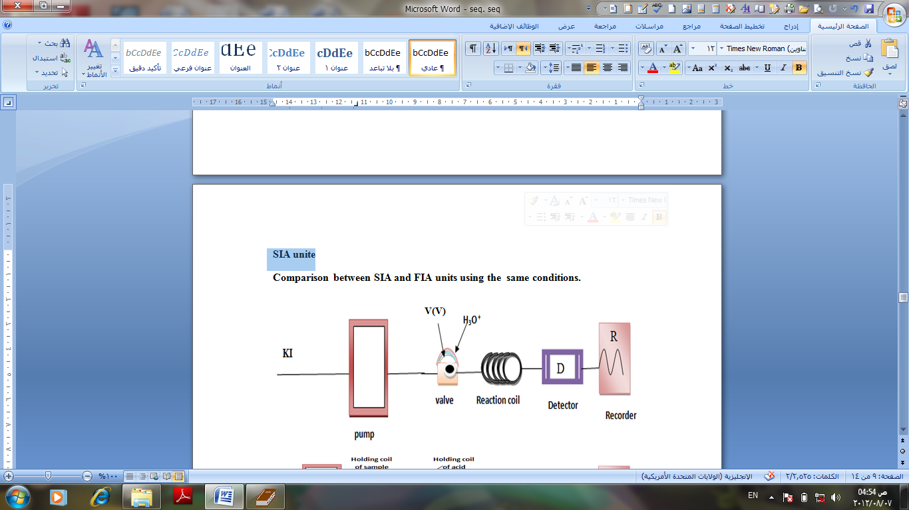

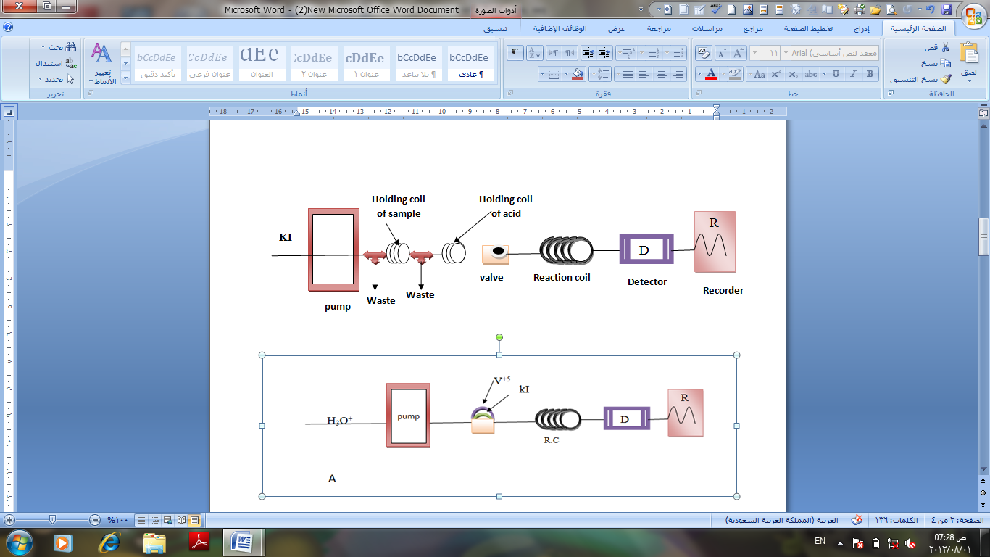
Fig.(8 ) : FIA unite

Fig.( 9 ) : SIA unite

Calibration curve in SIA method
The calibration curve is linear in the range of 0.02 - 4 mg l⁻¹. The detection limit is(0.01 ) mg l⁻¹.The result show in table (8) and fig.10.
Table 8: Effect of the concentration V(V) ion with peak height
R.S.D.% | S.D | peak height *(mV) | (ppm)Con. | No.
3.4482 | 1.0000 | 29.000 | 0.02 | 1
2.9349 | 1.1544 | 39.333 | 0.05 | 2
0.9510 | 1.1546 | 121.333 | 0.50 | 3
0.9523 | 2.0000 | 210.000 | 1.00 | 4
0.5570 | 2.3452 | 420.666 | 2.00 | 5
0.2881 | 1.7320 | 601.000 | 3.00 | 6
0.2557 | 2.0000 | 782.000 | 4.00 | 7
*peak height average of three times
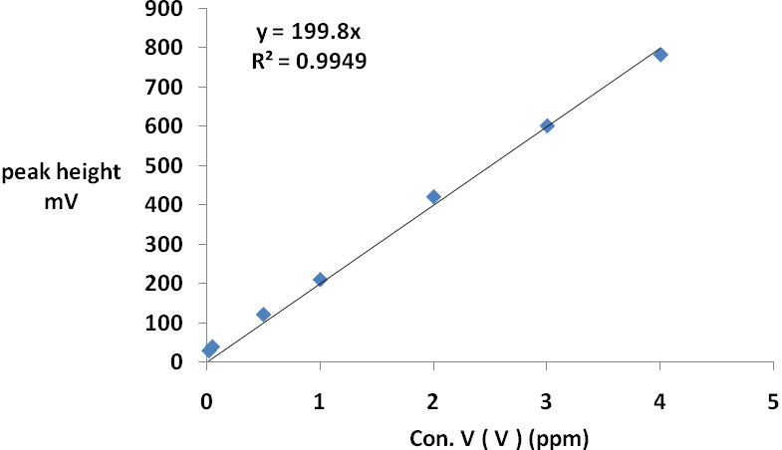

Fig.10: calibration curve of V(V) ion in SI method
Determination of Desperation
To measure the dispersion value in different sample zones of (0.5 and 1 ppm) vanadium ion, two experiments were carried out .
In the first experiment after mixing of reactants and form iodine that passes through manifold unit giving continuous response of constant concentration for vanadium ion; this indicates non-existence of dispersion effect by convection or diffusion[11-13].This measurement represents (H_{o}).While the second experiment includes injecting different concentration of (0.5 and 1 ppm)V(V) ion.The obtained value from this experiment represents intensity response for sample injected(H_{max}) as shown in fig.(11) and fig. (12). The equation used to calculate dispersion (D) is: $D=\frac{H_{o}}{H_{\text{max}}}$
As in table (9) and table ( 10), these values fall in limit state of dispersion.
Table 9: Determination of desperation of V(V)ion in FIA method
Vanadium ion concentration (ppm) | Response in (mV) |  | Dispersion (D)  $$D=\frac{H_{o}}{H_{\text{max}}}$$
Vanadium ion concentration (ppm) | H_{o} (mV) | H_{max} (mV) | Dispersion (D)  $$D=\frac{H_{o}}{H_{\text{max}}}$$
0.50 | 124.00 | 92.00 | 1.3478
1.00 | 268.00 | 180.00 | 1.4888

Table 10: Determination of desperation of V(V)ion in SI method
Vanadium ion concentration (ppm) | Response in (mV) |  | Dispersion (D)  $$D=\frac{H_{o}}{H_{\text{max}}}$$
Vanadium ion concentration (ppm) | H_{o} (mV) | H_{max} (mV) | Dispersion (D)  $$D=\frac{H_{o}}{H_{\text{max}}}$$
0.50 | 124.00 | 121.333 | 1.0219
1.00 | 268.00 | 210.000 | 1.2761

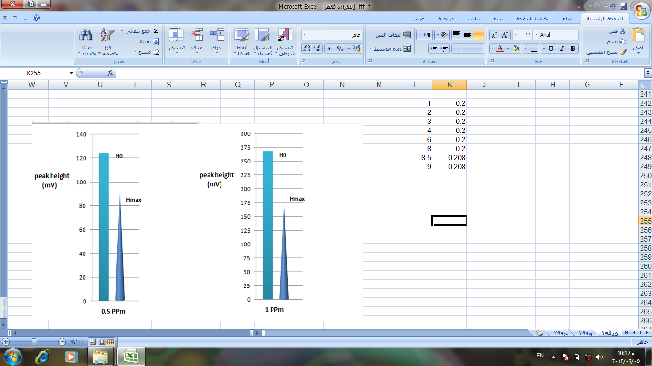

Fig. 11 : Desperation of determination V(V)ion in FIA method
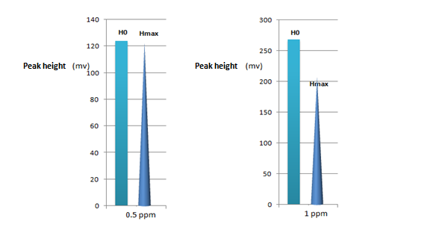

Fig. 12 : Desperation of determination V(V)ion in

SIA method

Comparison between the two methods
The two methods are use for the determination of V(V) as in table 11.

Table 11: Optical characteristics, precision and accuracy of the spectrophotometric determination of vanadium with FIA and SIA method.

Optical characteristics | FIA method | SIA method
Concentration linearity range(mg/ l ) | 0.05 – 1.50 | 0.02 – 4.00
λmax (nm) | 353 | 353
Detection limit (_mg/l) | 0.02 | 0.01
Slope | 184.9 | 199.8
Correlation coefficient | 0.9989 | 0.9949
Relative standard deviation (%),Determination for( 1 mg / l ) ,n=3. | 1.1111 | 0.9523
Desperation coefficient (average of two concentration (0.5 and 1 ) mg /l ) | 1.4183 | 1.1490
sampling rate ( sample/ h) | 50 | 60

References
1-M. Baeza, J. Bartrol, J. Alonso., Talanta 68 [2005] 245–252.
2-Dalibor Sat insky, Petr Solich, Petr Chocholous, Rolf Karli cek, Analytica Chimica Acta ,499 [2003] 205–214.
3-Petr Chocholous, Dalibor Satinsky , Radek Sladkovsky , Marie Pospis ilova, Petr Solich, Talanta, 77 [2008] 566–570.
4-Petr Chocholous, Dalibor Sat ınsky, Petr Solich , Talanta 70 [2006] 408–413.
5-J.F. van Staden, L.V. Mulaudzi, R.I. Stefan , Talanta 64 [2004] 1196–1202.
6-Alberto Chisvert , Jose-Vicente Izquierdo, Amparo Salvador, Anal Bioanal Chem, 374[2002],963–967
7- P. Rumori and V. Cerdà, Analytica Chimica Acta, 486 [2003], 227–235.
8- A. Asan, I. Isildak , M. Andac and F. Yilmaz , Talanta , 60 [2003], 861-/866.
9- Z. O. Tesfaldet, J. F. van Staden, R. I. Stefan,,Talanta , 64 [2004] ,1213–1219.
10- G. Zhengjun , Z. Xinshen, C. Guohe and X. Xinfeng, Talanta, 66 [2005],1012–1017.
11-D.Spas Kolev and D.Ian Mckelve,"Advances in Flow Injection analysis and related techniques", First edition, 54 [2008] , p.p 81-83.
12-I.M.A.Shakir,D.N.Taha and R. S. Khalaf,J.of Babylon university,4[2005],239-250.
13-D.N.Taha and L.A. AL- Nakash,J.of Thykar university[2010]101-109.

