Analysis of Troposphere Carbon Dioxide in IRAQ from Atmosphere Infrared Sounder (AIRS) data: 2010-2011
Jasim Mohammed Rajab Hazim Saleh Ahmed
Mosul University, College of Science, Department of Physics
Hussein Abdelwahab Mossa
The University of Mustansiriah, College of Education, Physics Department

ABSTRACT:
As the dominant anthropogenic greenhouse gas, Carbon Dioxide (CO₂) is the most prominent Greenhouse gas in Earth's atmosphere and plays a key role in earth's climate. It’s resulting more than 50% of the global warming when all greenhouse gases (excepting water vapor) are added together. Since the dawn of the Industrial Revolution, its concentrations increased over 110 ppmv. The troposphere CO₂ have been studied employing Atmosphere Infrared Sounder (AIRS), onboard NASA's Aqua Satellite, and data of CO₂ emission in Iraq during the period 2010 – 2011. The analysis for five dispersed stations shows the seasonal variation in the CO₂ fluctuated considerably observed between spring and autumn seasons. The mean and the standard deviation of monthly CO₂ was (391.77±4.55 ppm) for the entire period. The CO₂ in 2011 values was higher than its values in 2010 at all stations throughout the period. The highest value that occurred in this period was on March at Baghdad (396.32 ppm) and the lowest value was in September at Basra (387.22 ppm). Elevation in CO₂ values can be observed throughout the year over the congested urban and Industrial area. The monthly CO₂ maps for study area were obtained from the NASA-operated GIOVANNI portal (http://disc.sci.gsfc.nasa.gov/giovanni). The AIRS data and the Satellite measurements are able to measure the increase of the troposphere CO₂ concentrations over different regions.
Keywords- CO₂, AIRS, AMSU, Iraq
INTRODUCTION
Many gases occur naturally in the atmosphere while others are synthetic. The Carbon dioxide (CO₂) is the dominant anthropogenic greenhouse gas, represents an important component of climate change, and occurs naturally through the terrestrial biosphere and the ocean. Its concentrations increased over 110 ppmv since the dawn of the Industrial Revolution due to burning of fossil fuels and deforestation. Our reliance on fossil fuels has been firmly solidified and global population has increased, so emissions of these gases have risen. CO₂ resulting more than 50% of the global warming when all greenhouse gases (excepting water vapor) are added together (Jasim et al., 2011 a). Anthropogenic pollutants are emitted mainly from stationary sources, such as industrial or urban areas, or from specific locations are known, such as roads (Drori et al., 2012). It is a toxic in higher concentrations: 1% (10,000 ppm) will make some people feel drowsy, 7% to 10% cause dizziness, headache, visual and hearing dysfunction and unconsciousness within a few minutes to an hour (Shakhashiri, 2008). CO₂ contributes substantially to the greenhouse effect because it is easily excited by IR radiation. Thus, IR radiation can be absorbed and emitted during rotational transitions, which can be produced by collision energy transfer (Hill, 2004).
Across the Middle East region, people have always contended with excessive heat, shortage of rainfall, dust storms and harsh geography. In this century, climate change, industrial development, political upheaval, and war have left a legacy of environmental impacts and health problems. Iraq, it is considered one of Middle East country, industrialization; urbanization and rapid traffic growth have contributed significantly to economic growth. Emissions of heavy pollution are being created from major industrial zones, office buildings, manufacturing facilities, a dramatic increase in the number of residences, and increases in the number of motor vehicles (Metz, 1993).
It is very important to observe and document changes in the forcing terms such as gases, in order to evaluate and understand their effect of climate change, and to achieve more reliable longer range projections. The abundances of the atmosphere gases, over the past three decades, were obtained from a lot of sources such as Balloons, airplane and sparsely distributed measurement sites. Observations from space by satellite remote sensing only allows for such measurements in order to make over a reasonably short time period, and has very good global coverage increase our ability to access the climate change and the impact of human activities on the chemical composition of the atmosphere (Jasim et al., 2012). In addition, the free download satellite data provided by the Atmospheric Infrared Sounder (AIRS) instrument make it as a useful space device for monitoring the Earth’s atmosphere. Satellite measurements have been used in several studies which have provided some evidence for the transport or traces of atmospheric components from the surface to the upper atmosphere (Kar et al., 2004; Park et al., 2004 and reference therein; Li et al., 2005; Randel and Park, 2006; Xiong et al., 2009).
The AIRS is one of six instruments flying onboard NASA's Aqua satellite, launched on May 4, 2002. The instrument is designed to support climate research and improve weather forecasting. It includes 2378 infrared spectral channels provides spectral coverage in the 3.74–4.61μm, 6.20–8.22-μm, and 8.8–15.4-μm infrared wavebands at a nominal spectral resolution of λ∕∆λ=1200. Providing information for several greenhouse gases is one goal of the AIRS instrument, new Insights into Weather and Climate for the 21st Century, and study the water and energy cycle (Chahine et al., 2006; Jasim et al., 2011 b).
In this study the analysis of troposphere CO₂ was investigated for the period 2010 -2011 in Iraq using Level 3 monthly product (AIRX3C2M) Version 5 AIRS data. Results from the analysis of the retrieved mid-tropospheric CO₂ profile from the AIRS and AMSU instrument employed to evaluate and analyze the midtropospheric CO2 distribution over study area. The CO₂ data analyzed for over six stations; Baghdad (33.20°N, 44.20°E), Basra (30.30°N, 47.50°E), Mosul (36.2°N, 43.06°E), Flughafen 2 (32.44°N, 39.35°E), and Radif Al Khafi Hwy strip (31.55°N, 42.08°E), in study period. To better assess the impacts and distribution of CO₂ over Iraq for the year 2011, the spatial correlation for CO₂ has been analyzed using monthly average Level-3 AIRS data obtained from the NASA-operated GIOVANNI portal (http://disc.sci.gsfc.nasa.gov/giovanni).

STUDY ARIA
The study area is Iraq, a country in south-western Asia. It lies in the western part of Asia and occupies mostly the Mesopotamian Plain, located, between 29° and 38° N latitudes , and 39° and 49° E longitudes (a small area lies west of 39°). Iraq borders Turkey to the north, Syria to the northwest, Kuwait and Saudi Arabia to the south, Iran to the east, and Jordan to the southwest.

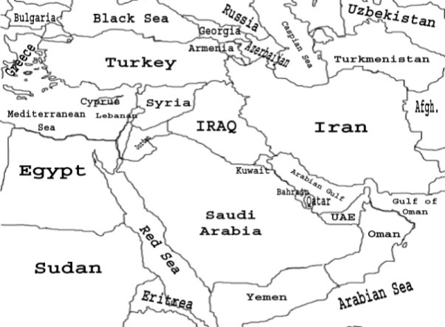
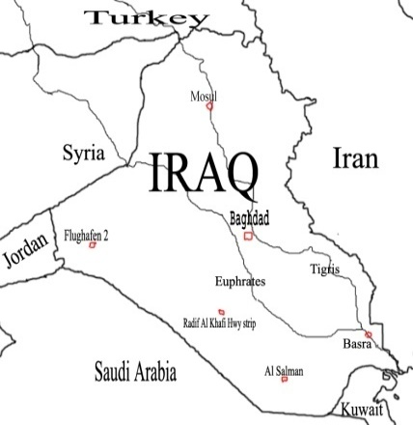

Figure 1. The geographical feature of study area
An area (Fig. 1) comprises of 437,072 square kilometres (168,754 sq mi); it is the 58th-largest country in the world. Country divided into four major regions: highlands in north and northeast; alluvial plain in central and southeast sections; and desert in west and southwest; rolling upland between upper Euphrates and Tigris rivers. These two major rivers, run through the centre of Iraq, flowing from northwest to southeast are fertile alluvial plains. The north of the country is mostly composed of mountains; the highest point being at 3,611 m (11,847 ft). Iraq has a narrow section of coastline measuring 58 km (36 mi) on the northern Arab Gulf (Metz, H. C., 1993).
MATERIALS AND METHODS
This research has been carried out for two years data from January 2010 to December 2011. In order to evaluate and analysis the troposphere CO₂ distribution over the study area, we selected five stations dispersed across Iraq; Baghdad, Mosul, Basra, Flughafen 2, and Radif Al Khafi Hwy strip. Results from the analysis of the retrieved mid-tropospheric CO₂ profile obtained from AIRS ascending (AIRX3C2M) Level-3 data, are utilized to investigate the monthly variability of Troposphere CO₂ in Iraq. Generally, twenty four monthly L3 ascending granules were downloading to obtain the desired output. Using AIRS website the AIRX3C2M product's files data, including the corresponding location and time along the satellite track in a HDF (Hierarchical Data Format) format on monthly basis, extracted from the Satellite and arrange in table using MS Excel.
To better assess the impacts and distribution of CO₂ over Iraq for the year 2011, the spatial correlation for CO₂ has been analyzed using monthly average Level-3 AIRS data obtained from the NASA-operated GIOVANNI portal (http://disc.sci.gsfc.nasa.gov/giovanni). The CO₂ data were obtained from 2º×2.5º (latitude × longitude) spatial resolution ascending orbits.
RESULTS
Fig 2 shows the monthly CO₂ from 2010 – 2011 for five stations; Baghdad, Basra, Mosul, Flughafen 2, and Radif Al Khafi Hwy strip, respectively. The mean and the standard deviation of monthly carbon dioxide was (391.77±4.55 ppm) for the entire period. The CO₂ experience various seasonal fluctuations depend on weather conditions and topography. There is a progressive increase in the CO₂ values with distinct growth rate variations observed during the 2010-2011 period. An increasing, long-term trend in CO₂ can be attributed to the human activity; combustion of fossil fuels and a significant net flux of CO₂ to the atmosphere as a consequence of land use changes, such as biomass burning. Year-to-year variations in fossil-fuel-related emissions are relatively increased as a result of various sources, including motor vehicles and other industrial sources. The CO₂ in 2011 values was higher than its values in 2010 at all stations throughout the period. Looking carefully at Figure 2, two much localized areas stand out against its background on July 2010: Mosul and Flughafen 2. They reveal enhanced in CO₂ values, due to the extensive biomass burning from the forest fire that have occurred on July in the province of Dohuk. In addition, the slight contribution from the northern of Mediterranean basin bring by northwesterly wind.
Fig. 3 illustrated the monthly CO₂ for five stations together from January 2010 to December 2011 respectively, the nominal peak of AIRS sensitivity and the magnitude of the seasonal variations in troposphere CO₂. The CO₂ experience various seasonal fluctuations depend on weather conditions. The seasonal variation in the troposphere CO₂ fluctuated considerably observed between spring and autumn seasons. A more particular examination shows subtle differences in the CO₂ spatial patterns for each season, with higher values for CO₂ in the spring (at central region) than in the autumn season (at southwest region). Seasonal variations are visible, but none are as pronounced or regular during the study period. The highest value that occurred in this period was on March at Baghdad (396.32 ppm) and the lowest value was in September at Basra (387.22 ppm).
This seasonal dichotomy results are primarily from the extensive sources are evident in the central, southern and west regions due to increased human activity through the burning of agricultural waste after harvest season, which coincides with the end of spring. In addition, the subsequent plumes contributed to CO₂ concentrations are from Mediterranean basin bring by northwesterly wide at the same time (Drori et al., 2012). In contrast, the anthropogenic sources have very small variability during late summer. The wind of 120 days" blows almost daily during the months of June through September and has great vertical motion over a large horizontal area, which can reduce the CO₂ concentrations (Anderson, 2004).
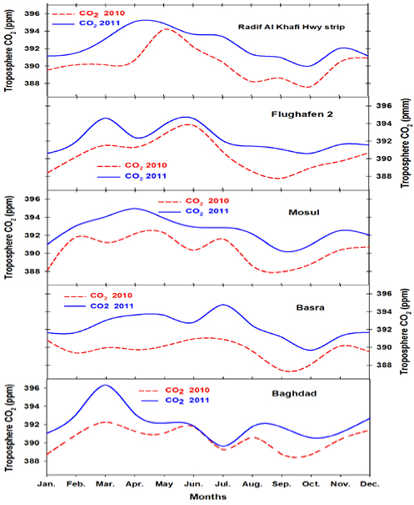
Figure 2. The Monthly troposphere CO₂ from 2010 - 2011 for five stations; Baghdad, Basra, Mosul, Flughafen 2, and Radif Al Khafi Hwy strip, respectively
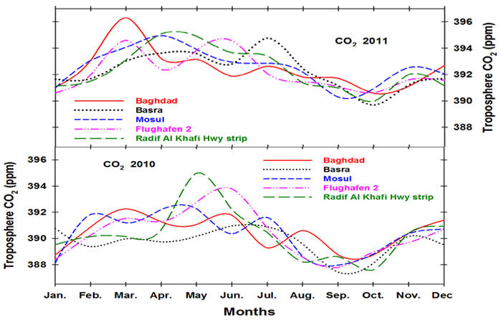
Figure 3. The monthly CO₂ for five stations together from January 2010 to December 2011 respectively.
Fig 4, a. illustrated AIRS monthly coverage retrieved troposphere CO₂ for the winter and spring seasons [December - May] 2011. Observed the gradual decline of CO₂ values at the onset of winter season, especially at western region as a result of the rain and southerly winds (called Kasus in Arabic) slowly increase in intensity as the front approaches and may reach gale force before the frontal passage, this event occur as frequently as two to three times per month between December and early March (Vishkaee et al., 2012). In February, the CO₂ values increase slightly to reach its maximum in spring, especially at central region due to the increased human activity in congested cities with many CO₂ sources. The highest value that occurred in this period was on March at Baghdad (396.32 ppm), and the lowest value was in January (390 ppm).
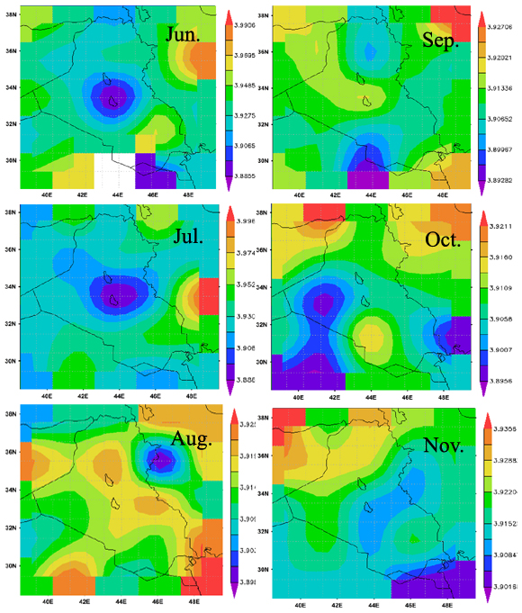
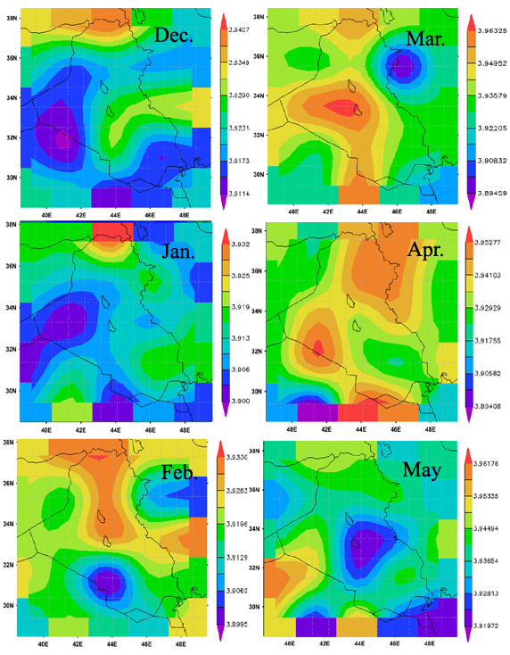
- (b)
Figure 4. The AIRS monthly coverage retrieved CO₂, (a) for winter and spring seasons [December - May] and (b) for summer and autumn seasons [June - November] in Iraq for the year 2011.
Fig 4, b. shows the distribution of monthly coverage CO₂ for summer and autumn seasons (June - November) 2011.. Differences in the CO₂ spatial patterns for each of the peak months, fluctuations are visible for most geographic regions for different months, but none is regular during these six months. Observed slight contribution during summer months from Turkey coincide with the impact of the northwesterly wind. The highest values of CO₂ were over western region during June (394.55 ppm, Flughafen 2). The lowest value of CO₂ was over Radif Al Khafi Hwy strip on October (390.72 ppm).
Overall, the figures 2, 3 and 4 a, b shows the CO₂ values in the north and central are higher than in the rest of areas throughout the year except the month of May with a explicit increases on the south area in August and October due to human activity and abundance sources of CO₂ at these area. . In addition, elevation in CO₂ values can be observed throughout the year over the congested urban and Industrial area. The CO₂ in 2011 values was higher than its values in 2010 at all stations throughout the period. In central (e.g., Baghdad), the CO₂ values were fewer variations than the rest of the areas throughout the year due to its geographical position, densely populated areas and high traffic, large-scale industrial and commercial activities.

CONCLUSION
This paper represents the attempt to quantify monthly distribution of troposphere CO₂ in Iraq based on satellite (AIRS) data. As demonstrated here, AIRS’ monthly views of troposphere carbon dioxide across the study area enable detailed analyses of both the spatial and temporal variations in the visualization of subsequent transport and emissions. We have just begun to investigate the wealth of information for the 2010 - 2011. The mean and the standard deviation of monthly CO₂ was (391.77±4.55 ppm) for the entire period. There is a progressive increase in the CO₂ values with distinct growth rate variations observed during the 2010-2011 period. The CO₂ in 2011 values was higher than its values in 2010 at all stations throughout the period. The CO₂ experience various seasonal fluctuations depend on weather conditions and topography. The highest value that occurred in this period was on March at Baghdad (396.32 ppm) and the lowest value was in September at Basra (387.22 ppm).
The CO₂ values in the north and central are higher than in the rest of areas throughout the year except the month of May with a explicit increases on the south area in August and October due to human activity and abundance sources of CO₂ at these area. . Elevation in CO₂ values can be observed throughout the year over the congested urban and Industrial area. The AIRS data and the Satellite measurements are able to measure the increase of the troposphere CO₂ concentrations over different regions.
ACKNOWLEDGMENT
The authors gratefully acknowledge the National Aeronautics and Space Administration (NASA) Goddard Earth Sciences Data Information and Services Center (DISC) for the provision of the AIRS data and images used in this paper, were acquired using GES-DISC interactive online visualization and analysis infrastructure (Giovanni).
REFERENCES
- Anderson, J. W., (2004). An analysis of a dust storm impacting operation Iraqi freedom, 25-27 March 2003. Naval Postgraduate School, Monterey, CA 93943-5000, California.
- Chahine, M. T., Thomas, S. P., Hartmut, H. A., Robert, A., Christopher, B., John, B., Luke, C., Murty, D., Eric, J. F., Mitch, G., Catherine, G., Stephanie, G., Scott, H., Fredrick, W. I., Ramesh, K., Eugenia, K., Bjorn, H. L., Sung-Yung, L., John, L. M., Mcmillan, W.W., Larry, M., Edward, O.T., Henry, R., Philip, R., William, S. L.,David, S., Strow, L. L., Joel, S., David, T., Walter, W., and Lihang, Z., (2006). AIRS Improving Weather Forecasting and Providing New Data on Greenhouse Gases. Am. Meteorol. Soc., 87, p. 911 –926.
- Drori, R., Dayan, U., Edwards, D. P., Emmons, L. K., and Erlick, C., (2012). Attributing and quantifying carbon monoxide sources affecting the Eastern Mediterranean: a combined satellite, modelling, and synoptic analysis study. Atmos. Chem. Phys., 12, p1067–1082.
- Hill, M. K. (2004). Understanding Environmental Pollution. New York, Cambridge University.
- Jasim Mohammed Rajab, M. Z. MatJafri, H. S. Lim and K. Abdullah, (2011a). Investigation on the interannual variability of Troposphere Carbon Dioxide from (AIRS) in Peninsular Malaysia: 2003-2009. 2011 IEEE Student conference on Research and Development (IEEE SCOReD 2011). 19th -20th, December, 2011. Putarjaya, Malaysia.
- Jasim, M. Rajab, Tan, K.C., Lim, H.S. and Mat Jafri, M.Z., (2011b). Investigation on the Carbon Monoxide Pollution over Peninsular Malaysia Caused By Indonesia Forest Fires from AIRS Daily Measurement, Air Pollution/Book 1. Rijeka, Croatia, INTECH, p. 115–136.
- Jasim, M. Rajab, Mat Jafri, M.Z., Lim, H.S., and Abdullah, K., (2012). Regression analysis in modelling of air surface temperature and factors affecting its value in Peninsular Malaysia. Optical Engineering, 51(10), 101702.
- Kar, J., Bremer, H., Drummond, J.R., Rochon, Y.J., Jones, D.B.A., Nichitiu, F., Zou, J., Liu, J., Gille, J.C., Edwards, D.P., Deeter, M.N., Francis, G., Ziskin, D. and Warner, J. (2004). Evidence of Vertical Transport of Carbon Monoxide from Measurements of Pollution in the Troposphere (MOPITT). Geophys. Res. Lett. 31: L23105, doi: 10.1029/2004GL021128.
- Li, Q.B., Jiang, J.H., Wu, D.L., Read, W.G., Livesey, N.J., Waters, J.W., Zhang, Y.S., Wang, B., Filipiak, M.J., Davis, C.P., Turquety, S., Wu, S.L., Park, R.J., Yantosca, R.M. and Jacob, D.J. (2005). Convective Outflow of South Asian Pollution: A Global Ctm Simulation Compared with EOS MLS Observations. Geophys. Res. Lett. 32: L14826.
- Metz, H. C., (1993). Iraq: A country study. Washington, library of congress cataloguing-in-publication data-4th ed. (Area Handbook series, ISSN 1057 – 5294).
- Park, M., Randel, W.J., Kinnison, D.E., Garcia, R.R. and Choi, W. (2004). Seasonal Variation of Methane, Water Vapor, and Nitrogen Oxides near the Tropopause: Satellite Observations and Model Simulations. J. Geophys. Res. [Atmos.] 109: D03302, doi: 10.1029/2003JD003706.
- Randel, W.J. and Park, M. (2006). Deep Convective Influence on the Asian Summer Monsoon Anticyclone and Associated Tracer Variability Observed with Atmospheric Infrared Sounder (AIRS). J. Geophys. Res. [Atmos.] 111: D12314, doi: 10.1029/2005JD006490.
- Shakhashiri. (2008). General Chemistry, www.scifun.org.
- Vishkaee, F. A., Flamant, C., Cuesta, J., Oolman, L., Flamant, P., and Khalesifard, H. R., (2012). Dust transport over Iraq and northwest Iran associated with winter Shamal: A case study. J. Geophys. Res. , vol, 117, D03201.
- Xiong, X., Houweling, S., Wei, J., Maddy, E., Sun, F. and Barnet, C. (2009). Methane Plume over South Asia during the Monsoon Season: Satellite Observation and Model Simulation. Atmos. Chem. Phys. 9: 783–794.

