IBM-2 Calculations of The Energy Levels of 90-94Sr and 156-160Yb

M.A.Al-Shareefi A.A.O.Musa,
Department of Physics – College of Science – Babylon university
Abstract :
In this work, we used (IBM-2) model to study the energy levels of ⁹⁰⁻⁹⁴Sr and ¹⁵⁶⁻¹⁶⁰Yb isotopes using the best fit values of parameters to construct the Hamiltonian, the results of this work have good agreement with experimental results , this work show that this isotopes in vibrational limit U(5) .
1. Introduction :
The interacting boson model is a valuably interpretive model aiding to understand the nuclear structure. IBM defines six-dimensional space described by in terms of unitary group, U(6). Different reductions of U(6) gives three dynamical symmetry limits known as harmonic oscillator [Iachello 1980] , deformed rotor and asymmetric deformed rotor which are labeled by U(5) , SU(3) and O(6) respectively[Casten 1988]
However, one should not confuse the symmetry triangle of the IBM to the triangle of thecollective model in which X(5) and E(5) appear. In the present study,the interacting boson model is used to describe the structures of ⁹⁰⁻⁹⁴Sr and ¹⁵⁶⁻¹⁶⁰Yb isotopes.
Recently, the Sr and Yb isotopes with has been studied experimentally and interpreted by several models. The ground state properties of even–even Sr isotopes have been the subject to theoretical and experimental studies involving in-beam γ -ray spectroscopy. Very little is known about the multipolarities of interband transitions in Nd nuclei.[Wahed 2005]
The low-lying states showing a rich collective structure in these regions, were investigated extensively in terms of various models, such as the interacting boson model (IBM), the fermion dynamical symmetry model (FDSM), the pair-truncated shell model (PTSM) and the nucleon-pair shell model.[Scholten 1978]
The outline of the remaining part of this paper is as follows:starting from an approximate theoretical background of the model, we give the basic formulations defined in the IBM-2 in Section 2. Then, the previous experimental and theoretical data are compared with the calculated values and the general features of even-even Sr and Yb isotopes in the range A=90-94 for Sr and A=156-160 for Yb are reviewed in section 3. The last section contains some concluding remarks.
2. Theoretical Basis :
2.1 IBM-2 model :
The microscopic picture of the IBM is very complicated.A commonly used microscopic picture is given in terms of collective pairs of nucleons. The S and D pairs of valence nucleons have angular momenta J = 0 and J = 2, respectively. These pairs correspond intuitively to the s and d bosons, respectively. The building blocks of the IBM-2 are the proton bosons s_{π}, d_{π} and the neutron bosons s_{ν}, d_{ν}. we tried to keep to a minimum number of free parameters in the Hamiltonian . We thus considered equal values for the neutron and proton d-boson excitation energy, in addition to the standard quadraupole interaction and Majorana term. We only considered the dipole neutron-proton boson interaction whose strength is characterized by a single parameter M_{πν}. The explicit expression of the Hamiltonian adopted in the calculations is : [Diab 2007]

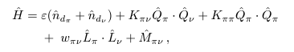(1)
where the indexes n_{dπ} and n_{dν} refer to neutron and proton bosons respectively, and M_{πν} is the Majorana term. Moreover,
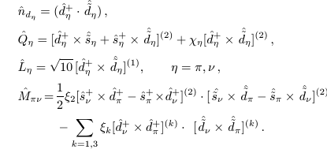
The E2 transition strengths were calculated by using the operator :[Green 2009]
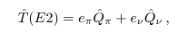 (2)
where e_{π} and e_{ν} are boson effective charges.

The M1 operator is given by :[ Pfeifer 2008]
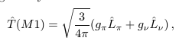(3)
where g_{π} and g_{ν} are the proton and neutron boson g-factors, respectively. The numerical diagonalization has been carried out by using the computer code NPBOS of Otsuka.
The mixing ratio is given by :
δ(E2/M1) = 0.835 E_{γ} ∆(E2/M1) (4)
3. Results and Discussions :
we used parameters extrapolated from the IBM calculations of ⁹⁰⁻⁹⁴Sr and ¹⁵⁶⁻¹⁶⁰ Yb isotopes , the fitted values of the parameters are given in Tables (1), These parameters are consistent with those of previous calculations. In general, at using IBM-2, we find the values of ε and κ decrease with increasing mass number.
Also,we can know the limit of nuclei(vibrational,rotational or ($γ$-unstable)by the parameters of IBM versions.Mixing ratios δ(E2/M1) for isotopes are given in Table (2)
Table 1 . The Hamiltonian parameters set used in the present study for the IBM-2 calculations of ⁹⁰⁻⁹⁴ Sr and ¹⁵⁶⁻¹⁶⁰Yb isotopes :
C_{Lπ}(L=0,2,4) (MeV) | C_{Lν} (L=0,2,4) (MeV) | χ_{π} | χ_{ν} | κ (MeV) | ε (MeV) | N_{ν} | N_{π} | Nucleus
0.82,0,0 | 0.93,-0.67,0 | - 1.05 | 0.56 | - 0.924 | 0.861 | 1 | 6 | ⁹⁰ Sr
0,-0.5,0 | - 0.55,- 0.1,0.1 | - 1.05 | 0.50 | - 0.901 | 0.824 | 2 | 6 | ⁹² Sr
0.6,0,0 | 0,- 0.48,0 | - 1.05 | 0.42 | - 0.887 | 0.785 | 3 | 6 | ⁹⁴ Sr
0.22,0,0 | 0.3, 0.0,0 | 1.2 | 0.77 | - 0.434 | 0.573 | 2 | 6 | ¹⁵⁶ Yb
0, 0.5,0 | 0.5, 0.1,0.1 | 1.2 | 0.79 | - 0.401 | 0.521 | 3 | 6 | ¹⁵⁸ Yb
0.6,0,0 | 0.1, 0,0 | 1.2 | 0.82 | - 0.384 | 0.504 | 4 | 6 | ¹⁶⁰ Yb
Table 2 . The mixing ratios values of ⁹⁰⁻⁹⁴Sr and ¹⁵⁶⁻¹⁶⁰Yb
¹⁵⁶⁻¹⁶⁰Yb |  |  |  | I_{i}→I_{f} | ⁹⁰⁻⁹⁴Sr |  |  |  | I_{i}→I_{f}
IBM-2 |  |  | Exp. | I_{i}→I_{f} | IBM-2 |  |  | Exp. | I_{i}→I_{f}
¹⁶⁰ Yb | ¹⁵⁸ Yb | ¹⁵⁶ Yb | Exp. | I_{i}→I_{f} | ⁹⁴ Sr | ⁹² Sr | ⁹⁰ Sr | Exp. | I_{i}→I_{f}
1.2470 | 1.2470 | 1.2470 | ---- | 2₁⁺→2₂⁺ | 6.3172 | 6.3172 | 6.3172 | ---- | 2₁⁺→2₂⁺
0.4259 | 0.4259 | 0.4259 | ---- | 2₁⁺→2₃⁺ | 0.1219 | 0.1219 | 0.1219 | ---- | 2₁⁺→2₃⁺
2.9090 | 2.9090 | 2.9090 | ---- | 4₁⁺→4₂⁺ | 14.8295 | 14.8295 | 14.8295 | ---- | 4₁⁺→4₂⁺
0.2161 | 0.2161 | 0.2161 | ---- | 3₁⁺→2₁⁺ | 6.4731 | 6.4731 | 6.4731 | ---- | 3₁⁺→2₁⁺
0.2856 | 0.2856 | 0.2856 | ---- | 1₁⁺→2₁⁺ | 0.1972 | 0.1972 | 0.1972 | ---- | 1₁⁺→2₁⁺
Fig.(1) : comparison between Experimental and Theoretical energy levels of ⁹⁰ Sr
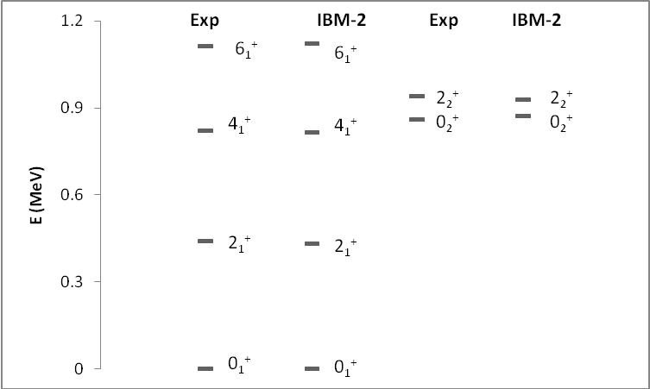
Fig.(2) : comparison between Experimental and Theoretical energy levels of ⁹² Sr
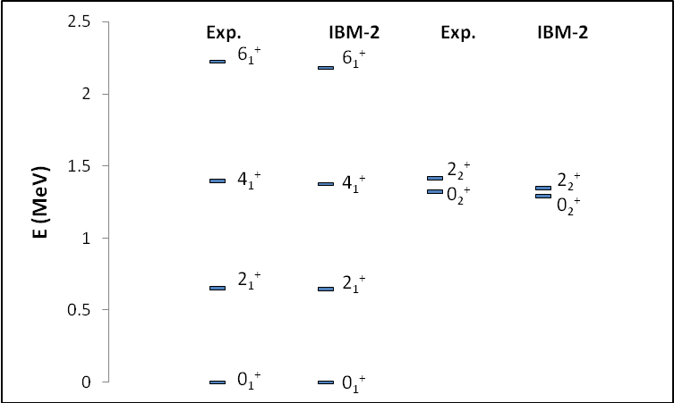

Fig.(3) : comparison between Experimental and Theoretical energy levels of ⁹⁴ Sr
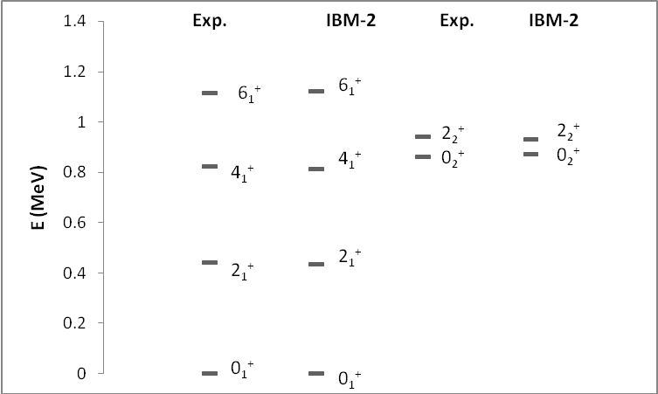

Fig.(4) : comparison between Experimental and Theoretical energy levels of ¹⁵⁶Yb
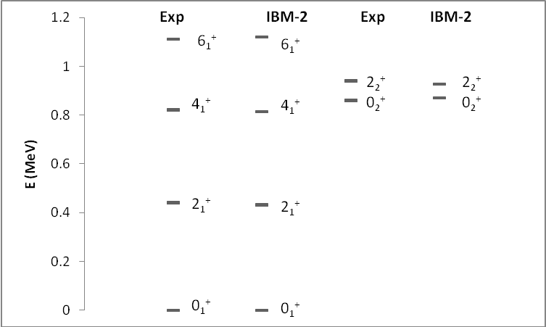

Fig.(5) : comparison between Experimental and Theoretical energy levels of ¹⁵⁸Yb
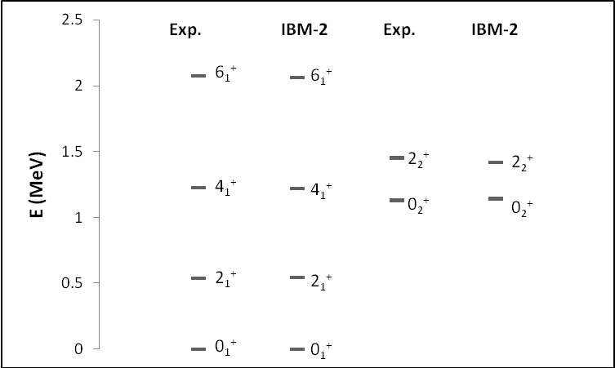
Fig.(6) : comparison between Experimental and Theoretical energy levels of ¹⁶⁰Yb
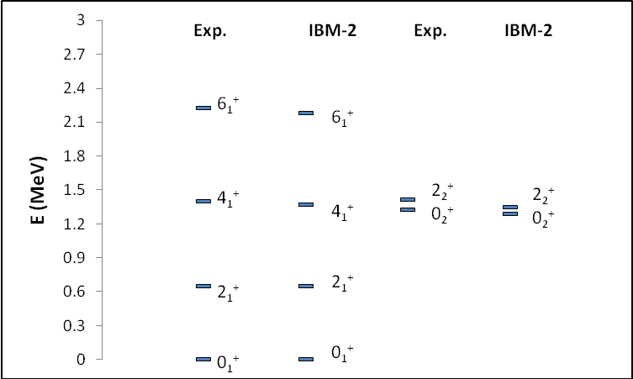
4. Conclusion :
In this work , Interacting Boson Model (IBM-2) have been used to calculate energy levels of some even-even nuclei with (A=90,92,94) and (A=156,158,160), We observed that IBM-2 is the best in study of this nuclei, also we conclude that all these nuclei in U(5) limit, energy levels of the low lying states of these nuclei were produced, the results are compared with available experimental data, Satisfactory agreements were produced. Mixing ratios δ(E2/M1) for transitions with ΔI = 0, I ≠ 0 were calculated. the results are compared with available experimental data, Satisfactory agreements were produced.
References
Casten, R. F. and Warner, D. D. (1988) ;"Interacting Boson Approximation"; Rev. mod. Phys 60, (389-465) .
Diab S.M. (2007);"Electric Monople of ¹⁵⁰Sm using IBM-2"; Romanian Journal of Physics, Vol. 53, Bucharest.
Green K. (2009) ; Nuclear Structure of ¹¹²Cd Through Studies of β decay; M.Sc. Thesis, University of Guelph .
Iachello, F. (1980) ;"An Introduction to the Interacting Boson Model"; Nuclear structure Edited by, Abrahams, K.; Allaart, K., and Dieperink, A. E. L. Plenum press (53-87).
Pfeifer W. (2008); An introduction to interacting boson model of atomic nucleus; plenum press .
Scholten O. ; Iachello, F. and Arima, A. (1978) ;"Interacting Bosons Model of Collective Nuclear States III. The Transition From SU(5) to SU(3)"; Ann. Phys. 115, (325-366) .
Singh B. (2008) ; Nuclear Data Sheets ; Vol. 109 No. 2.
Wahed S.S. (2005) ; "Theoretical Study of the Nuclear Structure of Even-Even Neodymium Isotopes ¹⁴⁴⁻¹⁵⁰Nd" ; M.Sc. Thesis, Mosul University.

