Evaluation of The Potential of Using Attapulgite Clay as Adsorbent For Removal of P-Chloroaniline(PCA) From Aqueous Solutions

Athab Z. H.* , Al-Sharify A.N
Chemistry Dept., College of Science Chemistry Dept., College for woman Science* ,
Babylon University, Iraq
Email alsharfawi@gmail.com

Abstract:-
In this study used an attapulgite clay as low cost adsorbents for adsorption of p- chloroaniline from aqueous solutions. The factors affecting of adsorption process such as pH , temperature , and equilibrium time were studied, was found the adsorption was increase at the pH values decrease and the optimum adsorption at pH (2), the effect of equilibrium time was also studied and it was found that the best contact equilibrium time at (80) min, and study effect of initial concentration of (PCA).
The effect of temperature on the equilibrium adsorption of PCA from aqueous solution using Attapulgite was investigated. Thermodynamic parameters, such as ΔG, ΔH, and ΔS were calculated and the results suggested that the PCA adsorption on Attapulgite clay was a spontaneous and endothermic process. The isotherm of this adsorption was investigated and the adsorption isotherm was found similar to S-shape according to Gilles classification, and that obeys Freundlich isotherm model .
Keywords:-attapulgite clay, p-chloroaniline, adsorption Isotherm, thermodynamic parameters.

Introduction:-
Water is the world’s most precious natural resource ,water pollution results in serious health problems, particularly in the developing countries and industry is also become very prominent in today’s society and its impact on water is increasingly significant [1].
The considerable contamination of the aqueous environment by organic pollutants still requires the development of simple and fast methods for the removal, separation, and determination of these compounds [2, 3]. In addition, a common problem in many industries is the disposal of large volumes of wastewater containing major classes of these organic compounds, which are mutagenic and carcinogenic, with high toxicological potentials. Among these discharged pollutants, aniline compounds are one of the most important common organic pollutants of industrial wastewater intermediates that are widely used in the manufacture of conducting polymers, rubbers, drugs, dyes, and pesticides [3]. The potential use of aniline compounds resulted in their large-scale disposal into wastewater. p-chloroaniline is a highly toxic agent to humans that is absorbed through the skin or through inhalation [4]. Efficient techniques for the removal of these highly toxic compounds from water have drawn significant interest [5].
As environmental pollution becomes of greater concern, alternative methods to filter wastewater are being studied. The interest or cheaper and more efficient adsorbents is mounting causing greater amounts of research to be conducted about adsorption. One of these areas of research is focusing upon adsorption by the clay minerals, such as bentonite and attapulgite clays are used as adsorbents for treatment of contaminated water [6]. Adsorption technology is prominent as the most effective method for removal of trace amount of organic pollutants for purification of water and wastewater in industrial application [7].
Attapulgite clay (palygorskite) is a hydrated magnesium aluminum silicate present in nature as a fibrillar clay mineral containing ribbons of a 2:1 structure main two layers tetrahedral contain Si(O,OH)₄ , in which is sandwiched octahedral layer contain M₂(OH)₆ where M is divalent cation [8]. Attapulgite has permanent negative charges on its surface, which enable it to be modified by cationic surfactants, to enhance contaminant retention, and to retard contaminant migration [9].
Attapulgite has the structural formula Si₈O₂₀(Mg,Fe,Al )₅(OH)₂(H2O)₄-4H₂O,and its ideal structure is studied by Bradley in 1940 [10].
Structure of attapulgite clay shown in figure 1.

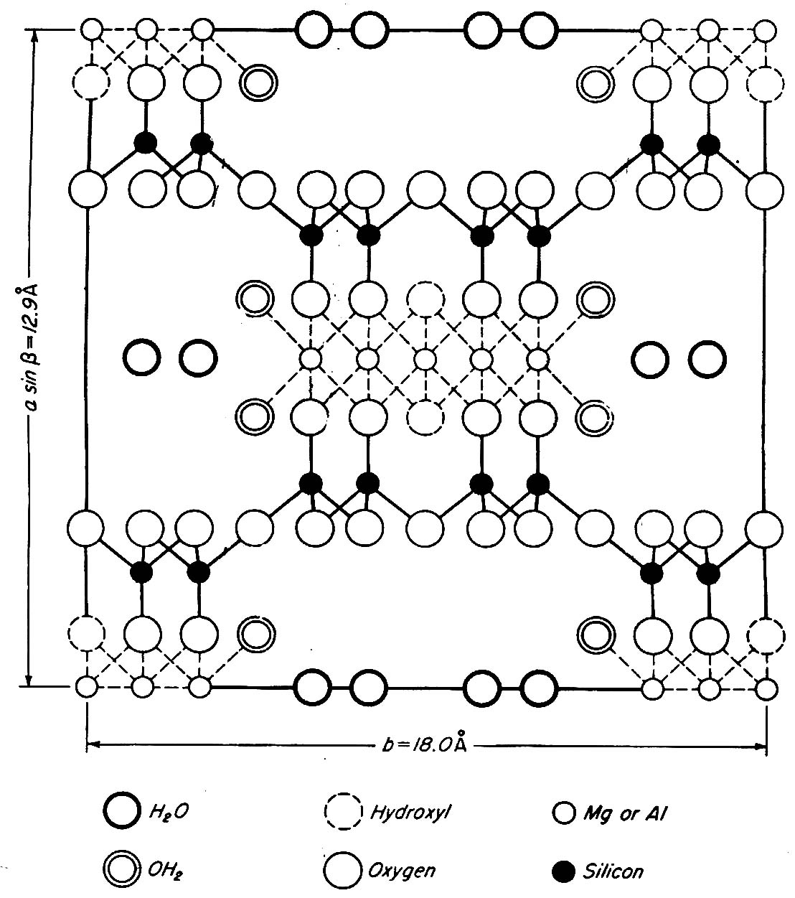

Figure (1): Stereo structure of attapulgite clay[11]

Because of its structural morphology and higher surface areas, attapulgite has received considerable attention with regard to the adsorption and the removal of organic pollution [10].
In the present paper attapulgite clay was used as an effective adsorbent for the removal of p-chloroaniline from it's aqueous solution.
Materials and methods:
a) Materials
1-Adsorbant:
p- chloroaniline was obtained from B.D.H. ,(99%). p-chloroaniline was used without further purification figure (2) shows the structure of the p- chloroaniline
NH₂
Cl

Figure 2: Structure of p- chloroaniline

2- Adsorbent:
Attapulgite with the formula of 44.66 % SiO₂, 13.36 % Al₂O₃ , 13.71% CaO, 4.2 % Fe₂O₃ , 3.2 % MgO , 0.23 % SO₃ and L.O.I % 17.79 . this clay was obtained from the general company for geological survey and mining, Baghdad , Iraq . The clay where immersed in1L of 0.001N HCl solution for two hours . the acidified clay were washed with double distilled water many times to remove the soluble materials. Then it was dried in the oven at 115˚C for twenty four hours .Using the available sieve (200 mesh) the maximum particle size obtained was (75μm) this particle size used in all experimentals .

b) Methods
A stock solution of p-chloroaniline (1000 mg/L) was prepared by dissolving appropriate quantity of this compound in double distilled water. This solution is further diluted to desired concentrations for obtaining the test solutions. the absorbance of solutions was measured on spectrophotometer at wave length 291 nm for p-chloroaniline with Shimadzu UV -Vis. Spectrophotometer-1650pc and Spectrophotometer Apel – PD-303 UV.
The pH of these compounds solutions were measured by Digital pH- Meter , Hanaa , Roman, and adjusted by 0.1N NaOH (BDH) and 0.1N HCl (BDH).
The effect of experimental parameters , like initial concentration , time of shaking , weight of the activated clay , pH values ,adsorption isotherm and the temperature were all studied .The experiments were carried out by changing one parameter at a time while the others constant and by using the Shaker Water Bath, SB. 4, Tecam. The amount of attapulgite in the slurry has been 0. 5gm / 25ml solution.

Results and Discussion
Calibration curve of (PCA)
The calibration curve of (PCA) was constructed using different concentrations of (PCA)) solution in range of (5-50 mg/L). The absorbances were measured at the maximum absorbance (ג max) wave length (291 nm) as shown in figure (3).
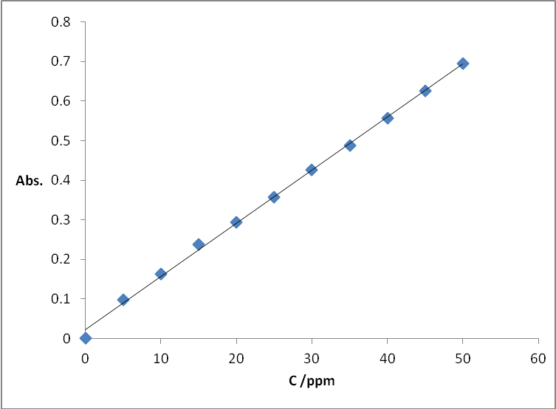
Figure (3) the calibration curve of (PCA)

Adsorption Procedure
The amount of (PCA) adsorbed on the surface of clay, Qe (mg/g), was calculated according to the following equation [12].
$$Q_{e}=\frac{\left(C_{o}−C_{e}\right)V}{m}\text{.}\text{.}\text{.}\text{.}\text{.}\text{.}\text{.}\text{.}\text{.}\text{.}\text{.}\text{.}\text{.}(1)$$
Where, C_{o} and C_{e} is the initial and final or equilibrium concentration of (PCA) ) in solution (mg /L) respectively, m is the clay mass in grams (gm) and V is the solution volume in liters (L).
The percentage amount of adsorbate adsorbed on the adsorbent was calculated by equation (2) [7].
$E\text{\%}=\frac{\left(C_{o}−C_{e}\right)}{C_{∘}}×\text{100}\text{.}\text{.}\text{.}\text{.}\text{.}\text{.}\text{.}\text{.}\text{.}\text{.}\text{.}\text{.}\text{.}(2)$
Where E% Percentage removal of the adsorbate.
Effect of Time on Adsorption
The equilibrium time required for the adsorption of (PCA) were almost (80) min on the (AT) as shown in Figure (4)

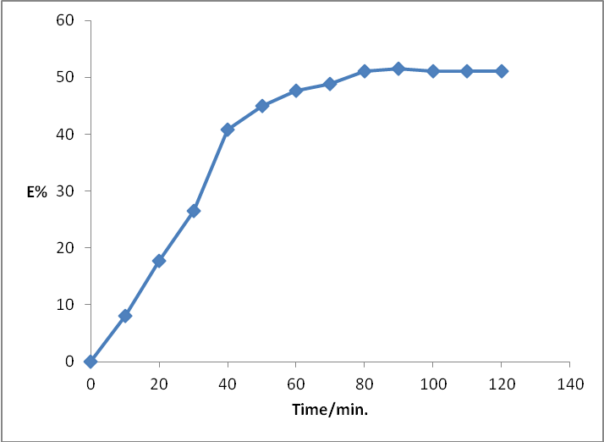
Figure (4) effect of contact time on adsorption of( PCA)
The result in figure (4) refer to the ( PCA) reach to the equilibrium state at the contact time (80)min . ( PCA) bonding with the oxygen ions on the surface of clay by hydrogen bonding .
Effect of pH on Adsorption
The pH range (2-12) was studied which shows the maximum amount of adsorption at pH=2 as shown in Figure ( 5 ) It is found practically that the pH change has not effect on the ג max of ( PCA) solution .
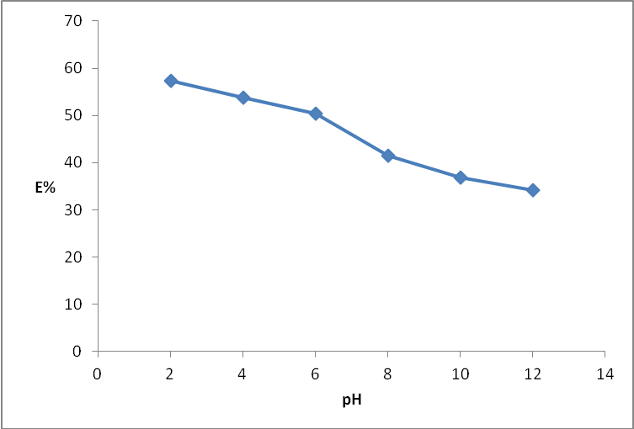
Figure (5) effect of pH value on adsorption of (PCA)
Aromatic amines that have ionization potentials can be easily on clays; these reactions may proceed chemically in clays .
the results shows the adsorption increase with decrease pH value is due to in the acid medium the -NH₂ substation on the aromatic ring in the (PCA) ionization to dipole pair (C₆H₅NH₃⁺) that is bonding with the negative site on the surface of clay by the Ion - dipole interaction.
Effect of temperature:-
Sorption of a chemical on a solid sorbent occurs when the free energy of the sorptive exchange is negative .

₌ ₋ ………..(3)
where ∆G is the change of the Gibbs free energy (kJ mol⁻¹) ∆H is the change in enthalpy (kJ mol⁻¹) and ∆S is the change in entropy (kJ mol⁻¹ K⁻¹). ∆H represents the difference in binding energies between the adsorbent and the adsorbate (solute) and between the solvent and the solute[13].
the mean value of the enthalpy change due do the adsorption of PCA by attapulgite clay over the temperature range studied can be calculated by the linear plotting of log K_{d} against 1/T according to Van’t Hoff Isochor equation using the least squares analysis shown in Figure ( 6 ). The mean enthalpy change can be determined from the slope of the straight line [14].

Log K_{d}=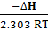+ Constant ………(4)
the Gibbs free energy change (ΔG) and the entropy change (ΔS) with temperature can be calculated According to equation 5 and 3 respectively, the results are arranged in Table 1.

5))...... . RTlnK_{d}- =
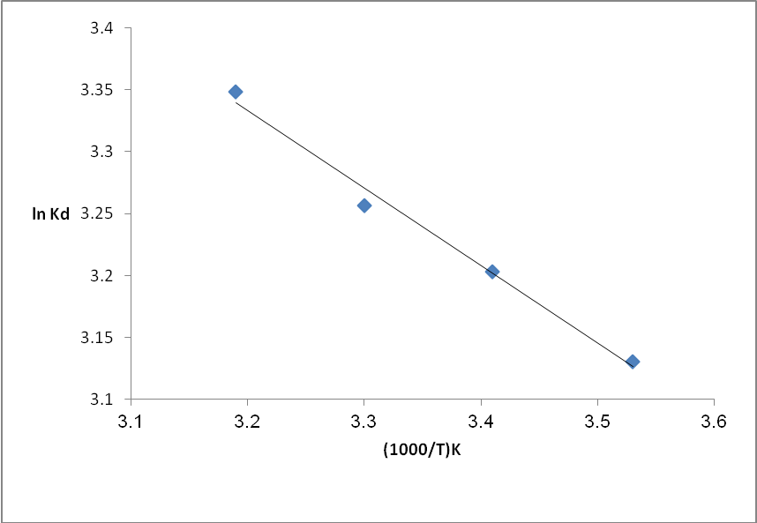
Figure (6) Van’t Hoff equation for adsorption of of (PCA)on attapulgite surface.
Table 1: The thermodynamic parameters for the adsorption PCA on the Attapulgite clay .

∆S/ (J/mole.K ) | ∆G / (kJ/mole) | ∆H / (kJ/mole) | T/(K)
29.66455 | -3.19882 | 5.19625 | 283
29.30113 | -3.38898 | - | 293
28.90808 | -3.5629 | - | 303
28.69214 | -3.78439 | - | 313

The adsorption capacity increased with increasing temperature.
The negative values of ΔG indicate the spontaneous nature of adsorption of (PCA) onto attapulgite. The value of ΔH was positive, which indicated that the adsorption reaction was endothermic. The positive value of ΔS shows that increasing randomness during the adsorption of (PCA) on attapulgite.
Adsorption Isotherm
Adsorption isotherm is useful to describe how solutes interact with adsorbents and very important to evaluate the feasibility of the adsorbate-adsorbent system. The isotherm data explained by theoretical or empirical equations provides preliminary prediction in modeling steps which is desired to practical operation.
Adsorption isotherms of ( PCA) on (AT) is presented in figure (7)

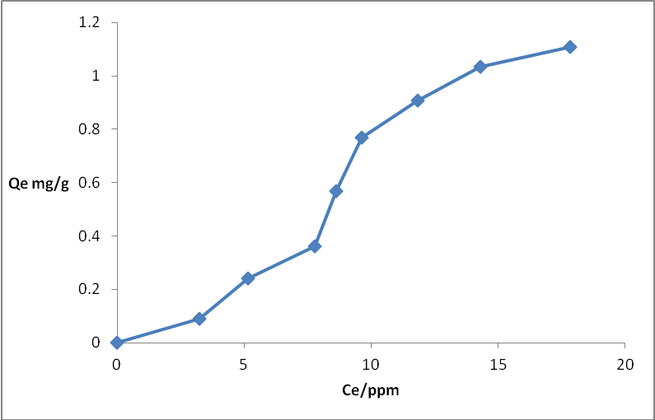
Figure (7) Adsorption isotherms of ( PCA)on (AT)

Adsorption isotherm similar to S-shape according to Gilles classification
Freundlich Isotherm Model
The adsorption curves were also applied to Freundlich equation. The Freundlich isotherm was calculated according to the following equation [15] .
$$Q_{e}=K_{f}C_{e}^{1/n}\text{.}\text{.}\text{.}\text{.}\text{.}\text{.}\text{.}\text{.}\text{.}\text{.}\text{.}\text{.}\text{.}\text{.}\left(6\right)$$
Where K_{f} is roughly an indicator of the adsorption capacity and (1/n) of the adsorption intensity all data are illustrated in table (2) and plots in Figure (8)

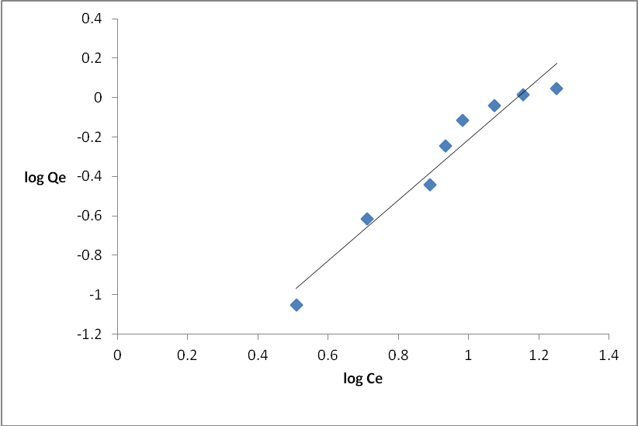
Figure (8) Freundlich isotherms for ( PCA) adsorption on (AT)
correlation coefficient (R² ) ,K_{f} and 1/n Values can be determined from the linear plot of ln(Q_{e}) vs. ln(C_{e}).

Table 2: Freundlich constants for adsorption of PCA
Freundlich constants
R² | K_{F} | 1/n
0.947 | 0.017 | 1.539

Langmuir Isotherm Model
The linear form of the Langmuir isotherm can be represented according to the following equation [16] .
$$\frac{C_{e}}{Q_{e}}=\frac{b}{Q_{m}}+\frac{C_{e}}{Q_{m}}\text{.}\text{.}\text{.}\text{.}\text{.}\text{.}\text{.}\text{.}\text{.}\text{.}\text{.}\text{.}\text{.}\left(7\right)$$
where Q_{e} amount of ( PCA) adsorbed per unit weight of adsorbent (mg/g), C_{e} is concentration of ( PCA)remaining in solution at equilibrium (mg/L)and Qm and b are Langmuir constants related to the adsorption efficiency and energy of adsorption respectively .

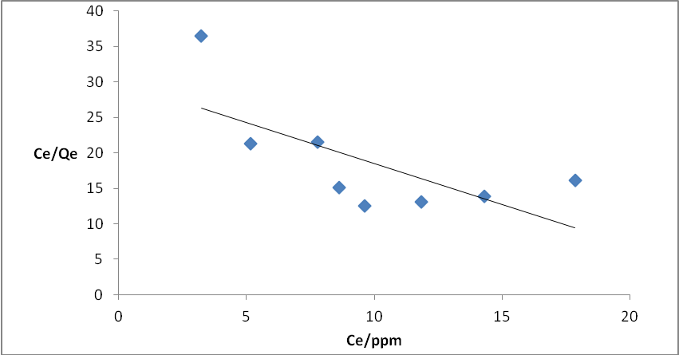
Figure (9) Langmuir isotherms for ( PCA) adsorption on (AT)
The Langmuir plots and correlation coefficients R² studied and showed the adsorption of ( PCA)on these two types of clays is not obeyed the Langmuir equation with correlation coefficients 0.96<R²>0.83.
the adsorption isotherm was found similar to S-shape according to Gilles classification, and that obeys Freundlich isotherm model and not obeyed the Langmuir equation.

Table 2: Langmuir constants for adsorption of PCA
Langmuir constants
R² | K_{L} | a
0.474 | 0.033 | 0.383

Conclusions
The equilibrium of the adsorption of p-chloroaniline on the attapulgite clay surface, have been investigated. The clays that used showed very high adsorption capacities to remove the PCA. The adsorption capacities were significantly affected by the initial PCA concentration and pH.
The results showed increased adsorption with the increase in the initial (PCA) concentration and the adsorption capacity increased with decrease in pH value .
The Freundlich equation agrees very well with the equilibrium isotherm but Langmuir equation did not give an accepted linearity.
The adsorption capacity increased with increasing temperature.
The negative values of ΔG indicate the spontaneous nature of adsorption of (PCA) onto attapulgite and the adsorption reaction was endothermic.
Nomenclature:
Q_{e} Equilibrium adsorption capacity mg/gm
K_{F} Freundlich constant.
K_{L} Langmuir constants
V volume of the solutions, L
W weight of clay, gm.
C_{o} initial solution concentration, mg/L.
C_{e} equilibrium solution concentration, mg/L.
R² correlation coefficient
1/n adsorption intensity.
E% Percentage removal of the adsorbate.
AT Attapulgite clay
PCA p-chloroaniline
References:
[1] D. S. Alessandro, Factors Affecting Sorption of Organic Compounds in Natural Sorbent/Water Systems and Sorption Coefficients for Selected Pollutants. A Review , J. Phys. Chem. Ref. Data, ,vol. 30,no. 1, pp187-433, 2001.
[2] S.D. Faust,and O.M. Aly, Adsorption process for water treatment, Butterworth publishers, London, 1987.
[3] S. A. El-Safty, A. Shahat, W. Warkocki,and M. Ohnuma, Building-Block-Based Mosaic Cage Silica Nanotubes for Molecular Transport and Separation, small, vol.7, no.1 , pp.62–65,2011.
[4] D.A. Cave, and P.M. Foster, Modulation of mdinitrobenzen and m-nitrosonitrobenzene toxicity in rat sertoli-germ cell cocultures, Toxicological Science, vol.14, no.1,pp. 199-207,1990.
[5] S. A. El-Safty, Water treatment from cadmium ions with nanomaterial sensors, Environmental Nanotechnology, vol.3, no.1, pp.36-41,2010.
[6] M.Kara, H.Yuzer, E.Sabah,and M. S.Celik, , “Sepiolite as an adsorbent for elimination of mine wastes,” Environmental Issues and Waste Management in Energy and Mineral Production 717 ,1998.
[7] H.I.Maarof, B.H. Hameed,and A.L.Ahmed, Adsorpti,on equlibrium of phenols from aqueous solution using modified clay,J.Jurnlera Kimia Malaysia ,vol 3,p85-96, 2003.
[8] C. E. Weaver,and L. D. Pollard, The Chemistry Of Clay Minerals , London, New York, 1973.
[9] H. S.CHIU, and J. J. WANG, Adsorption Thermodynamics of Cobalt Ions onto Attapulgite, Journal Of Environmental Protection Science, vol. 3, pp. 102 – 106,2009.
[10] Z. Wang ,Y. Zhou , and Y. Sun, Preparation, Characterization and Infrared Emissivity Study of Attapulgite@helical Polyurethane Composites, J Inorg Organomet Polym ,vol. 19,pp.202–207,2009
[11] Z.H. Athab , A Study of The Adsorption Ability and Separation of Aniline and Some of Its Derivatives From Aqueous Solutions By
Using Attapulgite Clay, M. Sc. Thesis , University of Babylon , 2011.
[12] A. Al-Futaisi, A. Al-Jamrah, and A. Al-Rawas, evaluation of the potential of using an omani attapulgite as a sorbent in treatment of
contaminated water, Ninth International Water Technology Conference, IWTC9 2005, Sharm 1230 El-Sheikh, Egypt.
[13] J. P. Hassett, and W. L. Banwart, in Reactions and Movements of
Chemicals in Soils, edited by B. L. Sawhney and K. Brown Soil Science
Society of America, Inc. and America Society of Agronomy, Inc., Madison, WI, 1989, Chap. 1, pp. 31–44.
[14] R. A. Alberty , “Physical Chemistry” ,7th edition ,Wiley ,New York , 1987.
[15] Y. El Mouzdahir, A. Elmchaouri, R. Mahboub, A. Gil b, and S.A. Korili, Equilibrium modeling for the adsorption of methylene blue from aqueous solutions on activated clay minerals, Desalination , vol. 250, pp. 335–338 , 2010.
[16] S. J.Gregg, and K. S. W. Sing, “The adsorption of gasses on porous solids ”. William Clowes and Sons, 1979.

