A mathematical Model for Computing Effects of Back Corona in wire-duct Electrostatic Precipitators of Karbala Cement
Fadhil K. Fulyful
Physics Department ,College Science , Karbala University ,Iraq
E-mail: Fadhil.Khaddam@ yahoo.com
Abstract
This paper numerically analyzes the voltage-current characteristics associated with wire-duct electrostatic precipitator control of particulates pollution. Two cases are considered, first the (WDEP) under dust free air, second dust loading when the back corona discharge is formed by a series of micro-discharges in the air spaces between the particles of the dust layer deposited on the collecting plate. The finite difference method (FDM) is used to solve Poisson's equation and to satisfy the current continuity equation, respectively .The variation of the voltage –current characteristics, depending on resistivity and particle layer thickness.
1-Introduction
A high negative voltage is applied to the small radius wire and collecting plate which is grounded. A corona is formed at the discharge electrode, creating electrons and negative ions which are driven toward the positive collection electrode by the electric field The corona discharge occur when the electric field near the wire is sufficient to ionize the gaseous species. Resistivity affects electrical conditions in the layer that forms on the grounded collector plate, voltage drop is formed across the dust layer as negatively charged particles arrive it and leak their electrical charges to the collection plate, because of the electrostatic voltage on the surface of the dust layer is quite high. Whereas the collection plate is grounded, electric field created and back corona is formed.
Back corona or reverse ionization describes the conditions where an electrical breakdown occurs in an ESP. Which has been the subject of a limited number of investigations [1-7]; its characteristics and effects are often described only on qualitative basis. Its presence inside of an electrostatic precipitator is usually associated to a threshold in the resistivity of the particle layer deposited on the plates. It is experimentally evidenced by a strong bend in the voltage-current characteristics. Previous mathematical models of back-corona inside the precipitator duct computed the voltage-current characteristics without taking into account the particle layer resistivity, particle layer thickness, sparking and voltage drop; they were based on a finite difference [8] or finite element [9] simulation of the glow-corona discharge, including the back-discharge ion production associated to the glow corona current density.
In this paper the influence of back corona on the V-I Characteristics of electrical precipitator is calculated by solving Poisson's and current continuity equations simultaneously by FDM. One of the most important parameter causes the back corona is the resistivity of the particle layer .A simple back corona model is developed to study the effects of resistivity and particle layer thickness.
2-Mathematical modeling of electrostatic precipitator
Fig. (1) Shows a schematic and top view of (WDEP) configuration. As the potential difference between the discharge wires and collecting plates is raised, the gas near the more sharply wire electrode breakdown at voltage above what is called the onset value and less than the spark breakdown value. This phenomena is called corona discharge, in this figure (2S_{y}) is the distance between two discharge electrodes respectively,(2S_{x}) is the distance between two collecting electrodes,(2a) is the electrode diameter, (L) is the precipitator length and (H)is the precipitator height.
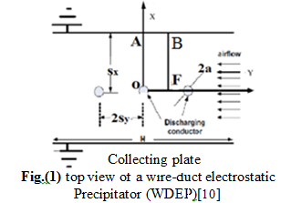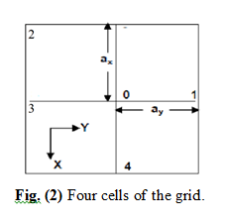
The values in table (1) are considered in this research
Table (1) main dimension of the precipitator dependent
Experiments  (refs.) | Voltage kV | Wire radius a(mm) | Wire to wire space  2Sy(cm) | Wire to plate space Sx(cm)
 | 32.7-51.8 | 1 | 23 | 11.5
 | 36.2-63.2 | 1 | 30 | 15
Predict sol. | 41.07-81.7 | 1 | 30 | 20

Finite difference method is applied in the above domain (OAEF) Figure(1) to solve Poisson’s equation and current continuity equation.
Because of the symmetry of the wire-plate geometry, only one quarter section can be executed and the solution repeated for all similar rectangles in the duct. The reduction of the problem domain leads to make program faster convergence, while in many researches used the domain as whole.
Using FDM the voltage at any grid point in Figure ( 2) can be estimated. The values of( a_{x} )and( a_{y} )are calculated under the limit of the cells which can be determined by the Finite Difference Program, if the number of the cells is increased the method gives sufficiently accurate results with reduced mesh size.
The following system of equations describes the corona discharge
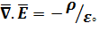...……………….. Poisson’s equation
…………………………current continuity equation
……………………. Field and potential relation

………………………… the current density equation
Where
is the electric field intensity vector
is the total space charge density
is the total current density vector
is the potential
is the permittivity of free space
K is the mobility of electron
The following assumptions and boundary conditions are essential requirements for finding a numerical solution
1- The influence of particle space-charge density on the electric field is negligible
2- The corona discharge is assumed to be distributed uniformly over the surface of the wires
3- Value of the electric field on the electrode discharge (E₀) which result from Peek’s derivative and later known as Peek’s formula [11 ]
$$E_{∘}=3\text{.}1×{\text{10}}^{6}\left(1+\frac{0\text{.}\text{308}}{(0\text{.}5×a)^{0\text{.}5}}\right)$$
4-Due to two-way symmetry the mathematical model is developed for one quarter of the regions between a pair of the wires and the plates. The problem domain is shown in Figure (1).
5- The ionic mobility is assumed to be constant.
6-The thickness of the ionization zone around the emitter is negligible.
7- The ion diffusion is neglected.
8-All the particles have the same diameter.
9- The various boundary conditions for potential V are,
$\begin{aligned}V \\ | \\ \end{aligned}_{O}=V_{0},E_{X}\begin{aligned}| \\ |\text{AB}\end{aligned}= 0 ,Valignl\begin{aligned}| \\ |\text{OF}\end{aligned}= 0 ,E_{y}\begin{aligned}| \\ |\text{AO}\end{aligned}= 0 , E_{y}\begin{aligned}| \\ |\text{BF}\end{aligned}=0$
Boundary conditions are
1-the electric potential at the two collecting plates are zero
2-the potential at the discharge wires is (V₀)
3-the electric field at the discharge wires is E₀
4-The various boundary conditions for potential (V) are, a first estimate of the voltages (V₀) at the discharge electrode is obtained using Cooperman’s equations
$$V(x,y)=V_{0}\frac{\sum_{m=−w}^{w}{\text{ln}\left[\frac{\text{cosh}\left[π(y−2{\text{mS}}_{y})/2S_{x}\right]−\text{cos}({πx}/2S_{x})}{\text{cosh}\left[π(y−2{\text{mS}}_{y})/2S_{x}\right]+\text{cos}({πx}/2S_{x})}\right]}}{\sum_{m=−w}^{w}{\text{ln}\left[\frac{\text{cosh}(π{{\text{mS}}_{y}}/{S_{x}})−\text{cos}({πa}/2S_{x})}{\text{cosh}(π{{\text{mS}}_{y}}/{S_{x}})+\text{cos}({πa}/2S_{x})}\right]}}$$

Where, (V₀) is the applied at the wire,( x , y )are the co-ordinate position in meters measured with the wire as origin, (Sx) is wire to plate spacing,(Sy) is half wire to wire spacing, a is the radius of the wire, and
(w) is the number of wires. Using FDM the electric field intensity at any grid point can be estimated according to the relation between electric field and the potential. (ρ₀) is obtained from the solution of current continuity equation. Using FDM the charge density ( ρi,j )at any grid point can be estimated. Voltages are updated by solving Poisson’s equation, the equations are iteratively solved, updating space charge density, voltage and electric field, until the difference between the voltages compute by Cooperman’s Eq. and the values obtained by solving Poisson’s Eq. is less than or equal one volts at all grid points.
3-Back corona discharge model
If the glow-corona discharge current, layer resistivity are high enough and the electric field is induced due to the voltage drop across the dust, a positive back-corona discharge is formed in the layer which deposited on collecting plates .From the dust layer positive ions exit, the back corona at the collection electrode produces ions of the opposite sign for corona discharge, which migrate toward the corona wire previously charged negative dust particle. Besides positive ions may attach to neutral dust particles, causing their drift backwards to the emitting electrodes. The electric field threshold (E_{t}) for back corona inception depends on different parameters including particle geometrical shape and compactness inside the dust layer, it’s value is very difficult to be measured, as particle layer condition and resistivity inside an electrostatic precipitator are strongly variable.in the literature there are no published values of the average electric field threshold( E_{t} ) however ,a layer threshold resistivity of about(2×10¹⁰) Ohm.cm is commonly indicated. By assuming an average current density on the collecting plates about (2.5-5.0 mA/m² ) ,it is possible to define an electric field threshold of the order (0.5-1×10⁵ V/m) [4 ] .
In order to quantify the threshold value ,the average electric field in the layer E_{l} is given by
E_{l} = ρ J
Where
E_{l} = electric field in the dust layer (V/m)
ρ = resistivity of the collected material (omh-m)
The estimation of back corona current density ( J_{b} )is given by[4 ]
J_{b}=K_{b}l^{0.4} (E_{l} –E_{t} )
This value is based on the electric field in the particle layer( E_{l} ),the value of the constant K_{p} (3×10⁻⁶ ) as well as the value of the power layer thickness (0.4 ),have been optimized on the basis of SRI resistivity probe measurements and on laboratory and industrial measurements.
This current calculation has been kept as simple as possible, it describes the steady state regime, and does not take into count the dynamic behavior for back corona.
Modeling voltage current characteristics in an electrostatic precipitator with back-corona needs a representation of the particle layer. Particle layer is characterized by his electrical resistivity. The increased voltage drop creates a higher electric field that increases back-corona current density and once more modifies the voltage drop. We have a positive feedback effect that is a typical phenomenon observed in the presence of back-corona.
4-Results
Voltage-current characteristics are a basic tool to analyses the operational conditions of an electrostatic precipitator, and to detect the onset of back-corona, that strongly affects the collection performances.

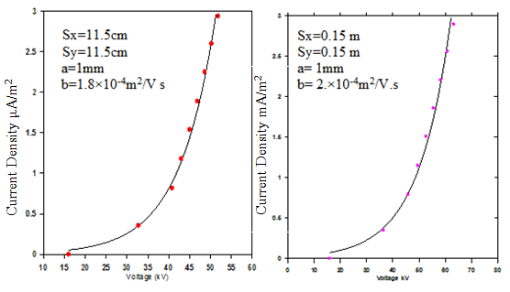
Figure3. ● Predicted result is compared with ― experimental data [9]

Fig. 3 is present a comparison of voltage-current characteristics for ESP with different geometrical parameters, the same graph for case of dust free air is obtained.
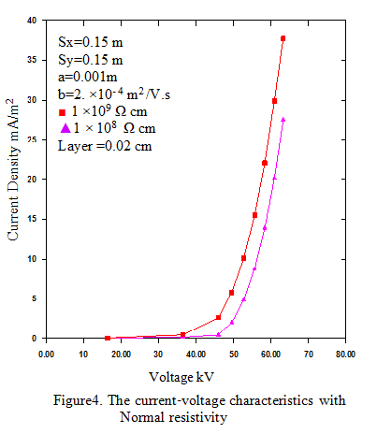
Fig.4 within the range of dust resistivity( 10⁸-10⁹ Ω.cm)the curve shape of voltage –current does not change and only the value of current density has simple increased according to the case ESP is loaded, then the resistivity range is normal and no back corona.

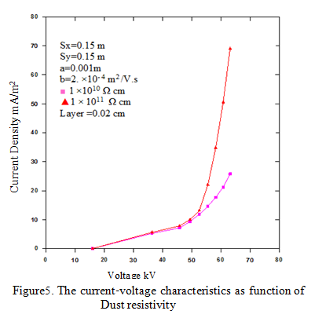

The computed influence of high resistivity (10¹⁰-10¹¹ Ω.cm) on the voltage-current characteristics is shown in Fig. 5, for a defined particle layer thickness of 0.02 cm. The resistivity value does have a great influence on voltage-current characteristics. The characteristics for normal dust resistivity Fig.4 are virtually identical with that obtained with clean plate Fig.3. As the resistivity value increase the current value increase too. Voltage –current curve slope is infinite or negative, a back corona occurs and decrease the efficiency of ESP.
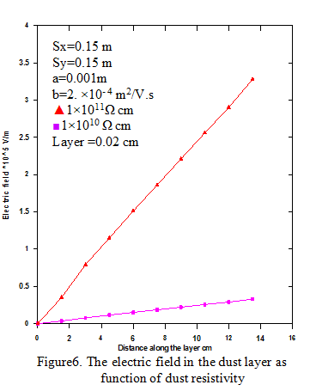

When the particulates have high resistivity, a voltage drop can develop on the layer on the collecting plates. If this voltage drop is high back corona occurs between discharge wires and the surface of the layer. The electric field increased (Fig. 6).
A strong positive field (instead negative field) occurs in the hole, which generates positive ions which neutralize the charged of the particles in the gas. The increased of electric field is another way for detecting back corona ,the value is 3.28 ×10 ⁵ V/m for resistivity 1×10¹¹ Ω.cm and the layer is 0.02cm

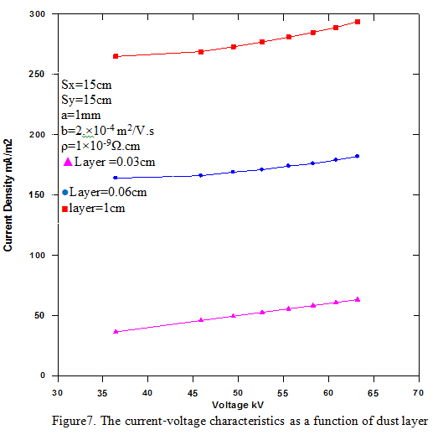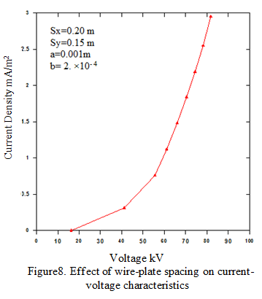

As a layer of dust builds up(Fig.7) ,back-corona takes place as layer thickness increase, with a decrease of the efficiency and increase of the current density while the applied voltage is remain constant, also the sprakover increased.

The effect of increasing wire-plate spacing on V-I characteristics does not gives any change on the shape of the curve (Fig.8) when compared with (Fig.3),only slightly increased in applied voltage ,from this results the increasing in wire-plate spacing cannot use as tool to reduce the effect of back corona.
5-conclusion
A numerical model was developed on the ESP’s at Karbala cement. This model contains two main modules, one for the determination of voltage-current characteristics in dust free case and another one to calculate the effect of back corona in loading case according the resistivity and dust layer, another way for detecting back corona between the dust layer and the collecting plate is the value of electric field between them.

Reference
[1] H.J. WHITE, Industrial electrostatic precipitation, Addison Wesley, 1963.
[2]G. BACCHIEGA, I. GALLIMBERTI, V. ARRONDEL, PH. RAIZER, J. LECOINTRE, M HAMLIL, “Static and dynamic back-corona characteristics”, IX ICESP, Kruger – South Africa, 2004.
[3]A. JAWOREK, T. CZECH, E. RAJCH, M. LACKOWSKI, “Laboratory studies of back discharge in fly ash”, Journal of Electrostatic, 64,p 306-317, 2006.
[4]G. BACCHIEGA, I. GALLIMBERTI, V. ARRONDEL, N. CARAMAN AND M. HAMLIL, Back corona model for prediction of ESP efficiency and voltage – current characteristics, ICESP X – Australia Paper 3B3, 2006.
[5] A. Jaworek ,A. TSobczyk , E. Rajch , Investigations of dc corona and back discharge characteristics in various gases, Journal of Physics: Conf. Ser. 142 012010 , 2008.
[6] A. Krupa , Electric field and charge distribution in back discharge in
Point-plane geometry, Journal of Physics: Conf. Ser. 301 012022, 2011
[7] Gabriel Nicolae POPA, Sorin Ioan DEACONU, Iosif POPA, Corina Maria DINIŞ, New trends in detection of back –corona discharge in plate- type electrostatic precipitator ,Act Technic corviniensis ,2012.
[8]P.A. LAWLESS, E. SPARKS, “A mathematical model for calculating effects of back corona in wire-duct electrostatic precipitators”, Journal of Applied Physics -- Volume 51, Issue 1, pp. 242-256, 1980
[9]S. CRISTINA, M. FELIZIANI, “Method for computing back-corona in an electrostatic precipitator”, III ICESP, Abano – Italy, 1987.
[10] B. S. Rajanikanth and M. V. Jayan, Simulation of Dust Loaded V-I Characteristics of a Commercial Thermal Power Plant Precipitator, IEEE Transactions on Dielectrics and Electrical Insulation Vol. 17, No. 1; February 2010.
[11] G. Cooperman,“A new voltage-current relation for low and high current densities”, IEEE Trans. Industry. Appl. Soc., Vol. 17, pp. 236 – 239, 1981.

