Design a Classification System for Brain Magnetic Resonance Image
Hussein Attya Lafta Esraa Abdullah Hussein
University of Babylon/ College of Computers and Sciences

Abstract
Automated and accurate classification of brain MRI is such important that leads us to present a new robust classification technique for analyzing magnetic resonance images[Chris 2003].
In this work , the proposed method consist of three stages collection of images, feature extraction , and classification . We are used gray-level co-occurrence matrix (GLCM) is used to extract features from brain MRI . These features are given as input to k-nearest neighbor( K-NN) classifier to classify images as normal or abnormal brain MRI .
Keywords
Brain MRI , Feature extraction , GLCM , K-NN .
ألخلاصة
التصنيف الدقيق لصور رنين الدماغ مهم مما يعطينا دافع لتقديم طريقه تصنيف قويه ودقيقه لتحليل صور رنين المغناطيسي .في هذا البحث , الطريقة المقترحة تتكون من ثلاث مراحل تجميع الصور , استخلاص المميزات و التصنيف . استخدمنا طريقه gray-level co-occurrence matrix (GLCM)لاستخلاص المميزات من صور رنين الدماغ . هذه المميزات تعطى كـ إدخال إلى طريقه التصنيف K-NN لتصنيف الصور إلى صور دماغ طبيعي أو غير شاذ أو صور دماغ شاذ أو غير طبيعي.

1 . Introduction
Brain tumor is any mass that results from abnormal growths of cells in the brain . It may affect any person at almost any age . Brain tumor effects may not be the same for each person , and they may even change from one treatment session to the next. Brain tumors can have a variety of shapes and sizes , it can appear at any location and in different image intensities . Brain tumor can be malignant or benign[Ahmed 2010] .
Many procedure and diagnostic imaging techniques can be performed for the early detection of any abnormal changes in tissues and organs such as computed tomography scan and magnetic resonance imaging (MRI) . Although MRI seems to be efficient in supplying the location and size of tumors , it is unable to classify tumor types [Ahmed 2010] .
In medical image analysis , the determination of tissue type( normal or abnormal) and classification of tissue abnormal are performed by using texture . MR image texture proved to be useful to determine tumor type [Ahmed 2010 ] .
In this work classification method based on K-NN . Extraction of texture features from images represents the information about the texture characteristics of the image and the variations in the intensity or gray level .
The paper is organized as follows: Related work is represented in section 2. Details of the proposed method are described in section 3.Section 4 contains details of experimental results . Conclusion presented in section 5 and future work is presented in section 6 .
2 . Related Works
In 2003, Chris A.Cocosco , Alex P. Zijdenbos and Alan C. Evan
Presented a fully automatic and robust brain tissue classification method by using a pruning strategy . Starting from a set of samples generated from prior tissue probability maps (a ‘model’) in a standard, brain-based coordinate system, the method first reduces the fraction of incorrectly labeled samples in this set by using a minimum spanning tree graph-theoretic approach. Then, the corrected set of samples is used by a supervised K-NN classifier for classifying the entire 3D image.
In 2006, Chaplot S., Patnaik L.M., and Jagannathan N.R. introduced a method for classification of magnetic resonance brain images by using wavelets transform as a tool for extraction features from brain MRI images based on GLCM method and use these features as input to support vector machine and neural network classifier .
In 2009, Jesmin Nahar , Kevin S.Tickle, A B M Shawkat Ali and Yi-Ping Phoebe Chen discussed how image data classification plays a vital role in detecting cancer, they proposed a hybrid approach combining both microarray data and image data for early detection of cancer.
In 2010, Ahmed Kharrat , Karim Gasmi, Mohamed Ben Messaoud , Nacera Benamrane and Mohamed Abid introduced a hybrid approach for classification of brain MRI tissues based on genetic algorithm(GA) and support vector machine (SVM).The optimal texture features are extracted from brain MRI images by using GLCM . These features are given as input to the SVM classifier. The choice of features are solved by using GA.
In 2011, V.Sivakrithika and B.Shanthi are proposed comparative study on cancer image diagnosis using GLCM to extract features from images and neuro-fuzzy as tool for classification stage.
In January , 2012 Sahar Jafarpour , Zahra Sedghi and Mehdi Chehel Amirani proposed method for classification brain MRI images they used GLCM to extract features from brain MRI and for selecting the best features ,PCA+LDA is implemented. The classification stage is based on artificial neural network(ANN) and k-nearest neighbor( K-NN) .

3 . Proposed Work
The methodology of the MRI brain image classification is as follow :
- Collection of images .
- Feature extraction .
- Classification using K-NN .
The proposed system are implemented on a real human brain dataset. The input dataset consist in 19 images: 10 images are normal, 9 abnormal images. These normal and abnormal images used for classification, are 256×256 sizes and acquired at several positions of the transaxial planes. These images were collected from the Harvard Medical School website[Harvard] .

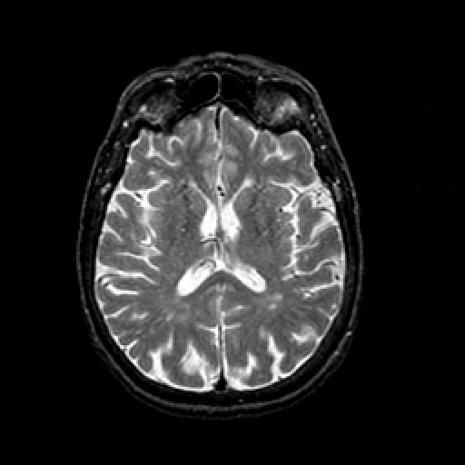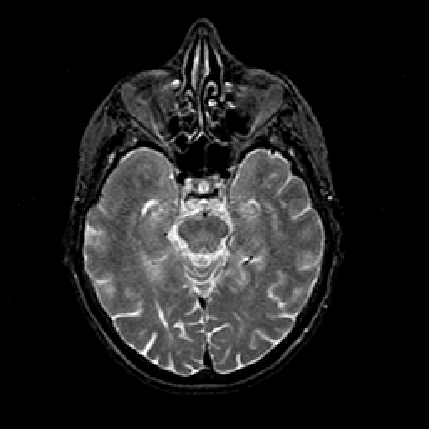
( A )
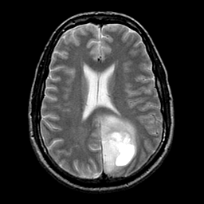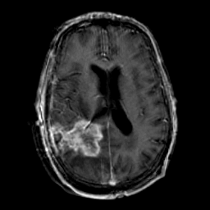
( B )
Figure (1) : Harvard dataset (A) normal (B) abnormal .

3.1 Feature Extraction
Feature extraction means identifying the characteristics found within the image , these characteristics are used to describe the object . Image features are useful extractable attributes of images or regions within an image [Gose 2009] .
Feature extraction methodologies analyze objects and images to extract the features that are representative of the various classes of objects . Features are used as inputs to classifiers that assign them to the class that they represent . In this work grey-level co-occurrence matrix (GLCM) features are extracted [Ahmed 2010] .

3.1.1 Grey-level co-occurrence matrix (GLCM)
A well-known statistical tool for extracting second-order texture information from images is the grey-level co-occurrence . The GLCM matrix is one of the most popular and effective sources of features in texture analysis . For a region , defined by a user specified window , GLCM is the matrix of those measurements over all grey level pairs [Acharya 2005] .
The GLCM matrix of an a image f(i,j) , containing pixels with gray levels {0,1,. . . , G-1 }, is a two-dimensional matrix C(i,j) where each element of the matrix represents the probability of joint occurrence of intensity levels i and j at a certain distance d and an angle θ . If there are L brightness values possible then the GLCM matrix will be an L × L matrix of numbers relating the measured statistical dependency of pixel pairs . Generally , four directions corresponding to angles of θ = 0 , 90 , 45 , 135 are used [Pratt 2007] . There will be one GLCM matrix for each of the chosen values of d and θ [Acharya 2005][Pratt 2007] . Figure (2) shows the four directions of this texture analysis technique .
45 | 90 | 135
0 | pixel

Figure (2) : Four directions of GLCM matrix .
This approach computes an intermediate matrix of statistical measures from an image . It then defines features as functions of this matrix . These features relate to texture directionality , contrast , and homogeneity on a perceptual level . The values of a GLCM matrix contains frequency information about the local spatial distribution of gray level pairs . Various statistics derived from gray level spatial dependence matrices for use in classifying image textures [Ritter 1996] . Figure (3) shows an example of a 5 × 5 image and its GLCM matrix for right
1 | 1 | 1 | 0 | 0
1 | 1 | 1 | 0 | 0
2 | 2 | 2 | 2 | 0
3 | 3 | 3 | 2 | 2
3 | 3 | 3 | 2 | 2
neighbors ( θ = 0 and d= 1) .

J | i
(a)
( b)
j
3 2 1 0
0 | 1 | 2 | 2
0 | 0 | 4 | 0
2 | 5 | 0 | 0
4 | 0 | 0 | 0
0
1
i
2
3

(c)
Figure (3) : (a) Template . (b) Original image . (c) GLCM .
Then each GLCM matrix will be normalized by dividing each element in C(i,j) by the total number of pixel pairs , which is represented as :
L-1
L-1

Cnorm (i,j) = C(i,j) / ∑ ∑ C(X,Y)
X=0
Y=0

Several texture measures are directly computed from the normalized spatial gray level dependence matrix, Cnorm(i,j) . These texture measures are called textural features. Using the normalized GLCM matrix(Cnorm(i,j)), the texture features are computed as follows [Gonzalez 2002] :

Max Probability :
F1= Max (Cnorm(I,J))
Entropy :
L-1
L-1

F2= - ∑ ∑ Cnorm(I,J) Log(Cnorm(I,J))
J=0
I=0

Contrast :
L-1
L-1

F3= ∑ ∑ (I-J)² Cnorm(I,J)
I=0
J=0

Inverse Difference Moment (IDM) :
L-1
L-1

F4= ∑ ∑ Cnorm(I,J) / 1+(I-J)²
I=0
J=0

Angular second moment :
L-1
L-1

F5= ∑ ∑ Cnorm(I,J)²
J=0
I=0

Mean :
L-1
L-1

F6= ∑ ∑ Cnorm(I,J) / L *L
I=0
J=0
Dissimilarity :
L-1
L-1
F7= ∑ ∑ (|I-J| * Cnorm(I,J))
J=0
I=0

Homogeneity :
L-1
L-1

F8= ∑ ∑ Cnorm(I,J) / 1+|I-J|
I=0
J=0

3.2 K-Nearest Neighbor (K-NN)
The K- nearest neighbor classifier is a simple supervised classifier that has yield good performance . This classifier computes the distance from the unlabeled data to every training data and selects the K neighbor with shortest distance . No requirement for training process makes this classifiers implementation simple . In t his work , the Euclidean distance is used for distance and K=3 .
4 . Experimental Results
Image dataset consist of 19 images including normal and abnormal images . We are use 10 images (out of 10 images 6 are normal and 4 are abnormal) are used for training process, and 9 images(out of 9 images 5 are abnormal and 4 are normal) for test process . Features are extracted from the images . Figure (4)

show the feature extracted from the images . The extracted features are directly fed to K-NN classifier .
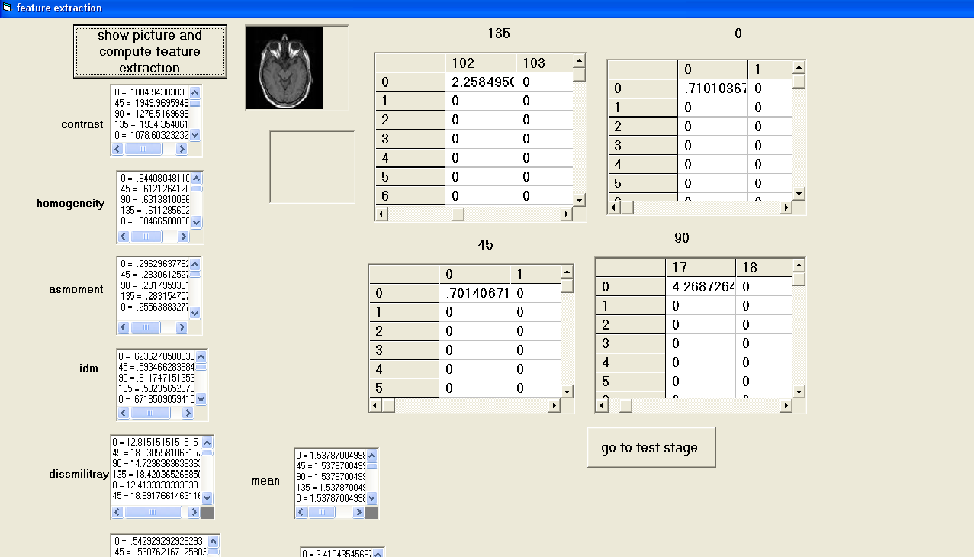
Figure (4) : The feature extracted from images .

In programming for simplicity we use " 0" to indicate for images that have class normal and " 1 " to indicate for images that have class abnormal , the results in test stage are shown in figure(5) . The accuracy of the proposed system is computed by using the equation as follow :
Accuracy =( Number of successful classification / Total number of test images) * 100% .
The accuracy of this system is 88 % .
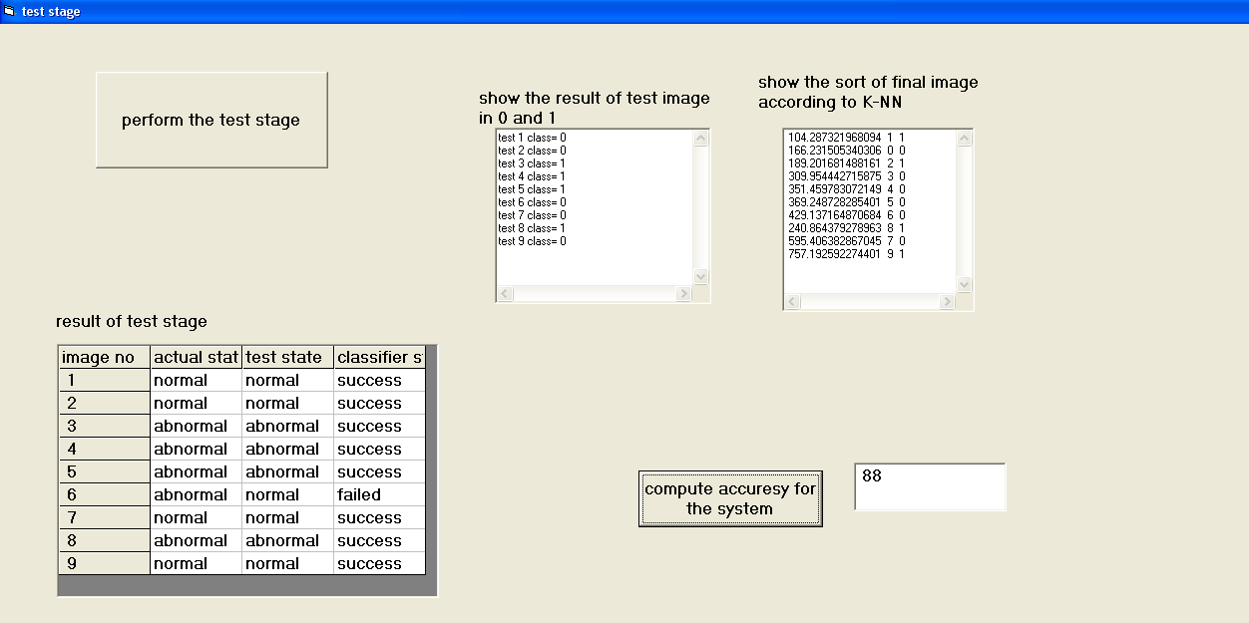

Figure (5) : Results from test stage .
5 . Conclusion
In this work , we are proposed a medical decision system with two class sets as normal and abnormal. This automatic detection system which is designed by gray-level co-occurrence matrix (GLCM) and supervised learning method (K-NN) obtain promising results to assist the diagnosis brain disease .The methodology in this paper is based on using image features and employing K-NN classifier to distinguish normal and abnormal brain MRI .The accuracy of the system is 88% .

6 . Future Work Suggestions
The suggestions for future work are :
1 – Using neural network in classification phase .
2 – Perform GLCM matrices in eight directions 0, 45 , 90 , 135 , 180 , 225 , 270 , and 315 .
3 – Using one of the enhancement methods to decrease image noise.
4 - The accuracy could be improved by including more number of sample images in dataset.

References
[Ahmed 2010] Ahmed K., Karim G., Mohamed B. M. ,Nacera B. and Mohamed A.," A hybrid approach for classification of brain MRI using genetic algorithm and support vector machine ,Issue 17, July-December 2010 P. 71-8 .

[Acharya 2005] Acharya T., and Ray A. K., "Image Processing Principles And Applications", Wiley-Interscience, USA,2005 .

[Chris 2003] Chris A. Cocosco, Alex P. Zijdenbos and Alan C. Evans, "A Fully Automatic And Robust Brain MRI Tissue Classification Method", Elsevier (2003) 513-527 .

[Gose 2009] Gose E., Johnsonbaugh R., and Jost S., "Pattern Recognition And Image Analysis" , New Delhi , 2009 .

[Gonzalez 2002] Gonzalez R. C., and Woods R. E., "Digital Image processing " , prentice Hall , USA, Second Edition , 2002 .

[Harvard] Harvard Medical School, Web, data available at http://med.harvard.edu/AANLIB/.

[Pratt 2007] Pratt W. K., "Digital Image Processing ", Fourth Edition ,Wiley-Interscience,USA,2007.

[Ritter 1996] Ritter G. X., and Wilson J. N., "Handbook of Computer Vision Algorithms In Image Algebra" , It Knowledge , 1996 .

