Experimental Investigation Of Three Various Sources Of Diesel Fuel On The Engine Performance
Naseer Salman Kadhim
Agricultural Machines and Equipment Department / College of Agriculture
University of Baghdad
ABSTRACT
The experiment including three sources of diesel fuel widely used in Iraq after 2003, one local diesel fuel produced from AL-Daura Refinery named Daura diesel fuel and two import diesel fuels one from Turkey named Turkish diesel fuel and the other from Iran named Iranian diesel fuel. Engine run at fixed speed 2500 rpm (revolution per minute) with five levels of loads (torques) 2, 4, 6, 8 and 10 N/m (Newton/ Meter). The experiment was executed according to a split plots design under Randomized Complete Design (R.C.D) with three replications. Least significant differences (L.S.D) were used to compare means of treatments at 0.05 levels. Brake Specific Fuel Consumption (BSFC), Indicated Power (IP), Exhaust Gas Temperature and Fuel Power (P_{ƒ}) were studied in this research. Results indicate that at torque 2 Nm different fuels have no significant effect on BSFC and P_{ƒ}, while in the other torques Turkish diesel fuel gives lower BSFC and higher IP followed by Daura diesel fuel .Iranian diesel fuel gives higher P_{ƒ}, exhaust gas temperature and BSFC for all torques. Thus can be seen that the sources of diesel fuel has a clear impact on the performance of diesel engines.

Keywords: Diesel fuel. Brake Specific Fuel Consumption (BSFC) .Indicated Power (IP).Fuel Power (FP).Exhaust Gas Temperature.

الخلاصة
اجري الاختبار لثلاث مصادر من وقود الديزل والتي يغلب استعمالها في العراق بعد عام 2003, احدهم محلي ينتج من مصفى الدورة سمي بوقود الدورة والاخران مستوردان احدهما مستورد من تركيا سمي بالوقود التركي والاخر ايراني سمي بالوقود الايراني.ثبتت سرعة المحرك ب 2500 دورة/دقيقة وبتسليط خمسة مستويات من الاحمال(العزوم) هي على التوالي 2, 4 , 6 ,8 و 10 نيوتن.متر . نفذت التجربة وفق تصميم الألواح المنشقة وفقا لتصميم (RCD ) مع ثلاثة مكررات واختبرت الفروق بطريقة اقل فرق معنوي على مستوى احتمالية 0.05 . تم دراسة استهلاك الوقود النوعي, القدرة البيانية, قدرة الوقود و درجة حرارة العادم في هذا البحث. واظهرت النتائج بانه عند العزم 2 نيوتن . متر لم يكن هناك أي تاثير معنوي لنوع الوقود على الاستهلاك النوعي وقدرة الوقود , بينما سجل وقود الديزل التركي اقل استهلاك نوعي للوقود عند بقية العزوم (4, 6 ,8 و 10 نيوتن متر على التوالي ويليه وقود الدورة. وكذلك سجل الوقود التركي اعلى قدرة بيانية عند كل الاحمال بينما سجل الوقود الايراني اعلى قدرة وقود واعلى درجة لحرارة العادم واعلى استهلاك نوعي للوقود عند كل العزوم . وعليه يمكن الاستنتاج بان هناك تاثير واضح لمصدر وقود الديزل على معاملات الاداء لمحرك الديزل.
االكلمات الدالة : وقود الديزل , الاستهلاك النوعي للوقود , القدرة البيانية , طاقة الوقود , درجة حرارة العادم

Introduction
American Bureau of Shipping ,(2001) , illustrated that petroleum product ,in general ,whether diesel fuel ,lubricating oil ,light fuel oil or heavy fuel oil ,are essentially composed of two major elements ,carbon and hydrogen, The combination of these two elements is called a hydrocarbon .Its ultimate source is crude oil as found in its natural states in various geological formations throughout the world. Crude oil consist of a very broad spectrum of hydrocarbon ranging from very light, volatile gases to heavy residues. Residual fuels are, in fact, the heavy residues resulting from the refining process. The more desired hydrocarbon and some less desirable ones are extracted from crude oil by the refining process. Colin,(1986). mentioned that the paraffinic hydrocarbons mostly found in diesel fuels, because of their lower specific gravity than aromatic hydrocarbons of the same boiling point, while naphthenic and olefinic compounds intermediate in density. Their (paraffinic) resistance to chemical change or oxidation is very good .These hydrocarbons are clean burning . Casey et al ( 2005) founded that the actual composition of diesel fuel can differ among refineries or over between batches produced at one refinery. Each component used tend to have somewhat different properties and interrelationships with properties of the fuel to which it is added, . Gary (1998). and Stalip and Prabhu (2010). indicated that It is probably safe to say that over 99 percent of the world's internal combustion engines use liquid fuels mostly derived from petroleum. Diesel No.1-D is used for cold weather applications and No.2-D is most common fuel for diesel vehicles. Number 4-D is used for medium to low speed engines used for stationary applications. Mohanty , ( 2007)., M.S.Shehata and S. M. Abdel Razek (2011)., Ganesan(2010). ,Yakup and Duran ,(2002) showed that the combustion process of different fuels is affected by: Viscosity which is used principally to give information about the handling, treatment and atomization of the fuel .However it also a rough indicator its carbon and asphalt content .The lower the viscosity, the easier it is to separate entrained water and solid particles. Although high viscosity fuels require proper preheating for good separator operation and heating before injection for good atomization, this characteristic usually can be handled without any problems Specific gravity (SG): The importance of specific gravity relative to diesel engine operation lies in the facts that today´ s standard fuel water. separating techniques are based upon the difference in density between the two substances. Therefore, as the specific gravity of fuel approaches 1.0, centrifuging becomes less effective. Some diesel engine fuels should be free of water and the salts normally dissolved therein. High specific gravity indicates a heavily cracked, aromatic fuel oil with poor combustion qualities, which can cause abnormal liner wear . this effect is most pronounced in smaller , higher speed diesels Cetane number(CN): Ignition quality is indicated by cetane Number. The lower the cetane number of a fuel ,the greater the ignition delay, and the longer the period of time between fuel injection and the beginning of the rapid pressure rise associated with fuel ignition and combustion. The cetane number of a fuel is dependent on the nature of the hydrocarbon from which the fuel is refined and the extend of the refinery processing on the crude oil. high viscosity fuels require proper preheating for good separator operation and heating before injection for good atomization, this characteristic usually can be handled without any problems. Fuel heating value : The heat contain in a fuel , or heating value (kcal/kg), is primarily affected by changes in specific gravity and its sulfur content in percent by weight . As the gravity of the oil increases, the ratio of carbon to hydrogen increases, as well as the sulfur content . The result is that there is less hydrogen with its high heating value available per kilogram, and a consequent decrease heat released during combustion. Flash Points of typical diesel fuel have little influence on the operation, performance and maintenance of main propulsion or auxiliary diesel engines. Oxygen content in fuel molecules, where oxygen atoms improve combustion quality of fuel. On contrast its decreases fuel heating value.

After 2003,there was shortage in the sources of energy in Iraq which obliged the government to import fuel (diesel) from Turkey and Iran ,that mean different sources of diesel fuel were available ,thus, the aim of this research is to study and evaluate the effect of sources diesel fuel on the performance of diesel engines for suke of study.

2-Experimental Setup
The experiment was conducted at Heat laboratory-College of engineering-University of Baghdad, to realize the effect of sources of diesel fuels on the performance of four stroke single cylinder direct injection (DI) diesel test engine.
2-1 Fuel
Three different sources diesel fuels (which widely used in Iraq) were used in this experiment, local diesel fuel named Daura produced from AL-Daura Refinery ,and two import diesel fuel one from Turkey named Turkish and the other from Iran named Iranian diesel fuel. Analyses of the three samples were conducted at Quality Control and Research Department /Al-Daura-Midland Refineries Company in Baghdad .results analyses were shown in Table 1.

Table 1. Fuel Properties [13]
Propeties | Daura | Turkish | Iranian
SP. Gravity @ 40˚C | 0.8496 | 0.8240 | 0.8472
Flash point ˚C | 80.0 | 53.3 | 65.3
Colour (ASTM) | 0.5 | 1.5 | 1.5
Pour Point ˚C | -9 | -15 | -15
Vis cSt @ 40 ˚C | 3.3 | 2.5 | 3.09
Carbon Res. Wt % | 0.15 | 0.25 | 0.46
Sulfur. Wt % | 1.1 | 1.059 | 0.754
Diesel Index | 62.2 | 60.0 | 60.2
Cetane No. | 58.5 | 50.5 | 58.5
Calorific Value kcal/kg | 10027 | 9883 | 10090
Distillation: I.B.P | 188 | 155 | 170
10 % | 224 | 182 | 203
20 % | 240 | 198 | 225
30 % | 254 | 211 | 246
40 % | 260 | 226 | 266
50 % | 277 | 245 | 284
60 % | 288 | 270 | 298
70 % | 300 | 297 | 312
80 % | 318 | 330 | 329
90 % | 343 | 374 | 350
E.P ˚C | 376 | > 400 | 382
T.D. % | 99 ML | -- | 98 ML
Res. | 0.9 ML | -- | 1.8 ML
Loss | 0.1 ML | -- | 0.2 ML
Rec. @ 350 % | 94 ML | 85 ML | 90 ML

2-2 Test Rig
The test rig for this experiment consist of
- engine TD111 type ('Robin' - Fuji DY23D) single cylinder four stroke DI diesel engine ,the technical specification of engine test shows in Table 2.

Table 2. Specification of the test diesel engine.[15]
Engine | 'Robin' - Fuji DY23D.
Piston Displacement | 230 cm³.
Stroke | 60 mm.
Bore | 70 mm.
Nominal Output | 3.5 kW at 3600 rev/min.
Maximum Torque | 10.5 Nm at 2200 rev/min.

- Hydraulic Dynamometer TD115:. Engine torque T, measured directly using a Hydraulic dynamometer Fig. 1 coupled to the engine output shaft .The power output is calculated from the torque by multiplying by the angular velocity in radians per second .Because the dynamometer acts as a brake on the engine .The power at the output shaft is referred the brake power. Pulkabek Willard W. [12].

$\frac{2π\text{NT}}{\text{60},\text{000}}$BP = …… (1)

Where :
BP = Brake Power (kW).
N = Engine Speed (rpm)
T = Torque Produced (Nm).

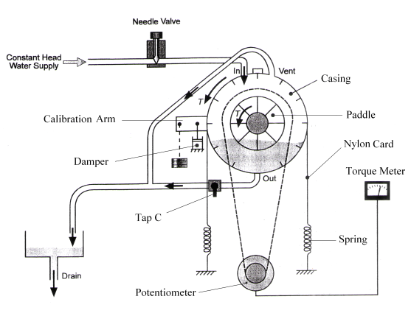
Fig. 1.Hydraulic Dynamometer

- The Measurement of Brake Specific Fuel Consumption (BSFC) :The measurement of fuel consumption is illustrated in Fig. 2. The fuel system is fed from a 4.5 liter fuel tank mounted on the top of the instrumentation unit. The fuel flows into the bottom of a pipette, graduated in volumes of 8, 16 and 32 mL

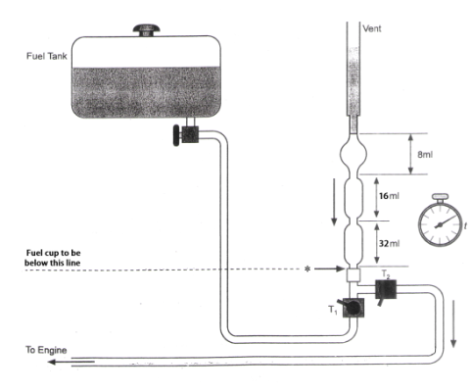
Fig. 2. Fuel Supply System

. The fuel consumption is determined by measuring the time (t) taken for the engine to consume a given volume of fuel, say (8) mL. Thus, the fuel consumption can be determined by the following equation. Chaven and Pathak [3].

m˚_{f} = $\frac{\text{sg}f×8×0\text{.}\text{001}}{t}×\text{3600}$………… (2)
Where :
m˚f = Fuel Consumption (kg/hr).
sgf = specific gravity of the fuel (kg/L).

Thus, specific fuel consumption can be obtained by the equation 3.Jain and Rai [7] :
BSFC = $\frac{m°f}{\text{BP }}$ ……………… (3)
Where :
BSFC = Brake Specific Fuel Consumption (kg/kW.hr).
BP = Brake Power (kW).
m˚f = Fuel Consumption (kg/hr

- TD114 instrumentation unit
The instrumentation unit is designed to stand beside the engine under test .In addition to housing the instruments necessary for measuring the engine performance, it contains fuel system, and the air box /viscous flow meter used to measure the consumption of air. The instrumentation Units shown in Fig.3..

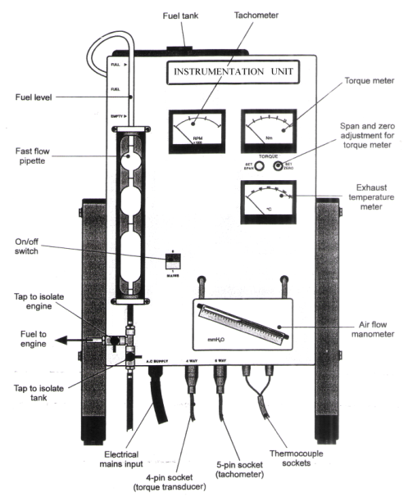
Fig. 2. Instrumentation Unit

-- Exhaust Gas Temperature: Exhaust Gas temperature is measured by a chrome/alumel thermocouple conforming to BS1827. The thermocouple is located in a 1/8” BSP union brazed into the exhaust pipe close to the cylinder block of the engine. Colour coded leads from the thermocouple are connected to terminals underneath the TD114 Instrumentation Unit .The temperature is indicated on a direct reading meter scaled from 0 to 1000 C°. The complete engine test rig shown in Fig. 4.

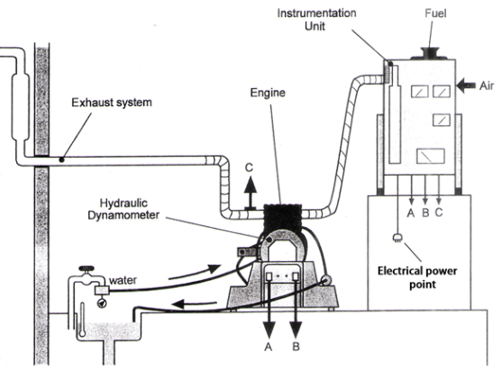
Fig.4. Complete Engine Test Rig

- The Measurement of Indicated Power :
The indicated power measured by willan`s line method. A graph connecting fuel consumption (Y-axis) and brake power (X-axis) at constant speed and different loads is drawn and it is extrapolated on the negative axis of brake power. The intercept of the negative axis is taken as the friction power of the engine at that speed. Thus, indicated power can be calculated from the following equation. Mohanty R.[9] .

IP = BP + FP …………………….. (4)
Where :
- IP = Indicated Power (kW).
- BP = Brake Power (kW).
- FP = Friction Power (kW).

- Fuel Power $Pf$ :
For measuring the fuel power we used the following formula for all source of diesel fuel. Pulkrabek
Willard W. [12].

$Pf=\frac{\text{LCV}m°f}{\text{3600}}$ ………….(5)

Where :
$Pf$ = Fuel Power (kW).
LCV = Lower Calorific Value (kJ/kg).
m˚_{f} = Fuel Consumption (kg/hr).

- Engine speed was measured electronically by pulse counting system. An optical head mounted on the dynamometer chassis contains an infrared transmitter and receiver.

2-3-Test Procedure
Practically, used three sources of diesel fuel Daura, Turkish, and Iranian, five levels of torques 2, 4, 6, 8, 10 Nm. at fixed engine speed 2500 rpm , drained and flushed the system before filling with fuel. Refill with fresh fuel before commencing a test requires removing any air bubbles that may be collected in the fuel system. The torque meter must be zeroed and calibrated before use. Eventually, recorded the temperature and pressure of the laboratory. The experimental works started a preliminary investigation of the engine running on Daura diesel fuel to determine the engine performance parameters characteristics, indicated power (IP), exhaust gas temperature, brake specific fuel consumption (BSFC) and fuel power ($Pf$). The same procedures were repeated for each fuel at the same operating conditions, for every fuel change, the fuel lines are cleaned and the engine is let to operate for about 40 minutes to stabilize at its new conditions. The difference in the measured parameters from the three sources diesel fuel are determined and compared at different operating conditions.
3-Results and Discussions
BSFC at 2500 rpm versus torques for different sources diesel fuel shown in Fig. 5. Engine fuel consumption depends on the engine load (torque). For low engine torque (2 Nm), BSFC for the three diesel fuels have maximum values. There is low difference in BSFC for the three fuels. On the contrary, for high torque (10 Nm) cases, the higher densities and

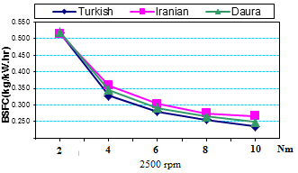
Fig. 5. BSFC versus torques at fixed speed
viscosities of Dura and Iranian diesel fuel comparing to Turkish diesel fuel is the main reasons for decreasing the BSFC for all torques, thus ,the delicate distribution of the fuel/air ʺpacketsʺ inside the sprays may be higher in Daura and Iranian diesel fuel than Turkish diesel fuel and this increases the required fuel per cycle .the findings are in good agreement with the findings of M.S. Shehata and S.M.Abdel Razek ,(2011).
Engine indicated power(IP) for different fuel at different torques shown in Fig. 6. The Indicated power increases with the increases of torque which increases the Brake power (BP) at fixed speed for all the three types of diesel fuel .Turkish fuel recorded the highest IP followed by Daura and Iranian diesel fuel .The reason for increasing the IP for Turkish fuel for all torques may be its lower relative density and lower viscosity ,The torque has a clear impact on indicated power, where indicated power decreases by decreasing the torque gradually. Highest percentage of indicated power was at 10 Nm followed it 8 Nm and lowest ratio of indicated power was at 2 Nm followed it 4 Nm for all fuels. It may be due to the increase of torque which leads to injecting more fuel inside combustion chamber to produce high energy to overcome the big load, this energy rising the temperature which leading to increase the amount of converting of chemical energy of fuel to useful work. This result agrees with Kidoguchi, et al. (2008).

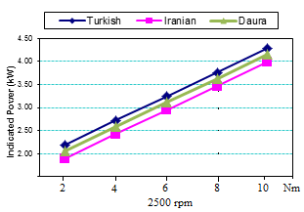
Fig. 6. Indicated Power versus torques at fixed speed

Fig. 7. Illustrates that the fuel source has an impact on its power. Highest rate of fuel power was in Iranian diesel fuel at 10 Nm followed by Daura and Turkish diesel fuel for all torques, because of the high rate of fuel consumption when using Iranian diesel fuel comparing with other sources. The torque has a clear impact on fuel power, the reason maybe to inject a high quantity of fuel for production a high energy to overcome the big load, as well as to increase the temperature of the engine leading to conversion and production more energy from the fuel in contrast to the small torques. These results agree with Gvidonas and Stasys(1998) .

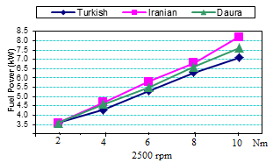
Fig. 7. Fuel power versus torques at fixed speed

The instantaneous exhaust gas temperature for different fuels are measured versus engine torques as shown in Fig. 8. Iranian diesel fuel registered higher exhaust temperature than Daura and Turkish diesel fuel respectively due to the delay of combustion resulting from slower characteristics of Iranian diesel fuel. The torque has a clear impact on exhaust temperature, where temperature increases by increasing the torque gradually. Highest percentage of temperature was at 10 Nm followed it 8 Nm and lowest ratio of temperature was at 2 Nm followed it 4 Nm for all fuels and speeds. It maybe due to the increase of the amount of fuel at high load, which generates more energy and more heat, and vice versa at low load. These results agree with Monyem A. and Van Gerpen ,( 2007).
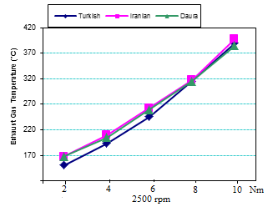
Fig. 8. Exhaust temperature versus torques at fixed speed

4- Conclusion
- The actual composition of diesel fuel can differ among refineries or over between batches produced at one refinery.
- High viscosity of the fuel change the spray chractaristics and burn pattern.
- Using Iranian or Daura diesel fuel for diesel engines have low Indicated and brake power in the other side have high rate BSFC,fuel power and exhaust temperature compared to Turkish diesel fuel.
- In order to get more detail related to variations of engine performance, the other fuel properties and engine design parameters should be investigated.
References:.
American Bureau of Shipping. Notes on Heavy Fuel Oil. ABS Plaza, Houston, TX USA,(2001).
Casey J. Hoffman, Dr. Bade Shrestha, S.O., Ph.D., P.E. Guruprasath Narayanan, Alternative Fuel Research Project, Technical Report Number MAE-05-10, July( 2005).
Chaven D.K. and Pathak, G.K.,Thermodynamics Engineering, First edition. Standard Book House, Rajsons Publications PVT. LTD. Delhi (2008).
Colin R. Ferguson, Internal Combustion Engines Applied Thermosciences.John Willy &Sons,Singapor,(1986).
Gary L. Borman and Kenneth W.Ragland, Combustion Engineering, first edition,WCB McGraw-Hill, Singapore, (1998).
Gvidonas L., Stasys S., “The influence of fuel additive on direct injection diesel engine fuel consumption and exhaust emissions “, Journal of KONES Internal Combustion Engines,Vol. 11, No.3-4, pp. 7-13,(2004).
Jain S.C, Rai C.R, FarmTractors, Second edition, Standard Publisher Distributors, Delhi,(2010).
Kidoguchi Y,, Yang, C,, Miwa, K.,” Effects of fuel properties on combustion and emissions characteristics of a direct injection Diesel engine” , SAE Paper 2000-01 1851.(2000).
Mohanty R.K., Text Book of internal combustion engines, first edition. Standard Book House, Delhi, ( 2007).
Monyem A. and Van Gerpen J.H., “The Effect of Biodiesel Oxidation on Engine Performance and Emissions”, Biomass and Bioenergy, V. 20, No. 4, pp. 317-325, (2001).
M.S. Shehata and S.M.Abdel Razek,”Experimental Investigation of Diesel Engine Performance and Emission Characteristics Using jojoba /Diesel Blend and Sunfower Oil “, Fuel, 90,pp.886-897, (2011).
Pulkrabek Willard W., Engineering Fundamentals of the Internal Combustion Engine, 2nd edition. Pearson Prentice Hall, Upper Saddle River, NJ.USA( 2004).
Quality Control and Research Department ,Al-Daura Midland Refineries Company, Iraq (2010).
Stalip N. and Prabhu, H. J., “Performance test of IC engine using karanja biodiesel blending with diesel “, Vol. 2, No 5, (2007).
TQ Education and Training ,Test Bed and Instrumentation for Small Engine, Manual, Ltd 2000.
V. Ganesan. Internal Combustion Engines. Third Edition, The Mc Graw-Hill Ccompanies, New Delhi, (2010).
Yakup Icingur,Duran Altiparmak.” Effect of fuel cetane number and injection pressure on a DI Diesel engine performance and emissions ". Energy conversion and mangment, 44: 389-397.(2002).

