The Lower and Upper Hausdorff Measure of an Iterated Function System with Parameter
Iftichar Mudhar Talb Karrar Kadum Abbas
Department of Mathematics College of Education for pure sciences
University of Babylon

Abstract:
In this paper calculate the lower and upper Hausdorff measure for fractal sets while give these set parameter , we will generalized the main theorem in (Dehua, Meifeng 2007) on other fractal sets with different parameters.
الخلاصة:
تناولت الدراسة حساب القيد الاعلى والقيد الادنى لقياس هازدورف لأهم واشهر الاشكال الكسورية مع الاعتماد على معلمة متغيرة (a) للطول ,() للزاوية .

1 Introduction
Estimating and computing the dimension and measure of the fractal sets is one of the important problems in fractal geometery. Generally speaking, it is computing the Hausdorff dimension and the Hausdorff measure. For a self-similar set satisfying the open set condition, we know that its Hausdorff dimension equals its self-similar dimension, but there are very few results about the Hausdorff measure, except for a few sets like the Cantor set on the line. Recently, some progress study have been made to compute lower and upper Hausdorff measure for Sierpinski gasket in (Dehua, Meifeng 2007) and other study about compute the exact value of Hausdorff measure of a Sierpinski carpet was calculated (Zuoling,Min 1999).
In this paper , we shall continue the study on the Hausdorff measures of the iterated function system with parameter .
2 Some Definitions and Lemmas
Definition(2.1):(Falconer 2003)
We deﬁne the diameter |A| of a(non-empty)subset of as the greatest distance apart of pairs of points in A. .Thus |A|= sup{ : x,y ∈ A}. In a ball of radius r has diameter 2r,and a cube of side length has diameter . A set A is bounded if it has ﬁnite diameter ,or equivalently , if A is contained in some(sufficiently large)ball.
Definition(2.2): (Falconer 2003)
Let A be closed subset of . A map is called a contraction on A if there is a number r with such that for all
Definition
(2.3):(Gulick 1976)
Let f be a map has the property that for some constant r with .
Then f is called a similarity of A , since has a shape similar to that of A.
The constant r is the similarity constant of f .
Definition(2.4):(Falconer 1997)
Let A be a subset of and , for all we define the Hausdorff measure as (A)=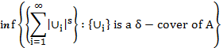 .
As increases , the class of -covers of A is reduced , so this infimum increases and approaches a limit as . Thus we define .
Lemma (2.5):(Falconer 2003)
Let and be a map such that
for a constant and then for each s
Lemma (2.6):(Dehua, Meifeng 2007)
Let A , we denote orthogonal projection onto -axis by proj , so that A is a subset of the proj(A) is the projection of A onto -axis .Clearly, , in either way proj is Lipschitz map thus, we have
Lemma(2.7):(Falconer 2003)
If A is a Borel subset of , then . Where is the volume of an n-dimension ball of diameter 1 , so that if n is even and 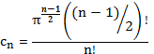 if n is odd.

3 Estimate Hausdorff Measure With Variable Parameter (a)and
In this section, we will prove the main results. First, we will try to use the length (a) as a variable parameter in some fractal shape and estimate lower and upper bounded Hausdorff measure.
Theorem (3.1)
For the Hausdorff dimension s =1 ,the Hausdorff measure of the 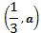 Sierpinski gasket S is as follows: where a
Proof : From the generation of the 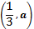Sierpinski gasket S, we can see that for each k 0, consists of isosceles triangles , which were denoted by . Each is called a k-th basic triangle.
It is clear that the k-th basic triangles of , is a covering of S. Let be the diameter of ,and then through the structure of S and , we have . then by definition of , we can get
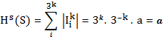
Where s=1 . Letting , then .
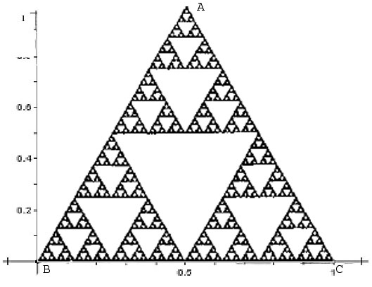
Figure 1 Projection of the Sierpinski Gasket S on the Line-BC
To estimate the lower bound Hausdorff dimension , we will project the Sierpinski gasket on the -.
Now ,we denote orthogonal projection onto by proj , so that projection of S onto -, clearly , proj is a Lipshitz mapping. Thus , by Lemma (2.5) and Lemma (2.6) , we have . As a sequence , we need to compute the value of . It is easy to see that projS is the line segment BC on the - . Therefore , Lemma (2.7) , we have
Where n=1. We have , with s=1 where a
Then .
Theorem (3.2)
For the Hausdorff dimension s =1 ,the Hausdorff measure o f the Sierpinski carpet G is as follows:
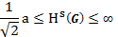 where a
Proof : From the generation of the Sierpinski carpet G, we can see that for each k 0, consists of squares , which were denoted by . Each is called a k-th basic square.
It is clear that the k-th basic triangles of , is a covering of G. Let be the diameter of ,and then through the structure of G and , we have . then by definition of , we can get
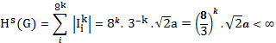
Where s=1 . by Letting , then .
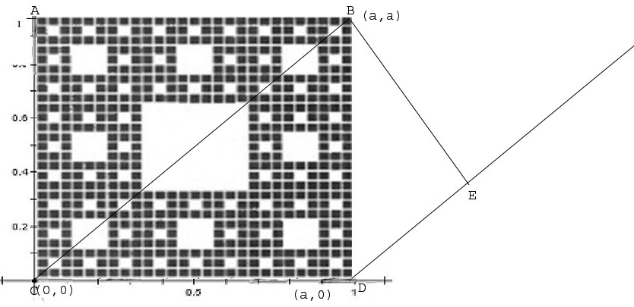
Figure 2 Projection of the Sierpinski carpet S on the Line-DE
To estimate the lower bound Hausdorff dimension , we will project the Sierpinski carpet on the straight line DE which parallel to the diameter of Sierpinski carpet.
Now ,we denote orthogonal projection onto DE by proj , so that projection of S onto , clearly proj is a Lipshitz mapping. Thus , by Lemma (2.5) and Lemma (2.6) , we have . As a sequence , we need to compute the value of . It is easy to see that projG is the line segment DE. Therefore, by Lemma (2.7), we have
Where n=1. We have , with s=1 where a
Now we will try to compute the value of .
From the figure above , we will not be able to compute the DE length by Pythagoras theory , because we have a triangle with two unknown side length , but we will try to calculate the length by depending on slop equation .
The slop equation for the first line DE is
…(3.1.1)
The slop equation for the second line BE is
…(3.1.2)
Since the line BE is orthogonal projection on DE then 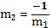 .
Now by equalized the two equation 1 and 2 to compute value.
By substitute the value of in equation 1
=a
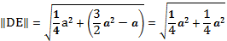
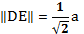
Then 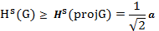 .
We realized in theorem above if we project sierpinski carpet into the- we will have , that's mean the lower bounded Hausdorff measure is effected by the slop of the straight line which we project the fractal shape on it.
Theorem (3.3)
For the Hausdorff dimension s =1 ,the Hausdorff measure o f the Menger sponge M is as follows:
where a
Proof : From the generation of the Menger sponge M, we can see that for each k 0, consists of cube , which were denoted by . Each is called a k-th basic cube.
It is clear that the k-th basic cube of , is a covering of M. Let be the diameter of ,and then through the structure of M and , we have . then by definition of , we can get
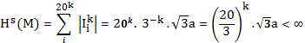
Where s=1 . by Letting , then .
To estimate the lower bound Hausdorff dimension , we will project the Menger sponge on the plane
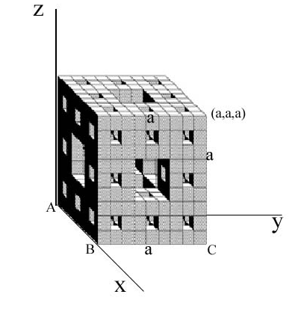
Figure 3 Projection of the Menger sponge M on the -plain
Now ,we denote orthogonal projection onto by proj , so that projection of M onto y-, clearly , proj is a Lipshitz mapping. Thus , by Lemma (2.5) and Lemma (2.6) , we have . As a sequence , we need to compute the value of . It is easy to see that projS is the square ABCD on the - . Therefore , Lemma(2.7), we have
Where n=1. We have , with s=1 where a
Now we will try to compute the Area value of the square ABCD . It's clear that the square ABCD is the base square of the Menger sponge that's mean the value of the side length for ABCD square is a , then
.
Then .
Theorem (3.4)
For the Hausdorff dimension s =1 ,the Hausdorff measure o f the Von Koch set K is as follows:
where a
Proof : From the generation of the Von Koch M, we can see that for each k 0, consists of piece , which were denoted by . Each is called a k-th piece of straight line.
It is clear that the k-th basic pieces of , is a covering of K. Let be the diameter of ,and then through the structure of K and , we have . then by definition of , we can get
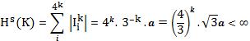
Where s=1 . by Letting , then .
To estimate the lower bound Hausdorff dimension , we will project the Von Koch on the -.
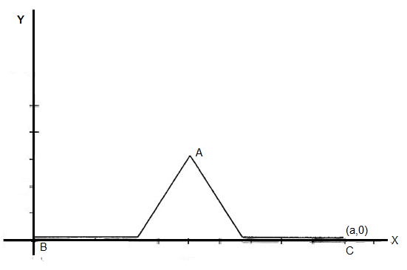
Figure 4 Projection of the Von Koch K on the Line-BC
Now ,we denote orthogonal projection onto by proj , so that projection of S onto -, clearly , proj is a Lipshitz mapping. Thus , by Lemma (2.5) and Lemma (2.6), we have . As a sequence , we need to compute the value of . It is easy to see that projK is the line segment BC on the - . Therefore , by Lemma (2.7), we have
Where n=1. We have , with s=1 where a
Then .

Second , we will try to use the angle as a variable parameter in some fractal shape and estimate lower and upper bounded Hausdorff measure.
Theorem(3.5)
For the Hausdorff dimension s =1 ,the Hausdorff measure o f the 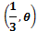 Sierpinski carpet G is as follows:
where 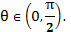
Proof : From the generation of the Sierpinski carpet G, we can see that for each k 0, consists of squares , which were denoted by . Each is called a k-th basic square.
It is clear that the k-th basic triangles of , is a covering of G. Let be the diameter of ,and then through the structure of G and 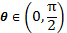,and the fundamental property of triangles we have . then by definition of , we can get
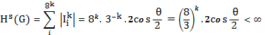 .
Where s=1 . Letting , then .
To estimate the lower bound Hausdorff dimension , we will project the Sierpinski carpet on the -.
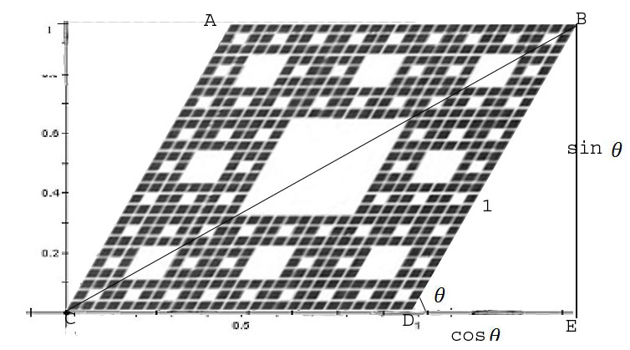
Figure 5 Projection of the Sierpinski Carpet S on the Line-CE

Now ,we denote orthogonal projection onto by proj , so that projection of G onto -, clearly , proj is a Lipshitz mapping. Thus , by Lemma (2.5) and Lemma (2.6), we have . As a sequence , we need to compute the value of . It is easy to see and from the figure above that projG is the line segment CD on the - plus . Therefore , by Lemma (2.7), we have
Where n=1. We have , with s=1 where a
Then
where
Theorem (3.6)
For the Hausdorff dimension s =1 ,the Hausdorff measure o f the Von Koch K is as follows:
where 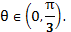
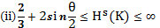 where 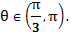

Proof : From the generation of the Von Koch K, we can see that for each
k 0, consists of piece , which were denoted by . Each is called a k-th piece of straight line.
It is clear that the k-th basic pieces of , is a covering of K. Let be the diameter of ,and then through the structure of K and 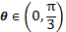, we have . then by definition of , we can get
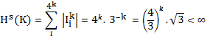
Where s=1 . by Letting , then .
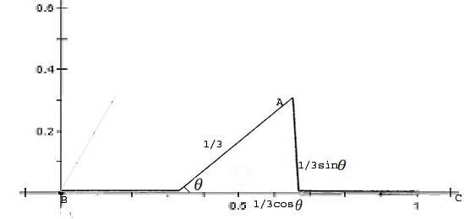
Figure 6 Projection of the Von Koch K on the Line-BC
To estimate the lower bound Hausdorff dimension , we will project the Von Koch on the -.
Now ,we denote orthogonal projection onto by proj , so that projection of S onto -, clearly , proj is a Lipshitz mapping. Thus , by Lemma (2.5) and Lemma (2.6), we have . As a sequence , we need to compute the value of . It is easy to see that projK is the line segment AC on the - . Therefore , by Lemma(2.7), we have
Where n=1. We have , with s=1 where 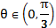.
Proof again From the generation of the Von Koch K , we can see that for each k 0, consists of piece , which were denoted by . Each is called a k-th piece of straight line.
It is clear that the k-th basic pieces of , is a covering of K. Let be the diameter of ,and then through the structure of K and and the fundamental property of triangles, we have . then by definition of , we can get
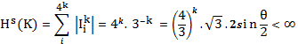
Where s=1 . by Letting , then .
To estimate the lower bound Hausdorff dimension , we will project the Von Koch on the -.
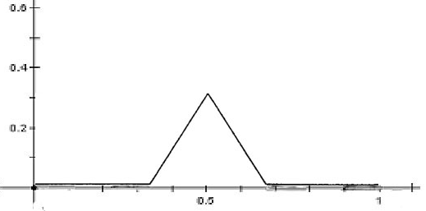
Figure7,a: Projection of the Von Koch set K on the Line-BC before changevalue of
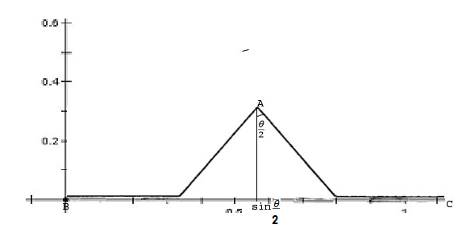
Figure7,b : Projection of the Von Koch set K on the Line-BC after change value of
Now ,we denote orthogonal projection onto by proj , so that projection of S onto -, clearly , proj is a Lipshitz mapping. Thus , by Lemma (2.5) and Lemma (2.6), we have . As a sequence , we need to compute the value of . It is easy to see that projK is the line segment BC on the - . Therefore , by Lemma (2.7) , we have
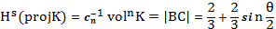
Where n=1. We have 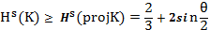 , with s=1 where

References:

Dehua L. and Meifeng D., 2007," The Hausdorff measure of the Attractor of an Iterated Function System", International journal of nonlinear science , Vol.3 No.2,pp.150-154

Falconer K., 2003, " Fractal Geometry Mathematical Foundations and Applications",
John Wiley & Sons, Ltd, England.

Falconer K. , 1997, "Techniques in Fractal Geometry", John Wiley & Sons, Ltd , England .

Gulick D. , 1976," Encounters With Chaos", MeGraw-Hill , USA .

Zuoling Zhou, Min Wu.,1999,"The Hausdorff measure of a Sierpinski carpet", Science in China (SeriesA).29(2),138-144

