A simple Flow Injection-Spectrophotometric Determination of Copper(II) using 4-(6-bromo-2-benzothiazolylazo) Pyrogallol as chromogenic agent

N.A.Nasser
Department of chemistry, College of science, Kufa University

D.N.Taha K.H.Kahdim
Department of chemistry, College of science, Babylon University

Abstract
A simple and facial flow injection method coupled with spectrophotometer detection was developed to determination of copper(II). The FIA system based on the reaction of Copper (II) with 4-(6-bromo-2-benzothiazolylazo) pyrogallol (4-Br-BTAP) at pH 5.8 with an absorption maximum at 570 nm. The optimum FIA variables were investigated. The proposed method has a linear calibration range 0.01-7.0 μg.mL⁻¹ of copper(II) with the regression whereas the observed detection limit was 0.008 μg.mL⁻¹ and the percentage of recovery of 103.64%. The proposed method was shown good precision with relative standard deviations was 0.96%. The sampling frequency was 120 determinations per hour. The method has been applied to the determination of copper in filling and metallic wire.
Keywords: Flow Injection Spectrophotometric, Determination, Copper.
الخلاصة
طريقة حقن جرياني بسيطة وسهلة تم دمجها مع الطريقة الطيفية لتقدير ايون النحاس الثنائي .ان نظام الحقن الجرياني يعتمد على تفاعل ايون النحاس الثنائي مع الكاشف العضوي 4-(6-برومو-2-بنزوثيازوليل ازو) بايروگالول(4-Br-BTAP) عند pH=5.8 وعند الامتصاص الاعظم 570 نانومتر. متغيرات الطريقة المتبعة بالحقن الجرياني تم دراستها. مدى الخطية لمنحنى المعايرة كان بحدود 0.01-7.0 مايكروغرام. مل⁻¹ من ايون النحاس الثنائي, وان قيمة حد الكشف كانت 0.008 مايكروغرام. مل⁻¹, ونسبة الاستيعادية %103.64 . الطريقة المقترحة ذات دقة عالية إذ ان قيمة الانحراف المعياري النسبي تساوي %0.96 . معدل قياس النماذج بالساعة كان 120 تقدير بالساعة. تم تطبيق الطريقة لتقدير النحاس في حشوة اسنان وسلك معدني.
Introduction
Flow injection systems are frequently preferred over batch procedures due to the advantages obtained. These advantages include high analytical frequency, ease of association with several types of detectors, good precision and accuracy, reduced disposal costs and a higher degree of safety for the operator in the handling of the solutions(Miranda et al., 2002; Valcarcel & Castro, 1991; Fang, 1993). Procedures involving flow injection systems that include derivatization reactions, solid-phase extraction, liquid–liquid extraction, sensors and enzymatic reactions have attracted scientists due to the growing demand for more sensitive and more selective analytical methodologies. These procedures involve the use of complexing reagents associated with solid supports employed for the formation of detectable species and the development of extraction procedures. Among these reagents, the benzothiazolylazo group deserve special attention because of its capacity to form complexes with several metals(Teixeira et al., 1999; Costa et al., 1998; Teixeira et al., 1998; Shibata, 1961). This property is shared with reagents widely used in several fields within analytical chemistry.
Copper is available in nature in a free state in the form of sulfides, chlorides and carbonates. Copper is utilized in electric industries and in industrially useful alloys(Seung-Hynutee & Hu-Sennchoi, 2003; Soyak, 1998; Pourreza, 2006). Biologically, copper plays an important role in carbohydrate and lipid metabolism (Greenwood & Earnshow, 1984; Flores et al., 2001; Flores et al., 2004) and is vital and toxic for many biological systems depending on it's concentration(Greenwood & Earnshow, 1984; Flores et al., 2001; Flores et al., 2004; Scheinberg & Ceruloplasmin, 1973). It's essential in small amounts for synthesis of hemoglobin and is essential constituents of about thirty enzymes and glycoprotein and it also promotes iron absorption in the gastrointestinal system. Copper is involved in the transportation of iron from tissues into plasma. It helps to maintain the myelin in the nervous system which is important in the formation of bone and brain tissues and it's necessary for other many important functions. Copper deficiency causes disease such as anemia while it's excess causes "Jaundice" and "Wilson Disease". As a pollutant, copper is of particular concern because of its high degree of toxicity of aquatic organisms.
Because of that, determination of trace amounts of copper is becoming increasingly in environmental pollution(Göksungur et al., 2005; Kim et al., 2001; Taher et al., 2005; Bakireioglu et al., 2004; Jainet al., 1997). Several analytical techniques have been monitored for the determination of copper(II) in different matrices, they include spectrophotometry(Yamini & Tamaddon, 1999; Shishehbore et al., 2005; Ankieewicz et al., 1999; Ghaz et al., 2006; Rekha et al., 2007), chemiluminescence(Sunda and Huntsman, 1991), atomic absorption spectrometry(Tautkus et al., 2004), Inductive coupled plasma–atomic emission spectrometry(Ferreira et al., 1998), Neutron activation analysis(Dybczyfiski et al., 1989) and flow injection analysis(Lazaro et al., 1984; Turkie, 2002).
In this paper, a simple, sensitive and rapid flow injection spectrophotometric method for the determination of copper in different matrices was explianed. It is based on the complexation between 4-Br-BTAP and copper(II) to form violet complex which is detected at 570 nm.
Experimental

Chemicals
All chemicals were used of analytical grade unless stated otherwise. All solutions were prepared with distilled water.
- The standard stock solution of copper (II) 100 μg.ml⁻¹ was prepared by dissolving 0.0392 g of CuSO₄.5H₂O (BDH) in less amount of distilled water then was completed in a 100-ml volumetric flask with ethanol. Working solutions were prepared freshly by appropriate dilution, using ethanol, of the stock solution.
- 4-(6-bromo-2-benzothiazolylazo)Pyrogallol (Nasser et al., ) (4-Br-BTAP)(0.75×10⁻⁴ M). Prepared by dissolving (0.0028)g of 4-Br-BTAP in 100ml of absolute ethanol (Hopkin & Williams).
Apparatus
• UV-Visible Spectrophotometer (Optima, Japan) with 10.mm flow through cell was used for absorbance measurements at570 nm.
• Teflon tubes and coils, home made.
• 4-Port Injection Valve, home made.
• Peristaltic Pump, 4-Channals, Ismatec, Switerland.

Selection of Optimized Conditions Using Univariate Method
This method was applied to select the optimum conditions for the FI spectrophotometric determination of copper(II). For this reason, a variable was modified while maintaining the other variables at their constant values(chosen by random). Then, by maintaining that variable at its optimum value, another was modified; all variables were optimized via this method(Vicente et al., 1994). Table 1 shows over which the variables involved in the FI system were studied and their optimum values.
All optimum values were chosen by judging from the highest peak height.

Table 1: Univariate optimization of chemical and FIA variables

Variable Studied range Optimum value
Wavelength(nm) 190-1100 570
pH 1.0- 6.0 5.8
Mixing coil length(cm) 30-125 50
Reagent concentration(mol.L⁻¹) 0.5×10⁻⁴ – 2.0×10⁻⁴ 0.75×10⁻⁴
Flow rate(ml.min⁻¹) 0.575-5.5 2.4
Injection volume(µl), for;
Reagent 117.75-274.75 196.25
Cu(II) 157-417 392.5

Results And Discussion
Absorption Spectra
The absorption spectra of the copper–4-Br-BTAP complex and corresponding 4-Br-BTAP reagent blank were shown in Fig. 1. It can be seen that the complex has the maximum absorption at 570 nm and the reagent blank solution was maximum absorption at 460 nm. Therefore, absorbance was measured at 570 nm.
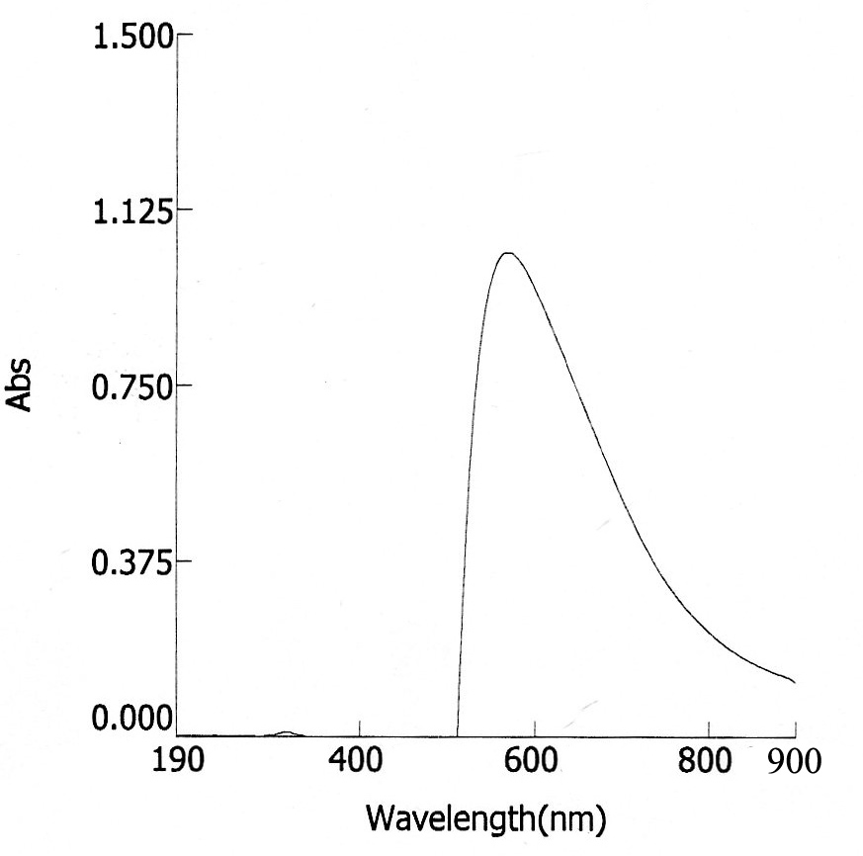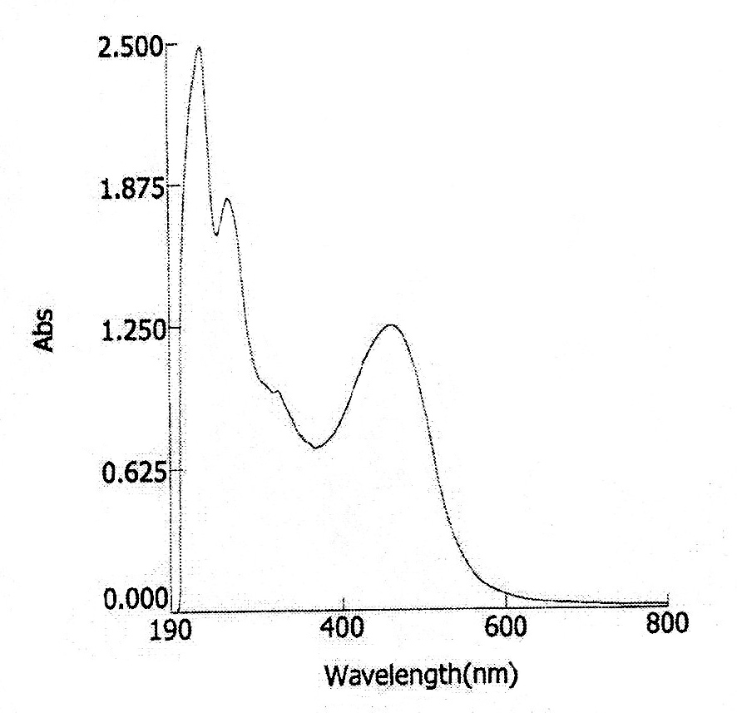

(a) (b)

Fig. 1: Absorption spectra of (a) copper–4-Br-BTAP complex and (b) 4-Br-BTAP reagent blank .

Manifold design
Figure 2 shows a flow diagram of the FIA system, which is a merging- zone system with carrier stream(ethanol) has a flow rate of 2.4 ml.min⁻¹.
Loop 1(L1) and loop 2(L2) were loaded by reagent and Cu(II) respectively, through injection valve(V). After passing of carrier, mixing of the metal ion and the reagent was taken place in a reaction coil.
The resulting colored complex was passed through the flow cell in the spectrophotometer where the absorbance was measured at 570 nm and the signal was recorded .

Fig. 2: Schematic diagram of the flow-injection system. CS: carrier stream, P: peristaltic pump, V: injection valve, L1: loop of reagent loading, L2: loop of Cu(II) loading, r.c: reaction coil, D: detector, R: reorder, W: waste.
Chemical Variables
Effect of 4-Br-BTAP concentrations
The concentrations(0.5, 0.75, 1.0, 1.25, 1.5, 1.75, 2.0) ×10⁻⁴ mol.L⁻¹ of 4-Br-BTAP were studied. Higher concentrations were resulted in a higher negative peak of the reagent blank. Consequently, a concentration of 0.75×10⁻⁴ mol.L⁻¹ of 4-Br-BTAP was chosen as optimum.
Effect of pH
Effect of pH on the peak height of copper complex was studied over the range 1.0-6.0 . pH more than 6.0 was avoided because of reagent solution gives distinct color change due to changing of its structure⁽³¹⁾, then was resulted in a higher negative peak of the reagent blank. Over the studied range absorbance increased as pH increased and pH=5.8 was chosen as optimum.
Physical Variables
Effect of Flow rate
The effect of flow rate was investigated in the range (0.575–5.5)mL.min⁻¹ using 5 μg.mL⁻¹ of Cu (II), 0.75×10⁻⁴ mol.L⁻¹ of 4-Br-BTAP at pH=5.8 . The flow rate of 2.4 mL.min⁻¹ was given the highest response. Figure 3 shows the variation of absorbance versus the total flow rate for the system.

Fig. 3: The variation of absorbance of copper complex versus the flow rate of the carrier stream.

Effect of Cu(II) Volume
The effect of Cu(II) volume was studied as a set of injected volumes of copper(II) varied between 157-417μl by changing the length of metal ion loop. Volume of 392.5 μl of copper(II) was selected as an optimum. Figure 4 shows the variation of absorbance versus copper(II) volume.

Fig. 4: The variation of absorbance versus copper (II) volume.

Effect of Reagent Volume
The effect of reagent volume was studied between 117.75-274.75 μl by changing the length of reagent loop. Volume of 196.25 μl of reagent was selected as an optimum. Figure 5 shows the variation of absorbance versus reagent volume.

Fig. 5: The variation of absorbance versus reagent volume.

Effect of mixing coil
Coils of variety lengths of (30, 40, 50, 60, 75, 100, 125) cm were studied. Fig. 6 shows that at higher lengths the absorbance was decreased due to increasing dispersion of the zone of complex. Optimum value of mixing coil length was chosen at 50 cm.

Fig. 6: The variation of absorbance versus mixing coil length.

Calibration Curve and Statistical Data
Using the proposed FI manifold for the determination of copper under the optimum conditions, the linear calibration graph over the range of 0.01 – 7.0 μg.ml⁻¹of copper standard solution was established, Fig. 7, which could be expressed by the regression equation(Miller & Miller; 1993) y = 34.35x+28.20 where y represents the peak height in mV and x is copper concentration in μg.ml⁻¹. Other analytical characteristics of the procedure were summarized in table 2.

Fig. 7: The calibration curve for the determination of copper (II).

Table 2: Analytical characteristics of the proposed procedure (N= no. of determinations)
Analytical parameter | Value
Molar absorptivity | 3.75×10³ L.mol⁻¹.cm⁻¹
Correlation coefficient (r) | 0.9949
Linear dynamic range | 0.01 – 7.0 μg.ml⁻¹
Limit of detection, LOD | 0.008 μg.ml⁻¹
Percent Relative error | +3.64
Percent Recovery | 103.64
Percent relative standard deviation | 0.96% (N= 8)
Time of reaction | 28 sec.

Repeatability
Repeatability was established through re-injection the same concentration of both copper(II) and 4-Br-BTAP. Figure 8 shows the repeatability of copper complex. The efficiency of the proposed FI unit for the determination of copper was reflected from the results of repeatability.

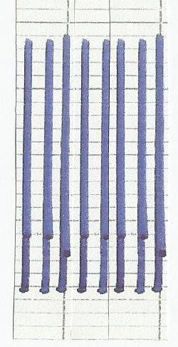

Fig. 8: Repeatability of copper complex. Cu(II)= 5 μg.ml⁻¹ , R=0.75×10⁻⁴ mol.L⁻¹
Dispertion
Dispertion(D) of applied method was determined according to relation(D=Hº/Hmax), where Hº represent peak height(mv) of complex without despertion(resulted from injection of, premixed in beaker, Cu(II) with 4-Br-BTAP) and Hmax represent peak height(mv) with despertion (resulted from our applied method). Figure 8 shows two peaks of complex were obtained by application these two cases. After applying the last relation, value of D=1.2 . This value was indicated that low dispertion accompanied the determination of copper(II) using flow injection unit which was proposed.

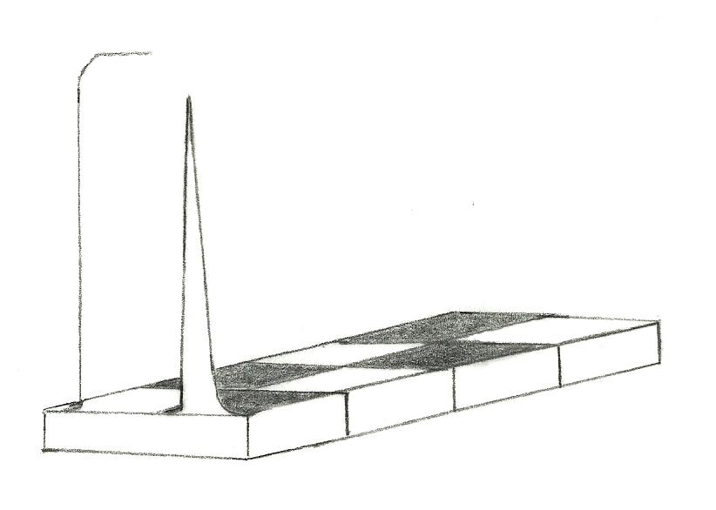
Signal without dispertion
Signal with dispertion
Abs.
mv
Time, sec.

Fig. 8: Dispertion of copper complex

Effect of Interfering Ions
The effect of seriously interfering cations(Pd²⁺, Cd²⁺, Fe³⁺ and MoO₄²⁻) for the determination of copper (II) at was studied. Table 3 shows the effect of these foreign ions on the determination of copper(II).
Suitable masking agents were used to mask its effects at three concentrations. No effect of these interfering ions on the determination of copper(II) at lowest concentration which was obeyed to the working range as indicated by interference(mv) and no masking agents were used as refereed by straight line(—).
Anions not affect on the determination of copper (II) since 4-Br-BTAP reacts only with cations especially at concentrations not exceeds the linear range.

Samples analysis
The proposed method was applied to the determination of Cu(II) in filling and wire used in the industry of tiers of cars. The samples digested according to applied procedure(Miller & Miller, 1993). The results were given in table 4 compared with those obtained by atomic absorption spectrophotometry, ABS. It is shown that the results obtained by the proposed FIA agreed well with those obtained by AAS.

Table 3: Masking of seriously interfering cations which affect on the determination of copper(II).
Best masking agent  mol. l⁻¹[ Conc. ] ، μl(Vol. ) | Interference  (cm) | Interferent  μg.ml⁻¹ | Cu(II)  μg.ml⁻¹
——  NH₄SCN (50) , [0.001]  NH₄SCN (50) , [0.0125] | 0.0  0.6  1.1 | 0.5  5 Pd²⁺  10 | 0.5  5  10
——  Ascorbic acid (100) , [0.5]  Citric acid (100) , [0.5]  5-sulphosalcylic acid (200),[0.1] | 0.0  1.3  1.8 | 0.5  5 Fe³⁺  10 | 0.5  5  10
——  Citric acid (100) , [0.05]  Citric acid (100) , [0.1] | 0.0  -1.2  -0.7 | 0.5  5 MoO₄²⁻  10 | 0.5  5  10
——  Ascorbic acid (100) , [0.0083]  Ascorbic acid (50) , [0.03] | 0.0  1.2  1.1 | 0.5  5 Cd²⁺  10 | 0.5  5  10

Table 4: Comparative determination of copper in filling and wire by using the proposed FIA and AAS methods*
sample | Proposed FIA method(%) | AAS(%)***
Filling(Rua Funchal 376)* * | 23.5±0.05 | 23.5±0.03
Wire | 0.115±0.009 | 0.100±0.006
*Average of three determinations, for FIA and AAS, at 95% confidence level.
**Provided from Degussa Dental Ltd., Brazil. Sample Composition Ag (46.5%), Sn (30%), Cu(23.5%).
*** Calibration method.
Conclusion
The proposed method has been satisfactorily applied to the determination of Cu(II) in samples of different matrices with high repeatability and low dispertion. In addition, the use of 4-Br-BTAP as complexing agent for copper determination using the proposed FIA device is simple and inexpensive which has been proven to be highly precise (RSD of less than 2%), sensitive (LOD = 0.008 μg.ml⁻¹), accurate (%recovery of 103.64) and rapid with a sample throughput of 120 h⁻¹. The proposed FIA system also consumed small amount of chemicals and reagents, with lower waste production than the batch-wise method.

References
Ankiewicz , B. ; Ptaszynski B. and Turek, A. Polish J. of Environmental
Bakireioglu, Y. ; Bakireiouglu, D.; Akman, S. Anal. Lett., 37 (2004) 1937
Costa, A. ; Teixeira, L. Jaeger, H. ; Ferreira, S. Mikrochim. Acta, 130 (1998) 41.
Dybczyfiski, R.; Wasek M. and Maleszewska, H.; Radioanal. J. Nucl. Chem., 130 (1989) 365
Fang, Z. (1993). Flow Injection Separation and Preconcentration, John Wiley, Weinheim, p.259
Ferreira, S.; Santos, H.; Ferreira, J.; Araújo, N.; Costa, A. and Jesus, D. ( 1998) Braz. Chem. Soc., 9 :525-530
Flores, E.; Costa, A.; Barin, J.; Dressler, V.; Paniz J. and Martins, A. (2001). Spectrchimica Acta Part B: Atomic Spectr., 56, 1875
Flores, E.; A. Saidelles, M. Mesko, M. Pedroso, V. Dressler, C. Bittencourt and A. Costa, Microchem. J., 77, (2004)113.
Ghaz, S. ; R. El-Shazly, M. El-Shahawi, G. Al-Hazmi, and A. El-Asmy, 3( 2006) 140-150
Göksungur, Y.; S. Uren, U. Güvenç, Bioresource Technol. 96 (2005) 103
Greenwood N. and Earnshow, A. (1984). Chemistry of the Elements, Pergamon, New York.
Jain. V.; S. Sait, P. Shrivastav, Y. Agrawal, Talanta, 45 (1997) 397
Kim, J. ; S. Akeprathumchia, S. Wickramasinghe, J. Membr. Sci., 182 (2001) 161
Lázaro, F. ; M. Castro and M. Valcárcel, Anal.Chim.Acta, 165, ( 1984) 177-185.
Miller J. and Miller, J. “Statistics for Analytical chemistry”, 3rd ed., Ellis Horwood Limited, England, (1993) 115, 222.
Miranda, C.; Carrilho, E. ; Gervasio, A.; Giné, Quim. M. Nova, 25 (2002) 412.
Nasser, N.; K. Kahdim and D. Taha, Journal of Oleo Science, 61(2012).
Pourreza, N. ; K. Ghanemi, Spectroscopy Lett., 39 (2006) 127
Rekha, D.; K. Suvardhan, K. Suresh Kumar, P. Reddyprasad, B. Jayaraj and P. Chiranjeevi, J. of Serb. Chem. Soc., 72( 2007) 299-310
Scheinberg, I. ; Morell and A. Ceruloplasmin, G.L. Eichhorn, Ed., “Inorganic Biochemistry”, vol. 1, Elsevier, New York, 1973, p. 306.
Seung-Hynuntee, Hu-Sennchoi, Bull. Korean Chem. Soc., 21 (2003) 1705
Shibata, S. Anal. Chim. Acta, 25 (1961) 348.
Shishehbore , M.; N. Nasirizadeh , A. Shabani and M. Tabatabaee , Canadian J. of Analytical Sciences and Spectroscopy, 50 ( 2005)130-134.
Soyak, M. Frensen's Environ. Bull., 7 (1998) 383
Studies, 8( 1999) 35-38
Sunda W. and Huntsman, S. Mar. Chem., 36 (1991) 137.
Taher, M.; S. Moberakeh, A. Mohamedesi, Turk. J. Chem., 29 (2005) 17
Tautkus, S. ; R. Kazlauskas,A. Sareiva, CHEMIJA, 15(2004)49-52
Teixeira, L. ; A. Costa, S. Ferreira, M. Carvalho, M. Freitas, J. Braz. Chem. Soc., 10 (1999) 519.
Teixeira, L.; A. Costa, A. Queiroz, A. Amorim, O. Bomfim, S. Ferreira, Mikrochim. Acta, 129 (1998) 103.
Turkie, N. Iraqi J. of Science , 43 (2002) 37-78.
Valcarcel, M.; Castro, M. (1991). Non-Chromatographic Continuous Separation Techniques, Royal Society of Chemistry, Cambridge, p.290
Vicente, A.; A. Arranz, J. Moreda and J. Arranz, Anal. Chem. Acta, 87 (1994) 298.
Yamini Y. and Tamaddon, A. Talanta, 49, 119 (1999).
Zenki, M. Analyst, 104, (1979) 323.

