Record Values of Marshall – Olkin Extended Weibull Distribution

Kareema Abed AL-Kadim
Babylon University ,College of Education for Pure Sciences
Marwa Jabar
Babylon University , College of Education

Abstract.
In this paper we discuss the Marshall – Olkin Extended Weibull (MOEW)Distribution
as the probability density function(p. d. f.) of four parameters .we use upper record values from the MOEWD and we establish some new recurrence relations between the single moments from the MOEWD(when scale (α=1)) as well as between the double moments. Therefore we derive best linear unbiased estimators(BLUE) of three parameters (scale, location, shape) of Marshall – Olkin Extended Weibull (MOEW)Distribution .
الخلاصه:
في هذا البحث تناولنا توزيع مارشيل –أولكن الموسع لويبل لداله الكثافة الاحتمالية بار بعه معلمات .استخدمت القيم المسجلة العليا لهذا التوزيع ,وإنشائنا علاقات تكرارية بين عزوم هذا التوزيع وعندما تكون معلمة القياس 1=α مع العزوم الثنائية .وكذلك تم اشتقاق المقدرات الخطية غير المتحيزة لثلاثة معلمات لهذا التوزيع وعندما 1=α.

Keyword: Marshall – Olkin Extended Weibull (MOEW)Distribution, Upper record values, Single moment, double moment, Best Linear Unbiased Estimators(BLUE)
1.Introduction
Record values arise naturally in many real life applications involving data relating to weather, sports, economics and life testing studies. Many authors have studied record values and associated statistics; for example, see Chandler(1952), Ahsanullah (1980, 1988, 1990, 1993, 1995), and Arnold, Balakrishna and Nagaraja (1992, 1998). Ahsanullah (1980, 1990), Balakrishnan and Chan (1993), and Balakrishnan, Ahsanullah and Chan (1995) have discussed some inferential methods for exponential, Gumbel, Weibull and logistic distributions. Marshall and Olkin introduced a new family of distribution in an attempt to add parameter to a family of distributions. Krishna^{b}(2011) introduce Marshall – Olkin Extended Uniform (MOEU)Distribution
The Weibull distribution gives the distribution of lifetimes of objects. It is also used in analysis of systems involving a weakest link. Weibull distributions may also be used to represent manufacturing and delivery times in industrial engineering problems, while it is very important in extreme value theory and weather forecasting. It is also a very popular statistical model in reliability engineering and failure analysis,
while it is widely applied in radar systems to model the dispersion of the received
signals level produced by some types of clutters. Furthermore, concerning wireless communications, the Weibull distribution may be used for fading channel modelling, since the Weibull fading model seems to exhibit good fit to experimental fading channel measurements. Sultan and Moshref (2000) have obtained the best linear unbiased estimators (BLUE) for the location and scale parameters of record values from the generalized Pareto distribution. Sultan (2007) calculating best linear unbiase estimators of the location and scale parameters of inverse Weibull distribution.Sultan (2010) we discuss lower record values from the inverse distribution (IWD) in two case .1) when the shape parameter is known and 2) when both of the shape and scale parameter are unknown. And we derive best linear unbiased estimators (BLUE) of scale parameters of inverse Weibull distribution (IWD).Mubark (2011)derive BLUEs of three parameters of Frechet distribution.
Marshall and Olkin [ 1997] introduced a new family of distributions in an attempt to add a parameter to a family of distributions. Let F(y) = P(Y > y) be the survival function of a random variable Y and α > 0 be a parameter. Then
(y;α ) =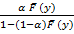 : < y< , α > 0; (1)
is a proper survival function. (y;α ) is called Marshall-Olkin family of distributions
by ( Krishna^{b} 2011).
The probability density function (p.d.f.) corresponding to (1) is given by
g (y;α ) =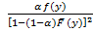 ; - < y < , α > 0
where f(y) is the p.d.f. corresponding to (y). The hazard (failure) rate function is given by
h(y,α)=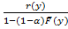, where r(x) =.
In our paper, we introduce the Marshall – Olkin Extended Weibull(MOEWD) of four parameters (two scale, one shape, one location) in Section(2). Section(3) we discuss upper record values from the Marshall – Olkin Extended Weibull (MOEW) distribution, we deduce some new recurrence relations of single and double moments of record values from weibull distribution of three-parameters(scale, shape, location) when scale α=1.in Section (4)we derive BLUEs of (MOEW) distribution (when α=1).in Section (5) Conclusion.
2. Marshall – Olkin Extended Weibull (MOEW)Distribution
Let y follows W(c ,β ,θ) distribution with survival function, then
(y)=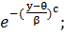 y θ , c 0, θ 0 (1)
We get a new distribution denoted by MOEW (α , c ,β ,θ) with survival function
(y,α,c,β,θ)=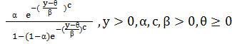

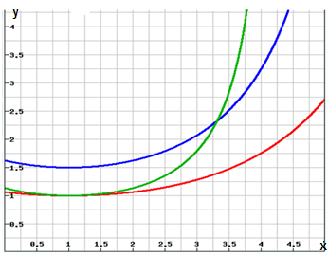

Figure 1:Graph of (y) for c=2,β=4,ɵ=1 and
for various value of α
The probability density function(p. d. f.) corresponding is (1.1) given by
g(y ,α ,c, β ,θ)=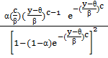 ,y

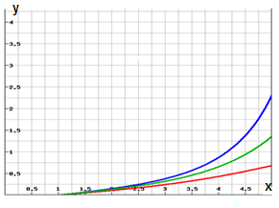
Figure 2:Graph of (y) for c=2,β=4,ɵ=1
and for various value of α
the graphs of survival function and distribution function p. d .f are drawn in Figures 1 and 2 .The shape of the (p. d. f.) g(y ,α ,c ,β ,θ) depends on parameter α .Namely, if increasing function on (α, c ,β ,θ) with.
a) g(0,α,c,β,θ)=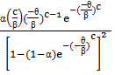
b) g(c, α, c ,β ,θ)=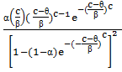
c) g(β, α ,c ,β ,θ)=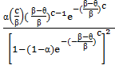
d) g(θ, α ,c ,β ,θ)=0
Otherwise, if α increasing function as above results.
The hazard rate function of a random variable y with MOEW (α ,c ,β ,θ) distribution is
h(y,α,c,β,θ)=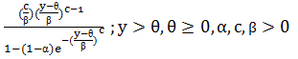
For α hazard rate is initially increasing and there exists an interval where it
changes . For αthe graph of hazard rate
function is drawn in Figure 3.
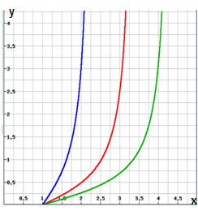
Figure 3:Graph of h(y) for c=2,β=4,ɵ=1
and for various value of α
3.Upper Record Values
Let be the n upper record values from the MOEWD of four-parameters. The p. d. f .of the is
_{n}(y)=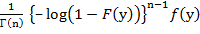 (2)
= 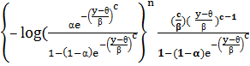
the joint p. d. f. of y_{u (m)} and y_{u (n)}is given by
f_{m,n}(x,y)=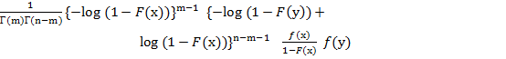
(3)
⁼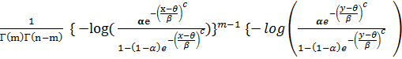

+log( 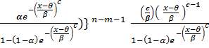
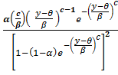 ;
Theorem :(3.1)
Let ,…,be the upper record values from the Marshall – Olkin Extended Weibull (MOEW)distribution when α=1)with density function

f (y)=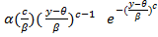 (4)
F(y) =1-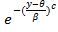 (5)
Then for n=1,2,…, and k=1,2,…
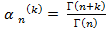 (6)
And for 1≤ m
consequently,
= E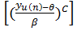= n
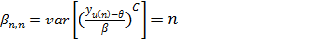
proof : From (2),(4),(5 ),we have
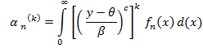
= 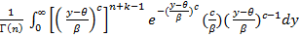

= 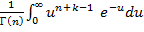
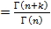
Hence ,we obtain (6 ).For proving (7 ) ,consider
=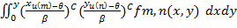
Where
I (y )=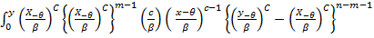dx
=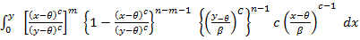
=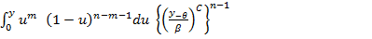
=B(m+1,n-m) 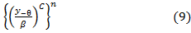
Substituting the expression for I(y)in (9)into(8)
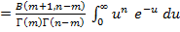
=m(n+1)
Note: For the Weibull distribution, it is easily observed that
By using this relation, we establish below some simple recurrence relations satisfied by the single and product moments of record values. such recurrence relations have been established for moment of order statistics from different distributions .
Theorem (3.2)
For n=1,2,…,and k=1,2,…,
(11)
Proof :Let us consider
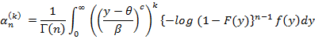
Upon integration by parts, we obtain
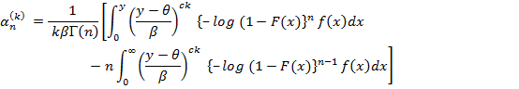
Then,(12) follows by rearranging (11)
Theorem (3.3)
For k ,L,m=1,2,…,
and for 1
Proof : For proving (13),Let us consider
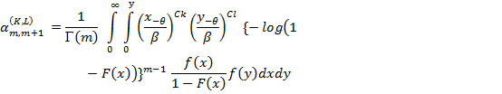
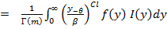 (15)
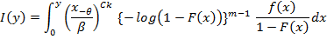
Upon integration by parts, we obtain
I(y)=(
Substituting the above expression for I(y)into( 15 ),we obtain
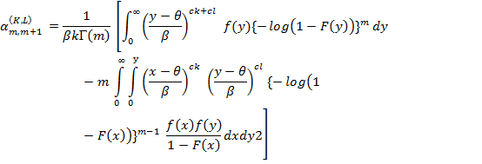
The relation in (16)is simply obtained by rearranging(25).
Next, for proving(14),let us write for 1mn-2
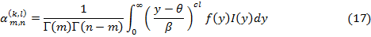
Where
I(y)=
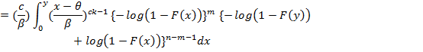
Upon integration by parts ,I(y) can be written as
I(y)=
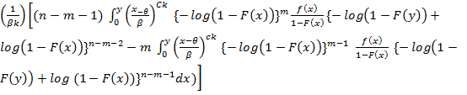

Substituting the expression for I(y)into eq.(17),we obtain
The relation in (18 )is simply obtained by rearranging (14)
4-Best Linear Unbiased Estimators of Marshall – Olkin Extended Weibull Distribution
Let be a random sample from the absolutely continuous cdf F(y; ), where is the location parameter and > 0 is the scale Parameter and c is the shape parameter. Let Y denote the vector of the order statistics in the sample. We
will now obtain estimators of and which are the best among the
unbiased linear functions of the components of Y.
Let X 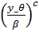 be the standardized population random variable with c.d.f.
F₀(x) = F(x; 0,1,1). Clearly, F₀ is free of the parameters and, hence, the means and the covariances of the order statistics from the X population, _{i ;n} and _{i;j;n} are free of them as well. Let X denote the vector of X-order statistics corresponding to Y. Then, it is clear that

and
COV(Y_{i; n} ,Y_{j; n} ) = (20)
for 1 ≤ i, j < n.
Let µ be the mean vector of X, and = (θ,β,c ) be the vector of the unknown
parameters. Further, let 1,α be an( n x 1)vector whose components are all l's. Then the n equations in (19) can be expressed in the matrix form as
E(Y) = A θ
where the( n x 3) matrix A = (1, µ , α ) is completely specified. Also, (20) can be put in the form
cov(Y) =² (21)
where cov(y) represents the covariance matrix of y, and
the covariance matrix of X, is known.
Suppose the goal is to choose θ and β, c so that we minimize the quadratic form
Q(θ) = (y – A θ)'∑⁻¹ (y – A θ)
= yʹ∑⁻¹ y - 2θ 1´ ∑⁻¹ y - 2β µ´∑⁻¹ y - 2Cά ∑⁻¹y + θ² 1´∑⁻¹ 1
+ 2θβ µ´∑⁻¹ 1 +β²µ´∑⁻¹ µ + 2βC µ´∑⁻¹ α +C² ά∑⁻¹ α+2θCά∑⁻¹ 1.
If Q(θ) is minimized when θ = , we say that and are the best linear unbiased estimators (BLUEs) of θ and β, C and equating to 0, we obtain the normal equations as
(1´ ∑⁻¹1)θ+(μ´∑⁻¹1)β+(ά∑⁻¹ 1)C= 1´∑⁻¹ y
( µ´∑⁻¹1)θ+(µ´∑⁻¹µ)β+(µ´∑⁻¹α)C= µ´∑⁻¹ y
( ά∑⁻¹1 )θ+(µ´ ∑⁻¹α)β+(ά∑⁻¹α)C= ά∑⁻¹ y
On solving these equations for θ and β ,C we obtain the solution
= - 1´ Y , = ά Y , = µ´ Y (22)
Where Г * is askew-symmtric matrix of
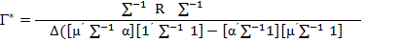
Where
∆ = (ά∑⁻¹α) (µ´∑⁻¹α)(1´∑⁻¹1)²(µ´∑⁻¹µ )--(ά∑⁻¹α) (µ´∑⁻¹α)(1´∑⁻¹ 1)(µ´∑⁻¹1
-- (ά∑⁻¹α)(ά∑⁻¹ 1)(µ´∑⁻¹1)(1´∑⁻¹1)(µ´∑⁻¹µ)+(ά∑⁻¹α)(ά∑⁻¹1)(µ´∑⁻¹1)³
-- (ά∑⁻ ¹1)² (µ´∑⁻¹µ)(µ´∑⁻¹α)(1´∑⁻¹1)+(ά∑⁻¹1)³(µ´∑⁻¹µ)(µ´∑⁻¹1)+
3(ά∑⁻¹1)(µ´∑⁻¹α)²(µ´∑⁻ ¹1)(1´∑⁻¹1) – 2(ά∑⁻¹1)²(µ´∑⁻¹α)(µ´∑⁻¹1)²
– (µ´∑⁻¹α )³(1´∑⁻¹1)²
and
R= - 1´(ά∑⁻¹α)(µ´∑⁻¹α)²(1´∑⁻¹1)(µ´∑⁻¹µ)1´+2α(µ´∑⁻¹µ)(ά∑⁻¹α)(µ´∑⁻¹α)
(1´∑⁻¹1)(µ´∑⁻¹1)1´µ(ά∑⁻¹α)(ά∑⁻¹1)(µ´∑⁻¹1)²(µ´∑⁻¹α)1´+α(ά∑⁻¹ 1)
(µ´∑⁻¹µ)(µ´∑⁻¹ α)²(1´∑⁻¹1)1´3α (µ´∑⁻¹α)³(µ´∑ ⁻¹1)(1´∑⁻¹1)1´+α(ά∑⁻¹ 1 )
(µ´∑⁻¹ α)² (µ´∑⁻¹1)²1´+1(µ´ ∑⁻¹α)⁴(1´∑⁻¹1)1´+1(ά∑⁻¹α)(µ´∑⁻¹α)(1´∑⁻¹1)(µ´
∑⁻¹µ)(ά∑⁻¹ 1 )µ µ(ά∑⁻¹α)(µ´∑⁻¹α)(1´∑⁻¹1)(µ´∑⁻¹1)(ά∑⁻¹1)µ´ α(ά∑⁻¹ α )
(ά∑⁻¹1) (µ´∑⁻¹ 1)(1´∑⁻¹1)(µ´∑⁻¹µ)µ´µ(ά∑⁻¹α)(ά∑1)²(µ´∑⁻¹1)²µ´α(α ´
∑⁻¹1)²(µ´∑⁻¹µ) (µ´∑⁻¹α)(1´∑⁻¹1)µ´+4α(ά∑⁻¹1)(µ´∑⁻¹α)²(µ´∑⁻¹1)(1´ ∑⁻¹
1)µ´α(ά∑⁻¹ 1) (µ´∑⁻¹α)(µ´∑⁻¹1)²µ´1(µ´∑⁻¹α)³(1´∑⁻¹1)
(ά∑1)µ´α(ά∑⁻¹ 1 ) (µ´∑⁻¹ µ ) (ά∑⁻¹µ)(1´∑⁻¹1)(µ´∑⁻¹1)ά.
Г**=∆⁻¹(∑⁻¹S∑⁻¹) is askew-symmtric matrix of
Г***=∆⁻¹(∑ ⁻¹U∑⁻¹) is askew-symmtric matrix of
where
S=µ(1´∑⁻¹1)(ά∑⁻¹1)(µ´∑⁻¹1)ά +1(1´∑⁻¹ α)²(µ´∑⁻¹ 1)µ´α(µ´∑⁻¹α)(1´∑⁻¹1) (µ´∑⁻¹1)1´ 1(µ´∑⁻¹α)(ά∑⁻¹1)(µ´∑⁻¹1)1´ .
and
u =α(1´∑⁻¹1)²(µ ´∑⁻¹µ)άα(1´∑⁻¹1)(µ´∑⁻¹1)²ά1(ά∑⁻¹1)(1´∑⁻¹1)(µ ´∑⁻¹ µ)ά+1(ά∑⁻¹1)
(µ´∑⁻¹1)²ά1(ά∑⁻¹1)²(µ´∑⁻¹1)µ´+µ(ά∑⁻¹1)² (µ´∑⁻¹ 1 ) 1´ +α(ά∑⁻¹1)(µ´∑⁻¹1)(1´∑⁻¹1)µʹ
α(µ´∑⁻¹α)(1´∑⁻¹1)µ´+α(µ´∑⁻¹α)(1´∑⁻¹ 1) (µ ´∑⁻¹1)1´+1(ά∑⁻¹1)(µ´∑⁻¹1)(µ´∑⁻¹α)1´
using (21 ),( 22), it is easily seen that
var( )=var(-1´ y)=β² 1´ 1 /∆
var( )=var(ά y )= ( α /∆
var(y)= µ/∆
cov( , =cov(1´ Г* y ,άy)= -β²1´α /
cov(, )=cov( -1´y, µ´y)= -1´µ /∆
cov( , )=cov( ά ,µ´ )= µ/∆
5.Conclusion.
We note that the Weibull distribution of three parameters is a special case of Marshall – Olkin extended Weibull distribution when α=1,α is a scale parameter. and we drive best linear unbiased estimators (BLUEs) of Marshall – Olkin extended Weibull distribution of three parameters.

References
Ahsanullah ,M.,(1980) Linear prediction of record values for the two parameter
exponential distribution, Ann. Inst. Statist. Math., 2, 363-368.
Ahsanullah ,M., Record values. In Balakrishnan N.and Basu A.P. (eds).(1995)
The Exponential Distribution: Theory, Methods and Applications, Gordon
and Breach Publishers Newark, New Jersey, 279-296.
Arnold B. C. Balakrishnan N. and Nagaraja, H. N. (1992). A First Course in
Order Statistics, John Wiley & Sons New York.
Arnold B. C. Balakrishnan N. and Nagaraja, H. N. (2008). A First Course in
Order Statistics. the Society for Industrial and Applied Mathematics. New York.
Balakrishnan N. and Chan P.S.,(1993). Record values from Rayleigh and Weibull distributions and associated inference, National Institute of Standards and Technology Journal of Research Special Publications, 866, 41-51
Balakrishnan N., Ahsanullah M., and Chan ,P.,S.(1995). On the logistic record values and associated inference, J. Appl. Statist. Sci., 2, 233-248.
Chandler K. N. (1952). The distribution and frequency of record values,J.
Roy.Statist. Soc., Ser. B 14,220-228
Chan P.S.(1993). A Statistical Study of Log-Gamma Distribution. McMaster University, Digital Commons @McMaster.
Krishna^{b} E., K.K. Joseª.(2011). Marshall – Olkin Extended Uniform Distribution. Probstat Forum,Vol.04,October,pages 78-88
Marshall, A.W. , Olkin, I.(1997).Anew method for adding a parameter to a family of distribution with applications to the Exponential and Weibull families. Biometrika , 8 4, 641-652.
Mubarak M.,(2011). Estimation of the Frèchet Distribution Parameters Based on Record Values . Arab J Sci Eng
Sultan K.S. and Moshref M. E.,(2000) Record values from generalized Pareto
distribution and associated inference, Metrika, 51, 105-116.
Sultan K.S.(2007). Record Values from the Modified Weibull Distribution and Applications. International Mathematical Forum, 2, no. 41, 2045 – 20
Sultan K.S.(2010). Record Values from Inverse Weibull Lifetime Model Different Methods of Estimation Intelligent information Management,2,631-636.

