Measurement of Radon and Uranium Concentrations in the Dates and their Seeds of Different Regions in Karbala Governorate

Abbas J. Al- saadi,
Department of Basic Medical Science, College of Dentistry, Karbala University,

Abdal-Sattar K. Hashim, Fadhil M. Hussein
Department of Physics, College of science, Karbala University,

Abstract
The radon (²²²Rn) and uranium (²³⁸U) concentration in dates (kistawi and zahdi brands) and their seeds were experimentally determined by using solid state nuclear track detectors CR-39. Samples were collected from twelve sites in Karbala governorate of mid region in Iraq. Heat drying method was used to concentrate the radioactive nuclides in measured samples. Sealed-cup technique employed to measure ²²²Rn.
The results obtained have shown that the average radon gas concentration in kistawi dates samples was found to be 187.242 Bq/m³ while the average radon gas concentration was found 197.477 Bq/m³ in zahdi dates samples.
The average uranium concentration in kistawi dates samples was 1.439 ppm, while in zahdi dates samples it was 1.540 ppm.
We also found that the average value of radon concentrations in kistawi seeds samples was 199.242 Bq/m³ and in zahdi seeds samples was 205.348 Bq/m³.
The average uranium concentration in kistawi seeds samples was about 1.509ppm, while in zahdi seeds samples it was about 1.578ppm.
The present results have shown that the radon gas concentration in all dates and their seeds samples is below the permissible limit from (International Commission of Radiation Protection) (ICRP) agency.

الخلاصة
في هذه الدراسة تم وصف نتائج قياس تراكيز الرادون واليورانيوم الموجودة في تمور الخستاوي والزهدي وبذورها باستعمال كاشف الاثر النووي البلاستيكي نوع CR-39 . جمعت العينات من اثنا عشر موقعا مختلفا من محافظة كربلاء الواقعة في وسط العراق واستخدمت طريقة التجفيف الحراري لقياس الرادون.
وجد معدل تركيز الرادون في عينات تمورالخستاوي Bq/m³ 187.242 و Bq/m³197.477 في عينات تمور الزهدي.
كذلك وجدنا معدل تراكيز اليورانيوم في عينات تمور الخستاوي 1.439 ppm بينما كان تركيزه في عينات تمور الزهدي 1.540ppm..
اما معدل تراكيز الرادون في عينات بذورالخستاوي كانت199.242 Bq/m³ وفي نوى الزهدي 205.348 Bq/m³ ومعدل تراكيز اليورانيوم في عينات نوى الخستاوي 1.509ppmوفي عينات نوى الزهدي1.578ppm .
كانت تراكيز العينات التي تم دراستها هي ضمن الحدود المسموح بها التي توصي بها المنظمة العالمية للوقاية من الاشعاع(ICRP) .

1. Introduction
Radiation is a natural part of the environment in which we live. All people receive exposure from naturally occurring radioactivity in soil, water, air and food. The largest fraction of the natural radiation exposure we receive comes from a radioactive gas, radon. Radon (²²²Rn) is emitted from uranium, a naturally occurring mineral in rocks and soil; thus, radon is present virtually everywhere in the air over the earth [J.Singh, et al,2009 and R. M. Yousuf, et al, 2009 ].
In the natural environment, radon element has three radioactive isotopes; namely: ²²²Rn (3.82 day), ²²⁰Rn (55 s) and ²¹⁹Rn ( ̴ 4 s ). Normally, ²²⁰Rn and ²¹⁹Rn and their progenies are neglected when studying “radon problem”[K. M. Abumurad, et al, 1997a. ,S. A. Durrani, et al,1997.and K.M. Abumurad, M. Al-Tamimi,2001.]. The immediate radon precursor is Radium ²²⁶Ra (1600 years). The forerunner of radium is ²³⁸U; which has a half-life of 4.47×10⁹ years. Uranium concentrations are commonly expressed in parts per million by weight (ppm) or in terms of the “specific activity” expressed in Becquerel per kilogram (Bq/kg).
Therefore, radon gas is part of our environment and about 80% of radon in the atmosphere comes from the top layers of ground [NCRP,1984]. Radon concentration varies greatly from one locality to another. Radon moves either by diffusion, transportation mechanisms or by both [A. Mogro-Campero, et al,1977].
Radon moves from one place to the other and leak out in the atmosphere from the soil. So the distribution of radon in soils has been related to geological controls in terms of its generation and migration; uranium content in bed rocks and soils influence production, and the soil characteristics (including the soil moisture and permeability) control the transportation of radon [D. Bajawa, et al, 2009].
The hazard of Radon comes from its radioactive progeny, which use their physical properties to spread or attach like aerosols do, trapped in the lung and depositing their alpha-particle energies in the tissue, producing higher ionization density than beta particles or gamma-rays. Lung cancer, skin cancer, and kidney diseases are the health effects attributed to inhalation of radon-decay products [IAEA,1989].
The aim of this work was to determine radon (²²²Rn) and uranium (²³⁸U) concentration in two types of dates (kistawi and zahdi brands) and also their date seeds which used as a food of humans and animals respectively.
Our present investigation was based on the study of 24 kistawi and zahdi dates samples and 24 kistawi and zahdi seeds samples from different regions of Karbala governorate.
.
2. Experimental Procedures
A. Samples Collection
Dates and date seeds samples (7g) were collected from twelve sites in Karbala governorate of mid region in Iraq. The sites includes Alhur north (NH), Alhur center (CH), Alhur south (SH), Alhussainia (HU), Alebrahimia (EB), Alhindia (HI), Aljadwal western (JW), Alkhairat (KH), center Karbala (CK), Ain Altamer south (SA), Ain Altamer center (CA) and Ain Altamer north (NA), see Fig. 1.

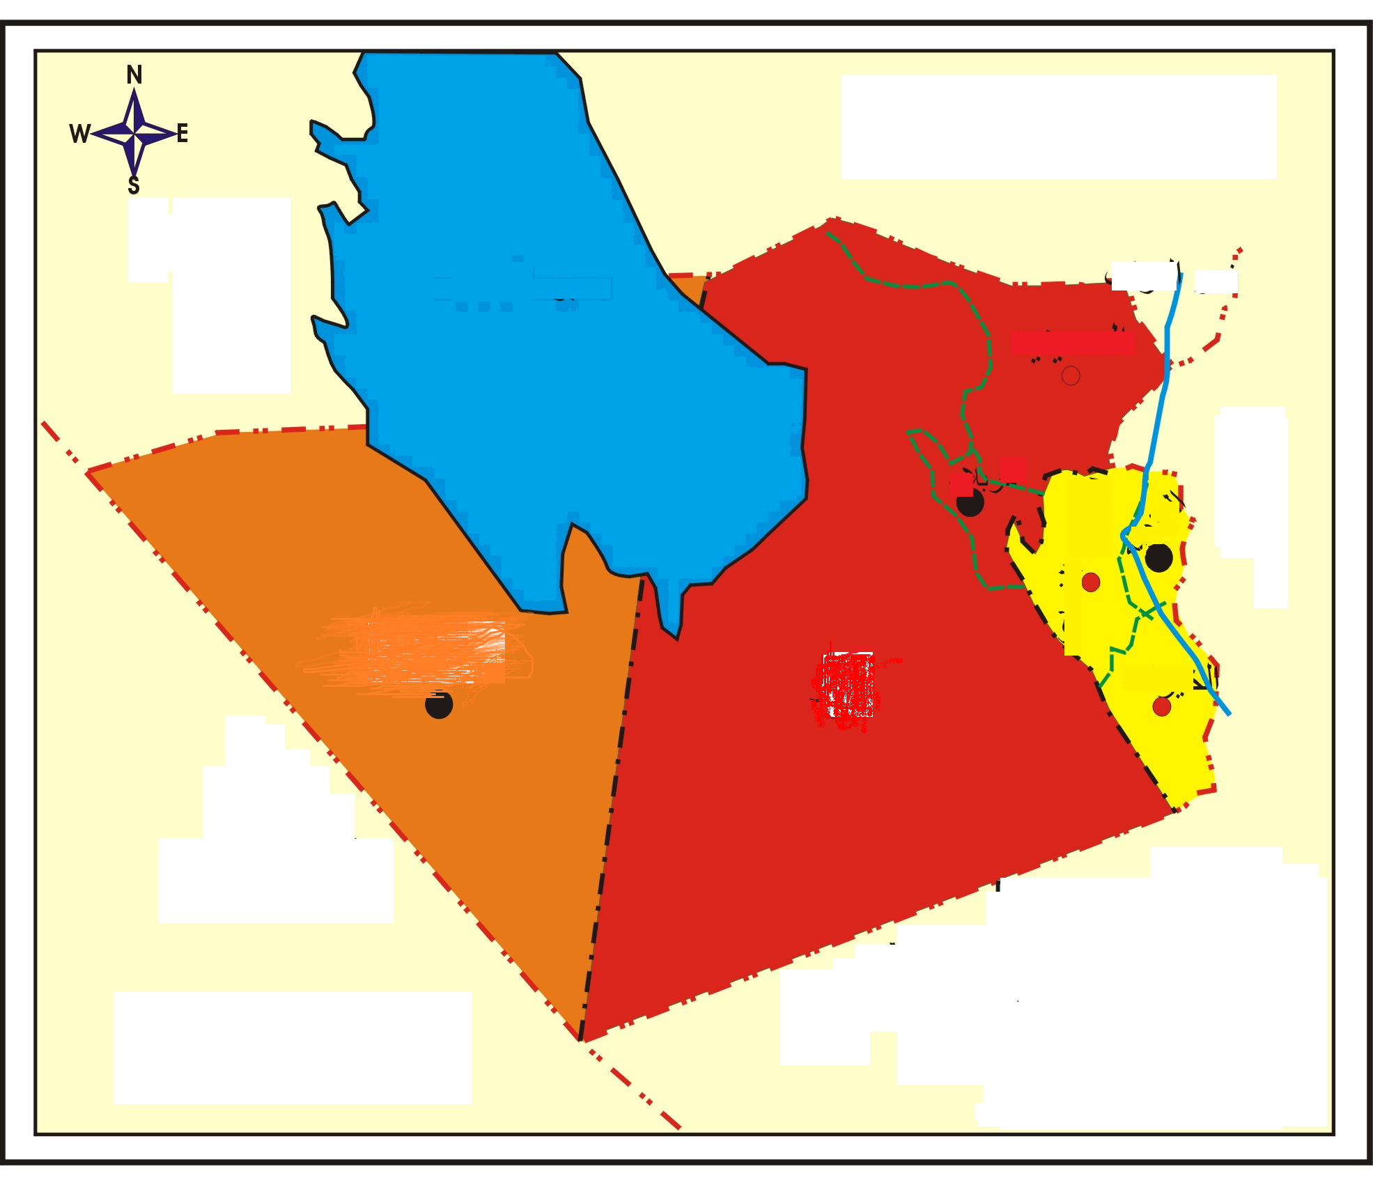
Alrazzaza

JW

NH●

CH•

SH●

●NA

CA

●SA

●CK

HU●
HI

Alanbar

Alanbar

Alnajaf

Babylon

Alfurat rever

KH•

●EB

Fig.(1): Sites of study in Karbala Governorate.

B. Sample Preparation
The samples first sieved in a mesh sieve, dried in a hot air oven at a temperature of 300 °C for 2 hours and their bulk densities were determined.
Test tube technique was used to determine (²²²Rn) levels in the samples, heat drying method employed to concentrate the radioactive nuclides in the samples.
The powder (residual precipitate) was dried by using each sample was transferred to a test tube (cylindrical container) of diameter (3.8 cm) and 6.5 cm in height, as shown in Fig.2. The area of each (CR-39) detector was (1×1) cm².

L(cm
h==

Sample
(5. 5) cm
Radon Gas
3.8cm
CR-39
Detector

Fig. 2. Test tube technique used in the study.

C. Etching and Scanning Process
The determinations of the concentrations of alpha particles emitted from radon gas in samples were performed by using the nuclear track detector (CR-39) of thickness (250 μm) from the intercast Europe srl company. The radon gas concentration in samples was obtained by using the sealed-cup technique as shown in Fig. (2). The test tubes were sealed and stored for 60 days (from 15-1-2011 to 14-3-2011). After that the (CR-39) track detectors were chemically etched using a (NaOH) solution of normality (6.25 N) at temperature of (70±1 Cº) for (6 h(, and then the detectors were washed in distilled water. The tracks densities per cm² were recorded using an optical microscope (kruss-mbl2000) with magnification (400x).
3. Method and Calculation
The density of the tracks (ρ) in the samples was calculated according to the following equation [Amalds, et al,1989].
In order to measure (²²²Rn) concentration levels in samples, the surface density of tracks on the employed detectors (ρ) measured in (Tr/cm²) and used in the following equation [A. Azam, et al, 1995]:
(2)
where,
C: ²²²Rn concentration within the test tube air, above the sample measured in (Bq/m³).
T: exposure time.
K: ²²²Rn gas diffusion constant. Such that [R. Barillon, et al, 1993]:
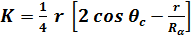 (3)
where,
r : test tube radius = 1.90 cm.
θc : critical angle for CR-39 = 35 degree.
R_{α}: range of ²²²Rn alpha particle in air= 0.0415 m.

By substituting, and in equation (3) we get:-
$$K=4\text{.}\text{8584}×{\text{10}}^{−2}\left(\frac{{\text{Trac}}/{{\text{cm}}^{2}}\text{.}\text{day}}{{\text{Bq}}/{m^{3}}}\right)$$
The ²²²Rn activity density C_{Rn} (Bq/m³) in the powder due to dates and date seeds sample in the test tube was determined according to the following relation [B. Al-Bataina, et al, 1997]:
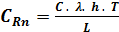 (4)
where,
λ: decay constant for (²²²Rn) = 7.554x10⁻³ (hr⁻¹).
h: distance from the powder surface to the detector = 0.055 m.
T: exposure time = 60 day
L: depth of the powder. (1cm)
The activity of (²²²Rn) in the dates and date seeds samples will be calculated in (Bq) unit from the following relation:
(5)
where,
V: Volume of the sample in the test tube
The activity of radon (A_{Rn}) in sample is [Richard and Josef, 1995]:
(6)
Using law radiation secular equilibrium ideal to find numbers of uranium atoms (N_{U}) in sample from the following equation:
(7)
Where λ_{U} is uranium decay constant (4.98×10⁻¹⁸ sec⁻¹).
W_{U} is uranium weight in sample can calculate from the following equation [Richard and Josef,1995]:
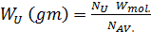 (8)
Where
W_{mol.} : weight molecular uranium
N_{AV.:} number of Avogadro 6.023×10²³atom/mol
To find uranium concentrations in units of part per million using the following equation: 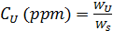 (9)
Where W_{s} is the weight of sample (7gram).

4. Results and discussion
4.1. Radon (²²²Rn) and Uranium (²³⁸U) Concentrations in Dates
The radon gas concentration and radon activity are tabulated in table (1) for kistawi dates samples in different regions of Karbala governorate. It has been shown that the highest radon gas concentration was 260.830 Bq/m³ in KH region while the lowest radon gas concentration was 136.313Bq/m³ in NH region.
The uranium concentration and uranium weight are tabulated in table (2) for kistawi dates samples in different regions of Karbala governorate. It has been shown that the highest uranium concentration was 2.006 ppm in KH region, while the lowest uranium concentration was 1.048 ppm in NH region.

Table (1): The values of the radon concentration (Bq/m³) and radon activity (Bq) for kistawi dates from different regions of Karbala government.
N_{Rn} ×10⁴ | C_{w} (Bq/Kgm) | A_{Rn}(Bq)  ×10⁻² | C_{Rn}(Bq/m³)  ×10³ | C(Bq/m³) | ρ(Trac/cm²) | Regions
4.407 | 13.220 | 9.254 | 8.160 | 136.313 | 396.231 | NH
5.804 | 17.410 | 12.187 | 10.746 | 179.514 | 521.804 | CH
5.517 | 16.547 | 11.583 | 10.213 | 170.619 | 495.951 | SH
5.024 | 15.069 | 10.548 | 9.300 | 155.372 | 451.631 | HU
6.284 | 18.848 | 13.194 | 11.633 | 194.337 | 564.891 | EB
6.653 | 19.957 | 13.970 | 12.317 | 205.772 | 598.131 | HI
6.900 | 20.296 | 14.488 | 12.774 | 213.395 | 620.290 | JW
8.434 | 25.969 | 17.708 | 15.613 | 260.830 | 758.171 | KH
7.776 | 23.325 | 16.328 | 14.396 | 240.501 | 699.079 | CK
4.448 | 13.343 | 9.341 | 8.236 | 137.584 | 399.924 | SA
4.928 | 14.781 | 10.347 | 9.123 | 152.407 | 443.013 | CA
6.475 | 19.423 | 13.596 | 11.988 | 200.266 | 582.127 | NA

Table (2): The values of the uranium concentration (ppm) and uranium weight (gm) for kistawi dates from different regions of Karbala government.
C_{U}(ppm) | N_{U}  ×10¹⁶ | W_{U}(gm)  ×10⁻⁶ | Regions
1.048 | 1.856 | 7.338 | NH
1.380 | 2.445 | 9.664 | CH
1.312 | 2.323 | 9.185 | SH
1.194 | 2.116 | 8.365 | HU
1.494 | 2.646 | 10.462 | EB
1.582 | 2.802 | 11.078 | HI
1.641 | 2.906 | 11.488 | JW
2.006 | 3.552 | 14.042 | KH
1.849 | 3.275 | 12.948 | CK
1.058 | 1.873 | 7.407 | SA
1.172 | 2.075 | 8.205 | CA
1.540 | 2.727 | 10.782 | NA
The radon gas concentration and radon activity are tabulated in table (3) for zahdi dates samples in different regions of Karbala governorate. It has been shown that the highest radon gas concentration was 252.359Bq/m³ in EB region while the lowest radon gas concentration was 147.325Bq/m³ in KH regions.
The uranium concentration and uranium weight are tabulated in table (4) for zahdi dates samples in different regions of Karbala governorate. The highest uranium concentration was 1.940 ppm in EB region while the lowest uranium concentration was 1.133ppm in KH region. Figures 3 and 4 have shown the distribution of radon and uranium concentration respectively in kistawi and zahdi dates samples for different regions in Karbala governorate.

Table (3): The values of the Radon concentration (Bq/m³) and radon activity (Bq) for zahdi date samples from different regions of Karbala government.
Regions | ρ(Trac/cm²) | C(Bq/m³) | C_{Rn}(Bq/m³)  ×10³ | A_{Rn} (Bq)  ×10⁻² | C_{w} (Bq/Kgm) | N_{Rn}  ×10⁴
NH | 462.711 | 159.184 | 9.529 | 10.807 | 15.438 | 5.147
CH | 541.501 | 186.290 | 11.151 | 12.647 | 18.067 | 6.023
SH | 498.413 | 171.466 | 10.264 | 11.641 | 16.629 | 5.544
HU | 625.214 | 215.089 | 12.875 | 14.603 | 20.860 | 6.955
EB | 733.549 | 252.359 | 15.106 | 17.133 | 24.475 | 8.160
HI | 553.812 | 190.525 | 11.405 | 12.935 | 18.478 | 6.160
JW | 636.294 | 218.901 | 13.103 | 14.861 | 21.230 | 7.078
KH | 428.240 | 147.325 | 8.819 | 10.002 | 14.288 | 4.763
CK | 696.617 | 205.348 | 12.292 | 13.941 | 19.916 | 6.640
SA | 711.390 | 244.736 | 14.650 | 16.615 | 23.736 | 7.913
CA | 617.828 | 212.548 | 12.723 | 14.430 | 20.614 | 6.872
NA | 482.408 | 165.961 | 9.934 | .11.267 | 16.095 | 5.366

Table (4): The values of Uranium concentration (ppm) and uranium weight (gm) for zahdi dates samples from different regions of Karbala government.
C_{U}(ppm) | N_{U}  ×10¹⁶ | W_{U}(gm)  ×10⁻⁶ | Regions
1.224 | 2.168 | 8.570 | NH
1.432 | 2.537 | 10.029 | CH
1.318 | 2.335 | 9.231 | SH
1.654 | 2.929 | 11.580 | HU
1.940 | 3.437 | 13.586 | EB
1.465 | 2.595 | 10.257 | HI
1.683 | 2.981 | 11.785 | JW
1.133 | 2.006 | 7.931 | KH
1.843 | 3.264 | 12.902 | CK
1.882 | 3.333 | 13.176 | SA
1.634 | 2.895 | 11.443 | CA
1.276 | 2.260 | 8.935 | NA

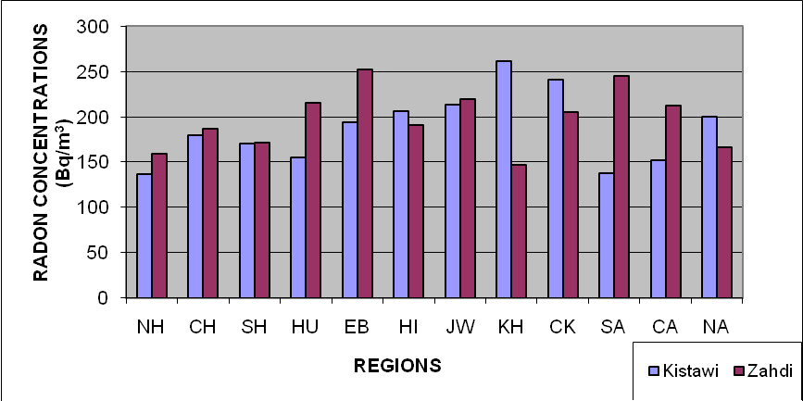

Fig. (3): Radon concentrations of kistawi and zahdi date samples for regions in Karbala governorate.

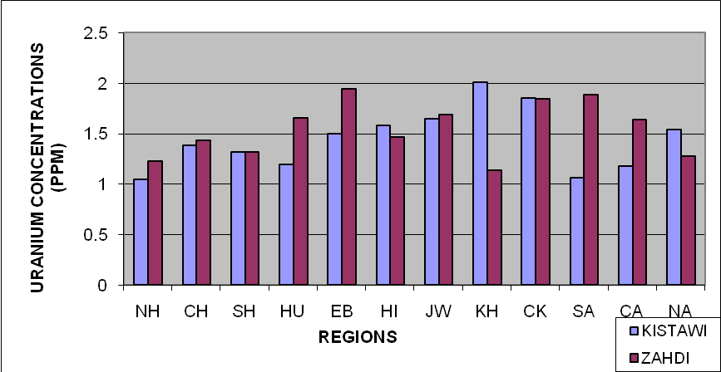

Fig. (4): Uranium concentrations of kistawi and zahdi samples for regions in Karbala governorate.

4.2. Radon (²²²Rn) and Uranium (²³⁸U) Concentrations in Date Seeds
The radon gas concentration and radon activity are tabulated in table (5) for kistawi seeds samples in different regions of Karbala governorate. It has been shown that the highest radon gas concentration was 263.795 Bq/m³ in JW region while the lowest radon gas concentration was 142.666 Bq/m³ in SA region.
The uranium concentration and uranium weight are tabulated in table (6) for kistawi seeds samples in different regions of Karbala governorate. It seen that the highest uranium concentration was 2.028 ppm in JW region while the lowest Uranium concentration was 1.097ppm in SA region.

Table (5): The values of the Radon concentration (Bq/m³) and radon activity (Bq) for kistawi seeds samples from different regions of Karbala government.
Regions | ρ(Trac/cm²) | C(Bq/m³) | C_{Rn}(Bq/m³)  ×10³ | A_{Rn}(Bq)  ×10⁻² | C_{w} (Bq/Kgm) | N_{Rn}  ×10⁴
NH | 431.933 | 148.596 | 8.895 | 10.088 | 14.411 | 4.804
CH | 609.210 | 209.584 | 12.546 | 14.229 | 20.326 | 6.777
SH | 530.421 | 182.478 | 10.923 | 12.389 | 17.697 | 5.900
HU | 455.324 | 156.643 | 9.376 | 10.635 | 15.192 | 5.065
EB | 697.848 | 240.077 | 14.371 | 16.299 | 23.284 | 7.763
HI | 722.470 | 248.548 | 14.878 | 16.874 | 24.105 | 8.037
JW | 766.788 | 263.795 | 15.791 | 17.909 | 25.584 | 8.530
KH | 630.139 | 216.784 | 12.977 | 14.718 | 21.025 | 7.009
CK | 563.660 | 193.913 | 11.608 | 13.165 | 18.806 | 6.270
SA | 414.697 | 142.666 | 8.540 | 9.686 | 13.836 | 4.613
CA | 508.262 | 174.855 | 10.467 | 11.871 | 16.958 | 5.654
NA | 619.059 | 212.972 | 12.748 | 14.459 | 20.655 | 6.886

Table (6): The values of Uranium concentration (ppm) and uranium weight (gm) for kistawi seeds samples from different regions of Karbala government.
Regions | W_{U}(gm)  ×10⁻⁶ | N_{U}  ×10¹⁶ | C_{U}(ppm)
NH | 8.000 | 2.023 | 1.142
CH | 11.283 | 2.854 | 1.611
SH | 9.824 | 2.485 | 1.403
HU | 8.433 | 2.133 | 1.204
EB | 12.925 | 3.270 | 1.846
HI | 11.534 | 2.918 | 1.647
JW | 14.202 | 3.593 | 2.028
KH | 11.671 | 2.952 | 1.667
CK | 10.439 | 2.641 | 1.491
SA | 7.680 | 1.943 | 1.097
CA | 9.413 | 2.381 | 1.344
NA | 11.466 | 2.900 | 1.638

The radon gas concentration and radon activity are tabulated in table (7) for zahdi seeds samples in different regions of Karbala governorate. The highest radon gas concentration was 264.642Bq/m³ in CK region while the lowest radon gas concentration was 151.560Bq/m³ in NH region.
The uranium concentration and uranium weight are tabulated in table (8) for zahdi seeds samples in different regions of Karbala governorate. The highest Uranium concentration was 2.035ppm in CK region while the lowest Uranium concentration was 1.165ppm in NH region.
Figures 5 and 6 have shown the distribution of radon and uranium concentration in kistawi and zahdi seeds samples for different regions in Karbala governorate.

Table (7): The values of the Radon concentration (Bq/m³) and radon activity (Bq) for zahdi seeds samples from different regions of Karbala government.
N_{Rn}  ×10⁴ | C_{w} (Bq/Kgm) | A_{Rn}(Bq)  ×10⁻² | C_{Rn}(Bq/m³)  ×10³ | C(Bq/m³) | ρ(Trac/cm²) | Regions
4.900 | 14.699 | 10.290 | 9.072 | 151.560 | 440.551 | NH
6.325 | 18.971 | 13.280 | 11.709 | 195.607 | 568.585 | CH
7.407 | 22.216 | 15.551 | 13.712 | 229.066 | 665.840 | SH
7.229 | 21.682 | 15.178 | 13.382 | 223.560 | 649.836 | HU
5.188 | 15.561 | 10.893 | 9.605 | 160.455 | 466.404 | EB
6.393 | 19.176 | 13.424 | 11.836 | 197.725 | 574.740 | HI
7.626 | 22.873 | 16.011 | 14.118 | 235.842 | 685.537 | JW
5.161 | 15.479 | 10.836 | 9.554 | 159.608 | 463.942 | KH
8.557 | 25.666 | 17.967 | 15.842 | 264.642 | 769.251 | CK
8.256 | 24.762 | 17.334 | 15.284 | 255.324 | 742.167 | SA
6.667 | 19.998 | 13.999 | 12.343 | 206.195 | 599.362 | CA
5.969 | 17.903 | 12.532 | 11.050 | 184.596 | 536.577 | NA

Table (8): The values of Uranium concentration (ppm) and uranium weight (gm) for zahdi seeds samples from different regions of Karbala government.
C_{U}(ppm) | N_{U}  ×10¹⁶ | W_{U}(gm)  ×10⁻⁶ | Regions
1.165 | 2.064 | 8.159 | NH
1.504 | 2.664 | 10.531 | CH
1.761 | 3.120 | 12.332 | SH
1.719 | 3.045 | 12.036 | HU
1.234 | 2.185 | 8.638 | EB
1.520 | 2.693 | 10.645 | HI
1.813 | 3.212 | 12.697 | JW
1.227 | 2.173 | 8.593 | KH
2.035 | 3.604 | 14.247 | CK
1.963 | 3.477 | 13.746 | SA
1.585 | 2.808 | 11.101 | CA
1.419 | 2.514 | 9.938 | NA

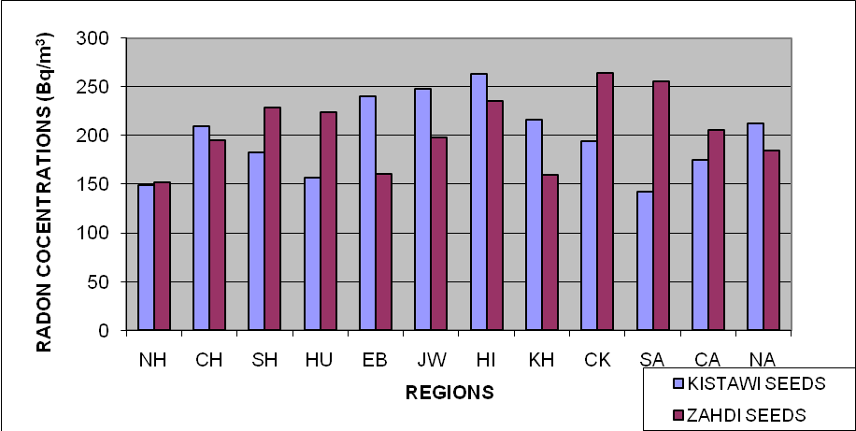

Fig. (5): Radon concentrations of kistawi and zahdi seeds samples for regions in Karbala governorate.

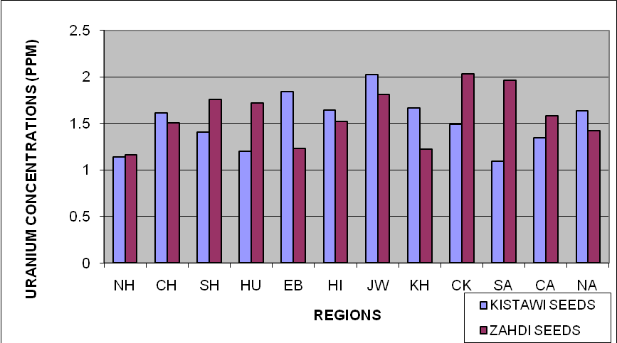

Fig. (6): Uranium concentrations of kistawi and zahdi seeds samples for regions in Karbala governorate.

Finally, the standard deviation, average, minimum and maximum radon gas concentration are tabulated in table (9) for all samples studies in Karbala governorate. The highest average radon gas concentration was 205.348 Bq/m³ in zahdi seeds (ZHIS) samples while the lowest average radon gas concentration was 187.242Bq/m³ in kistawi (KTI) samples.
Figure 7 shows distributed of average radon concentration for all samples studies in Karbala governorate.
In addition to that, the standard deviation, average, minimum and maximum uranium concentration are tabulated in table (10) for all samples studies in Karbala governorate. It shows that, the highest average uranium concentration was 1.578 ppm in ZHIS samples while the lowest average uranium concentration was 1.439 ppm in KTI samples.
Figure 8 have shown the distribution of average uranium concentration (ppm) for all samples studies in Karbala governorate.

Table(9):Radon concentrations and standard deviation (Bq/m³) for samples studies in Karbala governorate.
Samples | Radon Concentrations( Bq/m³)
Samples | Min. value | Max. value | Average | Sta. devation
Kistawi (KTI) | 136.313 | 260.830 | 187.242 | 39.455
Zahdi  (ZHI) | 147.325 | 252.359 | 197.477 | 33.205
Kistawi seeds  (KTIS) | 142.666 | 263.795 | 199.242 | 39.718
Zahdi seeds  (ZHIS) | 151.560 | 264.642 | 205.348 | 37.443

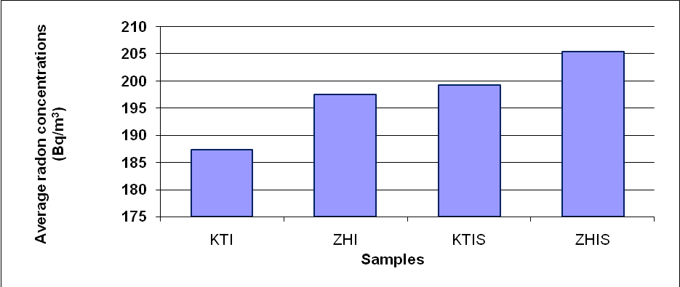
Fig. (7): Average radon concentrations of dates and date seeds samples in Karbala governorate.

Table (10): Uranium concentrations and standard deviation (ppm) for samples studies in Karbala governorate.

Samples | Uranium Concentration (ppm)
Samples | Min. value | Max. value | Average | Standard  deviation
Kistawi  (KTI) | 1.048 | 2.006 | 1.439 | 0.303
Zahdi  (ZHI) | 1.133 | 1.940 | 1.540 | 0.271
Kistawi seeds  (KTIS) | 1.097 | 2.028 | 1.509 | 0.284
Zahdi seeds  (ZHIS) | 1.165 | 2.035 | 1.578 | 0.287

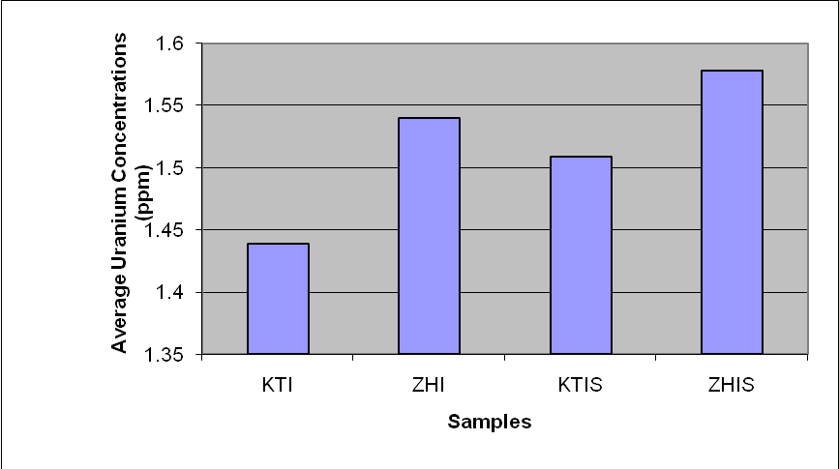
Fig. (8): Average uranium concentrations (ppm) of dates and date seeds samples in Karbala governorate

Conclusions
The results showed that radon concentration in date samples were ranged between (136.313 - 260.830) Bq/m³ and the highest concentration was found in kistawi sample at KH region, whereas the lower concentration was in the kistawi sample at NH region. Moreover it could be concluded that the radon concentration in date seeds were ranged between(142.666 -264.642)Bq/m³ and the highest concentration was found in zahdi seeds samples at CA region , whereas the lower concentration was in the kistawi seeds samples at SA region.
The concentration of uranium in dates ranged between (1.048-2.006)ppm, the highest uranium concentration in kistawi dates at KH region, while the lowest uranium concentration in dates samples was found in kistawi dates at NH region.
The concentrations of uranium in date seeds ranged between(1.097-2.035)ppm, the highest uranium concentration was found in zahdi seeds at CK region, while the lowest uranium concentration in date seeds samples was found in kistawi seeds at SA region.
The results also show that, the highest of average radon and uranium concentrations for all samples were obtained in zahdi seeds were 205.348 Bq/m³and 1.578ppm respectively. The lowest of average radon and uranium concentrations for all samples obtained in kistawi dates were 187.242 Bq/m³and 1.439ppm respectively.
Clearly the present results shown that the radon gas concentration in all dates and dates seeds samples was below the allowed limit coined by (International Commission of Radiation Protection) (ICRP) agency.

References
A. Azam, A. Naqvi, and D. Srivastava, Nucl. Geophys. 653., Radium Concentration and Radon exhalation measurements Using LR-115 type II plastic track detectors. 9(6) (1995).
A. Mogro-Campero, R. L. Fleischer, Sub terrestrial fluid conversion: a hydro thesis for long-distance migration of radon within the earth. Earth Planet. Sci. Lett.54, 321-325(1977).
Amalds, N.H.Custball and G.A.Nielsen, Cs137 in Montarq Soils, Health Physics, 57 No.6, P. 955-958 (1989).
B. Al-Bataina, A. Ismail, M. Kullab,K. Abumurad, and H. Mustafa, Radiation Measurement, 28(1) (1997) 591.
D. Bajawa . A. K. Goswami, I. Laskar, Radon exhalation rate studies in Makum coalfield area using track-etched detectors, Indian J. Phys. 83 (8) 1155-1162 (2009).
International Atomic energy agency, Measurements of radio nuclides in food and environment. Vienna. IAEA; Technical Reports Series 295, (1989).
J.Singh , H. Singh , S. Singh , B. Bajawa, Uranium, radium and radon exhalationstudies in some soil samples using plastic track detectors , Indian J. Phys. 83 (8) 1147-1153 (2009).
K. M. Abumurad., B. Al-Bataina, A. Ismail, M. Kullab, A. Al-Eloosy, A survey of radon levels in Jordanian dwellings during an autumn season. Radiat. Prot. Dosim. 69, 221-226(1997a).
K.M. Abumurada, M. Al-Tamimib, Emanation power of radon and itsconcentration in soil and rocks. Radiation Measurements 34, 423–426,(2001).
NCRP, (National Council on Radiation and Measurement),. Exposures from the uranium series with emphasis on radon and its daughters, Bethesda, MD, No.77 (1984).
Richard Tykva, D.Sc, Josef Sabol, D. Sc., Low- Level Environmental Radioactivity Sources and Evalution, U.S.A., (1995).
R. M. Yousuf, M. M. Husain and L. A. Najam, Measurement of Radon -222 Concentration Levels in Spring Water in Iraq , Jordan Journal of Physics,Volume 2, Number 2, pp. 89-93,(2009).
R. Barillon, D. Klein, A. Chambaudet, and C. Devillarde, Nucl. Tracks Radiat.Meas. 22(1-4), 281 (1993).
S. A. Durrani, R.(Eds.). Ilic, Radon Measurements by Etched Track Detectors:Aplication to Raddiation Protection, Earth Sciences and the Environment. World Scientific, Singapore,(1997).

