Fuzzy Conditional Reliability for Some Continuous Distributions
Hussein Ahmed Ali , Marwa Radi
Department of Mathematics , Collage of Education for Pure Sciences
Abstract
Fuzzy set theory has become a useful tool in the mathematical modeling of problem in operation research, including reliability engineering and applied recently in various fields. The problem of reliability with fuzziness is discussed by means of fuzzy mathematics In the world, there exists much fuzzy knowledge; knowledge that is vague, imprecise, uncertain, ambiguous, inexact or probabilistic in natural. Human thinking and reasoning frequently involve fuzzy information, originating from inherently inexact human concepts. Fuzzy sets have been able provide solutions to many real world problems. Suppose that an item has survived to time a , where T is the total time , then U = T - a is the future life random variable. The conditional reliability function defined by :
(t |a) = Pr (item survives a further time t | survives to a) Fuzzy reliability is the probability of a device performing its purpose in varying degrees of success for the period of time intended under operating conditions encountered The aim of this paper find the fuzzy condition reliability of a some continuous distribution where the random variable independent and dependent .
Key words: Fuzzy set, Fuzzy reliability, Exponential distribution, Weibull distribution Fuzzy conditional

الخلاصة
أصبحت نظرية المجموعات الضبابية وسيلة مفيدة في العرض الرياضي للمشكلة في بحوث العمليات ويضمن ذلك هندسة الثقة (المعولية) وتطبيقاتها الحديثة في الحقول المختلفة. أن مشكلة الثقة مع الضبابية مناقشة بواسطة الرياضيات الضبابية , في العالم هناك معرفة ضبابية كثيرة , المعرفة هي مبهمة أو غير واضحة أو غير الدقيقة أو غامضة أو احتمالية في الطبيعة. يتضمن التفكير وفكر الإنسان معلومات ضبابية كثيرا وينشأ من المعلومات الضبابية الغير دقيقة أصلا .المجموعات الضبابية زودتنا بحلول للعديد من مشاكل العالم المختلفة . نفرض إن مادة ما بقيت لتوقيت a , حيث إن T الوقت الكلي , فأن U=T-a متغير الحياة (الزمن) العشوائي المستقبلي. دالة الثقة الشرطية معرفة بالشكل:( (t |a) = Pr (item survives a further time t | survives to a الثقة الضبابية هي احتمال ان الأداة التي تودي غرضها في تغير درجات النجاح للفترة الزمنية المقصودة تحت حالة شروط (ظروف) العمل المحسوبة . الهدف من هذه البحث إيجاد الثقة الشرطية الضبابية لبعض التوزيعات المستمرة حيث المتغير العشوائي مستقل ومعتمد .
Introduction
In the world, there exists much fuzzy knowledge; knowledge that is vague, imprecise, uncertain, ambiguous, inexact or probabilistic in natural. Human thinking and reasoning frequently involve fuzzy information, originating from inherently inexact human concepts. Fuzzy sets have been able provide solutions to many real world problems. The concepts of fuzzy set have been introduced by Lotfi .A . Zadeh (1965) as an extension of classical notion of set and its developed to probability measures of fuzzy event by Lotfi . A. Zadeh (1968) and M . Sugeno (1974) Then developed the concepts of reliability which is defined in terms of probability, probabilistic parameters such as random variables, density function, distribution function and system reliability by Peter Harding and Associates Ptyltd (1996). The relationship between fuzzy and reliability has been proposed and developed by several authors (Caietal , 1991 ; Chen , 1994 ; Cai et al , 1995 ) . Then using the membership functions and probability measures of fuzzy set by Nozer .D. Sing purwalla and Jane M. Brooker (2004) Fuzzy reliability is the probability of a device performing its purpose in varying degrees of success for the period of time intended under operating conditions encountered. The aim of this paper find the fuzzy condition reliability of a some continuous distribution where the random variable independent and dependent .
. 2. Fuzzy Conditional Reliability

Suppose that an item has survived to time a , where T is the total time , then U = T - a is the future life random variable. The conditional reliability function defined by :

(t |a) = Pr (item survives a further time t | survives to a)

= Pr (U > t | T > a) u > 0

= Pr (T > a + t | T > a) u > 0

=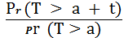

= 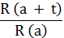

If the sign A denotes that a device performs its purpose adequately and the sign denotes one performance subsets, then in terms of the definition of fuzzy conditional probability , we have
1)) …. ………. ……. ……. P(A) P ( A ) =( P ( A
where denotes discussing one of fuzzy performance subsets and the sign denotes algebraic product . According to the definition of general reliability (R) and the definition of fuzzy reliability
() ,we know
P (A) = R P (A ) = ....... ……. ………. … (2)
Substituting Eq. (2) in to Eq. (1) , we obtain
= P ( A) R …… …..... …………. … (3)
Suppose that (R) is the degree of membership of R in and substitute (R) for P ( A) , then
(R) R ……. ....... … … ……. (4)
According to general reliability theory we have ,
R= 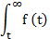 dt
Substituting it in to Eq. (4) , we obtain
(R) dt …… …… … ……… (5)
[ Tingjie Li , He Gao 1988 ]
3. Some Continuous Distribution
3.1 Exponential Distribution
The exponential distribution is a commonly used distribution in reliability engineering Mathematically, it is a fairly simple distribution, which many times lead to its use in inappropriate situations. The exponential distribution is used to model the behavior of units that have a constant failure rate (or units that do not degrade with time or wear out) .
The two-parameter exponential pdf is given by :

f (t) = λ t > 0 , λ > 0 ,

where γ is the location parameter , and λ is the scale parameter .
3.1.1 Exponential Statistical Properties
The mean E(T) is given by:

E(T) = 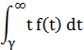

=
and the variance Var (T) is:
Var (T) =
3.1.2. The Exponential Reliability Function
The equation for the two - parameter exponential cumulative density function is given by:
F(t) = 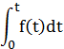
= 1-
The reliability function for two - parameter exponential distribution is given by:
R(t) = 1- F(t)
=
The hazard function (failure rate function) of exponential distribution is given by:
h(t) = 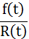 = 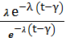 = λ
3.2 Weibull Distribution
Weibull distribution is one of the most widely used lifetime distributions in reliability engineering. It is a versatile distribution that can take on the characteristics of other
types of distributions, based on the value of the shape parameter, .

The two-parameter weibull pdf is given by :

f (t) = 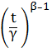 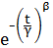 t 0 , > 0

where is the scale parameter .

3.2.1 Weibull Statistical Properties

The mean E(T) is given by:
E(T) = 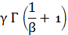
and the variance Var (T) is:
Var (T) = 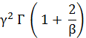 – 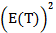
3.2.2. The Weibull Reliability Function
The equation for the two - parameter weibull cumulative density function is given by:
F(t) =
= 1- 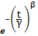
The reliability function for two – parameter weibull distribution is given by:
R (t) = 1 - F(t)
=

The hazard function (failure rate function) of weibull distribution is given by:
h (t) = = 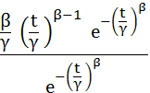 =
[Karpisek Zdenek , Stepanek Petr , Jurak Petr , 2010]
4. Fuzzy Conditional Reliability for Independ and Depended
in this paper , we discussed the fuzzy conditional reliability for some continuous distribution where random variables are independent and dependent .
4.1 When they have the same independent distribution
4.1.1 Exponential distribution
R(t) =
R() =
R (t |) =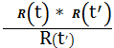
= 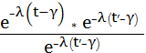
= 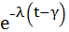
Where t and are random variables of survives times, that have Exponential distribution.
4.1.2 Weibull Distribution
R() = 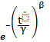
R() = 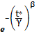
R (|) =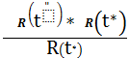
=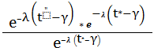
=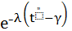
Where and are random variables of survives times, that have Weibull distribution.
4.2 When they have the different independent distribution
For Exponential distribution the reliability function is
R(t) =
And for Weibull distribution the reliability is
R() =
Then ,
R (t |) =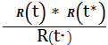
= 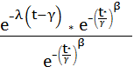
=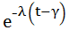
R () =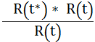
= 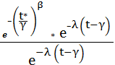
=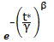
4.3 When they have the same dependent distribution
4.3.1 Exponential distribution
The membership of Exponential distribution is given by:
2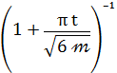 t 0 , > 0
Since ,
(R) R
= 2 *

Then ,
R (t |) =
= 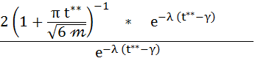
=2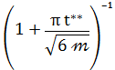
Where (t |) =
4.3.2 Weibull distribution
The membership of Weibull distribution is given by:
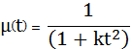 t 0
Where k is parameter
Since ,
(R) R
= 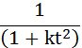 *
Then ,
R (|) =
= 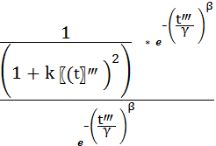
= 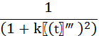
Where (|) = .
From the above work we conclusion that in the Exponential distribution and Weibull distribution the fuzzy conditional reliability gives same distributions when they are independent distributions , and gives the membership function of Exponential and Weibull distributions when they are depended distribution .
References
Chen Xiaowei , August 28, 2008 , " Fuzzy Differential Equations ", Uncertainty Theory Laboratory , Department of Mathematical Sciences , Tsinghua University .
Exponential Distribution , 2008\9 schools – wiki pedia selection , the free encyclo pedia – windows internet explorer .
Karpisek Zdenek , Stepanek Petr , Jurak Petr , vol . 17 , 2010 , "Weibull Fuzzy Probability Distribution For Reliability Of Concrete Structures "
Reliability Distribution – wiki pedia , the free encyclo pedia – windows internet explorer . . http:// go. Microsoft. Com / fwlink / linked = 69157
Tingjie Li , He Gao , 1988 , " Fuzzy Reliability " , Beijing Institute of Aeronautics and Astronautics .
Tso . Mike , " Reliability and Survival "
Weibull Distribution – wiki pedia , the free encyclo pedia – windows internet explorer . http:// go. Microsoft. Com / fwlink / linked = 69157

