Dissemination of Extended Spectrum
β-lactamases in Escherichia coli Isolated from Najaf Hospitals

Jenan Mohammed Hussein
Department of Biology,College of Education for Girls
Ali Almohana
Department of Microbiology College of Medicin, Kufa University
Eman Jar-Allah
Department of biology of sciences college , Babylon University

Abstract
Collectively 117 isolates of E. coli were obtained from 3 hospitals in Najaf during June to Augest 2010. The antibiotic susceptibility patterns of isolates were determined by disk approximation test. Phenotypic confirmatory test (PCT) was carried out for screening of ESBLs by CHROMagar method.Present study revealed that no ESBL producer E. coli isolates were confirmed by disk approximation test, the efficacy of CHROMagar method for the recognition of ESBL-producing isolates was second documented in Najaf. The high occurrence of ESBL producing E. coli isolates in this study may perhaps due to the large amount of third generation cephalosporins consumption, which has been reported as a risk factor for infection with ESBL-producing isolates bacteria
الخلاصة
جمعت 117 عزلة لبكتريا ايشريشيا القولون من ثلاث مستثفيات في مدينة النجف للفترة من حزيران وحتى آب (2010). وقد حددت نمط الحساسية للمضادات الحياتية لهذه العزلات باستخدام طريقة انتشار الاقراص. كما تم التحري عن انزيمات البيتا لاكتام واسعة الطيف بواسطة الفحص التأكسيدي المظهري على وسط الكروم الصلب. وقد اظهرت النتائج الحالية عدم فاعلية طريقة الاقراص في الكشف عن انزيمات البيتالاكتام واسعة الطيف المنتجة من قبل بكتريا القولون مقارنة مع طريقة اكار الكروم. وقد يعود الانتشار الواسع لبكتريا القولون المنتجة لهذه الانزيمات الى الاستهلاك المفرط لمضادات الجيل الثالث للسينالوسبورين والتي تعتبر عامل خطورة للاصابة بالبكتريا المنتجة لانزيمات المقاومة لمضادات البيتالاكتام .
1. Introduction
Extended-spectrum β-lactamases confer resistance to expanded spectrum cephalosporins including third-generation cephalosporins (cefotaxime ceftriaxon and ceftazidime) (Paterson, 2006; Apisamthanarak et al., 2007), and monobactams due to their ability to hydrolyze these compounds. Many ESBLs are derived from non-ESBL precursors by point mutation of bla genes, and the prevailing assumption is that these variants are selected by exposure to expanded-spectrum cephalosporins and/or monobactams in health care facilities (Hammond et al., 2000).
New generations of extended spectrum β-lactam antibiotics were designed to be effective in the presence of the (then) existing β-lactamases, but, following the use of these newer drugs, new variant (mutant) forms of β-lactamase have evolved; these can hydrolyze at least some of the newer antibiotics and are becoming widely disseminated (Singleton and Sainsbury, 2006). More than 150 types of ESBLs have been described and the majority of these enzymes belong to the TEM and SHV family (Mendelson et al., 2005; Moreno et al., 2007). ESBLs have evolved remarkably during the last 20 years and the organisms producing these genes, are responsible for increasing in nosocomial infections, morbidity and mortality especially amongst patients on intensive care and high dependency units.
2. Materials and Methods
Media used in this study listed in Table (1-1) were prepared in accordance with the manufacturer's instructions fixed on their containers. All the media were sterilized in the autoclave at 121°C for 15 min
Table (2-1): Culture Media

Medium | Manufacturer (Origin)
Brain heart infusion broth and agar | Mast Diagnostic (UK)
CHROMagar orintation | ChroMagar (France)
Eosin methylen blue agar | Himedia
MacConkey agar | Biolife (Italy)
Muller Hinton agar | Oxoid (UK)
MR-VP broth | Oxoid
Peptone water | Biolife
Simmons citrate agar | Mast Diagnostic
Triple sugar iron agar | Biolife
2.1 CHROMagar and Supplement Solution
The supplements were prepared according to ChroMagar (France) manufacturer recommendations by dissolving 57mg/ml of ESBL supplement in sterile D.W. vortex , homogenized and added in the proportion of 10ml/L of final melted orientation CHROMagar after cooled at 45ºC, then poured plate and used in the same day of preparation.
Table (2-2): Antibiotic Disks

Origin | Content | symbol | Antibiotic  name | Antibiotic subclass | Antibiotic class
Himedia | 30µg | Ac | Amoxi-clavc |  | -lactame/ß-lactamaseß  inhibitor combinations
Bioanalyse | 30µg | CTX | Cefotaxime | Cephalosporin III | Cephems (parenteral)
Bioanalyse | 30µg | CAZ | Ceftazidime | Cephalosporin III | Cephems (parenteral)
Bioanalyse | 30 µg | CRO | Ceftriaxone | Cephalosporin III | Cephems (parenteral)
Bioanalyse | 30µg | FOX | Cefoxitin | Cephamycin | Cephems (parenteral)
Bioanalyse | 30µg | AZT | Aztreonam |  | Monobactams

2.2 Detection of Extended-Spectrum β-lactamase Production
Two methods were performed for detection of ESBLs in significant bacteriuria E. coli isolates.
a) Disk Approximation Method
This method was carried out as modified by Bedenić et al. (2010) as follows: Muller-Hinton agar plate was inoculated with an overnight blood agar culture of the test bacterial isolate. Disks containing 30 µg cefotaxime, ceftazidime, ceftriaxione, and azetreonam were placed 15 mm (edge to edge) from a disk of augmentin (20 µg amoxicillin plus 10 µg clavulanate). Incubation followed for 16-20 hours at 35˚C. Any enhancement of the zone of inhibition between a β-lactam disk and augmentin disk was indicative of presence of an ESBL. E. coli ATCC 25922 was used as a negative control.
b) Detection of ESBL by CHROMagar Technique
Extended spectrum β-lactamase CHROMgar plates were streaked in the same day of preparation by overnight growth of E. coli. The plates were incubated at 37ºC for 24 hours according to manufacturer procedure. Growth of red colonies indicated to ESBL producer. The reference strain of E. coli ATCC 25922 was inhibited and used as negative control.
3. Results and Discusion
In this study, ESBL production was carried out by disk approximation test, in which the augmentation of the inhibition zone between a 30μg antibiotic disks of ceftazidime, ceftriaxone, cefotaxime and aztreonam toward amoxicillin-clavulanate disk. Present study revealed that no ESBL producer E. coli isolates were confirmed by this method (Table 3-1 Figure 3-1). This may be attributed to the fact that presence of ESBLs in a bacterial cell does not always produce a resistance phenotype when using the disk diffusion interpretive criteria published by the NCCLS (2003). Several studies have also shown that the disk approximation test failed to detect some ESBL-producing strains (Coudron et al., 1997;Al-Muhannak, 2010).

Table (3-1): Frequency of phenotypic ESBL production in 64 E. coli isolates using two confirmatory methods

Negative ESBLs | Positive ESBLs | Method
35 /117 (30%) | 82 / 117 (70%) | Chromo agar method
0 / 117 (0.0%) | 0 / 117 (0.0%) | Disk Approximation Method

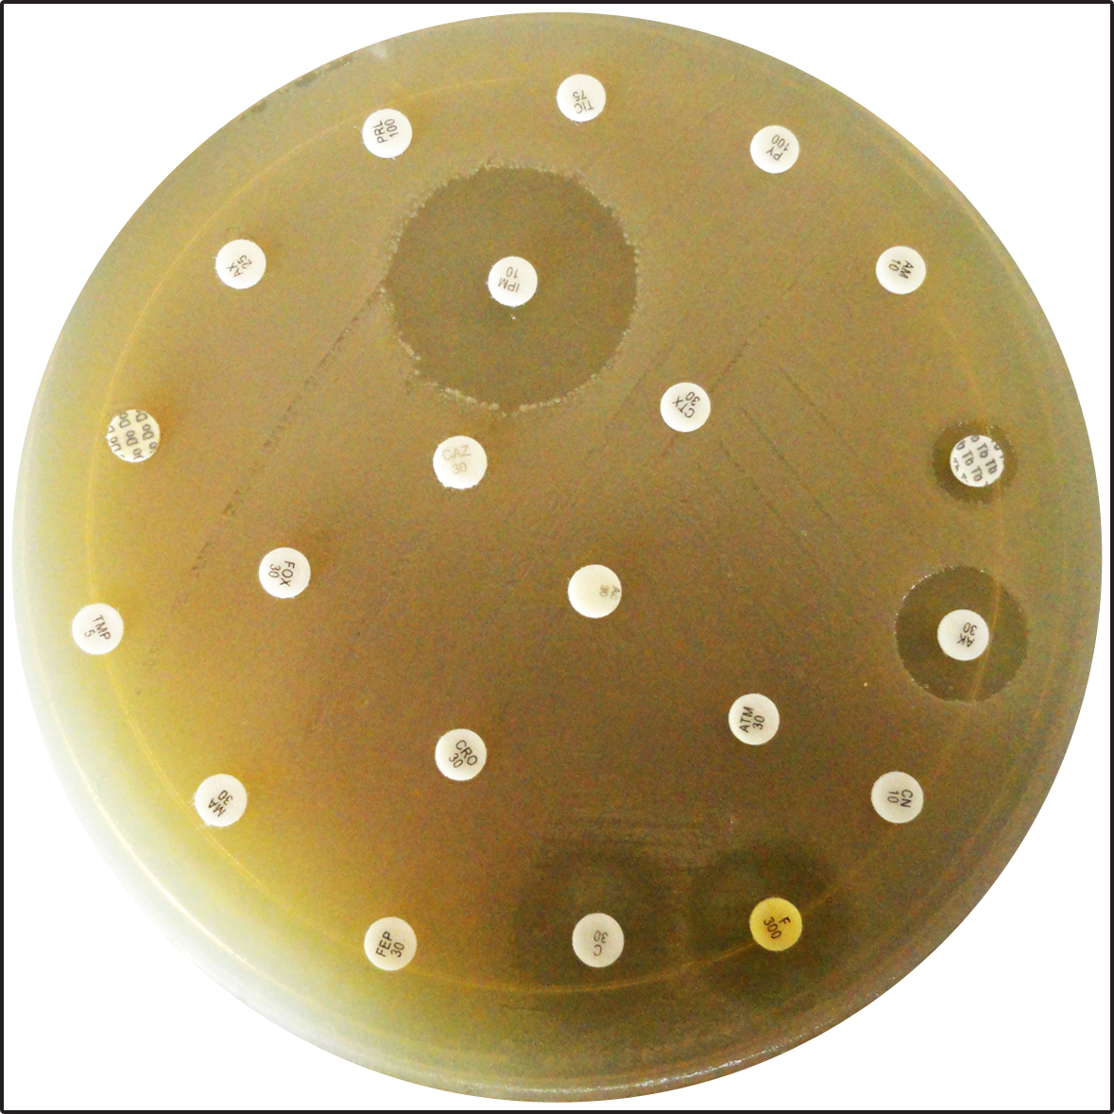
Figure (3-1):The disk approximation test
failed to detect some ESBL-producing strains

However, present result was mirrored to the results of Al-Sehlawi (2012), who reported that all K. pneumoniae isolates (100%) which recovered from clinical and hospital environment in Najaf were negative for this test. (20/10µg), is interpreted as synergy, indicating the presence of an ESBL. Negative results are supposed to occur if the AmpC activity is larger than activity of ESBL, which may lead to failure results (Yan et al., 2002).
In this investigation, the efficacy of CHROMagar method for the recognition of ESBL-producing isolates was second documented in Najaf after Al-Sehlawi (2012), and no studies published that used CHROMagar technique for detecting ESBL-producing E.coli isolates were available in other province of Iraq. Thus, this study, newly revealed that 51/64 (79.7%) of the quinolone and fluoroquinolones resistance E. coli isolates were confirmed as ESBL producers (Table 3-1 and Figure3-2). This inequality may be due to ESBL antibiotics supplemented CHROMagar allows growing of ESBL-producing organisms only, while inhibiting the growth of other bacteria including those carrying AmpC β-lactamase type.
This is an important feature of CHROMagar medium, since intrinsic AmpC β-lactamase has no clinical relevance, but often leads to ESBL false positive reading in the classical testing methods. The present study accomplished that CHROMagar technique is overall cost per single test, but had the advantage of saving time and materials. This study confirmed that detection of ESBL production is of importance in hospital isolates. Firstly, these isolates are probably more prevalent than currently recognized. Secondly, ESBLs constitute a serious threat to currently available antibiotics. Thirdly, institutional outbreaks are increasing because of selective pressure due to heavy use of extended-spectrum cephalosporins and lapses in effective control measures.

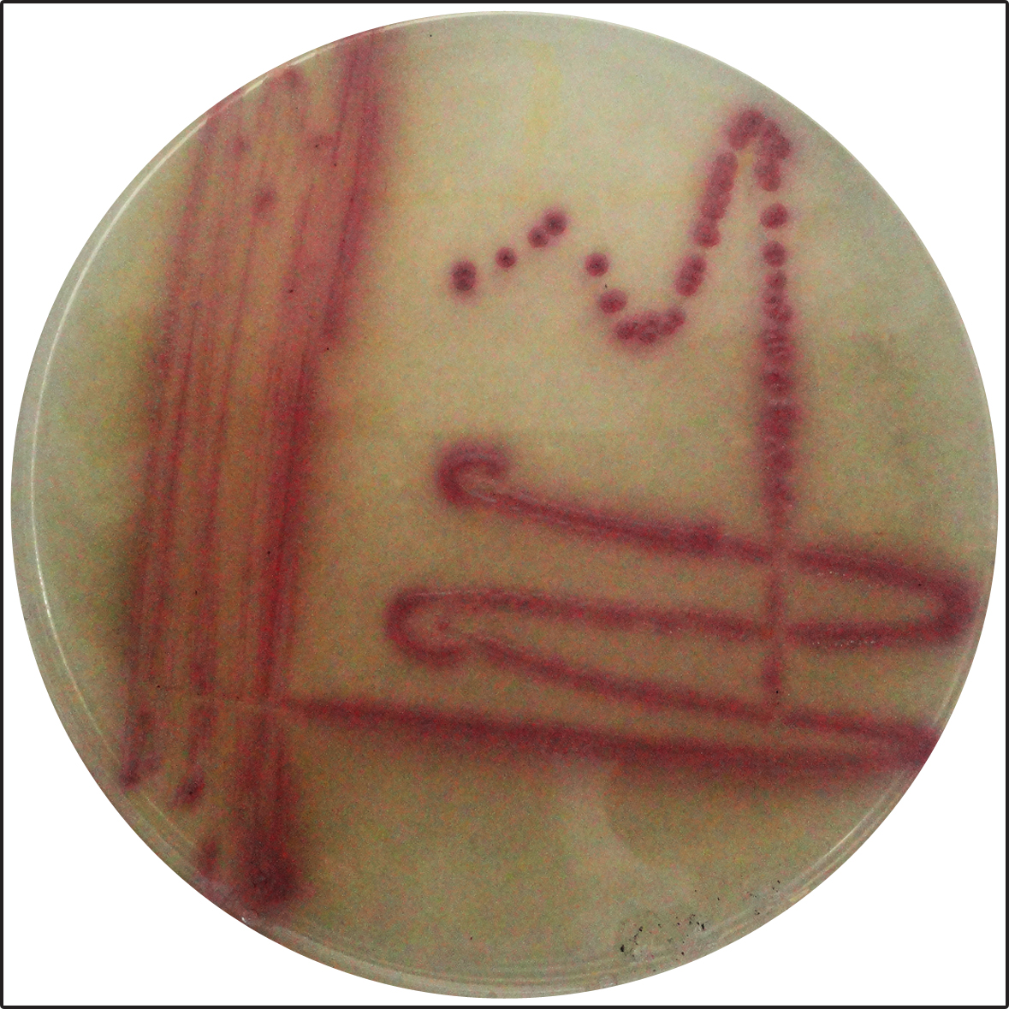

Figure (3-2): Appearance of ESBL producer E. coli isolate with deep red colonies on ESBL supplemented CHROMagar medium.
The high occurrence of ESBL producing E. coli isolates in this study may perhaps due to the large amount of third generation cephalosporins consumption, which has been reported as a risk factor for infection with ESBL-producing bacteria (Rice et al., 1991; Saurina et al., 2000). Moreover, the dissemination of ESBL producing E. coli isolates in this study may be due to the majority of β-lactamase have 1, 2, or 3 amino acid mutation from those of the parent enzymes TEM-1, TEM-2, and SHV-1 (Huseyin and Bahar et al., 2005). These mutations are thought to have evolved under selective pressures exerted by antibiotic treatment, and continued use of cephalosporin antibiotics inside and outside hospitals. However, present study suggested that ESBL producing isolates are already endemic in Najaf hospitals.
Additionally, present study revealed that not all cefotaxime, cetazidime, ceftriaxone and aztreonam resistance E. coli isolates were ESBL producers. Thus, there may be other mechanisms of resistance to third generation cephalosporins and aztreonam. In organisms that produce both ESBL and AmpC, clavulanate may induce hyperproduction of the AmpC β-lactamase leading to hydrolysis of the third generation cephalosporin thus masking any synergy arising from inhibition of the ESBL, producing false negative result in the ESBL detection test (Thomson, 2001). There are a number of instances whereby the screening tests are positive but the confirmatory tests are negative or indeterminate (Svard, 2007). However, coexistence of different classes of β-lactamases in a single bacterial isolate may pose diagnostic challenges. The ability to detect and distinguish between AmpC and ESBL-producing organisms has epidemiological significance and may have therapeutic importance as well.
The NCCLS (2007) recommends that for all confirmed ESBL producing strains, the test results should be reported as resistant for all penicillins, cephalosporins, and aztreonam regardless of the routine susceptibility test results. Whereas, β-lactam/β-lactamase inhibitor combinations (for example: piperacillin/tazobactam and amoxicillin/ clavulanate) are reported as susceptible.
Refrences
Paterson, D.L.; Mulazimoglu, L.; Casellas, J.M. (2000). Epidemiology of ciprofloxacin resistance and its relationship to extended-spectrum βeta-lactamase production in Klebsiella pneumoniae isolates causing bacteremia. Clin Infect Dis; 30: 473–8
Apisamthanarak, A.; Kiratisin, P.; Saifon, P.; Kitphati, R.; Dejsirilert, S. and Mundy,L.M. (2007). Clinical and molecular epidemiology of community-onset,extended-spectrum bea-lactamase-producing Escerichia coli infections in Thailand: a case-control study. Am. J. Infect. Control, 35: 606-612.
Hammond, D.S.; Schooneveldt, J.M.; Nimmo, G.R.; Huygens, F. and Giffard, P.M. (2000). bla_{SHV} genes in Klebsiella pneumoniae different allele distributions are associated with different promoters within individual isolates. Antimicrob. Agents Chemother., 49: 256-263.
Singleton, P., and Sainsbury, D. (2006). Dictionary of Microbiology and Molecular Biology, Third Edition John Wiley and Sons Ltd. 424.
Mendelson, G.; Hait,V.J.; Ben-Israel, D.; Gronich, E.; Granot, and Raz. (2005). Prevalence and risk factors of extended-spectrum beta-lactamase-producing Escherichia coli and Klebsiella pneumoniae in an Israeli long-term care facility.Eur. J. Clin. Microbiol. Infect. Dis., 24:17-22.
Moreno, A.; Bello, H.; Guggiana, D.; Domingues, M., and Gonzalez G. (2007). Extended-spectrum beta-lactamases belong to CTX-M group produced by Eschrichia coli strains isolates from companion animal treated with enorfloxacin. Vet. Microbiol., 129:203-208
Bedenić, B.; Vraneš, J.; Bošnjak, Z.; Marijan, T.; Mlinarić-Džepina, A.; Kukovec, T.; Knežević, J.; Anušić, M.; Beader, N.; Barl, P.; Leskovar, V. and Kalenić S. (2010). Emergence of CTX-M group 1 extended-spectrum ß-lactamase–producing Klebsiella pneumoniae strains in the community. Med. Glas., 7(1): 32-39.
Thomson, K.S. (2001). Controversies about extended-spectrum and AmpC beta-lactamases. Emerging Infectious Diseases, 7 (2): 333-336.
Coudron, P.E.; Moland, E.S. and Sanders, C.C. (1997). Occurence and detection of extended -spectrum β-lactamases in members of the family Enterobacteriacea at a Veterans Medical Center: seek and you may find. J. Clin. Microbiol., 35: 2593-2597.
Al-Sehlawi, Z.S.R. (2012). Occurrence and characterization of AmpC Beta-lactamases in Klebsiella pneumoniae isolated from Medical Center in Najaf. Ph.D. Thesis, College of Science, Babylon University.
Yan, J.J.; Ko, W.C.; Jung, Y.C.; Chuang, C.L. and Wu, J.J. (2002). Emergence of Klebsiella pneumoniae isolates producing inducible DHA-1 β-lactamase in university hospital in Taiwan. J. Clin. Microbiol., 40: 3121-3126.
Rice, L.B.; Yao, J.D.; Klimm, K.; Eliopoulos, G.M. and. Moellering, R.C. (1991). Efficacy of different β-lactams against an extended-spectrum β-lactamase-producing Klebsiella pneumoniae strain in the rat intra-abdominal abscess model. Antimicrob. Agents Chemother., 35:1243-1244.

Saurina, G.; Quale, J. M.; Manikal, V.M.; Oydna, E. and Landman, D. (2000). Antimicrobial resistance in Enterobacteriaceae in Brooklyn, NY: epidemiology and relation to antibiotic usage pattterns. J. Antimicrob. Chemother., 45: 895-898.
Huseyin, T. and Bahar, I.H. (2005). Molecular characterization of TEM- and SHV-derived extended-spectrum beta-lactamase in hospital-based Enterobactreiaceae in Turkey. Jpn. Infect. Dis., 58: 162-167.
Thomson, K.S. (2001). Controversies about extended-spectrum and AmpC beta-lactamases. Emerging Infectious Diseases, 7 (2): 333-336.
Svard, L. (2007). Evaluation of phenotypic and genotypic extended β-lactamase detection methods. school of biological sciences. MSc. Thesis, Dublin Institute of Technology. Uppsala University.
National Committee for Clinical Laboratory Standards. (2003). Performance standards for antimicrobial disc susceptibility testing. Disc diffusion. 8th ed. Informational supplement. M100-S13. NCCLS, Wayne, Pa.
National Committee for Clinical Laboratory Standards. (2007). Performance standards for antimicrobial susceptibility tests, 12th ed. Approved standard M100-S17. NCCLS, Wayne, Pa.
Al-Muhannak, F.H. (2010). Spread of some extended-spectrume ß- lactamases in clinical isolates of Gram-negative Bacilli in Najaf. M.Sc. Thesis, Kufa University, College of Medicin.

