An Efficient Hybrid Image Compression Using Context Pattern Method

Tawfiq A. Al-Assadi
Information Technology Babylon University
Nawfal Turki Obais
Department of Computer Science Babylon University
Abstract:
In this paper we describes a hybrid method to image compression which contain a texture pattern.The proposed system consist of two parts
(compressed and decompressed). The compressed part consist of the following stages:
- Apply the pattern context method to determine the pattern.
- Apply adaptive Conditional Image RLE to choose the optimal context to be compressed.
c.Apply the proposed algorithm.
Finally the decompressed part consist of many stages each one regard as inverse to correspond stage in compressed part.
Keyword: pattern context, Conditional Image RLE, texture pattern

الخلاصة:
في هذا البحث نصف طريقة هجينة لضغط الصور التي تحتوي نمط النسيج texture. النظام المقترح يتكون من جزئيين (ضغط وفك الضغط).
جزء الضغط يتكون من المراحل التالية:
- تطبيق طريقة نمط النسيج لإيجاد النمط.
- تطبيق خوارزمية (adaptive Conditional Image RLE) لاختيار السياق الأمثل للضغط
- تطبيق الخوارزمية المقترحة.
أخيرا جزء فك الضغط يتكون من عدة مراحل كل واحدة تعتبر كمعكوس للمرحلة المقابلة في جزء الضغط.
1.Introduction
The paper method introduces a new approach of data compression for certain type which is a part of image processing using pattern context with the use of their textures images in different patterns to found number of contexts were repeating from the patterns in image of patterns by (Conditional Image RLE) , choose the context that higher repetition by (Context-Based Methods ), generate indicator matrix of (1 value), convert the indicator value to (0) when choose any context, repeat this process while the context grand then (1), store the pattern value and context code and context values in compress file, some value storing without context if the context counter is (1).Data compression is the process of converting an input data stream (the source stream or the original raw data) into another data stream (the output, the bitstream, or the compressed stream) that has a smaller size. A stream is either a file or a buffer in memory.Data compression is popular for two reasons:
- People like to accumulate data and hate to throw anything away. No matter how big a storage device one has, sooner or later it is going to overflow. Data compression seems useful because it delays this inevitability.
- People hate to wait a long time for data transfers. When sitting at the computer, waiting for a Web page to come in or for a file to download, we naturally feel that anything longer than a few seconds is a long time to wait.
2.Image Compression
Image Compression has become the most recent emerging trend throughout the world. Some of the common advantages image compressions over the internet are reduction in time of webpage uploading and downloading and lesser storage space in terms of bandwidth. Compressed images also make it possible to view more images in a shorter period of time .Image compression is essential where images need to be stored, transmitted or viewed quickly and efficiently.
3.Conditional Image RLE
The method considers each scan line in the image a second order Markov model. In such a model the value of the current data item depends on just two of its past neighbors, not necessarily the two immediate ones. Figure 1.1 shows the two neighbors A and B used by our method to predict the current pixel X (compare this with the lossless mode of JPEG). A set of training images is used to count—for each possible pair of values of the neighbors A, B—how many times each value of X occurs. If A and B have similar values, it is natural to expect that X will have a similar value. If A and B have very different values, we expect X to have many different values, each with a low probability. The counts therefore produce the conditional probabilities P(X|A,B) (the probability of the current pixel having value X if we already know that its neighbors have values A and B).
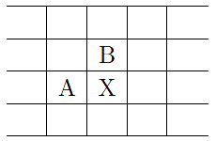
Figure 1: Neighbors Used To Predict X

Imagine a current pixel X with value 1 whose neighbors have values A=3, B = 1. The table indicates that the conditional probability P(1|3, 1) is high, so X should be assigned with few runs. On the other hand, the same X = 1 with neighbors A=3 and B = 3 can be assigned with many runs, since the table indicates that the conditional probability P(1|3, 3) is low. The method therefore uses conditional probabilities to detect common pixels (hence the name conditional RLE), and assigns them codes with few runs.
4.Context-Based Methods
Most image-compression methods are based on the observation that for any randomly selected pixel in the image, its near neighbors tend to have the same value as the pixel (or similar values). A context-based image compression method generalizes this observation. It is based on the idea that the context of a pixel can be used to predict (estimate the probability of) the pixel. Such a method compresses an image by scanning it pixel by pixel, examining the context of every pixel, and assigning it a probability depending on how many times the same context was seen in the past. The pixel and its assigned probability are then sent to an arithmetic encoder that does the actual encoding. The context of a pixel consists of some of its neighbor pixels that have already been processed. The diagram below shows a possible tow pixel context (the pixels marked P) made up of five pixels above and two on the left of the current pixel X. The pixels marked “?” haven’t been input yet, so they cannot be included in the context.

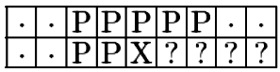
The main idea is to use the values of the seven context pixels as a 7-bit index to a frequency table, and find the number of times a 0 pixel and a 1 pixel were seen in the past with the same context. Here is an example:

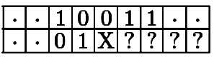
Since 1001101₂ = 77, location 77 of the frequency table is examined. We assume that it contains a count of 15 for a 0 pixel and a count of 11 for a 1 pixel. The current pixel is therefore assigned probability 15/(15 + 11) ≈ 0.58 if it is 0 and 11/26 ≈ 0.42 if it is 1.
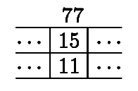
One of the counts at location 77 is then incremented, depending on what the current pixel is. Figure (2) shows ten possible ways to select contexts. They range from a 1-bit, to a 22-bit context. In the latter case, there may be 2²² ≈ 4.2 million contexts, most of which will rarely, if ever, occur in the image. Instead of maintaining a huge, mostly empty array, the frequency table can be implemented as a binary search tree or a hash table. For short, 7-bit, contexts, the frequency table can be an array, resulting in fast search.

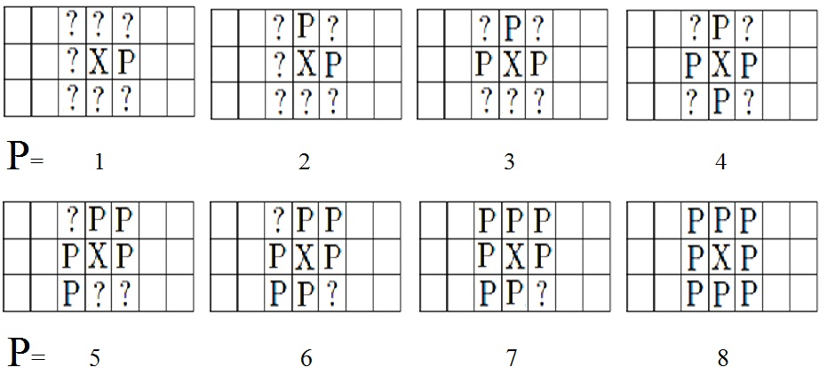

Figure 2: Context Pixel Patterns.

Experience shows that longer contexts result in better compression, up to about 2–9 bits. Contexts longer than that result in worse compression, indicating that a pixel in a typical image does not “relate” to distant pixels (correlations between pixels are typically limited to a distance of 1–2). As usual for a context-based compression method, care should be taken to avoid zero probabilities. The frequency table should thus be initialized to nonzero values, and experience shows that the precise way of doing this does not affect the compression performance significantly. It seems best to initialize every table entry to 1. When the process starts, the first pixels to be scanned don’t have any neighbors above them or to the left. A simple way to handle this is to assume that any nonexistent neighbors are zeros. It is as if the image was extended by adding as many rows of zero pixels as necessary on top and as many zero columns on the left.

5.Pattern Extraction
in the previous procedure to extract patterns that appear in a given corpus and calculate their frequency. This represents a similar approach to the usual TF (term frequency) approach. However, since in our research we do not use only single terms, but sentence patterns, it is necessary to propose a new nomenclature, namely PF (pattern frequency). PF is calculated for all patterns found in the matched corpus

6.Pattern Recognition
- A definition of pattern recognition, then, is a field whose objective is to assign an object or event to one of a number of categories, based on features derived to emphasize commonalities.
- What is pattern recognition? Could also be addressed by describing tasks to which it is applied.
- Pattern recognition is the study of how machines can observe the environment learn to distinguish patterns of interest make sound and reasonable decisions about the categories of the patterns

7.The Proposed System
From damaging between two methods (Conditional Image RLE) and (Context-Based Methods ) to suggest compressed system Provides for compressed pattern instead pixel as illustrated in the following stages:
First Stage: Compress processing using pattern context with the use of their textures images in different patterns to found number of contexts were repeating from the patterns in image of patterns by (Conditional Image RLE) , choose the context that higher repetition by (Context-Based Methods ), generate indicator matrix of (1 value), convert the indicator value to (0) when choose any context, repeat this process while the context grand then (1), store the pattern value and context code and context values in compress file, some value storing without context if the context counter is (1), as illustrated in figure (3) and showing same image in figure (4), showing results of compression to the images in table(1).

While context counter > 1
Original Image
Apply Conditional Image RLE
Choose Optimal Context with Large Pattern
Setting Indictor
Compress file
Store patters values, contexts codes, contexts values, Indicator and other values without context

Figure 3: Block Diagram of Compress processing


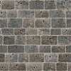


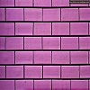
1
2
3
4
5

Fig. (4): images used to compressing
Table(1) results of image compression
Image name | Size of file before compress | Size of file after compress | Compression ratio
1 | 2038 KB | 569 KB | 72.08%
2 | 2038 KB | 776 KB | 61.92%
3 | 2038 KB | 859 KB | 57.36%
4 | 2038 KB | 856 KB | 57.99%
5 | 2038 KB | 732 KB | 64.08%

Second stage: Decompress processing consist of many stages each one regard as inverse to correspond stage in first stage, as illustrated in figure (5).

Original Image
Retrieve Indictor
Compress file
Retrieve patters values, contexts codes, contexts values and other values without context
For another levels

Figure 5: Block Diagram of Decompress processing

5. Conclusion:
The main characteristics of such computer system are listed here from determine the pattern, adaptive Conditional Image RLE, and the final results is considered satisfying by using this hybrid method that contains the previous characteristics. It has been designed and developed to compress the images of certain class like the "texture" images. It is based on the concept of the texture pattern for digital images Using Conditional Image RLE. Our efforts in this paper considered the following points to improve the performance of work:-
- Alternative the pattern context method to determine the pattern.
- Discard the undesired value that context under one and store without context.
- Compress the images without excite repeat neighborhood

References
Anna Saro Vijendran, Vidhya.B, 2011" A Hybrid Image Compression Technique Using Wavelet Transformation - MFOCPN and Interpolation ".
David Salomon, 2010 “Data Compression: The Complete Reference”, Springer international Edition.
Jian-hua Yeh, 2003 "Information Theory and Data Compression"
Lawrence O’Gorman, 2003 " INTERNATIONAL ASSOCIATION FOR PATTERN RECOGNITION".
Michal Ptaszynski , Rafal Rzepka, Kenji Araki, Yoshio Momouchi, 2011" SPEC - Sentence Pattern Extraction and Analysis Architecture".

