Molecular Study of Virulence Genes of Brucella Isolated from Human Clinical cases in Babylon Province
Mohammad Sabri A. Razzaq , Mohammad A. K. AlSaadi
College of Medicine University of Babylon
Abdul- Kareem S.. Al-Yassari
College of Vet. Medicine Al-Qasem Green University
Abstract:
The study was carried out in seven medical region; Babylon Hospital for Maternal and Pediatrics, Al-Hilla Surgical Teaching Hospital, Al- Qasim general Hospital , Al- Hashimia general Hospital , Marjan Hospital , Babylon public health libratory, and private labs . during the period from Dec.- 2010 to Jan.-2012. To evaluate the results of Molecular study of verulance factors gene of Brucellosis in human population. A total No. of 340 clinical blood samples5 ml were obtained from suspected patients with Brucellosis positive RBPT, Thirty from both sexes apparently healthy human individuals with rose Bengal negative were included as a control in this study. The samples were taken before adequate antibiotic treatment with age, sex group ranged from 9- 70 years. Study the verulence factors of Brucella species. is important at evaluated the Pathogenicity of this bacteria. Eight virulence factors were detected by using PCR technique, that all Brucella isolates possessed , Detection of virulence factors of Brucella isolates in present study ,incidence of specific PCR amplified fragment for genes (CBG, mviN ,manA, manB ,wbkA, omp25, omp31,and znuA ).
The virulence genes was present in most isolates belonging to Brucella spp.It was done at multiplex PCR by using two genes in each process, no.1,2,3,6,7,8 belong to B. melitensis , while no. 4,5 to B. abortus. These results indicate that each steps in the Brucella infection process can be mediated by a number of virulence factors and each strain may have a unique combination of these factors,this collection of virulence genes is made possible by the variety of genetic factors contributing the genome plasticity, such as plasmid, phages, and transposon elements, the total lack of virulence factor ratio ( 37.5%) in B.abortus than B. melitensis(12.5%) and the loses of this genes of total isolates were ( 50 %).. It was significant differences at level (P≤ o.o5).
الخلاصة:

تم أجراء الدراسة في سبعة مستشفيات هي م . الهاشمية العام , م .الحلة الجراحي، م .الولادة والأطفال،م. مرجان ،م. القاسم العام ، مختبر الصحة العامة ، المختبرات الأهلية / محافظة بابل خلال الفترة من شهر كانون الأول 2010 إلى شهر كانون الثاني 2012 . تم فحص 340 نموذج دم من المرضى وتحت أشراف الطبيب الاختصاصي بعد أجراء الفحص المختبري (RBT) وتم التعامل مع الحالات الموجبة للمرضى المشتبه بإصابتهم بحمى مالطا ، تراوحت أعمار المرضى بين 9 – 70 سنة للذكور والإناث وأظهر هدف الدراسة الجينية وجود علاقة وثيقة ومتشابه بين أنواع جرثومة البروسيلا من حيث عوامل الضراوة التي تتبعها البكتريا في أمراضيتها للنماذج الثمانية قيد الدراسة في الانسان .حيث وجد ثلاث عزلات فقدت جينات لعوامل الضراوة تعود لبكتريا البروسيلا المالطية

Introduction:
Brucellosis is azoonotic disease affecting animals and man in many parts of the world , it is required eradication of infection that prolonged treatment( Schutze et al ., 2011; Center food security, 2012). .Animals are considered as natural reservoir of human Brucellosis. Genetic and immunological evidence indicates that all members of the Brucella genus are closely related Nevertheless, based on relevant differences in host preference and epidemiology displayed by the major variants, as well as molecular evidence of genomic variation, it has many virulence factor causing sever Pathogenicity ( Marie- Rose Abdo., 2011)
Brucellosis is a multi-system disease that is endemic in many Mediterranean countries . The disease is transmitted to human by consumptions of infected unpasteurized dairy products, aerosol or by direct contact with infected animals (AKinci et al ., 2001; Jordi Perez-Gil et al ., 2012 ) ,or through ingestion of uncooked meat (Young, 2000). Occupational disease is contracted by exposure of abattoir workers and veterinarians to infected animals especially aborted fetuses, fluid, membrane, or urine (Boon et al., 2010 ; James Higgins et al ., 2012).
The routes of infection are multiple: food-borne, occupational or, linked to travel and even to bioterrorism (Godfroid et al., 2005). Brucella melitensis isthe most important zoonotic agent, followed by Brucella abortus, although human infection with B. abortus may be mild, it can cause troublesome and intractable illness the occurrence of the acute, often incapacitating infection in man caused by Brucella melitensis ( Boon et al ., 2010 ;). chronic infection may result in infection of secondary tissues lead to endocarditis, osteoarthritis, spondylytis, endocarditis, arthritis, osteomyelitis, meningitis, and severe neurological disorders, symptoms may also recur years after the original infection.(Zohreh Aminzadeh et al ., 2010 ; Ilian Radka Komitova1 et al., 2010). The World Health Organization (WHO) laboratory biosafety manual classifies Brucella in risk group III. Brucellosis is one of the five bacterial zoonoses, worldwide distribution, caused by organism belong to genus Brucella ( Corbel, 2006), but rarly leading to death (Doganay M. 2012).
Brucellosis is a zoonotic disease of worldwide distribution and economically the most ravaging that is associated with chronic serious sequels in humans (Memish and Balkhy, 2004; Kozukeev et al., 2006 ; Turan et al ., 2011).According to world health organization half million new human cases are reported each year worldwide and distribution for mor than 100 countries The diagnosis of the brucellosis is commonly delayed or missed because of minimal clinical picture. The laboratory diagnosis of brucellosis is slow due to the slow growth property of Brucella in culture media. diagnosis of brucellosis from smears of solid or liquid specimens.(Yagupsky, 1999; Xavier et al., 2009 ).A clinical presentation of the disease is non specific, and may be very atypical. Therefore, laboratory confirmation by an isolation or a detection of specific anti Brucella antibodies is essential for confirmation of the diagnosis (Young, 2000). However, positive blood cultures occur in 10% - 70% of suspected infections, depending on the duration, localization of the infection and the type of Brucella species. Because of their potential to detect very small numbers of organisms, PCR –based assays have been applied recently to diagnose many infectious diseases. However there are a few reports on the use of PCR for the diagnosis of human brucellosis from blood samples .
Materials and methods
Subjects
Human patients: A total No.of 340 clinical blood samples were collected from patients suffering from Brucellosis according to serological investigation ( ve+ rose Bengal test ), there were positive for Rose Bengal test, clinical signs , history epidemiological exposure , were admitted to seven hospitals: Babylon Hospital for Maternal and Pediatrics, Al-Hilla Surgical Teaching Hospital, Al- Qasim general Hospital , Al- Hashimia general Hospital , Marjan Hospital , Babylon public health libratory, and private labs . during the period from Dec.- 2010 to Jan.-2012. five ml blood samples were withdrawn from each patients and control , 3ml of it was ingected into prepared sterile trypticase soya broth Supplemented with 2% sodium citrate and Aerobicly incubated for 48 hours at 37ºC then it was subcultured on duplicate agar plates and incubated one in air and the other in an atmosphere containing an added 5-10 % carbon dioxide ( Alton et al ., 1988 ).
Bacteriological examination:
Blood samples were collected on basis of clinical indication by standard procedure(Alton., 1995) . culture for isolation of Brucella spp. was carried out by standard technique, including use of selective media , Brucella agar Base , Brucella selective media, Blood agar base, Nutrient agar, Brucella Selective supplements (Himedia – Accumax India). Brucella isolates were phenotypically identified with colonial morphology, Gram stain , modified Zieh1- Nee1sen method. and final identification with a series of conventional biochemical tests (Forbes ., 2007) . Bacteriological diagnosis was confirmed by PCR technique .
Materials used for PCR.
1-Wizard Genomic DNA purification kit /Promega- company/ USA .
2- GoTaq® Green Master Mix: provided by promega company/USA,
3- Primers used for diagnosis and virulence factor :
In this study, two types of PCR primers PCR primer were used as following:
- Brucella Detection Primers B4/B5 .These primers were located in region within a gene coding for 31-kDa membrane protein specific to the genus Brucella were used for detection and diagnosis of Brucella spp. Where, designed by (Baily et al., 1992) and provided by Alpha DNA Company (USA) as following table(1).

Table (1) Brucella Detection Primers B4/B5
Primer | Sequences |  | PCR product  Size
Brucella | B4 | 5'-TGGCTCGGTTGCCAATATCAA-3' | 223bp
Brucella | B5 | 5'-CGCGCTTGCCTTTCAGGTCTG-3' | 223bp
The lyophilized oligonucleotide primers were diluted first in 1 ml of TE (pH 8.0) and kept as stock in -20ºC then 100 µl of this stock was diluted in 1ml of deionized sterile distilled water to obtain nearly 10 pg/µl.
B- Brucella Virulence Factors Primers
These primers are specific for virulence factors genes in Brucella spp. were designed in this study by using NCBI Gene-Bank and Primer 3 online .These primers were provided by (Bioneer company, Korea) as following table(2).

Table (2) Brucella Virulence Factors Primers
Primer | Sequence (5’- 3’) |  | Product size
CBG | F | GAATTCGCCAATGAGGAAAA | 575bp
CBG | R | ACGATATCGGATGCGAAAAG | 575bp
MviN | F | GCAGATCAACCTGCTCATCA | 344bp
MviN | R | GGCCATAGATCGCCAGAATA | 344bp
ManA | F | TCGATCCAGAAACCCAGTTC | 271bp
ManA | R | CATACACCACGATCCACTGC | 271bp
ManB | F | GGCTGGTTCGAGAATATCCA | 228bp
ManB | R | CAATCGCATACCCTGGTCTT | 228bp
WbkA | F | GAGCGCTTAGGAATGCTGAT | 309bp
WbkA | R | CTCCTAGGTTCCAGCCCTTT | 309bp
omp25 | F | CGTACCTCACGGCTGGTATT | 188bp
omp25 | R | CGTACCGGCCAGATCATAGT | 188bp
omp31 | F | GCTGCTCCTGTTGACACCTT | 257bp
omp31 | R | GCTGAAATCGAACCCGTAAC | 257bp
ZnuA | F | CTGGGTCCGAGCATGTTTAT | 465bp
ZnuA | R | AGGCATCGAGTTTTTCTCCA | 465bp

Results & Discussion:
Isolation of Brucella spp. Among the 155 clinical blood samples (positive RBPT)from 340 human patients, eight isolates (5.16 %) isolates of Brucella were obtained from this samples 6 (75%) isolates that belonged to B.melitensis, 2 (25%) isolates that belonged to B.abortus, these results are identical with Al-Ouqaili (2006) who found that B. melitensis more prevalent among human brucellosis patients. using culture and biochemical methods and confirmed by PCR technique from 155 human patients .the results are shown in table (3).

Table (3) Results of human blood culture for Brucella spp.

Brucella isolates | RBT | Female |  | Male |  |  | Patient No. |  | isolate  No.
B.melitensis | + | 0 |  | 1 |  |  | 9b |  | 1
B.melitensis | + | 0 |  | 1 |  |  | 19 |  | 2
B.melitensis | + | 0 |  | 1 |  |  | 33 |  | 3
B.abortus | + | 1 |  | 0 |  |  | 50 |  | 4
B.abortus | + | 0 |  | 1 |  |  | 66 |  | 5
B.melitensis | + | 1 |  | 0 |  |  | 67 |  | 6
B.melitensis | + | 1 |  | 0 |  |  | 84 |  | 7
B.melitensis | + | 0 |  | 1 |  |  | 138 |  | 8
 | 8(5.16 %) |  | 3(37.5) |  |  | 5(62.5) |  | Total
This table indicates that Brucella spp. are difficult isolated from blood samples, followed by another samples , raw milk ,abdominal fluid, cheese. These results are identical with (Navarro et al.,2004) also with Al-Nakkas et al., (2005).

The PCR was positive in only 8 blood samples out of the 155 patient's samples with Brucellosis which represent 80% sensitivity while it was negative in all the control groups representing 100% specificity. High specificity (90%) and great sensitivity (98%) results are identical with (Fekete et al.,1992a; Marques et al.,2001).As expected, the primer pair used in this study succeeded in the amplification of a 223-bp fragment from the patient's blood which means that the DNA extracted from leukocyte pellets harboring Brucella's DNA, so yielded the predicted 223-bp fragment (Figure 1). To get confident, the identical amplification conditions were applicated on DNA extracted from Brucella . (Fekete et al., 1990) was the first to use PCR in the diagnosis of brucelloses and described it as a very specific, sensitive.. Blood and milk obtained from infected animals, revealed excellent PCR results (Baily et al.,1992 ; Leal-Klevezas et al.,1995; Romero et al.,1995a and Romero et al.,1995b).
The majority studies supporting present results in that the PCR sensitivity is better than that of culture and serological methods (Matar et al.,1996; Queipo-Orutno et al.,1997; Navarro et al.,1999; Al-Attas et al.,2000; Nimri, 2003 .
The genomes of genus Brucella , are contains two smaller circular chromosomes (Paulsen et al.,2002). G+C content is equal in the three species at 57%.There are approximately 3,200 – 3,4oo ORFs in each genome and its homology, so each have approximately ( 3 ) million base pairs (Mb ) of genomic DNA (Paulsen et al ., 2002 )

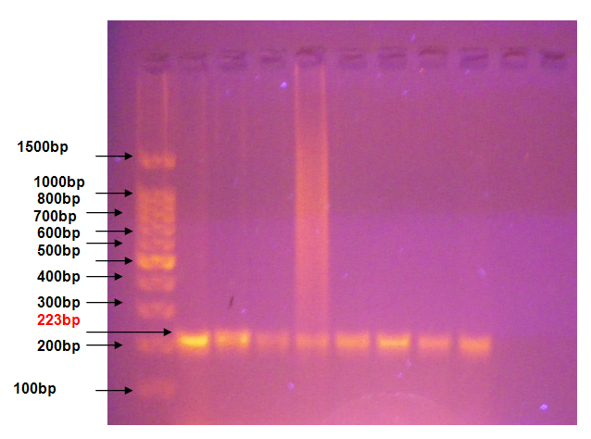
M 1 2 3 4 5 6 7 8

Figure (1): Agarose gel electrophoresis image, shown PCR products of diagnostic Brucella gene (B4,B5) from blood samples of human patients . where M: marker (100bp) Lane 1-8 positive results of blood samples in PCR
Mannosyltransferas (wbkA) , phosphomannomutase (manB).
All isolates of Brucella (8 isolates) were used to distinguish of virulence factors markers( wbkA and manB) . When wbkA marker was found in all isolates (100%) also manB was found in all samples, Figure (2 ) .
Too little information is available on this genes and DNA fragment to compared with another researchers . The function of this genes was intracellular survival, intracellular-modulatory activity, was appeared clearly bands in gel electrophoreses images.The presence of such genes in the Brucella genome will confirm that this bacteria is pathogen. According to Cloeckaert et al., (2003) LPS is the most significant virulence factor for Brucella which allowed to survival inside macrophages and other cells of the reticuloendothelial system by incidence of the
O-side chain on the lipo-polysaccharide of smooth strains.
Those results was agreed with present study when, manB; wbk was found in all Brucella isolates .(Caron et al., 1996; Lory and Tai, 1984). Those was found a smooth strain is more virulent than rough strains , Smooth LPS of Brucella has many atypical features, a relatively low toxicity for macrophage, low pyrogenicity ,this results was well- suited with current study, when the Brucella isolates taken in acute cases of human patients.

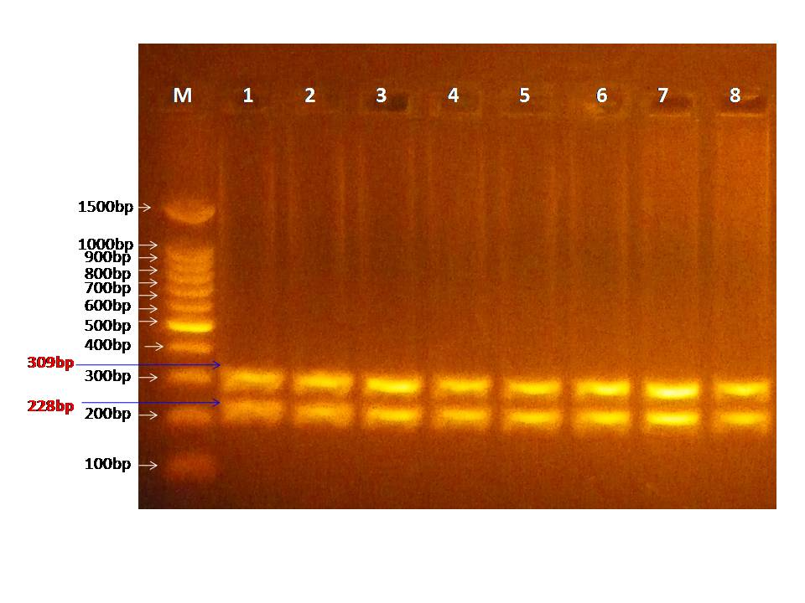
Figure ( 2): Agarose gel electrophoresis image of virulence factors genes ( wbkA) and (ManB ) gene of Brucella spp. which isolated from blood samples of human patients, where M: Marker (100bp) and Lane (1,2, 3,4, 5, 6, 7, and 8) shown positive PCR product for wbkA gene and ManB gene at PCR product (309bp) and (228bp)
Outer Membrane 31(omp31) and Cyclic Beta( 1-2) Glucan ( CBG).
By the same way, the omp 31 marker is present in all samples (8 isolates) from blood culture of human patients at B.melitensis and B. abortus . While marker( CBG) was absent in two isolates (25%) no.3,5 which is belong to B. melitensis and B. abortus respectively, Figure ( 3) .
The important virulence genes of Brucella are omp25 ( OMP 3a), omp 31 was detected by PCR assay in present study .it was identical with Santos et al., (1984).who had found a little difference among species has been observed in the OMP profile .The structure and composition of the Brucella cell envelope (CE) are quite peculiar. The Brucella membrane is composed of phosphatidylethanolamine (PE),PC, ornithine lipid (OL), cardiolipin (CL), and phosphatidylglycerol(PG) (Comerci et al .,2006; Conde-Alvarez et al .,2006 ;). Brucella spp. include cyclic β(1-2) glucan and this sugar is produced by cyclic β(1-2) glucan synthetase encoded by gene Cgs mechanism of a cyclic oligosaccharide molecule that is structurally similar to cyclodextrins and is capable of extracting cholesterol from cellular membrane. (Al-Arellano-Reynoso et al., 2005 ).
Brucella cyclic β-1-2 glucan could interfere with the maturation of the bacterial vacuole by disrupting cholesterol-rich lipid rafts present on phagosomal membranes and consequently prevent the Brucella containing vacuole (BCV) to fusion with lysosomes but is not osmotically regulated (Briones et al., 1997). The Cgs deletion mutant made from B. abortus were attenuated in vivo and in vitro but minimal attenuation was noted in Cgs mutants made from S2308 (field strain)indicating that strain difference may exists (Briones et al., 2001).In present study cbg gene is absent in two Brucella isolates due to mutation in it .
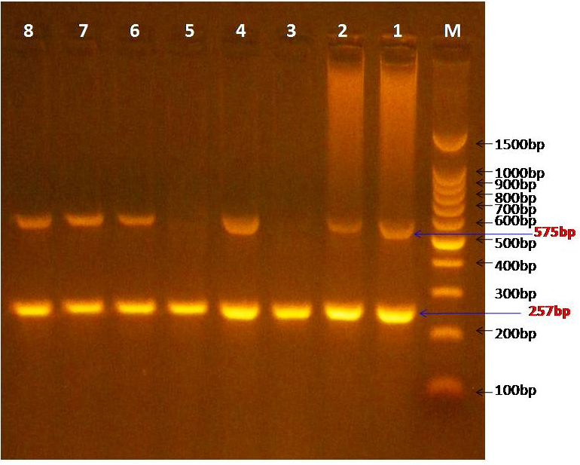

Figure (3) Agarose gel electrophoresis image of virulence factors genes (CBG) and
(OMP31 ) gene of Brucella spp. which isolated from blood samples of human patients, where M: Marker (100bp) and Lane (1,2, 4, 6, 7, and 8) shown positive PCR product for CBG gene at (575bp), where as Lane (1,2,3, 4, 5, 6, 7, and 8) shown positive PCR product for OMP31 gene at (257bp).
Membrane-bound protein (MviN) and OuterMembrane 25 (omp25) .

identified among the genomes. a number of fragment were shared between only Results of Brucella abortus isolates no. 4 was absent gene( omp25) and found in another isolates , while MviN genes was found in all eight local Brucella isolates ( B. melitensis , B. abortus ). Figure (4).
MviN is a membrane-bound protein (integral membrane protein) similar to one found in Salmonella that is necessary for virulence potency (.Katsukaka,1994).virulence-associated genes that have been identical in this study , with ( Pan , 1995 ) who has determent this virulence-associated genes in Brucella isolates. A number of insertion- deletion procedures and several polymorphic regions encoding putative outer membrane proteins were B. abortus and B. suis, B. abortus shared additional fragments and had less nucleotide polymorphisms with B. melitensis than B. suis (Halling et al.,2006).
The outer membrane contains only two components that have been identified virulence factors: the lipopolysaccharide (LPS) and the outer membrane proteins (OMPs) (Lory and Tai, 1984). The serum of susceptible animals contains a globulin and lipoproteins that suppresses growth of non- smooth, avirulant types and favor the growth of virulent types. Resistant animal species lack these factors ,so that rapid mutations to avirulence can occur. (Brooks et al., 2010 ).
There are important for explaining the differences in virulence and host specificity of Brucella spp. (Ratushna et al.,2005), at the same time as (Halling et al., 2006) mentioned that because of the similarity among the genomic sequences of Brucellae spp. differences among them with regards to host favorite virulence and infections cycle could be due to subtle variations in the conserved DNA and differential expression of conserved genes, rather than due to sole genomic DNA fragments of genus Brucella the two chromosomes of Brucella differ in two significant properties (Halling et al.,2006) .
he source of replication of the large chromosome (ch I) is typical of bacterial chromosomes, while that of the small chromosome (ch II) is plasmid like mainly of the essential genes are located on chr I.

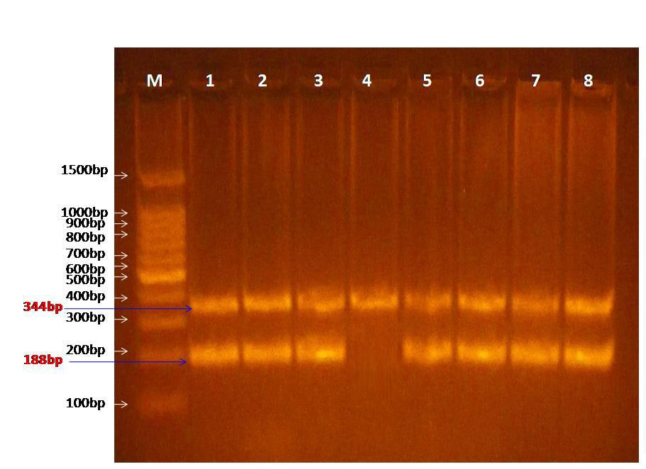

Figure (4): Agarose gel electrophoresis image of virulence factors genes (MviN) and (OMP25 ) gene of Brucella spp. isolated from blood samples of human patients. where M: Marker (100bp) and Lane (1,2, 3,4, 5, 6, 7, and 8) shown positive PCR product for( MviN) gene whereas Lane (1,2, 3,5 , 6, 7, and 8) shown positive PCR product for (OMP25) gene at (188bp) at PCR product (344bp) and (188bp) respectively.
Zinc ABC transporter periplasmic zinc-binding Protein ( ZnuA) and Mannose-6-phosphateisomerase (ManA).
Two markers ( ZnuA, Man A) were used together to show if Brucella isolates would posses them in its genome or not . It was observed after amplification of these markers by PCR that all Brucella isolates possessed the both markers except one isolates in which( Man A) was absent. Figure (5).
The present study found the ManA) gene was absent (12.5%) in one clinical Brucella isolates ( no.4) so in another isolates it has the same gene,but the (ZnuA) was present in all Brucella isolates (100%), Therefore B. melitensis is more virulent than B. abortus . Results showed that the infection by B. melitensis were more strong than those by B. abortus it has more virulence factor than B. abortus .
This may be due to the fact that B. melitensis is more virulent than B. abortus B. melitensis infection in agreement with Crawford et al., (1996) who reported that mice infected with B. melitensis had strong inflammatory response and prolonged splenomegaly. It has been documented that in animals and in human. Also,( Kilic S ,2008 ) the results showed greater number than present study (75%) , which have revealed that human brucellosis is almost exclusively caused by B.melitensis, accounting for 99% of total cases. However Al-Thwani et al. (2001) and Al-Ouqaili (2006) also found that B. melitensis more virulent among human brucellosis patients.
ZnuA (zinc ABC transporter ATP binding protein , zinc ABC transporter periplasmic zinc-binding Protein ). znuA gene present in Brucella melitensis would be similar to znuA in B. abortus ( Gee et al.,2005), it may also important factor for growth and virulence of Brucella abortus. Also this gene is an important factor for growth and survival , Zn concentration play chief role metabolic gene Zn A . One strategy involves the znu-ABC operon for high-affinity binding of Zn2 to allow survival where Zn2 levels are limiting. This requirement for zinc is evident by serving as a cofactor for the Cu, Zn superoxide dismutase (sodCgene) and enabling Brucella to resist oxidation by the host phagosome (Gee et al.,2005). In addition, Zn2is an essential structural or catalytic cofactor for many enzymes, and losing its ability to acquire the limited Zn levels from phagosomes would inhibit the activity of enzymes such as alkaline phosphatase, RNA polymerase, aspartate transcar- FIG. 4. B. abortus .znuA is effectively cleared by 8 weeks after infection.

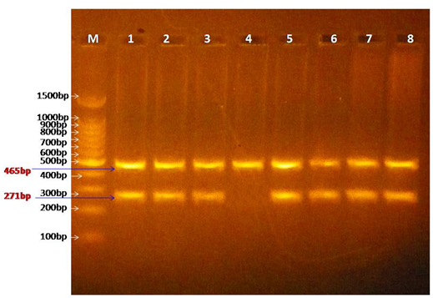

Figure (5) Agarose gel electrophoresis image of virulence factors genes (zunA) and (ManA ) gene of Brucella spp. which isolated from blood samples of human patients, where M: Marker (100bp) and Lane (1,2, 3,4, 5, 6, 7, and 8) shown positive PCR product for zunA gene whereas Lane (1,2, 3,5 , 6, 7, and 8) shown positive PCR product for ManA gene at PCR product (465bp) and (271bp) respectively.

References:

AL-Arellano-Reynoso B, et., (2005). Cyclic β-1,2-glucan is a Brucella virulence factor required for intracellular survival. Nat Immunol 6(6):618-625.
Al-Attas, R.A.; Al-Khalifa, M.; Al-Qurashi, A.R.; Badawy, M. and Al-Gualy, W. (2000). Evaluation of PCR, Culture and Serology for the Diagnosis of Acute Human Brucellosis. Annals of Saudi Medicine (20) p. 3-4.
Al-Ouqaili, M. T. (2006). Molecular, Bacteriological and Immunological Aspects in the Diagnosis of Human Brucellosis. Ph.D. thesis in medical microbiology. College of Med. Univ. of Baghdad.
Al-Thwani, A.N.; Shannshall, R.Z. and Al-Abbasi, A. (2001). Prevalence of brucellosis in man and animals in some Baghdad regions. J. Iraqi Sci. (42) p. 22-37.
Akinci, E.; Kamil Gol, M. & Balbay, Y. (2001). Acase of Prosthetic mitral valve endocarditis caused by Brucella abortus. Sc&. J. Infect. Dis. 33: 71-72.
Alton, G.G. and Forsyth, J.R. (1995). Brucella. ch.28 In Medmicro. (Internet).
Alton, G.G.; Jones, L.M.; Angus, R.D. and Verger, J.M. (1988). Techniques for the brucellosis laboratory. 1st ed. INRA. Paris. Ch.2 p. 114.
Al-Nakkas, A.; Mustafa, A. and Stephen, G. (2005). Large-scale evaluation of a single- tube nested PCR for the laboratory diagnosis of human brucellosis in Kuwait. J. Med. Microbiol. 54 p. 727-730.
Baily, G.G.; Krahn, J.B.; Drasar, B.S. and Stoker, N.G. (1992). Detection of Brucella melitensis and Brucella abortus by DNA amplification. J. Tropical Med. Hyg. (95) No. 4 p. 271-275.
Boon,N.A.; Colledge N.R.; Walker B. R., and Hunter, J. A. (2010). Davidsons principle and practice 21thed. London .U.K.pp:318-320.
Briones, G.; Inon de Iannino, N.; Roset, M.; Vigliocco, A.; Paulo, P. S. and Ugalde, R. A. (2001). Brucella abortus cyclic beta-1,2-glucan mutants have reduced virulence in mice and are defective in intracellular replication in HeLa cells. Infect. Immun. 69:4528-4535.
Briones, G.; Inon de Iannino, N.; Steinberg, M. and Ugalde, R. A. (1997). Periplasmic cyclic 1,2-beta-glucan in Brucella spp. is not osmoregulated. Microbiology 143:1115-1124.
Brooks,G.F., Butal, J.S., Carrol.I. and Morse ,S.A.( 2010 ). Medical Microbiology. 24 ^{rd} _{ed .Large Medical Books.}
Caron, E.; Gross, A.; Liautard, J. P. and Dornand J.(1996). Brucella species release a specific, protease-sensitive, inhibitor of TNF-α expression, active on human macrophage-like cells. J. Immunol. 156:2885-2893.
CDC, Centers of Disease Control and prevention(2012). Chapter 3, 1600 Clifton Rd. Atlanta, GA 30333, USA.
Cloeckaert, A.; Grayon, M.; Grépinet, O. & Boumedine, K. S. (2003). Classification of Brucella strains isolated from marine mammals by infrequent restriction site-PCR and development of specific PCR identification tests. Microbes. Infect. 5, 593–602.
Comerci, D. J., S. Altabe, D. de Mendoza, and R. A. Ugalde. (2006). Brucella abortus synthesizes phosphatidylcholine from choline provided by the host. J. Bacteriol. 188:1929–1934.
Conde-Alvarez, R., M. J. Grillo, S. P. Salcedo, M. J. de Miguel, E. Fugier, J. P. Gorvel, I. Moriyon, and M. Iriarte. (2006). Synthesis of phosphatidylcholine, a typical eukaryotic phospholipid, is necessary for full virulence of the intracellular bacterial parasite Brucella abortus. Cell. Microbiol. 8:1322– 1335.
Corbel, M.J. (1998). brucella in microbiological and microbial infection .9th .Ed Oxford University press inc . New York .
Corbel,M.J.,Alton,G,G.,Banai,M.,Diaz,R.andDranovskaia,B.A.(2006).Brucellosis in human and animals.WHO Press,Geneva.
Crowford, R.M.; VanDeverg, L.; Ywan, L.; Hadfieled, T.L.; Warren, R.I. and Hoover, D.L. (1996). Detection of pure attenuates Brucella melitensis infection in mice. Infect. Immun. 64: 2188-2192.
doganay M. (2012). human brucellosis: update of epidemiologicalclinical diagnostic, therepeutical features andprevention. tentative outline special issue for recent patents onantiinfectivedrug discovery.
Fekete, A.; Bantle, J. and Halling, S. (1992a). Detection of Brucella by polymerase chain reaction in bovine fetal and maternal tissue. J. Vet. Diagn. Invest. 4: 79-83.
Fekete, A.; Bantle, J.; Halling, S. and Sanborn, M. (1990). Preliminary development of a diagnostic test for Brucella using polymerase chain reaction. J. Appl. Bact. 69:216-227.
Forbes ,B. A., Daniel, F. S. and Alice, S. W. ( 2007 ) . Bailey and Scotts Diagnostic microbiology. 12 ed. Mosby. Elsevier Company, USA.
Gee, J. M., M. W. Valderas, M. E. Kovach, V. K. Grippe, G. T. Robertson, W. L. Ng, J. M. Richardson, M. E. Winkler, and R. M. Roop, Jr.( 2005). The Brucella abortus Cu,Zn superoxide dismutase is required for optimal resistance to oxidative killing by marine macrophages and wild-type virulence in experimentally infected mice. Infect. Immun. 73:2873–2880.
Godfroid, A.; Cloeckert, A.; Liautard, J.; Kohler, S.; Fretin, D.; Walravens, K.; Garin-Bastuji, B. and etesson, J. (2005). From the discovery of the Malta fever’s agent to the discovery of a marine mammal reservoir, brucellosis has continuously been a re-emerging zoonosis. Vet. Res. 36:313–326.
Halling, S.M., Peterson-Burch, B.D., Bricker, B.J., Zuerner, R.L., Qing, Z., Li, L.L., Kapur,Halling, S.M.; Gibas, C. and Boyle, S. (2006). Comparative Genomics of Brucella melitensis , B. suis and B. abortus in a text book of Brucella: Molecular and Cellular Biology. Ch. 5, 1st Ed. Horizon Scientific Press USA.
Ilian Radka Komitova1, Rumiana Nenova2, Iskra Tomova2, Snejanan Ivanova3Bojkovski4 Maced J (2010). Med Sci electronic publication ahead of print, published on September 10, as doi:10.3889/MJMS.1857-5773..0138.

James Higgins,Tod Stuber, Christine Quance, William H. Edwards, Rebekah V. Tiller, Tom Linfield, Jack Rhyan, Angela Berteand Beth Harris (2012). Molecular epidemiology of Brucella abortus isolates from cattle, elk, and bison in the United States, J. ASM .volume (78) ,issue 11.
Jordi Perez-Gil, Barbara M. Calisto, Christoph Behrendt, Thomas Kurz, Ignacio Fita and Manuel RodrigueConcepcion (2012). Crystal structure of the Brucella abortus deoxyxylulose 5-phosphate reductoisomerase-like (DRL) enzyme involved in isoprenoid biosynthesis, The American Society for Biochemistry and Molecular Biology:M112.354811v1.USA.
Katsukaka K, Okada T, Yokoseki T, Iino T. Gene. 1994;1:49–54.
Kilic S, Dizbay M, Hizel K, Arman D (2008).. In vitro synergistic activity of antibiotic combinations against Brucella melitensis using E-test methodology. Braz J Mic.;39:1-7.
Kozukeev, T.B.; Ajeilat, S.; Maes, E.; Favorov, M. and Centers for Disease Control and Prevention(CDC). (2006): Risk factors for brucellosis--Leylek and Kadamjay districts, Batken Oblast, Kyrgyzstan, January-November, 2003., MMWR Morb. Mortal Wkly Rep., 55 Suppl., 1: 31-4.
Leal-Klevezas, D.; Martinez-Vazquez, I.; Lopez-Merino, A. and Martinez-Soriano, J. (1995). Single-step PCR for detection of Brucella spp. from blood and milk of infected animals. J. Clin. Microbiol. 33(12): 3087-3090.
Lory, S. and Tai, P. (1984). Biochemical and genetic aspects of Pseudomonas aerginosa virulence. Curr. Top. Microbial. Imm. 118: 53.
Marie-Rose Abdo, Pascale Joseph, Jérémie Mortier, François Turtaut, Jean-Louis Montero, Bernard Masereel, Stephan Köhler, Jean-Yves Winum . ( 2011 ) . Anti-virulence Strategy against Brucella suis: Synthesis, Biological Evaluation and Molecular Modeling of Selective Histidinol Dehydrogenase Inhibitors. Org Biomol Chem. Apr 1;: 21461427.
Matar, G.M.; Khneisser, I.A.; Abdelnoor, A.M. (1996). Rapidlaboratory confirmation of human brucellosis by PCR analysis of atarget sequence on the 31 kilodalton Brucella antigen DNA. J. Vet.Microbiol. 34 (2), 477-478.
Memish, A.Z. and Balkhy, H.H. (2004): Brucellosis and international travel. J. Travel Med., 11 (1): 49-55.
Moreno, E. and Moriyon, I. (2002). Brucella melitensis. A nasty bug with hidden credentials for virulence Infect. In., 27: 33 – 41.
Nimri, L.F. (2003). Diagnosis of recent and relapsed cases of human brucellosis by PCR assay. BMC. Infectious Diseases. 3: 5.
Pan S Q, Jin S, Boulton M I, Hawes M, Gordon M P, Nester E W. Mol Microbiol. (1995).17:259–269.
Paulsen, I.T., Seshadri, R., Nelson, K.E., Eisen, J.A., Heidelberg, J.F., Read, T.D., Dodson, R.J., Umayan, L., Brinkac, L.M., Beanan, M.J., Daugherty, S.C., Deboy, R.T., Durkin, A.S., Kolonay, J.F., Madupu, R., Nelson, W.C., Ayodeji, B., Kraul, M., Shetty, J., Malek, J., Aken, S.E.V., Riedmuller, S., Tettelin, H., Gill, S.R., White, O., Salzberg,S.L., Hoover, D.L., Lindler, L.E., Halling, S.M., Boyle, S.M., Fraser, C.M., (2002). The Brucella suis genome reveals fundamental similarities between animal and plantpathogens and symbionts. Proceedings of the National Academy of Science of the United States of America 99, 13148–13153.
Navarro, E.; Casao, M. and Solera, J. (2004). Diagnosis of human brucellosis using PCR. Expert Reu. Mol. Diagn. 4(1) p. 115-123.
Navarro, E.; Fernandez, J.; Escribano, J. and Solera, J. (1999). PCR assay for diagnosis of human brucellosis. J. Clin. Microbiol. 37(5)p. 1654-1655.
Queipo-Ortuno IM, Morata P, Ocon P, Manchado P, de Dios Colmenero J.( 1997) . Rapid diagnosis of human brucellosis by peripheral-blood PCR assay. J Clin Microbiol; 35: 2927–2930.
Ratushna, V.; Sturgill, D.; Romamoorthy, S. and Poff, S. (2005). Identification of Transeribed Differentiating Genes in Brucella abortus, B. melitensis and B. suis. J. Bacteriology.
Romero, C.; Gamazo, C.; Pardo, M. and Lopez-Goni, I. (1995a). Specific detection of Brucella DNA by PCR. J. Clin. Microbiol. 33(3): 615-617.
Romero, C.; Pardo, M.; Grillo, M.; Diaz, R.; Blasco, J. and Lopez-Goni, I. (1995b). Evaluation of PCR and indirect enzyme-linked immunosorbent assay on milk samples for diagnosis of brucellosis in dairy cattle. J. Clin. Microbiol 33: 3198-3200.
Schutze Gorden E. Richard F. Jacobs. ( 2011). Brucella in Kliegman Behrman jenson , Nelson Text Book of Pediatrics 19th_{edition.}Chapter 199; Philadelphia , Pennsylvania.
Turan, H., Serefhanoglu, K., karadeli, E., Togan, T.and Arslan H.(2011). Osteoarticular involvement among 202 brucellosis cases indetified in central Anatolia region of turkey .international medicine , 50:421-8.
Xavier, M.N., Paixmo, T.A., Poester, F.P., Lage, A.P., Santos, R.L., in press. (2009) Pathology, immunohistochemistry, and bacteriology of tissues and milk of cows and fetuses experimentally infected with Brucella abortus. Journal of Comparative Pathology. doi:10.1016/j.jcpa..10.004
Yagupsky , P. (1999). Defection of Brucella in blood culture J. clin. Microbiol. 37:3437-344.
Young , E . J. (2000). Brucella species. p2386 -2893. In: mandell , G. L. ; Bennett , J E and Donil , (els). Prenceples and practice of infectious disease . 5th ed. Churchill Livingstone Edinpurgh.
Zohreh Aminzadeh*, Babak Farrokhi, Hossein Akhavan Zanjani, Farshid Aliyari, Zivar Baiati, Fatemeh Navaei and Jamal Mirzaei, (December 2010). Journal of Infectious Diseases and Immunity Vol.2(3) pp.41- 43.

