Evaluation of Chromosome Aberrations and Mitotic Index in Alloxan-Induced Diabetic Male Rats Treated with the Mixture of Plants Extracts Mixture
Maysaa’ A.Al-Joubori , Haider K. Zaidan , Ali H. Al Saadi
Dept. of Biology, College of Science, University of Babylon
Abstract
The effects of methanol-watery extracts mixture of five selective medicinal plantss on chromosome aberrations and mitotic index in alloxan-induced diabetic male rats were studied. The mixture used composed of five methanol-watery extracts of Trigonella faenum-graecum (fenugreek) seeds, Nigella sativa (black cumin) seeds, Zingiber officinale (ginger) rhizomes, Olea europeae (olive) leaves, and Fraxinus ssp.(ash) seeds. Cytogenetic study showed significant increasing (P<0.05) in mitotic index and chromosome aberrations in diabetic group while treatment with mixture of plants extracts significantly reduced mitotic index and chromosome aberration in all treatment groups and for different period of study (45, 60 and 75 days).
الخلاصة
درس تأثيرات خليط المستخلصات المائية الميثانولية لخمسة من المستخلصات النباتية الطبية المختارة على التشوهات الكروموسومية ومعامل الانقسام في ذكور الجرذان المستحث بها داء السكري بالالوكسان. يتكون الخليط المستخدم من خمسة مستخلصات مائية-ميثانولية(بذور الحلبة وبذور الحبة السوداء ورايزومات الزنجبيل واوراق الزيتون وبذور لسان العصفور).أظهرت الدراسة الوراثية الخلوية زيادة معنوية في معامل الانقسام والتشوهات الكروموسومية في المجموعة المصابة بداء السكري في حين ان المعاملة بخليط المستخلصات النباتية قللت وبصورة معنوية معامل الانقسام والتشوهات الكروموسومية في كل مجاميع المعاملة وافترات المعاملة المختلفة (45 و60 و75 يوم).
Introduction
Recently, the search for appropriate hypoglycemic agents has been focused on plantss used in traditional medicine (Rates, 2001). Medicinal plantss are frequently considered to be less toxic and free from side effects than the synthetic ones. The world health organization has also recommended that this should be encouraged, especially in countries where conventional treatment of diabetes seems insufficient (Santhakumari et al., 2006).
Chromosomal aberrations (CA) are disruptions in the normal number or structure of chromosomes, representing a major cause of genetic disorders. Numerical aberrations involve the loss or gain of entire chromosome, giving rise to monosomy or trisomy. Structural aberrations affect parts of chromosomes, usually implying a break in the chromosome and give rise to different rearrangements (Andreescu et al., 2010). The most suitable genotoxicity tests include CA, peripheral blood and bone marrow micronucleus (MN), and sperm morphology tests (Sumanth and Chowdary, 2010).
Some of the damaged cells show a large number of aberrations such as dicentrics, polycentrics, rings, and numerous acentric fragments (Movafag et al., 2007). DNA double stranded breaks are generally accepted to be the most biological significant lesion produced by ionizing radiation, and may ultimately result in cancer (Kammk and Lobrich, 2003).

Oxidative stress –induced DNA damage seems to play a role in the pathogenesis of type 1 diabetes mellitus (T1DM) (Cinkilica et al., 2009) and type 2 diabetes mellitus (T2DM) and its complications (Boehm et al., 2008).The study of Cinkilica et al.,2009 investigate the frequency of SCE, CA, and MN in T1DM patients compared with healthy controls. SCE, CA and MN tests were carried out with the blood cell cultures from 35 T1DM patients and 15 healthy, age –and sex –matched control subjects. Furthermore, it has been reported a significant increases of each of blood glucose level, genetic changes (DNA fragmentation, deletion or disappear of some base pairs of DNA, CA) and sperm abnormalities in hyperglycemic animals compared to normal animals (Ghaly et al., 2011).

Dyslipidemia which characteristic of T2DM leads to an increased production of aldehydes, including methylglyoxal which induces an increase of ROS (Bourajjaj et al., 2003), and ROS might, albeit indirectly, accelerate telomere attrition (Liu et al., 2002). Furthermore, methylglyoxal causes stable modification of DNA bases, which in turn induces CA, SCE, and MN in human lymphocytes treated in vitro (Migliore et al., 1990). Although there is an enzymatic defense against methylglyoxal-induced DNA mutation, e.g., the enzymes glyoxalase I and aldehyde reductase (Thornalley, 2003), both enzymes are highly dependent on the concentration of glutathione, which is severely reduced in diabetes (Barati et al., 2007).
This study was aimed to evaluate the possible cytoprotective effect of the methanol-watery extracts mixture of five medicinal plantss (fenugreek seeds, black cumin seeds, olive leaves, ginger rhizome and fraxinus seeds) and determine the efficiency of this mixture of plants extracts in the treatment of type 2 diabetes mellitus which may occur against harmful effect and damage in bone marrow cells of alloxan-induced diabetes in rats.

MATERIAL AND METHOD
1. Plants extract preparation: The plantss which used in this study were purchased from a local herbal markets except olive leaves were collected from gardens of Babylon university. The plantss parts used in this study were Trigonella faenum-graecum (fenugreek) seeds, Nigella sativa (black cumin) seeds, Zingiber officinale (ginger) rhizomes, Olea europeae (olive) leaves, and Fraxinus ssp.(ash) seeds. Oilve leaves were rised with water to remove dust, insecticides, and contaminated materials then dried in dark. All plantss materials were ground into fine powder.
The plantss extracts were prepared according to Sato et al. (1990). Each plants powder homogenize with solvent mixture (methanol: distal water) (20:80 v\v) in blander for 30 min , the mixture are infiltration and dry in oven 45 ^{ο}C for 24 hours , the product store in dark container. The mixture was prepared by mixing 0.5 ml of each extract (concentrations graded 10-100 mg /kg body weight).

2. Induction of diabetes: Injection of alloxan multiple doses of 120 mg/kg i.p was used for the induction of diabetes mellitus type 2 (T2DM). 36 albino male rats were used and randomly divided into six groups (n=6 each group) included; group I: normal negative control, group II: diabetic control, group III: normal rats treated with plants extracts s mixture for 60 days, group IV: diabetic rats treated with mixture of plants extracts for 45 days, group V: diabetic rats treated with mixture of plants extracts for 60 days, and group VI: diabetic rats treated with mixture of plants extracts for 75 days.
3. Solutions
1)Phosphate Buffer Saline (PBS): The following materials should be prepared in advance (0.8 gm of NaCl, 0.2 gm of PCl, 1.15 gm of Na2HPO4 and 0.2 gm of KH2PO4). These materials are dissolved in 500 ml of distilled water, then the volume is completed to 1000 ml. After adjusting the acidity of the solution to pH= 7.2 then it is sterilized (121 ^{ο}C, 1 bar for 20 minutes) and kept at 4 ^{ο}C (Sambrook and Rushell, 2001).
2) The Colchicine Solution: The Colchicine solution was prepared immediately before using it. This is carried out by dissolving one tablets (0.5 mg) of the drug in 1 ml of PBS, then the animal was injected intrapretonially (Allen et al., 1977).
3) Hypotonic Solution: The solution was prepared by dissolving 5.75 gm of KCl in 500
ml of distilled water, then the volume was completed to 1000 ml. It was sterilized and kept at 4 ^{ο}C (Allen, et al. 1977).
4) Fixative Solution: It was prepared immediately by mixing absolute methanol with glacial acetic acid. The ratio is 3:1 volume. The solution kept at 4 ^{ο}C (Allen, et al. 1977).
5) Giemsa Stain Solutions: Prepared according to Allen, et al. (1977).
a. Stock Solution of Giemsa Stain. 3.8 g. of Giemsa stain solution powder was dissolved in 25 ml of glycerin solution. The solution was put in water bath at 60 ^{ο}C for two hours with continuously shaking it. The solution was left for 30 minutes at 37 ^{ο}C, then 75 ml of absolute methanol was gradually added and simultaneously mixed. The solution was filtered and kept in a dim bottle as stock solution of Giemsa stain.

b. Sodium Bicarbonate was prepared by dissolving 7.5 gm of sodium bicarbonate (NaHCO3) in 50 ml distilled water, then the volume was completed to 100 ml.
Before the staining with Giemsa stain, the following materials are mixed, 1ml of stock solution of Giemsa stain, 1.15 ml of absolute methanol, 0.5 ml of sodium bicarbonate, and 40 ml of distilled water.

4. Preparation of karyotype of bone marrow cells
The chromosomes were prepared using direct method (Sharma and Sharma, 1980) with some modifications, the procedure as follow:
1-The rats were injected intraperitonially with colchicine ( 0.5 mg/kg body weight) to arrest the divided cells at metaphase and destroying the spindle fibers, and left for (3) hours.
2-The rats were sacrificed by cervical dislocation, immediately the femurs were removed and freed of muscles, the two ends of the femur bones were cut with sharp scissor until a small opening in the bone marrow canal became visible. Bone marrows were extracted from the femur by injection of 5 ml of hypotonic solution (KCL) using disposable syringe and collected the marrow in a centrifuge tube, then incubated in water bath at 37 ºC for 20 min. After incubation 1 ml of cold fixative was added slowly to the side of centrifuged tube, and then centrifuged at 2000 rpm for 2 min.
3-The supernatant was discarded and 5 ml of cold fixative was added to the precipitate slowly. The mixture was left for 5 min at room temperature then centrifuged again at 2000 rpm for 2 min.
4-The supernatant was discard and 3 ml of cold fixative was added slowly and left in ice bath for 5 min. Using Pasteur pipette, 3-5 drops of the chromosome suspension were dropped in the height 75 cm over a clean moist slide, then the slides air dried and stained with Giemsa stain.
5-At least 1000 metaphase cells per animal were scored to investigate chromosomal aberration.
5. Mitotic index:
Mitotic index was determined by scoring at least 1000 cells from each animal, and then MI was calculated by a ratio of mitotic cells to total cell number in 1000 cells of each rat, then the coefficient of division is obtained according to the following formula:

Mitotic Index (%) = The number of the dividing cells X 100 / The total number of cells (Shubber and Juma, 1999.)
6.Statistical analysis: Analysis of data was performed using statistical package for social science (SPSS) system/ version 17. Results expressed as mean ± standard error .The analysis of variance (ANOVA) was used for this purpose.

RESULTS
Mitotic Index (MI)
In diabetic group, there was a significant increasing (P<0.05) in MI (8.225 ± 0.51) compared with negative control. Normal & diabetic groups treated with mixture of plants extracts for different periods of study showed no significant differences in MI compared with negative control while the same groups (normal &diabetic groups treated with mixture of plants extracts ) showed significant decreasing (P<0.05) compared with diabetic control (Table -1).

Table (1): Mitotic index of experimental rats (mean ± S.E).
Mitotic index (MI) | Group
5.775 ± 0.333 a | Negative control
8.225 ± 0.511 b | Diabetic control
5.512 ± 0.560 a | Mixture of plants extracts e(60 days)
6.317± 0.235 a | DM + Mixture of plants extracts (45 days)
6.667 ± 0.604 a | DM + Mixture of plants extracts (60 days)
5.600 ± 0.228 a | DM + Mixture of plants extracts (75 days)

- Different letters refers to significant difference between groups
- Similar letters refers to non significant difference between groups
- n=6 each group
-S.E :standard error
Chromosomal Aberration
Alloxan–induced diabetes in experimental rats showed some chromosome aberrations in bone marrow cells .The majority of aberrations for all experimental groups were chromatid break, aneuploidy, fragmented chromosome, ring chromosome , multicentric chromosome and elongated chromosome as shown in figures (1). Tables (2) and (3) also showed changes in the means and percentage of chromosomes aberrations in bone marrow cells. Diabetic group showed significant increasing (P<0.05) in the means of all types of chromosome aberration in bone marrow cells and therefore, increasing in the percentage of chromosome aberrations (3)% compared with negative control (1.675)%. Normal group treated with mixture of plants extracts for 60 days showed no significant differences in the most means of chromosome aberration compared with negative control and the percentage was 1.822 % except ring chromosome which increased significantly (P<0.05) to 1.737±0.532 compared with negative control which was 0.5 ± 0.183, while means of aneuploidy, fragmented chromosome, ring chromosome, multicentric chromosome and elongated chromosome reduced significantly (P<0.05) compared with diabetic control. Mixture of plants extracts had effect in reducing chromosomal aberration percentage for different periods of treatment which was (1.538, 0.999, 0.877) % in diabetic groups treated with mixture of plants extracts for 45, 60, 75days respectively.

Table 2: Changes in some chromosomal aberrations means of bone marrow cells of experimental rats (mean±S.E).

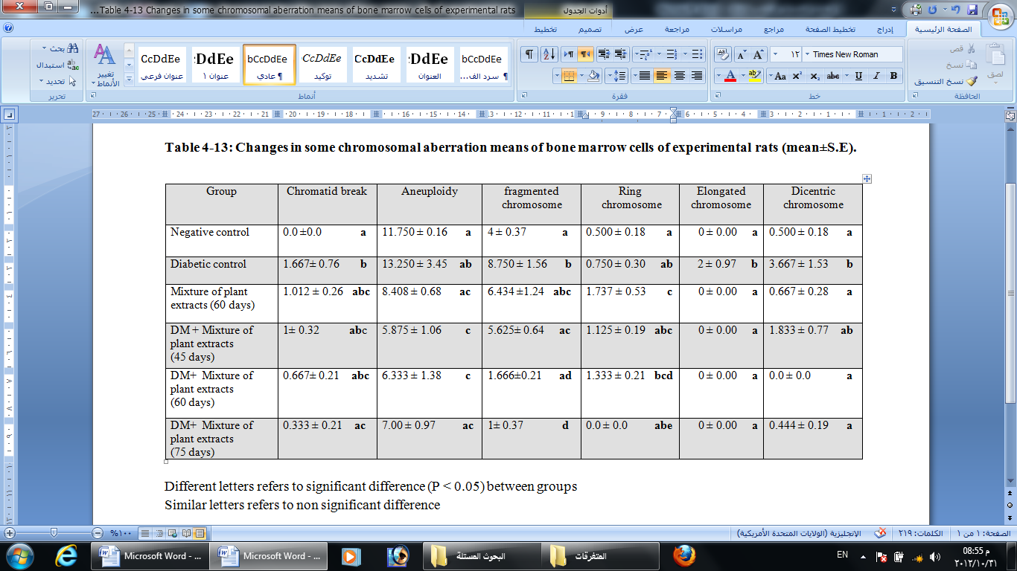

- Different letters refers to significant difference between groups
- Similar letters refers to non significant difference between groups
- n=6 each group
-S.E :standard error

Table 3: Percentage of some chromosomal aberrations of bone marrow cells of experimental rats.
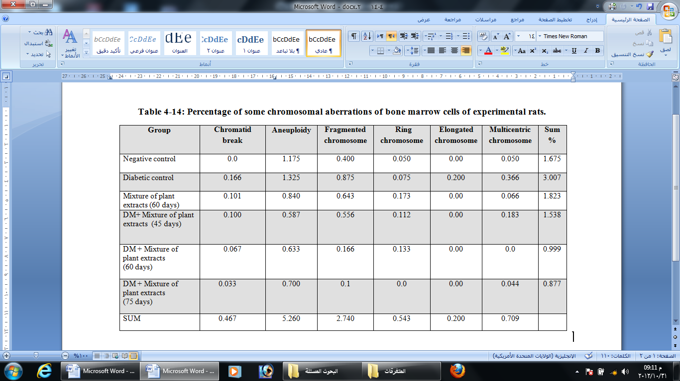

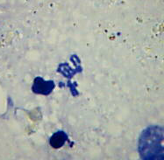
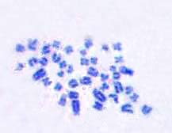
B

A

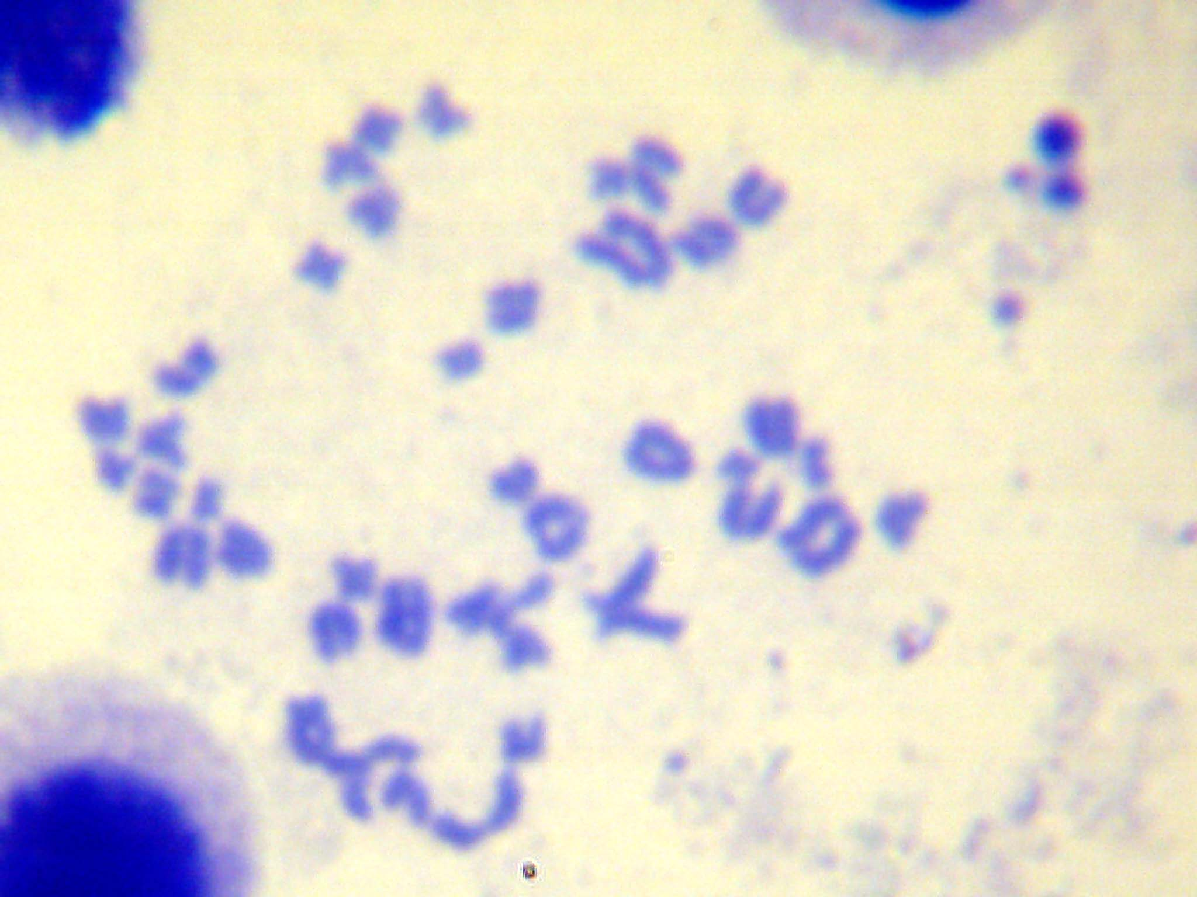

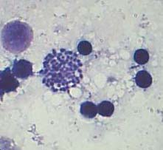

C

D
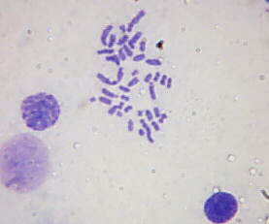

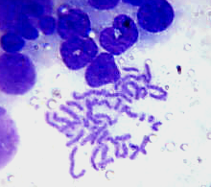

F
E

Figure (1): Metaphase chromosomes of bone marrow cells. A- Chromatid break of normal group treated with mixture of plants extracts for 60 days. B- Aneuploidy of diabetic group treated with mixture of plants extracts for 60 days. C- Fragmented chromosome of diabetic group. D- Ring chromosome of normal group treated with mixture of plants extracts for 60 days. E- Elongated chromosome of diabetic group. F- Multicentric chromosomes of diabetic group (Giemsa stain, 1000X).

Disscusion
Table (1) shows that MI of bone marrow cells of alloxan-induced diabetic group increased significantly (8.225±0.511) as compared with negative control may be because alloxan may cause increasing in insulin like growth factor-1(IGF-1) or insulin like growth factor-2(IGF-2). Insulin receptor (IR) of bone marrow cell may respond to another factor (other than insulin due to deficiency of insulin in diabetic rats) as insulin –like growth factor-2 (IGF-2) which bind with IR-A to sent mitogenic, antiapoptotic signals. Sciacca et al. (2003) mentioned that in 32D cells, a murine hematopoietic cell line, IR-A sends mitogenic and antiapoptotic signal in response to IGF-II. Since the IR and the IGF1 receptor (IGF1R), both evolved from a common ancestor gene, represent fundamental regulators of glucose metabolism and growth, respectively, in response to nutrient availability. Insulin resistance may favor an increased stimulation of the IGF1R by increasing IGF1 bioavailability (Belfiore and Malaguarnera, 2011). Accordingly, low levels insulin like growth factor binding protein-2 (IGFBP-2) and high IGF-1concentrations occur in insulin resistance patients (Samani et al., 2007).

In addition, this increasing in MI may be due to increased number of T-lymphocyte in bone marrow of diabetic group. Zhang et al.(2010) demonstrated that a large number of diabetogenic T –cell are present in the bone marrow of female NOD mice.The bone marrow T-cell from hyperglycemic mice profoundly higher proliferation and cytokine production in response to stimulation of β-cell antigen .
In normal group treated with mixture of plants extracts, MI is normal as compared with negative control .This result may be because this plants extracts has not any toxic or negative side effects on bone marrow cells and the most plantss used are save as reported by previous studies that revealed that fenugreek seeds and had no acute toxicity (Mowla et al., 2009). No side effects or lethal effects attributable to ginger (Sontakke et al., 2005; Nanjundaiah et al., 2009). Also, the clinical efficacy of seeds extract of fraxinus was assessed (Visen et al., 2009).
MI return to normal value in diabetic groups treated with mixture of plants extracts for different periods of study because mixture of plants extracts significantly reduced the high MI of diabetes. This result may due to the ability of the total compounds in mixture of plants extracts to act synergistically to inhibits the increased cell growth of bone marrow or may due to presence of some compounds in the mixture which reported to be inhibit cell growth and induced apoptosis as diosgenin and oleanolic acid or suppress mutagenicity as zingerone and phenolic compounds or have antitumor activity or cell growth inhibition as thumoquenone (TQ) due to its effect on cell cycle.
Continous feeding of 1% fenugreek seeds powder or 0.05% or 0.01% diosgenin for 1 week given with azoxymethane-induced rat colon carcinogenesis indicate that diosgenin inhibit cell growth and induces apoptosis in HT-29 human colon cancer cell line in a dose dependent manner. Furthermore, diosgenin induce apoptosis in HT-29 cells at least in part by inhibition of bcl-2 and by induction of caspase -3 protein expression (Raju et al.,2004). In addition, the role of TQ in influencing cell cycle regulator involved in apoptosis as well as in down-regulating the anti apoptotic proteins (Ismail, 2009) while Gali-Muhtasib et al. (2004) revealed that the principle activity of TQ was found to be due to its effects on the expression of cell cycle proteins. Womack et al (2006) have evaluated in 2006 the effects of a single dose of 5 μM of TQ which showed a 50% reduction in Hep-2 cell numbers after 24h. After 48 h the cells exhibited a four-fold decrease in total cell number which indicates that TQ given in a sub-therapeutic dose could alter cellular viability. Also, oleanolic acid is biologically active as an inhibitor of proliferation of leukemic cell (Es-Saady et al.,1994).
The data indicate the significant increasing (P<0.05) in the means of all types of chromosomes aberrations in bone marrow cells and therefore, increasing in the percentage of chromosome aberrations (3)% compared with negative control (1.675)% .This increased ratio of CA due to alloxan as diabetogenic induce oxidative stress and hence DNA strand breaks, fragmentation and loss of chromosomal integrity (Boehm et al., 2008). Okamoto (1985) proposed that reactive oxygen species produced from alloxan cause DNA strand breaks. This oxidative stress induced DNA damage seems to play a role in the pathogenesis of T1DM (Cinkilica et al., 2009) and type 2 diabetes and its complications. Oxidative stress due to chronic hyperglycemia leads to the generation of reactive oxygen species (ROS) and loss of chromosomal integrity (Boehm et al.,2008). This observation is in agreement with previous study which has been reported a significant increases of each of blood glucose level (BGL), genetic changes (DNA fragmentation, deletion or disappear of some base pairs of DNA, chromosome aberrations) and sperm abnormalities in hyperglycemic animals compared to normal animals (Ghaly et al., 2011).
The results observed that daily intake of mixture of plants extracts for 60 days to normal rats showed no significant differences in the most means of chromosome aberration compared with negative control and the percentage was 1.822 % except ring chromosome which increased significantly (P<0.05) to (1.737±0.532) compared with negative control (0.5 ± 0.183). This result may be due to the most compound containing are safe but giving them to normal rats induce formation of ring chromosomes in bone marrow cells. In diabetic group treated with plants extracts mixture, the mixture can reduce the frequencies and percentage of CA in rat bone marrow cells to 1.538, 0.999 and 0.877 % in diabetic groups treated with mixture of plants extracts for 45,60,75 days respectively. This result due to the ability of mixture of plants extracts which consisting of many antioxidant compounds which may act synergistically to maintains genomic stability in diabetic groups treated with mixture of plants extracts which decreasing oxidative stress in diabetic groups. In conclusion, treatment with mixture of plants extracts used in this study could reduce high MI and CA caused by alloxan-induce diabetes in male rats.

References
Allen, J.W. ; Shuller, C.F. ; Mendes, R.W. and Latt, S.A. (1977). A simplified technique for in vivo analysis of sister chromatid exchange using 5- bromodeoxy uridine tablets. Cytogenetic, 18, 231-237.
Andreescu, N.; Stoicanescu, D.; Belengeanu,A.; Farcas, S.; Popa, C.; Stoian, M.; Belengeanu, V. (2010). Unbalanced karyotype in a human foetus due to a recurrent familial translocation. Analele Universităţii din Oradea - Fascicula Biologie Tom. XVII / 1:9-13.
Barati, M.T.; Merchant, M.L.; Kain, A.B. (2007). Proteomic analysis defines altered cellular redox pathways and advanced glycation end product (AGE) metabolism in glomeruli of db/db diabetic mice. Am J Physiol Renal Physiol 293:1157–1165.
Belfiore, A. and Malaguarnera, R. (2011). Insulin receptor and cancer. Endocrine-Related Cancer 18 :125–147.
Boehm, B.O.; Moller, P.; Hogel, J.; Winkelmann, B.R.; Renner, W.; Rosinger, S.; Seelhorst, U.; Wellnitz, B.; Maorz, W.; Melzner, J. and Bruderlein, S. ( 2008). Lymphocytes of type 2 diabetic women carry a high load of stable chromosomal aberrations a novel risk factor for disease-related early death. DIABETES 57:2950-2957.
Bourajjaj, M.; Stehouwer, C.D.; van Hinsbergh, V.W. (2003). Role of methylglyoxal adducts in the development of vascular complications in diabetes mellitus. Biochem Soc Trans 31:1400 –1402.
Cinkilica, N. (1990). Evaluation of chromosome aberrations, sister chromatid exchange and micronuclei in patients with type-1 diabetes mellitus. Mutat. Res. 244 (1990) 251-256.
Es-Saady, D., Najid, A., Simon, A., Denizot, Y., Chulia, A. J. and Delage, C. (1994). Effect of ursolic acid and its analogues on soybean 15-lipoxygenase activity and the proliferation rate of a human gastric tumor cell line. Mediators Inflammation, 3, 181–184.
Gali-Muhtasib, H., M. Diab-Assaf, C. Boltze, J. Al-Hmaira, R. Hartig, A. Roessner and R. Schneider-Stock. (2004). Thymoquinone extracted from black seed triggers apoptotic cell death in human colorectal cancer cells via a p53-dependent mechanism. Int. J. Oncol. 25:857–866.
Ghaly, I.S.; Ahmed, E.S.; Booles, H.F.; Farag, I.M. and Nada, S.A. (2011). Evaluation of Antihyperglycemic Action of Oyster Mushroom (Pleurotus ostreatus) and Its Effect on DNA Damage, Chromosome Aberrations and Sperm Abnormalities in Streptozotocin-Induced Diabetic Rats. Global Veterinaria 7 (6): 532-544.
Ismail, M. Y. M. (2009). Therapeutic role of prophetic medicine Habbat El Baraka (Nigella sativa L.) - A review. World Appl Sci J 7(9): 1203-1208.
Kammk, R.; Lobrich, M. (2003). Evidence for a Lack of DNA double stranded break repairs in human cells exposed to very low X-ray doses. Proc Nate Acad Sci 29:5057-62.
Liu, L.; Trimarchi, J.R.; Smith, P.J.; (2002). Mitochondrial dysfunction leads to telomere attrition and genomic instability. Aging Cell 1:40–46.
Migliore, L.; Barale, R.; Bosco, E. (1990). Genotoxicity of methylglyoxal: cytogenetic damage in human lymphocytes in vitro and in intestinal cells of mice. Carcinogenesis 11:1503–1507.
Movafagh, A.; Maleki, F.; Fadaie, S.; Gashb, E.A. (2007). Persistent unstable chromosomal aberrations in lymphocytes of radiotherapy workers after 1st mitotic division in Tehran, Iran. Pak J Med Sci.,23( 2) : 254-258.
Mowla, A.; Alauddin, M.; Rahman, M.A.; Ahmed. K. (2009).
Antihyperglycemic effect of Trigonella foenum-graecum (fenugreek) seed extract in alloxan-induced diabetic rats and its use in diabetes mellitus: a brief qualitative phytochemical and acute toxicity test on the extract. Afr J Tradit Complement Altern Med 6(3):255-261.

Nanjundaiah, S.M.; Annaiah, H.N.M.; and Dharmesh, M.S. (2009). Gastroprotective effect of ginger rhizome (Zingiber officinale) extract: role of gallic acid and cinnamic acid in H+, K+-ATPase/H. pylori inhibition and anti-oxidative mechanism. eCAM 2009: 1 – 13.
Okamoto, H. (1985). Molecular basis of experimental diabetes: degeneration, oncogenesis and regeneration of pancreatic B cells of islet of Langerhans. BioEssay 2: 15-21.
Raju, J.; Gupta, D.; Rao, A.R.; Yadava, P.K.; Baquer, N.Z. (2001) .Trigonella foenum graecum (fenugreek) seed powder improves glucose homeostasis in alloxan diabetic tissues by reversing the altered glycolytic, gluconeogenic and lipolytic enzymes. Mol Cell Biochem 224: 45–51.
Rates, S.M. (2001). Plantss as source of drugs. Toxicon. 39: 603.297-302.
Samani, A.A.; Yakar, S.; LeRoith, D. and Brodt, P. (2007). The role of the IGF system in cancer growth and metastasis: overview and recent insights. Endocrine Reviews 28: 20–47.
Sambrook, J. and Russell, D. W. (2001). Molecular cloning- a laboratory manual. Cold Spring Harbor, NY: Cold Spring Harbor Laboratory Publications (third edition), vol. 1.
Santhakumari, P.; Prakasam, A.; Pugalendi, K.V. (2006). Antihyperglycemic activity of Piper betle leaf on streptozotocin-induced diabetic rats. J. Med. Food 9: 108-112.
Sato, T. ; Onse, Y. ; Nagase, H. and Kito, H. (1990). Mechanism of antimutagenicity of aquatic plants extracts against (benzo (a) yrene) in the Samonella assay . J. Mut. Res . 241:283-290 .
Sciacca, L.; Prisco, M.; Wu, A.N.; Belfiore, A.; Vigneri, R. and Baserga, R. (2003). Signaling Differences from the A and B Isoforms of the Insulin Receptor (IR) in 32D Cells in the Presence or Absence of IR Substrate-1. Endocrinology 144(6):2650–2658.
Sharma, A.K and Sharma, A. (1980). Chromosome techniques . 3 rd . Butter worth. London.
Shubber, E.K and Juma, A.S (1999). Cytogenetic effects of plants extract of Urtica dioca on mouse somatic cells. The Nucleus 42 (3)182-187.
Sontakke, S.; Thawani, V.; Naik, M.S. (2003). Ginger as an anti emetic in nausea and vomiting induced by chemotherapy:a randomized ,cross-over, double blind study. Indian Journal of Pharmacology 35: 32-36.
Sumanth, M and Chowdary, G.N. (2010). Antimutagenic activity of aqueous extract of Momordica charantia. Int. J. Biotechnol. Mol. Biol. Res. 1(4): 42-46.
Thornalley, P.J. (2003). The enzymatic defence against glycation in health, disease and therapeutics: a symposium to examine the concept. Biochem Soc Trans 31:1341–1342.
Visen, P. ; Saraswat , B.; Visen , A.; Roller, M; Bily, A.; Mermet, C.; He, K; Bai, N; Lemaire, B.; Lafay, S. and Ibarra, A. (2009). Acute effects of Fraxinus excelsior L. seed extract on postprandial glycemia and insulin secretion on healthy volunteers. Journal of Ethnopharmacology 126(2): 226-232.
Womack, K.; Erson, M.; Tucci, M.; Hamadain, E. and Benghuzzi, H. (2006). Evaluation of bioflavonoids as potential chemotherapeutic agents. Biomed Sci Instrum 42:464–469.
Zhang, Y.; Lee, A.S.; Shameli, A.; Geng, X.; Finegood, D.; Santamaria, P. and Dutz, J.P. (2010). TLR9 blockade inhibits activation of diabetogenic CD8+T cells and delays autoimmune diabetes. J Immunol 184: 5645-5653.

