Effects of Different Disinfectant Additives on Compressive Strength of Dental Stone

Qasim A. Mohammad , Radhwan H. Hasan
Department of Prosthetic Dentistry, College of Dentistry, University of Mosul.
Sadi Sh. Thiab
Department of Conservative Dentistry, College of Dentistry, University of Babylon.

Abstract:
Purpose: The aim of this study was to analyze the compressive strength of dental stone after incorporating different disinfectant solutions during stone models preparation.
Materials and methods: A one hundred eighty die stone type IV cylindrical specimens were prepared with dimensions of 20mm diameter and 40 mm height by adding different disinfectants (Sodium hypochlorite 1% and 0.5%, Chlorhexidine 2% and 1%, glutaraldehyde 2% and 1%, Iodine 4% and 2% and a control group without additives) divided into 18 groups, 10 specimens per each group (each two groups identical of same disinfectant and same concentration). Then one of each two identical groups was tested to evaluate its compressive strength after air drying for 24 hours while the other group tested after 48 hours.
Results: Chlorhexidine and glutaraldehyde in both concentrations and drying time as well as sodium hypochlorite 0.5% showed no significant difference in compressive strength compared to control group, and they showed higher values compared to sodium hypochlorite 1%. While Iodine groups in both concentrations and drying times showed the least values among all groups.
Conclusions: According to the results of this study, Chlorhexidine and glutaraldehyde 1-2% as well as 0.5% sodium hypochlorite can be added to disinfect die stone casts without affecting their compressive strength, while both sodium hypochlorite at a higher concentration and iodine at any concentration are not recommended to be used for this purpose .
Key words: dental stone, compressive strength, disinfectant solutions.
الخلاصة:
الهدف من هذه الدراسة هو دراسة تأثير اضافة مواد معقمة الى قوالب حجر الأسنان على قوة الكبس لهذه القوالب. تم تحضير نماذج اسطوانية من حجر الأسنان قطر القاعدة 20 ملم وارتفاع 40 ملم وبإضافة ماء كمادة قياسية او مواد معقمة بتراكيز مختلفة (كلورهيكسيدين 2% و 1% ، كلوتارالديهايد 2% و 1% ، هايبوكلوريد الصوديوم 1% و 0.5%، يود 4% و 2%) كان المجموع الكلي للنماذج المستخدمة 180 نموذج وتم توزيعها الى 18 مجموعة بواقع 10 نماذج لكل مجموعة (كل مجموعتين متماثلتين بمادة التعقيم ونسبته المئوية)، ثم تم فحص قوة كبس المجموعة الاولى من كل مجموعتين متماثلتين بعد 24 ساعة تجفيف بتركه معرض للهواء وفحص المجموعة الاخرى بعد 48 ساعة. واظهرت النتائج ان كل من الكلورهيكسيدين وكلوتارالديهايد وكذلك هايبوكلوريد الصوديوم بتركيز 0.5% ليس لها تأثير سلبي على قوة الكبس لحجر الأسنان مقارنة مع المجموعة القياسية بدون المواد المعقمة، وجميعها كانت اقوى من مجموعة هايبوكلوريد الصوديوم 1%. في حين كانت مجموعات اليود وبكلا التركيزين و بأي زمن تجفيف هي الادنى وبشكل معنوي مقارنة بجميع باقي المجموعات. يمكن الاستنتاج من هذه الدراسة انه بالإمكان استخدام الكلورهيكسيدين وكلوتارالديهايد 1-2% وكذلك هايبوكلوريد الصوديوم بتركيز منخفض 0.5% لتعقيم قوالب حجر الأسنان، في حين لا يمكن استخدام هايبوكلوريد الصوديوم بتراكيز اعلى وكذلك اليود بأي تركيز كان لهذا الغرض بسبب تأثيرهم السلبي على قوة الكبس لحجر الاسنان.

Introduction:
Gypsum products are not directly used restorative material in dentistry, but in spite of that they still considered as a very important adjunctive materials that utilized in a wide range of dental laboratory procedures (Hishmati RH et al 2002). The cast (working model) is a replica of teeth and/or oral structures on which an indirect restoration or an appliance is fabricated, so that it must have a reasonable strength in order to withstand the different laboratory steps without being distorted or broken (Hersek N et al 2002).
The first hour after mixing ; compressive strength is the measure of wet strength, while gypsum may take as long as 7 days to dry. For practical purposes stone casts would reach sufficient hardness after 24 hours (Kaiser DA 1976). There is no improvement in abrasion resistance between 24 hours and 7 days air (Van Noort R et al 1989). Stone manufacturers advised to wait 24-48 hours before manipulating gypsum casts (Hersek RH et al 2002).
In dentistry, there is an enormous exposure to pathogenic microorganisms in saliva and blood. Therefore, the ADA recommends that dentists and their assistants wear gloves, masks, and ocular protectors to protect patients and themselves from these potentially transmissible contaminants (Matheus GL et al 2009)
In prosthodontics, direct physical involvement between dental offices and laboratories is inherent to the manufacturing of prosthetics. Such proximity has been a cause of concern for regulatory agencies.
The disinfection of casts became an important procedure for obtaining non-contaminated models, in view of the potential transference of infectious agents of the blood or the saliva situated in the molds for the casts, thus establishing a cross-contamination control procedure as observed by Leung and Schonfeld (1983)
The disinfection of plaster models can be carried out through spraying or immersion in a disinfecting solution (Adabo GL et al 1999, Ivanovski 1995) and the incorporation of antimicrobial agents in the plaster mass (Ivanovski S et al 1995, Mansfield SM and White JM 1991), however, immersion of casts has been related by some authors as being deleterious to the final quality of the cast (Mansfield SM and White JM 1991) as spraying them with disinfecting solutions has not presented any harmful effects to the surfaces of the plaster casts (Stern 1991). However, due to the porosity of plaster, spraying may not disinfect the whole surface of the cast efficiently.
Since the disinfection process must be effective without causing alterations on the final quality of the casts, the incorporation of disinfecting solutions in plaster has been regarded as a promising alternative (Matheus GL et al 2009). The aim of this paper was to analyze the influence of disinfectants incorporation on the compressive strength related to type IV dental stone.

Materials and Methods
In this study, an acrylic split mold (Fig. 1) was designed and constructed for the purpose of the preparation of a stone samples with 40 mm height and 20 mm diameter in accordance to ADA specification No. 25 for dental gypsum products. The acrylic split mold was fabricated in the following manner: Two metal cylinders (with 40 mm height and 20 mm diameter) was prepared using computerized milling machine. A metal box-shape container with dimensions of 40 mm height, 50 mm width and 80 mm length (without roof and floor) was made. The metal cylinders and the metal box were painted with a thin layer of separating (Vaseline) to permit easy separation of the wax pattern. The metal box then fixed on a glass slab and the two metal cylinders were also fixed vertically on the glass slab inside the metal box with a same longitudinal line at the middle of the metal box. Dental wax (T.P. Regular, Major, Italy) was melted in a thermostatically controlled bath (KAVO GmbH, Germany) then poured in the metal box around the metal cylinders until the box completely filled with wax. Then another glass slab was put on the top surface of the box immediately after wax pouring before hardening to ensure smooth, flat surface of the wax pattern.
After hardening of the wax, the wax pattern easily separated from the metal box, the two metal cylinders also separated from the wax pattern. Then by using dissecting knife, the wax pattern was bisected longitudinally into two identical parts to produce wax pattern of a split mold. Then the two “wax” parts of the split mold was flasked, wax eliminated and packed with heat cured acrylic resin (Major Base 2, Major, Italy) and cured according to manufacturer instructions. By this method, the two parts of acrylic resin split mold were obtained. Then two holes were drilled transversely (one at each side of the split mold) permitting the fixation of the two parts together by the aid of two Teflon made screws and nuts to ensure correct alignment of the mold parts throughout the process of stone pouring.
Type IV dental stone (ALSTON, Ata Yapı Ürünleri San. ve Tic. Ltd. Turkey) were evaluated for the effect of incorporating different disinfectant solutions on the compressive strength.
Different disinfectant solutions were mixed with stone powder as follows (Matheus GL et al 2009):
Group 1– stone mixed with water according to the recommendations of the manufacturer (control);
Group 2– replace water with 2% Chlorhexidine gluconate (CHX).
Group 3– replace water with 1% Chlorhexidine gluconate .
Group 4– replace water with Glutaraldehyde 2%;
Group 5– replace water with Glutaraldehyde 1%;
Group 6– replace water with Sodium hypochlorite (NaOCl) 1%;
Group 7– replace water with Sodium hypochlorite 0.5%;
Group 8– replace water with Iodine 4%;
Group 9– replace water with Iodine 2%.

The recommended powder was added to the water or disinfectant solutions (100gm:24ml according to manufacturer's instructions) in a rubber bowel, and hand mixed for 1 minute to a smooth consistency (Anusavice KJ 1996). To reduce porosity, the dental stone was placed on dental vibrator (BEGO, Germany) for 30 seconds to expel air bubbles from the slurry. The assembled acrylic mold was placed on glass slab and the mixed stone was poured into the acrylic mold. Vibrator was used during pouring to get rid of air bubble incorporation within the poured stone. Immediately after pouring, another glass slab was placed at the top surface of the mold in order to get flat and parallel ends. After 20 minutes, the glass slabs were removed and the mold was dissembled carefully and the stone cylinders were easily separated from the mold (Fig. 1).
The samples were stored in ambient air at 20 ± 2 °C for 24 and 48 hours before testing. A total of 180 cylindrical stone samples were prepared, 20 samples from each disinfectant concentration that listed before plus 20 control samples, 10 samples from each identical 20 samples were tested after 24 hours and remaining 10 were tested after 48 hours.
Testing employed by Compression Tester (Alpha compression tester B-001/LCD, UK), speed of 1 mm/minute (Fig. 2), and maximum reading before the sample being failed or fractured was recorded, representing the compressive strength of that sample in Kilo Newton then converted to (kg/cm2)
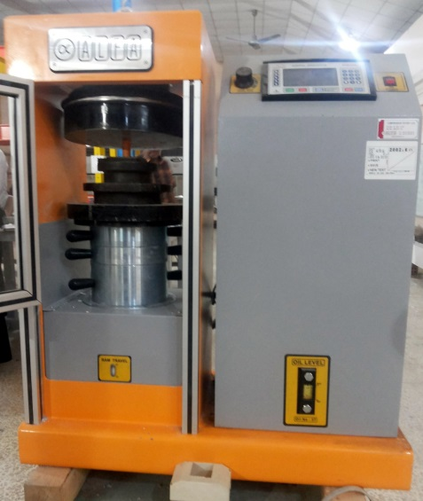
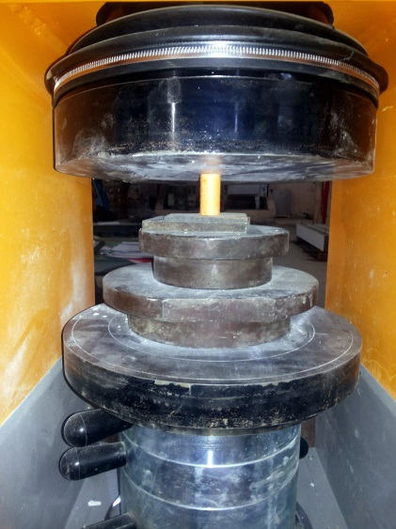
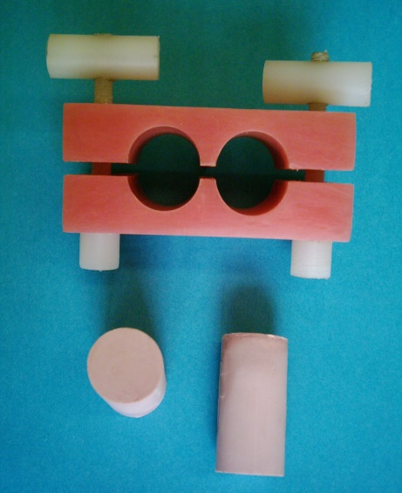
Fig. 1: The acrylic split mold with two stone cylindrical samples.

Fig. 2: Loading the stone sample with compression testing machine ALPHA B-001/LCD.

Results:
Mean value in Kg/cm2 and standard deviation of all tested groups were calculated by SPSS statistical program and listed at Tables 1 and 2 (24 and 48 hours respectively). t-test to compare between 24 hours and 48 hours groups revealed that 48 hours groups (772 ± 99) were significantly stronger than 24 hours groups (579 ± 80) (Table 3). Then groups of 24 hours and 48 hours have been analyzed using one-way ANOVA followed by Duncan multiple range test to compare means and there was significant differences among different groups (p ≤ 0.05). Regarding 24 hours groups (Table 4 and 5), there was no significant differences among the groups chlorhexidine 2% (626±23), chlorhexidine 1% (632±22), Glutaraldehyde 2% (620±24), Glutaraldehyde 1% (628±33), sodium hypochlorite 0.5% (610±50) compared to control group (643±25), and all were significantly higher than other groups, sodium hypochlorite 1% (538±38) was significantly higher than both iodine 4% (443±57) and iodine 2% (471±42) that showed the least values among all other groups, as presented in (Fig. 3). Groups of 48 hours drying time showed almost same significance pattern (Table 6 and 7), there was no significant differences among groups chlorhexidine 2% (835±27), chlorhexidine 1% (838±26), Glutaraldehyde 2% (826±30), Glutaraldehyde 1% (832±23), sodium hypochlorite 0.5% (750±38) compared to control group (843±29), and all were significantly higher than other groups, sodium hypochlorite 1% (808±50) was significantly higher than both iodine 4% (597±41) and iodine 2% (615±43) that showed the least values among all other groups, as presented in (Fig. 4).

Table 1: Mean and Standard deviation for 24 hours groups.
Groups | N | Mean Kg/cm2 | Std
Control | 10 | 643 | 25
CHX 2% | 10 | 626 | 23
CHX 1% | 10 | 632 | 21
Formaldahyde 2% | 10 | 620 | 24
Formaldahyde 1% | 10 | 628 | 33
NaOCl 1% | 10 | 539 | 38
NaOCl 0.5% | 10 | 611 | 50
Iodine 4% | 10 | 443 | 57
Iodine 2% | 10 | 471 | 42
N= number of samples, Std= standard deviation
Table 2: Mean and Standard deviation for 48 hours groups.
Groups | N | Mean Kg/cm2 | Std
Control | 10 | 843 | 29
CHX 2% | 10 | 835 | 27
CHX 1% | 10 | 838 | 26
Formaldahyde 2% | 10 | 826 | 30
Formaldahyde 1% | 10 | 832 | 23
NaOCl 1% | 10 | 750 | 38
NaOCl 0.5% | 10 | 808 | 50
Iodine 4% | 10 | 597 | 41
Iodine 2% | 10 | 615 | 43
N= number of samples, Std= standard deviation
Table 3: t-test to compare between 24 hours and 48 hours groups.
 | Test Value = 0
Groups | N | t | df | Sig.  (2-tailed) | Mean difference | 95% confidence interval of difference
 |  |  |  |  |  | Lower | Upper
24 hrs | 90 | 68.6 | 89 | 0.000 | 579 | 562 | 596
48 hrs | 90 | 74.1 | 89 | 0.000 | 771 | 750 | 792
N= number of samples, t= t value, df= degree of freedom

Table 4: ANOVA test for 24 hours groups.
 | Sum of squares | df | Mean square | F | Sig.
Between groups | 460661.6 | 8 | 57582.7 | 42.47 | 0.000**
Within groups | 109808.5 | 81 | 1355.6
Total | 570470.1 | 89
df= degree of freedom, F= Fvalue, **= highly significant

Table 5: Duncan multiple range test to compare between 24 hours groups.
Groups | N | Subset for Alpha=0.05
Groups | N | A | B | C
Control | 10 | 643
CHX 2% | 10 | 626
CHX 1% | 10 | 632
Formaldahyde 2% | 10 | 620
Formaldahyde 1% | 10 | 628
NaOCl 1% | 10 |  | 537
NaOCl 0.5% | 10 | 610
Iodine 4% | 10 |  |  | 443
Iodine 2% | 10 |  |  | 471
N= number of samples, groups within same letter column are not significantly different

Table 6: ANOVA test for 48 hours groups.
 | Sum of squares | df | Mean square | F | Sig.
Between groups | 769252.2 | 8 | 96156.5 | 77.76 | 0.000**
Within groups | 100170.0 | 81 | 1236.7
Total | 869422.2 | 89
df= degree of freedom, F= Fvalue, **= highly significant

Table 7: Duncan multiple range test to compare between 48 hours groups.
Groups | N | Subset for Alpha=0.05
Groups | N | A | B | C
Control | 10 | 842
CHX 2% | 10 | 835
CHX 1% | 10 | 838
Formaldahyde 2% | 10 | 826
Formaldahyde 1% | 10 | 832
NaOCl 1% | 10 |  | 750
NaOCl 0.5% | 10 | 808
Iodine 4% | 10 |  |  | 597
Iodine 2% | 10 |  |  | 615
N= number of samples, groups within same letter column are not significantly different

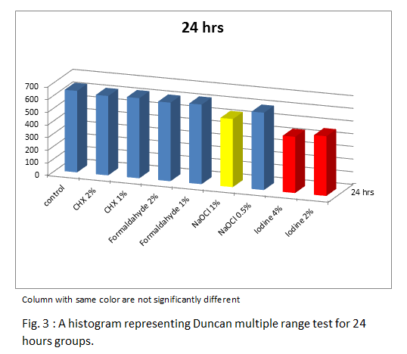

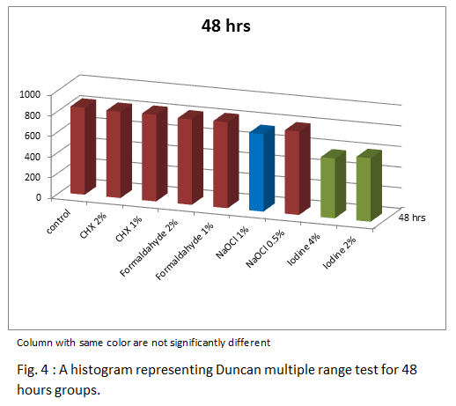

Discussion
Gypsum materials to be clinically useful, should possess high compressive strength and fracture, abrasion, resistance (Luebke RJ and Schneider RL 1985, Tuncer N et al 1993). Generally, the compressive strength of gypsum products is related to the water/powder ratio, mixing time, free water content in set product, volume of mixture, chemical composition, relative humidity, room temperature at which the material is stored and elapsed time after the cast is poured (Craig RG 1997).
Results of this study showed that higher concentration of all disinfectants results in lowering the compressive strength of type IV stone that used in the current study, but in both chlorhexidine and formaldehyde although higher concentrations showed lower strength but still values were not significantly differ than those of lower concentration groups within same drying time (24 hours, 48 hours separately). As well as both chlorhexidine and formaldehyde in low and higher concentrations showed no statistical difference with control group (24 hours and 48 hours groups showed same pattern) in spite of that control groups in both drying times showed higher values among all other groups. That is an indication of no remarkable reduction in compressive strength may happen if chlorhexidine or formaldehyde used for disinfection of type IV dental stone. A study by Matheus et al (2009) showed that chlorhexidine and formaldehyde also did not affect dimensional stability and surface detail reproduction. Setting time on the other hand was also within accepted ISO standard (Donovan T and Chee WW 1989) with chlorhexidine and formaldehyde.
Industrially, some chemical modifying agents are added to odontological plaster and may accelerate or delay the setting time. The rationale behind such behavior in these chemical agents has still not been completely elucidated, but it is known that low-solubility salts, such as sodium chloride and sodium sulfate in high concentrations diminish the amount of free water in the mixture and increase the concentration of the additives. So that when the solubility limit of salt is exceeded, it precipitates in the crystallization nucleus and poisons the mixture, modifying its normal conformation (O’Brien WJ 1997). Therefore, the substantial alteration provoked by the incorporation of sodium hypochlorite is supposedly due to the formation of a low-solubility salt that, when present in high concentrations, modifies the crystallization nucleus and consequently affects properties of gypsum products. However, Donovan and Chee (1989) and Breault et al (1998) obtained opposite results using a highly diluted concentration of sodium hypochlorite. That can be explained by the fact that some retardants act as accelerators when in low concentrations (O’Brien WJ 1997), thus it may shorten setting time and enhance gypsum mechanical properties simultaneously. Findings of current study are in agreement with findings of previously mentioned studies in that sodium hypochlorite in low concentration did not show significant reduction in compressive strength of type IV stone that used in this study in both of the drying time (24 and 48 hours), while higher concentration sodium hypochlorite significantly reduced the compressive strength in both drying times, this is due to the previously mentioned adverse effects of incorporating sodium hypochlorite with gypsum products as well as the increase in porosity of the casts as proved by Abdelaziz (2002). The increase in porosity is responsible for the weakening of plaster (reducing its resistance to compression and the diametrical traction) (Ivanovski S et al 1995, Abdelaziz KM et al 2002).
Iodine in lower concentration showed better compressive strength than higher concentration, but within the limits of current study both concentrations are not recommended to be used for the purpose of dental stone model disinfection since it showed the least values among all tested groups and in both drying times. Nevertheless, this particular behavior in these chemical agents is not fully known, as mentioned by several authors and they are in need for further study to be fully understood (Donovan T and Chee WW 1989, Ivanovski S et al 1995, Anusavice KJ 1996)
It has been proved that better drying for gypsum models gives better mechanical properties (Kaiser DA 1976, Hersek RH et al 2002, Hassan RH and Mohammed KA 2005). Within the range of this study, 48 hours groups showed significantly higher compressive strength than 24 hours groups, this fact gave a clue that whatever is the disinfectant solution used within specific recommended concentrations, but still factor of drying time play an important role in compressive strength property of type IV dental stone.

Conclusions
Within the limitations of this study:

- Chlorhexidine and formaldehyde in 1-2%, as well as sodium hypochlorite 0.5% don’t affect the compressive strength of type IV dental stone, whatever is the drying time.
- Sodium hypochlorite is not recommended to be used for type IV dental stone disinfection in a concentration more than 0.5%.
- Iodine totally not suitable for type IV dental stone disinfection in any concentration equal or more than 2%.
- Compressive strength is directly proportional with drying time of stone model regardless of type of disinfectant solution that have been used.

References
Abdelaziz KM, Combe EC, Hodges JS: The effect of disinfectant additives on the properties of dental gypsum: 1. Mechanical properties. J Prosthodont 2002; 11:161-167
Adabo GL, Zanarotti E, Fonseca RG, et al: Effect of disinfectant agents on dimensional stability of elastomeric impression materials. J Prosthetic Dent 1999; 81:621-624
Anusavice KJ. Phillips’ Science of Dental Materials. 10th ed., W.B. Saunders Company, Philadelphia, USA. 1996; pp. 189-191.
Breault, LG, Paul JR, Hondrum SO, et al: Die stone disinfection: incorporation of sodium hypochlorite. J Prosthodont 1998; 1:13-16
Craig RG. Restorative Dental Materials. 10th ed., St. Louis, Mosby. 1997; pp. 200-204.
Donovan T, Chee WW: Preliminary investigation of a disinfected gypsum die stone. Int J Prosthodont 1989; 3:245-248
Hassan RH, Mohammed KA. Effects of drying techniques on compressive strength of gypsum products. Al-Rafidain Dent J 2005: 5; 63-68.
Hersek N, Canay S, Akca K, Ciftci Y. tensile strength of type IV dental stones dried in microwave oven. J Prosthet Dent. 2002; 87: 449-502.
Hishmati RH, Nagy WW, Wirth CG, Ghuru VB. Delayed expansion of improved dental stone. J Prosthet Dent. 2002; 88:26-31.
Ivanovski S, Savage, NW, Brockhurst PJ, et al: Disinfection of dental stone casts: antimicrobial effects and physical property alterations. Dent Mater 1995; 1:19-23

Kaiser DA. A study of distortion and surface hardness of improved artificial stone casts. J Prosthet Dent 1976; 36: 373-380.
Leung RL, Schonfeld SE: Gypsum casts as a potential source of microbial cross-contamination. J Prosthetic Dent 1983; 2:210-211
Luebke RJ, Schneider RL. Microwave drying of artificial stone. J Prosthet Dent. 1985; 53: 261-265.
Mansfield SM, White JM: Antimicrobial effects from incorporation of disinfectants into gypsum casts. Int J Prosthodont 1991; 4:180-185
Matheus GL, Joao NAF, Sergio SN, Andre UDB, Rodrigo DPP. Effect of Incorporation of Disinfectant Solutions on Setting Time, Linear Dimensional Stability, and Detail Reproduction in Dental Stone Casts. J Prosthodontics 2009: 18: 521-526.
O’Brien WJ: Gypsum products. In O’Brien WJ (ed): Dental Materials and Their Selection (ed 2). Chicago, Quintessence, 1997, pp. 51-74.
Stern MA, Johnson GH, Toolson LB: An evaluation of dental stones after repeated exposure to spray disinfectants: Part I. Abrasion and compressive strength. J Prosthet Dent 1991; 5:713-718.
Tuncer N, Tufenkcioglu HB, Calikkocaoglu S. Investigation on the compressive strength of several gypsum products dried by microwave oven with different programs. J Prosthet Dent. 1993; 69: 333-339.
Van Noort R, Brown D, Causton BE. Review of dental materials. J Dent. 1989; 17: 1-20.

