Distribution of some Aquatic Plant in Kufa River - Iraq

Al-Hadiary M.J.S
mohammed j.alhaydari@uokufa.edu.iq
Al-Zurfi S.K.L
alzurfi_sadiq@yahoo.com
Department of Ecology - Faculty of science - University of Kufa
Abstract:
This study was done to survey an aquatic plants diversity in Al-kufa River, twenty two Sites were chosen to investigation this study during two season (Summer and Winter 2010).
The results showed that there are 61 species related to 30 family, the highest number of species were recorded in Site 22 ( 52 species), while the lowest number of species were recorded in Site 6 (28 species). The dominance family were Poaceae, Cyperaceae , Potamogetonaceae , Haloragaceae then Lentibulariaceae (13,11,8,7,5)% respectively, Shannon and N2 diversity indexes confirm that the biodiversity of aquatic plant increasing with downstream, and the number of submerged plant species were more than other form of life in Al-Kufa River while the lowest number of species was floating life form of aquatic plants.
Key words: Aquatic plants, Kufa River, Distribution, Diversity.

الخلاصة :
اختيار اجريت هذه الدراسة لمسح النباتات المائية في هذا نهر الكوفة خلال فصلي الصيف والشتاء لعام 2010، و لتحقيق اهداف الدراسة تم اختيار 22 موقعاً على طول مجرى نهر الكوفة.
اوضحت النتائج ان هناك 61 نوعاً من النباتات المائية تعود الى 30 عائلة , سجل أكبر عدد من الأنواع في الموقع 22 (52 نوعاً) ، بينما سجل اقل الانواع عدداً في الموقع 6 (28 نوعاً). سادت العائلة النجيلية ثم العائلة السعدية ثم العائلة البوتوموجيتونية ثم العائلة الهالوراكية والعائلة اللنتبيولارية بنسب (13 ,11 ,8, 7 ,5 ) % على التوالي، واثبت دليل شانون ودليل N2 للتنوع ان التنوع الحيوي لمجتمعات النباتات المائية يزداد مع اتجاه مجرى النهر الى الاسفل، واثبتت الدراسة ان السيادة كانت لانواع النباتات المائية الغاطسة و التنحي كان لانواع النباتات المائية الطافية.

Introduction:
A study of the diversity and distribution of aquatic plants is an essential component of understanding aquatic ecosystem due to the important ecological role of aquatic vegetation and the ability of the vegetation to characterize the water quality (Bornette et al. 1998). Aquatic plants are an important part of the aquatic food webs. They influence water quality by taking up nutrients, releasing dissolved organic matter, and increasing sedimentation by absorbing turbulent energy (Gross, 2003; Schallenberg and Waite, 2004).
Aquatic biodiversity has enormous economic and aesthetic value and is largely responsible for maintaining and supporting overall environmental health. Aquatic organisms rely upon the great diversity of aquatic habitats and resources for food, materials, and breeding grounds (Williams et al., 2004).
Factors including overexploitation of species, the introduction of exotic species, pollution from urban, industrial, and agricultural areas, as well as habitat loss and alteration through damming and water diversion all contribute to the declining levels of aquatic biodiversity in both freshwater and marine environments. As a result, valuable aquatic resources are becoming increasingly susceptible to both natural and artificial environmental changes. Thus, conservation strategies to protect and conserve aquatic life are necessary to maintain the balance of nature and support the availability of resources for future generations (EPA, 2003).
Because of Al-Kufa River is such important for several activities for the Najaf’s peoples (agriculture, industrial, domestic and drinking water, fishing, relaxation, and tourism), and there is no any study about the distribution and diversity of aquatic vascular plants, this study is comes. The main object of this work was to determine the species composition of various macrophyte species.
Study Sites:
At Al-Kifl city, the Euphrates subdivided into two parts: Al-Abassia and Al-Kufa river, the last one extends from Al-Kifl city via Al-Najaf government to Al-Diwania city, the total length of Kufa River is about 36 Km ,and its capacity reach to 552 m³.sec⁻¹. The water level in this river undergoes large fluctuations, the highest level occur during the high discharge seasons (end of March early April), the lowest water level in the summer (MWR, 2007).
A lot of villages and farms (animal, crop, and vegetation farms) are found along the River; there are domestic, municipal wastewater and agriculture drainage discharged to the River; in addition to the industrial wastes that which come from: the industrial region in Al-Najaf city, the leather industry, and the cement factory. All of above have affecting the water quality, distribution and diversity of aquatic vasicular plants.
To investigation this study, 22 Sites were chosen as clear in Table 1, the first two Sites lei before Al-Kufa Dam, second four Sites there is no anthropogenic effects (just some agriculture activity), in the third eight Sites there is direct effect of human activity with tourism relaxation wastes, in the fourth three Sites the effect of municipal wastewater of Al-Kufa city and water buffalo are clear, while the last five Sites affected directly with Al-Brrakia domestic wastewater plant and a lot of buffalo cultures.
Table 1: The sampling sites and their location by GPS
Site | N | E | Site | N | E
K. 1 | 32°12'15.58"N | 44°21'36.68"E | K. 12 | 32° 3'27.39"N | 44°23'32.83"E
K. 2 | 32°11'56.81"N | 44°21'5.81"E | K. 13 | 32° 2'42.34"N | 44°23'53.07"E
K. 3 | 32°11'0.03"N | 44°20'56.49"E | K. 14 | 32° 2'17.66"N | 44°24'37.61"E
K. 4 | 32°10'16.81"N | 44°21'7.57"E | K. 15 | 32° 1'49.59"N | 44°24'51.51"E
K. 5 | 32° 9'9.58"N | 44°21'31.51"E | K. 16 | 32° 1'9.91"N | 44°25'23.70"E
K. 6 | 32° 8'9.43"N | 44°21'29.63"E | K. 17 | 32° 0'42.59"N | 44°25'50.71"E
K. 7 | 32° 7'5.03"N | 44°21'17.11"E | K. 18 | 32° 0'19.57"N | 44°26'18.39"E
K. 8 | 32° 6'50.64"N | 44°21'17.92"E | K. 19 | 31°59'52.54"N | 44°26'36.64"E
K. 9 | 32° 6'29.67"N | 44°21'23.38"E | K. 20 | 31°59'19.23"N | 44°26'43.21"E
K. 10 | 32° 5'26.83"N | 44°22'21.23"E | K. 21 | 31°59'2.06"N | 44°27'5.76"E
K. 11 | 32° 4'33.27"N | 44°23'19.78"E | K. 22 | 31°58'46.62"N | 44°27'27.55"E

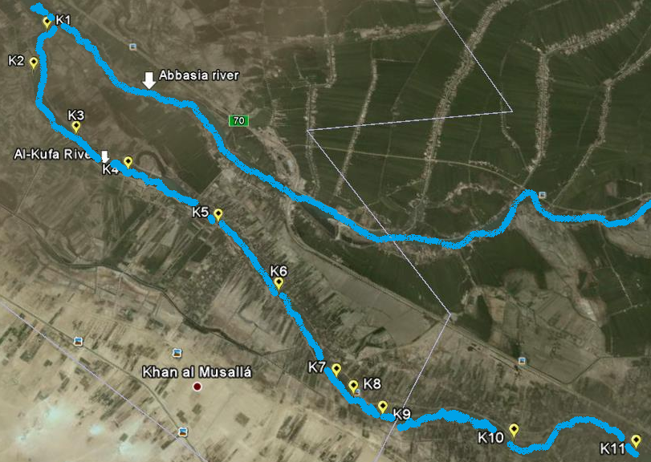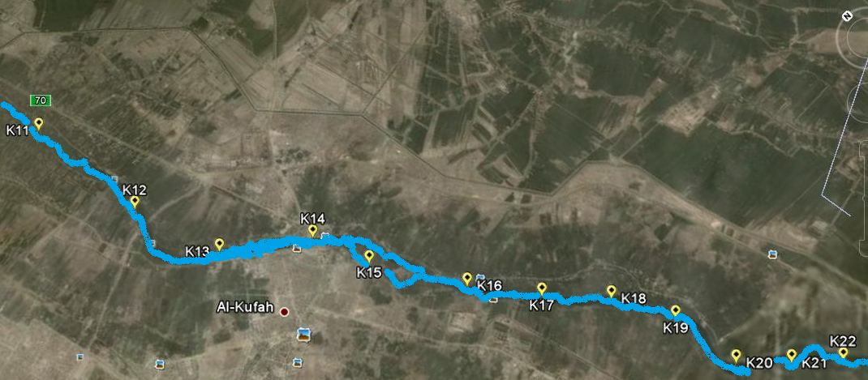
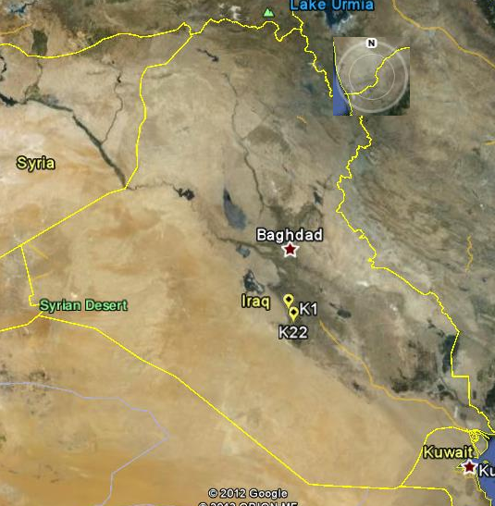
Figure 1: The maps of study sites in Al-Kufa River/ Iraq
Materials and methods:
The survey of this study was during summer and winter 2010 (at December, February, April, June, August, and October) 2010, at all study sites, the vegetation was sampled in randomly located 1m² quadrate plots along transects that were oriented perpendicular to the shoreline.
The centre points of the plots were no closer than 3m and no farther apart than 5m. The proximal end of each transect on the shoreline was located where the substrate became saturated; the distal end was established at the open water edge of a mat. Transects were located in an attempt to sample representative plant assemblages (Al-Kinzawi, 2007).
Plant identification was according to numerous scientific references (Townsend and Guest ,1966; 1968 ; 1974 ; 1980a ; 1980b; and Al-Saadi & Al-Mayah ,1983).
Canoca, Sigmaplot, Microsoft Excel software were used for data analysis , plots created, diversity calculation, and CCA (Canonical Correspondence Analysis) & the factors were tested for significance of relevant trends by the Monte Carlo Permutation test. (de Almeida and Gil, 2001; Komárková et al., 2003).
Results and Discussion
Four dominant macrophyte communities were identified during the period of study, Submergent, Free Floating, mergent, and Emergent macrophyte, these are explained in the table (2, 3, 4, and 5). Sixty one aquatic plant species were identified (29 , 43, 31, 30,30, 30, 28,30,30,33,34,35,32,34,35,36, 40,42, 40, 41, 48, 52 species in study Sites respectively), which are returned to 30 families, the dominant families were Poaceae Cypreceae, Potamogetonaceae, and Haloragaceae
The numbers of species were fluctuated according to Sites and seasons of study (figure: 2) that may be because different environmental factors during these periods (such as temperature, turbidity, nutrient availability, water running, water depth, etc ) (Neill, 1990; and Santamaria, 2002) and sediment quality (Wang and Yu, 2007; and Al-Haidarey, 2012).
As clear in figure (3), the number of Submergent species > Margins > Emergent > Floating (22 , 18, 12, and 9 species respectivlly), the form of life mainly depend on the depth , running speed of water, and water quality (Serag, and Khedr, 2001), this results comes agree with some previous studies in the other Iraqi freshwater ecosystems ( such as: Al-Essa, 2004; Al-Kenzawi, 2007; Hussain and Alwan, 2008; and Al-Zurfi, 2010).
The results showed that the species of Poaceae family > Cypreceae> Potamogetonaceae > Haloragaceae (8 species with 13.1%, 7 species with 11.5 % , 5 species with 8.2 % , 4 species with 6.5 % respectivly from total species number), and there are some families have 1-3 species with 1.64 % - 4.92 % from total species number ( figure: 4).
According to figure (5) the largest number of species was in the last group (last three Sites) of Sites especially at Site 22 that may be because these Sites have a shallow water, slow water flow, high availability of nutrients, and sediment quality with high organic matter percentage, that may be comes from human activity, while the decrease of diversity (Shannon and N2) in other upstream Sites that may be because exposed the aquatic plant to harvesting (grazing by water buffalo, caws, and fish), the deep of Sites increasing with upstream ward, the nutrient is decrease with upstream ward, and different in sediment quality (Al-Haidarey 2012) so the blooming and biodiversity of aquatic vascular plant is increasing with the downstream, that was agree with Serag and Khedr (2001) in El-Salam Canal in Egypt. From the figures 2 and 5, there are slightly change in curves (in diversity and species number) that was because of the effect of Al-Kufa Dam present leads to accumulation of seed bank and nutrient plus to slow of water running, change in depth and increasing in flood plain area (Ronald et. al., 2004).
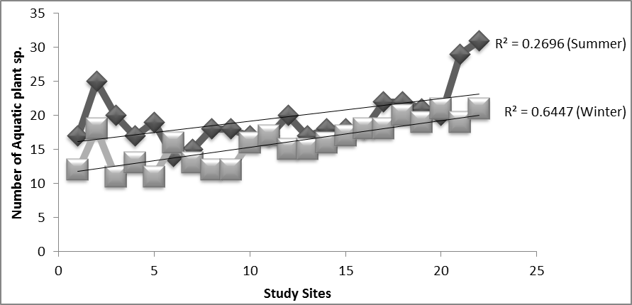
Figure 2: Number of Aquatic Macrophyte Species for each Site at study time.
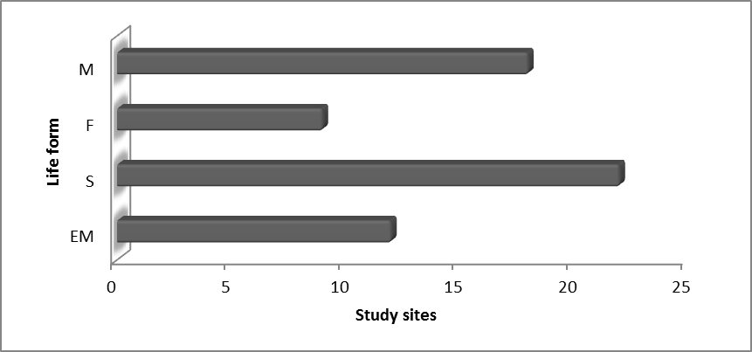
Figure 3: Number of species according on Life form (Life form: EM: Emergent; S: Submerged; F: Floating; M: Margin).
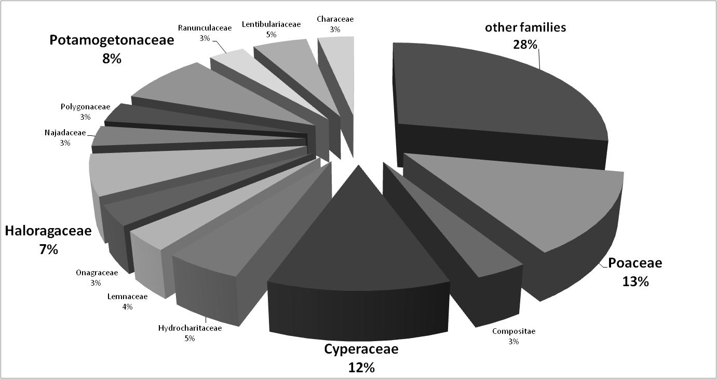
Figure 4: Percentage of Family Aquatic Macrophyte & Margin plants Species at study period.
A B
Figure 5: N2 (A) and Shannon (B) diversity indexes in studied Sites

Table (2): Existence of emergent macrophyte communities in the study sites during the study time.
Family name | Botanical Name | The Stations of study
Family name | Botanical Name | K1 | K2 | K3 | K4 | K5 | K6 | K7 | K8 | K9 | K10 | K11
Alismataceae | Sagittaria sagittifolia | - | - | - | - | - | - | - | - | - | - | -
Amaranthaceae | Alternanthera sessilis | + | + | + | + | + | + | + | + | + | + | +
Butomaceae | Butomus umbellatus | - | + | - | - | - | - | - | - | - | - | -
Marsileaceae | Marsilea capensis | + | + | + | + | + | + | + | + | + | + | +
Onagraceae | Jussiaea repenes | - | - | - | - | - | - | - | - | - | - | -
Poaceae | phragmites australis | + | + | + | + | + | + | + | + | + | + | +
Poaceae | Arundo donax | - | - | - | - | - | - | - | - | + | - | +
Cruciferae | Rorippa amphibian | + | - | + | + | + | + | + | + | + | + | +
Cyperacea | Schoenoplectus litoralis | - | + | - | - | - | - | - | - | - | - | -
Cyperacea | Cladium mariscus | + | + | + | + | + | + | + | + | + | + | +
Cyperacea | Cyperus michelians | + | + | + | + | + | + | + | + | + | + | +
Cyperacea | Cyperus laevigatus | + | + | + | + | + | + | + | + | + | + | +
Cyperacea | Cyperus difformis | + | + | + | + | + | + | + | + | + | + | +
Scrop5hulariaceae | Baccopa monniera | - | - | + | - | - | - | - | + | + | + | -
Typhaceae | Typha domingensis | + | + | + | + | + | + | + | + | + | + | +
Hydrochairtaceae | Ottelia alismoides | - | - | - | - | - | - | - | - | - | - | -
Labiatae | Mentha aquatic | + | + | + | + | + | + | + | + | + | + | +

Table 2 continued
Family name | Botanical Name | The Stations of study
Family name | Botanical Name | K12 | K13 | K14 | K15 | K16 | K17 | K18 | K19 | K20 | K21 | K22
Alismataceae | Sagittaria sagittifolia | - | - | - | - | - | - | - | - | - | + | +
Amaranthaceae | Alternanthera sessilis | + | + | + | + | + | + | + | + | + | + | +
Butomaceae | Butomus umbellatus | - | - | - | - | - | - | - | - | + | - | +
Marsileaceae | Marsilea capensis | + | + | + | + | + | + | + | + | + | + | +
Onagraceae | Jussiaea repenes | - | - | - | + | - | - | - | - | - | - | +
Poaceae | phragmites australis | + | + | + | + | + | + | + | + | + | + | +
Poaceae | Arundo donax | + | - | - | + | + | + | + | + | - | + | +
Cruciferae | Rorippa amphibian | + | + | + | + | + | + | + | + | + | + | +
Cyperacea | Schoenoplectus litoralis | - | - | - | - | - | - | - | - | + | + | +
Cyperacea | Cladium mariscus | + | + | + | + | + | + | + | + | - | + | +
Cyperacea | Cyperus michelians | + | + | + | + | + | + | + | + | + | + | +
Cyperacea | Cyperus laevigatus | + | + | + | + | + | + | + | + | - | + | +
Cyperacea | Cyperus difformis | + | + | + | + | + | + | + | + | + | + | +
Scrophulariaceae | Baccopa monniera | + | - | + | + | + | + | + | + | - | + | +
Typhaceae | Typha domingensis | + | + | + | + | + | + | + | + | + | + | +
Hydrochairtaceae | Ottelia alismoides | - | - | - | - | - | - | - | - | + | + | +
Labiatae | Mentha aquatic | + | + | + | + | + | + | + | + | + | + | +

Table (3): Existence of submerged macrophyte communities in the study sites during the study time.
Family name | Botanical Name | The Stations of study
Family name | Botanical Name | K1 | K2 | K3 | K4 | K5 | K6 | K7 | K8 | K9 | K10 | K11
Hydrochairtaceae | Vallisneria spiralis | + | + | - | - | - | - | - | - | - | - | +
Hydrochairtaceae | Hydrilla verticillata | - | - | - | - | - | - | - | - | - | + | -
Ceratophyllacea | Ceratophyllum demersum | - | + | + | - | - | - | - | + | - | + | -
Characeae | Nitella sp. | + | - | + | + | + | + | + | + | + | + | +
Characeae | Chara sp. | + | + | + | + | + | + | + | + | + | + | +
Haloragaceae | Myriophyllum spicatum | + | + | + | + | + | + | + | + | + | + | +
Haloragaceae | Myriophyllum verticillatum | + | + | + | + | + | + | + | + | + | + | +
Lentibulariaceae | Utricularia australis | - | + | - | - | - | - | - | - | - | - | -
Lentibulariaceae | Utricularia gibba | + | - | + | + | + | + | + | + | + | + | +
Lentibulariaceae | Utricularia minor | - | + | - | - | - | - | - | - | - | - | -
Najadaceae | Najas marina | + | + | + | + | + | + | + | + | + | + | +
Najadaceae | Najas minor | + | + | + | + | + | + | + | + | + | + | +
Potamogetonaceae | potamogeton crispus | + | + | + | + | + | + | + | + | + | + | +
Potamogetonaceae | potamogeton lucens | - | + | - | - | - | - | - | - | - | - | -
Potamogetonaceae | potamogeton nodosus | - | + | - | - | - | - | - | - | - | - | -
Potamogetonaceae | potamogeton pectinatus | - | + | - | - | - | - | - | - | - | - | -
Potamogetonaceae | potamogeton perfoliatus | - | + | - | - | - | - | - | - | - | - | -
Ranunculaceae | Rannunculus sphaerospermus | + | + | + | + | + | + | + | + | + | + | +
Ranunculaceae | Rannunculus trichuphyllus | - | + | - | - | - | - | - | - | - | - | -
Zannichellaceae | Zannichellia palustris | - | + | - | - | - | - | - | - | - | - | -

Table 3continued
Family name | Botanical Name | The Stations of study
Family name | Botanical Name | K12 | K13 | K14 | K15 | K16 | K17 | K18 | K19 | K20 | K21 | K22
Hydrochairtaceae | Vallisneria spiralis | - | - | - | - | - | - | + | + | - | + | +
Hydrochairtaceae | Hydrilla verticillata | - | - | + | + | - | + | + | + | - | + | +
Ceratophyllacea | Ceratophyllum demersum | + | - | + | + | + | + | + | + | + | + | +
Characeae | Nitella sp. | + | + | + | + | + | + | + | + | + | + | +
Characeae | Chara sp. | + | + | + | + | + | + | + | + | + | + | +
Haloragaceae | Myriophyllum spicatum | + | + | + | + | + | + | + | + | + | + | +
Haloragaceae | Myriophyllum verticillatum | + | + | + | + | + | + | + | + | - | + | +
Lentibulariaceae | Utricularia australis | - | - | - | - | - | - | - | - | + | - | -
Lentibulariaceae | Utricularia gibba | + | + | + | + | + | + | + | + | + | + | +
Lentibulariaceae | Utricularia minor | - | - | - | - | - | - | - | - | + | - | -
Najadaceae | Najas marina | + | + | + | + | + | + | + | + | - | + | +
Najadaceae | Najas minor | + | + | + | + | + | + | + | + | + | + | +
Potamogetonaceae | potamogeton crispus | + | + | + | + | + | + | + | + | + | + | +
Potamogetonaceae | potamogeton lucens | - | - | - | - | - | - | - | - | + | - | +
Potamogetonaceae | potamogeton nodosus | - | - | - | - | - | - | - | - | + | + | -
Potamogetonaceae | potamogeton pectinatus | - | - | - | - | - | - | - | - | + | + | +
Potamogetonaceae | potamogeton perfoliatus | - | - | - | - | - | - | - | - | + | + | +
Ranunculaceae | Rannunculus sphaerospermus | + | + | + | + | + | + | + | + | + | + | +
Ranunculaceae | Rannunculus trichuphyllus | - | - | - | - | - | - | - | - | - | - | +
Zannichellaceae | Zannichellia palustris | - | - | - | - | - | - | - | - | - | + | +

Table (4): Existence of mergent macrophyte communities in the study sites during the study time.
Family name | Botanical Name | The Stations of study
Family name | Botanical Name | K1 | K2 | K3 | K4 | K5 | K6 | K7 | K8 | K9 | K10 | K11
Asclepiadaceae | Cynanchum acutum | - | - | - | - | - | - | - | - | - | - | -
Capparaceae | Capparis spinosa L. | - | - | - | + | + | + | - | - | - | - | -
Cyperacea | Cyperus rotundus | + | + | + | + | + | + | + | + | + | + | +
Poaceae | Diplachne fusca(L) P.Beauv. | + | + | + | + | + | + | + | + | + | + | +
Poaceae | Imperata cylindrical L. | + | + | + | + | + | + | + | + | + | + | +
Compositae | Aster tripolium L. | - | - | - | - | - | + | - | - | - | - | -
Compositae | Eclipta alba | + | + | + | + | + | + | + | + | + | + | +
Poaceae | Panicum repens | - | - | - | - | - | - | - | - | - | - | -
Poaceae | Paspalum distichum L. | - | - | - | - | - | - | - | - | - | - | +
Poaceae | Polypogon fugax | - | - | - | - | - | - | - | - | - | - | -
Poaceae | paspalum paspaloides | - | + | - | - | - | - | - | - | - | - | -
Polygonaceae | Polygonum persicaria L. | - | - | - | - | - | - | - | - | - | - | -
Polygonaceae | polygonum salicifolium | + | + | + | + | + | + | + | + | + | + | +
Cyperacea | Fimbristylis sieberiana | + | + | + | + | + | + | + | + | + | + | +
Verbenaceae | phyla nodiflora L. | + | - | + | + | + | + | + | + | + | + | +
The Stations of study |  | K12 | K13 | K14 | K15 | K16 | K17 | K18 | K19 | K20 | K21 | K22
Asclepiadaceae | Cynanchum acutum | - | - | - | - | + | + | + | + | + | + | +
Capparaceae | Capparis spinosa L. | - | - | - | - | - | + | + | + | - | - | -
Cyperacea | Cyperus rotundus | + | + | + | + | + | + | + | + | - | + | +
Poaceae | Diplachne fusca(L) P.Beauv. | + | + | + | + | + | + | + | + | + | + | +
Poaceae | Imperata cylindrical L. | + | + | + | + | + | + | + | + | + | + | +
Compositae | Aster tripolium L. | + | - | - | + | - | - | + | + | - | - | -
Compositae | Eclipta alba | + | + | + | + | + | + | + | + | + | + | +
Poaceae | Panicum repens | - | - | - | - | - | - | - | - | + | - | +
Poaceae | Paspalum distichum L. | + | - | - | - | - | + | + | + | - | - | -
Poaceae | Polypogon fugax | - | - | - | - | + | - | + | - | + | - | -
Poaceae | paspalum paspaloides | - | - | - | - | - | - | - | - | - | - | +
Polygonaceae | Polygonum persicaria L. | - | - | - | - | - | + | + | - | - | - | -
Polygonaceae | polygonum salicifolium | + | + | + | + | + | + | + | + | + | + | +
Cyperacea | Fimbristylis sieberiana | + | + | + | + | + | + | + | + | + | + | +
Verbenaceae | phyla nodiflora L. | + | + | + | + | + | + | + | + | + | + | +

Table (5): Existence of Floating macrophyte communities in the study sites during the study time.

Family name | Botanical Name | The Stations of study
Family name | Botanical Name | K1 | K2 | K3 | K4 | K5 | K6 | K7 | K8 | K9 | K10 | K11
Adiantaceae | Ceratopteris thalicroides | + | + | + | + | + | + | + | + | + | + | +
Nymphaeaceae | Nymphaea alba | - | + | - | - | - | - | - | - | - | - | -
Onagraceae | Ludwigia repens | - | + | - | - | - | - | - | - | - | + | +
Haloragaceae | Nymphoides indica | - | + | - | - | - | - | - | - | - | - | -
Haloragaceae | Nymphoides peltata | - | + | - | - | - | - | - | - | - | - | -
Lemnaceae | Lemna gibba | - | + | - | - | - | - | - | - | - | + | +
Lemnaceae | Lemna minor | - | + | - | - | - | - | - | - | - | - | +
Salvinaceae | Salvinia natans | + | + | + | + | + | + | + | + | + | + | +
Pontederiaceae | Echhornia crassipes | - | - | + | + | + | - | - | - | - | - | -
The Stations of study |  | K12 | K13 | K14 | K15 | K16 | K17 | K18 | K19 | K20 | K21 | K22
Adiantaceae | Ceratopteris thalicroides | + | + | + | + | + | + | + | + | + | + | -
Nymphaeaceae | Nymphaea alba | - | - | - | - | - | - | - | - | + | + | +
Onagraceae | Ludwigia repens | + | + | + | - | + | + | - | - | + | + | +
Haloragaceae | Nymphoides indica | - | - | - | - | - | - | - | - | + | + | +
Haloragaceae | Nymphoides peltata | - | - | - | - | - | - | - | - | - | + | +
Lemnaceae | Lemna gibba | - | + | - | - | + | + | + | + | - | + | +
Lemnaceae | Lemna minor | - | + | + | + | - | + | + | + | + | + | +
Salvinaceae | Salvinia natans | + | + | + | + | + | + | + | + | + | + | +
Pontederiaceae | Echhornia crassipes | + | + | + | - | + | + | + | + | + | + | +

References:
Al-Essa, S.A.K. (2004). Ecological study of the aquatic plants and epiphytic algae in Shatt Al-Arab River. Ph. D. thesis, University of Basrah, Iraq, 191pp.
(In Arabic).
Al-Hadiary,M.J.S. (2012). The relationship between environmental variables and Bacterial community of Al-Kufa River sediments. Journal kufa Unversity of biology . propagation acceptable.
Al‐Kinzawi, M. A. H. (2007) Ecological Study of Aquatic Macrophytes in the Central Part of the Marshes of Southern Iraq, MSc Thesis, College of Science for Women, Biology Department, University of Baghdad, Iraq.
Al-Saadi, H.A. and Al-Mayah, A.R. (1983). Aquatic plants in Iraq. Published by Arabic Gulf Studies Center, University of Basrah, Iraq, 192 pp.
Al-Zurfi.S.K.(2010b). Ecological Study of Ibn Najim Marsh Plants in Central Mesopotamia Valley- Iraq. Ph.D. Thesis, College of Science, University of Kufa.(Arabic).
Barrett, S.C.H., Eckert, C.G. and Husband, B.C. (1993). Evolutionary processes in aquatic plant populations. Journal of Aquatic Botany, 44: 105-145.
Bornette, G.; C. Amoros; C. Castella and J.L. Beffy. (1998). Aquatic plant diversity in riverine wetlands: the role of connectivity. Fresh. Biol. 39: 267-283.
De Almeida, S.E.P., Gil, M.C.P. (2001). Ecology of Freshwater Diatoms from the Central Region of Portugal. Cryptogamie, Algol. 22 (1): 109-126.
EPA (2003). Available on www.epa.gov/envinicators/roe/index.htm
Gross, E.M. (2003). Allelopathy of aquatic autotrophs. Crit. Rev. plant Sci. 22:313-339.
Hussain, D.A. and Alwan, A.A. (2008).Evaluation of Aquatic macrophytes vegetation after restoration in East Hammar marsh, Iraq Marsh Bulletin 3(1) 32-44
Komárková, J., Komárek, O., Hejzlar, J. (2003). Evaluation of the Long Term Monitoring of Phytoplankton Assemblages in a Canyon-Shape Reservoir Using Multivariaten Statistical Methods. In: Straškrábová, V., Kennedy, R.H., Lind, O.T., Tundisi, J.G., Hejzlar, J. (Eds.). Limnology and Water Quality. Hydrobiologia 504: 143–157.
MWR. Manistry of Water Resources / Najaf (2007) General properties of Al-Kufa River , Annual report , Jun 2007.
Neill, C. (1990). Effect of Nutrients and Water Levels on Emergent Macrophyte Biomass in a Prairie marsh. Canadian Journal of Botany, 68(4-6): 1007-1017.
Ronald H. Fortney, Michael Benedict, Johan F. Gottgens, Timothy L. Walters, Brenda S. Leady, and James Rentch (2004). Aquatic plant community composition and distribution along an inundation gradient at two ecologically-distinct sites in the Pantanal region of Brazil, Journal of Wetlands Ecology and Management 12: 575–585.
Santamaria, L. (2002). Why are most aquatic plants widely distributed? Dispersal, clonal growth and small-scale heterogeneity in a stressful environment; Acta. Oecol. 23: 137–154.
Schallenberg, M and E. Waite (2004).Survey of Aquatic macrophytes in Lake Waihola,Summer 2002-2003. Limnology Report No. 9, Department of Zoology, University of Otago.
Serag, M.S. and Khedr, A.A. (2001). Vegetation- Environment Relationships along El-Salam Canal, Egypt. Journal of Environmetrics, 12: 219-232.
Townsend CC & Guest E (1966). Flora of Iraq. Vol. 2, Ministry of Agriculture Republic of Iraq, pp. 89-93.
Townsend CC, Guest E (1968) Flora of Iraq. Vol. 9. University Press, Glasgow, United Kingdom: Robert MacLehose and Company Limited.
Townsend CC, Guest E (1974) Flora of Iraq (Vol. 3). University Press, Glasgow, United Kingdom: Robert MacLehose and Company Limited.
Townsend CC, Guest E (1980a) Flora of Iraq (Vols. 4-I). University Press, Glasgow United Kingdom: Robert MacLehose and Company Limited.
Townsend CC, Guest E (1980b) Flora of Iraq (Vols. 4-II). University Press, Glasgow, United Kingdom: Robert MacLehose and Company Limited.
Wang, J. and Yu, D. (2007). Influence of Sediment Fertility on Morphological Variability of Vallisneria spiralis . Journal of Aquatic Botany, 87: 127-133.
Williams, P.; M. Whitfield; J. Biggs; S. Bary; G. Fox; P. Nicolet and D. Sear. (2004). Comparative biodiversity of rivers, streams, ditches and ponds in an agricultural landscape in Southern England. Biological Conservation. 115: 329-341.

