Electron Transport In DBA System Of Multiple Bridges
W.A.Abdul-Hussein ,S.I.Easa
Physics Department, College of Education, Basrah University,

Abstract
In this work, we investigate theoretically the effect of introducing many bridges in the donor-bridges-acceptor DBA system on the electron transport through the system. For this we using one the electron model, for which the Hamiltonian of the system consists of a single-level for both Donor and Accepter (i.e. Quantum dots) both coupled to a band bridge (wide band i.e. Quantum well band). The time dependent Schrödinger equation give us the system equations of motion which able us to put a formula for the occupation probabilities for donor and acceptor levels. We found that for one bridge the donor and acceptor levels are broadened and the coupling between the donor and acceptor states includes an imaginary part defined the interference effects as a result of the interactions of both donor and acceptor states with the bridge states. However, increasing the number of bridges more than one arise more additional important effects due to the interactions with the bridges, these are the quantum shifts in the donor and acceptor level as well as decay factor in the coupling strength between donor and acceptor states.Consequently, due to above findings, the amount of charge transport from donor to the acceptor will be less by increasing the number of bridges.
الخلاصة
في هذا البحث تم نظريا" اجراء فحص لمعرفة تأثير اضافة عدة جسور في النظام الجسري D-B-A على نقل الالكترون خلال النظام. ولهذا الغرض استخدمنا نموذج الالكترون الاحادي, الذي فيه نموذج هاملتونين النظام يتألف من مستوي منفرد لكل من المانح والقابل ( اي انه يقابل مستوي نقطة كمية ) مرتبطان الى حزمة جسر (حزمة عريضة اي انه تقابل حزمة بئر كمي ). معادلة شرويدنكر المعتمدة على الزمن تم الحصول على معادلات الحركة والتي مكنتنا من وضع صياغة لاحتماليات الملىء لمستويي المانح والقابل. وقد وجد انه بوجود جسر واحد فان مستويي المانح والقابل سوف تزداد عرضا" والترابط بين حالتي المانح والقابل يحتوي على جزء خيالي يعرف تأثيرات التداخل كنتيجة لتفاعل حالتي المانح والقابل مع حالات الجسر. على اية حال, فان زيادة عدد الجسور اكثر من واحد يؤدي الى تأثيرات مهمة اضافية بسبب التفاعلات مع الجسور, مثل ازاحات كمية في مستويي المانح والقابل وكذلك عامل اضمحلال في شدة الترابط بين حالتي المانح والقابل. وكنتيجة لما في اعلاه فان كمية الشحنة المنقولة من المانح الى القابل سوف تكون اقل بزيادة عدد الجسور.

1. Introduction
The electron transfer (ET) is one of the most important elementary physical, chemical and biological processes [Nitzan. 2006]. The most well known ET theory is the one of Marcus [Demkov, 1968]. In many cases the simple picture of a direct transfer of an electron from the donor (D) to the acceptor (A) does not apply. In special interest is the ET in configurations where a bridge (B) between donor (D) and acceptor (A) mediates the transfer. This kind of ET that we will focus in this paper, Bridge mediated ET reactions can occur via different mechanisms [Carrol (1986), Crothers (1977), Wernsdorfer (1999), and Wernsdorfer (1999)]: incoherent sequential in which the bridge level is populated or coherent super exchange [Kergueris (1999), and Ness (2000)] in which the mediating bridge level is not populated but nevertheless necessary for the transfer. Changing the environment [Ness (2000), and Holthaus (1995)] can modify which mechanism is mainly at work. The interested parameter to compute is the occupation probability $P_{A}(t)$ which define the probability of finding the system, that is prepared in the donor state, is in acceptor state. The electron tunneling rate in DBA system is determine by the barrier height (the energy gap between D and B) and width (spacer length between D and A) see fig.(1).
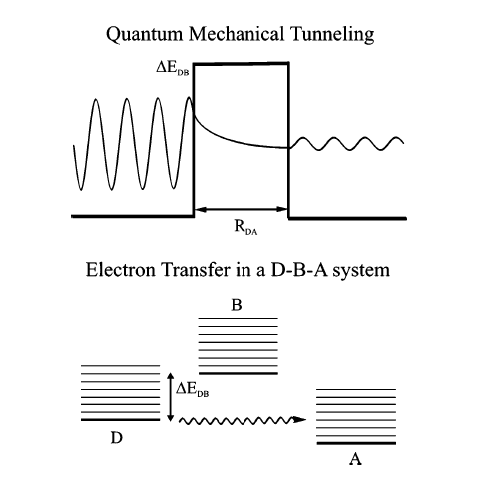
Figure (1): Diagram shows the quantum mechanical tunneling and
electron transfer in DBA system [K. Pettersson et al (2006)].
Recently, we have formulated and discuss the electron transfer through single unit bridge in DBA system [Ragab (2009)]. The purpose of this study is to investigate the effect of increasing number of the bridges on the occupation probabilities of the donor and acceptor (on the transport of the charge). For this purpose we give a simple, analytical solvable model based on the one electron Hamiltonian model formalism which depends on the evolutions of the wave function amplitude of the relevant DBA system component using time dependent perturbation.
Our interest in the electron transport through bridge systems in which both donor and accepter has a discrete levels (same as the quantum dot have) where we chose a single discrete level for each of them that responsible for the process. While, the density of bridge band level is taken as a constant (same as the quantum well density of the states have). Consequently, our interest in two D-B’s-A system which are the Quantum dot-Quantum wells-Quantum Dot (QD-QW’s-QD) system.

2. Theoretical method
To describe electron transport through (D-B’s-A) systems, it is assumed that the charge transfer between the donor and acceptor mediated by a number of bridge units as shown in fig (2).
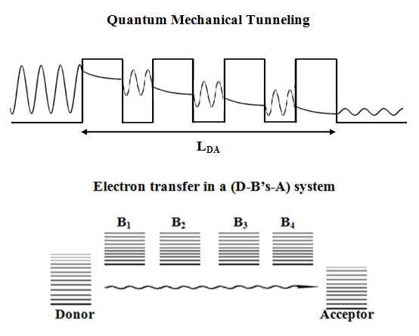
Figure (2): Diagram shows the quantum mechanical
tunneling and electron transfer in D-B’s-A system.
We used Dirac notations and write for the wave function of the (D-B’s-A) system, $ψ(t)$, which is taken to be a linear combination of bridge units as well as the donor and acceptor wave functions as :
$ψ(t)=C_{D}(t)|D⟩+C_{A}(t)|A⟩+\sum_{j}^{n}{\sum_{k}^{m}{C_{B_{\text{jk}}}}}(t)|B_{\text{jk}}⟩$ (1)
Here, $j$ is the number of bridge and k is the number of the energy level of $B_{j}$bridge. In typical experiments for electron transport through the donor-bridge-acceptor systems the initial charge state is prepared on a certain level of the donor by, e.g., photo excitation [Davis (1998)]. So, the charge is assumed to be initially localized on a donor; thus, the initial conditions are taken be
$C_{D}(0)=1$ ; $C_{A}(0)=0$ ; $C_{B_{j}}(0)=0$ (2)
The transfer of the charge from the donor to the acceptor through the bridge units is simulated by propagating the wave function, of eq.(1), according to the time-dependent Schrodinger equation
$Hψ(t)=iℏ\frac{∂ψ(t)}{∂t}$ (3)
Where, the system Hamiltonian operator $H$is given by
$H=H_{0}+V$ (4)
above, $H_{0}$is given by,
$H_{0}=E_{D}|D⟩⟨D|+E_{A}|A⟩⟨A|+\sum_{j}^{n}{\sum_{k}^{m}{E_{B_{\text{jk}}}}}|B_{\text{jk}}⟩⟨B_{\text{jk}}|$ (5)
and $V$is the part of the Hamiltonian that is produced due to the interactions between the components of the (D-B’s-A) system, it is given by:
$$V=V_{\text{DA}}|D⟩⟨A|+\sum_{j}^{n}{\sum_{k}^{m}{(V_{{\text{DB}}_{\text{jk}}}}|D⟩⟨B_{\text{jk}}|+V_{B_{\text{jk}}D}}|B_{\text{jk}}⟩⟨D|)+V_{\text{AD}}|A⟩⟨D|$$
$+\sum_{j}^{n}{\sum_{k}^{m}{(V_{{\text{AB}}_{\text{jk}}}}|A⟩⟨B_{\text{jk}}|+V_{B_{\text{jk}}A}}|B_{\text{jk}}⟩⟨A|)+\sum_{j,l≠j}^{n}{\sum_{k,h}^{m}{V_{B_{\text{jk}}B_{\text{lh}}}|B_{\text{jk}}⟩⟨B_{\text{lh}}|}}$ (6)
Eqs. (1, 4-6) are substituted in the time-dependent Schrodinger equation, eq.(3), to obtain the equations of motion for the (D-B’s-A) system as :
$i{\overset{˙}{C}}_{D}(t)=E_{D}C_{D}(t)+V_{\text{DA}}C_{A}(t)+\sum_{j}^{n}{\sum_{k}^{m}{V_{{\text{DB}}_{\text{jk}}}C_{B_{\text{jk}}}(t)}}$ (7)
$i{\overset{˙}{C}}_{A}(t)=E_{A}C_{A}(t)+V_{\text{AD}}C_{D}(t)+\sum_{j}^{n}{\sum_{k}^{m}{V_{{\text{AB}}_{\text{jk}}}C_{B_{\text{jk}}}(t)}}$ (8)
$i{\overset{˙}{C}}_{B_{\text{jk}}}(t)=E_{B_{\text{jk}}}C_{B_{\text{jk}}}(t)+V_{B_{\text{jk}}D}C_{D}(t)+V_{B_{\text{jk}}A}C_{A}(t)+\sum_{j,l≠j}^{n}{\sum_{k,h}^{m}{V_{B_{\text{jk}}B_{\text{lh}}}C_{B_{\text{lh}}}(t)}}$ (9)
In eqs.(7,8) and (9) $V_{\text{DA}},V_{\text{AD}},V_{{\text{DB}}_{\text{jk}}},V_{{\text{AB}}_{\text{jk}}},V_{B_{\text{jk}}D},V_{B_{\text{jk}}A},V_{B_{\text{jk}}B_{\text{lh}}}$are the matrix elements which represented the overlap between the wave functions for the components of the (D-B’s-A) system through a potential regions.
Defined :
$V_{{\text{DB}}_{\text{jk}}}=v_{B_{\text{jk}}}V^{{\text{DB}}_{j}}$, $V_{{\text{AB}}_{\text{jk}}}=v_{B_{\text{jk}}}V^{{\text{AB}}_{j}}$ , $V_{{}_{B_{\text{jk}}}B_{\text{lh}}}=v_{B_{\text{jk}}}v_{B_{\text{lh}}}V^{B_{\text{jk}}B_{\text{lh}}}$
$C_{B_{\text{jk}}}(t)=v_{B_{\text{jk}}}{\overline{C}}_{B_{\text{jk}}}(t)$, and $C_{B_{\text{lh}}}(t)=v_{B_{\text{lh}}}{\overline{C}}_{B_{\text{lh}}}(t)$ (10)
Where, $v_{B_{\text{jk}}}$related with an electronic density of state [M.Z.Ragab (2009)] of bridge as follow:
$ρ_{B_{j}}(E_{B_{j}})=\sum_{k}{{\left|v_{B_{\text{jk}}}\right|}^{2}}δ(E_{B_{\text{jk}}}−E_{B_{j}})$ (11)
Using eqs.(10) and (11) in eqs.(7-9), and then taking the electronic density of state $ρ_{B_{j}}(E_{B_{j}})$as constant by taking its average over the energy, ${\overline{ρ}}_{B_{j}}=1/4β_{B_{j}}$, with $4β_{B_{j}}$is the band width of the bridge$j$. We get:
${\overset{˙}{C}}_{D}(t)=−{\text{iE}}_{D}C_{D}(t)−{\text{iV}}_{\text{DA}}C_{A}(t)−i\sum_{j=1}^{n}{V^{{\text{DB}}_{j}}{\overline{ρ}}_{B_{j}}}\int{{\overline{C}}_{B_{j}}(t){\text{dE}}_{B_{j}}}$ (12)
${\overset{∘}{C}}_{A}(t)=−{\text{iE}}_{A}C_{A}(t)−{\text{iV}}_{\text{AD}}C_{D}(t)−i\sum_{j=1}^{n}{V^{{\text{AB}}_{j}}{\overline{ρ}}_{B_{j}}}\int{{\overline{C}}_{B_{j}}(t){\text{dE}}_{B_{j}}}$ (13)
${\bar{\overset{˙}{C}}}_{B_{j}}(t)=−{\text{iE}}_{B_{j}}{\overline{C}}_{B_{j}}(t)−{\text{iV}}^{B_{j}D}C_{D}(t)−{\text{iV}}^{B_{j}A}C_{A}(t)−i\sum_{j,l≠j}^{n}{V^{B_{j}B_{l}}{\overline{ρ}}_{B_{l}}\int{{\overline{C}}_{B_{l}}(t){\text{dE}}_{B_{l}}}}$ (14)
By using Green's function to solve eqs.(14) with (2), we get:
${\bar{C}}_{B_{j}}(t)=−{\text{ie}}^{−E_{B_{j}}t}[V^{B_{j}D}\int{C_{D}(t)e^{{\text{iE}}_{B_{j}}t^{'}}dt^{'}}+V^{B_{j}A}\int{C_{A}(t)e^{{\text{iE}}_{B_{j}}t^{'}}dt^{'}}$
$+\sum_{j,l≠j}^{n}{V^{B_{j}B_{l}}{\overline{ρ}}_{B_{l}}\int{\int{{\overline{C}}_{B_{l}}(t^{'}){\text{dE}}_{B_{l}}e^{{\text{iE}}_{B_{j}}t^{'}}dt^{'}}}}]$ (15)
and utilizing the integral $δ(t−t^{'})=\frac{1}{π}\int{e^{−{\text{iE}}_{{}^{B}}(t−t^{'})}{\text{dE}}_{B}}$
$δ(t−t^{'})$ represent Dirac Delta function, and since$\int{δ(t−t^{'})f(t)dt^{'}=f(t)}$ [Pipes (1970)] we get the following relation,
$\int{{\overline{C}}_{B_{j}}}(t){\text{dE}}_{B_{j}}=a_{\text{fn}}^{'}C_{D}(t)+b_{\text{fn}}^{'}C_{A}(t)$ (16)
Here, $f=1,2,3,\text{.}\text{.}\text{.}\text{.},n$ , and $n$ is the number of bridges in (D-B’s-A) system, where $a_{\text{fn}}^{'}$ is defined by the following forms:
$a_{\text{fn}}^{'}=\frac{\text{det}(Μ_{1},\text{.}\text{.}\text{.}\text{.}\text{.}\text{.}\text{.}\text{.}Μ_{f−1},D,Μ_{f+1},\text{.}\text{.}\text{.}\text{.}\text{.}\text{.}Μ_{l})}{\text{det}(Μ_{\text{nl}})}$ (17)

Here, $Μ_{\text{nl}}$ is the matrix elements of $Μ$, and given by,
$Μ_{\text{nl}}=δ_{\text{nl}}+(1−δ_{\text{nl}}){iπV}^{B_{n}B_{l}}{\overline{ρ}}_{B_{l}}$ (18)
$D_{n}$ is the matrix elements of $D$ given by:
$D_{n}=−{iπV}^{B_{n}D}$ (19)
$b_{\text{fn}}^{'}$ is defined by the following forms:
$b_{\text{fn}}^{'}=\frac{\text{det}(Μ_{1},\text{.}\text{.}\text{.}\text{.}\text{.}\text{.}\text{.}\text{.}Μ_{f−1},D,Μ_{f+1},\text{.}\text{.}\text{.}\text{.}\text{.}\text{.}Μ_{l})}{\text{det}(Μ_{\text{nl}})}$ (20)
Here, $Μ_{\text{nl}}$ is defined in eq. (18) and $A_{n}$ are the matrix elements of$A$, and given by:
$A_{n}=−{iπV}^{B_{n}A}$ (21)
Substituting eq.(16) in eqs.(12) and (13) , we get :
${\overset{˙}{C}}_{D}(t)=k_{1n}C_{D}(t)+k_{2n}C_{A}(t)$ (22)
${\overset{˙}{C}}_{A}(t)=k_{3n}C_{A}(t)+k_{4n}C_{D}(t)$ (23)
Where,
$\left(\begin{matrix}k_{1n}=−{\text{iE}}_{D}−i\sum_{j,f}^{n}{a_{\text{fn}}^{'}V^{{\text{DB}}_{j}}{\overline{ρ}}_{B_{j}}} \\ k_{2n}=−{\text{iV}}_{\text{DA}}−i\sum_{j,f}^{n}{b_{\text{fn}}^{'}V^{{\text{DB}}_{j}}{\overline{ρ}}_{B_{j}}} \\ k_{3n}=−{\text{iE}}_{A}−i\sum_{j,f}^{n}{b_{\text{fn}}^{'}V^{{\text{AB}}_{j}}{\overline{ρ}}_{B_{j}}} \\ k_{4n}=−{\text{iV}}_{\text{AD}}−i\sum_{j,f}^{n}{a_{\text{fn}}^{'}V^{{\text{AB}}_{j}}{\overline{ρ}}_{B_{j}}}\end{matrix}\right)$ (24)
Now by using Laplace transform to solve the eqs.(22) and (23), and then applying on the results its inverse Laplace transform one gets,
$C_{D}(t)=[\text{cos}(c_{n}t)−\frac{(k_{3n}+\frac{a_{n}}{2})}{c_{n}}\text{sin}(c_{n}t)]e^{−\frac{a_{n}}{2}t}$ (25)
$C_{A}(t)=\frac{k_{4n}}{c_{n}}\text{sin}(c_{n}t)e^{−\frac{a_{n}}{2}t}$ (26)
Here, $a_{n}=−(k_{1n}+k_{3n})$, $c_{n}=\sqrt{b_{n}−\frac{a_{n^{2}}}{4}}$ , $b_{n}=(k_{1n}k_{3n}−k_{2n}k_{4n})$
The donor level occupation probability, in this (D-B’s-A) system, can be expressed as:
$$P_{D}(t)={\left|C_{D}(t)\right|}^{2}=$$
$$−\text{sin}[(c_{n}−c_{n}^{})t])−\frac{(k_{3n}+\frac{a_{n}}{2})}{2c_{n}}(\text{sin}[(c_{n}+c_{n}^{})t]+\text{sin}[(c_{n}−c_{n}^{})t])+\frac{(k_{3n}+\frac{a_{n}}{2})(k_{3n}^{}+\frac{a_{n}}{2})}{2c_{n}c_{n}^{}}$$
$(\text{cos}[(c_{n}−c_{n}^{})t]−\text{cos}[(c_{n}+c_{n}^{})t])e^{−\frac{1}{2}(a_{n}+a_{n}^{})t}$ (27)
Similarly, the acceptor level occupation probability can be expressed as:
$P_{A}(t)={\left|C_{A}(t)\right|}^{2}=\frac{k_{4n}k_{4n}^{}}{2c_{n}c_{n}^{}}\left\{\text{cos}[(c_{n}−c_{n}^{})t]−\text{cos}[(c_{n}+c_{n}^{})t]\right\}e^{−\frac{1}{2}(a_{n}+a_{n}^{})t}$ (28)
Eqs.(21) and (22) can be written as,
$${\overset{˙}{C}}_{D}(t)=−i(E_{D}−Λ_{\text{Dn}}−{iΔ}_{\text{Dn}})C_{D}(t)−i(V_{\text{DA}}−V_{\text{dn}}−{\text{iV}}_{\text{sn}})C_{A}(t)$$
$${\overset{˙}{C}}_{A}(t)=−i(E_{A}−Λ_{\text{An}}−{iΔ}_{\text{An}})C_{A}(t)−i(V_{\text{AD}}−V_{\text{an}}−{\text{iV}}_{\text{sn}})C_{D}(t)$$
From which we conclude that:
1- Each level (of donor or acceptor) has broadened and shifted by an amount
$Δ_{(D,A)n}$ and $Λ_{(D,A)n}$ respectively due to their interactions with the $n$ bridges levels. For the one bridge we have:
$Δ_{(D,A)1}=π{\left|V^{(D,A)B_{1}}\right|}^{2}$ and $Λ_{(D,A)1}=0$ i.e. the quantum shift in the level is absent for one bridge but it appear for the interactions with more than one bridges.
- There is an interference interaction, we look at as a sink of charge of depth $V_{\text{sn}}$
(resulted from the interaction of the donor and acceptor levels with the same bridge) and a decay amount $V_{\text{dn}}$ in the donor and acceptor interaction strength $V_{\text{DA}}$(resulted from the interactions of the bridge levels among them). For the one bridge we have:
$V_{s1}={πV}^{{\text{AB}}_{1}}V^{{\text{DB}}_{1}}\bar{ρ_{B_{1}}}$and $V_{d1}=0$ i.e. the decay in the donor and acceptor interaction is absent in one bridge but it appear when the number of the bridge more than one.

3. Results and Discussion
There are many system parameters characterize the DBA system which affect the electron transport process and consequently affect the occupation probabilities$P_{D}(t)$ and$P_{A}(t)$. Such parameters are the time $t$ variation, spacer length $L_{\text{DA}}$ between donor and acceptor (or may be bridge length), number of bridge unites $n$ as well as other parameter that characterize the bridge system such as energy deference $Δ=E_{A}−E_{D}$ and coupling matrix elements ($V^{\text{DB}}$between donor and bridge, $V^{\text{AB}}$ between acceptor and bridge, and $V^{\text{DA}}$ between donor and acceptor) which are depend on the spatial variation of the corresponding wave functions.Results of electron transport simulations performed according to the method described in Section 2, where we are arranging the bridges in a parallel configuration along the straight line between donor and acceptor, are shown in the following Figures, when the interactions, between all components of (D-B’s-A) system, are effective (i.e. through space and bond transition) the charge is decay on the donor and growing on the acceptor such that $P_{D}<P_{A}$ and on increases the bridge units results that $P_{D}>P_{A}$ (see fig.(3)). The increases in the interaction strength between the donor and acceptor$V^{\text{DA}}$, leads to emptying the donor level such that,$P_{A}>P_{D}$, and the increases of bridge units leads to decreases filling of the acceptor level (see fig.(4)). When the interaction strength between donor and acceptor is greater than the donor-bridges and acceptor-bridges interactions leads to increases the number of oscillations that appears in the occupation probabilities, also their numbers and amplitude decreases with increasing bridge units number and the energy gap between donor and acceptor ($E_{A}−E_{D}$) respectively (see fig.(5)). However, these oscillations are vanished when the interaction strength in between donor, acceptor, and bridge units becomes larger than in between the bridge units (see fig.(6)).

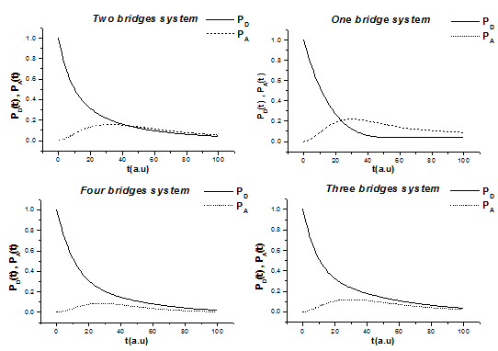
Figure 3. Time-dependent of survival probability of charge on a donor and
acceptor (dotted line) as function of time , using the following values of
interactions: $V_{0}^{\text{DA}}=0\text{.}\text{05},V_{0}^{\text{DB}}=V_{0}^{\text{AB}}=V_{0}^{\text{BB}}=0\text{.}1$.

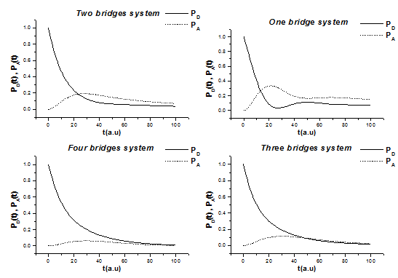
Figure4. Time-dependent of survival probability of charge on a donor and
acceptor (dotted line) as function of time, using the following values of
interactions: $V_{0}^{\text{DA}}=V_{0}^{\text{DB}}=V_{0}^{\text{AB}}=V_{0}^{\text{BB}}=0\text{.}1$ .
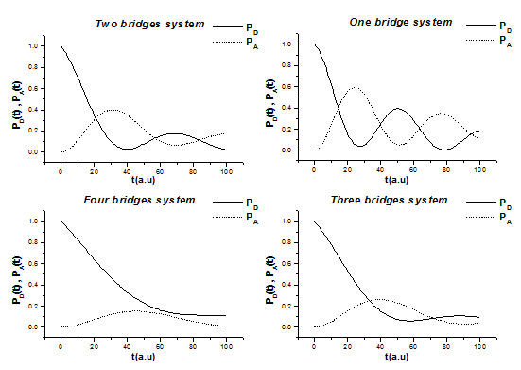
Figure 5. Time-dependent of survival probability of charge on a donor and
acceptor (dotted line) as function of time, using the following values of
interactions: $V_{0}^{\text{DA}}=V_{0}^{\text{BB}}=0\text{.}1,V_{0}^{\text{DB}}=V_{0}^{\text{AB}}=0\text{.}\text{05}$.

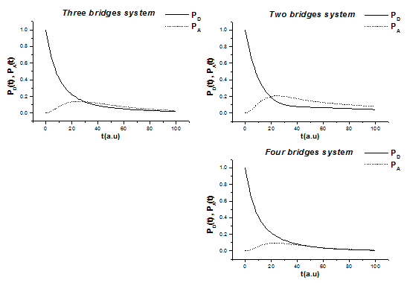
Figure 6. Time-dependent of survival probability of charge on a donor and
acceptor (dotted line) as function of time, using the following values of
interactions: $V_{0}^{\text{DA}}=V_{0}^{\text{DB}}=V_{0}^{\text{AB}}=0\text{.}1,V_{0}^{\text{BB}}=0\text{.}\text{05}$.

After a long time $t=\text{2000}a\text{.}u≈0\text{.}\text{05}\text{Ps}$which we thought to be sufficient for the charge transfer process to finish, we try to study the system characteristic effects. In figs.(7-9) we show for the case of wide bridge band the probabilities as a function of energy deference$E_{A}−E_{D}$, it is clear that the dependence are on the absolute value of this deference since the probabilities are symmetric with this deference. Using the following values of interactions: $V_{0}^{\text{DA}}=V_{0}^{\text{DB}}=V_{0}^{\text{AB}}=V_{0}^{\text{BB}}=0\text{.}1$

Figure 7. Survival probability of charge on a donor and acceptor (dotted line) as
function of energy deference, using the following values: $t=\text{2000} a\text{.}u , L=0$.

Figure 8. Survival probability of charge on a donor and acceptor (dotted line) as
function of energy deference, using the following values: $t=\text{2000} a\text{.}u , L=1 a\text{.}u$.

Figure 9. Survival probability of charge on a donor and acceptor (dotted line) as
function of energy deference, using the following values: $t=\text{2000} a\text{.}u , L=2 a\text{.}u$.

Increasing the strength of the interaction between the accepter and the bridge$V^{\text{AB}}$, which is given by; $V^{\text{AB}}=V_{0}^{\text{AB}}e^{−{αL}_{\text{AB}}}$, increases the occupation probabilities of the donor and acceptor as shown in fig.(10).
Figure 10. Survival probability of charge on a donor and acceptor (dotted line)
as function of strength of the interaction between the accepter and the bridge,
using the following values: $V_{0}^{\text{DA}}=V_{0}^{\text{DB}}=V_{0}^{\text{BB}}=0\text{.}1 ,E_{D}=−0\text{.}\text{15} \text{eV}, E_{A}=−0\text{.}2 \text{eV}$.

We study the electron transport through bridge system by considering both donor and accepter has a discrete levels same as the quantum dot levels and we chose only one level for each which is responsible for the process, while the density of bridge band level is taken constant either a wide band such as the case of quantum well density of level state. Consequently, we are studying the D-B’s-A system is QD-QW’s-QD system.
The important point is that one can control the charge accumulated on all parts of the system by varying the values of system characteristic such the spacer length$L$,$V^{\text{DA}}$, $V^{\text{DB}}$,$V^{\text{AB}}$, and$E_{A}−E_{D}$.

4. Conclusions
We conclude that on including more than one bridge we have the following effects:
- Each level (of donor or acceptor) has broadened and shifted by an amount $Δ_{(D,A)n}$and $Λ_{(D,A)n}$ respectively due to their interactions with the levels of $n$ bridges. The quantum shift for the case of one bridge $Δ_{(D,A)1}=0$ in the levels is absent for one bridge but it appear for more than one bridge. The broadening $Δ_{(D,A)n}$ in the levels is a collective effect from all bridges.
- The donor-acceptor interaction $V_{\text{DA}}$ includes an interference interaction $V_{\text{sn}}$ (resulted from the interaction of both the donor and acceptor levels with the same bridge) and a decay amount $V_{\text{dn}}$ in the $V_{\text{DA}}$strength (resulted from the interactions of the bridges levels among them self and with both the donor and the acceptor levels). The decay factor for the case of one bridge $V_{d1}=0$ in the $V_{\text{DA}}$ interaction strength is absent but it appear for more than one bridge.
The results of the first effect are to make the amplitude of the oscillation less and overall acceptor occupation probability is less. While the second effects is leading to less charge transport because the charge accumulated on the bridges.

References:
Carrol, C. E. F. T. Hioe," Generalization of the Landau-zener calculation to three levels", J. Phys. A: Math. Gen. 1151-1161, (1986).
Crothers, D. S. J.G. Huges," Stueckelberg close-curve-crossing phases", J. Phys. B10, L557, (1977).
Davis, W. B. W. A. Svec, M. A. Ratner, M. R.Wasielewski, "Molecular-wire behavior in p-phynylenevinylene oligomers ", Nature. 396, 60, (1998).
Demkov, Yn. N V.L.Osherov, Zh.Exp. Teor. Fiz, "Statistical theory of inelastic processes in plasmas: kinetic equations for coulomb plasmas with account of inelastic processes", 53, 1589 (1967); Engl. Transl. Sov. Phys. JETP, 26, 916, (1968).
Holthaus, M. G. H. Ristow, D.W. Hone, "Ac-field-controlled Anderson localization in disordered semiconductor superlattices", Phys. Rev. Lett., 75,3915-3917, (1995).
Kergueris, C. J.-P. Bourgoin, S. Palacin, D. Estere, C. Urbina, M. Magoga, and C. Joachim," Electron transport through a metal-molecule-metal junction ", Phys. Rev. B59, 12505, (1999).
Ness, H. A.J. Fisher,"Trasmission through peierls distorted one-dimensional atomic wires: quantum coherent electron-phonon coupling", Appl. Surface Science 162-163, 613-619, (2000).
Nitzan, A. " Chemical Dynamics in Condensed Phases", Oxford University Press, Oxford, (2006).
Pettersson, K. J. Wiberg, T. Ljungdahl, J. Martenson and Bo. Albinson,="Interplay between barrier width and height in electron tunneling: photoinduced electron transfer in prophyrin-based donor-bridge-acceptor systems", J. Phys. Chem., A, Vol. 110, P.319-326, (2006).
Pipes L.A. and L.R. Harvill ,"In applied mathematics for engineers and physicists", MC Graw-Hill , (1970).
Ragab, M. Z. "Charge transfer through bridged system",M. Sc. thesis, Basrah University, (2009).
Wernsdorfer W and R. Sessoli, "Quantum phase interference and parity effects in magnetic molecular clusters ",Science, 284, 133, (1999).
Wernsdorfer, W T. Ohm, C. Sangregorio, R. Sessoli, D. Mailly, C. Paulsen,"Observation of the distribution of molecular spin states by resonant quantum tunneling of the magnetization ", Phys. Rev. Lett. 82, 3903, (1999).

