Denoising An Image Based On Particle Swarm Optimization (PSO) Algorithm
Amera Abdul .Wohid Funjan AL.Tayee
Department of Mathematics, Ibn Hayan Education College, Babylon University
Abstract
This work aims to provide processing on noised image based on the particle swarm optimization (PSO) method using a formal analogy with physical systems. By postulating that the swarm motion behaves similar to both classical and quantum particles, The proposed system have been established a direct connection between separate fields of study,. Within this framework, it becomes quite can to employ the recently introduced quantum PSO algorithm to denoised image. The physical theory of the PSO(particle swarm optimization) is used to suggest some improvements in the algorithm itself. At the end, we provide a panorama of applications demonstrating the power of the PSO, classical and quantum, in handling difficult engineering problems. The goal of this work is to provide a general multi-disciplinary view on various topics in image processing, with unified framework of the swarm dynamics.At the end , the proposed PSO algorithm is used to optimize the best degree for de-noising. Simulation results show that the excessive smoothness of proposed method of conventional methods are used for image processing.
الخلاصة:
ان هذا العمل يهدف الى معالجة الضوضاء في الصورة بالاعتماد على طريقة مثالية جسيمات السرب باستخدام صيغة تناظرية مع الأنظمة الفيزيائية. بافتراض إن حركة السرب تتصرف بشكل مماثل لكلا الجسيمات الكلاسيكية والكمية، النظام المقترح أسس اتصال مباشر بين الحقول المنفصلة في الدراسة .من خلال هذا الاطار البحثي فانه اصبح ممكن استخدام مؤخرا خوارزمية مثالية جسيمات السرب الكمي في التخلص من عامل الضوضاء. النظرية المادية (الفيزيائية) ان الخوارزمية المقترحة قد استخدمت للتحسين في الخوارزمية نفسها. وفي النهاية فاننا نقدم نموذج من التطبيقات التي تدل على قوة خورازمية مثالية جسيمات السرب، من الناحية الكلاسيكية والكم في معالجة المشاكل الهندسية الصعبة. والهدف من هذا العمل هو تقديم وجهة نظر عامة متعددة التخصصات حول موضوعات مختلفة في معالجة الصور مع إطار موحد لديناميكية السرب, تستخدم الخوارزمية المقترحة لتمثل الدرجة الافضل للتخلص من عامل الضوضاء في الصورة. والنتائج تبين ذلك التنعيم المفرط للصورة بواسطة الطريقة المقترحة من الطرق التقليدية في معالجة الصورة.

1. Introduction
The concept of PSO is inspired by social and cooperative behavior displayed by various species like birds, fish etc. The PSO system consist of a population (swarm) of potential solutions called particles. Each particle has an associated fitness value[Rongbo Zhu; 2010].
These particles move through search space with a specified velocity in search of optimal solution. Each particle maintains a memory which helps it in keeping the track of the best position it has achieved so far. This is called the particle’s personal best position (pbest) and the best position of the swarm has achieved so far is called global best position (gbest). PSO uses two primary operators: Velocity update and Position update. During each generation each particle is accelerated towards the gbest and its own pbest[Said M; 2008].
A parameter estimation method of denoising image process model based on an improved particle swarm optimization (PSO) algorithm is proposed , And the method was used in noised image process. The particles in the improved PSO algorithm are partitioned into several sub-swarms adaptively according to the energy of the swarm to prevent the particles from going into a local optimum, thus ensuring that the algorithm converges to the global optimal solution. A results show that the method can effectively realize accurate estimate of model parameters on noised image process. The accuracy of the model can meet the requirements of state estimation and condition control in image process[Maurice Clerc;2006].

2. Image denoising
In this paper we have no intention of providing a survey of this vast activity on image denoising. Instead, we concentrate on a PSO algorithms. These methods have been found in recent years to be highly effective and promising, often leading to the best known performance in terms of the noise removal results they achieve.
Our exposition starts with PSO algorithm that builds on the rough core of representation modeling. And adopting a global treatment of the image denoising problem. Then we present various improvements of this method that propose local processing, learning of the shrinkage curve, incorporating dictionary training, and more.
We start by a proper modeling of the problem. An ideal image (of size pixels) is measured in the presence of an additive zero-mean white and homogeneous Gaussian noise, v, with a known standard-deviation . The measured image, y, is thus

We aim to design an algorithm that can remove the noise from y, returning as close as possible to the original image, y0. We start by a direct application of the ideas for solving this problem, and evolve from there to more advanced techniques[Brigitte Forster; 2010].
The signal denoising problem has been mentioned over and over again, and when it comes to solving it using sparse and redundant representation modeling, we were always led to some variant of the optimization problem ,
The threshold is closely tied with the noise power, and a natural choice of it would be , with . The solution to this problem, denoted by ˆx, is the sparse representation that represents the desired clean image. Thus, the denoised output is .
Let us demonstrate an elementary image denoising algorithm that relies on a redundant dictionary. We aim to denoise an image for the approximation of the solution of the problem posed in Equation (2) we use the thresholding algorithm. Thus, the overall denoising process is comprised of the formula
where S_{T} is a scalar hard-thresholding operator (i.e., ST (z)=0 for |z| <T, and ST (z)=z otherwise) [Konstantinos E; 2010].
Since the columns of A are not 2-normalized we should scale the thresholds by these norms, implying that the i-th entry y in the vector is to be threshold by the value . Put differently, we can used a fixed value of threshold T in the formula
where W is a diagonal matrix that contains the norms of the atoms,. Note that this algorithm could be interpreted as the first iteration in an iterative-shrinkage algorithm, which is initialized with zeros.
Also, for each entry xi in the representation we define its neighborhood N(i) (e.g., near-by entries in the spatial domain having similar orientation and scale). The formulation
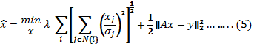
replaces the weighted -norm with a new mixed measure that promotes neighborhood groups of entries to behave similarly (either all the elements in the neighborhood are zeros, or all become active). For the case where the neighborhood contains only the center entry, this formulation coincides with the one posed in Equation (5).
3. Particle Swarm Optimization
The basic PSO algorithm can be described as follows: Each particle in the swarm represents a possible solution to the optimization problem existing. During PSO iteration, every particle accelerates independently in the direction of its own personal best solution found so far, as well as the direction of the global best solution discovered so far by any other particle [Sanjay Ranka; 2010]. Therefore, if a particle finds a promising new solution, all other particles will move closer to it, exploring the solution space more thoroughly.
Lets denotes the swarm size. Each particle 1 ≤ i ≤ s is characterized by three attributes:
(1) The particle position vector Yi;
(2) The particle position change (velocity) vector Vi;
(3) The personal (local) best position achieved by the particle so far Ŷi. Moreover, let G denote the best particle in the swarm.
- Practical part
The PSO algorithm can be resumed as follows:
- Initialize Yi and Vi, and set Ŷi = Yi for i = 1, 2… s.
- Evaluate each particle Yi for i = 1, 2… s.
- Let G to be the best particle in {Ŷ1, Ŷ 2...Ŷ s}
- For i = 1, 2… s. do:
Update Vi according to:
V =wV +cr (Yˆ -Y)+ c r (G-Y)
Update Yi according to:
Yi = Yi + Vi
5. Go to Step 3, and repeat until convergence.
Where w inertia weight factor; c1,c2 self-confidence factor and swarm-confidence factor, respectively; r1, r2 two random numbers uniformly distributed between 0 and 1.
If Yi is better than Ŷi , then Ŷi =Yi
5. Go to Step 3, and repeat until convergence.
Particles' velocities on each dimension are clamped to a maximum velocity Vmax.
The velocity on that dimension is limited to Vmax, if the sum of accelerations would cause the velocity on that dimension to exceed Vmax, which is a parameter specified by the user.
This algorithm is illustrated in figure 1.
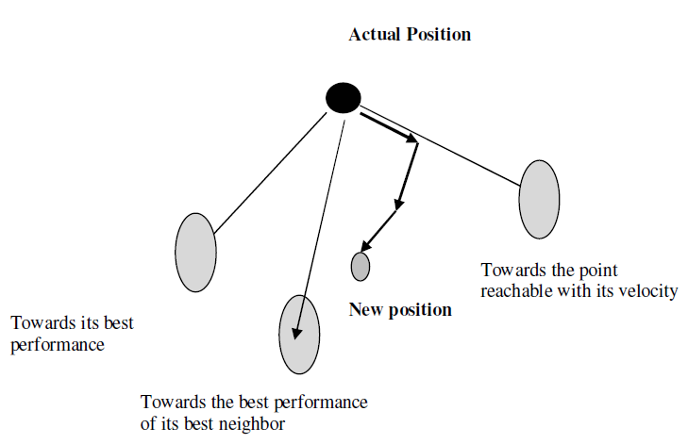
Figure 1. Principle of the movement of a particle

4. Results
Based on the information obtained from the image noised compared with the proposed PSO denoising image, used to verify the effectiveness of the proposed performs the actual restoration of the degraded image using the PSO algorithm. In addition, the random valued impulse noise, the proposed method is compared with the conventional method, and the perk signal noise random (PSNR) be higher up to 5dB. This proposed method been compared with conventional methods undetected has decreased significantly, when using the results of the proposed noise detection, removal may be due to noise than conventional methods. In addition, the random impulse, if the noise pulse, will has a small difference between neighboring pixels and the noise, the conventional method be higher than noise. The proposed method using a threshold smaller noise and will increase in the rate of undetected and suppressed. Thus, in a random valued impulse noise, the proposed method improved the PSNR improvement. The proposed method improves the detection accuracy is determined by the noise, can lead to improved recovery confirmed.
As shown in figure (2) the original image which used as a sample to implemented to process work in our paper. Figure (3) impulsive noise by adding random values to Salt/pepper, A conventional method processed results shown in figure (4) a more conventional flat portion (such portion of the background) stands out residual noise. On the other hand, the proposed method is significantly reduced in the flat part as shown in figure (5).
The proposed method (PSO) is almost reducing the false positives with the conventional method, which is greater than the conventional method to reduce undetected. As a result, the outline is stored in the same level as conventional methods of noise is considered to be flat while it was eliminated than the conventional method.
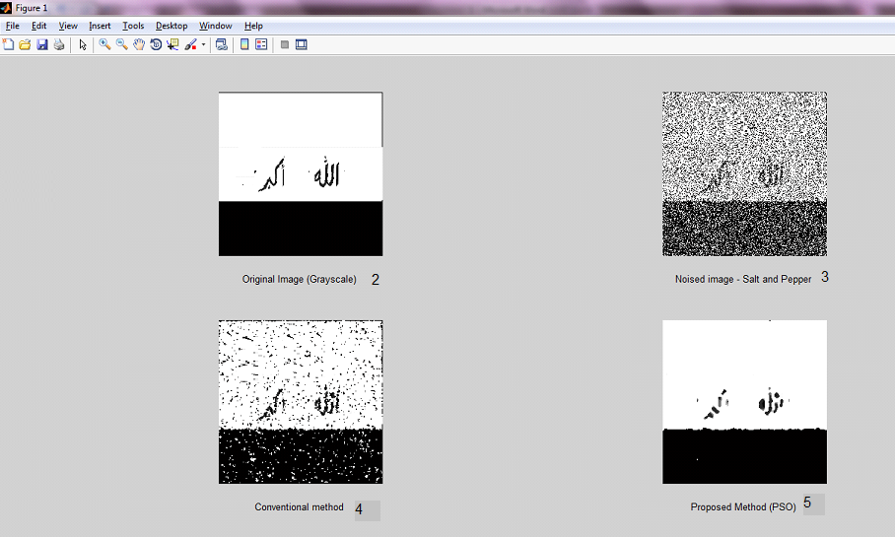

In next step, we embed the salt and pepper noise to the grayed image, as shown in figure 3.
A conventional method processed in our paper to compared a denoising image later with proposed one, as shown in figure 4. Finally, implemented a PSO method to get best position of noise with best adaption in image array to evaluate the new position during process of PSO and used to optimize the thresholding to get best threshold for de-noising an image. After denoising the signal of image should be smoothed to reduces root mean square error (RMSE), and have a better performance than the conventional methods as shown in figure 5.
In table 1. The results of PSO in best position, best adaption, and adaption array, also calculation of PSNR for both methods (conventional and proposed).
Best Position | 0.5494
Best adaption | 14.6674
Adaption array | 12.0307  14.5951  14.5951  14.5951  14.6674
PSNR in dB for Conventional method | 17.9972
PSNR in dB for proposed method | 12.6505
Table 1. Results and PSNR

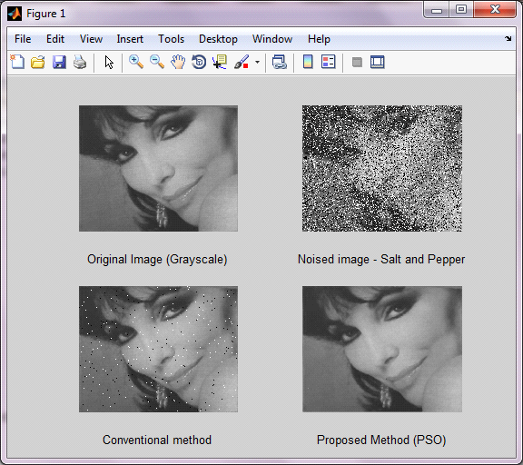
Figure 6. Example of the work
Best Position | 0.4124
Best adaption | 31.7615
Adaption array | 10.8081  10.8081  30.5195  30.5195  31.7615
PSNR in dB for Conventional method | 32.8448
PSNR in dB for proposed method | 24.6861
Table 2. Results and PSNR

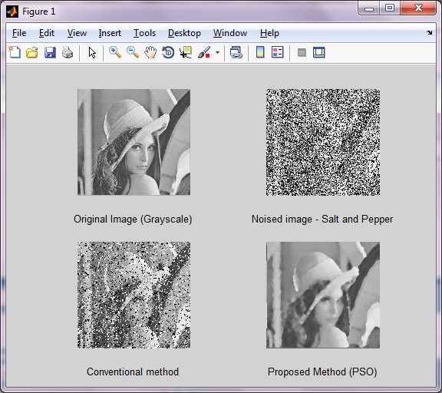
Figure 7. Example of work
Best Position | 0.7419
Best adaption | 19.0330
Adaption array | 19.0015  19.0015  19.0330  19.0330  19.0330
PSNR in dB for Conventional method | 22.7783
PSNR in dB for proposed method | 12.0719
Table 3. Results and PSNR
6. Conclusions
By applying the PSO (particle swarm optimization) for the denoising image filter gives a better performance compared with other technique.
During implementation of this approach it was found that the PSO technique get best results of the filtered images by increasing the number of iterations. Although it can various results by change these parameters to achieve an optimal function that gives the best filtered image. So these coefficients must be the right choice to find better results.
Future work includes funding an optimum function for the PSO approach to get the coefficients of the rational filter that gives the best results for image filtered , Also changed some criteria for the image as the block size of the image and the particle size in PSO approach.

7. References
Rongbo Zhu,Yanchun Zhang,Baoxiang Liu, Chunfeng Liu ,"Information Computing and Applications", International Conference, ICICA 2010.
Said M, Mikki and Ahmed A, Kishk ,"Particle Swarm Optimization: A Physics-Based Approach", Morgan & Claypool; 2008.
Maurice Clerc," Particle Swarm Optimization", London W1T 5DX Newport Beach, CA 92663, 2006.
Brigitte Forster, Peter Massopust,"Four Short Courses on Harmonic Analysis", Springer,2010.
Konstantinos E. Parsopoulos, Michael N. Vrahatis, "Particle Swarm Optimization and Intelligence: Advances and Applications", Information science reference, 2010.
Sanjay Ranka ,Arunava Banerjee, Kanad Kishore, Biswas Sumeet, Dua Prabhat Mishra, Rajat Moona, Sheung-Hung Poon Cho-LiWang (Eds.) "contemporary computing", third international conferences,IC3, Noida ,India,2010.

