Calculations Of Refractive Index For (MBBA) Liquid Crystal Material At Different Temperatures
Abdul – Aziz Obead M. Abdul – Karim J. R. Mohammed Abdul – Ammer Karar Abd – Ali O.
Babylon Uni. Science College Physics Dept.

Abstract:
In this paper , calculation of refractive index values at different temperatures of
(4-Methoxy - Benzylidene -4- Butyl -n- Aniline) (MBBA) , liquid crystal in nematic phase derived from benzidine ( one of Schiff basses compounds ) were done , which has chemical structure .

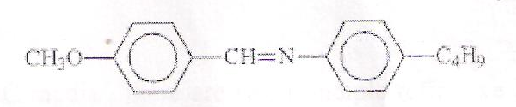

The measurements were done in the temperatures range (288 - 333 K) . The result shows that , the index of refraction values decreases from (1.3760 – 13505) with increase temperature in that thermal range.

الخلاصة :
تم في هذا البحث حساب قيم معامل الانكسار بدرجات حرارية مختلفة للمادة البلورية السائلة
4-Methoxy - Benzylidene -4- Butyl -n- Aniline) (MBBA)
ذات الطور النيماتي والمشتقة من البنزدين (احد مركبات قواعد شيف) التي تمتلك التركيب الكيميائي :

القياسات اجريت عند المدى الحراري (288-333) كلفن . النتائج توضح ان قيم معامل الانكسار تتناقص بزيادة درجة الحرارة عند المدى المذكور .
(1.3760 – 13505)من

Introduction:
Liquid crystal signifies a state of aggregation that is intermediate between the crystalline solid and the amorphous liquid . As a rule, a substance in this state is strongly anisotropic in some of its properties and yet exhibits a certain degree of fluidity, which in some cases may be comparable to that of an ordinary liquid . Liquid crystals are partially ordered , anisotropic fluids , thermodynamically located between the three dimensionally ordered solid state crystal and the isotropic liquid . Their discovery is generally dated back to the year 1888 , when the Austrian botanist Friedrich Reinitzer reported on the observation of compounds (cholesteryl benzoate and cholesteryl acetate) with apparently two multing points [Reinitzer, 1888] .
The refractive indices and call gap determine the phase retardation or phase change of the liquid crystal devices employed for either amplitude or phase modulation and also use in cosmetic materials and medicat rings which covered chemical compounds [Li and Wu,2004] .
In this research , we will first describe the origins of the liquid crystal refractive indices and temperature dependence.
In 2004 , three Floridian researchers ( Li., Sebastian and Tson Wu ) studied temperature effect on liquid crystal refractive indices and found that if the operating temperature is far below its clearing point , the temperature - dependent refractive indices can be approximated as a parabolic form , in addition, a linear relationship between square refractive index (n²( and temperature is found [ Li., and et al ., 2004] .

Theoretical part :
The nematic liquid crystal differs from a normal liquid in that it is composed of rod-like molecules with the long axes of neighbouring molecules a ligand approximately parallel to one another . The classic Claudius — Mossotti equation correlates the permittivity £ with molecular of anisotropic media with molecular polarizability a as [Jackson, 1962] :
$\frac{δ−1}{δ+2} =\frac{4π}{3} Nα$ (1)

Where is the molecular packing density, or number of molecules per unit volume . In the optical frequency regime, substitute n² and obtain the Lorentz equation [Born and Wolf, 1980 ]
$\frac{n^{2}−1}{n^{2}+2} =\frac{4π}{3} Nα$ (2)

For anisotropic liquid crystal ( LC ) media , there are two principle refractive indices , n_{e} and n₀ , represent the refractive indices for the extraordinary ray and ordinary ray respectively . In principle each refractive index is supposedly related to the corresponding molecular polarizabilites .
In 1964 , Vuks made an assumption that the internal field in a crystal is the same in all directions [ Vuks, 1966 ] :
$E_{i}=\frac{(n^{2})+2}{3} E$ (3)
where Ei is the internal field , the average field that acts a molecules, and E is the microscopic electric field With this assumption, Vuks derived the following equation for anisotropic media [Alkeskj old and et. al., 2003] :
$\frac{(n_{{}^{e,0}}^{2})+1}{(n^{2})+2}= \frac{4π}{3}{Nα}_{e,0}$ (4)
where
$(n^{2})=(n_{e}^{2}+2n_{0}^{2})/3$ (5)
To describe the temperature - dependent birefringes , the hailer approximation has been commonly employed when the temperature is not too close to the clearing point ( T_{c}) [Ouderkirk and et al. 2000] :
$Δn(T)=(Δn)_{0}(1−T/{\text{Tc}})^{B}$ (6)
where (Δn)₀ is the LC birefringence in crystalline state , the exponent B is a material constant .
Experimental part :
A Schiff base may be defined as an organic compound which contains a characteristic functional group of carbon-nitrogen double bond $\left(R^{'}R^{''}C=NR^{'''}\right)$.

A linkage called azomethine or imine linkage. If the group ($R^{'}=H$,$R^{''}$ and $R^{'''}$ = aromatic groups) the compounds are called anils, benzanils, or the widely used benzylidene anilines. Most of the work has been done on the latter type of Schiff bases as well as on the substituted derivatives. Much work has been made on Schiff bases complexes, their stability, spectra, and other properties that can be readily determined . The refractive index of ( MBBA) liquid crystal at different temperature (288-333 K) was measured by using ( Abbe Refractometer , Schmid + Haensch ) device which its work in the visible light region ( 4000 - 8000 nm) , the calibration
was done using sterilized water at temperature ( 25 °C ) which is found that the refractive index value is (1.3335 ) , but the value of it in the tables is (1.3334) , that is refer upon the percentage error is ( + 0.000 1 ) . The ( MBBA ) solutes by using the absolute ethanol ( CH₃CH₂OH ) . The refractometer was connected to the water bath .
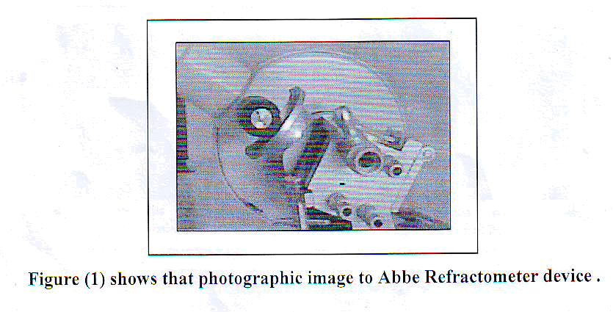

Result and Discussion :
By adding or mixing ( 0.5 ml) from (MBBA) got , in the liquid form upon the slide of device and temperature controlling , we found many values of refractive index , as shown in the Table (1) . Figures a , b and c , respectively refers to the relationship between the refractive index and temperature in the heating , cooling and average . The problem is that the viscosity of nematic liquid crystal is an anisotropic quantity and at least three different viscosity coefficients have to be taken into account, as proposed by Miesowicz (Ginovska et al., 2001).

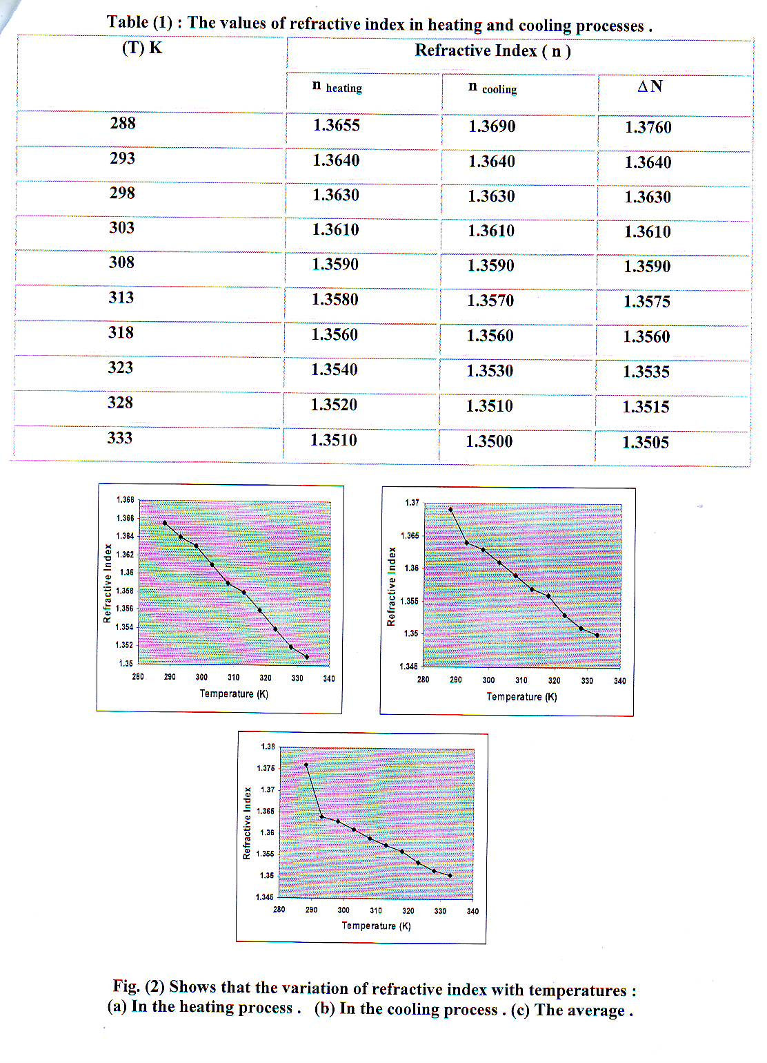
Average))
at
at

c
b
a

The temperature effect is particularly important for projection displays because of the thermal effect of the lamp , the temperature of the display panel could reach 50 °C . It is important to know beforehand the liquid crystal properties at the anticipated operating temperature . The thermal nonlinearity of liquid crystal refractive indices is also very important for same new photonic applications , such as photonic band gap fibers [Alkeskjold and et. al. ,2004] and thermal solutions [Warenghem,2002].
On the other hand , the average refractive index decreases linearly with increasing temperature as [Li and et.al.,2004] , and that is conjugated with figure (1- a , b , c) :
n=A—BT (7)
where , A and B , are materials constants
Because the liquid crystal density decreases with increasing temperature . As the temperature increases ,the density decreases almost linearly. Since refractive index depends on density , so refractive index decreasing with the increasing of teams shown in fig ( a,b,c ) Due to the second-order phase transition, a disrupt density change occurs at ~ 35.3 °C .

Conclusions :
1. MBBA , liquid crystal is one of the most organic material takes best values of refractive index that . in used in monitoring applications .
2. Refractive index values decrease with increasing temperature in the thermal range (288-333K) , so this organic materials have good property from different optical applications .
References :
Alkeskjold, T.T A.Bjarklev , D.S.Hermann, and J.Broenge, (2003), Optical devices based liquid crystal photonic bangap fibers, Opt. Express, 11, 2589.
Alkeskjold, T.T J.Laegsgaard , A.Bjarklev, D.S.Hermann , A.Anawati , J.Broenge J.Li , and S.W.Wu(2004), All optical modulation in dye-doped nematic liquid crystals photonic bangap fibers, Opt. Express 12, 5857 .
Bom M and E.Wolf, (1980), Principle of optics , 6 edn. New York.
Ginovska, M.; Czechowski, G.; Andonovski, A. and Jadzyn, (2001). Polish J. Chem., 75 pp.(1505-1511) .
Jackson, J.D (1962), Classical Electrodynamics , 2. edn. New York.
June Li Sebastian Gauza ,(2004), and Shin-Tson Wu, Temperature effect on liquid crystal refractive indices , AIP.Jour., 96,19.
Li J. and S.T.Wu ,(2004), Two-coefficient Cauchy model for low birefringence liquid crystals , J.Appl.Phys., 96,170.
Ouder J Kirk , S.Cobb , Jr., 13.D.Cull , M.F.Weber , and D.L.Wortman, (2002), Transfiaction displies , with reflactive polarizing transfiactors , USA Patent , 6 124 , 9171 , Sep. 26.
Reinitzer, F (1888), Monatsh. Chem., 9,421.
Vuks, M.F. (1966) , Determination of the optical anisotropy of aromatic molecules from the double refraction crystals, Opt. Sopekrosk., 20 , 644.
Warenghem M. , J.F.Henninot , F.Derrin , and G.Abbate, (2002) , Thermal and orientational spatial optical solutions in dye-doped liquid crystalsMol.Cryst.Liq.Cryst., 373 , 213.

