Applications Of Gis Software In Irrigation Project Management
تطبيقات برنامج نظم المعلومات الجغرافية في إدارة مشاريع الري
Hashim Isam Jameel Al-Safi
Technical Institute Shatra – Department of Irrigation and Drainage Techniques
Abstract
Irrigation is one of the most important input for an efficient and sustainable agricultural production. Irrigation experts are seeking the ways in which the water is used very efficiently. So, good and sustainable irrigation project management leads to success of irrigation. A providing large amount of data are of great necessity for management of large scale irrigation projects. This work involves a theoretical study to use the gis software in irrigation project management. The study have been applied on the north zone of hilla-kifil irrigation project which is located in the middle part of iraq. It includes four applications of gis software namely (gis mapping, database integration, planning/management and modeling). The aims of these applications are to present the importance of using the gis software in many purposes in irrigation project management. The study shows individually the benefits of using of each application in irrigation project and the necessary data required for each application.
Key wards : gis, irrigation management, database, model integration.
الخلاصة
الري هو أحد أهم المدخلات للإنتاج الزراعي الفعال و المدعوم. خبراء الري يسعون إلى الطرق التي يكون فيها الماء المستخدم فعال جدا. لذلك، إدارة مشاريع الري الجيدة و المدعومة تؤدي إلى نجاح الإرواء. إن تجهيز كمية كبيرة من المعلومات هو ضروري جدا لإدارة مشاريع الري الكبيرة الحجم. إن هذا العمل يشمل دراسة نظرية لاستخدام برنامج نظم المعلومات الجغرافية في إدارة مشاريع الري. الدراسة طبقت على المنطقة الشمالية لمشروع حلة – كفل الأروائي و الذي يقع في الجزء الوسطي من العراق. الدراسة تضمنت أربعة تطبيقات لبرنامج نظم المعلومات الجغرافية و المسماة (رسم خرائط برنامج نظم المعلومات الجغرافية، تكامل قواعد البيانات، تخطيط / إدارة و النمذجة). الأهداف من هذه التطبيقات هي لتقديم أهمية استخدام برنامج نظم المعلومات الجغرافية في بعض الأغراض في إدارة مشاريع الري. الدراسة بينت بصورة منفردة فوائد استخدام كل تطبيق في مشاريع الري و البيانات الضرورية اللازمة لكل تطبيق.
- Introduction
One of the world’s great challenges is to increase food production in a sustainable manner so that a rapidly growing global population can be fed. The world’s growing population and production, combined with unsustainable consumption patterns, is putting increasing stress on land, water and other essential resources (degirmenci et al., 2005). The two-third of all water of the world is used in irrigation, and 40% of total agricultural production is obtained from irrigated areas. Unsustainable and insufficient management of irrigation projects leads to poor performance of irrigation projects. The poor design, construction, operation and maintenance are also a shortcomings which lead to poor performance of irrigation systems (gundogdu et al., 2005). Information which helps to system manager must be easily accessible in irrigation management. Most of the data related irrigation is characterized geographically. Use of gis software is of great importance in establishing databases for irrigation systems in order to have readily, accessible and not superfluous data, data must be collected, recorded and interrelated in systematic way. For that reason it is very important to organize database which is the basis of the information system (gundogdu et al., 2005). Mapping is an important component in irrigation district management and operations. Most irrigation districts have large maps covering the walls of lobbies and boardrooms. Generally, these maps shows the district boundaries and surrounding areas. In many cases, highlighters have been used to indicate the distribution system and the maps are littered with Handwritten Notes Made Over The Years (Daniel Et Al., 2003). Although A Gis Software Package Can create useful, colorful maps, gis is more than just a map. Gis software can be used in many purposes in irrigation project management such as a mapping tool, a database integration tool, a planning/management tool and gis can be used in modeling ( fipps & eric, 2003) . Also gis software has a great importance in irrigation project management to drawing the layers, inputting of the data, analyzing and processing of the input data and outputting of the results and reports.

- Objective of the study
the aim of this study is to present theoretically the importance of applying the gis software in irrigation project management to serve in the purposes of mapping, database integration, planning/management and modeling. The study is applied on the north zone of hilla-kifil irrigation project which is located in the middle part of iraq. Firstly, in this study is tried to determine most needed data for irrigation project management. After determination of data about irrigation project management, data classification and standardization were done.
- Description of the study area
hilla-kifil project was constructed in 1981. The north part of the project is located between 44◦ 13' to 44◦ 28' eastern longitude and 32◦ 36' to 32◦ 44' northern latitude. The total project area covers 57500 hectare and extends about 50 km from north to south and 20 km from west to east, at its broadest.
the boundaries of the project area are formed by the kifil canal, running parallel to the euphrates river on the west, shatt al-hilla from the north to the east and by the road from hilla on the east to kifil on the south as shown in (fig. 1).
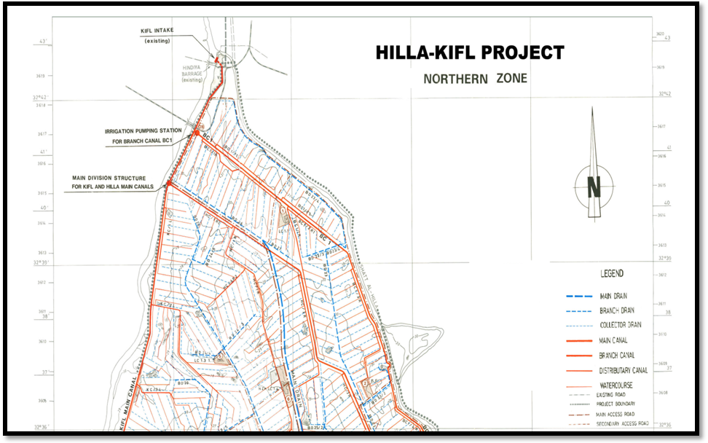
Figure (1) location map of the north zone of hilla-kifil irrigation project.

- Material and method
  - materials :
in this study, arc catalog ver. 9.2 have been used to build the drawing files which are used to draw irrigation system, drainage system, roads network, …, etc. Also arc map ver. 9.2 have been used to inputting of the data, analyzing and processing of the input data and outputting of the results and reports.
  - Methods :
in order to establish a database in irrigation project management, main steps were given in (table 1). Initially, it was tried to determine the database which is used in irrigation project management herein. For that purpose, the management systems of irrigation network which is operated or transferred by government were evaluated. Graphical and non-graphical data such as topography, soil, road network, irrigation system, drainage system, land use pattern was determined and collected for creation of information system (gundogdu et al., 2005).
Table (1) main steps of creation a gis-supported database in irrigation project management.

Data determination
Data classification
Data organization
Determination of data features and contents
Determination of relationship between data
Determination of analysis

after data classification and organization phase, contents of attribute table of graphical and non-graphical data types was tried to determine for each geographical object. Geographical data is a data which connected with location and it includes location and shape information of the geographical object. There are two forms on the structure of geographical data that are extensively used raster and vector formats (burrough, 1986). There are three geographical feature on both forms: point, line and polygon. These features are separately identified on the raster and vector forms (scott, 1993). There are some specific features of geographical objects. These features are called as attribute. Attribute data defines geographical object and its’ details. Classified graphical data was transferred to gis-environment so that data has become a main component of irrigation management works. Every graphical data is created on separate coverage to make easy analysis and queries to set relationship between data. Some of the data is non-graphical (numerical and alfa numerical data). These data's types can be expressed as character, integer number, real number or date. Information tables was created to analysis, to query and to relate numerical and alfa numerical data. Key field on attribute table or information table was used to have relationship between different tables.
after determination of the coverage and info tables of irrigation management information system, relationship between coverage and information tables were created. Thus, relationships can be set when user works on the coverage to information table or when user works information table to coverage. Therefore, analysis and queries can realize easily. Needed queries and analysis were determined after determination of all components of information system.
- Applications
  - Gis As A Mapping Tool
one basic function of gis is the production of customized maps that can be updated and reformatted as needed. Most irrigation districts begin gis program because of their need for continuing updating district maps and information, including distribution networks, canal sizes and lining, infrastructure locations, and other district facilities and their corresponding attribute information. In this study arc catalog ver. 9.2 (an application of the gis software) have been used to build the drawing files of all features of the irrigation project. In addition, gis maps are used in some purposes including:
- Allowing districts to have accurate and up-to-date maps as when changes occur.
- Defining conditions of the infrastructure to help identify segments needing increased maintenance or rehabilitation.
- Combining data based on spatially and find relationships.
- Solving location or property disputes.
- To determining the size of a service area.

Also gis mapping is used for the following purposes (daniel et al., 2003) :

- Data organization – spatial organized stream flow data, water quality data, turnout deliveries, distribution system layout and flow rates, ground water elevation , crop type, irrigation methods, …,etc.
- Data retrieval – crop and irrigation method acreage, biannual ground water elevation contour generation, lengths of canals and laterals, analysis of wet land and riparian habitat.
- Presentation – presenting the organized data as well as recommendations for a strategic modernization plan.
for the present study, the mapping of the study area have been done by using the arc catalog ver. 9.2 to build the drawing files of all features of the project and by using the arc map ver. 9.2 to drawing these features as shown in figures (2-a and 2-b) .
Figure (2-a) drawing files of the features of the project by using arc catalog.
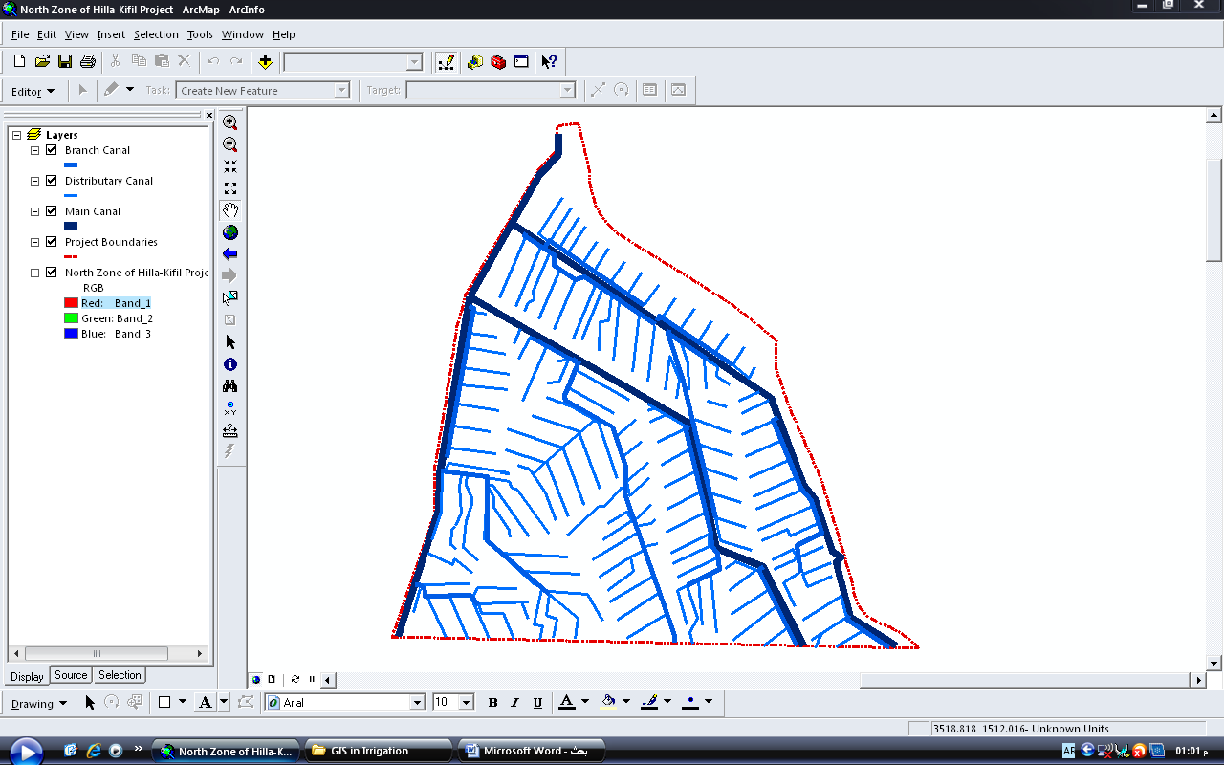
Figure (2-b) shows the boundaries of the north zone of the project and the irrigation system (main, branch and distributaries canals) by using arc map.
  - gis and database integration
databases components which will be created for irrigation project management were considered in two different groups: permanent project data and yearly changing project data. Permanent project data was shown in (table 2). Permanent project data constitutes basic database of the model and this data is entered to the system only ones for each irrigation project.
Table (2) permanent project data.
Map data | Information data
Water resource  project border  irrigation system  drainage system  road system  land ownership map  soil map  topographical map  construction map  water table observation wells map | land ownership data  irrigation channel data  drainage channel data  road system data  meteorological station data  climatologically data  crop data  soil data  personnel data

annual project data is obtained depending on irrigation season. These data can be obtained monthly, daily or hourly. Classified data as yearly project data is shown in (table 3).
Table (3) irrigation project yearly data.
Land use data
Irrigation project
Irrigation channel
Drainage channel
Maintenance data
Water table level
Groundwater electrical conductivity
Water charges
Daily water requirement
Personnel
Equipment use
Other

to obtain relationship between yearly project data and permanent project data, an appropriate framework was established. For example, to enter water demand data to system for any year, planting crops can select from plant information database. System will have a connection with parcel database so that annual data about parcel can be entered to the system. Crop to be planted can be selected from plant information database. Plant specifications such as growing period, crop coefficient, root depth … etc. Were given in plant information database. When entering plant cropping time, harvest time of every plant can be calculated by plant information database according to plant growing periods. Yields and crop prices are entered by users. Consequently, all information will be saved in an information file for that year. Also to enter the data of irrigation system (types of canals(main canal, branch and distributaries canals), their dimensions and slops, their design discharge,…, etc), it can be entered from the attribute table of each feature by using the arc map as shown in figures (3-a and 3-b).
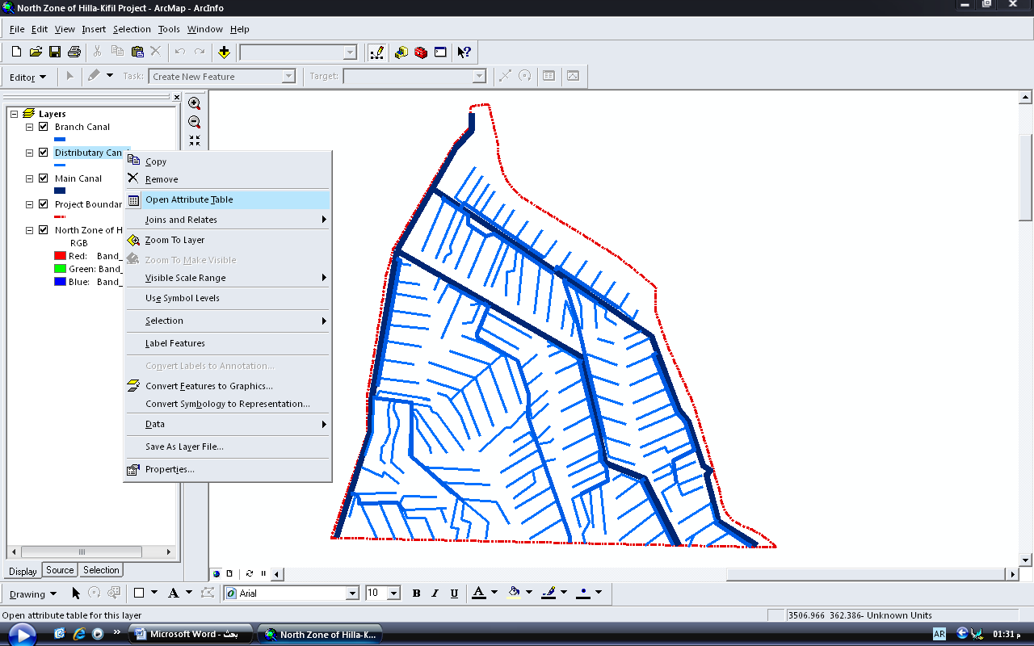
Figure (3-a) opening the attribute table of the selected feature to enter canal properties.
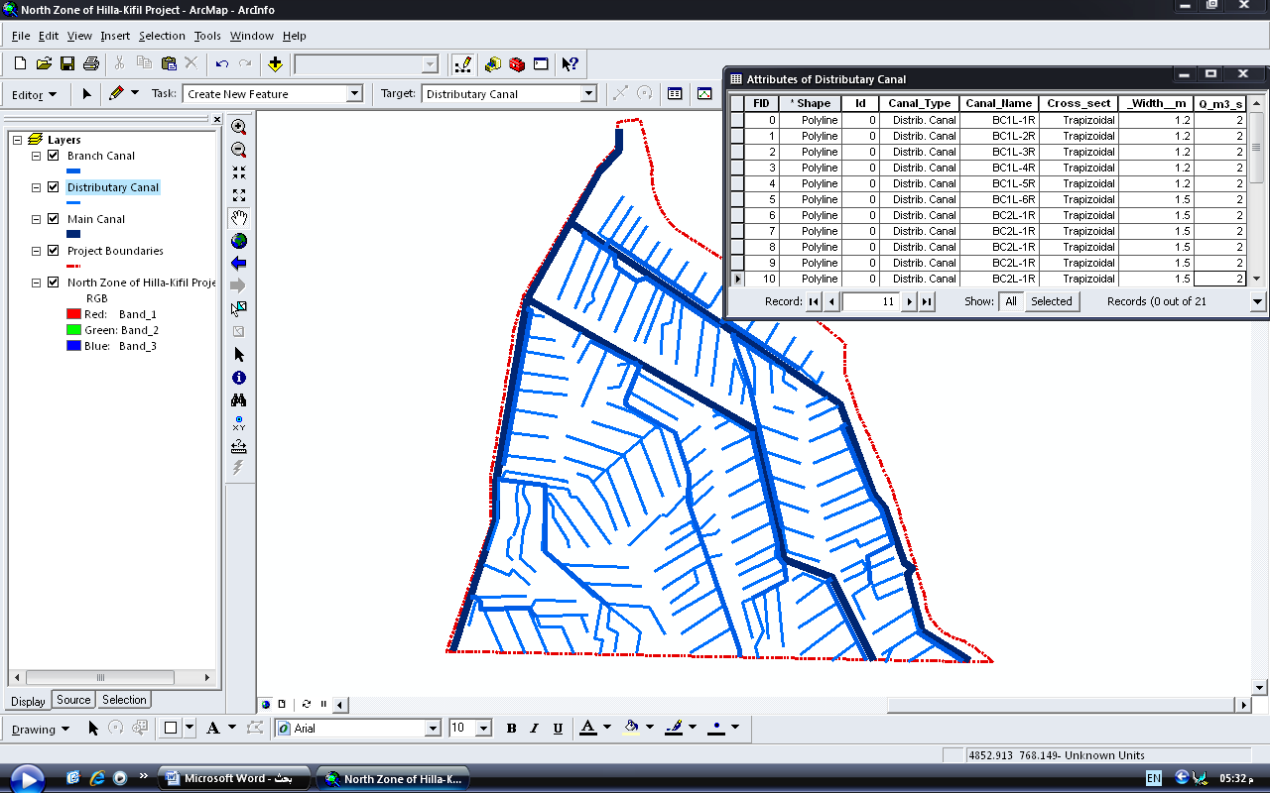
Figure (3-b) attribute table of the distributaries canals showing their properties.
created database provides the user to inquiry information related irrigation project in gis environment. Either permanent data or yearly changing data can be inquired in database. Some of example of queries are as follows (gundogdu et al., 2005) :
- Parcel irrigated by selected channel and its size.
- Crop pattern under selected channel.
- Selected channel specifications.
- Channels which irrigate selected parcel.
- Crop pattern under selected parcel.
- Selected parcel specification.
- Water structures in project area.
- Maintenance locations on channel.
- Parcels belongs owners.

  - Gis As A Planning/Management Tool

gis can serve as a powerful resource for planning and management. The only limitations are the imagination and the availability of data. A combination of gis mapping, data collection, and field measurements can be used to identify any problems in irrigation project. For example, the combination can be used to identify infrastructure problems in irrigation districts, the potential water saving benefits of specific rehabilitation projects, indication of the locations of deficiencies or problems in the project,…, etc. The next step of this process is to use the information obtained from the above combination to discussing on whether plan rehabilitation projects and/or re-designing areas, or in the case of system problems that would not allow for a change in the infrastructure, a change in the management of the system must be happened.
one common use is to visually represent information for quick analysis. In the fig. Below (fig. 4), distributaries canals that have been remaining unlined in the project are highlighted in beryl green.
Figure (4) visually represent information which shows the unlined distributaries canals in the project.

  - Gis And Modeling
better interpretation of hydro geological data often requires that their spatial location be incorporate into the analysis. Gis can be used for storing hydro geological data as well as their spatial locations in a relational database. It also provides the facility to analyze the spatial data objectively using various logical conditions. As a result, nowadays, gis is widely used for spatial modeling of hydro geological prospect of a large area with more reliability. Gis are best suited for handling a wide range of data from different sources for a quick and cost-effective assessment (shahid & nath, 2004). Local
for example on modeling in this study is the hidrogest. Hidrogest is a software application using database operation through a designed interface. It is an irrigation projects management tool that integrates different models for different purposes. This application and its interface join the databases with those models, thus creating a management tool. Although this is a gis application, it can also be used without gis software losing its user-map functionalities.
mathematical models need data to operate and produce new information. Besides almost all models allow manual input data, they are developed over a unique internal database. These internal databases have large variability of formats (.mdb, .txt, .dbf, etc.) Specifically adapted to the model where they are integrated. However, a large amount of data in these databases is or should be the same for several models, like soil data, crop data, climatic data, and other. Applying a single database structure will increase data stability and validation using diverse models and by comparing and reusing output data between models. Thus, if data should be the same for various models it becomes difficult to maintain and synchronize all different databases of all existing models. The centralization of all data in a single database has thus the following advantages (pedro et al., 2005):
• maintenance – it is no longer necessary to synchronize several databases, including with different formats. Data are updated only in one database;
• accessibility – data can be accessed in only one physical location;
• integration – standard data types and structured data allow to cross information between models;
• technologic evolution – allows modification of data type formats without changing the models.
the linkage between the models and the database is made through a database interface, which is part of hidrogest. Changing database format will only take effect on this interface.
the main purpose of hidrogest is to play a role of workbench for usage of various models, integrating them with a unique database (fig. 5). Note that a single database it is not composed by only one file, but by a combination of one or more files with one or more formats.
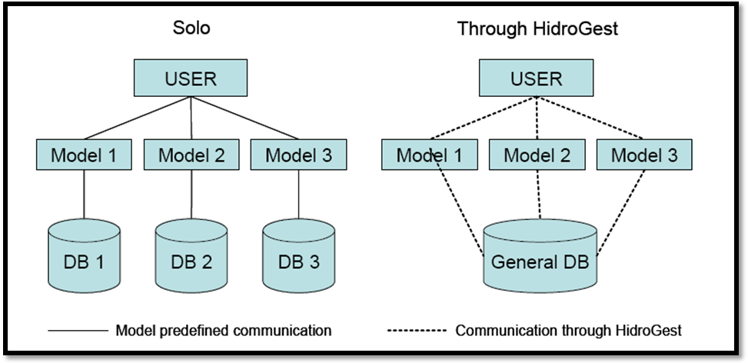
Figure (5) scheme of model's usage with and without hidrogest .
the use of the mathematical models along with the gis application is made through the development of an interface (model interface) that is used has a gis application toolbar. This toolbar accedes the different models available. The database management system is a software that allows managing the database information and its querying (fig 6). Any change made in the data tables within the databases is considered as input data, as any parameter used in the advanced queries definition. The output data is presented as data tables or graphical representation in gis.
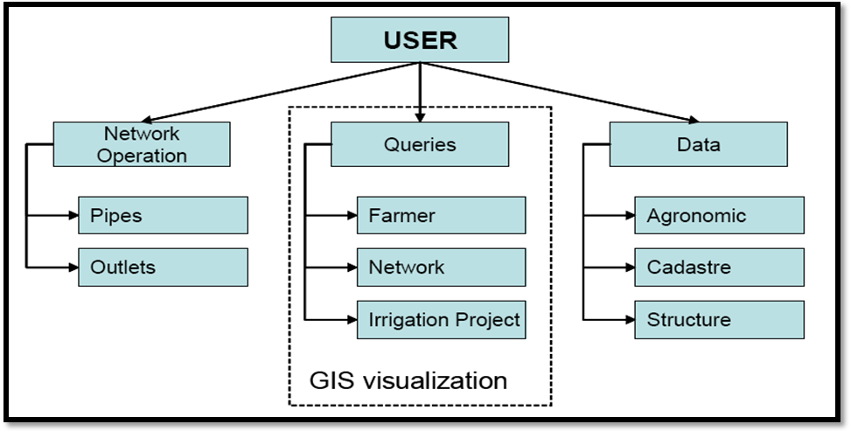
Figure (6) generic functioning scheme .
- Conclusions
water is becoming an increasingly scare source and therefore limiting agricultural development in many regions and countries of the ward. Efficient and sustainable water management of water resources is increasingly becoming a policy objective. In this study, four applications of gis software have been applied on the north zone of hilla-kifil irrigation project to show the advantages of gis software in irrigation project management. These applications are : gis mapping, database integration, planning/management and modeling.
gis mapping is slowly becoming commonplace in irrigation districts as the need for more accurate and organized data becomes increasingly important. Gis mapping can be an effective tool to organize, retrieve and present spatial data for irrigation districts.
gis software can serve as a powerful resource for planning and management a wide range of data in large scale districts and processing of these data in a sustainable way. Also the applications of gis software can be used in integration of the database which is an irrigation projects management tool that integrates different models for different purposes.
mathematical models simulation represents a great share in scientific investigation’s software development. However, simulation models acceptance by potential users is below expectation due to diverse reasons. One is that it is difficult to gather technical information and to manage this information on the simulation models. Thus, the need to replicate the same information through different models can be an unpleasant task. It is then necessary to develop support tools for simulation models in order to reduce the existing gap between these models and the skills of potential users. The compatibility of different simulation models cannot be forgotten since it allows reutilization and complementation of diverse functionalities.

- References
Burrough, p.a. (1986): "principles of geographical information system for land resources assessment " oxford university clerandon pres, 346 s.
daniel, j. H., charles, m.b. and stuart, w. S. (2003) : " gis mapping for irrigation district rapid appraisals" irrigation training and research center, california polytechnic state university.
Degirmenci, h., buyukcangaz, h. And korukcu, a. (2005) : "stakeholders and their information requirements in monitoring and evaluation (m&e) of irrigation projects." university of uludag, faculty of agriculture, agricultural eng. Dept. Bursa/turkey.
Fipps, g. And eric l. (2003) : "study on using the gis software as a tool in irrigation districts and projects." biological and agricultural engineering, 2117 texas a&m university, college station, tx 77843-2117.
Gundogdu, s. K., degirmenci, h., and demirtas, c. (2002) : " study on creation of gis supported database in irrigation project management." university of uludag, agricultural faculty, department of agricultural engineering, bursa, turkey.
Pedro, m , joão, r. And luís, s. P. (2005) : " hidrogest, a gis application for irrigation projects management and model integration" center for agricultural engineering research, institute of agronomy, technical university of lisbon, tapada da ajuda, 1349-017 lisbon, portugal.
Scott, s. (1993): "water and sustainable agricultural development" dvwk bulletin 19, verlag paul parey, hamburg/berlin 1993. P. 19-50.
Shahid, s. And nath, s.k. (2004) : "gis integration of remote sensing and electrical sounding data for hydro geological exploration." journal of spatial hydrology , vol.2 no.1, rajshahi university, rajshahi-6205, bangladesh.

