Study The Biological Activity of Caffeine Salicylate With Theoretical Investigations

Zainab Shakir Abdullah
Department of Chemistry, College of Science, University of Basrah
Kawthar H. Mehdi
Department of Biology, College of Science, University of Basrah,
^{Abstract}
The study showed that the caffeine salicylate is a good antimicrobial compare with the standard Streptomycin antibiotic, and the cytotoxicity assay against the human red blood cells equal to the 100-200 ppm concentration of the caffeine salicylate . The B3LYP hybrid functional calculations appeared that the salicylate changes the oxidation and reduction potentials of caffeine, also their active positions in structure. The Binding energy decreases as the distance or the rotation angle between the caffeine salicylate increases. The caffeine salicylate is not planer.
Key Word: Caffeine salicylate, antimicrobial, cytotoxicity, streptomycin, ab initio.
Introduction:
Caffeine is a 1,3,7- trimethyl xanthine alkaloid compound is a central nervous system and metabolic stimulant (Nehlig et.al, 1992). It is used both recreationally and medically to reduce physical fatigue and restore mental alertness when unusual weakness or drowsiness occurs ,resulting in increased alertness and wakefulness (Bolton & Gary Null, 1981). The most significant effect being inhibition of phosphodiesterase resulting in increase in intracellular cAMP levels; effect on intracellular calcium levels and antagonism of adenosine receptors (Serafin, 1995).A part from that, caffeine has also been reported to be an antimicrobial agent most effective against E. coli (Ramanaviciene et.al, 2003), and this is attributed to the effect of caffeine on DNA and protein synthesis in E. coli report also indicate that caffeine enhances the inhibitory effect of certain antibacterial agents like penicillin and tetracycline against Staphylococcus aureus and furazolidone against vibrios (Banerjee & Chatterjee, 1981). However ,since caffeine is a base and can accept a proton, it can react with an acid to from salt. If the acid used is salicylic acid, the salt formed, caffeine salicylate, see described in Fig.1 (Willamson et.al, 2007). The present study aims is preparation of caffeine salicylate and study the antibacterial activity and the cytotoxicity. Then we try to using the ab initio computations to study some properties such as the binding nature between the caffeine and salicylate and the oxidation-reduction potential.
الخلاصة
أظهرت الدراسة الحالية أن الساليسيلات الكافيين له قدرة جيدة كمضاد للجراثيم مقارنة مع المضاد الحيوي القياسي الستربتوميسين، كما أظهر فحص السمية ضد خلايا الدم الحمراء البشرية انه مساويا لتركيز جزء في المليون 100-200 من الساليسيلات الكافيين. من خلال الحسابات النظرية (باستخدام نظرية دوال الكثافة B3LYP) أن جذر الساليسيلات يغير كل من قابلية التأكسد والاختزال والمواقع الفعالة لمادة الكافيين. كما ان طاقة الترابط بين الساليسيلات والكافيين تتناقص مع زيادة كل من المسافة وزاوية الدوران بينهما. وان الساليسيلات والكافيين لا يقعان ضمن نفس المستوي الفراغي.

Experimental procedures:
A- Material:
1-Caffeine (HOPKIN&WILLIAMS) ,Salicylic acid (MERCK) ,Dichloromethane (Lab) and petroleum ether(BDH).
2-Standard bacteria strains: Bacillus subitilis PCI 219, E.coli NCTC 5933 & Staphlococcus aureus NCTC 6571.
3-Cilinical bacteria: The clinical strains from Al-Faihaa hospital: Escherichia coli, Staphylococcus aureus.
4-Ready culture media: Muller-Hinton agar (Difco). Culture media was prepared according to information of manufacture company.
B- Prepared of caffeine salicylate:
Initially, we Add equimolar amount of salicylic acid into the round bottom flask, followed by (2-3 mL) of dichloromethane and heat the mixture to boiling. Then we remove the round bottom flask from the heat and add petroleum ether drop wise until a solid white precipitate just begins to form. Now add dichloromethane in drops so as to just dissolve the precipitate. The solution cool very slowly to room temperature, then put it on ice to aid the crystallization. The crystals filtered by the vacuum filter using the Hirsh funnel and rinse with petroleum ether. Last, we leave the solid in a tarred weigh boat, and it covered with a filter paper (Willamson et.al, 2007).

C- Identification of caffeine salicylate:
The determination of melting point: Melting point electro-thermal is used for the determination of melting point of the prepared compound.
D- The minimum inhibitory concentration (MIC):
The minimum inhibition concentration (MIC) of the caffeine and caffeine salicylate were determined according to the method of (Spooner & Sykes, 1972) against different types of reference and clinical strains of bacteria, with different concentration of the compounds ranging from (0.4, 1, 2.5, 5, 10, 25, 40, 100 and 200 µg/ml) in compared with standard streptomycin antibiotic.
E- Cytotoxicity assay:
The cytotoxicity activity of the caffeine and caffeine salicylate, were determined against human red blood cells by using a suspension of 1ml. of the blood dissolved in 20 ml. of normal saline solution. Different concentrations of the caffeine and caffeine salicylate, were prepared separately dissolved in DMSO solution, then 100µl of each concentration was added to 2 ml. of blood. The turbidity of the mixture was examined after 10, 30 and 60 min. before the blood cells were heamolysate completely (Nair et.al, 1989).
Theoretical approach and computational details
The theoretical methods can be used to further investigate and predict the physical and chemical nature of hydrogen bonding interactions and some other properties (Al-anber et.al, 2008). The ab initio calculations were performed to study the caffeine, salicylate and caffeine salicylate together using the Gaussian 98 program (Frisch et.al, 1998). The geometries for all structures were fully optimized at density-functional-theory (DFT) level with the CEP-31G basis set using the gradient optimization method. The applied DFT method used the B3LYP hybrid functional (a parameterized combination of Becke’s exchange functional, the Lee, Yang and Parr correlation functional and the exact exchange) (Becke, 1993).

Results and Discussion
Prepared of caffeine salicylate and identification by melting point (MP) was equal to 137C○ . The caffeine salicylate has sharp melting point, that is mean it is pure. For our theoretical investigation it was important to find the geometry optimized for caffeine, see figure 2, and salicylate alone, and then for caffeine salicylate, see figure 3, as complex using B3LYP/CEP-31G. The geometry optimized for complex of caffeine salicylate shows that they are not in the same plane, where the dihedral angle between them is equal to 53.5º. According to the Koopmans' theorem (Koopmans, 1933), we can note that the ionization potential of caffeine, the ability for given electron, increases by 0.325eV due to its connected with salicylate. While the ability for accepted electron, electron affinity, lower comparison to the caffeine alone by 0.885eV. Generally, the salicylate lowers the oxidation potential and increases the reduction potential for caffeine. The results of the population analysis using the B3LYP/CEP-31G, the molecular orbital coefficients, for caffeine and caffeine-salicylate are shown in table 1 and table 2 respectively. Where we can note the oxygen atom 10 has the major role in oxidation potential of caffeine, see figure 2. While in the caffeine salicylate form the oxygen atom 7 has the major role, see figure 3. Also, we may note that the carbon atom 4 has the biggest role in reduction potential of caffeine, while in the caffeine salicylate form the carbon atom 24 own this biggest role, see table 2. The binding energy between the caffeine and the salicylate, BE = E(caffeine salicylate) - (E(caffeine) + E(salicylate)), due to the optimized form was equal to -4.367eV, which it will decrease rapidly and then disappear as the distance between the caffeine and the salicylate increases by quantity ~1.17Aº, see figure 4. This case may explore the ability limited of the solvent potential on the caffeine salicylate to splitting them. The binding energy as a function of rotation angle between the caffeine salicylate shows in figure 5. Where there is decreases in the binding energy with the rotation angle, but this rotation angle is not enough to separating each one from another. Table 3. shows the results of the MIC values of the caffeine and caffeine salicylate against gram positive were varied from (0.35 - 2.5 µg/ml), while against gram negative bacteria were varied from (1.5 -10 µg/ml). The results shown that the activity of caffeine salicylate was higher than the standard one against gram positive and gram negative bacteria, and in compare with the standard streptomycin antibiotic the activity was nearly the same this indicate that the caffeine and caffeine salicylate compounds have a strong antibacterial activity. Generally, it is clear that the gram positive strain ( Staphylococcus aureus NCTC 6571) was more effected than gram negative strain (Escherichia coli NCTC 5933). It has been postulated that cell membrane of Escherichia coli contain many condensed fat layers compared with Staphylococcus aureus which contain a thick layer of peptidoglycan compounds and the effect of caffeine on the bacteria may be due to the first exposure of the microorganisms against these compounds [14]. The result in table 4 shows that the caffeine compound had a cytotoxicity against the human red blood cells within concentration ranging between 200-250 ppm, by using DMSO solution as a control. The cytotoxicity of these compounds against the red blood cells. The result in table 4 that 100-200 ppm concentration of the caffeine salicylate one was the cytotoxicity concentration on the red blood cells duo to the aggregation of these compounds inside the blood cells, the effect of these compounds in their cytotoxicity were similar to several types of antibiotics specially the nucleoside antibiotics such as Tubercidine.
Conclusion:
The caffeine salicylate is a good antimicrobial compare with the standard streptomycin antibiotic, and the cytotoxicity assay against the human red blood cells equals 100-200 ppm concentration of the caffeine salicylate. According to the theoretical calculations the salicylate changes the oxidation and reduction potentials of caffeine, also their positions in structure. Due binding energy results where this factor decreases as the distance or the rotation angle between the caffeine salicylate increases. The geometrical structure of the caffeine salicylate is not planer.

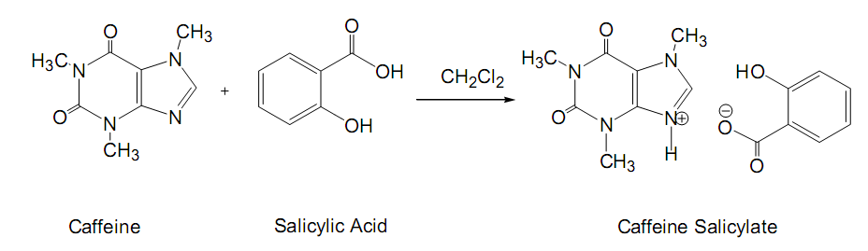
Figure 1. Prepared reaction of the caffeine salicylate.

Figure 2. The geometry optimized for caffeine using B3LYP/CEP-31G.

Figure 3. The geometry optimized for caffeine salicylate as complex using B3LYP/CEP-31G.

Table 1. The molecular orbital coefficients for caffeine using the B3LYP/CEP-31G.
Atom | HOMO | LUMO | Atom | HOMO | LUMO
1N | 0.18982 | 0.44424 | 8N | 0.68773 | 0.81178
2C | 0.15206 | 0.13476 | 9C | 1.34764 | 0.43383
3N | 0.13125 | 0.54757 | 10O | 1.51123 | 0.5428
4C | 0.34624 | 1.17316 | 11O | 0.36302 | 0.57012
5C | 0.67903 | 0.4205 | 12C | 0.05215 | 0.0729
6C | 0.43923 | 0.79731 | 13C | 0.04014 | 0.11503
7N | 0.9643 | 0.15677 | 14C | 0.32187 | 0.10822

Table 2. The molecular orbital coefficients for the caffeine salicylate using the B3LYP/CEP-31G.

Atom | HMO | LUMO | Atom | HMO | LUMO
1C | 0.86553 | 0.00806 | 18N | 0.01965 | 0.42708
2C | 0.16553 | 0.00537 | 19C | 0.01536 | 0.69148
3C | 0.77357 | 0.00839 | 20C | 0.02137 | 0.51688
4C | 0.44577 | 0.03227 | 21C | 0.00858 | 0.76265
5C | 0.5522 | 0.02085 | 22C | 0.00772 | 0.87966
6C | 0.57494 | 0.05455 | 23C | 0.01009 | 0.30025
7O | 0.89716 | 0.01356 | 24C | 0.02864 | 1.02061
8C | 0.09761 | 0.06014 | 25O | 0.00936 | 0.06984
9O | 0.08028 | 0.04325 | 26O | 0.00731 | 0.67057
10O | 0.33754 | 0.07865 | 27C | 0.00166 | 0.07751
16N | 0.00817 | 0.44289 | 28C | 0.0411 | 0.07426
17C | 0.01606 | 0.09201 | 29C | 0.00313 | 0.07416

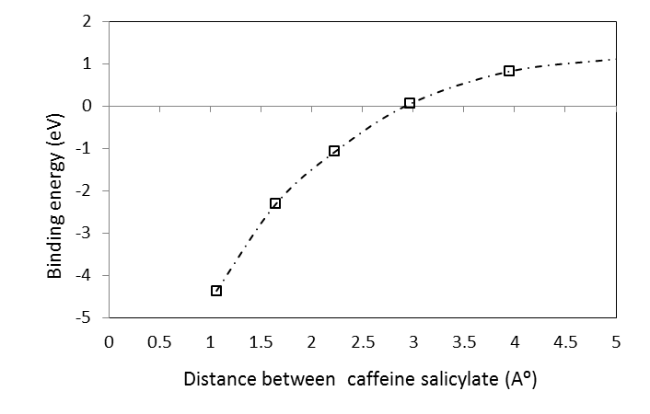
Figure 4. The binding energy between the caffeine and the salicylate as a function of distance between them using the B3LYP/CEP-31G.

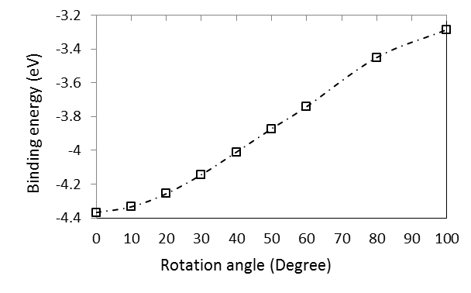
Figure 5. The binding energy between the caffeine and the salicylate as a function of the rotation angle between them using the B3LYP/CEP-31G.

Table 3. The minimal inhibitory concentration of the caffeine and caffeine salicylate.
Bacterial strains | MIC (µg /ml )  C CS S
Bacillus subtilis PCI 219 .  Escherichia coli NCTC 5933  Staphylococcus aureus NCTC 6571  Escherichia coli R  Staphylococcus aureus R | 2.5  10  0.15  3.5  0.5 | 0.9  8.5  0.35  2.5  0.35 | 1.2  1.5  0.9  1.8  0.8
R: Clinical strains from Al-Faihaa hospital, C: Caffeine, CS: caffeine salicylate and S: Standard Streptomycin.

Table 4. The cytotoxicity of the caffeine and caffeine salicylate.
Compound | Concentration ( ppm ) | Toxicity against RBC
DMSO  Caffeine  caffeine salicylate | -  0.5  10  50  100  200  0.5  10  50  100  200 | NT  NT  NT  NT  NT  T  NT  NT  NT  T  T
NT: not toxic, T: toxic and DMSO: di methyl sulfoxide.

References:
Nehlig, A. J.L. Daval & G. Debry , “Caffeine and the central nervous system: Mechanisms of action, biochemical, metabolic and phychostimulant effect”, Brain Res Rev, 17, 139-70(1992).
Bolton Ph.D. & M.S. Gary Null, “Caffeine: psychological Effects, Use and Abuse”, (http://WWW.garynull.com/Documents/Caffeine Effects.htm) .Orthomolecular Psychiatry 10, 202-211(1981).
Serafin, W.E. “Methylxanthines; The pharmacological Basis of Therapeutics”, McGraw-Hill, New York (1995).
Ramanaviciene, A. V. Mostovojus, I. Bachmotova & A. Ramanavicius,(2003).”Anti-bacterial effect of caffeine on Escherichia. coli and Pseudomoas flurescens”.Acta Medica Lituanica, 10: 185-188.
Banerjee S.K. & S.N. Chatterjee, ”Radiomimetic property of furazolidone and caffeine enhancement of its lethal action on the vibiros”, Chem. Biol. Interact.,37, 321-335(1981).
Willamson, K.L R.D. Minard & K.M. Masters, “Macroscale and Microscsale Organic Experiments”.5th ed. ; Houhton Mifflin: Boston, 156-160, 169-170(2007).
Spooner D. F. & G. Sykes, “Method in Microbology”, Academic press. INC. London Ltd., 7B, 211-276(1972).
Nair, M. G. A. R. Putnam, S. K. Mishra, M. H. Mulks, W. H. Taft, J. E. keller & J. R. Miller, “Faeriefungin a new broad spectrum antibiotic from Strepomyces griseus var. autotrophicus”, J. Natural Product, 52, 797-809(1989).
Al-anber, M. J. , Z. S. Abdullah & A. A. Salih, “Theoretical ab initio study of the electric field effects on the structure and stability of G:C base pair”, FIZIKA A (Zagreb), 17, 151–158(2008).
Frisch, M. J. G. W. Trucks, H. B. Schlegel, G. E. Scuseria, M. A. Robb, J. R. Cheese-man, V. G. Zakrzewski, J. A. Montgomery, Jr., R. E. Stratmann, J. C. Burant, S. Dapprich, J. M. Millam, A. D. Daniels, K. N. Kudin, M. C. Strain, O. Farkas, J. Tomasi, V. Barone, M. Cossi, R. Cammi, B. Mennucci, C. Pomelli, C. Adamo, S. Clifford, J. Ochterski, G. A. Petersson, P. Y. Ayala, Q. Cui, K. Morokuma, N. Rega, P. Salvador, J. J. Dannenberg, D. K. Malick, A. D. Rabuck, K. Raghavachari, J. B. Foresman, J. Cioslowski, J. V. Ortiz, A. G. Baboul, B. B. Stefanov, G. Liu, A. Liashenko, P. Piskorz, I. Komaromi, R. Gomperts, R. L. Martin, D. J. Fox, T. Keith, M. A. AlLaham, C. Y. Peng, A. Nanayakkara, M. Challacombe, P. M. W. Gill, B. Johnson, W. Chen, M. W. Wong, J. L. Andres, C. Gonzalez, M. Head-Gordon, E. S. Replogle, & J. A. Pople, “Gaussian 98”, Gaussian Inc., Pittsburgh PA, (1998).
Becke, A. “Density-functional thermochemistry. III. The role of exact exchange”, J. Chem. Phys., 98, 5648(1993).
Koopmans, T. “Ordering of Wave functions and Eigen energies to the electrons of an Atom”, Physica, 1, 104-113(1933).
Joreme, J. J. Berry & T. Staley, “Microbiology Dynamic and diversity”, Sannders college Publishing, 5, 880-881(1997).
Ghannoum M.A. & L.B. Rice, “Antifungal agents. mode of action, mechanisms of resistance, and correlation of these mechanisms with bacterial resistance”, Clin Microbiol Rev 12, 501–517 (1999).

