Study Of The Electrical Properties For Cr⁺⁴:YAG Crystal In A Passively Q-Switched–Mode Locked (QML) Nd:Gdvo₄ Laser At 912 Nm
Methaq Mutter Mehdy AL-Sultani
College of education for girls – Kufa University
Abstract:
The electrical properties of Cr⁺⁴:YAG crystal had been calculated as [ dielectric constant (ε) , dielectric time (τ_{die}) , permittivity (Є) , permeability (μ) , electrical response time (T_{E}) , laser wave propagation speed through crystal (V_{P}) , skin depth (δ) , electrical susceptibility (χ ) , crystal impedance (Z ) , electrical conductivity (σ ) , induced electrical polarization (P_{in}) , molar polarization (ρ_{p}) and wave number (K) ] and some of other properties as ( transmittance (T) and refractive index(n)) at (90% and 95% ) initial transmission for saturable absorber (Tu) , in the passively Q-switched mode –locked (QML) Nd:GdVO₄ laser system at (912nm). It can be concluded that each of electrical and magnetic flux density in Cr⁺⁴:YAG crystal which was incurrence to laser wave are mainly dependent on free electrons exists in it , while the electrical polarization are dependent on the number of crystal molecules in the ground-state .
الخلاصة:
حسبت الخواص الكهربائية لبلورة Cr⁺⁴:YAG مثل [ثابت العزل ( ε) , زمن العزل الكهربائي (τ_{die}) , السماحية (Є) , النفوذية (μ) , زمن الاستجابة الكهربائية (T_{E}) ,سرعة اختراق موجة الليزر خلال البلورة (V_{P}) , العمق (δ) , القابلية الكهربائية (χ ) , ممانعة البلورة (Z ) , التوصيلية الكهربائية (σ ) , الاستقطاب الكهربائي المحتث (P_{in}) , الاستقطاب المولاري (ρ_{p}) فضلا عن العدد الموجي (K ) ] و بعض من الخواص الاخرى مثل ( النفاذية (T) و معامل الانكسار (n) ) عند (90% و 95% ) نفاذية ابتدائية للمادة الماصة المشبعة (Tu) في منظومة ليزر Nd:GdVO₄ المحكم نوعيتها سلبيا والمقفل نمطها (QML) عند الخط (912nm) . لقد امكن الاستنتاج بان كلا من كثافة الفيض الكهربائي والمغناطيسي في بلورة Cr⁺⁴:YAG المعرضة لموجة الليزر تعتمد بصورة رئيسية على عدد الالكترونات الحرة فيها , اما الاستقطاب الكهربائي فيعتمد على عدد جزيئات البلورة في المستوى الأرضي .
Keywords : QML laser , Cr⁺⁴:YAG , Nd:GdVO₄ , electrical properties .
1-Introduction :
Nd:GdVO₄ crystal has many excellent characteristics as a laser medium so it is widely used for Q-switching . The influence of up conversion on Nd:GdVO₄ laser was discussed ([V.Ostroumov, et al.,1998). The GdVO₄ crystal is a high-efficiency medium for both micro lasers and powerful diode pumping lasers (A.I.Zagumennyi ,et al.,2003). V.Lupei,et al., concluded that Vanadates , such as , Nd:GdVO₄ is very useful for highly efficient microchip lasers (V.Lupei , et al.,2003). Up to (4.82 watt) laser output power at (1.34µm) was obtained using Nd:GdVO₄ crystal which was grown by the Czochralski method (H.Zhang ,et al.,2003) , Fig.(1) shows the as-grown Nd:GdVO₄ crystal boules.

Fig.(1) : The as-grown Nd:GdVO₄ crystal boules (H.Zhang, et l.,2003)
The periodically poled LiNbO₃ (PPLN) crystal continues to attract a great interest as a QPM device for generation in blue ,green ,or violet ranges , while using it with Nd:GdVO₄ laser (M.Kiminori, et al.,2003).
A passively Q-switched operation of c-cut Nd:GdVO₄ by Cr⁺⁴:YAG crystal was demonstrated (J.Liu,etal.,2003).An efficient compact diode-pumped actively Q-switched Nd:GdVO₄ laser at (1521nm) was demonstrated by use of the nonlinear optical process of stimulated Raman scattering (Y.F.Chen,etal.,2004), while L. Krainer et al., demonstrated a compact diode-pumped Nd:GdVO₄ laser with a repetition rate of (9.66 GHz) and (0.5-W) average output power (L.Krainer,etal.,2004). The characteristics of thin-disk lasers such as Nd:GdVO₄ laser were examined both experimentally and theoretically (A.J.Kemp, et al.,2004).
In 2005 , A gnesi et al., could overcome the Q-switching instabilities for multi GHz Nd:GdVO₄ which results from high repetition rates (A.Agnesi,etal.,2005) , but J.Yang et al., demonstrated a diode-pumped passively Q-switched mode-locked (QML) Nd:GdVO₄ laser using a Cr⁺⁴:YAG saturable absorber with a high repetition rate , which was formed with a simple flat-flat cavity (J.Yang,et al.,2005).
Emission at (879 nm) in Nd:GdVO₄ has been obtained with diode pumping (E.Herault, et al.,2006). The performance of passively Q-switched Nd:GdVO4 laser with Cr⁺⁴:YAG as a solid state saturable absorber has been studied theoretically (I.M.Azzouz, et al.,2006) , while Cr⁺⁴:YAG / Nd⁺³:GdVO₄ monolithic microchip laser act as the high repetition rate passively Q-switched laser (S.Forget,etal.,2006) and a compact diode-end-pumped passively Q-switched Nd⁺³:GdVO₄ / Cr⁺⁴:YAG self-Raman laser at 1176 nm was demonstrated (W.B.Shan, et al.,2007). A passively Q-switched all solid-state Nd:LuVO₄ -1.06 µm was demonstrated by using Cr⁺⁴:YAG as saturable absorber (F.Q.Liu,etal.,2007).
Q-switched pulses with a pulse duration of 20 nsec , pulse energy 4.2 µJ and pulse repetition rate (200KHz) were produced by a diode-end-pumped passively Q-switched Nd:GdVO₄ laser operating at 1.06 µm with ( In0.25Ga0.75 ) (B.Zhang, et al.,2007). Dual-polarization oscillations (DPO) on different transitions have been observed for the first time in a mirror-coated thin-slice Nd:GdVO₄ laser possessing a large fluorescence an isotropy with laser-diode (LD) pumping , oscillation spectra, input-output characteristics , pump dependent pattern formations and noise power spectra are studied experimentally (J.Y.KO, et al.,2007).
A multi-pass pumped Nd:GdVO4 laser with cw maximum output power of (14.9 watt ) at (1.06µm) and that generated (9.1 watt) of green light at (0.53 µm )was demonstrated (N.Pavel,2008) and through using both Cr⁺⁴:YAG and GaAs saturable absorbers , a diode- pumped double passively Q-switched Nd:GdVO₄ laser is realized and compared with a single passively Q-switched laser (L.Min, et al.,2008).
The recovery time of the absorber is affected by the Q-switched laser pulse length and repetition rate , which results in changes of the output power , peak power and pulse duration of a cw-pumped Cr:YAG passively Q-switched Yb:YAG pulsed laser , were presented in a general model (M.Lu, et al.,2009).
With V⁺³:YAG as saturable absorber , the simple and highly efficient 1.06µm Q-switched and mode-locked (QML) Nd:GdVO₄ laser is realized (J.L.Xu, et al.,2010). A diode-end-pumped passively Q-switched (912nm) Nd:GdVO₄/Cr⁺⁴:YAG laser and its efficient intra cavity frequency-doubling to (456 nm) deep-blue laser were demonstrated (F.Chen, et al.,2010) and a high power diode-end-pumped passively Q-switched and mode-locking Nd:GdVO₄ laser at (912 nm) was demonstrated using Cr⁺⁴:YAG crystal as the intra cavity saturable absorber (F.Chen, et al.,2011).
In this paper , we will introduce a study of the Cr⁺⁴:YAG crystal electrical properties at (912 nm) Q-switched and mode-locking (QML) Nd:GdVO₄ laser and them relation with laser pulse characteristics , such as , pulse power and duration .
2-Theory:
The passive Q-switching is a technique modulates output laser characteristics to the highest power , shortest duration for giant laser pulse according to saturation absorption process . Many materials , such as , crystals , liquid dyes and semiconductors are useful in passive Q-switching for lasers. Passive Q-switching can be implemented using materials which have more molecules in ground state (G.S). These molecules absorb laser photons , excite to higher excited state (H.EX.S) . Absorption process are continues until saturation occurred (ground state becomes empty and higher excited state completely full ) . After that , rapid decay for all molecules to ( G.S ) suddenly occur in short time and largest laser pulse power has been produced .Fig.(2) shows the saturation absorption process in the absorber .
Fig.(2) :The saturation absorption process in the absorber (M.Lu, et al.,2009) .
Laser is a homogenous , coherence , monochromatic electromagnetic wave with highest intensity . Laser light suffers from many processes when transform across material as Q-switch crystals ; Transmittance (T) which can be defined as the ratio between transmitted laser power (P) and incident laser power (PO) (V.March, et al.,2009 and L.Berggren, et al.,2004):
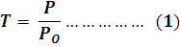
Laser photons also suffer from refraction , so the refractive index (n) of material will be changed with incident laser intensity variation . Refractive index (n) has been calculated using follow relationship (V.S.Zapasskii, et al.,2005) :
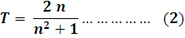

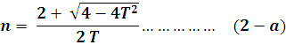

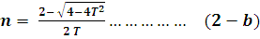
The material have several electrical properties which have been affected by laser light . The dielectric constant ( ε ) refers to that portion of material which hasn’t any free charges . The following equation show (ε ) (R.W.Waynant, et al.,2000) :
K_{m} = 1 for rear media so that dielectric constant (R.W.Waynant, et al.,2000) :
Laser has specific velocity ( V_{P}) when across within crystal (J.Hecht, et al.,2000) :
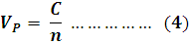
Where (C) the speed of light in the vacuum ( J.Hecht, et al.,2000) :
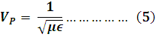
Where (Є) is permittivity of material which can be defined as the ratio of the electric flux density to the electric field strength and (μ ) is the material permeability which known as the ratio of the magnetic flux density to the magnetic field strength. Material permittivity (Є ) can also be given as (E.J.Rothwell, et al.,2001) :
Where (Єo) is the permittivity of free space of (8.854x10-12 F/m) and (μ) can also be calculated according to (J.T.Verdeyen,1995 , S.Kasap, et al.,2002 and C.R.Robertson,2008) :
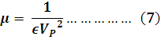
Electromagnetic field of laser had been suffered from resistivity (Z) within across media . (Z) may be given as (J.Bird,2003) :
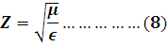
Electrical conductivity (σ ) is a property of a material that quantifies the ease with which charges flow inside the material along an applied electric field. (σ) can be calculated using following eq.(S.Kasap, et al.,2002,J.Bird,2003 and A.Moliton,2007):
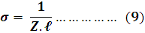
Where (ℓ) is the material thickness .
An electromagnetic field (laser) reaches a specific depth in material which intercepts its way , this depth known as ( skin depth ( δ)) (M.C.Gupta, et al.,2007):
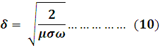
Where (ω ) is the incident wave frequency . Both of electrical conductivity (σ ) and permittivity (Є) of any media , have been continued for specific time which known as electrical response time (T_{E} ) (M.C.Gupta, et al.,2007) :
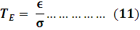
Electrical susceptibility (χ ) is a material quantity that measures the extent of polarization in the material per unit field (A.Moliton,2007) :
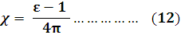
The induced electronic polarization (P_{in}) is the displacement of the electron cloud of an atom with respect to the positive nucleus . P_{in} can be given as (J.Hecht,etal.,2000,J.T.Verdeyen,1995 and A.Moliton,2007) :
Where (N) is the material molecules number .( q ) is the number of anti-bond electric charges which given by each molecule multiplied by charge .
While molar polarization of a material ( ρ_{p}) had be given as (M.C.Gupta, et al.,2007) :
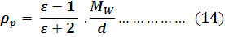
Where( M_{W}) is the material molecular weight , (d) is the material density .
Wave number (K) is a magnitude of wave vector in material which shown in following eq.(S.Kasap, et al.,2002)
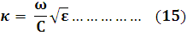
In the beginning of laser (or any electromagnetic wave ) applying on any material , nothing happened for its electrical properties for period called as (dielectric time( τ_{die} )) (M.C.Gupta, et al.,2007):
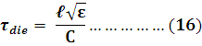
- Experimental setup :
The experimental setup for the Q-switched mode-locked (QML) 912 nm Nd:GdVO₄ laser system has be shown in fig.(3).
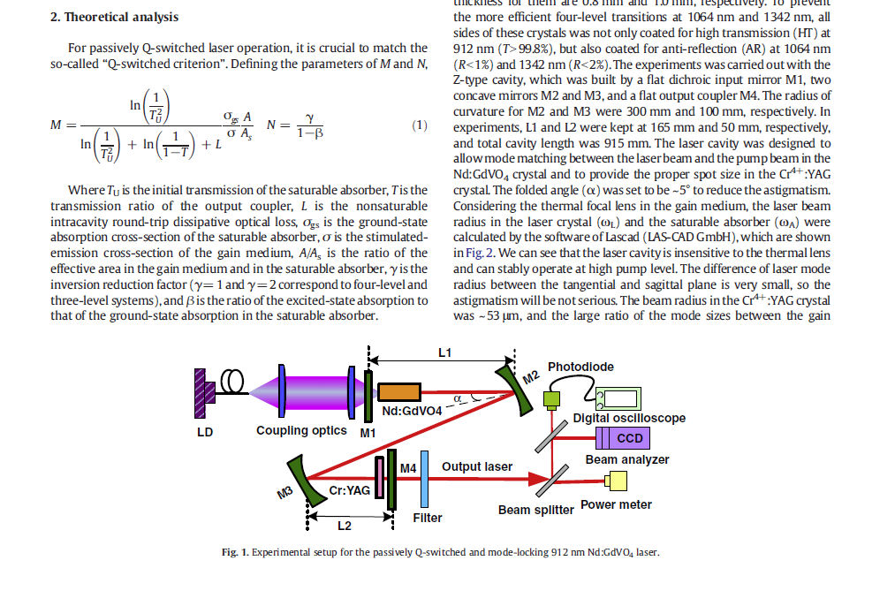
Fig.(3) The experimental set up for (QML) Nd:GdVO₄ laser with Cr⁺⁴:YAG (F.Chen, et al.,2011)
A fiber-coupled LD ( HLU110F400,LIMO Inc.) was employed as the pump source . The pump beam was coupled into the gain medium by a series of coupling optics and the beam spot radius generated in the crystal was ~ 100 μm . An a-cut conventional Nd:GdVO₄ crystal with a Nd⁺³- doping concentration of 0.1 at % and the dimensions of 3x3x6 mm3 had been chosen as the gain medium. QML laser was obtained by placing the Cr⁺⁴:YAG crystals near the output coupler of the Z-type laser cavity . Diameters of Cr⁺⁴:YAG crystals with Tu=95% and Tu=90% are (10mm) , but thickness for them are (0.8mm) and (1.0 mm) , respectively .
The experiments was carried out with the Z-type cavity , which was built by a flat dichroic input mirror M1 , two concave mirrors M2 and M3 , and a flat output coupler M4 . The radius of curvature for M2 and M3 were (300mm) and (100mm) , respectively. In experiments , L1 and L2 were kept at (165 mm) and (50mm) , respectively and total cavity length was (915 mm). The laser cavity was designed to allow mode matching between the laser beam and the pump beam in the Nd:GdVO₄ crystal and to provide the proper spot size in the Cr⁺⁴:YAG crystal . The folded angle (α) was set to be ~ 5o to reduce the astigmatism. The beam radius in the Cr⁺⁴:YAG was ~(53 μm ) and the large ratio of the mode sizes between the gain medium and the absorber was sufficient to achieve high –quality Q-switching . Output laser spectra and the power were measured by a fiber spectrometer (HR 4000) and a laser power meter (PM 30) , respectively . An average output power , pulse width and repetition rate had been measured at different values of pump power and when the initial transmission (Tu) of Cr⁺⁴ :YAG were 90% and 95% . The temporal traces of the (QML) laser pulses of 912 nm Nd:GdVO4 laser had been shown in Fig.(4) and Fig.(5) shows The temporal traces of (QML) laser pulses obtained with Cr⁺⁴:YAG crystal of initial transmission Tu=90% and Tu=95% , respectively . Output laser spectra and the power were measured by a fiber spectrometer (HR4000 , Ocean Optics Inc.) and a laser power meter PM30 (PM30, Coherent Inc.) (F.Chen, et al.,2011) . These measured data had been listed in appendix (1).
Fig.(4): The temporal traces of the (QML) laser pulses of 912 nm Nd:GdVO₄ laser (F.Chen, et al.,2011)
Fig.(5) : The temporal traces of (QML) laser pulses obtained with Cr⁺⁴:YAG crystal of initial transmission Tu=90% and Tu=95% , respectively (F.Chen, et al.,2011).
Nd:GdVO₄ has proved to be an excellent gain medium because of its high absorption coefficient and large thermal conductivity . Fig.(6) shows the energy diagram and laser transition of Nd:GdVO₄ and table (1) explain the characteristics of Nd:GdVO₄ laser .

Fig.(6): The energy diagram and laser transition of Nd:GdVO₄ (E.Herault, et al.,2006)
Table (1): The characteristics of Nd:GdVO₄ laser (E.Herault, et al.,2006 and A.J.Kemp, et al.,2004)
Specification | value
Laser emission wavelength | 912nm , 893nm , 879nm , 1063nm
Emission cross-section at 912nm | 6.6x10-20 cm2
Pump threshold maximum at 912 nm | 3.8 W
Maximum output power at 912 nm | 1.69 W
Thermal conductivity | 11.7 W/m.K
Peak pump wavelength | 808 nm
Peak pump absorption | 57 cm-1
Polarization | llc
Pump band width | 13.5
Ground state splitting | 409 cm-1
The energy diagram of Cr⁺⁴:YAG crystal had been explained in the fig.(7) , and it's parameter had been shown in the table (2).
Fig(7): Cr:YAG energy level diagram (M.A.Jaspan, et al.,2004)

Table (2): The main parameters for Cr⁺⁴:YAG crystal ( F.Chen, et al.,2010)
Parameter | value
Crystal structure | Cubic
Dopant | 0.5 – 3% Cr
Melting point | 1970oC
Density | 4.56 gm/ cm³
Thermal conductivity | 12.13 W/m/K
Loss coefficient | 0.003 cm⁻¹
Fluorescence lifetime | 3.4 μsec
Optical damage threshold | >500 MW/cm²
Molecular weight | 330
Ground-state absorption cross-section of Cr⁺⁴:YAG at 912 nm | 1.4x10-28 cm²
Inversion reduction factor | 2
The ratio of the effective area in the gain medium and in the saturable absorber | 0.95
Nonsaturable intracavity round-trip dissipative optical loss | 0.1
Initial transmissivity of the Cr⁺⁴ :YAG | 90% , 95%

4- Calculations and results :
Each of transmittance (T) and refractive index (n) of Cr⁺⁴:YAG crystal at λ = 912 nm at different values of absorbed pump power , had been calculated using eqs.(1 and 2-a , respectively) . The Cr⁺⁴:YAG crystal electrical properties , such as , dielectric constant (ε) , speed of laser wave (V_{p}) , permittivity (Є) , permeability (μ) , resistivity (Z) , conductivity (σ) , skin depth (δ) , electrical response time (T_{E}) , electrical susceptibility (χ) , the induced electronic polarization (P_{in}) , molar polarization (ρ_{p}) , wave number (K) and dielectric time (τ_{die}) , had been calculated using eqs. ((3-a) – 16 ), respectively, at λ = 912 nm for different values of absorbed pump power by Nd:GdVO₄ laser . Where (ℓ) is of (0.8 mm at Tu=95%) and of (1mm at Tu=90%) , (ω) is of (20.654 x10¹⁴ Hz ) , (P_{O} )is of (1.69 watt ) , (N) of (83.18x10²⁶ molecule) , (M_{w}) of (330) , (d) of (4.56 gm/ cm³) and (q) of (332.72 x10²⁶ ) . The electrical properties of Cr⁺⁴ :YAG crystal as ((ε) , (Vp) , (Є) , (μ) , (Z) , (σ) , (δ) and (χ) ) , had been plotted as a function of absorbed pump power in figs.(8-16) , while each of ( (T) , (n) , (T_{E}) , (P_{in}) , (ρ_{p}) , (K) and (τ_{die}) , had been listed in table (3) . The dependent data in this research as ( average output power , repetition rate and pulse width ) at different values of absorbed pump power and at Tu=90% and 95% , had been listed in appendix (1) .
Table (3 ) : The results each of ( (T) , (n) , (T_{E}) , (P_{in}) , (ρ_{p}) , (K) and (τ_{die})
Abs. pump power  (Watt) | T |  | n |  | T_{E}  X10⁻⁹  (sec) |  | Pin  X10¹⁰  Coulomb .molecule |  | ρ_{p}  x10⁻³  (m³) |  | K  X10⁶  (m⁻¹) |  | τ_{die}  x10⁻¹¹  (sec)
Abs. pump power  (Watt) | Tu=  90% | Tu=  95% | Tu=  90% | Tu=  95% | Tu=  90% | Tu=  95% | Tu=  90% | Tu=  95% | Tu=  90% | Tu=  95% | Tu=  90% | Tu=  95% | Tu=  90% | Tu=  95%
11 | - | 0.07 | - | 26.6 | - | 71.4 | - | 30.0 | - | 72.0 | - | 29.1 | - | 7.10
13 | 0.059 | 0.14 | 33.8 | 13.5 | 113.6 | 36.3 | 48.5 | 7.71 | 72.17 | 71.1 | 37.1 | 14.8 | 3.56 | 3.60
14.5 | 0.177 | 0.28 | 11.2 | 6.97 | 37.4 | 18.5 | 5.28 | 2.01 | 70.66 | 68.0 | 12.2 | 7.64 | 3.73 | 1.85
16 | 0.369 | 0.44 | 5.22 | 4.28 | 17.4 | 11.4 | 1.11 | 0.73 | 64.96 | 61.6 | 5.73 | 4.69 | 1.74 | 1.14
18 | 0.532 | 0.59 | 3.47 | 3.05 | 11.5 | 8.15 | 0.46 | 0.35 | 56.91 | 53.2 | 3.80 | 3.35 | 1.15 | 0.81
19 | 0.710 | 0.76 | 2.40 | 2.13 | 7.99 | 5.68 | 0.20 | 0.14 | 44.39 | 39.1 | 2.63 | 2.33 | 0.79 | 0.56
21 | 0.739 | 0.96 | 2.26 | 1.32 | 7.54 | 3.54 | 0.17 | 0.03 | 41.89 | 14.6 | 2.48 | 1.45 | 0.75 | 0.35
22 | 0.769 | 0.97 | 2.13 | 1.28 | 7.10 | 3.41 | 0.14 | 0.02 | 39.17 | 12.7 | 2.33 | 1.40 | 0.70 | 0.34
24 | 0.769 | 0.98 | 2.13 | 1.21 | 7.10 | 3.22 | 0.14 | 0.01 | 39.17 | 9.69 | 2.33 | 1.32 | 0.70 | 0.32
25 | 0.769 | 0.99 | 2.13 | 1.11 | 7.10 | 2.97 | 0.14 | 0.01 | 39.17 | 5.46 | 2.33 | 1.22 | 0.70 | 0.29

5-Discussion:
Table (3) , appendix (1) and figs.(8-16) show that when absorbed pump power increased as repetition rate (R_{P}) increased , each of transmittance (T) , speed of laser wave (V_{p}) , impedance (Z) , skin depth ( δ) and laser pulse power are increased also , while each of index of refraction (n) , dielectric constant (ε) , permittivity (Є) , permeability (μ) , electrical conductivity (σ) , electrical response time (T_{E}) , electrical susceptibility (χ) , electrical induced polarization (P_{in}) , molar polarization (ρ_{p}) , wave number (K) , dielectric time (τ_{die}) and laser pulse duration of Cr⁺⁴:YAG crystal were decreased .
The increasing of pumping repetition rate causes an increasing of laser power absorbed by Cr⁺⁴:YAG crystal , which leads to higher values of excited molecules in the crystal as effective absorption , crystal will be rear to laser photons (higher T ) . Laser arrays will suffer from less refraction from crystal (less n ) .
The laser wave can be traveled through crystal in a high speed ( V_{p}) and a high depth ( δ ) through crystal because of higher values of excited molecules in the higher excited states in the crystal . The impedance (Z) were increased and the electrical conductivity (σ) of crystal had been decreased with increasing of absorbed pump power as to the most lower energy levels were empty which didn’t allow to electrons from crossing through it .
The dielectric constant (ε) depends on the density of atoms or molecules which have more polarizability (R.W.Waynant, et al.,2000) and we notice from fig.(8) that the increasing of absorbed pump power leads to decreasing in (ε) and less dielectric time (τ_{die}) as shown in table (3) , due to less polarizabilities of molecules ( molecules in the ground state ) .
The absorbed pump power didn’t contributes in electrons separation from atomic nucleus in molecules (S.Kasap, et al.,2002) which clearly appears in decreasing both electric induced polarization (P_{in}) and molar polarization (ρ_{p}) . This behavior can be attributed to that the absorbed pump power had been exploited in crystal bleaching (saturation absorption process ) .
Cr⁺⁴:YAG crystal within saturation absorption process , has less electric flux density and less magnetic flux density with respect to higher electric and magnetic field strength of laser wave through crystal and less electrical conductivity (σ) and less anti-bond electrons in crystal , then Cr⁺⁴:YAG has less permittivity (Є) and permeability (μ) (C.R.Robertson, et al.,2008) with increasing of absorbed pump power. The electric field (E) of laser wave didn’t cause any increasing for free electrons in crystal so the electric response time (T_{E} ) will be decreased as shown in table (3) . The electric susceptibility (χ) has been decreased with increasing of absorbed pump power , because of less polarization in the crystal ( less Pin ) { χ is defined as the quantity which measures the extent of polarization in the material per unit field (S.Kasap, et al., 2002)} . Wave number (K) is the magnitude of wave propagation direction through crystal (A.Moliton,2007) , then we notice from table (3) that the increasing of absorbed pump power causes decreasing in (K) . This refers to that the laser wave propagation will be decreased as higher absorption through crystal .
The results of laser pulse characteristics and Cr⁺⁴:YAG crystal electrical properties which had been shown in Table (3) and appendix (1) and figs.(8- 16), were studied at( 90%) and( 95%) Cr⁺⁴:YAG initial transmission and in the same absorbed pump power . We notice from them that must increase repetition rate of pumping when the initial transmission was increased , as overcome the transmittance losses . That results increasing in output laser power in spite of increasing pulse width ( the laser pulse energy was increased hurriedly .
The increasing of initial transmission (Tu) affects on the Cr⁺⁴:YAG transmittance after laser absorption ( T was increased) with crystal refraction decreased ( n decreased ) . This consolidates laser propagation speed through crystal ( V_{p} was increased ) with high depth ( high δ skin depth ) .
Cr⁺⁴:YAG dielectric constant (ε) and dielectric time (τ_{die}) were decreased with initial transmission increasing . This behavior can be attributed to that Cr⁺⁴:YAG crystal couldn’t be able to store electrical energy in it because of it's high transmittance as less number of free electrons in crystal which affects on electrical conductivity (σ) decreasing and high impedance will be resulted .
For the same absorbed pump power , each of permittivity (Є) and permeability (μ) were decreased with initial transmission (Tu) increasing as less electrical and magnetic flux density exists in crystal according to high electric and magnetic field strength for laser wave. Then , each of electrical response time (T_{E}) and electrical susceptibility (χ) were decreased because less electrical flux density which results from less free electrons exists in it . The increasing of excited molecules with (Tu) increasing , was the main reason to decreasing both induced electrical polarization (P_{in}) and molar polarization (ρ_{p}) as less molecules in the ground state . The decreasing of wave number (K) is the strongest indicator to less electronic flux density .
6-Conclusions:
The improvement of laser pulse characteristics (highest laser power and less pulse duration ) can be achieved using high repetition rate for pumping and high initial transmission of Cr⁺⁴:YAG crystal to realize highest pump power . Some of Cr⁺⁴:YAG properties had been consolidated laser pulse characteristics such as ( transmittance T , speed of laser wave propagation V_{p} , impedance Z , and skin depth δ ) which are directly proportion with laser pulse power , while other properties as ( ε , Є . μ , σ , T_{E} , χ , P_{in} , ρ_{p} , K and τ_{die} ) were inversely proportion with it . It can be concluded that the electrical and magnetic flux density in the crystal were dependent on free electrons which are decreased in the progress of saturation absorption . The main conclusion is that the electrical polarization depends on the number of the crystal molecules in the ground state which are directly proportion with it . It can be utilized from Q-switching technique in giant laser pulses generation which are used in many scientific , medical , industrial applications .

Appendix(1)
The dependent data in this research (F.Chen., et al.,2011)
Pulse width (nsec) |  | Repetition rate (KHz) |  | Average output power (W) |  | Absorbed pump power (W)
Tu=95% | Tu=90% | Tu=95% | Tu=90% | Tu=95% | Tu=90% | Absorbed pump power (W)
290 | - | 20 | - | 0.125 | - | 11
260 | 115 | 40 | 5 | 0.25 | 0.1 | 13
250 | 100 | 70 | 20 | 0.475 | 0.3 | 14.5
225 | 80 | 90 | 30 | 0.75 | 0.62 | 16
225 | 95 | 120 | 40 | 1.00 | 0.9 | 18
230 | 105 | 140 | 45 | 1.3 | 1.2 | 19
230 | 75 | 170 | 50 | 1.625 | 1.25 | 21
225 | 80 | 200 | 60 | 1.64 | 1.3 | 22
210 | 75 | 205 | 65 | 1.66 | 1.3 | 24
200 | 70 | 220 | 80 | 1.68 | 1.3 | 25

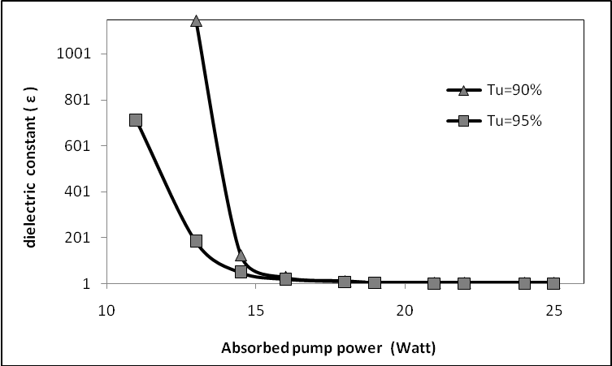
Fig (8)
Dielectric constant (ε) of (90% and 95% initial transmission ) Cr⁺⁴:YAG crystal as a function of absorbed pump power at 912 nm (QML) Nd:GdVO₄ laser
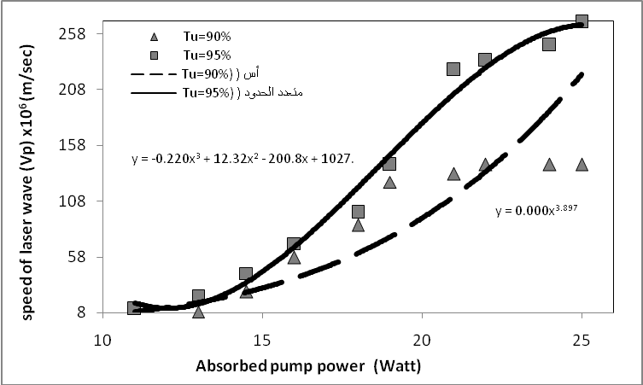
Fig.(9)
Speed of laser wave (V_{p}) in (90% and 95% initial transmission ) Cr⁺⁴:YAG crystal as a function of absorbed pump power at 912 nm (QML) Nd:GdVO₄ laser
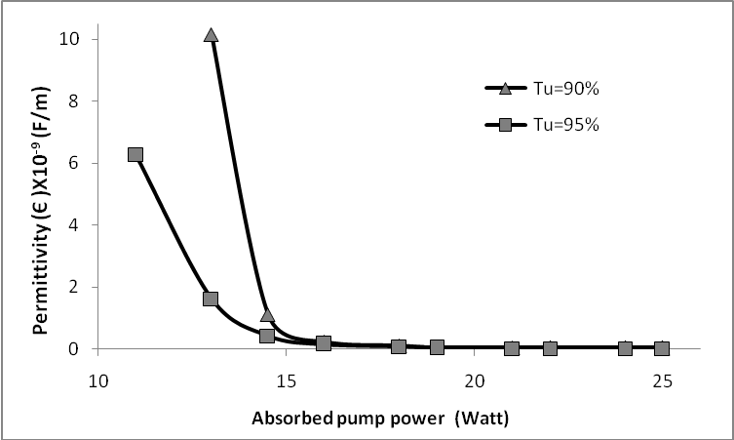
Fig.(10)
The permittivity (Є) of (90% and 95% initial transmission ) Cr⁺⁴:YAG crystal as a function of absorbed pump power at 912 nm (QML) Nd:GdVO₄ laser
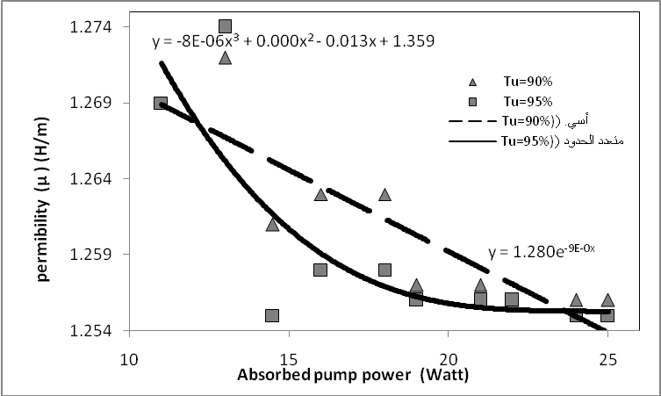
Fig.(11)
The permeability (μ) of (90% and 95% initial transmission ) Cr⁺⁴:YAG crystal as a function of absorbed pump power at 912 nm (QML) Nd:GdVO₄ laser
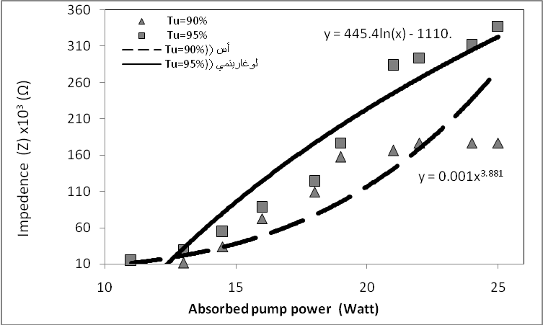
Fig.(12)
Impedance (Z) of (90% and 95% initial transmission ) Cr⁺⁴:YAG crystal as a function of absorbed pump power at 912 nm (QML) Nd:GdVO₄ laser
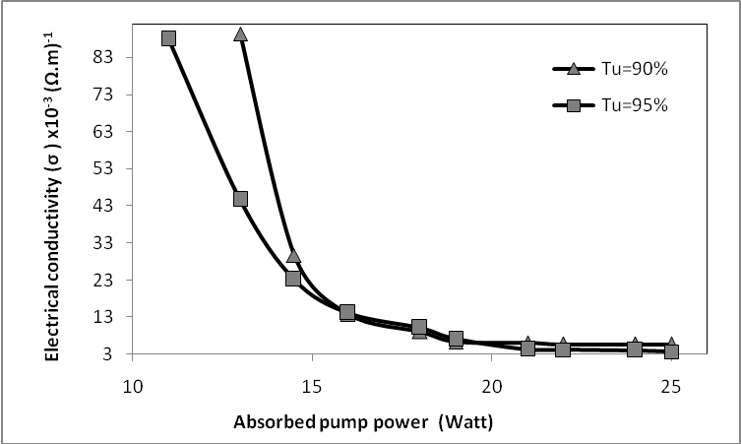
Fig.(13)
Electrical conductivity (σ ) of (90% and 95% initial transmission ) Cr⁺⁴:YAG crystal as a function of absorbed pump power at 912 nm (QML) Nd:GdVO₄ laser
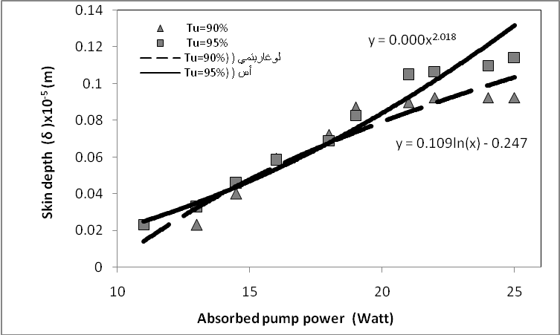
Fig.(14)
Skin depth (δ) in (90% and 95% initial transmission ) Cr⁺⁴:YAG crystal as a function of absorbed pump power at 912 nm (QML) Nd:GdVO₄ laser
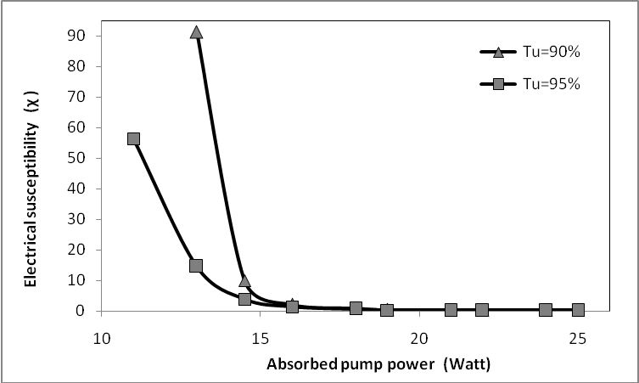
Fig.(15)
Electrical susceptibility (χ ) of (90% and 95% initial transmission ) Cr⁺⁴:YAG crystal as a function of absorbed pump power at 912 nm (QML) Nd:GdVO₄ laser
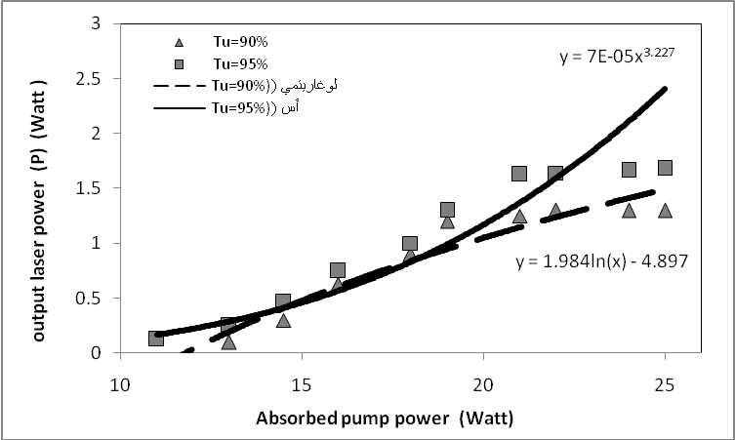
Fig.(16)
The output 912 nm (QML) Nd:GdVO₄ laser by (90% and 95% initial transmission ) Cr⁺⁴:YAG crystal as a function of absorbed pump power

7-References :
. A.Agnesi , F.Pirzio , A.Tomaselli , G.Reali and C.Braggio , 2005, " Multi-GHz tunable-repetition-rate mode-locked Nd:GdVO₄ laser ", Optics Express, 13(14) , (1-6) .
. A.I.Zagumennyi ,V.A.Mikhailov , V.I.Vlasov , A.A.Sirotkin,V.I.Podreshetnikov , Y.L.Kalachev , Y.D.Zavartsev , S.A.Kutovoi and I.A.Shcherbakov,2003 , " Diode-pumped lasers based on GdVO₄ crystal ", laser physics , 13(3),(311-318).
. A.J.Kemp , G.J.Valentine and D.Burns , 2004, " Progress towards high-power , high-brightness neodymium-based thin-disk lasers", Progress in quantum electronics, 28 , (305-344) .
. A.Moliton , 2007, " Basic electromagnetism and materials ", springer sciences Business media, LLC , (2-59) , .
. B.Zhang , G.Li , M.Chen , G.Wang and Y.Wang, 2007 , "Passively Q-switched Nd: GdVO₄ laser with In0.25Ga0.75As being an output coupler ", Optics & laser technology , 39 , (1094-1097).
. C.R.Robertson ,2008, " Fundamental electrical and electronic principles ", C.R.Roberston , Elsev ier Ltd., printed in Slovenia , (84-119).
. E.Herault , F.Balembois and P.Georges , 2006 ," Nd:GdVO₄ as a three-level laser at 879nm",Optics letters, 31(18),(2731-2733).
. E.J.Rothwell and M.J.Cloud , 2001, " Electromagnetics ", CRC Press LLC , (18-38) .
. F.Chen , X.Yu, X.Li,R.Yan,C.Wang , D.Chen , Z.Zhang and J.Yu , 2011, " High power diode-pumped passively Q-switched and mode-locking Nd: GdVO₄ laser at 912nm ", Optics communications , 284 , (635-639) .
. F.Chen , X.Yu, X.Li,R.Yan,C.Wang , M.Luo , Z. Zhang and J.Yu , 2010 , " Diode-pumped passively Q-switched 912nm Nd: GdVO₄ laser and pulsed deep-bluo laser by intracavity frequency-doubling ", Optics communications , 283 , (4036-4040).
. F.Q.Liu , H.R.Xia , S.D.Pan , W.L.Gao , D.G.Ran , S.Q.Sun , Z.C.Ling , H.J.Zhang , S.R.Zhao and J.Y.Wang , 2007 , " Passively Q-switched Nd:LuVO₄ laser using Cr⁺⁴:YAG as saturable absorber ", Optics & laser technology , 39,(1449-1453).
. H.Zhang , C.Du , J.Wang , X.Hu , X.Xu , C.Dong , J.Liu , H.Kong , H.Jiang , R.Han , Z.Shao and.Jiang ,2003, " Laser performance of Nd:GdVO4 crystal at 1.34 μm and intracavity double red laser ", J.Crystal growth, 249 , (492-496).
. I.M.Azzouz and A.El-Nozahy , 2006 ," Numerical study of Cr⁺⁴:YAG passively Q-switching Nd:GdVO₄ laser ", Egypt.J.Solids , 29(1) , (215-225).
. J.Bird , 2003, " Electrical and electronic principles and technology ", 2nd Ed., printed and bound in Great Britain , (5-6) .
. J.Hecht , L.S.Watkins and R.A.Becker , 2000, " Opto electronics ", Electrical Engineer handbook , 3,(7-9).
. J.L.Xu , H.T.Huang , J.L.He , J.F.Yang , B.T.Zhang , C.H.Zuo , X.Q.Yang and S.Zhao , 2010, " The characteristics of passively Q-switched and mode-locked 1.06 μm Nd⁺³: GdVO₄ laser with V:YAG saturable absorber ", Optical materials , 32 , (522-525).
. J.Liu , J.Yang and J.He ,2003," Diode-pumped passively Q-switched c-cut Nd:GdVO₄ laser", Optics communications , 219 , (317-321).
. J.T.Verdeyen , 1995, " Laser electronics ", 3ed prentice-Hall , Inc., printed in USA , (9-10) .
. J.Y.Ko , C.C.Lin , K.Otsuka , Y.Miyasaka , K.Kamikariya , K.Nemoto , M.C.Ho and I.M.Jiang , 2007 , " Experimental observations of dual-polarization oscillations in laser-diode-pumped wide-aperture thin-slice Nd⁺³: GdVO₄ lasers ", Optics express , 15(3) , (945-954).
. J.Yang , J.Liu and J.He , 2005 , " A compact Q-switched and mode-locked diode-pumped Nd:GdVO₄ laser with Cr⁺⁴:YAG ", Laser physics , 15(8),(1137-1141) .
. L.Berggren , 2004, " Optical absorption and electrical conductivity in Lithium intercalated amorphous tungsten oxide films ", Comprehensive summaries of Uppsala dissertations from the faculty of science and technology , (16-23) .
. L.Krainer , D.Nodop , G.J.Spühler , S.Lecomte , M.Golling , R.Paschotta , D.Ebling , T.Ohgoh , T.Hayakawa , K.J.Weingarten and U.Keller , 2004, " Compact 10-GHz Nd:GdVO₄ laser with 0.5-W average output power and low timing jitter ", Optics letters, 29(22),(2629-2631) .
. L.Min , L.S.Shan , L.Lei , W.W.Wei , C.Fei and L.Jie , 2008, " Diode-pumped double passively Q-switched Nd⁺³: GdVO₄ laser ", optoelectronics letters , 4(5) , (331-334) .
. M.A.Jaspan , D.Welford and J.A.Russell , 2004, " Passively Q-switched microlaser performance in the presence of pump-induced bleaching of the saturable absorber ", 43 (12) , (2555-2560) , .
. M.C.Gupta and J.Pallato , 2007, " Handbook of photonics", 2nd Ed., CRC Press Taylor & Francis group ,LLC .
. M.Kiminori , M.Akihiro , S.Tomoya , Y.Kazuhisa , P.Nicolaie , S.Ichiro and T.Takunori , 2003 , " High-power continuous wave green generation by single –pass frequency doubling of Nd:GdVO4 laser in a periodically poled Mgo:LiNbO₃ operating at room temperature ", Jpn.J.Appl.Phys.42 , L1296 , (169-171).
. M.Lu , C.R.Chatwin , R.C.D.Young and P.M.Birch , 2009, " Numerical simulation of a cw-pumped Cr:YAG passively Q-switched Yb:YAG pulsed laser ", Optics and lasers in Engineering , 47 , (617-621) .
. N.Pavel , 2008 , " IN-Band pumping of Nd-Based solid-state lasers ", Romanian reports in physics , 60(4) , (995-1012).
. R.W.Waynant and M.N.Ediger , 2000, " Electro-optics handbook ", 2nd Edition , MC Grew-Hill , INC , (10.3) .
. S.Forget , F.Druon , F.Balembois , P.Georges , N.Landru , J.P.Féve , J.Lin and Z.Weng, 2006 ," Passively Q-switched diode-pumped Cr⁺⁴:YAG/Nd⁺³: GdVO₄ monolithic microchip laser ", Optics communications , 259, (816-819).
. S.Kasap , H.Ruda and Y.Boucher , 2002, " An illustrated dictionary of optoelectronics and photonics : important terms and effects ", version (1.3.1), Chairman of US federal reserve , (19-135) .
. V.Lupei , N.Pavel , Y.Sato and T.Taira , 2003, " Highly efficient 1063-nm continuous – wave laser emission in Nd:GdVO4 ", Opt.Lett. , 28(23) , (2366-2368).
. V.March , M.Arrayás , J.L.Trueba , J.Montanyá , D.Romero, G.Solá and D.Aranguren , 2009, "Features of electrical discharges in air triggered by laser ", J.of Electrostatics , 67 , (301-306).
. V.Ostroumov , T.Jensen , J.P.Meyn,G.Huber and M.A.Noginov),1998, " Study of luminescence concentration quenching and energy transfer upconversion in Nd-doped LaSc₃(BO₃)₄ and GdVO₄ laser crystals ", J.Opt.Soc.Am.B , 15(3),(1052-1060.
. V.S.Zapasskii and G.G.Kozlov , 2005, " Saturable absorber coherent population oscillations and slow light ", Valilov state optical institute , (1-10) .
. W.B.Shan , P.J.Ying, M.J.Guang , L.Y.Min ,H.E.Juan , Z.Zhe , G.L.Lan and T.H.Ming , 2007 ," Diode end-pumped passively Q-switched Nd⁺³: GdVO₄ self-raman laser at 1176 nm ", Chin.Phys.Lett., 24(1) ,(112-114) .
. Y.F.Chen , 2004 ," Efficient 1521-nm Nd:GdVO₄ raman laser", Opticsletters , 29(22),(2632-2634).

