Spectrophotometric Determination Of Mn(Vιι) By Using Pyrazolon Azo As An Analytical Reagent
Huda.S.Abdul-Ridah , Rana.S.Alshemari
Department of Chemistry, College of Science ,Babylon University
Hussain.J.Mohammed
Chemistry Department/ Faculty of Dentistry.
Abstract:
Anew and selective spectrophotometric method for the determination of trace amount of Mn(VΙΙ) in aqueous sample is reported.The interaction in solution between Mn(VΙΙ) and 4-[4′-antipyriyl)azo]-3-bromo phenol(APBP) was studied. In the presence of (APBP) – Mn(VΙΙ) forms an intense color. Soluble complex that is stable and has a maximum absorption at(564)nm,εmax of(0.126x10⁴)L.mol⁻.cm⁻¹ was studied. A linear correlation(0.3-5)μg/ml was found between absorbance at λmax and concentration. The stability constant was found to be(0.114x10⁶ )L.mol⁻¹ . The relative standard deviation, recovery and relative error values of method were found. The effect of diverse ions on the determination of Mn(VΙΙ) to investigate the selectivity of method and masking agents effect on absorbance were also studied.
Key word :Mn(VII),determination ,spectrophotometry ,pyrazolon azo bromo phenol .
الخلاصة:
تضمن البحث طريقة جديدة وذات انتقائية عالية في تقدير الكميات الضئيلة للمنغنيز(IIV) في نماذج مائية . تم دراسة التفاعل الحاصل بين الكاشف 4-[4′(انتيبيرل)ازو]-3- برومو فينول وايون المنغنيز(IIV) ونتيجة هذا التفاعل تكون معقد ذائب ملون له أعلى امتصاص عند الطول الموحي(564) نانوميتر ومعامل امتصاص مولاري (0.126x 10⁴ ) لتر.مول⁻¹ .سم⁻¹وكانت العلاقة الخطية بين الامتصاص والتراكيز تتراوح بين(5-0.3) مايكروغرام.مل⁻¹ عند الطول الموحي الأعظم. كذلك تم حساب ثابت الاستقرار للمعقد وكانت قيمته (0.114x10⁶) لتر.مول⁻¹.كما تم تحديد دقة وضبط الطريقة التحليلية المتبعة. ودرس تأثير الايونات المتداخلة عند تقدير Mn (IIV) المختار في هذه الطريقة وتم حجب تأثيرها باستخدام عوامل حجب مناسبة.
Introduction:
Manganese is an abundant element naturally occurring in some minerals and is found in many types of rock. Manganese does not occur in the environment as apure metal, but as a component of more than 100 minerals, including, sulphide,oxides,carbonates, silicates,phosphates and borates.The most significant application of manganese is in the production of ferromanganese ,or metallic manganese, which is used in the steel industry to improve hardness,stiffness,and strength of steel (Zolotov ., 1990 ; Milena.,2008). Manganese(VΙΙ) occurs in the violet permanganate ion,MnO₄⁻ ,a powerful oxidant(Marczenko.,1976) .Flame atomic absorption is a widely used method for routine trace analysis of Mn(VΙΙ)
( Mizuike.,1983; Gaokar etal.,2005; Konstantine.,2002),however a large manganese contents have been determined as MnO₄⁻ by differential spectrophotometry(Barkovskii etal.,1962; Huseyin etal.,2006; Doroschuk etal.,2004). The permanganate method has also been applied in automatic procedures for determining manganese in steel and slags(Scholes etal.,1963; Scholes etal.,1966). Awide variety of reagents are available for the determination of Mn(VΙΙ) such as formaldoxine which has been applied in the spectrophotometric determination of manganese in natural waters(Goto etal.,1962),pyridyl azo naphthol(PAN) has been used to determine manganese in(Be,Pt,Au) ( Goto etal.,1969) Azo-dyes with hetrocyclicdiazo-component form colored complexs with many metal ions in solution(Hassan.,2007; Mohammed etal.,2009; Mohsen.,2009).Great number of the spectrophotometric methods based on these reactions were developed and used in analytical chemistry(Savic etal.,2006). Azo pyrazole derivatives and its metal complexes can be used as inkjet,they have got fastness properties for dying papers(Savic etal.,1994) .They can also be used in subtractive photographic process and for the production of color transparences and color pictures and have many applications(Abo El-Char etal.,2007) .Therfore,there is a continued interest in the synthesis of new organic reagents that could be able to be used for direct and rapid spectrophotometric determination of trace Mn(VΙΙ).Azo pyrazole is organic reagenst used recently for the determination of trace level of elements in biological and environmental samples. Based on these observation this paper reports anew spectrophotometric method for determination of trace Mn(VΙΙ) with anew reagent without preconcentration .This method offers the advantage of simplicity,rapidity,high sensitivity and direct determination of Mn(VΙΙ) without separation. Synthesis and characterization of the reagents are described. The formula of the(APBP) is shown in figure-1.

Fig-1:-Formula for the reagent (APBP)

Experimental:
Reagents:
All chemicals used were of analytical grade reagent. Water was purified and distilled. The organic reagents were prepared by coupling reaction of diazonium salt 4-amino antipyrine with 3-bromo phenol in alkaline solution at(0-5)ºc to form dark yellow azo dye,according to the method describe by Mohamed(Mohamed.,2001) scheme(1)Stock aqueous solution of Mn(VΙΙ) (100)μg.ml⁻¹ was obtained by dissolving the required quantity of (KMnO₄) in(100)ml distilled water. The working solution (10)μg.ml⁻¹ is prepared by dilution of the appropriate volume of standard Mn(VΙΙ) solution before use .The(5x10⁻⁴)mol.L⁻¹ of reagent(APBP) were prepared by dilution in ethanol (250)ml.The acidity of solution was adjusted by means of dilute HCl and NaOH. Aqueous solution of different cations (100)μg.ml⁻¹ were obtained by dissolving the appropriate substance in distilled water.
Apparatus:
The absorption spectra were recorded with (UV-1650) spectrophotometer (Shimadzu-Japan),while absorption measurements were obtained with UV-Visible (Spectra-Sc,U.S.A) spectrophotometer both with 1cm quartz cells.The PH measurements were made with digital PH- meter (Philips,PW9421-England).Digital balance ,Sartorius(BP3015-Germany),and water bath(90,Humbury-England).The conductance measurement were carried out using WTW,720,Germany conductivity meter.
Procedure:
The solutions to be studied were prepared in 5ml Volumetric flask .Exactly measured volume of Mn(VΙΙ) and organic reagent(APBP) solution were introduced in the flasks and they were filled up to the mark with disttled water after adjusted acidity with (HCl&NaOH) pH (1.5) . Absorbance of each solution was measured against corresponding blank similarly prepared.
Results and discussion:
The influence of wave length ,amount of organic reagent and concentration of Mn(VΙΙ) on the absorbance was studied in order to establish the optimal working conditions for the quantitative determination of Mn(VΙΙ).The effect of various parameters on the absorbance intensity of the form products were studied. The stoichiometry of complex was predicted and the stability constant determined.
Influence of the wave length:
The spectrum recorded for a solution containing Mn(VΙΙ) and organic reagent are presented in Fig-2.Achemical interaction between Mn(VΙΙ) and organic reagent has occurred . Due to the fact that organic reagent absorbs little at the maximum complex wave length (λmax=564nm),all further measurement have been performed versus a corresponding blank.

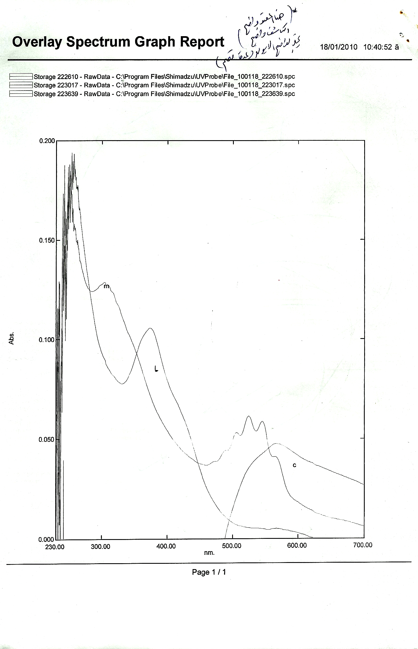
m=metal
L=reagent
C=complex

Fig-2:Absorption spectra of the reagent and Mn(VII)complex.
Effect of reagent concentration:
For up 2μg.ml⁻¹ of Mn(VΙΙ), the effect of reagent concentration on the absorbance of complex was studied by varying the volume of (APBP) from(0.5-5)ml which its concentration is(5x10⁻⁴)M . The required volumes of(APBP) were found to be 3ml to complete the reaction of Mn(VΙΙ) fig-3.
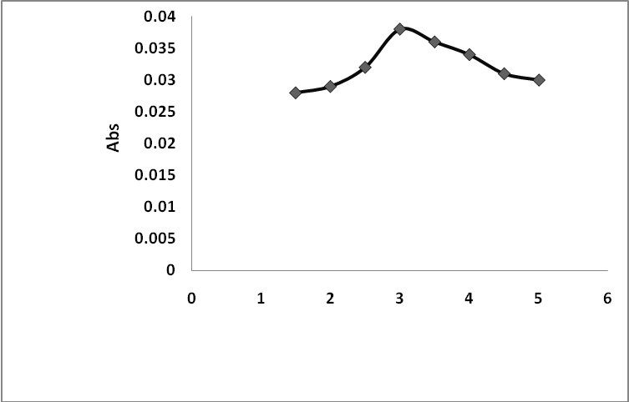
Conc(R)
Fig-3:Effect of reagent concentration

Effect of PH :
The experimental results demonstrated that the absorbance results demonstrated that the absorbance of Mn(VΙΙ) . APBP system is maximum and constant in the pH rang (1-2),(fig-4) therefore pH of (1.5)was adopted as optimum pH.

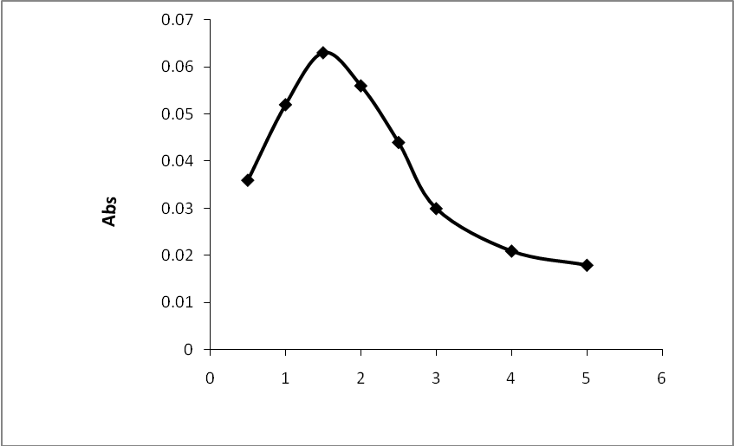
pH
Fig-4:Effect of pH on the absorbance of Mn(VII)-APBP at room temp.
Chromogenic reaction of APBP with metal ions:
The reaction of the reagent APBP with 18 cations was tested . It was found that the APBP reagent reacts mainly with (Ni²⁺,Pb²⁺,Mn⁷⁺,WO₄²⁻,Cu²⁺,CrO₄²⁻,Pt²⁺,Pd²⁺,Bi⁺,Na⁺)ions.

Stability of the chromogenic system:
A. Effect of Time:
Fig-5. show that the complex system reaches a maximum value of absorbance within (5)min. and remains constant up to(24)hrs.
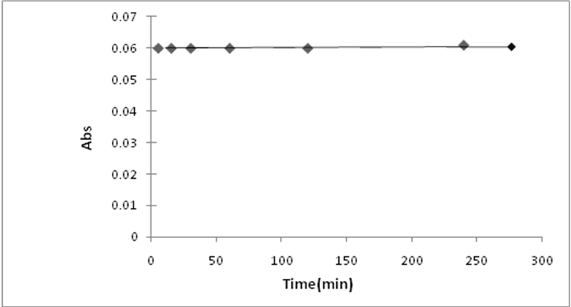
Fig-5:-Effect of time on the absorbance of the Mn(VII)-APBP at room temp

B-Effect of temperature:
The effect of temperature in the range (5-60)ºC on the absorbance of Mn-APBP complex was studied figure(6). T he maximum absorption was obtained when the temperature was varied between 25ºC and 45ºC for complex . At temperature higher than 45ºC the absorbance gradually decreased until it reaches 60ºC ,which may be due to dissociation of the complex.

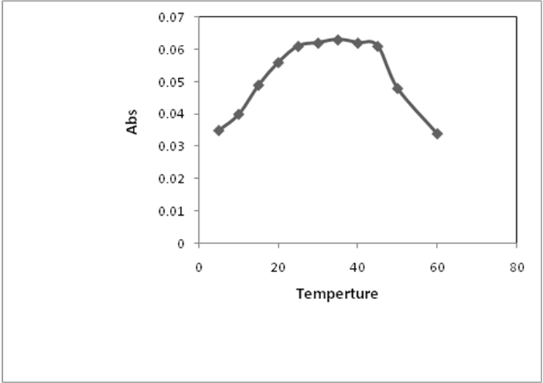
Fig-6:-Effect of tempertuer of the Mn(VII) complex
Composition and stability constant of the complex :
The composition and apparent stability constant were evaluated by both of continuous variation and mole ratio methods. Fig.(7&8)both methods indicate that the ratio of Mn(VΙΙ)-APBP complex is (1:1) at pH =1.5 with stability constant of (0.114x10⁶)L.mol⁻¹ (Vosburgh etal.,1941;Chabsha etal.,1986).
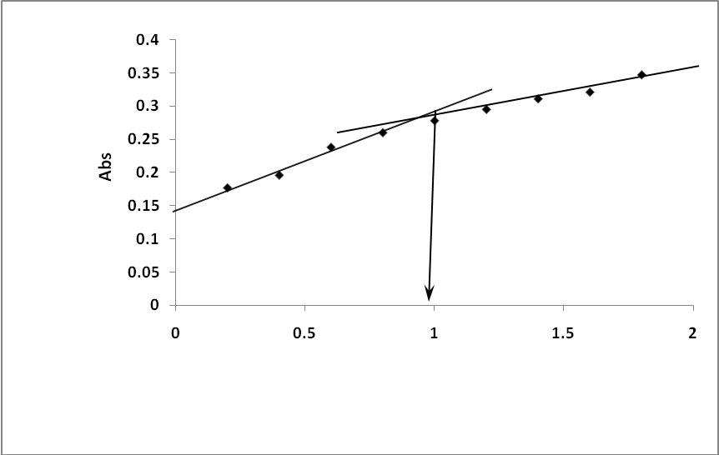
mol(R)/mol(M)

Fig-7:-mol ratio plot for Mn-APBP complex at optimum condition
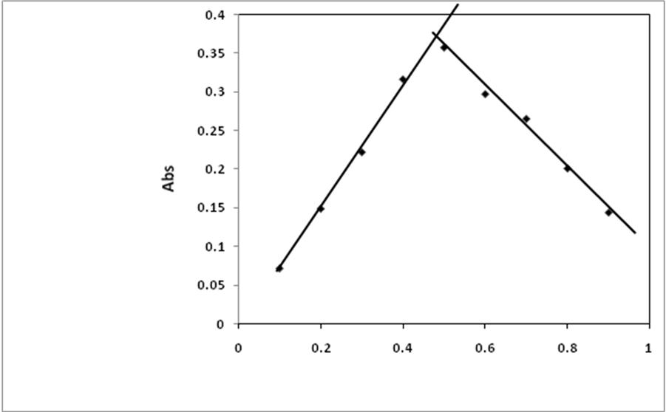
Vm/VL+Vm

Fig-8:- continuous variation plot for Mn-APBP complex at optimum condition
Calibration graph and sensitivity:
Under the optimum conditions a linear calibration graph fig(9) was obtained over the concentration range of(0.3-5)μg.ml⁻¹ of Mn(VΙΙ).The average molar absorpitivity was found to be (0.126x10⁴) L.mol⁻¹.cm⁻¹ with correlation coefficient(r) was (0.999).The Sandells′ sensitivity was(0.0434)μg.cm⁻².
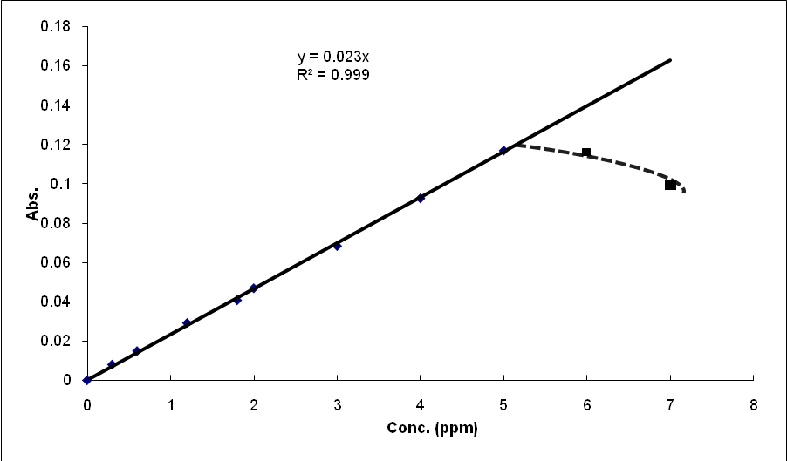
Fig-8:- Calibration curve of Mn(VII)-APBPcomplex
Conductivity measurements:
The solubility of the complex in dimethyl sulfoxide and ethanol permitted of the molar conductivity of (10⁻³)M solution at 25ºC and by comparison the electrolytic nature for complex . The low values of molar conductance data listed in table(1), indicate that the complex are non electrolyte.
Complex | Conductivity measurements S.mole⁻¹.cm²
Mn-APBP | Ethanol | DMSO
Mn-APBP | 5.4 | 20.69
Table.1: Conductivity Values of complex ccComplex Complex complex

Precision and Accuracy
The precision and accuracy of this analytical procedure was estimated by calculating the(R.S.D)% and percent realative error(Erel%),and found that (R.S.D)%was (2.1)% to 3 μg.ml⁻¹ of Mn(VII).The recovery and Erel% for the complex solution containing 3 μg.ml⁻¹ were found to be (98.34)%(-1.6).The detection limit was found to be (0.190) μg.ml^{-1.}These results indicating that this method is highly precise,very accurate and suitable for determination of Mn(VII) spectrophotometrically.

Interferences
The selectivity of Mn-APBPsystem is enhanced by carrying out the determination of 6ppm of Mn in presence of 10ppm of divere ions.These ions are (Bi⁺,Na⁺,Ni²⁺,Pb²⁺,Cu²⁺ ,WO₄²⁻,CrO₄²⁻,Pd²⁺ and Pt²⁺) which also react with the reagent APBP.An error of±5% in absorbance reading was considered tolerable.The results are listed in tble(2).It is found that (Na⁺,Ni²⁺, WO₄²⁻ and CrO₄²⁻) do not interfere at the same conditions,where as(Pb²⁺,Cu²⁺, Bi⁺, Pd²⁺ and Pt²⁺) interfere seriously.Suitable masking agents were examined for elimination the effect of the interfering ions shown in table(2).
Table(2):- Effect of interfere ions and masking agents for elimination intering on study of Mn(VII) (5) μg.ml⁻¹by proposed procedure
Masking agent ( )ml,[ ]M | Error% of Mn(VII) complex | Interference ions
Ascorbic acid (1),[0.1] | 45+ | Bi⁺
_ | +3.8 | Na⁺
_ | +1.4 | Ni²⁺
Oxalic acid(0.5),[0.1] | +15 | Pb²⁺
_ | -4.5 | WO₄²⁻
Citric acid(0.5),[0.01] | +25 | Cu²⁺
_ | 3.1- | CrO₄²⁻
KSCN(2.5),[0.2] | +23.4 | Pt²⁺
KSCN(3),[0.2] | +32.6 | Pd²⁺

IR spectra of reagent and its complexes
The FT-IR bandsof the (APBP) and its Magnesium (VII) complex with their probable assignment are give in table- 3.The IR spectrum of the ligand shows abroad band at 3345 cm⁻¹ , which can be attributed to the phenolic OH group .However, the υ(N=N) stretching band in the free ligand is observed at 1550 cm⁻¹ .This band is shifted to lower with low intensity 1500 cm⁻¹ frequency values upon complexation suggesting chelation via the (M-N)( Omar etal.,2005; Mohamed etal.,2002) The IR spectrum of the ligand revealed a sharp band at 1650 cm⁻¹ due to υ (C=N) of the N pyrozol azo nitrogen.The band of (C=O) is shifted to lower frequencies in the complex indication to that it has been affected upon chelation to the metal ion(Wagner etal.,2001).The bonding of oxygen to the metalion is provided by occurrence of bands at (496 )cm⁻¹ as the result of υ(M-O).

Table.3 :- Selected IR data of (APBP) and its complex with Mn(VII)
Ν (M-N) azo | ν (C-H) Aromat | ν (M-O) | ν (C-O) | ν (N=N) | ν (C=N) | ν (OH) | Compound
-  420 w | 3055 m  3030 m | -  496 w | 1150 s  1143 s | 1550 m  1500 m | 1650 s  1531 s | 345m3  3320 m | APBP  Mn(APBP)

S: sharp, m: medium ,w: weak

Conclusion:
The reagent forms with Mn(VII) a (1:1) stable complex .On this basis a spectrophotometeric method for quantitative determination trace of Mn(VII) was elaborated. This method has a sensibility comparable with the consecrated extractive spectrophotometeric methode and it has the great advantage that permits the direct determination of Mn(VII) without separation.

References :
Abo El-Char .M.F, Abdel-chani.N.T., Badr .Yand El-Borady. O.M.J.Issecoscienes and Technology Vision,3(3),58-63,(2007).
Al.Chabsha.T.S and Al.Abach.M.Q"fundamentals of Analytical chemistry".346,1986.
Al.Hassan. H.S,M.D Thesis,University college of Kufa,Najaf,(2007).
B.Huseyin , Aydan E. and Latif. E,Eurasian J. ,1,1,pp:42-53,(2006).
Barkovskii,V.F and Vtorygina,I.N. ,Zh. Analit.Khim.17,865,(1962).
Doroschuk V.O., Lely S.O. Ushok, Ishchen Ko V.B. and S.A. Kwichenko V.B.,Talanta,(64),4,pp:853-856,(2004).
Gaokar U.G. and Eshwar M.C. ,Micro chimica Acta.,78,pp:247-252,(2005).
Goto,K.,Komatsu,T. and Furuka Wa,T., Anal.chim.Acta 27,331,(1962).
Kaeser. A,Stingelin.W,Eur.pat.Appl.Ep591,103,C.A,121,233064F,(1994).
Konstantine M.L. ,chem.pap. ,56,3,pp:194-198,(2002).
Marczenko.Z." spectrophotometric determination of elements" Warsaw,Poland ,first edition,(1976),pp:338:346.
Marzenko,Z.,Kasiura,K.and Krasiejko,M.mMikro ,chim.Acta(1969),625, chem. Anal.(Warsaw)14,1227,(1969).
Milena V.Taseska , Irina B.karadjova and Trajce Z.stafilov. "Eurasian journal of Analytical chemistry ", Bulgaria,Vol.(3),N(1),(2008),pp:18.
Mizuike .A'Enrichment Techniques of trace' Analysis springer:Berlin,(1983) .
Mohamed .G.G., Zayed. M.AandAl.Gamel .N.E,spectro chim.Acta.,58,3167,(2002). Mohamed. G.G.Spectrochimica.Acta part A,57,411,(2001).
Mohammed .H.j,A.Y.Mohee and Abdul-Ridha. H.S,J. for science,V(3),P(59-70) (2009).
Mohsen .S.S.,National journal of chemistry,V(34), p(375-382) ,(2009).
Omar. M.m. and Mohamed .G,spectro.chim.Acta. part A,61,929, (2005).
Savic.J and Vasicm.V.Acta chim.solv,53,p:(36-42) ,(2006).
Scholes,P.H and Thulbourne,C.,Analyst. 88,702 (1963):89,466(1964).
Scholes,P.H.,Z.Anal. chem..222,162 (1966).
Vosburgh.W.C and Cooper.G.R,J,Am.Chem.Soc, 63,437,1941.
Wagner .K.A, Danied. R.Mc and self. D,J.AoAc Int,84,1934,(2001).
Zolotov.Y.A kuzmin.N.M 'preconcentration of trace elements',Elesevier msterdam,(1990).

