Object Motion Simulation According To Physical Equations In One Dimension
. Musa Kadhum Muhsen , Ghaidaa Abdul- Hafidh Jaber
University of Babylon, College of Science, department of physics
Abstract
The aim of this research is building algorithms of object motion simulation and tracking the object (target) in sequence frames with different directions and according to physical equations or mathematical functions with different initial conditions.Computer program has written in visual basic language (version 6) depend on mathematical models to detect a motion of object in one–dimension (1D) to calculate important variables in motion such as distance, displacement, velocity, speed and the energy (kinetic and potential).
الخلاصة
الهدف من هذا البحث هو بناء خوارزميات لمحاكاة حركة جسم وتتبع الجسم (الهدف) باطر متتابعة وباتجاهات مختلفة وطبقا لمعادلات فيزياوية اومعادلات رياضية مع شروط ابتدائية مختلفة. كتابة برنامج حاسوبي بلغة فيجوال بيسك (الاصدار 6) معتمدا على نماذج رياضية لتحديد حركة جسم ببعد واحد لحساب متغيرات مهمة بالحركة مثل المسافة، الازاحة، السرعة، الانطلاق، والطاقة (الحركية والكامنة).

1.Introduction
We can see motion in natural events such as clouds moving, rain and snow falling or in the activities of people who walk. The branch of physics concerned with the study of motion and what produces and affects motion is called mechanics. Mechanics is usually divided into two parts: kinematics and dynamics. Kinematics deals with the description of the motion of objects without consideration of what causes the motion. Kinematics expressions that may be used to solve any problem involving one-dimensional motion at constant acceleration. The kinematics method requires the specific positioning of the object's movements over time [Serway,2000 and Stuart,1998]. The reason behind using moving images was that, these images have impressive effects to everyone who watching them. However the images effect increase when these are move similar to the real representation or real motion[Thannon,2003].

2.Theoritical Part
2.1.Digital Image
A digital image represents a two-dimensional array of samples as a function f(x,y), where each sample is called a pixel [Koschan,2008]. Precision determines how many levels of intensity can be represented (bit a unit of computer memory), and is expressed as the number of bits/pixel [Westwater,1997].
According to precision, images can be classified into:
1. Binary images, represented by 1 bit/pixel (black or white colored pixels only).
2. Computer graphics, represented by 4 bits/ pixel.
3. Gray scale images, represented by 8 bits/ pixel.
4. Color images, represented with 8, 24 or more bits/ pixel .
The apparent color of an object is influenced primarily by two physical factors: 1) the spectral power distribution of the illuminant and 2) the surface reflectance properties of the object. In image processing, the RGB (red, green, blue) color space is usually used to represent color [Yilmaz,2006]. RGB color image is made up of three color channels. Each channel contains 8-bit grayscale information defining the amount of each color component of the full color image [Seul,2000]. The overlaid color channels mean a single pixel of an RGB color image contains 24-bit color information, which can define up to 16.7 million possible colors [Richards,2006].
2.2.Simulation
The simulation describes the pertinent aspects of the system as a series of equations and relationships, normally embedded in a computer program. Simulation is a descriptive tool, allowing us to experiment with a model instead of the real system [Al-Aujany,2006]. Simulation embodies the principle of "learning by doing'', to learn about the system we must first build a model of some sort and then operate the model [Stuart,1998 and Ingalls,2002]. Motion is the change of the position of a body during a time interval. To describe the motion, numerical values (coordinates) are assigned to the position of the body in a coordinate system[Serway,2000].
2.3.Uniformly Accelerated Motion
The average velocity (V) of a particle is deﬁned as the particle’s displacement ($Δx$) divided by the time interval ($Δt$) during which that displacement occurred [Urone,2001]:
$V=\frac{Δx}{Δt}$ (1)
The average speed of a particle ($S_{a}$), a scalar quantity, is deﬁned as the total distance ($d$) traveled divided by the total time ($t$) it takes to travel that distance [Serway,2000]:
$S_{a}=\frac{d}{t}$ (2)
avery common and simple type of one-dimensional motion is that in which the acceleration is constant [Serway,2000].
$V_{x_{f}}=V_{x_{i}}+\text{at}$ (3)
This powerful expression enables us to determine ($V_{\text{xf}}$) an object’s velocity at any time ($t$) if we know the object’s initial velocity ($V_{\text{xi}}$) and its constant acceleration ($a$). We can obtain another useful expression for displacement ($x_{f}−x_{i}$) at a constant acceleration ($a$)[Battista,2007]:
$x_{f}−x_{i}=V_{x_{i}}t+\frac{1}{2}{\text{at}}^{2}$ (4)
Finally, we can obtain an expression for the ﬁnal velocity ($V_{\text{xf}}$) that does not contain a time interval [Gibilisco,2002]:
$(V_{x_{f}})^{2}=(V_{x_{i}})^{2}+2a(x_{f}−x_{i})$ (5)
the kinetic energy($k$)of a particle of mass ($m$) moving with a velocity ($V$) is deﬁned as[Al-Bovik,2000]:
$k=\frac{1}{2}{\text{mV}}^{2}$ (6)
The product of the magnitude of the gravitational force ($\text{mg}$) acting on an object and the height ($y$) of the object. The symbol for gravitational potential energy is ($U_{g}$), and so the deﬁning equation for gravitational potential energy is [Landau,1981]:
$U_{g}=\text{mgy}$ (7)
2.4.Object's Center
Determination the object (target) center is an important step in tracking operation, especially, in computing the distance between the previous location of a moving object and current location of that object. Finding the center of an object will help us to locate an object in the two-dimensional image plane [Landua,1981 and Aws,2002].We can compute the center of an object by using the following equation[Al-Aujany,2006]:
$\text{Cx}=\frac{X_{\text{min}}+X_{\text{max}}}{2}$ and $\text{Cy}=\frac{Y_{\text{min}}+Y_{\text{max}}}{2}$ (8)
3.Practical Part
Finding the center of a moving object will help us to determine the object position, its linear velocity and it's kinetic energy. Computing target center using equation (8) on object move according to equation (3), the simulation of this motion as shown in figure (1) and the shape of it as shown in figure (2)

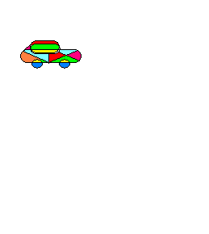



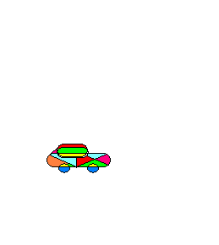
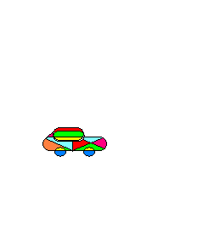
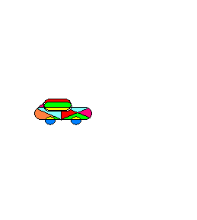
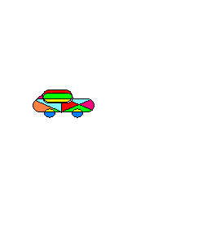
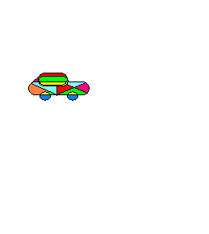
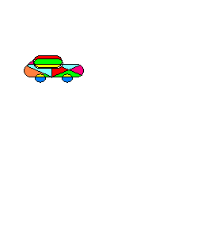
5 6 7 8
9 10
1 2 3 4

Figure (1): Motion of object according to the equation($V_{x_{f}}=V_{x_{i}}+\text{at}$)
(generate 10 frames)

Figure (2): Shape of motion of object according to the equation ($V_{x_{f}}=V_{x_{i}}+\text{at}$)
Then the object motion simulation according to equation (4) as shown in figure (3) and the shape of this motion as shown in figure (4) with different initial velocities:

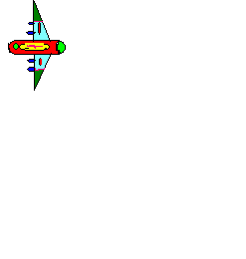



















1 2 3 4
5 6 7 8
9 10 11 12
13 14 15 16
17 18 19 20

Figure (3): Motion of object according to the equation($x_{f}−x_{i}=V_{x_{i}}t+\frac{1}{2}{\text{at}}^{2}$)
(generate 20 frames)

Figure(4): Shape of motion of object according to the equation
($x_{f}−x_{i}=V_{x_{i}}t+\frac{1}{2}{\text{at}}^{2}$)

Now simulate the motion of object according to equation (5) shown in figure (5) and it's shape as shown in figure (6)







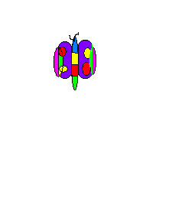



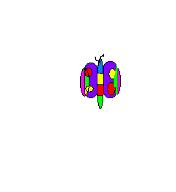

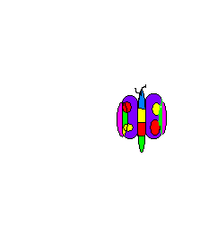
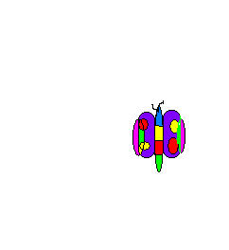


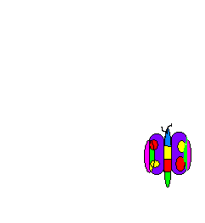


1 2 3 4
5 6 7 8
9 10 11 12
13 14 15 16
17 18 19 20

Figure (5): Motion of object according to the equation $(V_{x_{f}})^{2}=(V_{x_{i}})^{2}+2a(x_{f}−x_{i})$(generate 20 frames)

Figure(6): Shape of motion of object according to the
equation $(V_{x_{f}})^{2}=(V_{x_{i}})^{2}+2a(x_{f}−x_{i})$

Figure (7) represents simulation of the motion of moving object according to the exponential function with constant (a) but variant (b) as equation (9) below and the shape of this motion as shown in figure (8):
$y={\text{ae}}^{b}$ (9)











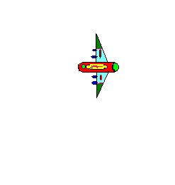

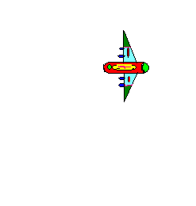

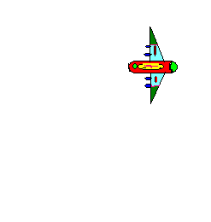




1 2 3 4
5 6 7 8
9 10 11 12
13 14 15 16
17 18 19 20

Figure(7): Motion of object according to exponential function

Figure(8): Shape of motion of object according to exponential function
For all these previous cases, the speed, velocity, kinetic energy and the potential energy can be calculated according to equations (1), (2), (6) and (7) respectively for any moving object with any initial conditions, and the values of them have got from our program in visual basic program for any step from the first frame to the last frame.

4.Conclusions
- Simulation of the motion of moving object with any initial conditions and with any initial position in image plane.
- Calculation of the speed, the velocity, the kinetic and the potential energy, which were very important to study moving object in nature.
- It's possible to simulate any object and move it according to an equation that needed.

5.References
Al Bovik ," Hand Book of Image Video Processing", Academic Press, Elsevier, 2000.
Alan Giam Battista, Betty Mc Carthy Richardson and Robert C.richardson, "College physics"2nd eddtion, Vol. 1, McGraw Hill, 2007.
Alper Yilmaz, Omar Javed and Mubarak Shah, "Object Tracking: A Survey", ACM Computing Surveys, Vol. 38, No. 4, Article 13, 2006.
Andreas Koschan and Mongi Abidi ,"Digital Color Image Processing", John Wiley & Sons, Inc., 2008.
Aws Najem Abood, "Analytical Study for Thermal Images Processing Techniques Used for Targets Detection", M.Sc. thesis, University of Baghdad, 2002.
John A. Richards and Xiuping Jia, "Remote Sensing Digital Image Analysis An Introduction", 4th edition, Springer-Verlag Berlin Heidelberg, 2006.
Landau L. D. and Lifshitz E. M., "Course of Theoretical Physics ", Reed Educational and Professional Publishing Ltd, 1981.
Mealing Stuart," The Art and Science of Computer Animation", Intellect Books, 1998.
Michael Seul, Lawrence O'Gorman and Michael J.Sammon, "Practical Algorithms for Image Analysis", Campridge University Press, 2000.
Musa Kadhum Muhsen Al-Aujany ," A Study of Simulation of Motion and Orientation of Moving Object by Using Moving Images", Ph.D. thesis , Mustansiriya University, 2006.
Paul Peter Urone, " Gollege Physics ", 2nd edition, Thomson Learning, Inc., 2001.
Raymond A. Serway and Robert J . Beichner ," physics For Scientists and Engineers " 5th edition , 2000.
Raymond Westwater and Borko Furht ," Real-Time Video Compression Techniques and Algorithms ", Kluwer Academic,1997.
Ricki G. Ingalls," Introduction to Simulation", Winter Simulation Conference, 2002.
Stan Gibilisco, "Physics Demystified", McGraw-Hill, 2002.
- غادة ذنون يونس ، " تتبع اللهب في الصور الرقمية الملونة المتحركة "، رسالة ماجستير، علوم حاسبات ، جامعة الموصل، 2003.

