Adsorption Study For Removal Of Rhodamine 6G From Aqueous Solutions By Using Iraqi Attapulgite And Flint Clays

Sadiq .J. Baqir
Babylon University - College of Science - Chemistry Department
Zahraa. H. Athab, Suaad. T. Saad
Babylon University - College of Science for Women Chemistry Department

Abstract:
In this study attapulgite (AT) and filnt (FLN) clays are used as low cost adsorbents for adsorption of (R(6G)) in aqueous solution, and the factors affecting the adsorption process were studied, including the effect of pH which shows increase with increase of pH values to all clays in this study .The effect of equilibrium time was also studied and it was found that the best time was at (30 minutes) for (AT) , (40 minutes) for (FLN), then the effect of clay weight was studied , The results indicate that the percentage removal at equilibrium for (R(6G)) by using (AT) and (FLN) clay were 88% and 85% respectively. The adsorption isotherm was found to be similar to S-shape according to Gilles classification, and that obeys Freundlich isotherm model.

Key words:-Attapulgite clay, Flint clay, Rhodamine 6G, Adsorption.

الخلاصة :
في هذه الدراسة تم استخدام طين الاتبلغايت وطين الفلنت كمواد امتزاز رخيصة لامتزاز (R(6G)) من محلولها المائي , حيث تم دراسة تاثير العوامل المؤثرة على الامتزاز وتتضمن تأثير pH و وجد ان الامتزاز يزداد مع زيادة قيمة pH لجميع الاطيان قيد الدراسة , ودرس ايضا تأثير زمن الاتزان حيث وجد ان زمن الاتزان هو( 30 دقيقة ) بالنسبة لطين الاتبلغايت و40) دقيقة ) بالنسبة لطين الفلنت، وكذلك درس تأثير وزن الطين.النتائج دلت ان النسبة المئوية للإزالة عند الاتزان لصبغة الرودامين بواسطة استخدام طيني الاتبلغايت والفلنت هي 88% ,85% على التوالي. ايزوثيرم الامتزاز ايضا درس ووجد ان الامتزاز على شكل S حسب تصنيف Gillesوهذا يتفق مع معادلة فرندلش للامتزاز .

Introduction:
Dyes are natural or synthetic colorants used in various industries such as textile , tanneries , paints , pulp and paper industries. These dyes are common water pollutants and they may be found in trace amounts in industrial wastewater ( Robinson et al., 2001) (Jadhhav et al., 2004) (Geethakarthi et al., 2011) even if a small amount of dyes is present in water , it is visible and therefore undesirable and can affect the physicochemical properties of fresh water ( Teng et al., 2006) . In addition to the unwanted colors of dyes , some of these degrade to produce carcinogens and toxic products( Nursyaza Husnabt . Shaharuddin,2009).
There are various methods for dye removal which include coagulation and chemical oxidation , membrane separation process, electrochemical, aerobic and anaerobic microbial degradation but all of these methods suffer from limitations, and non of them was successful for completely removing the color from water (Tahir et al., 2008) ( Tahir et al., 2009).
Dyes can be effectively removed by adsorption process in which dissolved dye compounds were attached to the surface of adsorbents. There is growing in using low cost and commercially available materials for the adsorption of dyes. A wide variety of materials such as palm fruit ( Nasser et al., 1995), silica fumes ( Mohan et al., 1998) , natural zeolite ( Meshko et al., 2001) and different types of clay (montmorillonite , kaoline ( Yavuz et al.,2002) and attapulgite) (Al-Sharify et al.,2010) are being used as low – cost alternative to activated carbons .
Clay materials have been receiving much attention because they are cheaper than activated carbons , found in great amounts in the earth high specific area with chemical and mechanical stabilities .Therefore clays are applied in the adsorption fields technology including the removal of amines (Breen ,1991) , metals (Naseem et al., 2001) , phenols (Strockmeyer et al ., 1991), organic pigments and dyes ( Shawabkeh et al., 2003).
Clay minerals are aluminosillicates with a lamellar structure formed by the condensation of tetrahedral (Th) SiO₂ and octahedral (Oh) Al₂O₃(dioctahedral) or MgO (trioctahedral) sheets. Part of the structural Si⁴⁺ , Al³⁺or Mg²⁺ can be isomorphically substituted by cations with lower valance providing to the clay lamellas a net negative charge .this negative charge is compensated by inorganic cations (Na⁺, K⁺,Ca²⁺) which are absorbed at the external surface of the clays .These hydrated cations are interchangeable and induces the stacking of clay layers in parallel plans giving rise to the tactoidal structure of clay with an interlayer distance around 1-2 nm this interlayer space is expandable and can accommodate a great variety of inorganic and organic cations by simple cation exchange mechanisms ( Martinez et al., 2004).
In this research two types of clays (AT and FLN) were used as
an effective adsorbent for the removal of ( R(6G)) dye from aqueous solution.
Materials and Methods:
Adsorbate:
Rhodamine (6G) was obtained from Chem. Supply., table (1) shows the structure and the characteristic of this dye (Leekaa , 2005).

Table (1) Structure and the characteristic of R(6G)

Specification sheet |  | Structure of R(6G)
Chemical formula | ( C₂₈H₃₁ N₂O₃ Cl) | 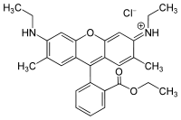
Molar mass | 479.02
Solubility | Water

A stock solution of (R (6G)) (1000 mg/L) was prepared by dissolving the assigned quantity of the dye in double distilled water. This solution is further diluted to the desired concentrations for obtaining the test solutions. The absorbance of solutions was measured at the wave length 525nm with Shimadzu UV -Vis. Spectrophotometer-1650 pc and Spectrophotometer Apel – PD-303 UV.
The pH of the dye solutions was measured by Digital pH- Meter, Hanaa, Roman and adjusted by 0.1N NaOH and 0.1N HCl solution (BDH).

Adsorbent:
Attapulgite with the formula of 44.66 % SiO₂, 13.36 % Al₂O₃ , 13.71% CaO, 4.2 % Fe₂O₃ , 3.2 % MgO , 0.23 % SO₃ and loss on ignition (L.O.I.) % 17.79(Al-Sharify et al.,2010) , and flint clay with the formula of 46% SiO₂, 34 %Al₂O₃ , 1% CaO, 1% Fe₂O₃ and 13 % loss on ignition L.O.I, were used in this work the two clays were obtained from the general company for geological survey and mining, Baghdad , Iraq . The particle size of them is about 200 mesh. The clays where immersed in 0.001N HCl solution for two hours. The acidified clays were washed with double distilled water many times and then dried at 115˚C.

The effect of experimental parameters, like initial dye concentration, time of shaking, weight of the clay and pH values were all studied experiments were carried out by changing one parameter at a time while the others are constant.

Results and Discussion
Calibration Curve of (R(6G))
The calibration curve of (R (6G)) was constructed using different concentrations of (R (6G)) solutions in distilled water, in range of (2-16) mg/L. The absorbances were measured at the maximum absorbance wave length (ג max) (525 nm) as shown in figure (1).
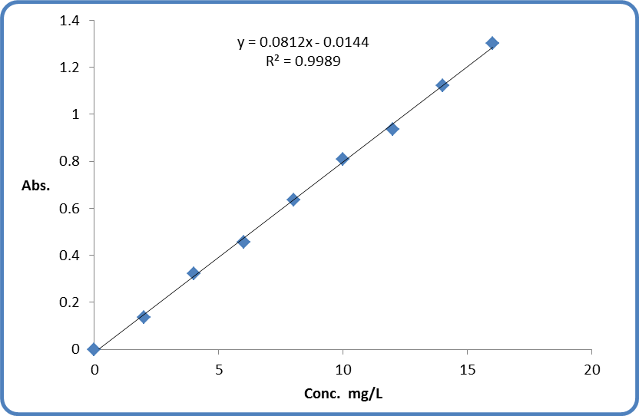
Figure (1) Calibration curve of (R (6G))

Adsorption Procedure
The amount of (R(6G)) adsorbed on the surface of clay, Qe (mg/g), was calculated according to the following equation (Al-Futaisi et al. , 2005) :-
$$Q_{e}=\frac{\left(C_{o}−C_{e}\right)V}{m}\text{.}\text{.}\text{.}\text{.}\text{.}\text{.}\text{.}\text{.}\text{.}\text{.}\text{.}\text{.}\text{.}(1)$$
Where, C_{o} and C_{e} is the initial and final or equilibrium concentration of (R (6G) ) in solution (mg /L) respectively, m is the clay mass in grams (gm) and V is the solution volume in liters (L).
The percentage amount of adsorbate adsorbed on the adsorbent was calculated by equation (2).
$E\text{\%}=\frac{\left(C_{o}−C_{e}\right)}{C_{∘}}×\text{100}\text{.}\text{.}\text{.}\text{.}\text{.}\text{.}\text{.}\text{.}\text{.}\text{.}\text{.}\text{.}\text{.}(2)$
Where E% Percentage removal of the adsorbate.
Effect of Time on Adsorption
The equilibrium time required for the adsorption of (R (6G)) were almost (30) min for (AT) and (40) min for (FLN) as shown in figure (2)

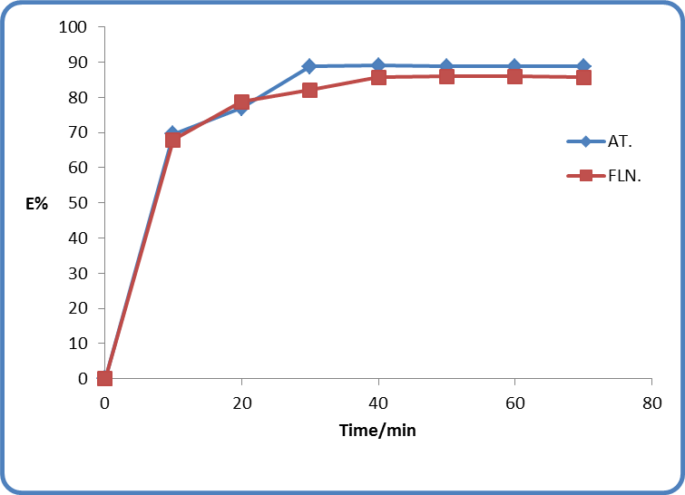
Figure (2) Effect of contact time on adsorption of( R(6G))

Effect of pH on Adsorption
The pH range (2-12) was studied and it was found that the maximum amount of adsorption occur at pH=10 as shown in figure ( 3 ), also it was found practically that the pH change has not effect on the ג max of ( R(6G)) solution .

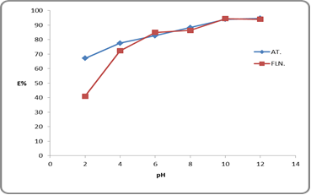
Figure (3) Effect of pH value on adsorption of( R(6G))

Effect of Clay Weight on Adsorption
The effect of clay weight was studied using different weights between (0.1-0.7) gm of clays , the maximum amount of adsorption using both types of clays was found (0.5 ) gm as shown in figure ( 4 )
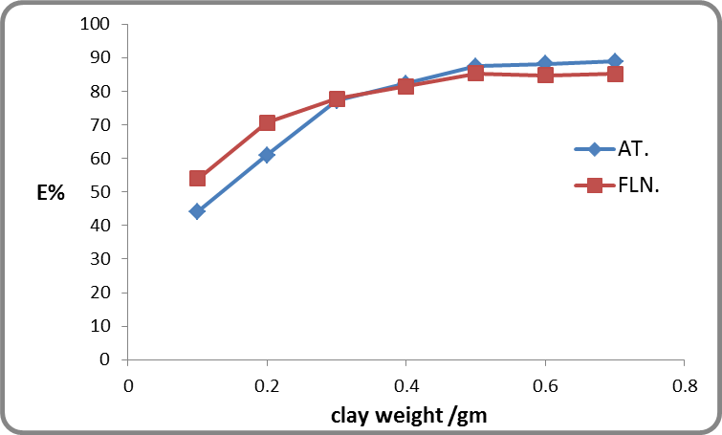

Figure (4) Effect of clay weight on adsorption

Adsorption Isotherm
Adsorption isotherm is useful to describe how solutes interact with adsorbents and very important to evaluate the feasibility of the adsorbate-adsorbent system. The isotherm data explained by theoretical or empirical equations provides preliminary prediction in modeling steps which is desired to practical operation.

Adsorption isotherms of ( R(6G)) on (AT) is represented in figure (5) and for (FLN) in figure (6).

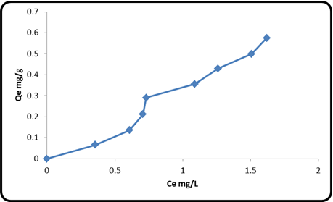

Figure (5) Adsorption isotherms of ( R(6G))on (AT)

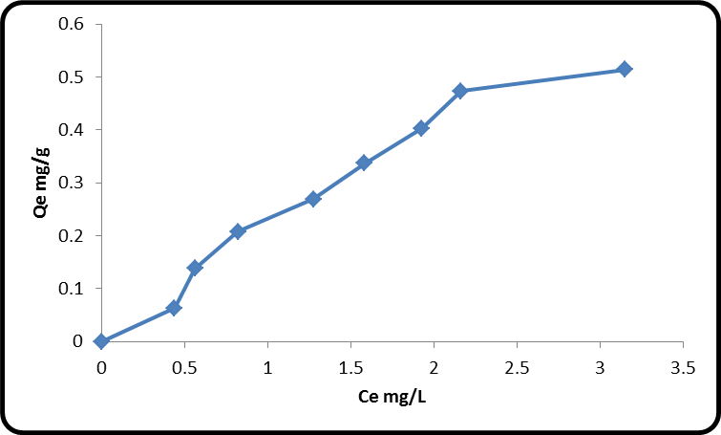

Figure (6) Adsorption isotherms of (R(6G))on (FLN)

Adsorption isotherm similar to S-shape according to Gilles classification

Freundlich Isotherm Model
The adsorption curves were also applied to Freundlich equation. The Freundlich isotherm was calculated according to the following equation (Baqir et al. , 2008) :-
$$Q_{e}=K_{f}C_{e}^{1/n}\text{.}\text{.}\text{.}\text{.}\text{.}\text{.}\text{.}\text{.}\text{.}\text{.}\text{.}\text{.}\text{.}\text{.}\left(3\right)$$

Where K_{f} is roughly an indicator of the adsorption capacity and (1/n) of the adsorption intensity all data are illustrated in Figure (7, 8).

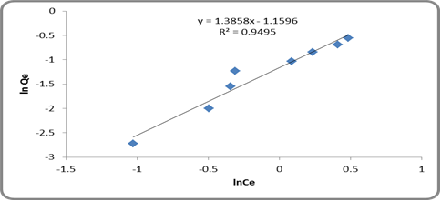
Figure (7) Freundlich isotherms for ( R(6G)) adsorption on (AT)

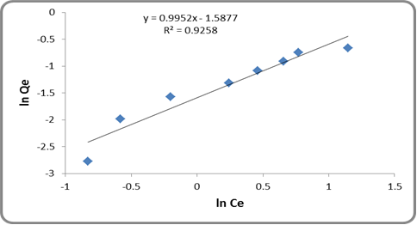
Figure ( 8) Freundlich isotherms for ( R(6G)) adsorption on (FLN)

K_{f} and 1/n Values can be determined from the linear plot of ln(Q_{e}) vs. ln(C_{e}). The Freundlich isotherm fits quite well with the experimental data (correlation coefficient 0.854<R² <0.987.

Langmuir Isotherm Model
The linear form of the Langmuir isotherm can be represented according to the following equation (Gregg et al. ,1979):-

$$\frac{C_{e}}{Q_{e}}=\frac{b}{Q_{m}}+\frac{C_{e}}{Q_{m}}\text{.}\text{.}\text{.}\text{.}\text{.}\text{.}\text{.}\text{.}\text{.}\text{.}\text{.}\text{.}\text{.}\left(4\right)$$

where Q_{e} amount of ( R(6G)) adsorbed per unit weight of adsorbent (mg/g), C_{e} is concentration of ( R(6G))remaining in solution at equilibrium (mg/L)and Qm and b are Langmuir constants related to the adsorption efficiency and energy of adsorption respectively .
The Langmuir plots and correlation coefficients R² studied and showed the adsorption of ( R(6G))on these two types of clays is not obeyed the Langmuir equation with correlation coefficients 0.96<R²>0.83.
the adsorption isotherm was found similar to S-shape according to Gilles classification, and that obeys Freundlich isotherm model and not obeyed the Langmuir equation.

Conclusions
The equilibrium of the adsorption of rodamaine 6G on the attapulgite clay and flint clay surface, have been investigated. The clays that used showed very high adsorption capacities to remove the rodamaine 6G. The adsorption capacities were significantly affected by the initial rodamaine 6G concentration and pH.
The results showed increased adsorption with the increase in the initial (R (6G)) concentration and with, the adsorption capacity increased with increase in pH.
The Freundlich equation agrees very well with the equilibrium isotherm but Langmuir equation did not give an accepted linearity.
Nomenclature:
Q_{e} Equilibrium adsorption capacity mg/gm
K_{f} Freundlich constant.
V Volume of the solutions, L
W Weight of clay, gm.
C_{o} Initial solution concentration, mg/L.
C_{e} Equilibrium solution concentration, mg/L.
R² Correlation coefficient
1/n Adsorption intensity.
E% Percentage removal of the adsorbate.
AT Attapulgite clay
FLN Flint clay
R(6G) Rhodamine 6G

References:
Al-Futaisi A.,A.Al-Jamrah and Al-Rawas ,Ninth International Water Technology Conference ,1229, (2005).
Geethakarthi , A . B.P. Phanikumar , Int. J. Environ . Sci . Tech.,8(3)561-570,2011.
Al-Sharify , A .N. A .F. Al-kaim , R. Sahib and A .M . Kadhum , Journal of Arab Universities for Basic and Applied Sciences ,8 , 1- 16,2010.
Breen C, Clay Min., 26,473, 1991.
Jadhhav D. N and A .K . Vanjara , Indian Journal of Chemical Technology , 11 , 42-50 , 2004.
Hajira. Tahir. , Uzma. H., Qazi . Jahanazeb, and Muhammad . Sultan., African Journal of Biotechnology, 7,3906-3911,2008.
Hajira. Tahir. , Qazi . Jahanazeb, and Muhammad . Sultan., African Journal of Biotechnology , 8 , 3584- 3589 ,2009.
Khadhim L. H, M.Sc. thesis , College of Education for Women/ University of Kufa, 2005.
Min-Yu. Teng, Su-Hsia Lin, desalination 194, 156-165,2006.
Nasser, M .M M. F. Hamoda and G .H. Radwan, Water Sci. Technol., 32,27,1995.
Strockmeyer M and K .Kruse , Clay Min., 26.431.1991.
NURSYAZA HUSNA BT . SHAHARUDDIN, BSc. thesis, Univirsiti Teknologi MARA ,2009.
Yavuz O. and A. H .Aydin , Fresenius Envir.Bull.,11,377,2002.
Shawabkeh R.A and M .F. Tutunji, Appl. Clay Sci., 24,111,2003.
Naseem R and S. S . Tahir , Water Res., 35, 3982, 2001.
Robinson .T., Mmullan .G., Merchant. R . Nigam, P. Bioresour. Tech., 77, 247-255, 2001.
Baqir S. J., A. F Al-Kaim .and A .M . Kadhum, Journal of Kerbala University ,vol 6, p.82-97 ,(2008).
Gregg, S. J and K. S. W. Sing, “The adsorption of gasses on porous solids ”. William Clowes & Sons, (1979).
Mohan, S.V. V.V.S. Mamatha and J.Karthikeyan, Fresenius Envir.Bull., 7,51,1998.
Martinez V. et al. Langmuir 20, 4715, 2004.
Meshko V. , I . Markovska, M . Mincheva and Rodriques, WaterRes.,35,3357,2001.

