Experimental Investigation of Two-Phase Flow (Gas –Liquid) Around A Straight Hydrofoil In Rectangular channel

Riyadh S. Al-Turaihi
College Of Engineering/Babylon University
Abstract:
This paper includes experimental investigation to study the effects of air and water discharge for different angle of attacks for straight hydrofoil and built an experimental rig to study the two phase flow.
In this work three different angle of attack (θ = 0°, 15° and 30°) are considered .The water discharge (Q_{w}) at different quantities (Q_{w}=12, 17, 27 and 37 L/min) and different air discharge (Q_{a}=5, 15, 25 and 35 L/min) were taken. The maximum inlet velocity at the test section for air is (4.758 m/s) and for water is (1.217 m/s).
The results show that when the angle of attack increase at constant amount of air and water discharge the pressure difference increased at inlet and outlet the rectangular channels. The results explain that when both water and air discharge at constant angle of attack the pressure difference increased at inlet and outlet the rectangular channels.
الملخص:
يتضمن البحث دراسة عملية لدراسة تأثير كل من معدل جريان الماء والهواء حول جناح مستقيم داخل قناة مستطيله شفافه لعدة زوايا ميلان للجناح و بناء منظومة للجريان ثنائي الطور.
النتائج العملية تم أخذها باستخدام عدة زوايا هجوم (θ = 0°, 15° and 30°) و باستخدام عدة كميات من الماء (Q_{w}=12,17,27and37) لتر/دقيقة و عدة كميات من الهواء (Q_{a}=5, 15, 25 and 35) لتر/دقيقة و باستخدام أقصى سرعة جريان للهواء بمعدل 4.758 م/ثا و سرعة ماء 1.217 م/ثا.
لقد بينت النتائج بان زياده كل من زاويه الهجوم للريشه بثبوت كل من كمية الماء والهواء او زيادة معدل جريان الهواء بثبوت كل من زاوية الهجوم و معدل جريان الماء او زبادة معدل جريان الماء( Q_{w}) بثبوت كل من زاوية الهجوم و معدل جريان الهواء(Q_{a} ) فان فرق الظغط على طرفي القناة الدقيقه يزداد.
Key words: gas-liquid, air water, two phase flow, straight hydrofoil, rectangular microchannel, angle of attack.

1-Introduction:
Two-phase flow is a complex system that is composed of two mixed phases (such as gas and liquid, gas and solid) flowing together. There are various flow states (so called flow patterns, which is one of the important parameters in two-phase flow). For example, the flow patterns of gas-liquid two-phase flow in a horizontal pipe could be bubble flow, slug flow, plug flow, annular flow and wavy flow. Two-phase flow exists widely in industry, such as boiler system, chemical and metallurgical plants, transportation of oil, natural gas and liquids with low boiling point (Haifeng,2004).
Cavitation is defined as the process of formation of the vapor phase of liquid when it is subjected to reduced pressure at constant ambient temperature. The two-phase flow around hydrofoil and two –phase in channels was investigated in theoretical and experimental studies. However, Pinelli and Magelli (2000), studied liquid- and gas-phase macro mixing behavior in gas-liquid high-aspect-ratio reactors stirred with multiple hydrofoil impellers pumping downward. They used water, a sodium sulfate solution, and poly (vinylpyrrolidone) solutions of viscosity up to 110 m Pa.s as the liquid. They studied the influence of impeller speed, gas flow rate, and viscosity on the model parameter and dimensionless relationships were given. They studied the model parameter dependence on the operating conditions. Taek et al.(2000), studied velocity distribution around a hydrofoil, the inverse problem of the hydrofoil. They formulated the inverse problem by representing the hydrofoil in terms of vortices within the framework of linear potential theory. From the mathematical formulation, it was known that the inverse problem turns out to be ill-posed in the usual topology. Leroux et al.(2005),they carried out in the scope of a numerical-experimental collaborative research program, whose main objective was to understand the mechanisms of instabilities in partial cavitating flow. Experiments were conducted in the configuration of a rectangular foil located in a cavitation tunnel. Investigated partial cavitation by multipoint wall-pressure measurements together with lift and drag measurements and numerical videos. The computations were conducted on two-dimensional hydrofoil section and were based on a single fluid model of cavitation: the liquid/vapor mixture was considered as a homogeneous fluid. Saito et al.(2007), simulated three-dimensional unsteady cavitating flow around a NACA0015 hydrofoil fixed between the sidewalls and clarified the mechanism of U-shaped cloud cavity formation. They used a local homogeneous model for the modeling of the vapor–liquid two-phase medium. They employed the cell-centered finite volume method to discretize the governing equations. They computed the turbulent eddy viscosity coefficientby using the Baldwin–Lomax model with the Degani–Schiff modification. Uchiyama and Degawa(2007),concerned with the two-dimensional simulation for an air-water bubbly flow around a hydrofoil. They simulated the bubbly flow around a hydrofoil of NACA4412 with a chord length 100mm. It was confirmed that the simulated distributions of air volume fraction and pressure agreed well with the trend of the measurement and that the effect of angle of attack on the flow is favorably analyzed. These results demonstrate that the vortex method was applicable to the bubbly flow analysis around a hydrofoil. Lee et al.(2007), focused the development of numerical code to deal with incompressible two phase flow around two dimension hydrofoil combined with cavitation model with (k-ε) turbulent model. Compared the simulation results to experimental data to verify the validity of the developed code. Also, the comparison of the calculation results was made with LES(Large Eddy Simulation) results to evaluate the capability of conventional turbulence models such as k-ε model. Li et al.(2008),studied supercavitation around a hydrofoil based on flow visualization and detailed velocity measurement. The main purpose of their study was to offer information for validating computational models, and to shed light on the multiphase transport processes. They used a high-speed video camera to visualize the flow structures under different cavitation numbers. They used a particle image velocimetry (PIV) technique to measure the instantaneous velocity and vorticity fields. Ellenrieder and Pothos(2008), Particle image velocimetry was used to examine the flow behind a two-dimensional heaving hydrofoil of NACA 0012 cross section, operating with heave amplitude to chord ratio of 0.215 at Strouhal numbers between 0.174 and 0.781 and a Reynolds number of 2,700. Wang and Dong (2009), used gray level co-occurrence matrix (GLCM) and the gray level-gradient co-occurrence matrix (GLGCM) to analyze gas/liquid flow images. They captured Gas/liquid two-phase flow experiments were practiced and high-speed images. They extracted a set of textural features from the GLCM and GLGCM. Ying Hu(2010), simulated the flow around a single foil. Effort had been made to search for better ways for imposing the interface conditions of the multi-mesh system and partial slip condition on the foil wall. Talimi et al.(2012),reviewed numerical studies on the hydrodynamic and heat transfer characteristics of two-phase flows in small tubes and channels. These flows were non-boiling gas–liquid and liquid–liquid slug flows. The review began with some general notes and important details of numerical simulation setups. The review was then categorized into two groups of studies: circular and non-circular channels. According to this review, there were some large gaps in the research literature, including pressure drop and heat transfer in liquid–liquid slug flows. Skin and Mostowfi (2012), developed a model of a bubble train flow accompanied with mass transfer in a long capillary tube. Their modeling approach accounts for expansion of gas bubbles and flow velocity increase along the channel due to the pressure drop caused by friction losses. They studied the effect of the channel diameter, the channel length, and the bubble nucleation frequency on the deviation of the system from equilibrium. Abadie et al.(2012),investigated experimentally and numerically the effect of fluid properties and operating conditions on the generation of gas–liquid Taylor flow in microchannels. Visualisation experiments and two dimension numerical simulations had been performed to study bubble and slug lengths, liquid film hold-up and bubble velocities. The results showed that the bubble and slug lengths increased as a function of the gas and liquid flow rate ratios. Mashud and Shakil(2012), they presented a numerical study of periodic cavitating flow around NACA0012 hydrofoil .The cavitation condition was model through a bubble dynamics cavitation model. Milan et al.(2012),they described experiments carried out in the cavitation tunnel with the rectangular test section of 150 × 150 × 500 mm and the maximum test section inlet velocity of 25 m/s. These experiments had been aimed to visualize the cavitation phenomena as well as to quantify the erosion potential using pitting tests evaluated during the incubation period for the cast-iron prismatic hydrofoil with the modified NACA profile.
In this paper, the experimental study for two phase flow (gas –liquid) a round straight hydrofoil behavior in rectangular channel is presented.

2-The Experimental Apparatus and Procedure:
The experimental equipments and instruments are used to measure the pressure difference a cross the test section. Figure (1) shows the experimental equipments and measurements system.
1-pump connected with flow meter. The pump from Hitachi Ltd. type (ov) ,has specification quantity (0.08 m³/min),head (8 m).The flow meter has volume flow rate range of (10-80 L/min). (figure (2)
2- Air compressor: Air was used as the gas phase. The type of compressor is Recomendamos Aceite/Worthington. It has specification capacity (0.5 m³) and maximum pressure (16 bar).
3-The test section: The test section have rectangular cross section (10 cm*3cm) and have length (70 cm) show the behavior of the two phase flow (gas and liquid) around the straight hydrofoil and measure the pressure difference and records this behavior. (Figure (3))
4-A flow meter was used to control the gas volume flow rate that enters test section. It has a volume flow rate range of (5-50 L/min) .
5- The pressure transducer sensors are used to record the pressure field with a range of (0-1) bar. These pressure transducer sensors are located in honeycombs at entrance and end of channel. The pressure sensors with a distance of (15.7 cm) between them are measured with an accuracy of (0.1%). (Figure (4))
6- Interface: This interface is connected with a personal computer so that the measured pressure a cross the test section is displayed directly on the computer screen.
7- A Sony digital video camera recorder of DCR-SR68E model of capacity 80 GB with lens of Carl Zeiss Vario-Tessar of 60 x optical, 2000 x digital was used to visualize the flow structures.
8-The detailed of a hydrofoil located in the test section, at (29 mm) in height and all dimension of straight hydrofoil is given figures (5-a)and(5-b).
Experimental are carried out to show the effect of different operation conditions on pressure difference a cross test section .Such conditions are water discharge, air discharge and different values of attack angle of straight hydrofoil in test section. The selected experimental values are presented in Table (1).
ater discharge(L/min) ( Q_{w}) | Air discharge(L/min) ( Q_{a}) | Angle ofstraight hydrofoil(Degree) (θ)
12 | 5 | 0
17 | 15 | 15
27 | 25 | 30
37 | 35 | -
Table (1) Values of operation conditions used in experimental.
The flows of both gas and liquid are regulated respectively by the combination of valves and by-passages before they are measured by gas phase flow meter and liquid phase flow meter. The gas phase and the liquid phase are mixed in mixing device before they enter test section. When the two-phase mixture flows out of the test section, the liquid phase and the gas phase are separated in liquid storage tank.
The experimental operation steps are:
- A set the attack angle of hydrofoil (0 degree).
- Turn on the pump at the first value (12 L/min).
- Turn on the air compressor at the first value (5 L/min).
- Record the pressure drop through the test section and record the motion of the two-phase flow by the digital camera.
- The above procedure; it will be repeated by changing the water discharge, air discharge and the angle of hydrofoil according to the Table (1), we will get different data.
3-Results and Discussion:
3-1The effect of angle of attack
Figure (6) shows the water discharge (Q_{w}=12 L/min) and air discharge (Q_{a}=5 L/min) for different values of angle attach for straight hydrofoil (θ= 0,15 and 30º ) .The figure explain that the bubble and cavity becomes larger and longer when the angle of attach increases at constant air and water discharge and the flow become unstable behind and beside the straight hydrofoil. This is due to the increase the angle of attack, the straight hydrofoil becomes generation to the vortexes.
Figures (7,8 and 9) explain the water and air discharge (Q_{w}=12,17 and 37 L/min) and air discharge (Q_{a}=15,25 and 35 L/min) respectively for different values of angle attach for straight hydrofoil (θ= 0,15 and 30º ) . The figures explain that when the amount of air at constant amount of water increases or the amount of water at constant amount of air increases the velocity of air or water increases respectively will causes the turbulence in flow. Also when increase the angle of attack the flow becomes unstable and the bubble and cavities becomes more and large and observed more the bubbles and cavities around the straight hydrofoil especially beside and behind the straight hydrofoil.
The results show that when increases the angle of attack leads to the hydrofoil becomes generation of vortex and the flow becomes unsteady and most bubble cavities develop to the cloud cavitations and strong vortexes from all surfaces of straight hydrofoil.
3-2The effect of water discharge
Figures (10,11 and 12) explain the air and water discharge (Q_{a}=5 L/min) (Q_{w}=12,17,27 and 37 L/min) respectively for different values of angle attach for straight hydrofoil (θ= 0,15 and 30º ) .The figure (10) ) shows the air discharge (Q_{w}=5 L/min) and water discharge (Q_{w}=12,17,27 and 37 L/min) at angle of attack (θ= 0º) .The figure explain that the flow smooth approximately and the number or amount of bubble are low and have small size at low water discharge. This is due to the low velocity of water at low water discharge. Also when increase the water discharge the size and number of bubble increase and the bubble cavities develops to cloud cavitations especially at large water discharge. This is due to the high velocity of water at large water discharge which leads to the more turbulence in the flow. At angle of attack (θ= 0º), the flow be symmetrical at both side of straight hydrofoil. Figure (11) shows the air discharge (Q_{w}=5 L/min) and water discharge (Q_{w}=12,17,27 and 37 L/min) at angle of attack (θ= 15º) . The figure explain that the flow becomes unstable and unsymmetrical around the straight hydrofoil and the number and size of bubble become large compared with angle of attack(θ= 0º).Also appear the vortexes behind and beside the straight hydrofoil from all surfaces and bubble cavities develops to cloud cavitations compared with the same condition at angle of attach (θ= 0º) .Figure (12) shows the air discharge (Q_{w}=5 L/min) and water discharge (Q_{w}=12,17,27 and 37 L/min) at angle of attack (θ= 30º) . The figure explain that at the same condition we note that the flow becomes unstable and unsymmetrical around the straight hydrofoil .Moreover the number and size of bubble become large compared with angle of attack (θ= 15º).Also the vortexes be strong vortexes from all surfaces (lower and upper) and the bubble cavities develops to cloud cavitations and strong vortexes behind the straight hydrofoil are observed.
3-3The effect of air discharge
Figures (13, 14 and 15) explain the water and air discharge (Q_{a}=17 L/min) (Q_{a}=5,15,25 and 35 L/min) respectively for different values of angle attach for straight hydrofoil (θ= 0,15 and 30º ) . Figure (13) shows the water discharge (Q_{w}=17 L/min) and air discharge (Q_{a}=5, 15, 25 and 35 L/min)at angle of attack (θ= 0º) . The figure explain that at angle of attack (θ= 0º), the amount the bubble and cavities is low at air discharge (Q_{a}=5 L/min) and the amount the bubble and cavities increase with increase the air discharge .Moreover the bubble cavities develops to cloud cavitations and appear the vortexes beside and behind the straight hydrofoil and being strong vortexes when increase the air discharge. Figure (14) shows the water discharge (Q_{w}=17 L/min) and air discharge (Q_{a}=5, 15, 25 and 35 L/min) at angle of attack (θ= 15º). The figure explain that the size and amount of bubble and cavities increase compared with the same condition at angle of attack (θ= 0º). Moreover appear bubble beside and behind the straight hydrofoil especially at low air discharge then the bubble and cavities develops to cloud cavitations at high air discharge. Figure (15) shows the water discharge (Q_{w}=17 L/min) and air discharge (Q_{a}=5, 15, 25 and 35 L/min) at angle of attack (θ= 30º). The figure explain that the size and amount of bubble and cavities increase compared with the same condition at angle of attack (θ= 0 and 15º). Also appear vortexes beside and behind the straight hydrofoil and develops to cloud cavitations at high air discharge .This is due to the straight hydrofoil be important effect to generation the vortexes in rectangular channel which effect on pressure difference across the inlet and outlet the channel.
Figure (16) shows the pressure with time at inlet and outlet of rectangular channel across the straight hydrofoil. The figure explains that water discharge (Q_{w} =17 L/min) and air discharge (Q_{a}=5 and 15 L/min) at angle of attack (θ= 30 and 15º) respectively. Moreover when the air discharge increase the pressure fluctuation increase .This is due to high inertia force in two phase flow.
Figure (17) shows the pressure difference with air discharge at different angle of attack for straight hydrofoil (θ= 0,15 and 30º ) for different value of water discharge (Q_{w} =12,17,27 and 37 L/min). The figure explain that at the same angle of attack when increase the air discharge and water discharge the pressure difference increase .This is due to the increase the air or water discharge the speed of flow increase, transition from laminar to turbulent boundary layer occurs therefore the pressure difference increase . Also when increase the angle of attack for straight hydrofoil the pressure difference increase .This is due to when increase the angle of attack the straight hydrofoil becomes generation to turbulent also increase the pressure difference at inlet and outlet of rectangular channels.
Figure (18) shows the pressure difference with air discharge at water discharge (Q_{w}=12,17,27 and 37 L/min) for different angle of attack for straight hydrofoil (θ= 0,15 and 30º ). The figure explain that when increase the air and water discharge the pressure difference increase and when increase the angle of attack of straight hydrofoil the pressure difference increase.

4-CONCLUSIONS:
In this investigation ,many experiments done to measure the pressure and pressure difference at inlet and outlet of rectangular channel across the straight hydrofoil the observer and visualization is investigate the bubble and cavities around the straight hydrofoil by using the air-water two-phase flow as working fluid. The summarized of investigation is:
- For constant water discharge and angle of attack the pressure difference increased when air discharge increase.
- For constant air discharge and angle of attack the pressure difference increased when water discharge.
- For constant air and water discharge the pressure difference increased as angle of attack of straight hydrofoil increased.
- The angles of straight hydrofoil play an important role to satisfy the bubbly flow.

1-Water Tank  2-Water pump  3-Valve  4-Water Flow meter  5-compressor  6- Air Flow meter  7-Valve  8-Pressure sensor  9-Test Body  10-Tese section  11-Interphase  12-personal computer | 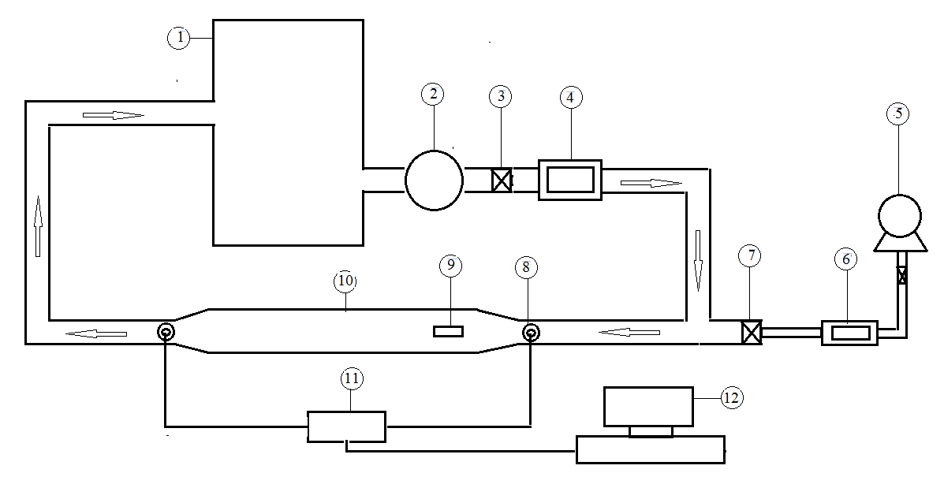

Figure (1) The Experimental Equipment and Measurements
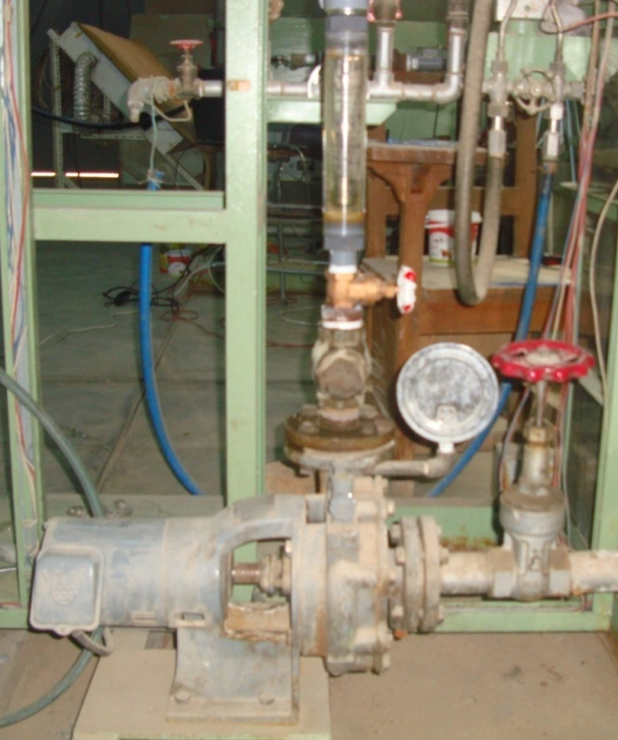  Fig (2)The pump and flow meter | 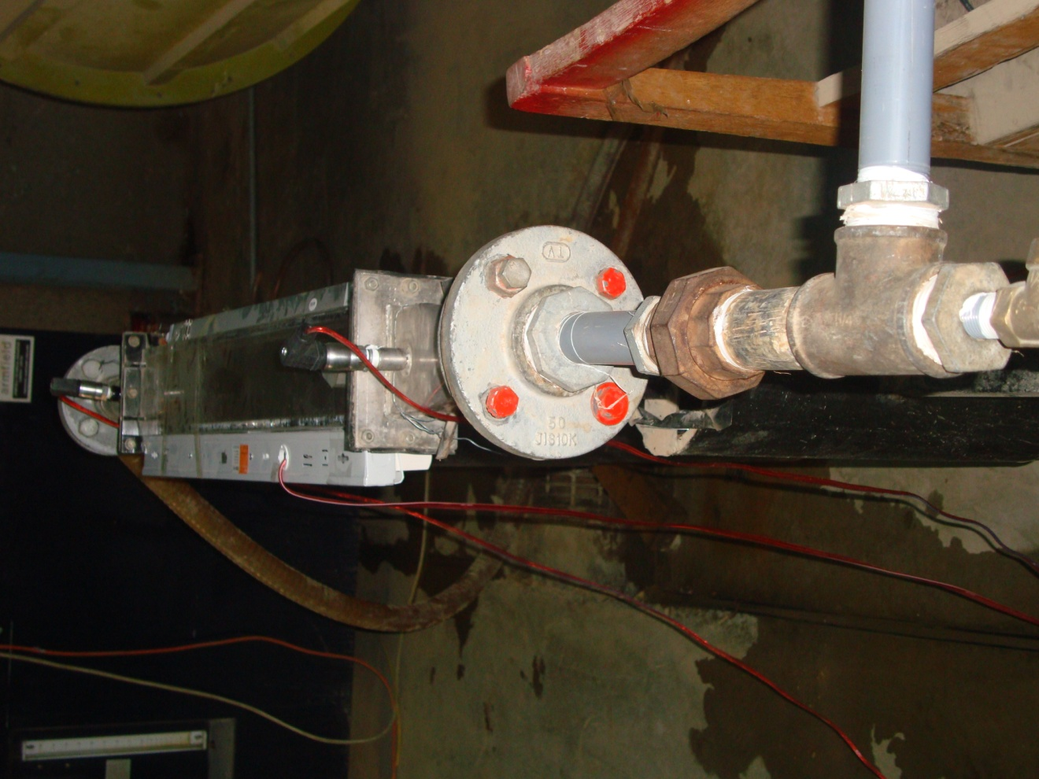  Fig (3) The test section(rectangular microchannel)

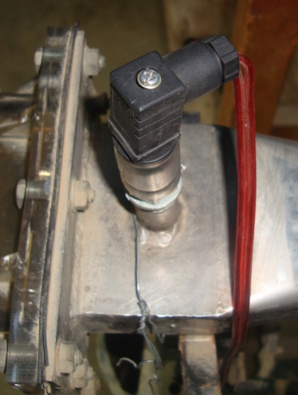  Fig (4) The pressure Sensor | Fig (5-a) The straight hydrofoil (all dimension in mm)
  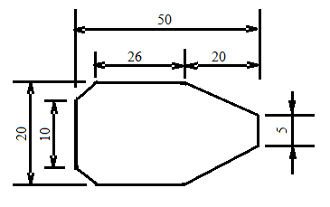

 | 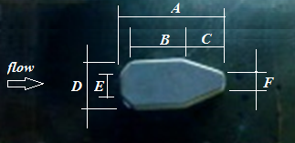
  Symbol | Dimension in(mm) | Symbol | Dimension in(mm)
  A | 50 | D | 20
  B | 26 | E | 10
  C | 20 | F | 5
Fig (5-b) The straight hydrofoil

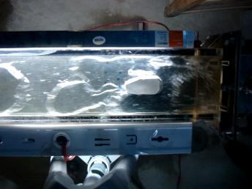  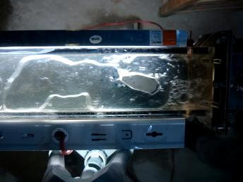  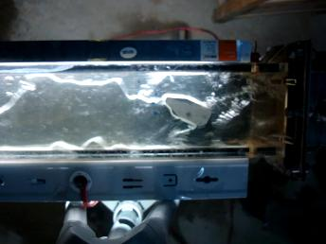 | 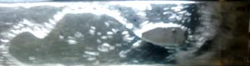  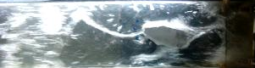  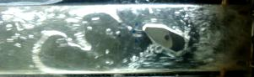
Fig(6) the water discharge (Q_{w}=12 L/min) and air discharge (Q_{a}=5 L/min) for different angle of attack (θ= 0,15 and30 º) | Fig(7)the water discharge (Q_{w}=12 L/min) and air discharge (Q_{a}=15 L/min) for different angle of attack (θ= 0,15 and30 º)

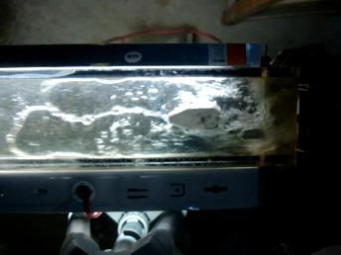  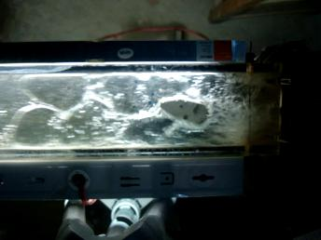  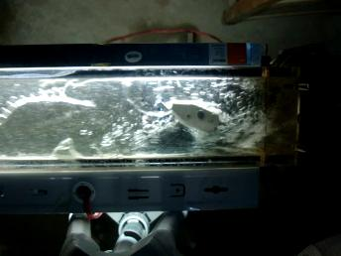 |  | 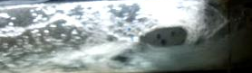  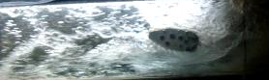  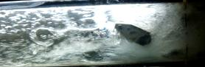
Fig(8) thewater discharge (Q_{w}=17 L/min) and air discharge (Q_{a}=25 L/min) for different angle of attack (θ= 0,15 and30 º) |  | Fig(9) the water discharge (Q_{w}=37 L/min) and air discharge (Q_{a}=35 L/min) for different angle of attack (θ= 0,15 and30 º)
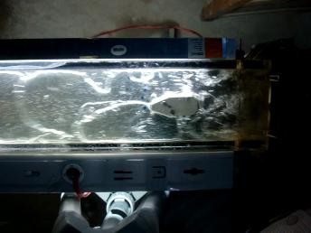  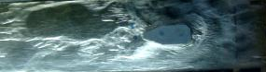  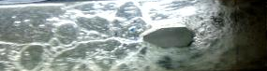 | 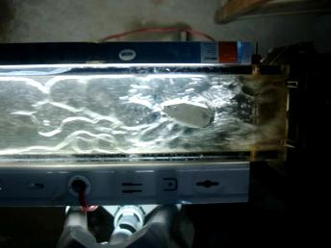  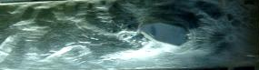  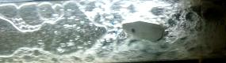
Fig(10) The Air discharge (Qa=5 L/min) and angle of attack (θ= 0 º) for different water discharge (Qw=12,17,27 and37 L/min) | Fig(11) The Air discharge (Q_{a}=5 L/min) and angle of attack (θ= 15 º) for different water discharge (Q_{w}=12,17,27 and37 L/min)

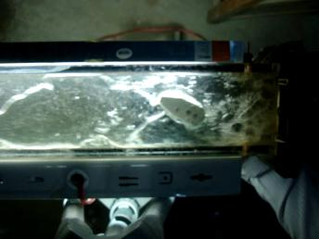
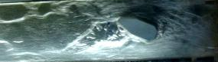
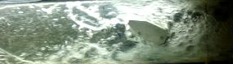

Fig(12) The Air discharge (Q_{a}=5 L/min) and angle of attack (θ= 30 º) for different water discharge (Q_{w}=12,17,27 and37 L/min)

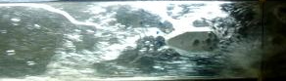  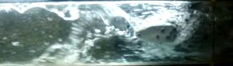 | 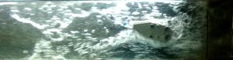  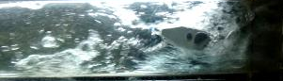
Fig(13) The water discharge (Q_{w}=17 L/min) and angle of attack (θ= 0 º) for different air discharge (Q_{a}=5, 15, 25 and 35 L/min) | Fig(14) The water discharge (Q_{w}=17 L/min) and angle of attack (θ= 15 º) for different air discharge (Q_{a}=5, 15, 25 and 35 L/min)

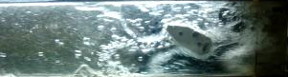

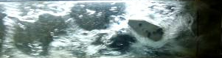
Fig(15) The water discharge (Q_{w}=17 L/min) and angle of attack (θ= 30 º) for different air discharge (Q_{a}=5, 15, 25 and 35 L/min)

Figure (16) the pressure with time at inlet and outlet of rectangular channel across the straight hydrofoil

Figure (17) the pressure difference with air discharge at different value of water discharge

Figure (18) the pressure difference with air discharge at different value of angle of attack for straight hydrofoil

References:
Davide Pinelli and Franco Magelli , 2000,” Analysis of the Fluid Dynamic Behavior of the Liquid and Gas Phases in Reactors Stirred with Multiple Hydrofoil Impellers “,Ind. Eng. Chem. Res.,( 39),p.p. 3202-3211.
Dmitry Eskin and Farshid Mostowfi, 2012,” A model of a bubble train flow accompanied with mass transfer through a long microchannel” International Journal of Heat and Fluid Flow (33), p.p.147–155.
Haifeng Ji, Zhiyao Huang, Baoliang Wang and Haiqing Li, 2004,” Monitoring System of Gas-liquid Two-phase Flow” Instrumentation and Measurement Technology Conference, Como. Italy. 18-20 May.
Hongyi Wang and Feng Dong, 2009,” Image Features Extraction of Gas/liquid Two-Phase Flow in Horizontal Pipeline by GLCM and GLGCM”, the Ninth International Conference on Electronic Measurement & Instruments ( ICEMI),.
Jean-Baptiste Leroux, Olivier Coutier-Delgosha and Jacques André Astolfi, “ A joint experimental and numerical study of mechanisms associated to instability of partial cavitation on two-dimensional hydrofoil”, PHYSICS OF FLUIDS 17, 052101 (2005).
K. D. von Ellenrieder and S. Pothos, 2008,” PIV measurements of the asymmetric wake of a two dimensional heaving hydrofoil” Exp. Fluids ( 44),p.p.733–745.
Md. Mashud Karim and Mohammad Shakil Ahmmed, 2012,” Numerical study of periodic cavitating flow around NACA0012 hydrofoil”, Ocean Engineering (55) ,p.p.81–87.
Milan Sedlář, Martin Komárek, Michal Vyroubal and Miloš Müller, 2012,” Experimental and numerical analysis of cavitating flow around a hydrofoil”, EDP Sciences, EPJ Web of Conferences 25, 01084 .
Seyoung Lee, Changjin Lee and Soohyung Park, 2007,” Unsteady Cavitation and Cryogenic Flow Cavitation around 2D Body”, Fifth International Conference on Computational Science and Applications.
Taek S. Jang, Hang S. Choi and Takeshi Kinoshita, 2000,” Numerical experiments on an ill-posed inverse problem for a given velocity around a hydrofoil by iterative and
noniterative regularizations”, Journal of Marine Science and Technology,(5),p.p107–111.
Tomomi Uchiyama and Tomohiro Degawa, 2007,” Vortex Simulation of the Bubbly Flow around a Hydrofoil” International Journal of Rotating Machinery, Article ID 72697, 9 pages Volume.
Thomas Abadie ,Joeelle Aubin , Dominique Legendre and Catherine Xuereb, 2012,” Hydrodynamics of gas–liquid Taylor flow in rectangular microchannels “,Microfluid Nanofluid (12),p.p.355–369.
Xiangbin Li ,Guoyu Wang , Mindi Zhang and Wei Shyyb, 2008,” Structures Of Super Cavitating Multiphase Flows”, International Journal of Thermal Sciences (47) ,p.p.1263–1275.
Yoshinori Saito , Rieko Takami ,Ichiro Nakamori and Toshiaki Ikohagi , 2007,” Numerical analysis of unsteady behavior of cloud cavitation around a NACA0015 foil”, Comput Mech (40),p.p.85–96.
Ying Hu, Hua Li and Heming Cheng,2010,” Turbulent Flow Simulation Around Two-Dimensional Hydrofoil”, 2010 3rd International Conference on Biomedical Engineering and Informatics (BMEI 2010).
V. Talimi , Y.S. Muzychka and, S. Kocabiyik,2012 ,” A review on numerical studies of slug flow hydrodynamics and heat transfer in microtubes and microchannels” International Journal of Multiphase Flow (39) ,p.p. 88–104.

