Experimental Investigation of Two-Phase GAS-Liquid Slug Flow Inclined Pipe

ESAM M. ABED RIYADH S. AL-TURAIHI
DEPT. OF MECH. ENG., UNIVERSITY OF BABYLON

Abstract
The experimental results of flow pattern and pressure drop of gas–liquid flow in inclined pipe are presented. The diameter of test section is 50 mm, and overall length of 4 m. The inclination angle of the test section is 30º. Air and water are used as working fluids. The gas superficial velocity and liquid superficial velocity are varied in a range of (1.358142-5.432568) m/s and (0.169764-1.527884) m/s, respectively. The pressure drop along the test section of the pipe is also measured. The characterization of flow patterns is achieved via visual observations and by analysis of local pressure measurements. The observed flow patterns are presented in terms of flow pattern maps for pipe inclination. The slug two-phase flow patterns are observed in the experiments. A video camera recording and pressure transducer sensor with interface are used to study flow regimes and pressure drop through test section. The following flow regimes, depending on the superficial liquid and gas velocities are observed. The flow regime and pressure fluctuating across pipe depending on superficial liquid and gas velocities. It noted that the pressure decreases with distance along pipe when gas superficial velocity increased and also increased liquid superficial velocity.
Keywords: Pressure drop; Gas-liquid; inclined pipe
الخلاصة
الغرض من البحث هو دراسة الجريان ثنائي الطور لنبوب بقطر 50 ملم و طول 4 متر و يميل بزاوية 30 درجة عن لأفق.هبوط الضغط على طول مقطع الاختبار تم قياسه. تم استخدام الهواء و الماء كمائع تشغيل. تم استخدام سرعة هواء و ماء مختلفة وبمعدل (1.358142-5.432568) م/ث و (0.169764-1.527884) م/ث على التوالي. تم ملاحظة الجريان نوع (slug) أثناء التجارب. تم استخدام كاميرة فيديو لتحليل الصور و كذلك استخدام متحسسات ضغط مثبتة على الأنبوب في 4 مواقع .تم الاستنتاج أن شكل الجريان يعتمد على سرعة الهواء و الماء وكذلك لوحظ أن الضغط يتناقص مع طول الأنبوب عند زيادة سرعة الهواء والماء.
Nomenclature
P: pressure (m bar) D: pipe diameter (m) X: distance (m)
Ug: gas superficial velocity (m/s) Ul: liquid superficial velocity (m/s)
Q_{g}: Gas discharge (m³/s) Q_{l}: liquid discharge (m³/s) Ap: Peripheral Area (m²)
Al: Liquid Area (m²) Um: Gas Drift velocity (m/s) α: void fraction
C₀: two-phase distribution coefficient ρ: density (kg/m³)

Introduction
The study of two-phase flows has great significance for several technological applications. Its which exists widely in a wide range of industrial applications, such as condensers, evaporators, distillation towers, nuclear power plants, boilers, crude oil transportation and chemical plants among others. The transportation of gas and liquid in conducts can lead to several topological configurations called flow patterns or flow regimes. This flow regime is usually observed when gas and liquid flow rates are sufficiently high. The simultaneous presence of gas and liquid in a pipe requires a more complex method of analysis than that applied to single phase flow problems. Two-phase gas–liquid flow was investigated in theoretical and experimental studies. However, Roumazeilles et al. (1994) uncounted the downward simultaneous flow of gas and liquid in hilly terrain pipelines and injection wells. Developed most of methods for predicting pressure drop in gas-liquid, two phase flow in pipe for either
upward vertical or upward inclined pipe. They investigated experimentally downward concurrent slug flow in inclined pipe. They designed and built a new test facility to a acquire data for the entire range of pipe inclination angles. Obtained liquid holdup and pressure drop measurement for downward inclination angles form (0º) to (-30º) at different flow condition. Cook and Behnia (2000) presented a comprehensive treatment of all sources of pressure drop within intermittent gas-liquid flows. Calculated pressure loss associate with the viscous dissipation within a slug is, and the presence of dispersed bubbles in a slug was account for, without recourse to the widely used assumption of homogenous flow. The results show that existing intermittent flow models predict pressure gradients considerably lower than were observed. Lewis, et al. (2002) discussed utility of the hot-film anemometry technique in describing the internal flow structure of a horizontal slug flow pattern within the scope of intermittent nature of slug flow. It was shown that a single probe can be used for identifying the gas and liquid phases and for differentiating the large elongated bubble group from the small bubbles present in the liquid slug. Ullmann, et al. (2003) investigated the effects of inclination on the characteristics of laminar countercurrent liquid–liquid flow both experimentally and theoretically. Experimental results showed that with a slight off-vertical inclination the phases tend to segregate and the basic flow pattern in inclined tubes was stratified flow. Both models predict the existence of the two modes that had been observed in the column and their associated holdups. Ribeiro, et al. (2006) compared new data on pressure drop and liquid hold-up obtained in a horizontal square cross-section channel against several existing correlations and models for gas–liquid flow. The hold-up data were taken for conditions of wavy-stratified and pseudo-slug flow. Pressure drop results were only obtained for wavy-stratified flow. Wongwises and Pipathattakul (2006) studied experimentally two-phase flow pattern, pressure drop and void fraction in horizontal and inclined upward air–water two-phase flow in a mini-gap annular channel. They observed and recorded the flow phenomena, which are plug flow, slug flow, annular flow, annular/slug flow, bubbly/plug flow, bubbly/slug–plug flow, churn flow, dispersed bubbly flow and slug/bubbly flow by high-speed camera. Also observed a slug flow pattern was found only in the horizontal channel while slug/bubbly flow patterns are only in inclined channels. When the inclination angle was increased the onset of transition from the plug flow region to the slug flow region (for the horizontal channel) and from the plug flow region to slug/bubbly flow region (for inclined channels) shift to a lower value of superficial air velocity. Arvoh et al. (2012) studied a combination of gamma measurements and multivariate calibration was applied to estimate multiphase flow mixture density and to identify flow regime. The experiments were conducted using recombined hydrocarbon. These were conducted at a temperature of 0 ºC and a 75-bar pressure. Two angles of inclination (1º and 5º) and two water cuts (15% and 85%) were investigated. The estimated mixture densities were accurate as compared with those from the single-energy gamma densitometer with the root mean square error of prediction of 13.6 and 9.7 kg/m³ for 1º angle of inclination and 17 and 26.6 kg/m³ for 5º pipe inclination.
Flow patterns observed in upward inclined flow are quite similar to those observed in vertical upward flow, especially for near-vertical systems. They include bubbly and dispersed bubbly, slug, churn and annular flow in inclined systems. Gould, et al. (1974) published flow pattern maps for horizontal and vertical flow and for up-flow at 45º inclinations. Spedding and Nguyen (1976) compared the flow regime maps developed by others with air-water experimental data for conditions from vertically downward flow to vertically upward flow. Each slug unit was comprised of three separate sections. The first of these sections was the highly turbulent mixing vortex. Visual observations suggest that this section was highly aerated at moderate and high flow rates. The slug body follows the mixing vortex and has a significantly greater liquid holdup. The velocity profile within this section was assumed to be close to that of fully developed pipe flow. The trailing section consists of the bubble above the liquid film. Here it was assume that the film contains no entrained gas bubbles. Analysis of the flow was based on the mass flow conservation equations for either phase. The mass flow rate of liquid within a slug unit can be expressed as the sum of liquid flow within the slug and film sections yielding as Gopal (1994).

Experimental Set-Up And Procedures
The experimental flow facility at the college of engineering of the Babylon University includes an inclined measuring test section, water and air delivery systems, a two-phase mixing section, and instrumentation measuring. The schematic diagram of the experimental apparatus is shown in Fig.1. The test section with a diameter 50 mm and overall length of 4 m, made of transparent Perspex are used in the present study. Pressure drops are measured over a range of air velocities (1.358142-5.432568) m/s, and water velocities from (0.169764-1.527884) m/s which covered slug flow regimes. A two-phase mixing section has been designed and manufactured for the production of slug flows. The air is separately introduced through nozzle at the center of inlet of the pipe. The water at room temperature and atmospheric pressure from the water tank is pumped through the water flow meter, the air–water mixer and the test section. The surplus water is sent back to storage tank through the control valve. Water in the system is controlled by water flow meter with different measure range. The water is supplied by a centrifugal pump from a tank. The water flow rate is measured before entering into the two-phase mixer by an inductive flow meter. The air at room temperature and atmospheric pressure from the air compressor is compressed to the air tank with high pressure. The gas phase used in the present study is the compressed air supplied by air compressor. It is then fetched through a filter and pressure regulator circuit followed then entering to air flow meters, then air is mixed with water at mixing section.
Flow patterns are defined and distinguished based on the criteria of visual observations, photographic and video evidence. Flow patterns are observed visually for every single input of air and water mass flow rate. These observations are repeated to ensure enough repeatability in the observed flow patterns. The visual observations are supplemented with aid of high resolution 13.8 megapixels SONY digital video camera. Sometimes it is difficult to visually recognize the flow pattern, so video camera played a key role in determining flow pattern. To calculate pressure effect on the distance of the pipe the pressure sensors are used and connecting with the interface and then to the personal computer so that the measured pressure a cross the test section is displayed directly on the computer screen. Experimental are carried out to show the effect of different operation conditions on pressure difference a cross test section .Such conditions are water superficial velocities, air superficial velocities for an angle of pipe is 30º. Each ran of experimental is fixed water discharge with various air discharge. The selected experimental values are presented in table (1).

Table (1) the values of operation conditions used in experimental.
U_{l} | 0.169764 | 0.339529 | 0.679059 | 1.018589 | 1.358119 | 1.527884
U_{g} | 1.358142 | 2.716284 | 4.074426 | 5.432568 | - | -
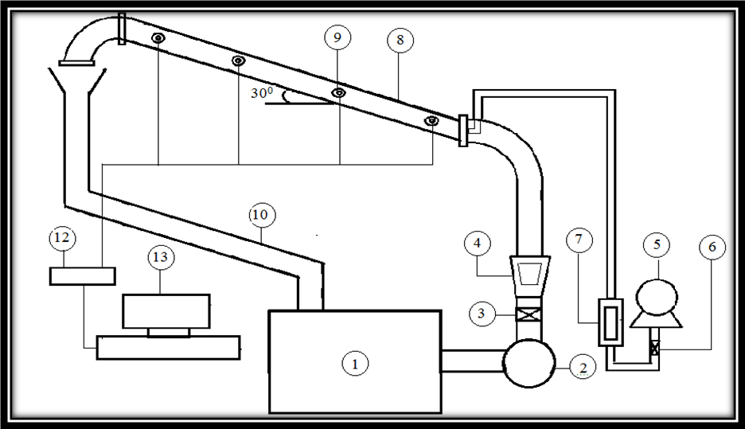

Fig.1 show the experimental equipments and measurements system
1-Water Tank 2-Water pump 3-Valve 4-Water Flow meter 5-compressor 6- Valve 7- Air Flow meter 8- Test section 9-Pressure sensor 10-Return pipe 12-Data logger 13-personal computer
The Superficial velocity is the velocity that a phase would travel at if it flowed through the total cross sectional area available for flow. Thus, the liquid and gas superficial velocities are defined as Al-Adwani 2003.
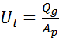 and 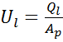 (1)
Liquid holdup is defined as the fraction of a pipe cross-section or volume increment that is occupied by the liquid phase. The value of HL ranges from 0 (total gas) to 1 (total liquid). The liquid holdup is defined by
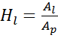 (2)
The term void fraction or gas holdup is defined as the volume fraction occupied by the gas where
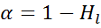 (3)

The mixture velocity can be defined as the velocity of the two phases together, as follow:
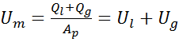 (4)

The void fraction correlation that gives better predictions when compared with available experimental data, proposed by Woldesemayat and Ghajar (2007) as following expression:
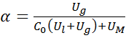 (5)
Where:
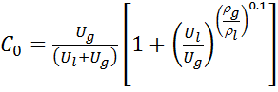 (6)

And,
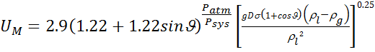 (7)

Results
Visualization of Flow Patterns
The first and simplest approach to study two-phase flow behavior in deviated pipes is to visualize the flow. Flow patterns play very important roles in two-phase flow. Each regime has certain hydrodynamic characteristics, occurrence in nature and many applications in industries. In this work, the designation of the flow pattern has been based largely on individual interpretation of visual observation, carried out through the transparent pipe section of the rig, by means of a video system as well as the eye.
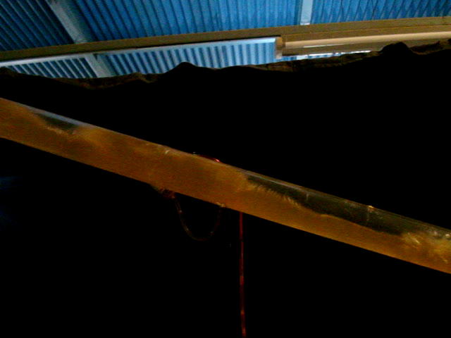
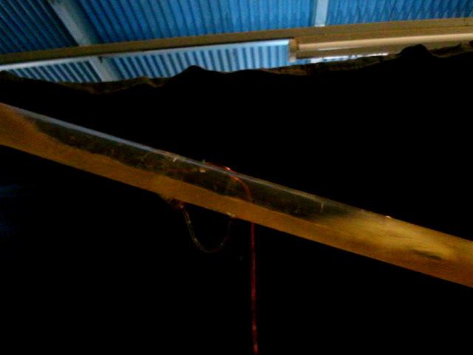
Figures 2, 3, 4 and 5 show an instantaneous side view of air-water flow into the pipe, obtained by video camera. The flow is from the left to the right, the distance in the flow direction, shown in this image is L = 60 mm, the gas superficial velocity is (1.358142-5.432568) m/s, the liquid superficial velocity (0.169764-1.527884). Using the video system, it is found that liquid slug consists of three parts. The first part is the wake region of the leading Taylor bubble that assimilates the falling liquid film, which is extremely turbulent, disorderly and disturbance with maximum void fraction. In this part, the liquid carrying dispersed small bubbles flows downward in the near wall zone, whereas liquid flows upward in the core of pipe. The second part is regarded as the transition region from the wake to the fully developed dispersed bubble region. In this part, the bubbles come from the core area of the wake region and then gradually spread across the entire cross section of pipe. The third part is defined as the minimum void fraction region, which may be either turbulent or laminar. In this part, the void fraction distribution is very similar to that of fully developed dispersed bubble flow. As the air discharge increases, the air superficial velocity increased too and the number of slug consisting increased too. The size of bubble increase when air discharge increased for all water discharges. It has been found that the minimum stable liquid slug length is relatively insensitive to the gas and liquid flow rate, and is fairly constant for a given pipe diameter.
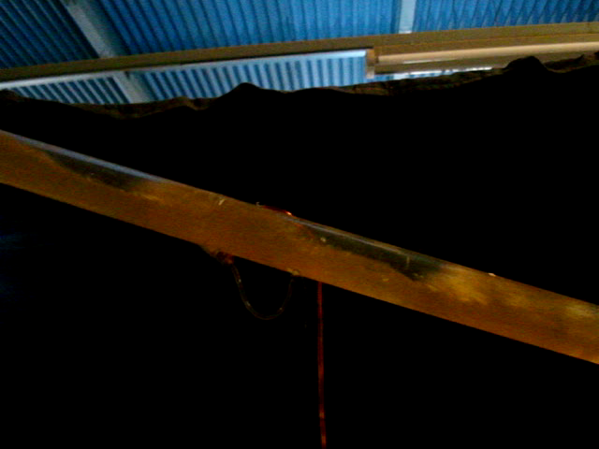
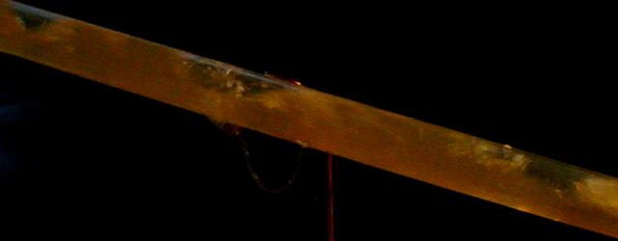

- Q_{l}=20 l/min and Q_{g}=10 l/min b. Q_{l}=20 l/min and Q_{g}=20 l/min
- Q_{l}=20 l/min and Q_{g}=30 l/min d. Q_{l}=20 l/min and Q_{g}=40 l/min
Fig.2 Visualization of flow patterns for constant water discharge (Ql=20 l/min) and various air discharges (Q_{g}=10, 20, 30 and 40 l/min).
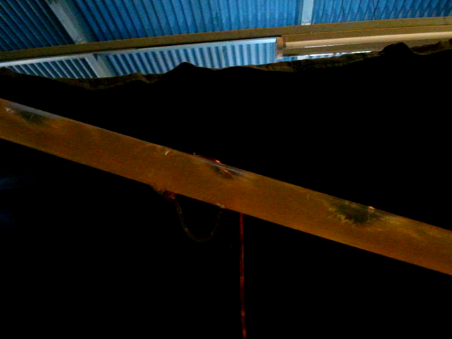
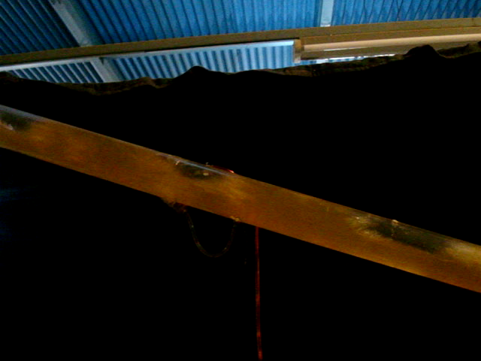
Q_{l}=40 l/min and Q_{g}=10 l/min b. Q_{l}=40 l/min and Q_{g}=20 l/min

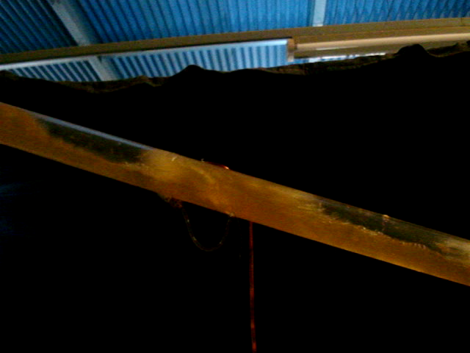
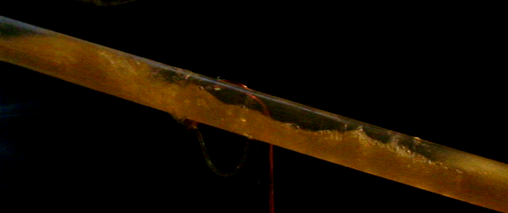
- Q_{l}=40 l/min and Q_{g}=30 l/min d. Q_{l}=40 l/min and Q_{g}=40 l/min
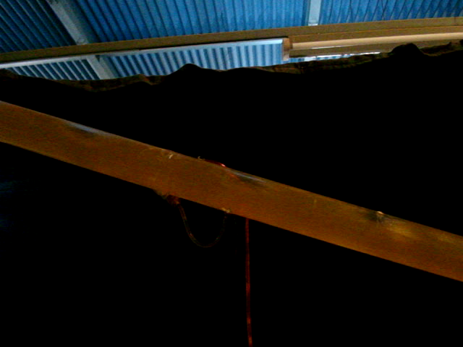
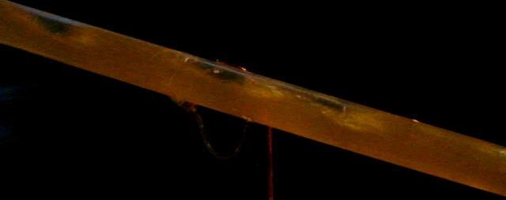
Fig.3 Visualization of flow patterns for constant water discharge (Q_{l}=40 l/min) and various air discharges (Q_{g}=10, 20, 30 and 40 l/min).
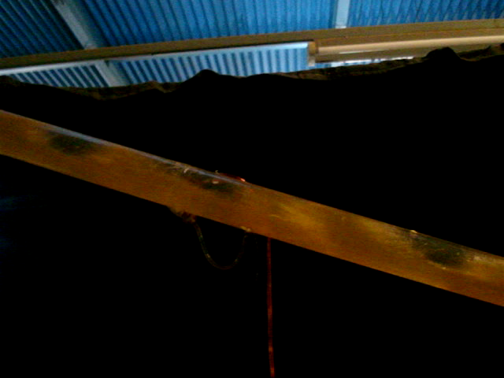
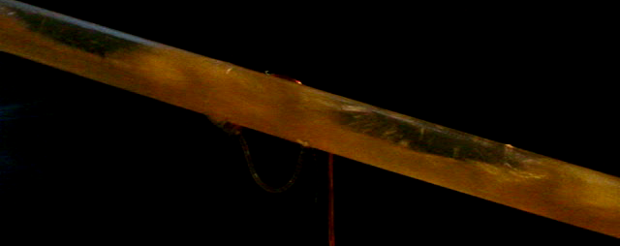
- Q_{l}=80 l/min and Q_{g}=10 l/min b. Q_{l}=80 l/min and Q_{g}=20 l/min
c. Q_{l}=80 l/min and Q_{g}=30 l/min d. Q_{l}=80 l/min and Q_{g}=40 l/min
Fig.4 Visualization of flow patterns for constant water discharge (Q_{l}=80 l/min) and various air discharges (Q_{g}=10, 20, 30 and 40 l/min).
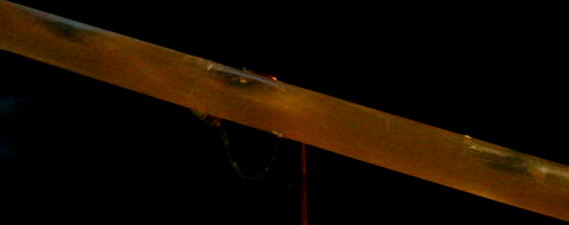
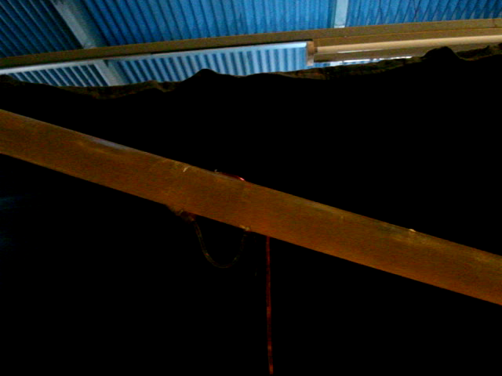
- Q_{l}=120 l/min and Q_{g}=10 l/min b. Q_{l}=120 l/min and Q_{g}=20 l/min
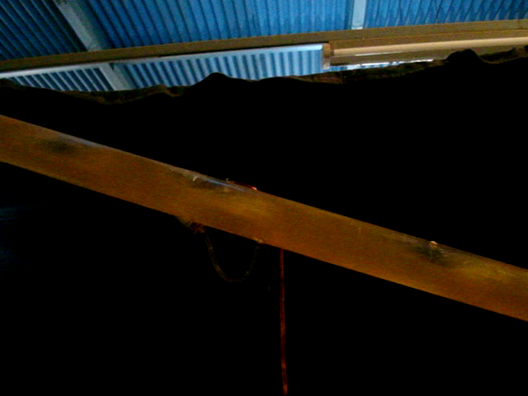
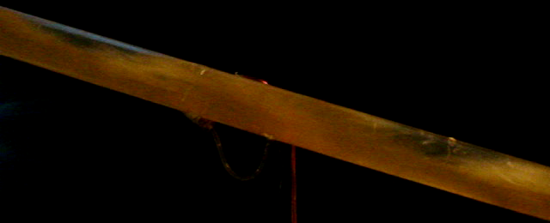
c. Ql=120 l/min and Qg=30 l/min d. Ql=120 l/min and Qg=40 l/min
Fig.5 Visualization of flow patterns for constant water discharge (Q_{l}=120 l/min) and various air discharges (Q_{g}=10, 20, 30 and 40 l/min).

Pressure Drop
Pressure is an important parameter in pipeline design. The pressure loss in a system is an essential variable for the determination of the pumping energy for a given flow. In this work, pressure has been obtained in the form of a time series by using a pressure transducer. The pressure for two-phase flow is higher than in single phase flow for the same mass flow. The lower density leads to a larger fluid velocity. For the same fluid density, two-phase flow has larger turbulences than a single phase, leading to larger dissipative pressure losses than for a single phase flow. For this complex phenomenon there is not any analytical description. The pressure measurement is carried out by several pressure transducers at the two-phase along the test section. The pressure data is acquired from a total of 4 pressure taps distributed along the bottom center of the pipe in order to avoid, as much as possible, the presence of air in the lines leading to the transducer.
Figures 6, 7, 8 and 9 show relation between the pressure and liquid superficial velocity for various pressure tap location (x1, x2, x3 and x4) and each tap represent pressure transducer. After analysis of all the experiments, it is found that the pressure tendency to drop along the length of pipe increased with the increasing of the superficial gas velocity when the liquid superficial velocity remains constant as shown. Also, it is noticed that the pressure drop increases in values with the increase of the liquid flow rate or specifically the superficial liquid velocity for the same superficial gas velocity. The gas-liquid fluids that the fluid of higher viscosity causes higher increase in pressure, and there is no doubt that liquids having higher viscosity than gases, so for constant superficial gas and liquid velocities when the slug body crossing the pressure sensor the pressure reading of that sensor will increase suddenly and then back to its original reading when the film region or the elongated Taylor bubble crossing it causing a rapidly fluctuation of the pressure sensors readings.

Figure (6) relation between pressure and liquid superficial velocity (Q_{g}=10 l/min)

Figure (7) relation between pressure and liquid superficial velocity (Q_{g}=20 l/min)

Figure (8) relation between pressure and liquid superficial velocity (Q_{a}=30 l/min)

Figure (9) relation between pressure and liquid superficial velocity (Q_{a}=40 l/min)

From the experimental observation, it is found that during the gas stage there are several liquid slugs' pass in the upward pipe section in most cases and their lengths are longer than the length in normal slug flow. These liquid slugs are produced in the inclined pipe caused by the sudden expansion of the compressed gas for the pressure decrease and moved rapidly. Figures 10, 11, 12, 13, 14 and 15 show relations between the pressure and distance along pipe for various gas superficial velocity and constant liquid superficial velocity, it noted that the pressure decreases with distance along pipe when gas superficial velocity increased and also increased liquid superficial velocity. And the slug liquid appears when the fluctuation in pressure accrues.

Figure (10) relation between pressure and distance along pipe (Q_{l}=20 l/min)

Figure (11) relation between pressure and distance along pipe (Q_{l}=40 l/min)

Figure (12) relation between pressure and distance along pipe (Q_{l}=80 l/min)

Figure (13) relation between pressure and distance along pipe (Q_{l}=120 l/min)

Figure (14) relation between pressure and distance along pipe (Q_{l}=160 l/min)

Figure (15) relation between pressure and distance along pipe (Q_{l}=180 l/min)

Considering the pressure drop in the inclined pipe, it could be seen from Figures 16, 17, 18 and 19 that the pressure drop depends on flow pattern and velocity of gas and liquid. At low liquid velocity, the increase of gas velocity until the flow pattern changed to slug flow makes the pressure drop increase quickly. This is because when the gas velocity increases, the liquid slug is pushed by the high speed gas to move rapidly, and causes the pressure drop to increase abruptly. When the gas velocity further increases until the flow pattern changes from slug flow to annular/slug flow, the liquid is more replaced by gas and the rise of pressure drop stops. When the gas velocity is high enough to induce sufficient turbulence in the fluid, the pressure drop begins to rise again, due to friction.

Figure (16) relation between pressure and distance along pipe for various superficial velocity with (Q_{g}=10 l/min)

Figure (17) relation between pressure and distance along pipe for various superficial velocity with (Q_{g}=20 l/min)

Figure (18) relation between pressure and distance along pipe for various superficial velocity with (Q_{g}=30 l/min)

Figure (19) relation between pressure and distance along pipe for various superficial velocity with (Q_{g}=40 l/min)

Liquid Holdup
The liquid holdup in the slug body or gas void fraction is an important parameter for the design of multiphase pipelines and associated separation equipment. The most physically based explanation is that the liquid holdup depends on the flow pattern, since for different flow patterns the two phases will arrange and travel at different velocities; it is obvious that the liquid holdups will be different. When the liquid superficial velocity is increased the liquid holdup decreased too with constant liquid superficial velocity as fig. 20. Also liquid holdup decrees with increasing liquid superficial velocity. In Fig.21 a comparison is presented for liquid holdup between the data of the present work and some data of Perez (2007). The conditions are not exactly the same however the most similar conditions were chosen to compare. It can be observed that the agreement is good.

Figure (20) relation between pressure and Gas superficial velocity

Figure (21) Compression present work with Perez (2007).

Conclusion
The experimental results of flow pattern and pressure drop of gas–liquid flow in inclined pipe are presented. The diameter of test section is 50 mm, and overall length of 4 m. The inclination angle of the test section is 30º. Air and water are used as working fluids. The gas superficial velocity and liquid superficial velocity are varied in a range of (1.358142-5.432568) m/s and (0.169764-1.527884), respectively. The slug two-phase flow patterns are observed in the experiments. The experimental results showed that the inclination angle has a significant effect on the flow pattern transition and pressure drop. A video camera recording and pressure transducer sensor with interface are used to study flow regimes and pressure drop through test section in a 30º inclined pipe. The following flow regimes, depending on the superficial liquid and gas velocities, are observed. The flow regime and pressure fluctuating across pipe depending on superficial liquid and gas velocities. It noted that the pressure decreases with distance along pipe when gas superficial velocity increased and also increased liquid superficial velocity. And the slug liquid appears when the fluctuation in pressure accrues. The liquid holdup decreased when increased gas superficial velocity and depends on the flow pattern Also, it can be observed that the agreement is good.

Reference:
Al-Adwani F.A., 2003, "Application Of Mechanistic Models In Predicting Flow Behavior In Deviated Wells Under Ubd Conditions", MSc. Thesis Louisiana State University.
Arvoha B. K., Hoffmannb R., Valleb A. and Halstensena M., 2012, ”Estimation of volume fraction and flow regime identification in inclined pipes based on gamma measurements and multivariate calibration”, Journal Chemometrics; Vol.26, PP. 425–434.
Cook M. and Behnia M., 2000, "Pressure Drop Calculation And Modeling Of Inclined Intermittent Gas-Liquid Flow", Chemical Engineering Science, Vol.55, P.P 4699-4708, ().
Ghajar A. J. and Tang C., 2010, "Void Fraction And Flow Patterns Of Two-Phase Gas-Liquid Flow In Various Pipe Inclinations", 7th International Conference on Heat Transfer, Fluid Mechanics and Thermodynamics, Antalya, Turkey
Gopal M., 1994, "Visualization and Mathematical Modeling of Horizontal Multiphase Slug Flow", PhD. Thesis, University of Nottingham, August.
Gould, T. L., Tek, M. R., and Katz, D. L., 1974, “Two-phase flow through vertical, inclined or curved pipes”, J. Pet. Tech., Vol. 19, PP. 815-828.
Lewis S., Fu W.L., Kojasoy G., 2002,"Internal Flow Structure Description Of Slug Flow-Pattern In A Horizontal Pipe', International Journal of Heat and Mass Transfer, Vol.45, P.P.3897–3910,.
Perez V. H., 2007, "Gas-liquid two-phase flow in inclined pipes ", PhD. Thesis, University of Nottingham, September.
Ribeiro M., Ferreira V., Campos L.M., 2006.,” On The Comparison Of New Pressure Drop And Hold-Up Data For Horizontal Air–Water Flow In A Square Cross-Section Channel Against Existing Correlations And Models”, International Journal of Multiphase Flow, Vol.32, P.P. 1029–1036.
Roumazeilles, P.M., Yang, J., Sarica, C., Chen, X.,Wilson, J., and Brill,J.P.,1994,"An Experimental Study on Downward Slug Flow in Inclined Pipes"Annual Technical Conference and Exhibition held in New Orleans,LA.,U.S.A.,PP.25-28.
Spedding, P. L. and Nguyen, V. T., 1976, “Regime maps for air-water two-phase flow”, Chemical Engineering Science, Vol. 35, PP. 779-793.
Ullmann A., Zamir M., Ludmer Z., Brauner N., 2003,” Stratified Laminar Countercurrent Flow Of Two Liquid Phases In Inclined Tubes”, International Journal of Multiphase Flow (29) p.p.1583–1604,.
Woldesemayat, M. A. and Ghajar, A. J., 2007,"Comparison of Void Fraction Correlations for Different Flow Patterns in Horizontal and Upward Inclined Pipes", International Journal of Multiphase Flow, Vol. 33, No. 4, PP. 347-370.
Wongwises S. and Pipathattakul M., 2006,” Flow Pattern, Pressure Drop And Void Fraction Of Two-Phase Gas–Liquid Flow In An Inclined Narrow Annular Channel”, Experimental Thermal and Fluid Science Vol. 30, P.P. 345–354.

