Evaluation of Using Local Coarse Aggregate of Kerbala Quarries in Production of High Strength Concrete

Najah M. L. Al-Maimuri Mohammed K. Al Khafaji
Babil Tech.Institute, Babylon

Jabbar A. J. Al Khafaji
Babil Tech.
Abstract:
The use of White Crushed Gravelfrom Kerbela Quarries in the design of high strength concrete mixes is evaluated through this research. Two grades of mixes are undertaken; they are A (40 Mpa) and B (60 Mpa)of compressive strength. The mixes proportion is used for the design in these mixes are (0.35 and 0.3 water/cement ratio), (446kg/m³ and 550kg/m³ cement), (0.8 liter/kg super plasticizer( for each A and B mixes respectively.
The fresh concrete tests results indicate that mixes made of the Crushed White Gravel characterized with slump value of 57 and 52 mm and compaction factor of (0.95, 0.92) for the mixes type A and B respectively.
The maximum compressive strength of (43.6and 62.2)Mpa,the modulus of elasticity of (40.5 and 43.4) Gpa, the modulus of rupture of (6.3 and 6.7)Mpa, the splitting tensile strength of (4.5 and 4.9 Mpa, the Ultra Sonic Pulsevelocity of (4.25 and 4.58)Km/sfor both A and B mixes respectively at 28 days.
المستخلص:
تم تقييم استخدام الحصى الابيض المكسر من مقالع كربلاء قي تصميم الخلطات الكونكريتية عالية المقاومة. تم تناول نوعين من الخلطات بمقاومة انضغاط(A) (40 Mpa) و B))(60Mpa).ان نسب تصميم الخلطات هو (0.35 و0.3 ماء\سمنت), (446كغم\م³ , 550 كغم\م³), (0.8 لتر\م³) لكلا الخلطتان A و B على التوالي.
ان نتائج فحوصات الخرسانة الطرية بينت ان الخلطتين المصنوعتينمن الحصى الابيض المكسّر كانت باقل هطولومقداره 52 , 57ملم للخلطة ب وعامل رص هو 0.95 ,0.92 للخلطتان A و B على التوالي. ان اعلى مقاومة الانضغاط هي 43.6 و 62.2ميكاباسكال ومعامل مرونة 40.5 و 43.4 كيكا باسكال ومعامل التصدع 6.3 و 6.7 ميكا باسكال ومقاومة شد الانشطار4.5 و 4.9 ميكا باسكال وسرعة الموجات فوق الصوتية هي 4.25و 4.58 كم\ثانية و لكلا الخلطتين A و B في عمر 28 يوم على التوالي.
Introduction
Construction industry is using natural resources of preliminary minerals necessary for it in neighboring regions. Frequently projects managers faces constantly the problems of concrete mixes failures in most civil engineering problems enterprises; these problems surely are issued by many factors, among them the badness of the coarse aggregate. Searching for the best alternative is always the dominant phenomena. Extensive researches are frequently deals with enhancement of concrete mixes characteristics, but actually researchers develop materials occupy the zone of mortar structure. Many attempts are made for this purpose. In general in UK the HSC mixes include concrete with a characteristic compressive strength of 60 MPa or more.
John and Ban (2003) confine the factors govern the strength of concrete mixes as; aggregate properties, cement paste properties, properties of the transition zone between cement paste and the aggregate, and relative proportion of constituent materials. In this research, it is focused on the coarse aggregate effect in the industry of HSC mixes technology. Bing et al (2001) tested the effect of coarse aggregate type on the compressive strength, splitting, tensile strength, fracture energy, characteristic length and elastic modulus of concrete. They concluded that HSC can be made by selecting high- strength aggregate. Yaguband Imran (2006) described the effect of aggregate size on the compressive strength of HSC. Five course aggregate sizes were used; 37.5, 25, 20, 10, and 5mm with natural sand of 3.48mm of maximum sizeas fine aggregate and Portland Cement. It is accordingly concluded that 10mm and 5mm showed higher compressive strength than other sizes of aggregates.Bing and Juanyu (2004) investigated the effect of aggregate size distributions and the volume fraction of aggregate on the fracture parameters of HSC with strength 50-80 Mpa under three-point bending test.Cheeand Wan (2011) indicates that most investigations on HSC used coarse aggregates in order the amount of free-water content for hydration is not reduced. They focused on the effect of free-water being absorbed by the coarse aggregate. The results show that the slump values are drastically reduced more than 80% and considerable increments of 3% and 16% for the compressive strength and modulus of rupture respectively.Paramasivam(2006) used a suitable mix to develop HSC using crushed sandstone coarse and fine aggregates. Three types of curing conditions have been employed to investigate the effect of curing on strength and durability. It was found a combination of silica fume and fly ash as partial replacement of cement with crush sandstone aggregates offers synergistic effect on workability, strength, and durability. Finally, he concludes that sandstone aggregates can be used in HSC production.Badawy et al (2007) used the dolomite and basalt (obtained from different location in Eygpt) as a partial replacement of coarse aggregate in normal strength concrete NSC and HSC. The results show that the compressive strength of dolomite concrete is higher than that of basalt and gravel concretes. Aitcin and Mehta (1990)indicate that transferring process of transition zone is weakened by smooth rounded gravel rather than rough and crushed gravels. They indicate that crushed aggregate particles may be severely micro-cracked; moreover it is associated with high number of microcracks in large particles. Consequently, the common sizes (5-10mm nominal size) are recommended to be used in HSC mixes. They also indicated that the coarse aggregate must be stressed to select the appropriate sources which are much more critical for HSC than for conventional concrete.
It is pronounced that aggregate strength becomes increasingly important as target strength increases. The suitability of crushed white aggregate for use in HSC meeting the requirements for various applications, namely foundations, paving reinforced and prestressed concrete, has examinedby the authors and reported elsewhere next.

Research Significance
In the middle and south of Iraq, civil engineering enterprises suffer the problems of coarse aggregate discrepancy of compatible specifications to standards. The main origin of a common type of the coarse aggregate is Tigris River Arm in Samarra County. Unfortunately, these areas are infected by the terroristic war which extremely affects the coarse aggregatematerial transportation activity in recent few years; the later problem accordingly increases the costs of black aggregate at the destination they are requested.
The purpose of thisresearch is to evaluate the use a local type of coarse aggregate (white gravel) of Kerbala Quarries in production of HSC mixesand to investigate theirphysical properties andmechanical performance.

Materials and Experimental Work
Before navigation in this manipulation ofHSC Mixes Design, it must obviously be recognized, that there is no unique constituent for HSC. John and Ban (2003) indicated that HSC can be made of a wide range of materials and mix proportions which correspondingly produce a slight variation in the properties.

- Cement
Ordinary Portland cement (Tasluja) is used in this research. Table (1) and Table (2) Show the physio-chemical properties of cement which conforms to IQS No.5/1984
Table (1) Physical Properties of Cement
Allowable Limits According to IQS No.5/1984 | Results | Test
≥ 45 min  ≤ 600 min | 135  240 |  | Settin Time, Min,  Initial  Final
≥ 230 | 280 |  | Fineness (Blaine), m²/kg
≥ 15  ≥ 23 | 20  30.5 |  | Compressive Strength, MN/m²  at 3days  7days
≤ 0.8 | 0.028 |  | Soundness (Auto Clave), %

Table (2)Chemical Properties ofCement
Allowable Limits According to IQS No.5/1984 | % by Weight | Oxide
- | 64.16 | CaO
- | 20.59 | SiO₂
- | 5.92 | Al₂O₃
- | 3.29 | Fe₂O₃
≤4 | 2.20 | MgO
≤2.5 if C₃A <5%  ≤2.8 if C₃A >5% | 2.21 | SO₃
- | 0.76 | Free Lime
≤4% | 0.8 | Loss on Ignition
≤1.5% | 1.75 | Insoluble Residue
- | 61.684 | C₃S
- | 23.2 | C₂S
- | 5.146 | C₃A
- | 9.97 | C₄AF%
- Coarse Aggregate
White Crushed gravel of Kerbalaquarries are used as coarse aggregate with a maximum aggregate size and sulfate content of (20mm) and 0.02% respectively. Table (3) shows its gradation which conforms to (IQS No 45/1984).

Table (3) Gradation of coarse Aggregate (Crushed White Gravel)
d | %Passing by Weight | Allowable Limits According to IQS No.5/1984to IQS No.45/1984
37.5 | 100 | 100
20 | 100 | 95-100
10 | 59 | 30-60
5 | 0.4 | 0-10

Table (4) presents the results of specific gravity, Loss Angles (abrasion), and absorption tests for the white crushed gravel.

Table (4):Experimentalproperties of Crushed White Gravel
Property | Max Allowable limit According to  IQS 45\1984 | Crushed White Gravel
Specific Gravity Test | 2.6 (Typical Value) | 2.55
Loss Angles Test (%) | 30% | 25.50
Absorption Test (%) | 5% | 2.22
Fine Aggregate
The local type of Kerbala Sand is used for its rounded grains, specific gravity of 2.64, the ratio of sulfat content is 0.23% and fineness modulus of 2.915. Table (5) includes the grading of the used sand.
Table (5) Gradation of Fine Aggregate (Kerbala Sand)
Sieve Size, mm | %Passing by Weight | Allowable Limits According to IQS 45\1984, Zone 2
10 | 100 | 100
4.75 | 95 | 90-100
2.36 | 78 | 75-100
1.18 | 63 | 55-100
0.6 | 40 | 35-59
0.3 | 30 | 8-30
0.15 | 2.5 | 0-10

- Superplasticizer
Flocretesuperplasticizer (SP905) is used toreduce W\C, slump loss, to offer excellent workability, increase the compressive strength,high ability against bleeding or segregation, low resistance and easy for pumping,suitable bubble content, no bad influence on concrete modulus of elasticity, good freeze resistance,high compatibility, compatibly with many cement types and mineral admixtures, particularly fit for high durability concrete and self- compacting concrete. Table (6) presents the physoi-chemical properties of this superplasticizer according to ASTM C494 Type B and G.

Table (6) Physio-Chemical Properties of SP905
items | index
Appearance | light brown liquid
Freezing Point | -2 C⁰
Cement paste fluidity (cement base) (mm) | 250（W/C=0.29）
pH | 6-8
Chloride % | Nile

Mixes Design Proportion and Issues
The mix design in this research is based on the following general basic considerations for HSC mixes designJohn and Ban (2003):-
- W/C ratio will typically be in the range 0.25 – 0.35
- The proportion of fine aggregate to the total aggregate is about 45% and 40% for mixes A and B respectively.
In general, two types of mixes have been attempted of concrete cubes according to British Method (BS 5328 Part2: 1997). The mixes proportion has been estimated and listed in Table (7).

Table (7) Designed Mixes proportion
Mix Notation | Cement,  kg/m³ | Fine Aggregate,  kg/m³ | Gravel,  kg/m³ | Water,  kg/m³ | SP905,  Liter | W/C | Designed Compressive Strength, Mpa
A | 446 | 830 | 975 | 183 | 0.8 for each 100kg of Cement | 0.35 | 40
B | 550 | 660 | 990 | 165 | 0.8 for each 100kg of Cement | 0.3 | 60

Laboratorial Tests
In this research, the fresh and hard concrete tests have been carried out to check the potential performance of the prepared samples for the foregoing A and B mixes as follows:
- Fresh Concrete Test
The slump and the compaction factor tests have been conducted for both A and B mixes according to ACI 116R-90, ASTM C143-90, and BSEN 12350-2000, the results are listed in Table (8).
- Hardened Concrete Test
Cylindrical samples of concrete with dimensions of (150 mm in diameter and 300 mm in height) are prepared and cured in fresh water to be tested later on for both A and B mixes.
- Density Evaluation
The density of the concrete samples are measured when the sample are wet. The concrete density is investigated for ages in between 7-90 days.
- Compressive Strength
The strength test results, cubes specimens (150*150*150)mm are used. The standard Practice prescribed by {BS 1881 Part:108-1983] and BS 1881 Part: 116-1983]. After(7,28,56, and 90) days of curred in water at 25C⁰, the load on the cubes should be applied at constant rate of stress equal to 0.2-0.4 Mpa/second until failure.
- Spliting Tensile Strength
The most commonly used test for estimating the tensile strength of concrete are the (ASTM C496), splitting tensile test (150*300) mm Concrete cylinder is subjected to compression load along twp axial lines which are diametrically opposite.
- Flexural Strength
The beams with dimensions (150*150*520) mm are casted according to BS 1881 part: 118, 1983. By using two points loading machine with capacity of 200 tons. The tensile strength is usually calculated by using indirect measurements such as the measurements of the modulus of rupture (MOR) according to ASTM C78-1983).
- Elastic Modulus
The measurement of vthe elastic modulus if HSC can be done in the same way as for usual concrete. The use of set-up reduces considerably the time devoted the measurement of the elsticmodulud. The set-up is composed of two Yokes separeated by a distance equall to half length of the spacemen to be tested. Boefore loading, the specimen, the temporary supports are removed and the load and the relative displacement of the two ringes are recorded simultaneously.
- Stress- Strain
A cylindrical samples of (150*300) mm are places in the compression mechine and tested under an axial load. The compressive strength is recirde for each deformation of dial gauge reading. The test is continued until faulure of concrete cylinder. This proportion is prescribed in BS 1881 part: 121-1983 and ASTM C494-94.
- Ultra-Sonic Pulse Velocity Test (UPV)
UPV gives direct information direct information about the concrete. This is along-established non-distructive test method which determines the velocity of longitudinal waves. This determination consists of measiurement of the time taken by pulse-hence the nae of the method to travel a measured distance. The test method is prescribed by (ASTM C597- 1991 and by BS 1881 part:203- 1986).
Results &Discussion
- The results of slump and compaction factor have been conducted for both A and B mixes are listed in Table (8). It has been found that high strength concrete slump often appears to require more efforts to compact than more conventional concrete of similar slump; this is properly due to a combination of high cement content and high levels of admixture, this agree with held Aitcin& Mehta (1990).
- The average density of six standard concrete cylinder, the density increased with age, it can be seen that from Fig. (1), the density values are in the range from (2452-2460) Kg/m³. For mix A and in the range from (2456-2463) kg/m³ for mix B. This is concerned to the ages (7-90) days.
The effect of Kerbala coarse aggregate on the compressive strength for both mixes A and B are shown in Fig.(2). It is observed that a compressive strength is increseased from (20-50) Mpa and (25-70) Mpa for both A and B mixes for the ages 7-90 days respectively. In addition the splitting tensile strength is increased from (4.1-5.4) Mpa and (4.2-5.8) Mpa for the ages 7-90 days. This is shown in Fig.(3).
Fig.(4) presents the rupture modulus variation with the ages modulus of rupture increased with ages of both mixes A and B from (5-7.5) Mpa and ( 5.3-8) Mpa respectively. The variation in the modulus of rupture for A and B mixes is about 10% reduction which is agreed with Aitcin (1998).
View which is saying that the crushed rock aggregates are generally preferred to smooth gravels as there is some evidence that the strength of transition zone and improved the transfer of the streses from the best to the aggregate particles become more effective.
- The stress- strain curves are represented graphically in in Fig.(5) and Fig. (6) for A and B mixes respectively. The trends of the curves are as expected. The trend of the curve B mix is more ascent as compared with that of curve A.This indicates that mix B offers more strength than mix A.
- Fig.(7) shows the variation of the elastic modulus with curing time advance from (32- 46)Gpa and from (33- 50)Gpa for both mixes A and Brespectively which is agreed with Neville (2000). View which saying that the effect of the shape and mineralogy of the coarse aggregate offer a significant influence over elastic modulus and stiffer aggregate will achieve a much higher modulus than softer granular aggregate.
- Fig.(8) shows the UPV versus age. The variations are noticed for all ages which are fallen within 5% for early and late ages for both mixes.

Table (8) Fresh Concrete Tests Results
Mix Notation | Slump Test, mm | Compaction factor,
A | 57 | 0.95
B | 52 | 0.92

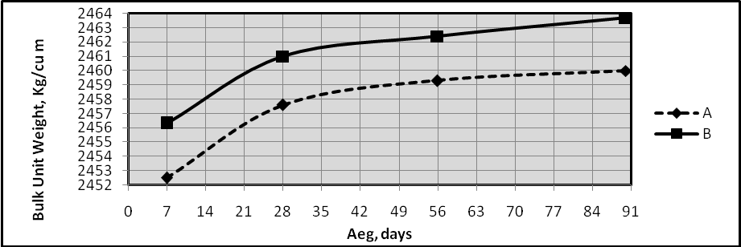
Fig.(1) Bulk Density of the resulting Mixes

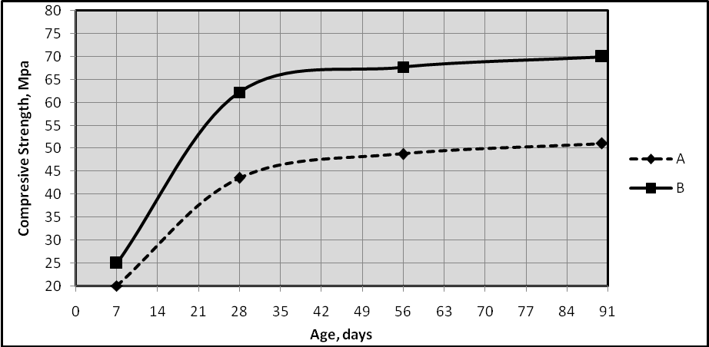
Fig.(2) Compressive Strength Versus Age
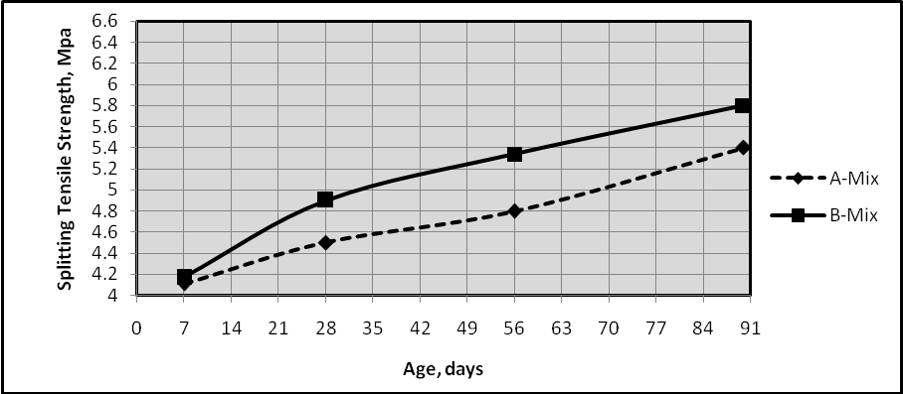
Fig.(3) Splitting Tensile Strength Versus Age

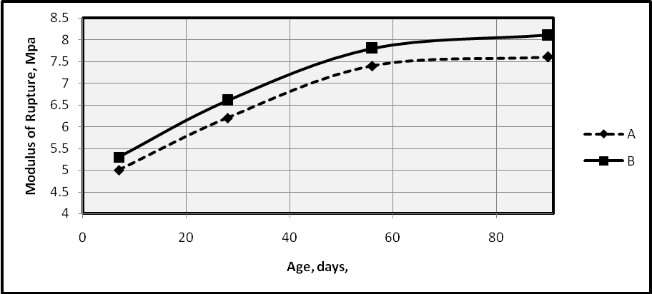
Fig.(4) Rupture Modulus Variation Versus Age

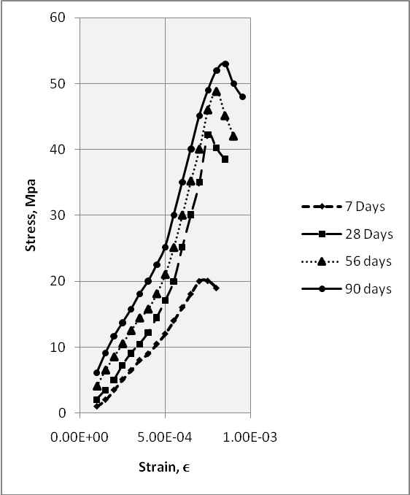
Fig.(5) Stress-Strain Curves of A Mix
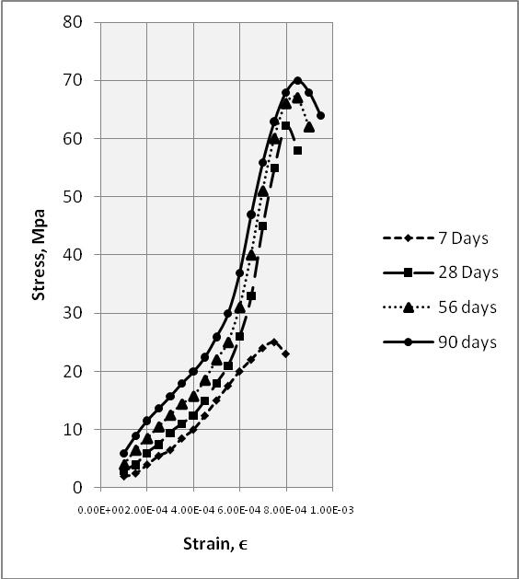
Fig.(6) Stress-Strain Curves of B Mix

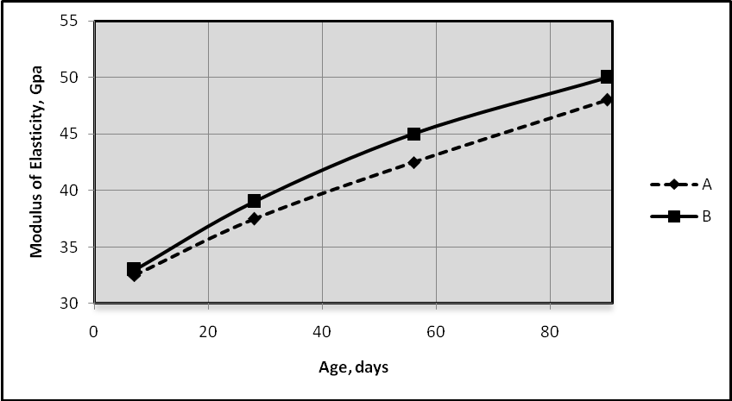
Fig.(7) Elastic Modulus Variation with Age

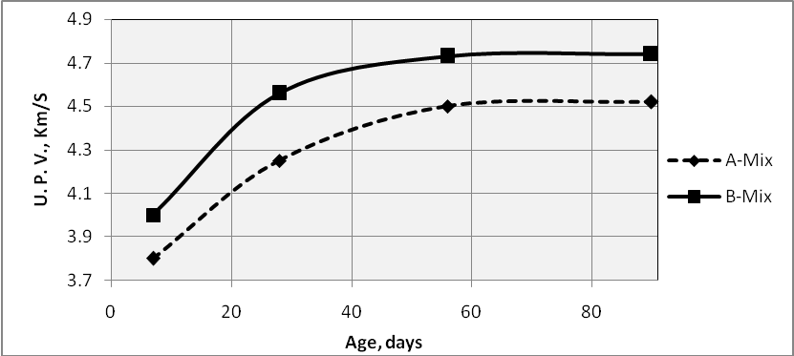
Fig.(8) Ultra Sonic Pulse Velocity Versus Age

Conclusions
Several conclusions may be extracted:
- An acceptable compressive strength up to 70.4Mpa after 90 days curing age is obtained by the use of the Crushed White Gravel of Kerbala Quarries in the concrete mixes design.
- Since the current mixes which are made of Crushed White Gravel of Kerbala Quarries characterized with low workability, thus more plasticizer should be used during mixes design.
- The resulting mixes offer an acceptable modulus of elasticity values up to 50 Gpa.
Recommendations
It is recommended to use the White Crushed Gravel of Kerbala quarries in the manufacturing of high strength concrete mixes ispossible in the middle and south of Iraq under the highlight of this research.

References
Aitcin P. C., , (1998) “High Performane Concrete E & F Span; London, PP.199.
Aitcin P.C. & Mehta P.K, , (1990) “Effect of Coarse Aggregate Charateristics on Mechanical Properties of High Strength Concrete”. ACI Materials Journal, 87, No. 2, 103-107.
Badawy A. A., Sallam H. E. and Seleem M. H., (2007) “Effect of Coarse Aggregate Type and Specimen Geometry on Mechanical Properties of NSC and HSC” Material Eng, Dept., Faculty of Eng., ZagazigUnv., Zagazig, Eygpt.
Bing C. and Juanyu Liu, (2004) “ Effect of Aggregate on the Fracture Behavior of High Strength Concrete” Department of Civil Eng., Shanghai JiaotongUnv. 200240, PR China.
Bing. C., Wu Y., and Dong Z., (2001) “Effect of Coarse Aggregate Type on Mechanical Properties of High Performance Concrete” TongiUnv. Sping Road 1239, Shanghai 200092, China.
Central Organization for Standardization and Quality Control, “ Iraqi Standard Specification (IQS) No.5/1984 Ordinary Portland Cement”, Baghdad, Iraq.
Central Organization for Standardization and Quality Control, “ Iraqi Standard Specification (IQS) No.45/1984 Natural Aggregate Using in Concrete and Building” Baghdad, Iraq.
Chee Khoon, and Wan Chi, , (2011) “The Effect of Coarse Aggregate Saturation Condition on the Properties of High Strength Concrete” Department of Civil Engineering, Unv. Malaysia Samark 94300 Kota Samarahan, Malaysia.
Helland. S., (1996) “Application of High Strength Concrete in Norway”. ACI SP167, 27-54,.
John Newman⁽¹⁾. & Ban SengC⁽²⁾. ,(2003) “Advanced Concrete Technology”. (1) Dpt. Of Civil. Eng. mperial Coll.London. (2)School of the Built Environement Napier Unv. Edinburgh.
Neville A. M., , (2000) “Properties of Concrete”, British Library Cataloguing in Publication Data.
Paramasivam S K., , (2006) “Study on High Performance Concrete Using Sandstone Aggregates”Phd Thesis, Unv. Malaysia Sabah.
Yaqub M. and Imran Bukhari, (2006) “Effect of Size of Coarse on Compressive Strength oh High Strength Concretes” Unv. of Eng. And Technology Texila, Pakistan,.

