Evaluate the Discharge Cofficient of Semi Circular Weir (notch)

Eman Mehdi Al-Mousawi Udai Adnain Jahad Anees Kadhum Idrees AL-Saadi
College of engineering College of engineer College of engineering University of Babylon University of Babylon University of Babylon
eman.mehdi64@yahoo.com eng.udaijahad@yahoo.com anees_al_saadi@yahoo.com
Abstract
The weir applications in the measurement of discharge large and small channels are open in the field or the laboratory, and in general can be defined weir as a handicap regularly happen flow from it. More weirs widespread and commonly used is the weirs sharp with a notch of rectangular and triangular, which is often where the coefficient of discharge cd starts from 0.55 for the rectangular notch and 0.59 for the triangular notch, but these transactions are affected by viscosity and surface tension, roughness of the plate and weir.
In this research was the work of models with semi-circular notch, meaning it took half a circular notch in three different models diameters (6cm, 8cm, 10cm) and operated with hydraulic bench in the laboratory, all models in the same conditions in terms of temperature and for several times and is intended here all models are models of the notch-sections (semi-circular, v-notch and rectangular). The values ​​of discharge coefficient (cd) of the rectangular notch between (0.73- 0.71) while the discharge coefficient (cd) of the V- notch between (0.85- 0.78), while the discharge coefficient (cd) for the half-circular notch between are such that no (0.93- 0.88). To find out the best form of notch weir took the coefficient of discharge (cd) function on it. From above can be inferred that the weirs with a half-circular notch is the best in terms of hydraulic discharge measurement in rectangular notch weirs with and v-notch.
الخلاصة
أن للهدار تطبيقات واسعة في قياس التصاريف الكبيرة والصغيرة للقنوات المفتوحة في الحقل أو المختبر,وبصورة عامه يمكن تعريف الهدار على انه أي عائق منتظم يحدث الجريان من فوقه.أكثر الهدارات انتشارا وشيوعا في الاستخدام هي الهدارات الحادة ذات الثلمة المستطيلة والمثلثة والتي غالبا مايكون فيها معامل التصريف cd يبدأ من 0.55 بالنسبة للثلمة المستطيلة و0.59 بالنسبة للثلمة المثلثة لكن هذه المعاملات تتأثر باللزوجة ,والشد السطحي ,وخشونة صفيحة الهدار.
في هذا البحث تم عمل نماذج ذات ثلمه نصف دائرية, أي انه أخذت الثلمة النصف دائرية بثلاث نماذج مختلفة الأقطار (6 سم, , 8سم,10سم) وشغلت النماذج بأستخدام الطاوله الهيدروليكيه في المختبر(مختبر الهندسه المدنيه) بنفس الظروف من ناحية درجة الحرارة ولعدة مرات ويقصد هنا بجميع النماذج هي النماذج للثلمة ذات المقاطع (نصف دائرية,ومثلثة و المستطيلة). وعند ملاحظة النتائج وجد أن قيم معامل التصريف (cd) للثلمة المستطيلة يتراوح بين(0.73- 0.71) في حين أن معامل التصريف (cd) للثلمة المثلثة يتراوح بين(0.85- 0.78) بينما معامل التصريف (cd) للثلمة النصف دائرية فأنة يتراوح بين (0.93- 0.88). ولمعرفة أفضل شكل لثلمة الهدار أخذ معامل التصريف (cd) كدالة على ذلك.

Introduction:-
A weir is a wall or plate positioned in an open outlet to measure the flow of water. It also refers to a wall or obstacle used to manage the flow from settling tanks and clarifiers to make certain a consistent flow rate and avoid short-circuiting.
The purpose of the weir is to intercept the water flowing down the stream The structure consists of a pond-like basin, a stilling well, a V-notch weir, a flume, and concrete wings, which reach slightly outwards uphill to catch and direct the stream and any nearby ground water into the flume and basin. The weir is anchored in the bedrock so that no water can flow under it. The V-notch functions to control the flow of the water out of the basin. Stream water passes between the concrete wings, through the flume and ponds in the concrete basin. Water flows out through a steel V-shaped notch situated in the basin's downstream wall. The V-notch controls the flow of water out of the pond-like basin and the more water there is coming down the stream, the higher it will rise in the basin and V-notch as it spills over. Flow rates for any given height in the V-notch were measured empirically at the time the weir was installed and are checked periodically. Mathematical functions are prepared which relate the height of the water in the basin to the flow rate. (Michael et al., 2006).
The geometry of the V-Notch weir makes it ideal for accurately measuring both low and high flows. The weirs currently installed at many sites were machined from a ¼” 6061 Aluminum plate. This alloy is both easily machined and is resistant to gathering. The weir plates are securely mounted and sealed to frame in the flow path. The design, construction, and discharge coefficient of the weirs are largely based on the guidelines set in the ASTM Standard Test for Open-Channel Flow Measurement of Water with Thin-Plate Weirs (ASTM, 1996).
(USBR, 1997) provides equations for a "standard" fully contracted rectangular weir and a "standard" suppressed weir. The U.S. Bureau of Reclamation has conducted many weir tests over several decades using weirs with particular dimensions - usually b's in 1 ft. increments up to about 10 ft. Therefore, any weir outside their tested dimensions is non-standard, and their equations should not be used. To provide a single reliable, accurate method to model all rectangular weirs (suppressed, partially contracted, and fully contracted), the Kindsvater-Carter equation (Kindsvater and Carter, 1959) was developed. It is more complex than the USBR standard weir equations. However, USBR (1997) states that the Kindsvater-Carter method is at least as accurate, if not more, than the standard weir equations for suppressed and fully contracted weirs. And further, the Kindsvater-Carter equation reliably models partially contracted weirs. ISO (1980), ASTM (1993), and USBR (1997) all recommend using the Kindsvater-Carter method for all rectangular weirs. (Kindsvater, C. et al., 1959).
(Fadda D. et al., 1997). Most of them considered a simple geometrical shape and rectangle meshes were employed. There is little investigation on the flow over a semicircular weir, and scarcely any detailed and systematical work that studied the flow patterns over a semicircular weir, the separation and reattachment of the flow over the weir and the distribution of the bottom shear stress. In this paper the turbulence flow over a semicircular weir is investigated. In order to adapt the geometrical shape of the boundary, the unstructured mesh is employed. The method of VOF is adopted to trace the free surface. For the unstructured mesh, the shape of the free surface is difficult to simulate accurately. In this paper the geometric reconstruction approach is used to improve the accuracy of the calculation. The standard k-~ model is used for the turbulence closure. Four types of flow patterns: surface jet; surface wave; plunging jet and hydraulic jump are presented in the paper. The effects of Reynolds number Re, Froude number Fr and the ratio of weir height to water depth D/H on the flow patterns are discussed. The position of the separation and reattachment of the flow over the weir and the bottom shear stress at downstream of the weir are also studied and discussed. The flow patterns have been visualized in water tunnel and the flow velocity at downstream of the weir are measured by means of LDV method. The bottom shear stress is calculated according to the velocity profile. The numerical results are compared with the experimental results.

Case study
The main objective of the research is to find the values ​​of coefficient of discharge cd to the type of proposal for a semi-circular notch and compare this with the coefficients of the common notches (triangular and rectangular notch) hydraulically.
Semicircular weir (notch)
A semicircular broad crested weir consists of an obstruction in the form of a raised portion of bed extending across the full width of the channel. This raised portion has a shape of semicircle. The basic difference between broad crested weir and the present model is the curvature of stream lines. The effect of curvature is to produce appreciable acceleration components or centrifugal forces normal to the direction of flow (Chow, 1959).
Another feature of this model that it has larger discharge capacity than the broad crested weir and sharp crested weirs. Related applications include three models of polished wood models with different radius of curvature. In the present study the models calibrated to determine the relation between the head and rate of discharge. Semicircular weir is a new type of construction developed in 1990's. It has many advantages compared with other types of weirs. So this type of weir is used in hydraulic engineering recently. It is very important to investigate the behaviors of the flow over the weir, the bottom shear stress and the local scour around the semicircular weir. There are a number of numerical studies on water flow over obstacles, most of which are based on the in viscid model (Lamb H.,1945; Forbes LK, Schwartz LW.,1982 ; Dias and Broeck(Dins F, Vanden Broeck JM.1989). For the condition of small deformed free surface, the motion of the free surface can be simulated by an in viscid model. When the free surface undergoes a large deformation with turbulence, the in viscid model is invalid. The method of Volume of Fluid (VOF) (Hirt CW, Nichols BD. 1981) developed in 1980's is suitable to simulate the condition of large deformed free surface. This method is used to investigate the hydraulic jump and breaking waves (Liu QC., 2000).
Theoretical Background
Can be described as equivalent discharge passing over a rectangular open as follows:
Qa= cd*2/3*(2g) ^{0.5} *L*h ^{(3/2)} ------------ (1)
Can be described as equivalent discharge passing over v-notch open as follows:
Qa=18/5*cd*(2g)^{0.5}*tan(ϕ /2)*h^{2.5} ---------------(2)
Can be described as equivalent discharge passing over a semicircular open as follows:
Qa=cd (2gh) ^{0.5}*(d²/16(Ө -sin θ)) ------------ (3)
Where:
Qa = Actual flow rate (m³/s).
Qth = Theoretical flow rate (m³/s).
g = gravity (m/s²).
cd = is the coefficient of discharge (varies).
L= width of Rectangular Weir (m).
h = head of water on weir (m).
ϕ = angle of V-Notch (varies).
θ = angle of semicircular (varies).
d=diameter of the weir (m).
Va= Actual velocity (m/s).

Experimental Work
For measuring large and small open flows in field or laboratory, the weir field wide application. A weir may be defined in a general way as “any regular obstruction over which flow occurs," thus, for example, the overflow section (spillway) of a dam is a special type of weir and may be utilized for flow measurement. However, weirs for measuring purposes are usually of more simple and reproducible form, consisting of smooth, vertical, flat plates with upper edges sharpened. Such weir, called sharp crested weir, appear in a variety of forms, the most popular of which is the rectangular weir, this type has a straight, horizontal crest and extend over the full width of the channel in which it is placed. The flow picture produced by such a weir is essentially two-dimensional and for this reason. (Johnk. Vennard, Robert L. Street, (1957)).

Method of Experiment
The principle steps that depended on it in Method of experiment:
1. Proven notch plate (rectangular) in the space provided in the channel of Hydraulic bench.
2. Equipped with water to the channel that begins to rise above the bottom edge of the notch and then stopped processing and let the water settle at the bottom edge of the notch.
3. Prepare the bench with electricity and hydraulic pump equipped with water supply.
4. Waiting for the stable flow (4-8) minute to run consistently discharge.
5. Move the hook gauge and level so that the water level corresponding "zero line on the hook gauge (must be placed level on a scale appropriate distance on the front notch.
6. Prepare a water of the channel so that increasing the amount of cargo over the notch of varying amount, each one centimeter or so. "
7. Record volume of water accumulated in the tank with the time for each case.
8. Repeat the process on points of (1-5) for the other runs.
9. Replace the paper plate rectangular notch, with triangular notch and semicircular notch and count the steps above.
- Used both notches laboratory (triangular and rectangular) and have been working different diameter types of semi-circular notch with diameter (6cm, 8cm and10cm).
- Figures (1) and (2) show the Experimental work in the lab.

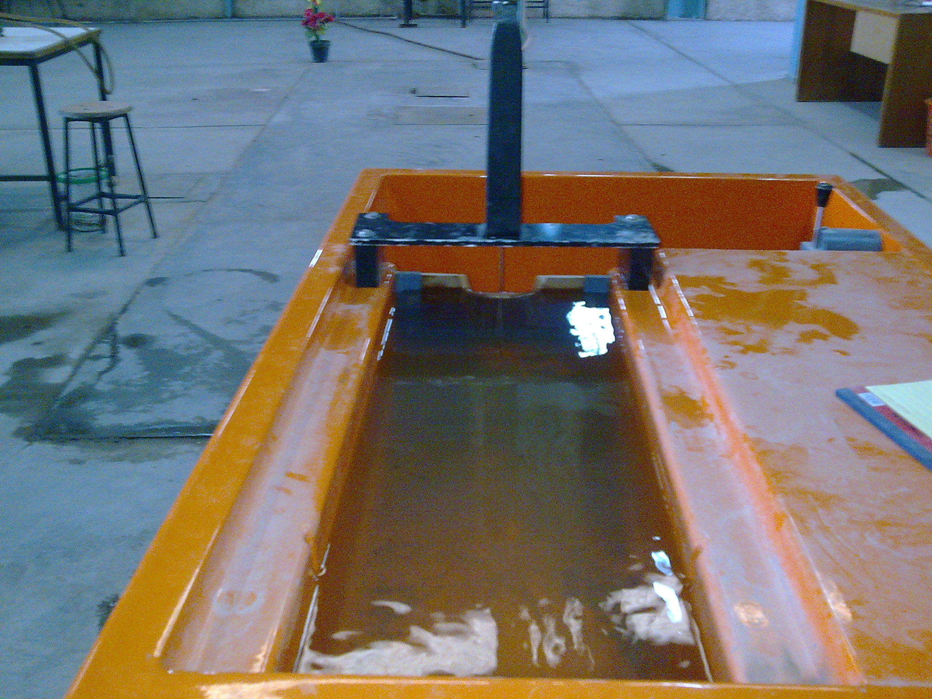
Fig (1) The experimental work in the lab

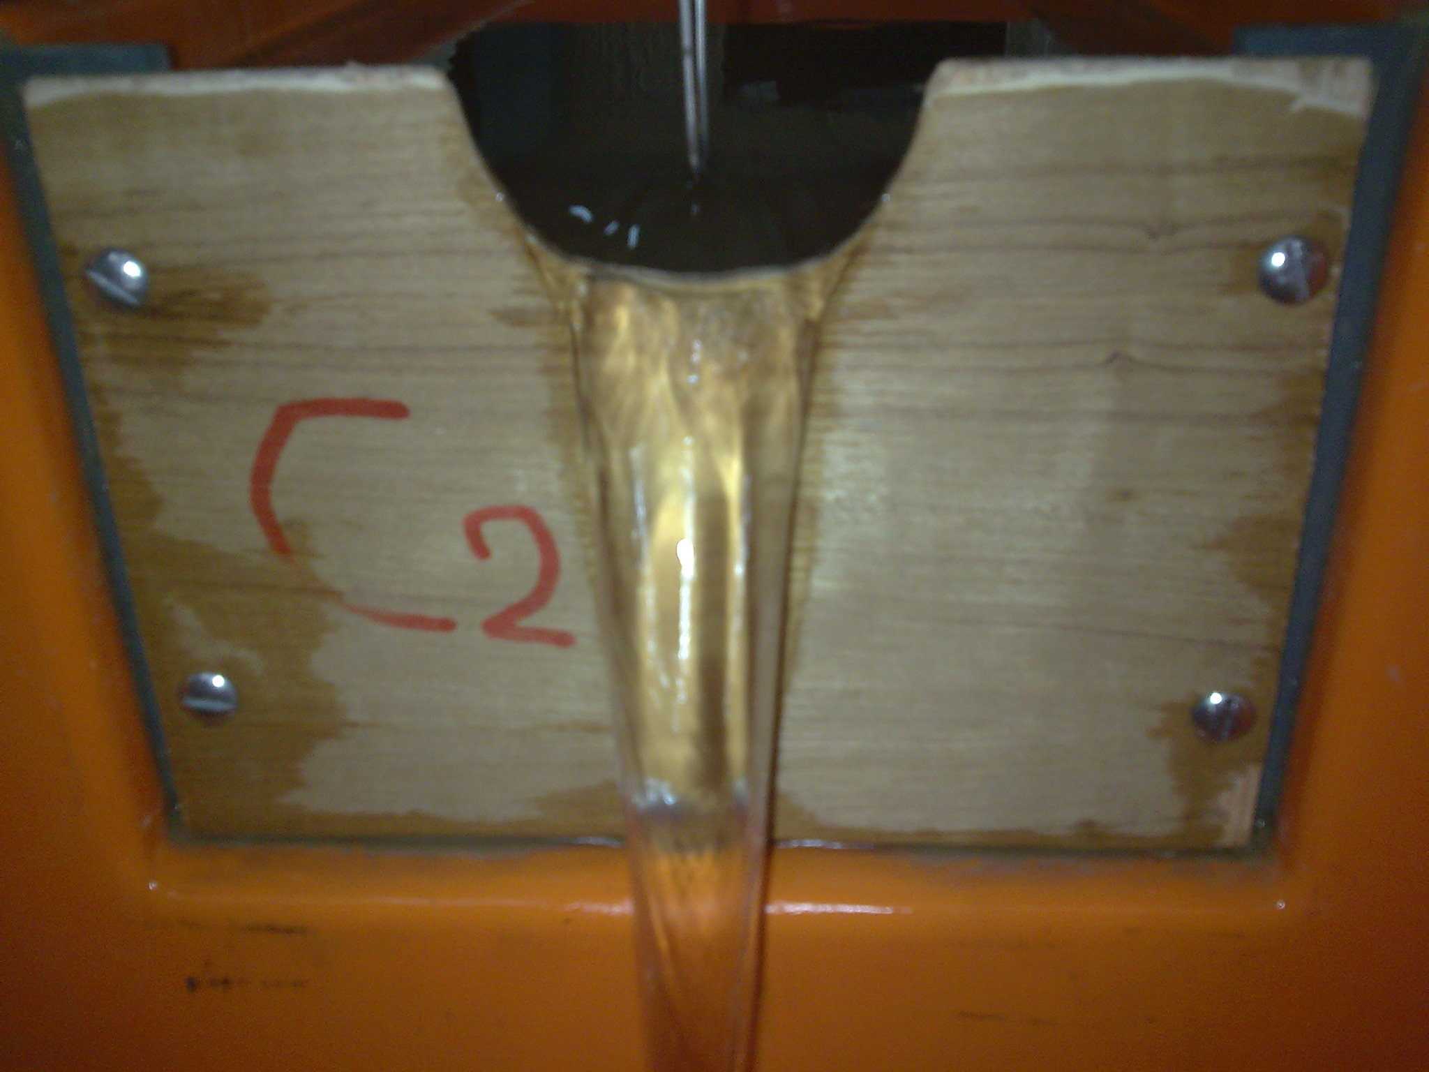
Fig (2) The semicircular weir (d=10 cm) in the lab

Example for Calculations
To show the calculations take examples below for each the types of weirs that used in the work.
1. Rectangular weir
Take rectangular weir as the example.
Example: Take run No. 1 as example.
Data: vol=0.0017m³,Time=29 s , H=0.0095m
By equation Q=V/T
Q= 0.0017 /29 =0.0586 m³/s
By equation (1).
Q= cd*2/3*(2g) ^{0.5} *L*h ^{(3/2)}
cd=Q/(2/3*(2g)^{0.5}*L*h ^{3/2})
cd=0.0586/(2/3*(2*9.81)^{0.5}*0.03*0.0095^{(3/2)})
cd=0.71
2. V-notch weir
Take v-notch weir as the example.
Example: Take run No. 1 as example.
Data: vol=0.002 m³, Time=49s ,H=0.014m
By equation Q=V/T
Q=0.002/49=0.0408 m³/s
By equation (2).
Qa=18/5*cd*(2g)^{0.5}*tan(θ /2)*h^{2.5}
cd=Q/18/5*(2g) ^{0.5}*tan(ө/2)*H ^{2.5}
cd=0.0408/(18/5*(2*9.81)^{0.5}*tan(90/2)*0.014^{2.5}
cd=0.75
3. Semicircular weir (d=6 cm).
Take semicircular weir (d=6 cm) as the example.
Example: Take run No. 1 as example.
Data: vol=0.0036 m³, Time=31.1 s, H=0.0246 m
By equation Q=V/T
Q= 0.0036/31.1=0.116×10⁻³ m³/s
By equation : Qa=cd(2*gh)^{0.5}*(R²/32*(Ө-sin ө))
cd=Q/(2gh)^0.5*(d^2/16(Ө-sinө))
cd=0.116×10⁻³/(2*9.81*0.0246)^0.5*(0.06^2/16(1.389-0.98))
cd=0.90
4. Semicircular weir (d=8 cm).
Take semicircular weir (d=8 cm) as the example.
Example: Take run No. 1 as example.
Data: vol=0.0029 m³, Time=13.8 s, H=0.031m
By equation Q=V/T
Q= 0.0029/13.8= 0.21×10⁻³m³/s
By equation: Qa=cd(2*gh)^{0.5}*(R²/32*(Ө-sin ө))
cd=Q/(2gh)^0.5*(d^2/16(Ө-sinө))
cd=0.21×10⁻³ /(2*9.81*0.031)^0.5*(0.08^2/16(1.343853-0.974))
cd=0.91.
5. Semicircular weir (d =10 cm)
Take semicircular weir (d=10 cm) as the example.
Example: take run No. 1 as example
Data: vol=0.00017 m³, Time=46 s , H=0.0068 m
By equation Q=V/T
Q= 0.00017/46= 0.037×10⁻⁵ m³/s
By equation: Qa=cd(2*gh)^{0.5}*(R²/32*(Ө-sin ө))
cd=Q/(2gh)^{0.5}*(d²/16(Ө-sinө))
cd=0.037×10⁻⁵ /(2*9.81*0.0068)^{0.5}*(0.1²/16(0.370904-0.362))
cd=0.91
Results
The results of the all work can be shown in figures and table below:-

Fig (3) Rating rectangle weir.

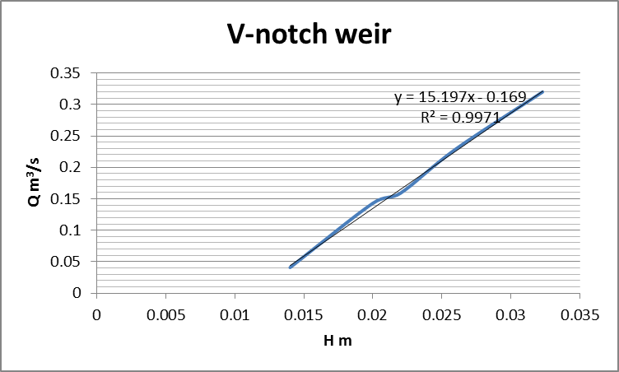
Fig (4) Rating v- notch weir.
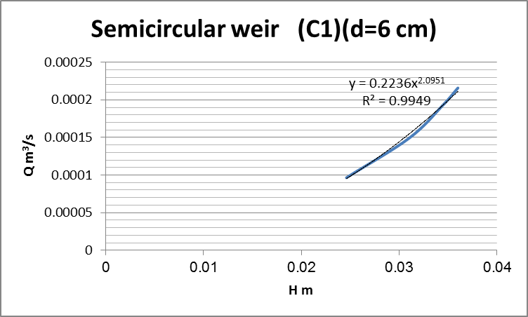
Fig (5) Rating of semicircular weir (d=6 cm).

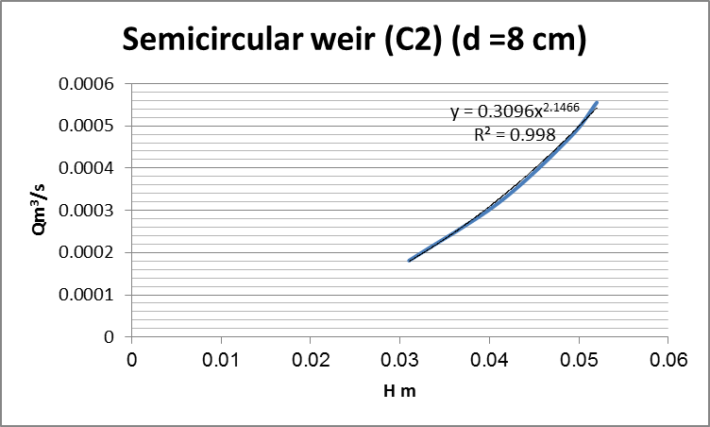
Fig (6) Rating semicircular weir (d=8cm).
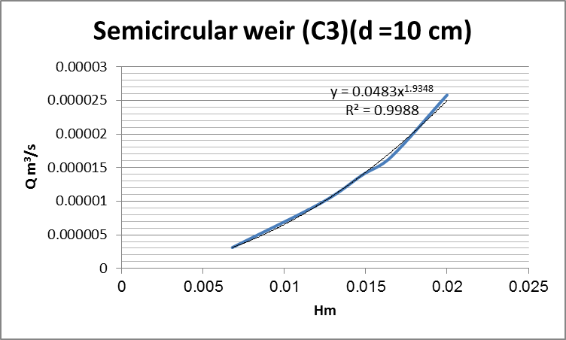
Fig (7) Rating of semicircular weir (d=10 cm).

Table (1): values of discharge coefficient

Run No. | cd of rectangle weir | cd of v- notch weir | cd of semicircular weir (d=6 cm) | cd of semicircular weir (d=8cm) | cd of semicircular weir (d=10 cm)
1 | 0.71 | 0.75 | 0.90 | 0.91 | 0.91
2 | 0.72 | 0.84 | 0.92 | 0.91 | 0.90
3 | 0.73 | 0.82 | 0.93 | 0.90 | 0.90
4 | 0.72 | 0.85 | 0.89 | 0.88 | 0.91
5 | 0.73 | 0.79 | 0.91 | 0.93 | 0.93
Average cd | 0.722 | 0.816 | 0.91 | 0.906 | 0.91
Conclusions
Through experiments erected on the notch (Rectangular, V-Notch and Semicircular) has been obtained for discharge coefficient cd as follows:-
1. Rectangular notch cd= (0.71- 0.73)
Average (cd) = 0.722
2. V-Notch cd= (0.78-0.89)
Average (cd) = 0.816
3. Semi- circular notch
- Semi- circular notch (d=6 cm) cd=(0.89- 0.93)
Average (cd) = 0.91
- Semi- circular notch (d=8 cm) cd=(0.89- 0.93)
Average (cd) = 0.906
- Semi- circular notch (d=10 cm ) cd=(0.90- 0.93)
Average (cd) = 0.91
- AVETAGE cd=0.909
From above we note that the values cd in the semi-circular notch is the best in terms of being a once hydraulic values ​​cd higher than the other notches.
Recommendations
Recommendations can be included in points below: _
1. Recommended to use semicircular notch in the field measurements and laboratory being given discharge coefficients higher than their counterparts (rectangle, v-notch).
2. Re-work the other forms by adding sections (trapezoidal section EQ, and a section of trapezoidal half hexagonal).
References:
ASTM ,1993. American Society for Testing and Materials. ASTM D5242. Standard method for open-channel flow measurement of water with thin-plate weirs. 1993.
ASTM ,1996. "Standard Test Method for Open-Channel Flow Measurement of Water with Thin-Plate Weirs," D 5242-92(Reapproved 1996), American Society of Testing and Materials, West Conshohocken, PA.
Chow, 1959, V.T. ,"Open Channel Hydraulics", McGraw-Hill Book Co. , 1959.
Dins F, Vanden Broeck JM,1989. Open channel flow with submerged obstacles. J Fluid Mech, 1989,206:155~170.
Fadda D, Rand PE.,1997 "Open channel flow over submerged obstructions: an experimental and numerical study". J Fluids Eng, 1997, 119:906~910.
Forbes LK, Schwartz LW,1982. Free-surface flow over a semicircular obstruction. J Fluid Mech, 1982,114:299N314.
Hirt CW, Nichols BD., 1981. Volume of fluid (VOF) method for the dynamics of free boundaries. Comput Phys, 1981, 39:201~, 225.
ISO ,1980. International Organization of Standards. ISO 1438/1-1980(E). Water flow measurement in open channels using weirs and venturi flumes - Part 1: Thin plate weirs. 1980.
Johnk. Vennard, Robert L. Street,(1957)."Elementary Fluid Mechanics" SI version.
Kindsvater, C. E. and R. W. Carter. 1959. “Discharge characteristics of rectangular thin-plate weirs”. Transactions, American Society of Civil Engineers. v. 24. Paper No. 3001.
Lamb H. Hydrodynamics. Dover, 1945 "Open channel flow".
Liu QC, Chen CT,2000. “Numerical study of turbulence characteristics in hydraulic jumps”. Chinese J Hydraulics, 1993, 1:1~10 .. Bradford SF. Numerical simulation of surf zone dynamics. J Waterway Port Coastal and Ocean Eng, 2000, 126:1~13 .
Michael Robinson, Robert Houghtalen,(2006) "Dangerous dams". Rhode Island Canoe/Kayak Association (Rhode Island ).
USBR ,1997. U.S. Department of the Interior, Bureau of Reclamation. Water Measurement Manual. 1997.

