Numerical Analysis of Non-Prismatic Beam on Elastic Foundation under Generalized Loadings

Najla'a H. AL-Shareef
Civil Eng./Babylon University
Abstract:
The main aim of this paper is to investigate the linear elastic behavior of non-prismatic beam on Winkler foundation. The finite differences method was used to solve the governing differential equations for different configurations of non-prismatic cross-section and loading cases with different end supports. The results from these different cases are plotted together and check the accuracy of the solutions, which referred to the good efficiency of this analysis. The results indicated that present non-prismatic beam decreasing in deflection for longitudinal direction (width of beam b) and transverse direction (depth of beam h) about (80.67-81.81%)and(75.99-81.81% ) , respectively for different cases of loading. The results indicated that the value of Bending Moment is increasing for different cases of loading for non-prismatic beam compared with prismatic beam about (68.53-96.5%), while decreasing in Shear force due to point load at mid span about (51.64%).
Key words: Non-prismatic beam, Foundation, Winkler, Finite difference, Loading.
الخلاصة:
إن الهدف الرئيسي لهذا البحث هو دراسة التصرف المرن للعتبات قليلة العمق وذات المقاطع الغير متماثلة والمستندة على الأساس المرن لـ(Winkler). في حل المعادلات الحاكمة استخدمت طريقة الفرو قات المحددة. تم اشتقاق صيغ موسعة بالفرو قات المحددة لمعالجة حالات مختلفة من الأعتاب الغير متماثلة المقطع وكذلك حالات مختلفة للأحمال العرضية. تم رسم النتائج لحالات مختلفة لغرض المقارنة ومعرفة دقة الحلول وقد أشارت النتائج إلى كفاءة الطريقة المستخدمة . من أهم النتائج التي توصل إليها البحث هو التأثير السلبي المتفاقم لتغيير المقطع في منطقة عزم الانحناء الأكبر. حيث يصل الاختلاف إلى (80.67-81.81%) و (75.99-81.81% ) في الهطول في حالة التغيير بعرض المقطع و بعمق المقطع على التوالي. وتشير النتائج أيضا إلى زيادة في العزوم بنسبة تتراوح من (68.53%)إلى96.5%)) لحالات مختلفة من التحميل بينما أشارت النتائج إلى نقصان بقوى القص بنسبة (51.64%) في حالة التحميل بمنتصف العتب.
Notation
w = w(x) is the deflection (m).
u = u(x) is the horizontal displacement in the neutral axis (m).
K_{z}= modulus of sub grade reaction in z-direction multiplied by the width of the beam (b),(kN/m³).
E = modulus of elasticity of the beam material,(kN/m²).
I= moment of inertia of the beam section (m⁴)
A=cross-sectional area of the beam(m²).
b= width of the beam,(m). h= depth of the beam,(m), Δx= small divided piece on x-axis.
q=q(x) is the intensity of the distributed loading on the beam ,(kN/m).
$Μ_{Ο}$and $Ρ_{o}$ = the concentrated moment and load at free edge .

1.Introduction
Non prismatic beams have been used in various structure including buildings and bridges since the ﬁrst decades of the previous century, with an increasing application as the structural engineering techniques were improving. (Khan and Al-Gahthi 1995), presented an exact solution of continuous
solutions for non-prismatic beams of linear and parabolic profiles are derived and exact relations are obtained in terms of the variables over the nodes( beam supports) . Much research has examined different methods to retrieve the stiffness matrix for the non prismatic beam element. These methods involve direct integration of the governing differential equations . (Just, 1977; Karabalis and Beskos, 1983; Biondi and Caddemi, 2007), modifyed stiffness methods to consider tapering (Portland Cement Association (PCA), 1958; El-Mezaini et al., 1991; Balkaya, 2001), established the ﬂexibility matrix and inversing it (Eisenberger, ; Vu-Quoc and Léger, 1992; Frieman and Kosmatka, 1992; Frieman and Kosmatka, 1993; Tena-Colunga, 1996), and apply transfer matrices (Luo et al., 2007; Luo et al., 2006). All these methods may suffer the following deﬁciencies: 1. Some of these methods will recover the stiffness matrix for some special simple cases of tapering such as linear or parabolic depth variation along rectangular or I-shaped beams; while for other cases, they will be frustrated due to complex representation of shape functions and stiffness matrices (Karabalis and Beskos, 1983; Brown, 1984; Banerjee andWilliams, 1986). 2. Some of these methods, such as establishing the ﬂexibility matrix and inversing it, will only retrieve the stiffness matrix, and are unable to recover the shape functions, which might be necessary for the analysis procedure based on stiffness formulation (Eisenberger, 1985; Tena-Colunga, 1996). (Ali 2010) dealt with the linear elastic behavior of thin beam with openings on Winkler foundation, with both normal and tangential frictional resistances. The finite difference method was used to solve the governing differential equations for different configurations of openings and loading cases including both transverse loads and external moments
This paper is an attempt to analysis non-prismatic beams with different configurations of cross-section on Winkler type foundation by the method of finite differences.
2.Formulation
Due to the complexity of this problem, assumptions are made to obtain easier and acceptable solutions. The classical theory of beams bending [Euler-Bernoulli theory]is based on certain simplifying assumptions :
1. The plane transverse sections will remain plane after bending (no warping).
2. The normal lines to the middle plane will remain normal to the deflected middle plane (no shear deflection).
3. Normal strain (Єz)in the normal direction is zero.
4. The compression restraint is assumed to be proportional to the transverse displacement while the frictional restraint is considered to be proportional with horizontal displacement (Winkler model).
According to the small deflection theory and linear stress-strain relationships, the governing equations for thin beam on elastic foundation shown below [Hetney]:
(1-a)
(1-b)
Where:
w = w(x) is the deflection (m)
u = u(x) is the horizontal displacement of the neutral axis (m)
K_{z}= modulus of sub grade reaction in z-direction to be multiplied by the width of the beam (b) ,(kN/m²).
K_{x}= modulus of sub grade reaction in x-direction to be multiplied by the width of the beam (b) ,(kN/m²).
E = modulus of elasticity of the beam material,(kN/m²).
I= moment of inertia of the beam section (m⁴)
A=cross-sectional area of the beam(m²).
b= width of the beam,(m).
h= depth of the beam,(m).
q=q(x) is the intensity of the distributed loading on the beam ,(kN/m).

2. Numerical Solution by Finite Differences Method
For the interior nodes, the central difference is always for node (i), while backward or forward difference is used for edge nodes. The central difference for the first, second, and fourth derivatives are:
${\left(\frac{\text{dy}}{\text{dx}}\right)}_{i}=\frac{−y_{i−1}+y_{i+1}}{2Δx}$ (2)
${\left(\frac{d^{2}y}{{\text{dx}}^{2}}\right)}_{i}=\frac{y_{i−1}−2y_{i}+y_{i+1}}{{\left(Δx\right)}^{2}}$ (3)
${\left(\frac{d^{4}y}{{\text{dx}}^{4}}\right)}_{i}=\frac{y_{i−2}−4y_{i−1}+6y_{i}−4y_{i−1}+y_{i+2}}{{\left(Δx\right)}^{4}}$ (4)
Where
y= is the function of w or u
Δx= small divided piece on x-axis
The basic equations (1 –a and b) in finite differences are applied at any node (i), as follows:

i+1
i
i-1
3
2
1
n
n-1
n-2
edge nodes
Interior nodes

edge nodes

Fictitious
nodes
Fictitious
nodes
ΔX
ΔX

Fig.(1) FDM discretization of the elastic beam

$\frac{w_{i−2}−4w_{i−1}+6w−4w_{i+1}+w_{i+2}}{{\left(Δx\right)}^{4}}+\frac{{\left(Κ_{z}\right)}_{i}}{{\left(\text{ΕΙ}\right)}_{i}}w_{i}+\frac{{\left(Κ_{x}\right)}_{i}}{2{\left(\text{ΕΙ}\right)}_{i}}\left\{\left(\frac{u_{i+1}−u_{i−1}}{2Δx}\right)−\frac{h}{2}\text{.}\frac{w_{i−1}−2w_{i}+w_{i+1}}{{\left(Δx\right)}^{2}}\right\}=\frac{q_{i}}{{\left(\text{ΕΙ}\right)}_{i}}$ (5-a)
$\frac{{\left(Κ_{x}\right)}_{i}h}{2{\left(\text{ΕΑ}\right)}_{i}}\text{.}\frac{w_{i+1}−w_{i−1}}{2Δx}−\frac{{\left(Κ_{x}\right)}_{i}}{{\left(\text{ΕΑ}\right)}_{i}}u_{i}+\frac{u_{i−1}−2u_{i}+u_{i+1}}{{\left(Δx\right)}^{2}}=0$ (5-b)
And in simple form, becomes:
(6-a)
$\frac{−{\left(Κ_{Χ}\right)}_{i}h_{i}Δx}{4{\left(\text{ΕΑ}\right)}_{i}}w_{i−1}+\frac{{\left(Κ_{Χ}\right)}_{i}h_{i}\left(Δx\right)}{4{\left(\text{ΕΑ}\right)}_{i}}w_{i+1}−\left(2+\frac{\left(Κ_{Χ}\right)i{\left(Δx\right)}^{2}}{{\left(\text{ΕΑ}\right)}_{i}}\right)u_{i}+u_{i−1}+u_{i+1}=0$ (6-b)
3. Modeling of Different Configurations of Applied Loadings
Different types of the applied loads can be treated and simulated as uniform load per unit length (q) along the piece (Δx), as follows:
- distributed load of any function q(x):
Here, calculate the area under the curve q(x) for distance (Δx/2) on each side of node (i) and then divided by Δx, as follows

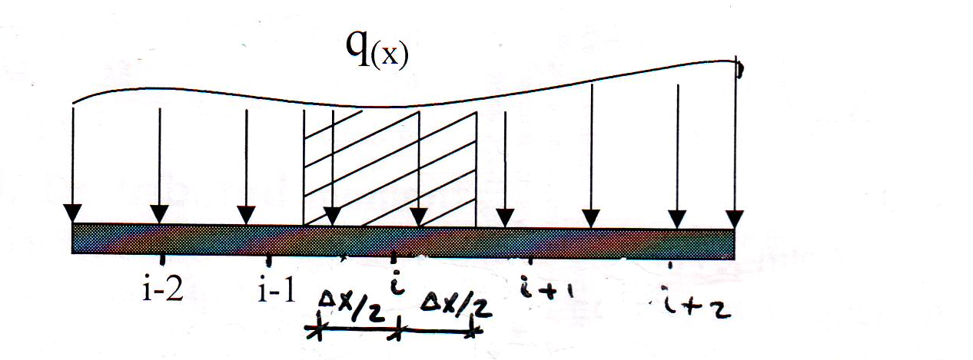
ΔX
ΔX

Fig.(2)UDL on elastic beam and distributed of nodes

(7)
- concentrated loads
For any node (i) , uniformly distributed load transform to concentrated load acting on the nodes as follows:
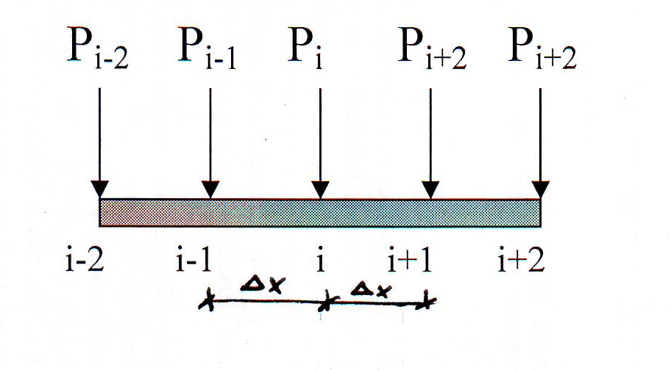
$q_{i}=\frac{Ρ_{i}}{Δx},q_{i−1}=\frac{Ρ_{i−1}}{Δx},q_{i+1}=\frac{Ρ_{i+1}}{Δx}\text{.}\text{.}\text{.}\text{.}\text{.}\text{.}\text{.}\text{.}\text{.}\text{.}\text{.}\text{.}\text{.}\text{.}\text{.}\text{etc}$ (8)
ΔX
Fig.(2)Point Load on elastic beam and distributed of nodes

4. Boundary Conditions and Internal Forces
The boundary conditions are:
- simply supported edge
No deflection, this gives w_{o}=0 (9a)
No bending moment , this gives M_{o}=0 and then w₁= - w₋₁ (9b)
b. fixed supported edge
No deflection, this gives w_{o}=0 (10a)
No rotation , this gives ${\left(\frac{\text{dw}}{\text{dx}}\right)}_{o}=0$, and then w₁ =w₋₁ (10b)
- free edge with concentrated moment and load
$Μ=Μ_{Ο}=−\text{ΕΙ}{\left(\frac{d^{2}w}{{\text{dx}}^{2}}\right)}_{Ο}=−\text{ΕΙ}\frac{w_{−1}−2w_{o}+w_{1}}{{\left(Δx\right)}^{2}}$ (11a)
$V=Ρ_{o}=−\text{ΕΙ}{\left(\frac{d3w}{\text{dx}3}\right)}_{Ο}=−\text{ΕΙ}\frac{−w_{−1}+3w_{o}−3w_{1}+w_{2}}{{\left(Δx\right)}^{3}}$ (11b)
Where $Μ_{Ο}$and $Ρ_{o}$ are the concentrated moment and load at free edge .
On the other hand, the internal forces ((bending moment and shearing force)) can be determined from strength of materials, as follows [Temoshenko] :
$Μ_{\left(Χ\right)}=−\text{ΕΙ}\frac{d^{2}w}{{\text{dx}}^{2}}$ (12a)
and
$V_{\left(Χ\right)}=−\text{ΕΙ}\frac{d^{3}w}{{\text{dx}}^{3}}$ (12b)
In finite difference, at node (i) the internal forces become:
$Μ_{i}=−\text{ΕΙ}\frac{w_{i−1}−2w_{i}+w_{i+1}}{{\left(Δx\right)}^{2}}$ (13a)
and
………forward (13b)
Or:
………backward (13c)
5.Applications
In this section, a examples of non-prismatic beam are analyzed using two cases of boundary conditions: simple supports and fixed supports. Different loading conditions are applied to both cases and the results obtained using the proposed model are validated against those derived from classical solution methods.
5.1 Non-Prismatic beam in depth
In this case , to check the accuracy of the method of finite differences in this field. In Figs.(3), simply supported non-prismatic beam under uniformly distributed load, point load at mid span and two points load on elastic foundation for two ended supported , in condition for all non-prismatic beams are the same volume concrete . In this case studied three ratios of depth for beam section (h₂=h₁, h₂=1.5h₁ and h₂=2h₁) were considered as listed below.
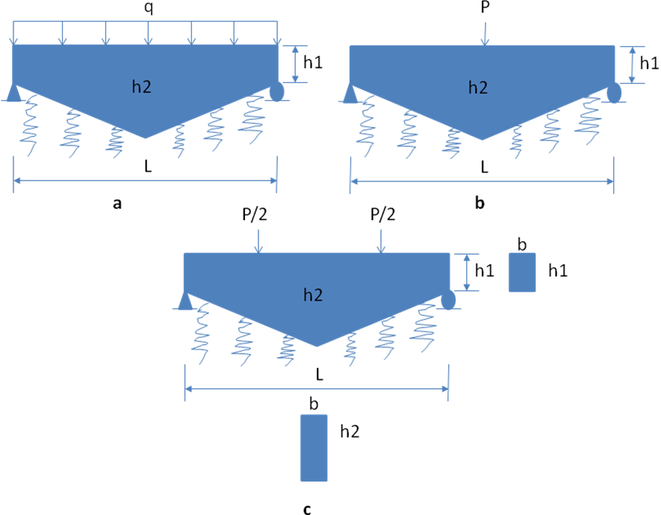
Fig.(3) Non-Prismatic Beam (1) a) UDL(20kN/m) b) Point load(P=100kN) c) Two Points Load(P/2
b₁= h₁=.25m
L=5m, Δ_{x}=.5m
E=25*10⁶kN/m²
K_{z}=10⁴kN/m³

The results of these cases are compared with those available from theory [Hantny 1974] and compared with prismatic beam (h₂=h₁) [Ali 2010] as shown in Figs. (4,5 and 6).
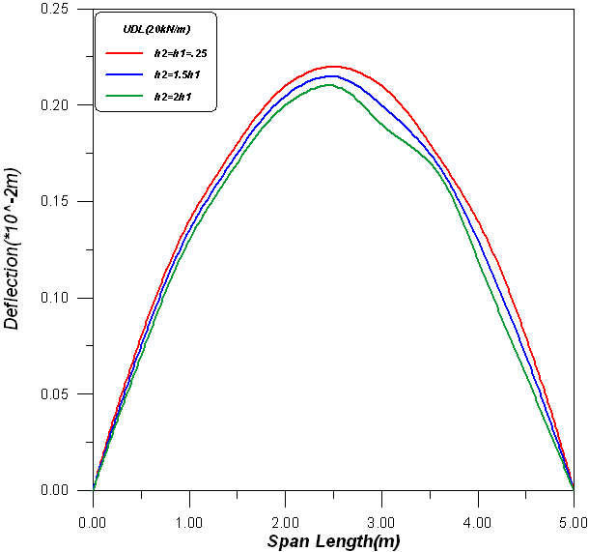
Fig(4) Non-prismatic beam(1) under UDL

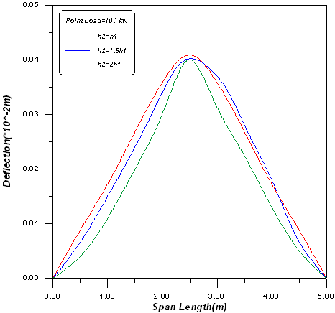
Fig(5) Non-prismatic beam(1) under point load at mid span

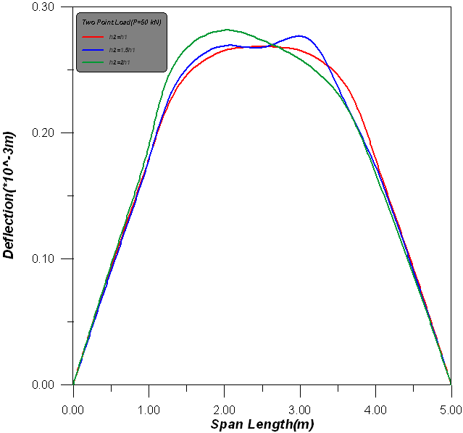
Fig(6) Non-prismatic beam(1) under Two Point Load at L/3 of span

The results indicated that present non-prismatic beam decreasing about (76%) in deflection due to UDL when h₂=2h₁ , (80.9% )in deflection under point load at mid span when h₂=2h₁ and (81.81%) in deflection due to two point load (P/2)when h₂=1.5h₁. The maximum deflection happen in UDL when h₂=h₁ , it's obtain in figs.(7).

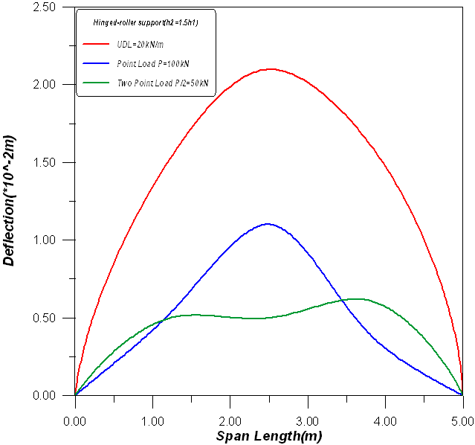
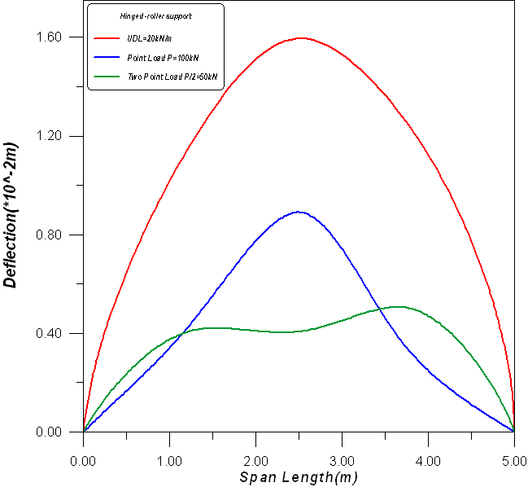

(b)
Fig(7) Effect of Different types of load on the non-prismatic beam(1) deflection.
h₂=1.5h₁ b. h₂=2h₁
(a)

Figs.(8a,b and c) show the maximum bending moment and shear force occur in non-prismatic beam with h₂=1.5h₁ under uniformly distributed load and the percent of increasing in bending moment for non-prismatic beam comparing with prismatic beam about (83.53%) , while decreasing in Shear force due to point load at mid span about (51.64%).

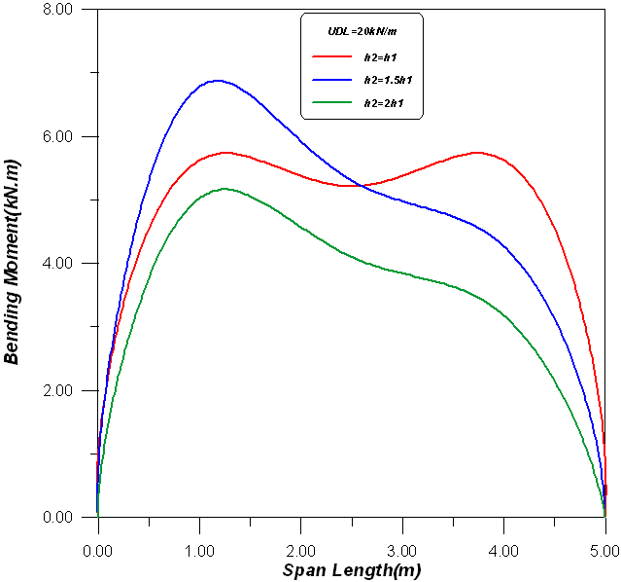
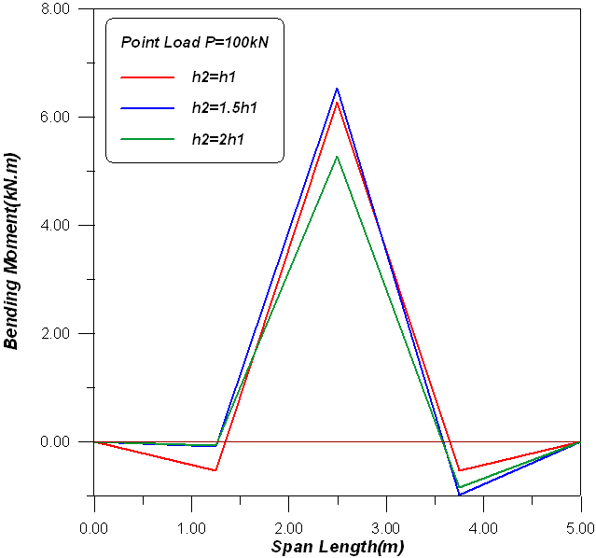

(a)
(b )

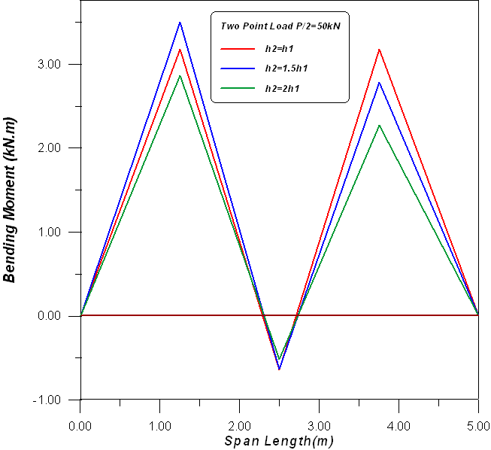

(c)

(c)
Fig.(8) Bending moment for non-prismatic beam (1) under different types of loading.
UDL b. Point load at mid span c. Two point load

For different cases of end supports and their effective on deflection for non prismatic beam which indicated in fig.(9), the result show different about (88.81%) decreasing in deflection due to point load at mid span with simply supported beam.

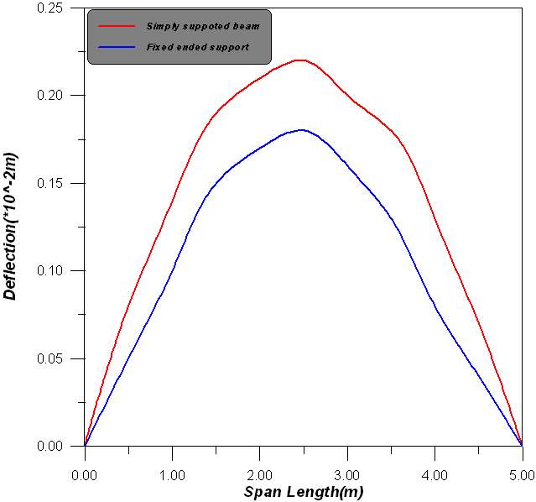

Fig.(9) Non-prismatic beam (1) under point load at mid span with different types of supported.

5.2 Non-Prismatic beam in width
This case study, includes three different value of width for beam (b₂=b₁ , b₂=1.5b₁ , b₂=2b₁ and depth is constant h=.25m ) in top view are shown in fig.(10). Simply supported non-prismatic beam(2) under uniformly distributed load, point load at mid span and two points load on elastic foundation for two ended supported , in condition for all non-prismatic beams are the same volume concrete .

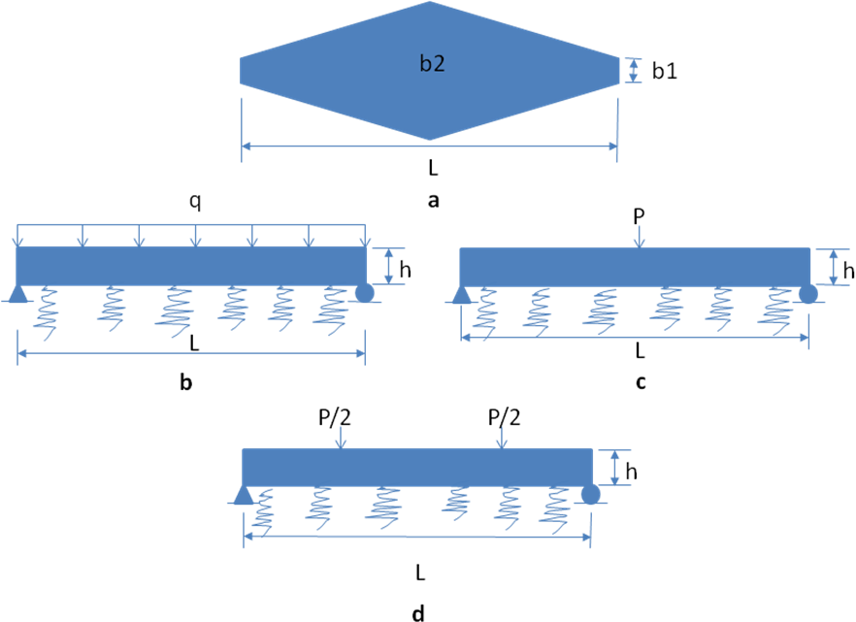
b₁=h₁=.25m
L=5m, Δ_{x}=.5m
E=25*10⁶kN/m²
K_{z}=10⁴kN/m³

Fig.(10) Non-prismatic beam (2) under different types of loading.
- Top view of beam b. UDL c. Point load at mid span d. Two point load

The results of these cases are compared with those available from theory [Hantny 1974] and compared with prismatic beam (h₂=h₁ , b₂=b₁) [Ali 2010] as shown in Figs. (11,12and 13).

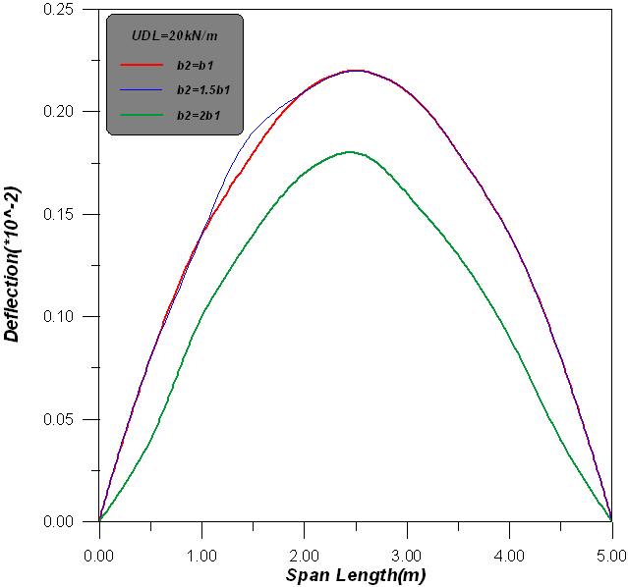
Fig(11) Non-prismatic beam (2)under UDL

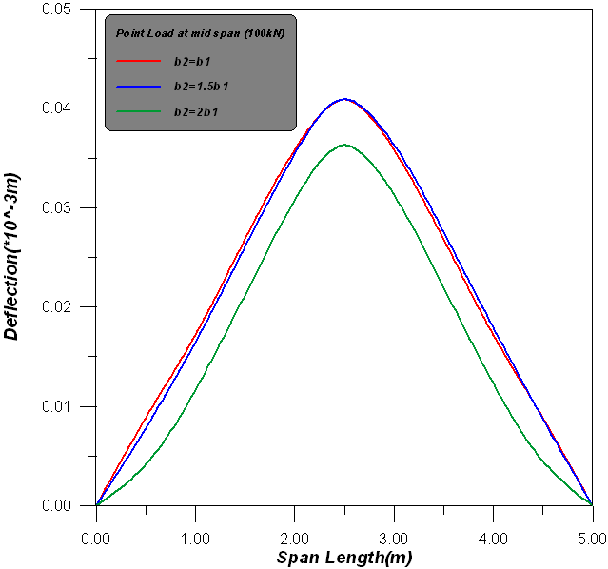
Fig(12) Non-prismatic beam(2) under Point Load at Mid

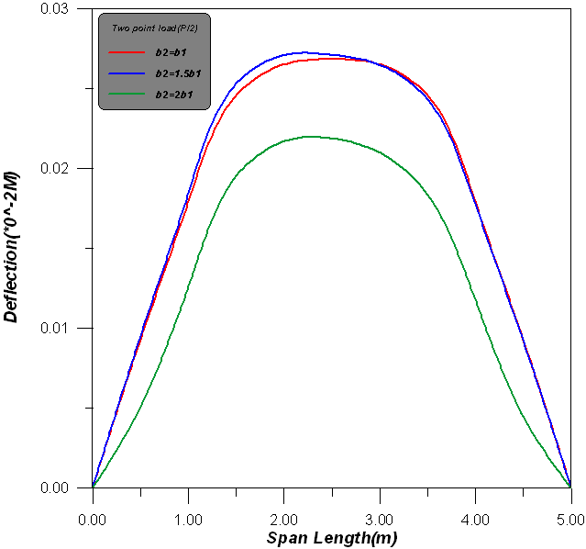

Fig(13) Non-prismatic beam(2) under Two Points Load

The results indicated that percent of non-prismatic beam decreasing about (23.2%) in deflection due to two point load (P/2) when b₂=2b₁ and (27.67%) in deflection due to two point load (P/2)when b₂=1.5b₁. The maximum deflection happen in UDL when b₂=1.5b₁ , it's obtain in figs.(14).

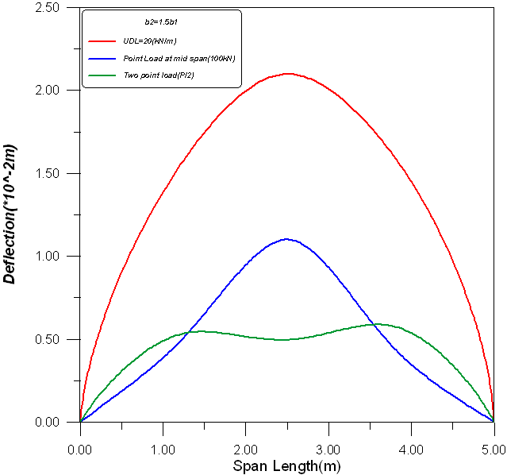
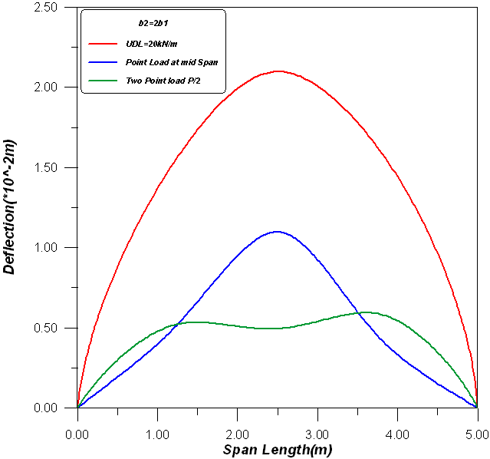

(a )
(b )

Fig(14) Effect of Different types of load on the non-prismatic beam(2) deflection.
- b₂=1.5b₁ b. b₂=2b₁

For different cases of end supports and their effective on deflection for non prismatic beam which indicated in fig.(15), the result show different about (88.81%) decreasing in deflection due to uniformly distributed beam with fixed ended support.

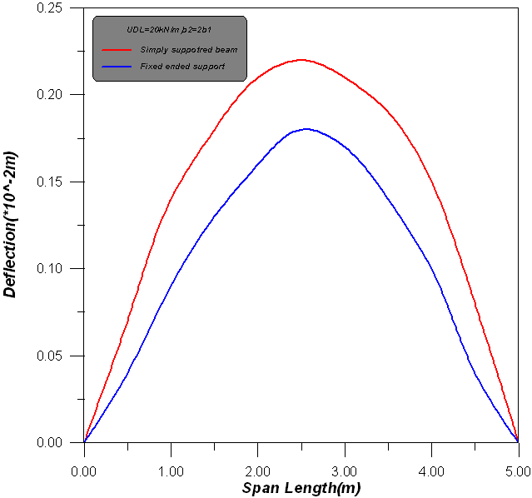

Fig.(15) Non-prismatic beam (2) under uniformly distributed beam with different types of supported.

Fig.(16a,b and c) ,show the results between non-prismatic beam (1) and(2) with h₂=2h₁ and b₂=2b₁ under different types of loading. The results indicated the maximum deflection occur in prismatic beam and the present of convergence in deflection about (98.4% and 96.89%) between h₂=2h₁ and b₂=2b₁ under point load at mid span and two point load at L/3 , respectively.

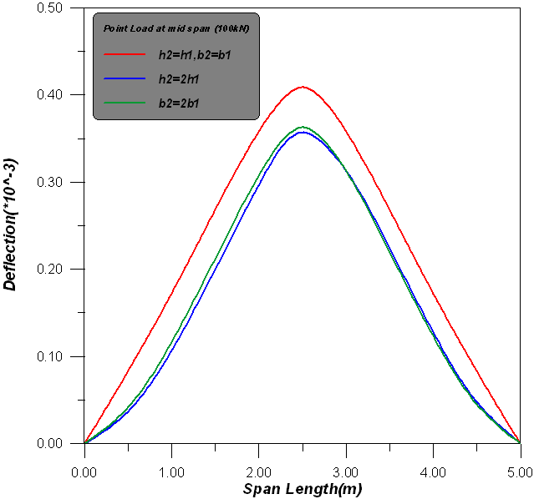
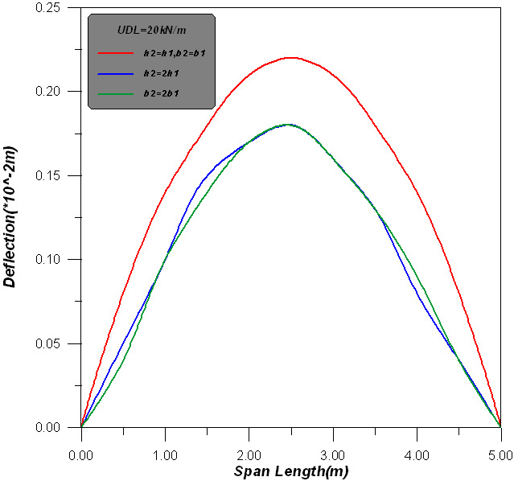

(a )
(b )

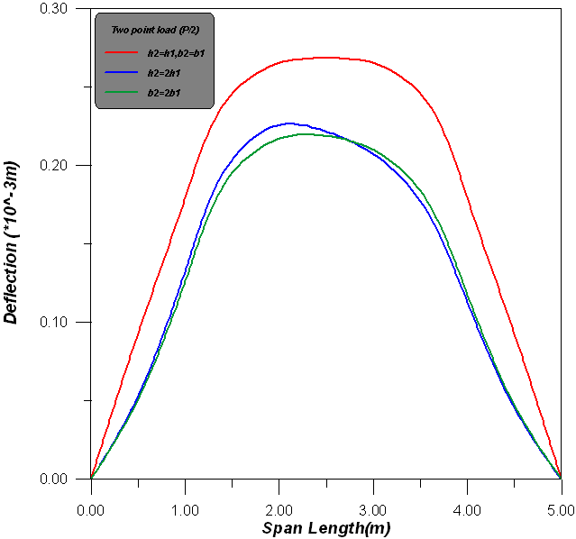

(c )
Fig.(16) Non-prismatic beam (2) and (1) with h₂=2h₁ and b₂=2b₁ under different types of loading.
a. UDL b. Point load at mid span c. Two point load

The maximum bending moment in non-prismatic beam(1)with h₂=1.5h₁ under uniformly distributed load ,point load at mid span and two point load at L/3 acting, the percent of convergence is about( 75.95,80.7 and 81.71%), respectively . These results plotted in fig.(17). While the percent of convergence about (86.66%,21.4% and 94.44%) in shear force under uniformly distributed load, point load at mid span and two point load at L/3 acting, respectively

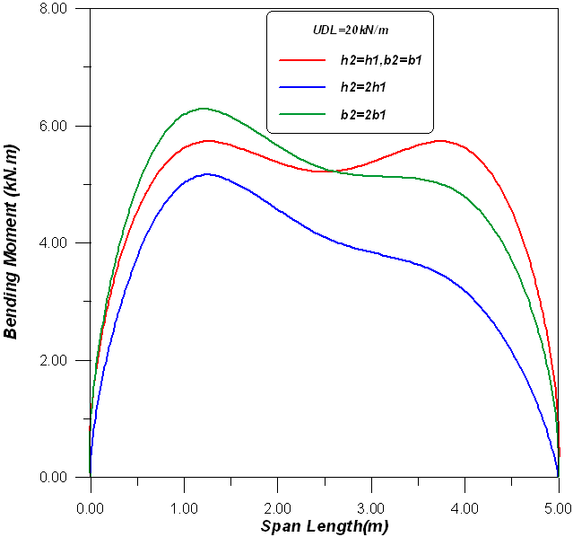
(a )
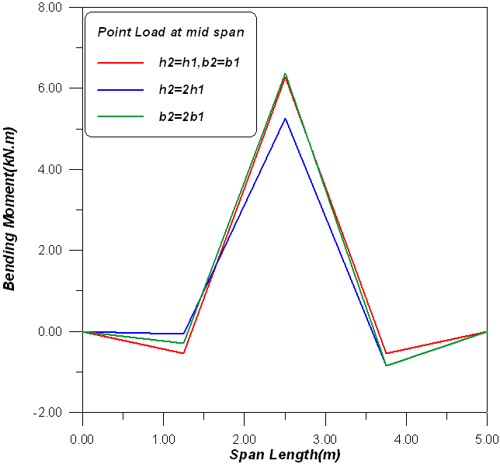

(b)

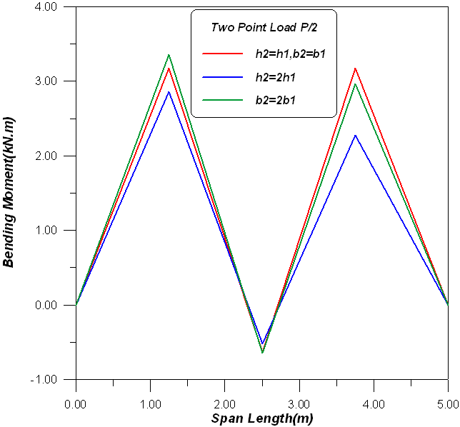
(c )
Fig.(17) Bending moment for non-prismatic beam (1) and beam (2) under different types of loading.
UDL b. Point load at mid span c. Two point load

The effect of end support on the non-prismatic beam (1) and beam (2) with h₂=2h₁ and b₂=2b₁ under different types of loading. Fig(18) indicated these effective.
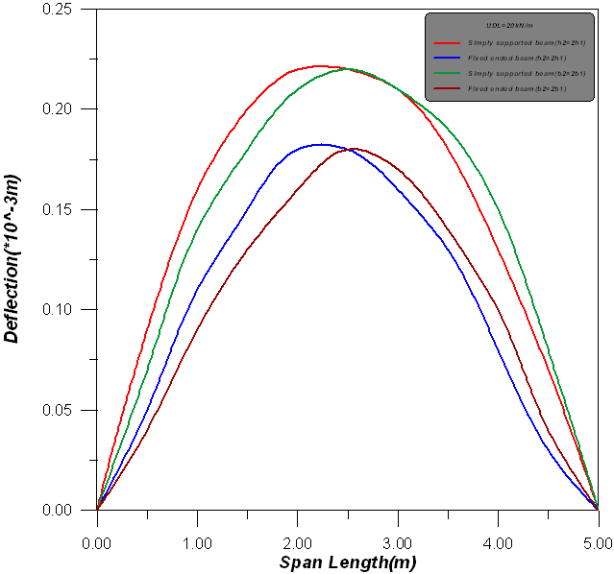
(a )

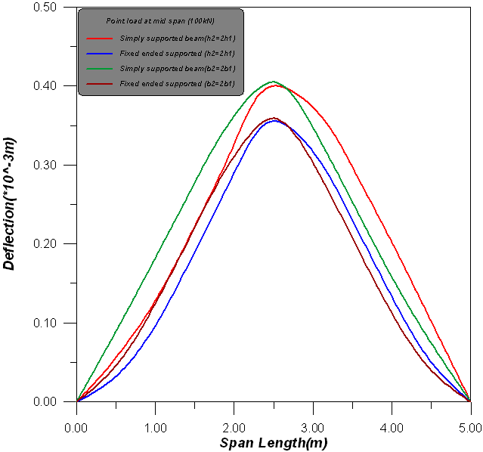
(b )
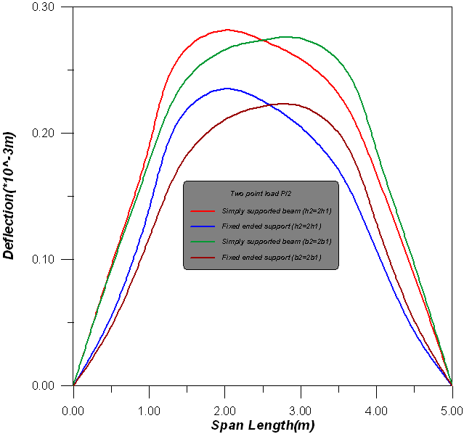

( c)
Fig.(18) Deflection for non-prismatic beam (1) and beam (2) under different types of loading with two types of end support. a. UDL b. Point load at mid span c. Two point load.

5.4 Non-Prismatic beam in depth through the span(max. depth at mid span)
Consider the following problem of a single span non-prismatic beam(4) of length L=5m on elastic foundation as shown in Fig.(19). The depth of the beam at the ends h₁=.25m ,b₁=.25m and h₂=1.5h₁ varies to h₂=2h₁. The two condition end supported and carrying three different types of loads. E=25*10⁶ kN/m² , K_{z}=10⁴ kN/m³ ,q=20 kN/m, P=100 kN.

(a )
q
L
h₂
h₁
(b )
L
h₂

h₁
P
(c )
L
h₂

h₁
P/2
P/2
Fig(19) Non-prismatic beam(4) on elastic foundation a) UDL=20kN/m b) Point Load at mid span P=100KN, c) Two Point Load at L/3 P/2=50KN.

The results plotted in Figs.(20) for beam (4) , the difference between two ended conditions gives (47.18,58.69 and 51.58%) in maximum deflection under uniformly distributed load , point load at mid span and two point load at L/3, respectively.

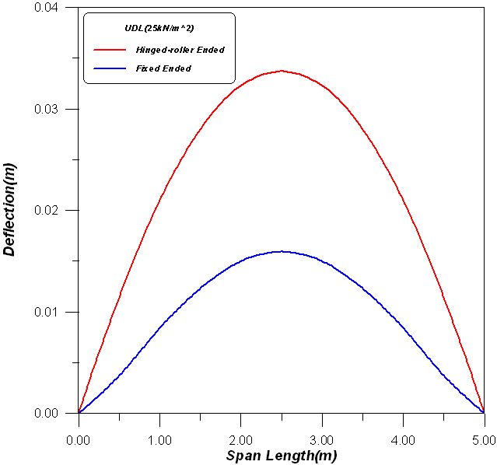
(a)

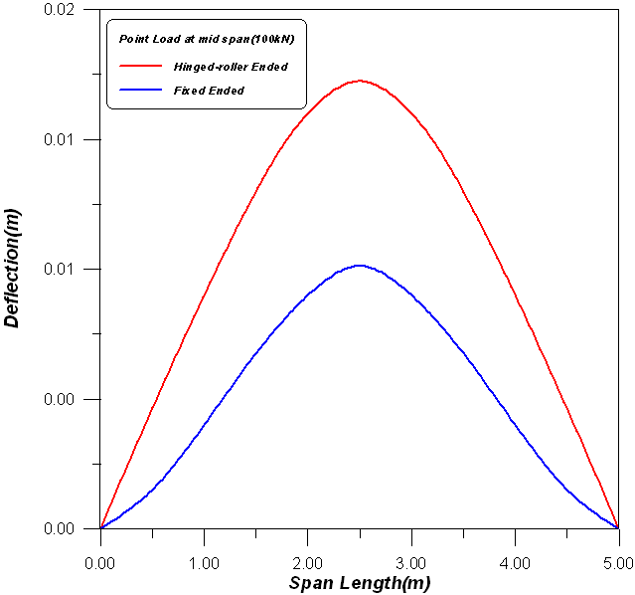

(b)
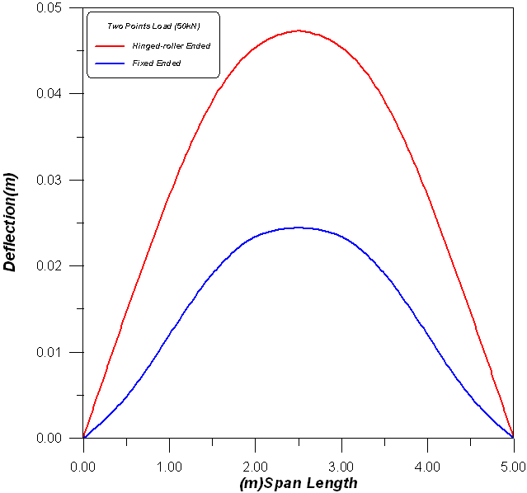
(c )
Fig.(20) Deflection for non-prismatic beam (4) with types of support
a. UDL b. Point load at mid span c. Two point load.

Finally ,the effect of varying of non-prismatic beam cross-section under three cases of loading can be explained in Fig.(21). From this results, it can be noticed that the maximum deflection occur in non-prismatic beam (3) under UDL and point load at mid span with the large depth at the ends of the beam, with percent of decreasing about (87.98 and 35.29%), respectively. While , the two points load at (L/3) of span is acting the maximum deflection occur in non-prismatic beam (4) with the large depth at the mid span of the beam with percent about (74.42%).

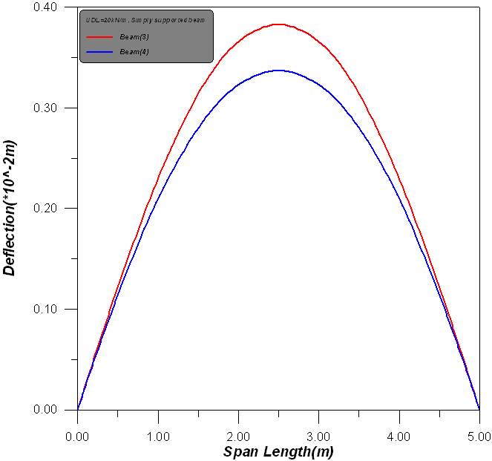
(a )
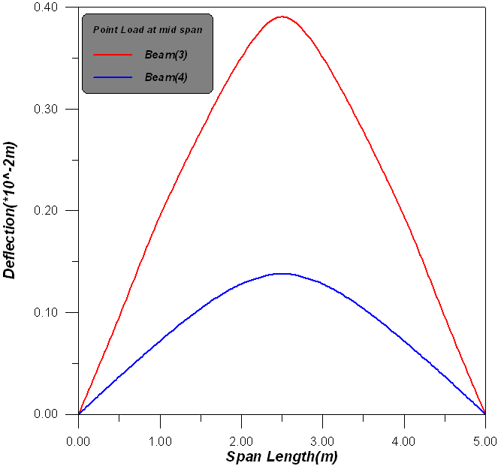
( b)

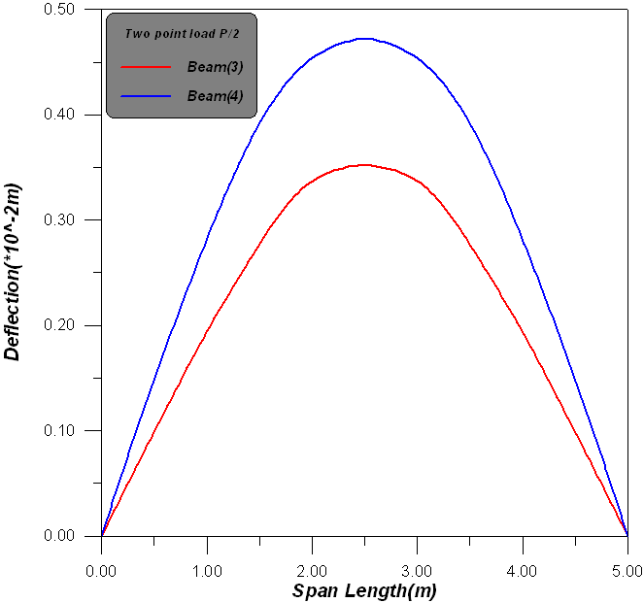
(c )

Fig.(21) Deflection in non-prismatic beam (3) and non-prismatic beam (4) with types of support
a. UDL b. Point load at mid span c. Two point load.

From following Fig.(22), it can be plotted there is pronounced increasing of bending moment about(34.75 and 50.19%) for non prismatic beam(4) compared with bending moment in beam(3) due to uniformly distributed load and point load at mid span , respectively. While , the percent of decreasing in bending moment in beam(4) about (13.15%) due to two point load acting at L/3.
On the other hand, the convergence of shear force about (69.86,15.74 and 20.90%) for beam (3) and beam(4) under uniformly distributed load, point load at mid span and two point load at L/3, respectively.
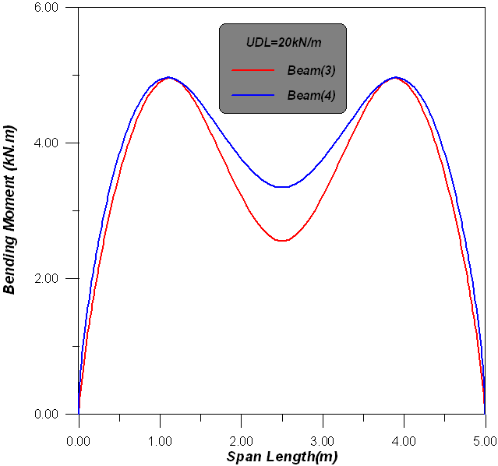
(a )

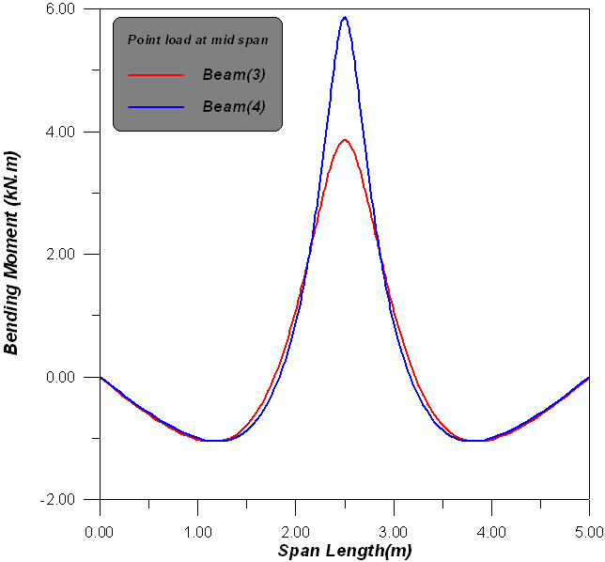
( b)

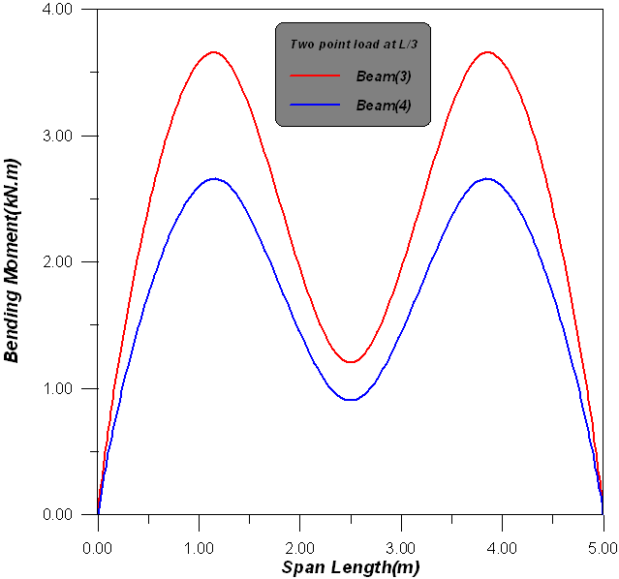
(c )
Fig.(22) Bending Moment in non-prismatic beam (3) and non-prismatic beam (4)
a. UDL b. Point load at mid span c. Two point load.

5. Non –Prismatic Cantilever Beam
The non prismatic beam with three separate segments, shown in Fig. (23), is considered, and fixed at the left end. This example is notable as it will illustrate the efficiency of the procedure to deal with both kinds of discrete and smooth discontinuities simultaneously. The ﬁrst half of the beam is tapered smoothly, with the depth of the rectangular section varying linearly from (2h to h). At the midpoint of the second half, section depth drops abruptly from (h to h/2). The sample beam with the length (L= 8 m) , depth (h= 0.4 m) , width ( b= 0.1 m) , and elastic modulus (E = 210 GPa ) , under two types of load (concentrated load P= 50 kN at the free end, and uniform distributed load q= 10 kN/m.
L/2
L/4
L/4
P
b
b
b
h
h/2
h(x)=2h(1-x/L)
Fig(23) Simple Non-prismatic Cantilever beam [Shooshtrai 2010]

From following Fig.(24), it can be noticed that little difference between the present numerical analysis and the procedure to ﬁnd the exact shape functions and stiffness matrices of non-prismatic beam elements for the Euler Bernoulli and Timoshenko formulations. [Shooshtrai 2010] , the percentage of convergence is equal to (91%) , on the other hand, from these result the effect of modulus sub-grade frictional resistance at interface was found to be noticeable about (15%).

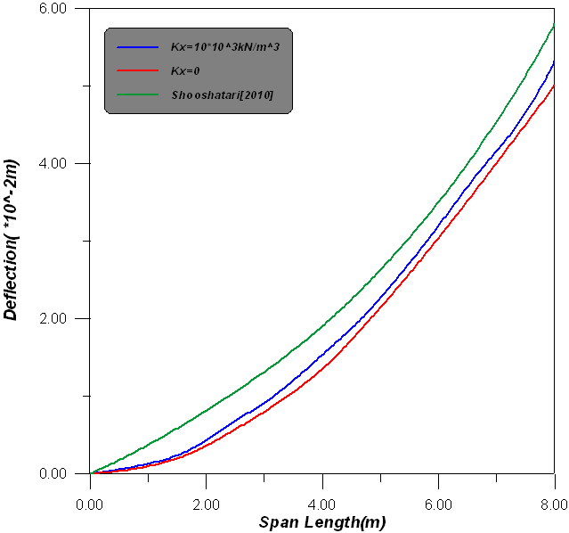
Fig(24) Deflection on Non-prismatic cantilever beam .

6.Conclusions
From the numerical analysis of many problems of non-prismatic beams on elastic foundation with comparison of prismatic beam under effect of different configurations of loading and end conditions, many conclusions can be drawn:
The results indicated that present non-prismatic beam decreasing about (80.67-81.81%)and(75.99-81.81% )in deflection for longitudinal direction (width of beam b) and transverse direction (depth of beam h) , respectively for different cases of loading.
The present numerical analysis and the procedure for another procedure , the percentage of convergence is equal to (91%) , on the other hand, from these result the effect of modulus sub-grade frictional resistance at interface was found to be noticeable about (15%).
- The value of maximum bending moment is the same in h₂=2h₁ and b₂=2b₁ but the location of these values is changed under uniformly distributed load and two point load at L/3 acting, but the percent of convergence is about ( 75.95,80.7 and 81.71%) in bending moment under point load acting.
- The results shows that the percent of convergence about (86.66%,21.4% and 94.44%) in shear force under uniformly distributed load, point load at mid span and two point load at L/3 acting, respectively .
- The maximum deflection occur in non-prismatic beam (3) under UDL and point load at mid span with the large depth at the ends of the beam, with percent of decreasing about (87.98 and 35.29%), respectively. While , the two points load at (L/3) of span is acting the maximum deflection occur in non-prismatic beam (4) with the large depth at the mid span of the beam with percent about (74.42%).
- Increasing of bending moment about(34.75 and 50.19%) for non prismatic beam(4) compared with bending moment in beam(3) due to uniformly distributed load and point load at mid span , respectively. While , the percent of decreasing in bending moment in beam(4) about (13.15%) due to two point load acting at L/3.
- The convergence of shear force about (69.86,15.74 and 20.90%) for beam (3) and beam(4) under uniformly distributed load, point load at mid span and two point load at L/3, respectively.
References
Al-Gahtani, H.J., Khan, M.S., 1998. "Exact analysis of non-prismatic beams". Journal of Engineering Mechanics ASCE 124 (11), 1290e1293.
Ali ,A. Y., 2010, "Numerical Analysis Of Beams With Openings Under Generalized Loadings On Elastic Foundation"
Balkaya, C., 2001." Behavior and modeling of non-prismatic members having T- sections". Journal of Structural Engineering ASCE 127 (8), 940e946.
Banerjee, J.R., Williams, F.W., 1986." Exact Bernoulli-Euler static stiffness matrix for a range of tapered beam-columns. International Journal for Numerical Methods in Engineering 23, 1615e1628.
Bazeos, N., Karabalis, D.L., 2006." Efficient computation of buckling loads for plane steel frames with tapered members". Engineering Structures 28, 771e775.
Biondi, B., Caddemi, S., 2007." Euler Bernoulli beams with multiple singularities in the ﬂexural stiffness". European Journal of Mechanics A-Solids 26, 789e809.
Brown, C.J., 1984." Approximate stiffness matrix for tapered beams. Journal of Structural Engineering ASCE 110 (12), 3050e3055.
Eisenberger, M., 1985. "Explicit stiffness matrices for non-prismatic members". Computers and Structures 20 (4), 715e720.
Eisenberger, M., 1985. "Explicit stiffness matrices for non-prismatic members". Computers and Structures 20 (4), 715e720.
El-Mezaini, N., Balkaya, C., Citipitioglu, E., 1991. "Analysis of frames with non-prismatic beam elements". Journal of Structural Engineering ASCE 117 (6), 1573e1592.
Frieman, Z., Kosmatka, J.B., 1992. "Exact stiffness matrix of a non-uniform Beam extensions, torsion and bending of a Bernoulli-Euler beam". Computers and Structures 42 (5), 671e682.
Frieman, Z., Kosmatka, J.B., 1993." Exact stiffness matrix of a non uniform beamed bending of a Timoshenko beam". Computers and Structures 49 (3), 545e555.
Hetney, M.,1974, "Beams on Elastic Foundations ",Ann Arbor, The University of MichigaPress,1974.
Just, D.J., 1977." Plane frameworks of tapering box and I-section". Journal of the Structural Division ASCE 103 (1), 71e86.
Karabalis, D.L., Beskos, D.E., 1983. "Static, dynamic and stability analysis of structures composed of tapered beams". Computers and Structures 16 (6), 731e748.
Luo, Y., Wu, F., Xu, X., 2006. "Element stiffness matrix and modiﬁed coefficients for circular tube with tapered ends". Journal of Constructional Steel Research 62, 856e862.
Luo, Y.Z., Xu, X., Wu, F., 2007." Accurate stiffness matrix for non-prismatic members". Journal of Structural Engineering ASCE 133 (8), 1168e1175.
Portland Cement Association (PCA), 1958. Handbook of frame constants: "beam factors and moment coefficients for members of variable section". Skokie, III.
Shooshtrai , A. , R. Khajavi 2010," An efficient procedure to ﬁnd shape functions and stiffness matrices of non-prismatic Euler Bernoulli and Timoshenko beam elements" European Journal of Mechanics A/Solids 29 (2010) 826e836.
Tena-Colunga, A., 1996. "Stiffness formulation for non-prismatic beam elements". Journal of Structural Engineering ASCE 122 (12), 1484e1489.
Vu-Quoc, L., Léger, P., 1992. "Efficient evaluation of the ﬂexibility of tapered I-beams accounting for shear deformations". International Journal for Numerical Methods in Engineering 33, 553e566.

