Investigation of Townsend Energy Factor and Drift Velocity for Air in Terms of L, G & E/P

Farhan Lafta Rashid Ibrahim G. Faiadh. M. I. Ismael,
Ministry of Sciences & Technology
Abstract
In this work had been determine the Townsend's energy factor K_{T} and the electron drift velocity in terms of electron mean free path L in unit of pressure, the energy loss factor G and the applied electric field to the gas pressure ratio at 300 ºK in air. The obtain transport coefficients by solved numerically transport equation solution and had be fed to the derived equations.
The obtained results had be graphically draw as a function for its variables, which appeared a good agreement with published experimental data.
الخلاصة
تم في هذا العمل، تحقيق عامل طاقة تاون سيند K_{T} وسرعة انجراف الالكترونات بدلالة معدل المسار الحر بوحدة الضغط L، عامل فقدان الطاقة G ونسبة شدة المجال الكهربائي إلى ضغط الغاز وعند درجة حرارة 300 كلفن في الهواء. تم الحصول على معاملات الانتقال عن طريق حل معادلة الانتقال عددياً ومنها تم تغذية هذه المعاملات إلى المعادلات التي تم اشتقاقها.
النتائج التي تم الحصول عليها تم رسمها كدوال لمتغيراتها، حيث أظهرت النتائج تطابقاً جيداً مع النتائج العملية العالمية المنشورة.

Introduction
The motion of free electrons in air are computed by the method developed by Townsend, such as, the drift velocity W of the center of mass of a group of electrons through the gas, as a function of E/p; Townsend's energy factor K_{T} which refers the ratio of the mean energy of agitation of an electron to the mean energy of thermal agitation of a gas molecule; the mean free path L of an electron at unit of pressure (1mm of Hg= 1 Torr) and finally Bailey's energy loss factor G, which is of importance in ionosphere studies is obtained from the experimental dependence of the mean proportion η of its energy lost by an electron in a collision with a gas molecule. In this paper we study the theoretical formula are derived for K_{T} and W in terms of L, G and E/P (Huxley-1949, Boris-2001).
Numerical procedure
The mean free path L at unit of pressure dose not vary rapidly with mean velocity $\overline{U}$, and then η gives by the following equations at E/P<2.5 (Crompton, 1953).
$η=G(1−1/{K_{T}})(1)$
when supposed the Maxwell's law distribution and Druyvesteyn's law then:
$K_{1}=K_{T}(\text{Maxwell}=M)(2)$
$$K_{1}=1\text{.}\text{14} K_{T}(\text{Druyvesteyn}=D)(3)$$
where,
$$K_{1}=\frac{e}{K T_{g}}\frac{D}{μ}$$
where, e is electron charge=1.602×10⁻¹⁹ C, K is Boltzmann constant=1.3805×10⁻²³J K⁻¹, T_{g} is the gas temperature in Kelvin, D/µ is the diffusion coefficient to the mobility ratio in eV. The Eq.(1) and the following Eqs. at E/P < 2.5
$η=1\text{.}\text{79}×{\text{10}}^{−\text{14}}{W_{M}^{2}}/{K_{1}}$ (Maxwell) (4)
$η=1\text{.}\text{68}×{\text{10}}^{−\text{14}}{W_{D}^{2}}/{K_{1}}$ (Druyvesteyn) (5)
Substitute Eq.(5) into Eq.(1) yields:
$$1\text{.}\text{68}×{\text{10}}^{−\text{14}}{W^{2}}/{K_{1}}=G(1−1/{K_{T}}) (6)$$
substitute Eq.(3) into Eq.(6) yields:
$\frac{1\text{.}\text{68}×{\text{10}}^{−\text{14}}W^{2}}{1\text{.}\text{14} K_{T}}=\frac{G(K_{T}−1)}{K_{T}}$
$\frac{1\text{.}\text{474}×{\text{10}}^{−\text{14}}W^{2}}{K_{T}}=\frac{G(K_{T}−1)}{K_{T}}$…………… …. (Druyvesteyn) (7)
substitute Eq.(4) into Eq.(1) yields:
$$1\text{.}\text{79}×{\text{10}}^{−\text{14}}{W^{2}}/{K_{1}}=G(1−1/{K_{T}})(8)$$
substitute Eq.(2) into Eq.(8) yields:
$1\text{.}\text{79}×{\text{10}}^{−\text{14}}{W^{2}}/{K_{T}}=G(K_{T}−1)/{K_{T}}$………. ….(Maxwell) (9)
but from the following equations we can find (Huxley,1949):
$$L=7\text{.}\text{33}×{\text{10}}^{−9}\frac{W\sqrt{K_{1}}}{E/P}(\text{10})$$
$L=7\text{.}\text{05}×{\text{10}}^{−9}\frac{W\sqrt{K_{1}}}{E/P}(\text{11})$substitute Eq.(3) into Eq.(10) yields:
$$L=7\text{.}\text{33}×{\text{10}}^{−9}\frac{W\sqrt{1\text{.}\text{14}K_{T}}}{E/P}$$
$L=7\text{.}\text{33}×{\text{10}}^{−9}\frac{W_{D}\sqrt{K_{T}}}{E/P}$ (Druyvesteyn) (12)
substitute Eq.(2) into Eq.(11) yields:
$L=7\text{.}\text{05}×{\text{10}}^{−9}\frac{W_{M}\sqrt{K_{T}}}{E/P}$ (Maxwell) (13)
since
$W_{M}=0\text{.}\text{851}\frac{E}{H}\text{tan} θ$ (Maxwell)
$W_{D}=0\text{.}\text{9426}\frac{E}{H}\text{tan} θ$ (Druyvesteyn)
where,
$θ={\text{tan}}^{−1}\left(\frac{e}{m}\frac{H}{ν_{m}}\right)$
$$H=\frac{E}{V_{d}}{\left(K_{1}−1\right)}^{0\text{.}5}$$
From Eqs.(7, 12) we can find:
$$W^{2}=\frac{G(K_{T}−1)}{1\text{.}\text{474}×{\text{10}}^{−\text{14}}}(\text{14})$$
$$W=\frac{L(E/P)}{7\text{.}\text{83}×{\text{10}}^{−9}}\frac{1}{K_{T}}(\text{15})$$
By square Eq.(15) and it's equal with Eq.(14) yield:
$W^{2}=\frac{G(K_{T}−1)}{1\text{.}\text{474}×{\text{10}}^{−\text{14}}}={\left[\frac{L(E/P)}{7\text{.}\text{83}×{\text{10}}^{−9}}\right]}^{2}\frac{1}{K_{T}}$……………..(Druyvesteyn) (16)
Eq.(16) represents W in term of L, G and E/P.
from Eqs.(9, 13) and squaring Eq.(13) and equal them, yield:
$W^{2}=\frac{G(K_{T}−1)}{1\text{.}\text{79}×{\text{10}}^{−\text{14}}}={\left[\frac{L(E/P)}{7\text{.}\text{05}×{\text{10}}^{−9}}\right]}^{2}\frac{1}{K_{T}}$…………..(Maxwell) (17)
Eq.(17) represents W in term L, G and E/P; where expressed in unit V/cm.
from Eq.(16) obtained:
$K_{T}(K_{T}−1)=\frac{1\text{.}\text{474}×{\text{10}}^{−\text{14}}L^{2}(E/P)^{2}}{{\left(7\text{.}\text{83}×{\text{10}}^{−9}\right)}^{2}G}$
$$K_{T}(K_{T}−1)=\text{240}× \frac{L^{2}}{G}(E/P)^{2}(\text{18})$$
i.e.
$K_{T}=\frac{1+{\left[1+\text{960}\frac{L^{2}}{G(E/P)^{2}}\right]}^{1/2}}{2}$…………………………….(Druyvesteyn) (19)
Eq.(18) represents K_{T} in term L, G and E/P.
from Eq.(16) also obtained:
$$W=\frac{L(E/P)}{7\text{.}\text{83}×{\text{10}}^{−\text{19}}}\frac{1}{\sqrt{K_{T}}}$$
$W=\frac{1\text{.}\text{27}×{\text{10}}^{8}L(E/P)}{{\left\{\frac{1+{\left[1+\text{960}L^{2}(E/P{)^{2}}/G\right]}^{0\text{.}5}}{2}\right\}}^{1/2}}$………………….(Druyvesteyn) (20)
Eq.(20) represents W in term L, G and E/P.
from Eq.(17) obtained:
$$K_{T}(K_{T}−1)=\frac{1\text{.}\text{79}×{\text{10}}^{−\text{14}}(L(E/P))^{2}}{{\left(7\text{.}\text{05}×{\text{10}}^{−9}\right)}^{2}G}$$
$K_{T}(K_{T}−1)=\text{360}\frac{L^{2}}{G}(E/P)^{2}$ ………………………. (Maxwell) (21)
$K_{T}(K_{T}−1)=\frac{1+{\left[1+\text{1440}\frac{L^{2}}{G(E/P)^{2}}\right]}^{1/2}}{2}$………..……….(Maxwell) (22)

Eq.(21) represents K_{T} in term L, G and E/P.
from Eq.(17) also obtained:
$W=\frac{L(E/P)}{7\text{.}\text{05}×{\text{10}}^{−\text{19}}}\frac{1}{\sqrt{K_{T}}}$ (23)
$W=\frac{1\text{.}\text{42}×{\text{10}}^{8}L(E/P)}{{\left\{\frac{1+{\left[1+\text{1440}\frac{L^{2}(E/P)^{2}}{G}\right]}^{1/2}}{2}\right\}}^{1/2}}$……………………….(Maxwell) (24)
Eq.(24) represents W in term L, G and E/P.
From Eq.(1) when E/P<2.5 refers the $η$ depends on K_{T} with G=0.0013, for Druyvesteyn's low. From the above at L=0.04, we substitute these values to the Eqs.(19-20) respectively obtained as a special case, which:
$K_{T}=\frac{1+{\left[1+\text{1181}\text{.}5(E/P)^{2}\right]}^{1/2}}{2}$…………… ……(Druyvesteyn) E/P<2.5 (25)
$W=\frac{5×{\text{10}}^{7}(E/P)}{{\left\{\frac{1+{\left[1+\text{1181}\text{.}5(E/P)^{2}\right]}^{1/2}}{2}\right\}}^{1/2}}$…… ……..(Druyvesteyn) E/P<2.5 (26)

at, 1181.5(E/P)² >>1
$K_{T}=0\text{.}5+\text{17}\text{.}\text{18} E/P$ (Druyvesteyn) (27)
$W=1\text{.}\text{206}×{\text{10}}^{7}E/P$ (Druyvesteyn) (28)
Eqs.(25-28) were refer K_{T} and W in term E/P for especial case from Eq.(18) yields:
at: K_{T}>>1,
$K_{T}=\frac{\text{15}\text{.}4}{\sqrt{G}}L ( E/P)$ (Druyvesteyn) (29)
at: K_{T}=1,
$K_{T}=1+\frac{\text{240} L^{2} (E/P)^{2}}{G}$ (Druyvesteyn) (30)
Eqs.(29-30) were represent K_{T} in term L, G and E/P. from Eq. (21) yields:
at K_{T}>>1,
$K_{T}=\frac{\text{18}\text{.}9}{\sqrt{G}}L ( E/P)$ (Maxwell) (31)
at: K_{T}=1,
$K_{T}=1+\frac{\text{360} L^{2} (E/P)^{2}}{G}$ (Maxwell) (32)
Eqs.(31-32) were represent K_{T} in term L, G and E/P.
Time – Dependent Electron Boltzmann Equation:
In this work could be used the final form taken by the time – dependent Boltzmann equation for electrons, as used in this paper, to obtain the transport coefficients, namely drift velocity, V_{d}, the ratio of the diffusion coefficient to the mobility, $D/μ$ and the momentum transfer collision frequency, $ν_{m}$. Finally insert this parameters to our equations.
The standard procedure to study this problem starts with a Boltzmann equation usually written in the form (Guerra -2001,ابراهيم-2004):
$\frac{∂F}{∂t}+∇_{r}⋅(\text{vF})−∇_{v}⋅\left(\frac{e E}{m}F\right)={\left(\frac{∂F}{∂t}\right)}_{c}$ (33)
since $F(r, v, t)$ refers the electron velocity distribution function constrained to the normalization condition $\int{F \text{dv}=n_{e}(r, t),}$ with $\text{dv}$ and $n_{e}$ are velocity space and the electron density respectively, $∇_{r}$ and $∇_{v}$ are the gradient operators, e and m (m=9.109×10⁻²⁸ gm) are the electron absolute charge and mass, and the right – hand side of Eq.(33) refers a collision operator.

Results and Discussion:
In this study had be investigate the Townsend's energy factor for air in term L, G & E/P; this results appeared a good agreement with the reference (Huxley,1949).
Figs.(1-3) are showing the Townsend's energy factor K_{T} versus the mean free path at unit of pressure, L, G and E/P. Fig(1) appeared the decreasing of K_{T} with L increasing, i. e. the electrons losses it's energy through the L, but figs.(2, 3) appeared the K_{T} increasing with G and E/P.
Fig.(4) appears the electron drift velocity was decreasing with L because the electrons could be its energy by the collisions through the mean free path L, but figs.(5, 6) the electron drift velocity could be increase with G and E/P because the electrons were gain the energy from the applied electric field.
Figs.(7-10) were represent the special case for E/P < 2.5 which is the Townsend's energy factor K_{T} and drift velocity W, as a functions of E/P< 2.5 for the special case, this figures were show the increasing of K_{T} and W with E/P; for figs.(9, 10) the increasing was a ramp form for 1181.5(E/P)² >> 1.
Figs.(11-13) are referring the Townsend's energy factor as a function of: the mean free path, L, the energy loss factor, G and the applied electric field to the gas pressure ratio for Maxwell and Druyvesteyn distribution law for air, from fig.(11) at K_{T}>>1 it's appeared decreasing the Townsend's energy factor with increasing of the mean free path L, because the electrons losses it's energy by the collisions, but for figs.(12, 13) at K_{T}>>1 the Townsend's energy factor could be increase with the energy loss factor G.
Fig.(14) at K_{T}=1 was appear the decreasing Townsend's energy factor with mean free path L, but figs.(15, 16) the Townsend's energy factor K_{T}, with G and E/P because the electrons gains the energy from the applied electric field.
K_{T} (eV) |  |  | 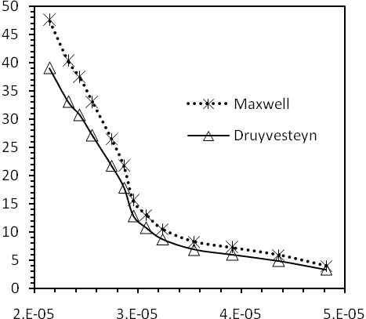
 |  |  | L (cm)
Fig.(1): The Townsend's energy factor, K_{T}, as a function of the electron mean free path, L, at unit of pressure for Eq.(22) and Druyvesteyn {Eq.(19)} distribution in Air.
K_{T} (eV) |  |  | 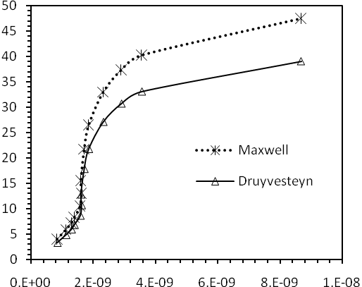
 |  |  | G
Fig.(2): The Townsend's energy factor, K_{T}, as a function of the energy loss factor, G, at unit of pressure for Maxwell {Eq.(22)} and Druyvesteyn {Eq.(19)} distribution in Air.

K_{T} (eV) |  |  | 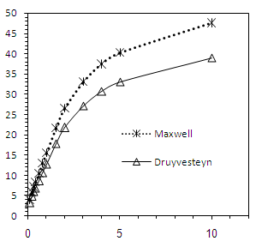
 |  |  | E/P (V cm⁻¹ Torr⁻¹)
Fig.(3): The Townsend's energy factor, K_{T}, as a function of the applied electric field to the gas pressure ratio, E/P, for eq.(22) and Druyvesteyn {Eq.(19)} distribution in Air.
W (cm/s) |  |  | 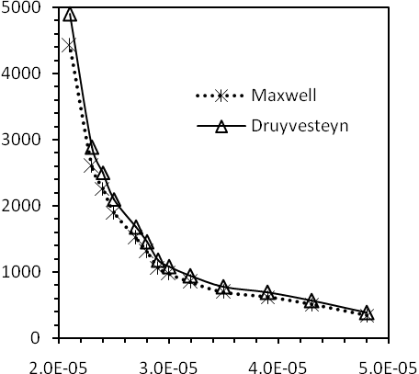
 |  |  | L (cm)
Fig.(4): The drift velocity, W, as a function of the electron mean free path, L, for Maxwell {Eq.(24)} and Druyvesteyn {Eq.(20)} distribution in Air.
W (cm/s) |  |  | 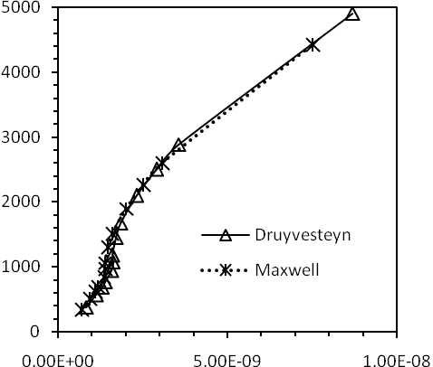
 |  |  | G
Fig.(5): The drift velocity, W, as a function of the energy loss factor, G, for eq.(24) and Druyvesteyn {Eq.(20)} distribution in Air.
W (cm/s) |  |  | 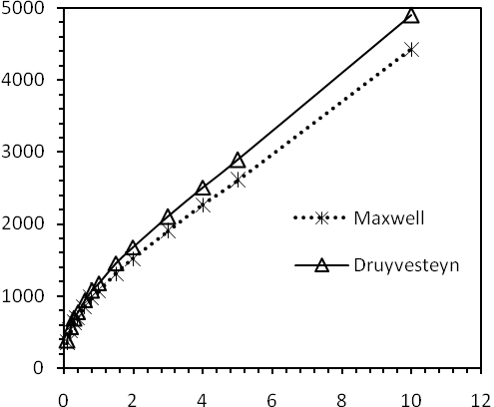
 |  |  | E/P (V cm⁻¹ Torr⁻¹)
Fig.(6): The drift velocity, W, as a function of the applied electric field to the gas pressure ratio, E/P, for eq.(24) and Druyvesteyn {Eq.(20)} distribution in Air.
K_{T} (eV) |  |  | 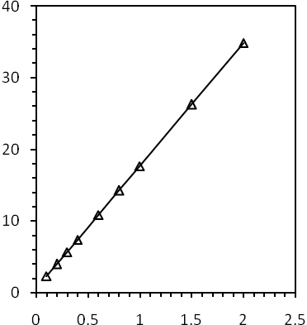
 |  |  | E/P (V cm⁻¹ Torr⁻¹)
Fig.(7): The Townsend's energy factor, K_{T}, as a function of the applied electric field to the gas pressure ratio, E/P, for Druyvesteyn {Eq.(25), E/P<2.5} distribution in Air.
W(cm/s) |  |  | 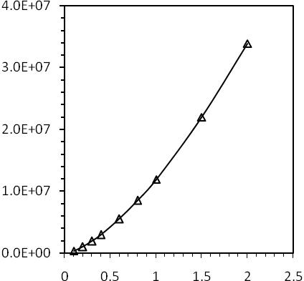
 |  |  | E/P (V cm⁻¹ Torr⁻¹)
Fig.(8): The drift velocity, W, as a function of the applied electric field to the gas pressure ratio, E/P, for Druyvesteyn {Eq.(26), E/P<2.5} distribution in Air.
K_{T} (eV) |  |  | 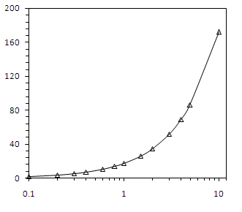
 |  |  | E/P (V cm⁻¹ Torr⁻¹)
Fig.(9): The Townsend's energy factor, K_{T}, as a function of the applied electric field to the gas pressure ratio, E/P, for Druyvesteyn {Eq.(27), 1181.5(E/P)²>>1} distribution in Air.
W (cm/s) |  |  | 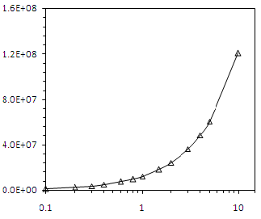
 |  |  | E/P (V cm⁻¹ Torr⁻¹)
Fig.(10): The drift velocity, W, as a function of the applied electric field to the gas pressure ratio, E/P, for Druyvesteyn {Eq.(28), 1181.5(E/P)²>>1} distribution in Air.
 | K_{T} (eV) |  |  | 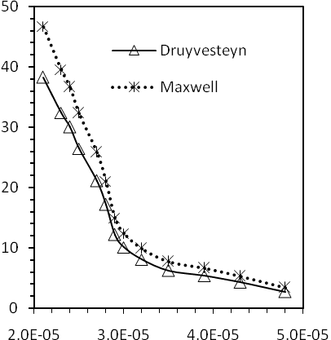
 | L (cm)
 | Fig.(11): The Townsend's energy factor, K_{T}, as a function of the electron mean free path, L, for Eq.(31) and Druyvesteyn {Eq.(29)} distribution in Air.
 | K_{T} (eV) |  |  | 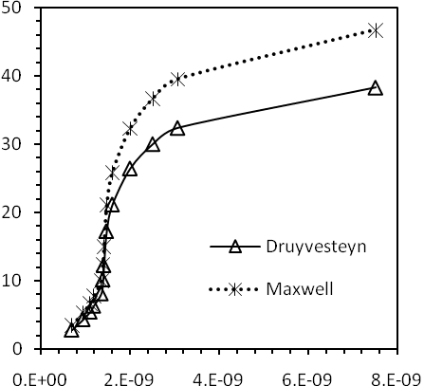
 | G
Fig.(12): The Townsend's energy factor, (K_{T}>>1), as a function of the energy loss factor, G, for eq.(31) and Druyvesteyn {Eq.(29)} distribution in Air.

K_{T} (eV) | 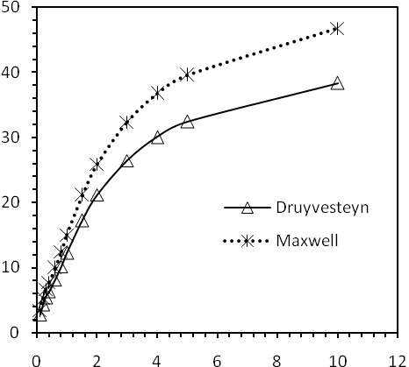
E/P (V cm⁻¹ Torr⁻¹)
Fig.(13): The Townsend's energy factor, (K_{T}>>1), as a function of the applied electric field to the gas pressure ratio, E/P, for eq.(31) and Druyvesteyn {Eq.(29),} distribution in Air.

K_{T} (eV) | 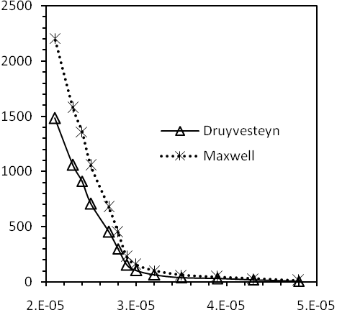
L (cm)
Fig.(14): The Townsend's energy factor, (K_{T}=1), as a function of the electron mean free path, L, for eq.(32) and Druyvesteyn {Eq.(30)} distribution in Air.

 | K_{T} (eV) | 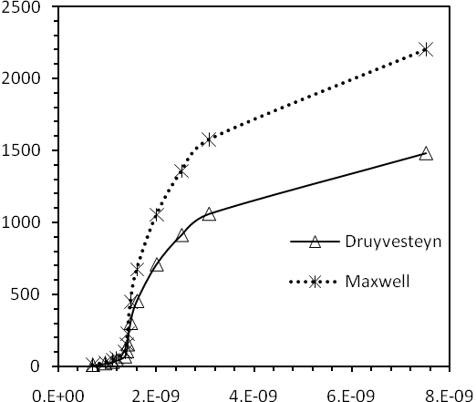
 | G
 | Fig.(15): The Townsend's energy factor, (K_{T}=1), as a function of the energy loss factor, G, for Eq.(32) and Druyvesteyn {Eq.(30)} distribution in Air.
 | K_{T} (eV) | 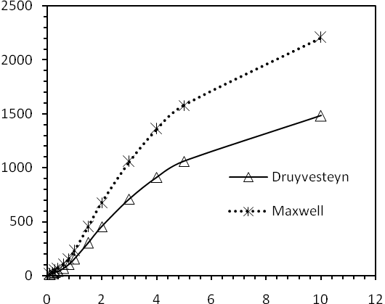
 | E/P (V cm⁻¹ Torr⁻¹)
 | Fig.(16): The Townsend's energy factor, (K_{T}=1), as a function of the applied electric field to the gas pressure ratio, E/P, for eq.(32) and Druyvesteyn {Eq.(30),} distribution in Air.

References
I. G. Faiadh, M. I. Ismaeel, F. G. Hamudy& S. S. Dawood,(2011),Applicable Studies of the Slow Electrons Motion in Air with Application in the Ionosphere,Eng.&Tech. Journal,v.29,No.3.. & Tech.29, No.3, 2011Eng. & Tech. Journal,
Boris M. Smirnov, (2001), Physics of Ionized Gases, John Wiley & Sons., Inc.New York.
Crompton R. W., Huxley L. G. and Sutton D. J., (1953), Experimental Studies of the Motions of Slow Electrons in Air with Application to the Ionosphere., Proc. Roy. Soc., A218, PP. 507-519.
Guerra V., Sá P. A. & Louerio J.,(2001),Relaxation of the Electron Energy Distribution Function in the Afterglow of a N₂ Microwave Discharge Including Space-Charge Field Effects, Phys. Rev. E, Vol. 63, PP. 1-13.
Huxley L. H. G.,Phil D.& Zaazou A. A., (1949), Experimental and Theoretical Studies of the Behaviour of Slow Electrons in Air. I, Proc. Roy. Soc. A169, PP. 402-425.
المصادر
ابراهيم كيطان فياض واخرون, (2004), انتقال الالكترونات في مزيج من غاز الاركون والهليوم والنتروجين, مجلة جامعة النهرين, المجلد 7(2) ص: 63-71.

