Improve the BER Performance of 64PSK, 4×2 STBC using (8,4) exHamming Turbo Product Code

Samir Abd AlCathem Khother
Electrical Engineering Department, Collage of Engineering, Babylon University

Abstract
M array space time block code (STBC) system can provide high data rate wireless services in a rich scattering environment multi input multi output (MIMO) channel but increasing modulation order (M) degrades the bit error rate (BER) performance of the system. The aim of this work is to improve the BER performance of 64PSK STBC using turbo product code .This paper gives an introduction to the basic concepts of MIMO channel and explains the implementation of the 4 transmitters STBC encoder/ decoder. The two main parts used in STBC decoder, channel estimator and maximum ratio combiner, were illustrated. Channel estimator was build using orthogonal pilot training sequence. Finally product block code and its iterative decoding using soft in soft out maximum likelihood decoder were illustrated.
Computer simulation for four different space time block codes schemes including rate 1, 0.75 STBC's as well as two rate 0.5 STBC's with two different code dimensions are explored. These STBC's techniques are implemented in MATLAB2010 and analyzed for BER performance according to their modulation order (M=4, 16 and 64PSK) and number of receiver antennas (Nr=1, 2, 4 and 8). Finally, (8,4) exHamming turbo product code was combined with 64PSK 4×2 STBC's system and evaluate the new BER performance in MIMO Rayleigh fading channel.
الخلاصة
منظومات الترميز الفضاء الزمني(STBC's) ذات التضمين المصفوفي النوني (M) يوفر خدمات لاسلكيه ذات معدل معلومات عاليه خلال قناة متعددة الادخال و الاخراج ذات ظروف بعثره عاليه, لكن زياده الرتبه النونيه للمضمن يضعف خصائص معدل الاخطاء لهذا النظام.الهدف من هذا العمل هو تحسين خصائص معدل الاخطاء لل(64PSK STBC) باستعمال شفرات الضرب التكراريه . هذه الورقه تعطي مقدمه للافكار الاساسيه لقنوات متعددة الادخال و الاخراج و توضح كيف بناء مشفر/محلل الشفره لمنظومه الترميز الفضاء الزمني ذو الاربع مرسلات. تم توضيح القسمان الاساسيان المستعمله مع محلل الشفره لمنظومه الترميز الفضاء الزمني وهما : مخمن القناة و المازج ذو النسبه الكبرى. مخمن القناة تم بنائه باستعمال سلسه التدريب الطيار المتعامده. بالنهايه تم توضيح شفرات الضرب التكراريه ومحلل الشفره التكراري باستعمال محلل الشفره ذو الدخل و الخرج الناعم ذو التشابه الاعظم.
محاكاة حاسوبيه لاربع انواع مختلفه من مرمزات الفضاء الزمني تتضمن معدل 1, 0.75 (STBC's) وكذلك اثنان من معدل 0.5 (STBC's) لهما حجما شفره مختلف. هذه ال(STBC's) تم بنائها باستعمال (MATLAB2010) وتم تحليل خصائص معدل الاخطاء لها تبعا للرتبه النونيه (M=4, 16 and 64PSK) و عدد هوائيات الاستلام(1,2,4 and 8) . بالنهايه تم مزج (8,4)شفرة هامن الموسعه للضرب التكراري مع4×2 (64PSK STBC) وحساب خصائص معدل الاخطاء ضمن قناة قناة متعددة الادخال و الاخراج ذات خفوت رايلي.
1. Introduction
In new information age, high data rate and strong reliability in wireless communication systems are becoming the dominant factors for a successful exploitation of commercial networks .Multiple input multiple output systems have revolutionaries wireless communications technology with the potential gains in capacity when using multiple antennas at both transmitter and receiver ends of a communications systems. New techniques were required to realize these gains in existing and new systems which account for the extra spatial dimension. Space time block code technology has been adopted in multiple wireless standards, including Wi-
Fi, WiMAX and proposed for future systems (3GPP). For the sake of further improving the performance, forward error correction schemes may be invoked for protecting against noise, multi-path fading and other channel environments. Many error-correcting codes have been applied to STBC such as convolutional codes, Reed-Solomon codes, low-density parity-check (LDPC) codes and turbo codes [Ludovic Costa, etl,2011 , Mesbahul M.,etl, 2011, Luis Alberto, 2006]. In the turbo code decoding algorithms are used with soft outputs, as the MAP (Maximum a Posteriori) algorithm, Log-MAP and max-log-MAP, based on trellis diagram of two concatenated recursive convolutional codes[Savo G. Glisic, 2007]. In this paper we will apply iterative decoding of product codes, it is also known as turbo product code, based on soft-input/soft-output maximum likelihood decoder described by [Ramesh Mahendra Pyndiah, 1998].

1.1 MIMO Channel Model
MIMO systems are composed of three main elements, namely the transmitter (TX), the channel (H), and the receiver (RX). In this paper, N_{t} is denoted as the number of antenna elements at the transmitter, and N_{r} is denoted as the number of elements at the receiver as shown in Fig.1.

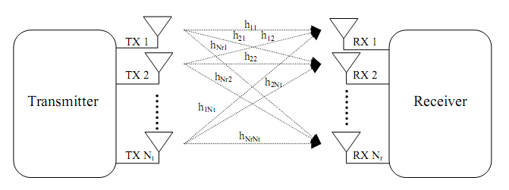
Figure 1: MIMO system block diagram

The channel with N_{r} outputs and N_{t} inputs is denoted as a N_{r} × N_{t} matrix:

H=$\left(\begin{matrix}h_{1,1} & h_{1,2} & & h_{1,\text{Nt}} \\ \text{.} & \text{.} & & \text{.} \\ \text{.} & & \text{.} & \text{.} \\ h_{\text{Nr},1} & h_{\text{Nr},1} & & h_{\text{Nr},\text{Nt}}\end{matrix}\right)$……………………………………………………..(1)
Where each entry h_{i,j} denotes the attenuation α, phase shift θ and delay $τ$between the j_{th} transmitter and the i_{th} receiver[Rose Trepkowski,2004].
$h={αe}^{jθ}δ(t−τ)$……………………………………………………………………...(2)
It is assumed throughout this paper that the MIMO channel behaves in a “quasi-static” fashion, i.e. the channel varies randomly between burst to burst, but fixed within a transmission. This is a reasonable and commonly used assumption as it represents an indoor channel where the time of change is constant and negligible compared to the time of a burst of data [Luis Miguel, 2009].

1.2 Four Transmitter Rate 1 STBC Encoder
In this paper M PSK, gray mapping constellations, modulation scheme is used. In the 4 transmitters rate1 space time encoder ,each group of m-information bits ($m={\text{log}}_{2}(M)$and m≥2) is first modulated and mapped into their corresponding constellation points, denote by $s_{1}$,$s_{2}$,$s_{3}$,$s_{4}$and enter the space time encoder [Roger A Hammons, etl, 2000].
The space time encoding can be represented by p×Nt encoding matrix:
$G=\overset{\begin{matrix}j=1 & & 2 & \text{.} & \text{.} & \text{.} & \text{.} & \text{Nt}\end{matrix}}{\left(\begin{matrix}s_{1} & s_{2} & 0 & 0 \\ −s_{2}^{} & s_{1}^{} & 0 & 0 \\ 0 & 0 & s_{3} & s_{4} \\ 0 & 0 & −s_{4}^{} & s_{3}^{}\end{matrix}\right)}\begin{matrix}t_{1} \\ t_{2} \\ : \\ t_{p}\end{matrix}$………………….…………………………………….(3)
Where each element in the G is the transmitted symbol at time t_{i} from j_{th} transmitter antenna. Encoder rate is k/p where k is the number of input symbols and p is length of transmitted sequence for each transmitter .As example for above encoding matrix k=p =4, therefore the encoding rate=1.
The key feature of the designing such matrix is that the transmitted sequences from the any two transmitter are orthogonal, i.e.
${\left(G^{T}\right)}^{}×G=D_{p}$……………………………………...……………………………….(4)
Where D_{p} is p×p diagonal matrix [Savo G. Glisic, 2007, Muhammad,etl ,2010].
The encoding process of such code is illustrated in Fig. 2.

Transmitted sequence
M-ary modulation

Rate1 4TX STBC Encoder

Modulated
Symbols
s₄,s₃,s₂,s₁

TX4
TX1
Figure 2: Four transmitter rate 1STBC encoder

Data Bits

1.3 STBC Decoder
As shown in Fig. 3, for four transmitter rate 1 STBC ,the received signals at i_{th} antenna during the time t₁, t_{2,} t₃ and t₄ are:
$r_{i}^{t_{1}}=h_{i,1}s_{1}+h_{i,2}s_{2}+n_{i}^{t_{1}}$……...……………………..…………………………(5-a)
$r_{i}^{t_{2}}=−h_{i,1}s_{2}^{}+h_{i,2}s_{1}^{}+n_{i}^{t_{2}}$………………….…………….……………………(5-b)
$r_{i}^{t_{3}}=h_{i,3}s_{3}+h_{i,4}s_{4}+n_{i}^{t_{3}}$…………………………………..………………..…(5-c)
$r_{i}^{t_{4}}=−h_{i,3}s_{4}^{}+h_{i,4}s_{3}^{}+n_{i}^{t_{4}}$………………………………….…………………(5-d)
In above equations, the Additive White Gaussian Noise (AWGN) components added at each receiver antenna i during the transmission time instants t₁, t_{2,} t₃ and t₄, are denoted$n_{i}^{t_{1}}$, $n_{i}^{t}$,$n_{i}^{t_{3}}$and $n_{i}^{t}$ respectively. In matrix form the received signal for all receivers [Muhammad, etl, 2010]:
$R=H×G^{T}+n$ ……….…………….……………………………………………….(6)
The decoding process requires signal combining and maximum likelihood demodulator. The fading components can be recovered at the receiver side using channel estimator through commonly known procedures, such as pilot training sequences.
Figure 3: Four transmitter STBC decoder with MIMO channel
TX1
h_{i,2}
..,
,
RX(1)
..,
,
RX(i)
..,
,
RX(Nr)
h_{i,4}
,
,
,
,
Channel estimator
Maximum Ratio Combiner
(MRC)

ML- Demodulator
H
Received bits
R
R
h_{i,1}
h_{i,3}
TX4
STBC Decoder

1.4 Orthogonal Pilot Training Sequence Channel Estimator
At the beginning of each frame of symbols to be transmitted from transmit antenna j, a pilot training sequence W_{j} of length L pilot symbols is appended, as example for four transmitters [Kala Praveen, 2010]:
$\left(\begin{matrix}W_{1} \\ W_{2} \\ W_{3} \\ W_{4}\end{matrix}\right)=\left(\begin{matrix}w_{1,1} & \text{.} & & \text{.} & & w_{1,L} \\ \text{.} & \text{.} & & & & \text{.} \\ \text{.} & & \text{.} & & & \text{.} \\ w_{4,1} & \text{.} & & \text{.} & & w_{4,L}\end{matrix}\right)$……………..…......…………………………..(7)

Any two sequences W_{u},W_{v} are designed to be orthogonal to each other( dot product equal to zero):
W_{u}.(W_{v})*=$\sum_{b=1}^{L}{w_{u},_{b}×{\left(w_{v},_{b}\right)}^{}}$=0 (for any u≠v)……….………………...…………..(8)
Let R= (r_{i,1} ,……, r_{i,L}) is the received sequence at antenna i during the training period, then:
$\left[\begin{matrix}r_{1,1} & \text{.} & \text{.} & r_{1,L} \\ & \text{.} & & \\ & & \text{.} & \\ r_{\text{Nr},1} & \text{.} & \text{.} & r_{\text{Nr},L}\end{matrix}\right]$=$\left[\begin{matrix}h_{1,1} & \text{.} \\ \text{.} & \\ \text{.} & \text{.} \\ h_{\text{Nr},1} & \text{.}\end{matrix}\begin{matrix}h_{1,4} \\ \\ \\ h_{\text{Nr},4}\end{matrix}\right]$×$\left(\begin{matrix}w_{1,1} & \text{.} & & \text{.} & & w_{1,L} \\ \text{.} & \text{.} & & & & \text{.} \\ \text{.} & & \text{.} & & & \text{.} \\ w_{4,1} & \text{.} & & \text{.} & & w_{4,L}\end{matrix}\right)$+$\left[\begin{matrix}n_{1,1} & \text{.} & \text{.} & n_{1,L} \\ & \text{.} & & \\ & & \text{.} & \\ n_{\text{Nr},1} & \text{.} & \text{.} & n_{\text{Nr},L}\end{matrix}\right]$……….............(9)
The above equation can be rewrite in form:
R=[H₁,H₂,H₃,H₄]×$\left[\begin{matrix}W_{1} \\ W_{2} \\ W_{3} \\ W_{4}\end{matrix}\right]$+[n]=[H₁×W₁+H₂×W₂+ H₃×W₃+H₄×W₄]+[n]…..……....(10)
Where H_{j} is the j_{th} column of H matrix. Our goal is to estimate fading channel coefficients (H) using pilot training sequences (W) and received sequence R therefore to find H_{j} ,channel estimator multiply (dot product) received sequence R by (W_{j})*and the result will be :

R.(W_{j})* =H_{j} ×W_{j} . (W_{j})*+n ×(W_{j})*………………………………………...………..(11)
Note that W_{j} . (W_{j})* is a known scalar factor, therefore:
H_{j}=$\left[\begin{matrix}h_{1,j} \\ \begin{matrix}\text{.} \\ \text{.}\end{matrix} \\ h_{\text{Nr},j}\end{matrix}\right]$=$\frac{R\text{.}(W_{j})^{}}{W_{j}\text{.}(W_{j})^{}}$-$δj$……………………………...…………………….……(12)
Where $δj$ is the zero mean random estimation error [Savo G. Glisic, 2007, Kala Praveen , 2010].

1.5 Maximum Ratio Combiner (MRC)
The key feature of the designing MRC is that the sequences transmitted from any two different antenna elements are orthogonal to each other, therefore decoding of the four transmitters rate1 STBC described above can be easily deduced from the received signal equations (5-a,b,c,d). Let us assume that we wish to estimate symbol $s_{1}$and the values to be added at the linear combiner are:
1- ${\left(h_{i,1}\right)}^{}×r_{i}^{t_{1}}$since $r_{i}^{t_{1}}$ contain $h_{i,1}×s_{1}$ term.
2- $h_{i,2}×{\left(r_{i}^{t_{2}}\right)}^{}$ since $r_{i}^{t_{2}}$ contain $h_{i,2}×s_{{}_{1}}^{}$ term.
Therefore the decision metric $\overset{\text{\sim }}{s_{1}}$to decode s₁ from $r_{i}^{t_{1}}$and $r_{i}^{t_{2}}$ is:
$\overset{\text{\sim }}{s_{1}}=\sum_{i=1}^{\text{Nr}}{\left({\left(h_{i,1}\right)}^{}×r_{i}^{t_{1}}+h_{i,2}\left(r_{i}^{t_{2}}\right)\right)}$…………...……………………………………...…(13)
By substituting Eqs.( 5-a and 5-b ) we have:
$\overset{\text{\sim }}{s_{1}}=\sum_{j=1}^{2}{\sum_{i=1}^{\text{Nr}}{\left({\left|h_{i,j}\right|}^{2}×s_{1}\right)}}+\sum_{i=1}^{\text{Nr}}{\left({\left(h_{i,1}\right)}^{}×n_{i}^{t_{1}}+h_{i,2}{\left(n_{i}^{t_{2}}\right)}^{}\right)}$=${\left|\left|H\right|\right|}^{2}×s_{1}+φ_{1}$………………...(14)
Where $φ_{1}$error is a zero mean, random variable error [George Tsoulos,2006, Savo G. Glisic, 2007].
From above equation we can see that:

1-$\overset{\text{\sim }}{s_{1}}$depend on the transmitted signal$s_{1}$only because the transmitted sequence from all transmitters are orthogonal.
2-The decision statistics are composed by an amplification of the transmitted signals and a noise component. The signal amplification is equal to the sum of the amplitudes of all channel coefficients. The noise component is a sum of the receiver antenna noises multiplied by channel fading components therefore we must divide the Eq.(14 ) by ${\left|\left|H\right|\right|}^{2}$[ George Tsoulos,2006].
By using same procedure we can find the decision metrics $\overset{\text{\sim }}{s_{1}}$,$\overset{\text{\sim }}{s_{2}}$,$\overset{\text{\sim }}{s_{3}}$and$\overset{\text{\sim }}{s_{4}}$ that used in MRC to estimate the values of all transmitted signal.

$\left(\begin{matrix}\overset{\text{\sim }}{s_{1}} \\ \overset{\text{\sim }}{s_{2}} \\ \overset{\text{\sim }}{s_{3}} \\ \overset{\text{\sim }}{s_{4}}\end{matrix}\right)=\frac{1}{{\left|\left|H\right|\right|}^{2}}\sum_{i=1}^{\text{Nr}}{\left(\begin{matrix}{\left(h_{i1}\right)}^{}×r_{i}^{t_{1}} & + & h_{i2}{\left(r_{i}^{t_{2}}\right)}^{} \\ {\left(h_{i2}\right)}^{}r_{i}^{t_{1}} & − & h_{i1}{\left(r_{i}^{t_{2}}\right)}^{} \\ {\left(h_{i3}\right)}^{}r_{i}^{t_{3}} & + & h_{i4}{\left(r_{i}^{t_{4}}\right)}^{} \\ {\left(h_{i4}\right)}^{}r_{i}^{t_{3}} & − & h_{i3}{\left(r_{i}^{t_{4}}\right)}^{}\end{matrix}\right)}$……………….………….………….(15)

2. Turbo Product Block Code
From previous description we can conclude that BER performance of STBC is too poor at low SNR therefore we need powerful error correction code to improve BER performance.
2.1 Product Codes
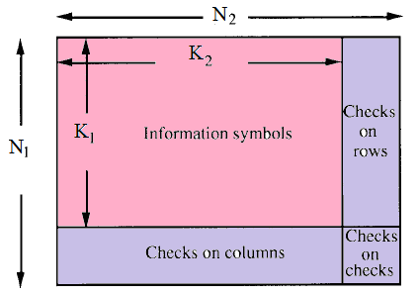
Figure 4: Product code

The concept of product codes is to build very long block code by using two or more short block codes. A product code is define by serial concatenation of two block codes, outer code $C1$ with parameters $(N_{1},K_{1})$and the inner code $C2$with parameters$(N_{2},K_{2})$, where $N_{i}$ and $K_{i}$ stand for codeword length and number of information bits respectively. The parameters of product codes are ($N_{1}×N_{2}$,$K_{1}×K_{2}$) and the code rate $R$is given by $R=R1×R2$as shown in Fig. 4 [Ramesh Mahendra Pyndiah, 1998].

2.2 Soft Input Soft Output ML-Decoder
A decoding algorithm that processes soft-decision inputs and produces soft-decision outputs is called Soft In Soft Out (SISO) decoding algorithm. This algorithm performs maximum likelihood bit estimation, and thus produces reliability information (soft-output) for each received bit. However, this algorithm is applied to decode short binary block codes only.
Let’s consider the transmission of a (N,K) linear block code C on a Gaussian channel using binary symbols {-1,+1}.The following mapping is considered 0$→$-1, and 1$→$+1. Y=[y₁,…,y_{j},….y_{N}] is the received codeword. Computing the soft decision at the output decoder of the j_{th} bit $y_{j}^{'}$ requires two codewords C^{+1(j)} and C^{-1(j)}, where C^{+1(j)} =[$c_{1}^{+1(j)},\text{.}\text{.}\text{.},c_{j}^{+1(j)},\text{.}\text{.}\text{.}\text{.}c_{N}^{+1(j)}$] is the codeword $∈$ C, that $c_{j}^{+1(j)}$=+1, and has minimum Euclidean distance with Y. C^{-1(j)} =[$c_{1}^{−1(j)},\text{.}\text{.}\text{.},c_{j}^{−1(j)},\text{.}\text{.}\text{.}\text{.}c_{N}^{−1(j)}$] is the codeword $∈$ C, that $c_{j}^{−1(j)}$=-1, and has minimum Euclidean distance with Y. The decision output is:
$y_{j}^{'}=\left(\frac{{\left|Y−C^{−1(j)}\right|}^{2}−{\left|Y−C^{+1(j)}\right|}^{2}}{4}\right)$ ………………………………………..………..(16)
and
${\left|Y−C^{i}\right|}^{2}=\sum_{j=1}^{N}{(y_{j}−c_{j}^{i})^{2}}$………….…..……………………………...…….………..(17)
Is the squared Euclidean distance between Y and $C^{i}$[Ramesh Mahendra Pyndiah, 1998].

2.3 Iterative Decoding of Product Codes
To build iterative decoder for product code we will approximate the Eq.(16) as:
$y_{j}^{'}=y_{j}+w_{j}$ ………………………………….………….………...………….……(18)
where w_{j} is the extrinsic information for j_{th} code bit, and is given by :
$ℓ≠j\underset{N}{}×c_{ℓ}^{+1(j)}×p_{ℓ}$…………………………………...….………...….………...(19)
and
$p_{ℓ}=\begin{aligned}\left\{0 \text{if} c_{ℓ}^{+1(j)}=c_{ℓ}^{−1(j)} | \right.\end{aligned}$ ……………………….…………………………...… (20)
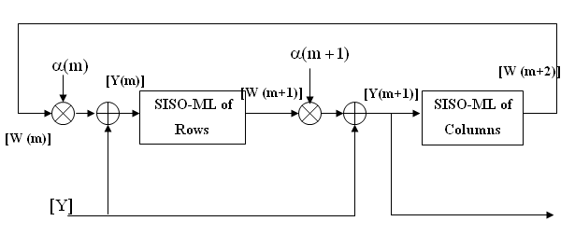
Figure 5: Iterative decoding of product codes using SISO ML decoder

Figure. 5 illustrates the block diagram iterative decoder of product codes using

SISO ML decoder. Here we considered the decoding of rows and columns of a product code that is transmitted on an AWGN channel using M-PSK signaling. At first iteration, [W(1)] is set to zero, where [W(m)] is the extrinsic information at m_{th} iteration. The soft input for each decoder is given by:
$[Y(m)]=[Y]+α(m)[W(m)]$…………………….……………………………….(21)
Where $α(m)$is a scaling factor used to reduce the effects of the extrinsic information in soft decoder in the first decoding steps when the BER is relatively high, it takes a small increases as the BER tends to zeros. The values of $α$ with the decoding step are chosen as [Ramesh Mahendra Pyndiah, 1998]:
$α$=[0.0, 0.2, 0.3, 0.5, 0.7, 0.9, 1,1,…]………………………………...…………...(22)

3. Simulation and Result
This paper focus on four transmitters STBC with different encoding rates that present in Table(1) [Luis Miguel, 2009, Vahid Tarokh, etl, 1999]. These STBC's systems are implemented in MATLAB2010 and analyzed for BER performance according to their modulation order (M=4, 16 and 64PSK) and number of receivers (Nr=1, 2, 4 and 8).

Table(1) 4-transmiter STBC encoding matrix and there MRC.
STBC1  Rate=1 k=4, p=4 | G | $$\overset{}{\left(\begin{matrix}s_{1} & s_{2} & 0 & 0 \\ −s_{2}^{} & s_{1}^{} & 0 & 0 \\ 0 & 0 & s_{3} & s_{4} \\ 0 & 0 & −s_{4}^{} & s_{3}^{}\end{matrix}\right)}$$
STBC1  Rate=1 k=4, p=4 | MRC | $$\left(\begin{matrix}\overset{\text{\sim }}{s_{1}} \\ \overset{\text{\sim }}{s_{2}} \\ \overset{\text{\sim }}{s_{3}} \\ \overset{\text{\sim }}{s_{4}}\end{matrix}\right)=\frac{1}{{\left|\left|H\right|\right|}^{2}}\sum_{i=1}^{\text{Nr}}{\left(\begin{matrix}{\left(h_{i1}\right)}^{}×r_{i}^{t_{1}} & + & h_{i2}{\left(r_{i}^{t_{2}}\right)}^{} \\ {\left(h_{i2}\right)}^{}r_{i}^{t_{1}} & − & h_{i1}{\left(r_{i}^{t_{2}}\right)}^{} \\ {\left(h_{i3}\right)}^{}r_{i}^{t_{3}} & + & h_{i4}{\left(r_{i}^{t_{4}}\right)}^{} \\ {\left(h_{i4}\right)}^{}r_{i}^{t_{3}} & − & h_{i3}{\left(r_{i}^{t_{4}}\right)}^{}\end{matrix}\right)}$$
STBC2  Rate=0.5 k=2, p=4 | G | $$\overset{}{\left(\begin{matrix}s_{1} & s_{2} & 0 & 0 \\ −s_{2}^{} & s_{1}^{} & 0 & 0 \\ 0 & 0 & s_{1} & s_{2} \\ 0 & 0 & −s_{2}^{} & s_{1}^{}\end{matrix}\right)}$$
STBC2  Rate=0.5 k=2, p=4 | MRC | $$\left(\begin{matrix}\overset{\text{\sim }}{s_{1}} \\ \overset{\text{\sim }}{s_{2}}\end{matrix}\right)=\frac{1}{{\left\|H\right\|}^{2}}\sum_{i=1}^{\text{Nr}}{\left(\begin{matrix}{\left(h_{i,1}\right)}^{}×r_{i}^{t_{1}} & + & h_{i,2}{\left(r_{i}^{t_{2}}\right)}^{} & + & {\left(h_{i,3}\right)}^{}r_{i}^{t_{3}} & + & h_{i,4}{\left(r_{i}^{t_{4}}\right)}^{} \\ {\left(h_{i,2}\right)}^{}r_{i}^{t_{1}} & − & h_{i,1}{\left(r_{i}^{t_{2}}\right)}^{} & + & {\left(h_{i,4}\right)}^{}r_{i}^{t_{3}} & − & h_{i,3}{\left(r_{i}^{t_{4}}\right)}^{}\end{matrix}\right)}$$
STBC3  Rate=0.5 k=4, p=8 | G^{T} | $\left(\begin{matrix}s_{1} & −s_{2} & −s_{3} & −s_{4} & s_{1}^{} & −s_{2}^{} & −s_{3}^{} & −s_{4}^{} \\ s_{2} & s_{1} & s_{4} & −s_{3} & s_{2}^{} & s_{1}^{} & s_{4}^{} & −s_{3}^{} \\ s_{3} & −s_{4} & s_{1} & s_{2} & s_{3}^{} & −s_{4}^{} & s_{1}^{} & s_{2}^{} \\ s_{4} & s_{3} & −s_{2} & s_{1} & s_{4}^{} & s_{3}^{} & −s_{2}^{} & s_{1}^{}\end{matrix}\right)$
STBC3  Rate=0.5 k=4, p=8 | MRC | $$\begin{aligned}\left(\begin{matrix}\overset{\text{\sim }}{s_{1}} \\ \overset{\text{\sim }}{s_{2}} \\ \overset{\text{\sim }}{s_{3}} \\ \overset{\text{\sim }}{s_{4}}\end{matrix}\right)=\frac{1}{{\left\|H\right\|}^{2}}\sum_{i=1}^{\text{Nr}}{(\begin{matrix}{\left(h_{i,1}\right)}^{}×r_{i}^{t_{1}} & +{\left(h_{i,2}\right)}^{}r_{i}^{t_{2}} & +{\left(h_{i,3}\right)}^{}r_{i}^{t_{3}} \\ {\left(h_{i,2}\right)}^{}r_{i}^{t_{1}} & −{\left(h_{i,1}\right)}^{}r_{i}^{t_{2}} & −{\left(h_{i,4}\right)}^{}r_{i}^{t_{3}} \\ {\left(h_{i,3}\right)}^{}r_{i}^{t_{1}} & +{\left(h_{i,4}\right)}^{}r_{i}^{t_{2}} & −{\left(h_{i,1}\right)}^{}r_{i}^{t_{3}} \\ {\left(h_{i,4}\right)}^{}r_{i}^{t_{1}} & −{\left(h_{i,3}\right)}^{}r_{i}^{t_{2}} & +{\left(h_{i,2}\right)}^{}r_{i}^{t_{3}}\end{matrix}}\begin{matrix}+{\left(h_{i,4}\right)}^{}r_{i}^{t_{4}} \\ +{\left(h_{i,3}\right)}^{}r_{i}^{t_{4}} \\ −{\left(h_{i,2}\right)}^{}r_{i}^{t_{4}} \\ −{\left(h_{i,1}\right)}^{}r_{i}^{t_{4}}\end{matrix} \\ \begin{matrix}\text{.}\text{.}\text{.}\text{.}\text{.}\text{.}\text{.}\text{.}\text{.}\text{.}\text{.}\text{.}\text{.}\text{.} & +h_{i,1}×{\left(r_{i}^{t_{5}}\right)}^{} & +h_{i,2}{\left(r_{i}^{t_{6}}\right)}^{} & +h_{i,3}{\left(r_{i}^{t_{7}}\right)}^{} & +h_{i,4}{\left(r_{i}^{t_{8}}\right)}^{} \\ \text{.}\text{.}\text{.}\text{.}\text{.}\text{.}\text{.}\text{.}\text{.}\text{.}\text{.}\text{.}\text{.}\text{.} & +h_{i,2}{\left(r_{i}^{t_{5}}\right)}^{} & −h_{i,1}{\left(r_{i}^{t_{6}}\right)}^{} & −h_{i,4}{\left(r_{i}^{t_{7}}\right)}^{} & +h_{i,3}{\left(r_{i}^{t_{8}}\right)}^{} \\ \text{.}\text{.}\text{.}\text{.}\text{.}\text{.}\text{.}\text{.}\text{.}\text{.}\text{.}\text{.}\text{.}\text{.} & +h_{i,3}{\left(r_{i}^{t_{5}}\right)}^{} & +h_{i,4}{\left(r_{i}^{t_{6}}\right)}^{} & −h_{i,1}{\left(r_{i}^{t_{7}}\right)}^{} & −h_{i,2}{\left(r_{i}^{t_{8}}\right)}^{} \\ \text{.}\text{.}\text{.}\text{.}\text{.}\text{.}\text{.}\text{.}\text{.}\text{.}\text{.}\text{.}\text{.}\text{.} & +h_{i,4}{\left(r_{i}^{t_{5}}\right)}^{} & −h_{i,3}{\left(r_{i}^{t_{6}}\right)}^{} & +h_{i,2}{\left(r_{i}^{t_{7}}\right)}^{} & −h_{i,1}{\left(r_{i}^{t_{8}}\right)}^{}\end{matrix})\end{aligned}$$
STBC4  Rate=3/4 k=3, p=4 | G | $$\left(\begin{matrix}s_{1} & s_{2} & s_{3} & 0 \\ −s_{2}^{} & s_{1}^{} & 0 & s_{3} \\ s_{3}^{} & 0 & −s_{1}^{} & s_{2} \\ 0 & s_{3}^{} & −s_{2}^{} & −s_{1}\end{matrix}\right)$$
STBC4  Rate=3/4 k=3, p=4 | MRC | $$\left(\begin{matrix}\overset{\text{\sim }}{s_{1}} \\ \overset{\text{\sim }}{s_{2}} \\ \overset{\text{\sim }}{s_{3}}\end{matrix}\right)=\frac{1}{{\left\|H\right\|}^{2}}\sum_{i=1}^{\text{Nr}}{\left(\begin{matrix}{\left(h_{i,1}\right)}^{}×r_{i}^{t_{1}} & +h_{i,2}{\left(r_{i}^{t_{2}}\right)}^{} & −h_{i,3}{\left(r_{i}^{t_{3}}\right)}^{} & −{\left(h_{i,4}\right)}^{}r_{i}^{t_{4}} \\ {\left(h_{i,2}\right)}^{}r_{i}^{t_{1}} & −h_{i,1}{\left(r_{i}^{t_{2}}\right)}^{} & +{\left(h_{i,4}\right)}^{}r_{i}^{t_{3}} & −h_{i,3}{\left(r_{i}^{t_{4}}\right)}^{} \\ {\left(h_{i,3}\right)}^{}r_{i}^{t_{1}} & +{\left(h_{i,4}\right)}^{}r_{i}^{t_{2}} & +h_{i,1}{\left(r_{i}^{t_{3}}\right)}^{} & +h_{i,2}{\left(r_{i}^{t_{4}}\right)}^{}\end{matrix}\right)}$$

3.1 Influence of Number of Receivers
Figure. 6 shows the BER performance of undecoded 64PSK STBC's with different number of received antennas (Nr=1,2,4,8). It's obvious that increasing number of received antennas provides significant coding gain but the system complexity will be very large.
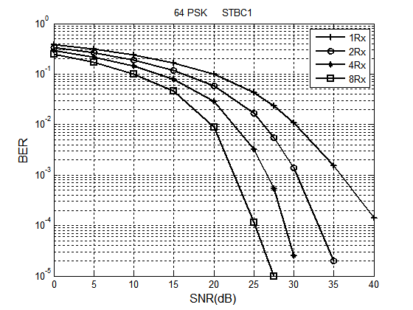
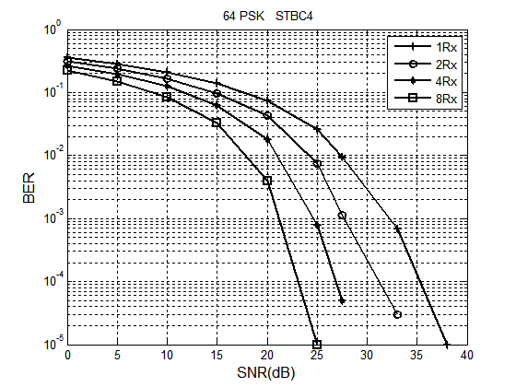
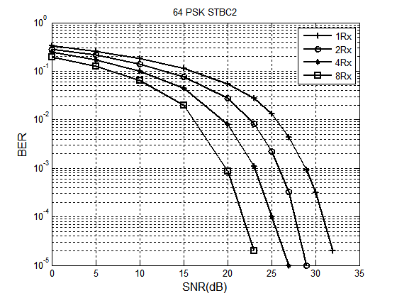
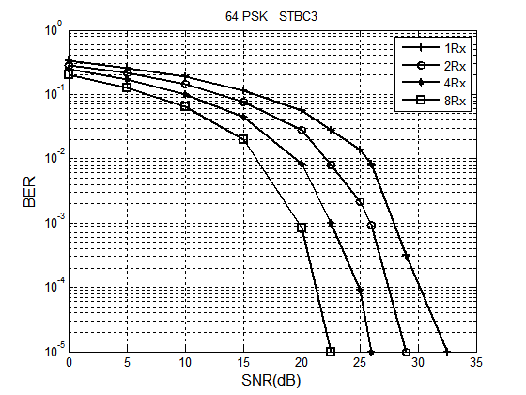
Figure 6: Influnce of number of receivers on BER performance of STBC

3.2 Influence of Modulation Order
Figure. 7 shows a comparison between the BER performances of 2 receivers STBC with different modulation order (M=4, 16 and 64). It can be seen that the high modulation order provides most awful BER performance.

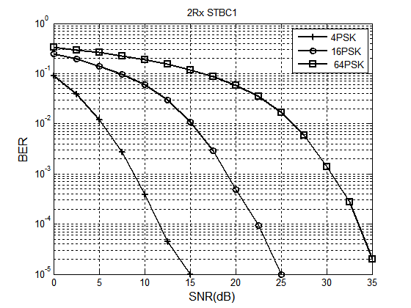
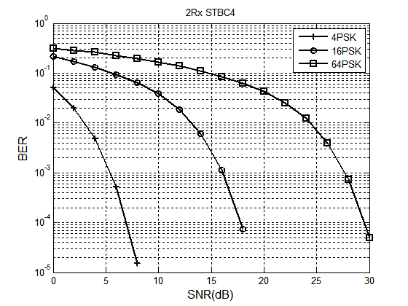
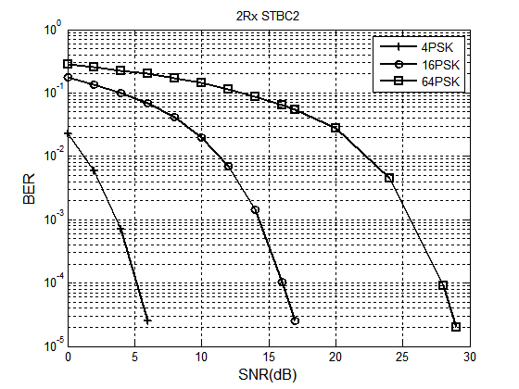
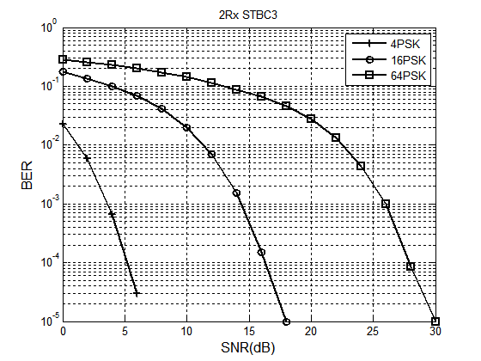
Figure 7: Influence of modulation order on BER performance of STBC

3.3 STBC with Turbo Product Code
We will improve the BER performance of 64PSK 4×2 STBC's systems (since it gives acceptable complexity and high bit rate) by combining them with (8,4) exHamming turbo product code. In all systems, a random data generator generates digital information bits, frame-by-frame, where each frame is 4×4 bits length . Each frame encoded by (8,4) exHamming product code that made the code ward is 8×8 bits length. Sum zero bit must padding to made the codeword length as integer multiple of k×log₂(64) . Each codeword frame is modulated using 64PSK modulator and encoded by STBC. The encoded symbols are transmitted by four antenna through MIMO Rayleigh fading channel model described in section 1.1, then complex AWGN is added to the transmitted signal.
At receiver end, the received symbols are decoded, using MRC with prefect knowledge with channel coefficient and soft decision 64PSK demodulate. Turbo decoder use output of demodulator (after removing padding bits) and apply iterative decoding that describes in section 2.3. At each iteration decoded bits are compared with originally generated information bits frame to compute BER corresponding to a given SNR as shown in Fig. 8. Total number of transmitted bits used is about 2×10⁵ bits.

4×2 MIMO Rayleigh fading
Data bits
(8,4)×(8,4) exHamming product code
64PSK soft decision demod.
k-input, p-output
4 Tx STBC Encoder
2 Rx STBC Decoder

64PSK mod.
Turbo decoder
Received bits
Zero padding
Removing padded
bits
Figure 8: 2×4 STBC with (8,4) exHamming product code system
By running this model (using MATLAB2010) the BER performance of 64PSK 4×2 STBC's describes in Table (1) with (8,4) exHamming product code is shown in Fig. 9. It is obvious these BER performances are best and powerful as compare with BER performance of undecoded STBC's .

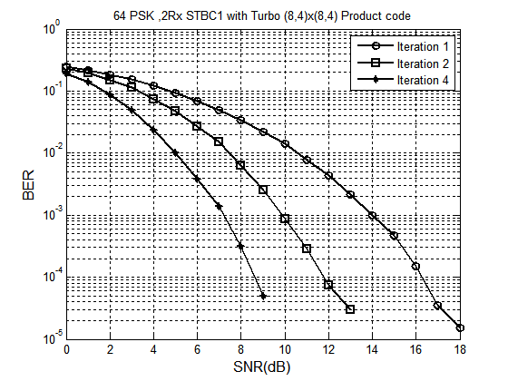
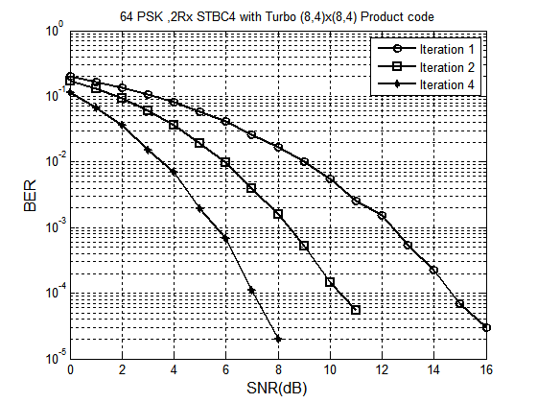
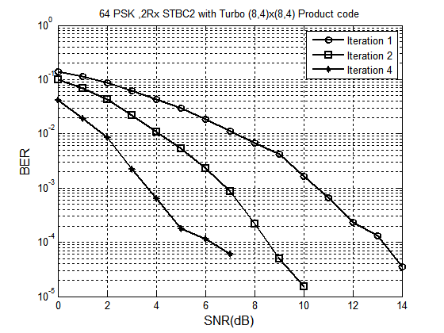
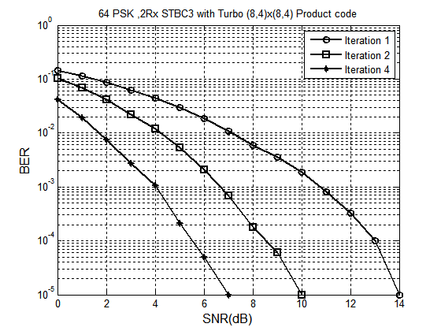
Figure 9: BER performance of turbo decoding for 64PSK 4×2 STBC's

4. Conclusions
In this paper, we have evaluated the BER performance of a four different encoding matrix for 4Tx MPSK STBC system based on its number of receivers and its modulation order. The first important thing can be concluded that good BER performance can be obtain when:
- STBC rate is low, as example BER performance of rate0.5 STBC3.
- Modulation order is small, as example BER performance of 2PSK.
- Number of received antenna is high, as example BER of performance 8Rx.
But these points are not good solutions to obtain good BER performance, because low rate STBC or small modulation order made transmission rate very low while increasing number of received antennas made the system complexity too large.
This paper illustrates a simple method to improve the BER performance of STBC without changing its modulation order or number of received antenna by combing it's encoder with product code and apply iterative SISO ML-decoding algorithm at receiving side. We can apply this iterative decoding algorithm on any binary block code (Hamming, BCH, RM,…, with any code dimension) with soft decision MPSK demodulator to obtain powerful performance but we choice (8,4) exHamming code since its provide good BER performance with low decoding complexity (since number of codeword =2⁴) and combing it with high rate acceptable complexity 4×2 ,64PSK STBC. The main disadvantage of using (8,4) exHamming turbo code that bit rate will reduce by 0.25 and decoding time will increase, because it's iterative decoding natural.
Finally, by comparing the BER performance of rate2/4 STBC2 and rate4/8 STBC3 we can see STBC3 provide low coding gain as compare with STBC2 (about 0-1dB for undecoded and 0-2dB for decoded system). This coding gain compare with huge MRC complexity of STBC3 can be lossless. Therefore we can conclude that STBC code dimension don't affect widely on BER performance. This coding gain may be change if we choice different FEC decoding algorithm (or different FEC encoder), or different type of channel or different modulation type.

References
George Tsoulos, (2006),"MIMO System Technology for Wireless Communications", Taylor & Francis Group, LLC, Boca Raton London ,New York
Kala Praveen Bagadi, (2010)''MIMO-OFDM Channel Estimation using Pilot Carries'' International Journal of Computer Applications Vol.2, No.3, pp.1-8.
Luis Alberto Paredes Hernández and Mariano García Otero, (2006),'' A New LDPC-STB Coded MC-CDMA Systems with SOVA-Based Decoding and Soft-Interference Cancellation''4th European Signal Processing Conference (EUSIPCO 2006), Florence, Italy, pp.1-5
Luis Miguel, (2009), ''MIMO Space-Time Block Coding (STBC): Simulations and Results'' Personal & Mobile Communications,Vol.23,No.2, pp.1-8
Mesbahul M. Alam, Touhidul Islam A.Z.M. and Enayet Ullah S., (2011)''Performance Analysis of a Concatenated LDPC Coded Alamouti-Based STBC-OFDM System on Text Message Transmission'' International Journal of Computer Science, Engineering and Applications (IJCSEA) Vol.1, No.3, pp.1-9
Muhammad Sana Ullah and Mohammed Jashim Uddin, (2010) ''Performance Analysis of Wireless MIMO System by Using Alamouti’s Scheme and Maximum Ratio Combining Technique'' International Journal of Advanced Engineering Sciences and Technologies Vol.8, Issue No.1, pp.19 – 24
Ramesh Mahendra Pyndiah, (1998) ''Near Optimum Decoding of Product Codes: Block Turbo Codes'', IEEE Trans. Comm., Vol.46, No.8, pp.1003-1010
Roger A. Hammons and Hesham El-Gamal, (2000) '' On the Theory of Space–Time Codes for PSK Modulation'' IEEE Transactions on Information Theory, Vol. 46, No. 2, pp. 524-542
Rose Trepkowski, |(2004),'' Channel Estimation Strategies for Coded MIMO Systems '' MSc. Thesis, Blacksburg, Virginia
Savo G. Glisic, (2007), '' Advanced Wireless Communications'' John Wiley & Sons Ltd Second Edition
Torres P., Ludovic Costa , and Gusmão A. ,(2011),''Mobile Communications with STBC And Turbo Codes'' International Conference on Innovations , MECAHITECH 11, Vol. 3, pp.1-10.
Vahid Tarokh, , Hamid Jafarkhani, and Robert A. Calderbank ,)1999), ''Space–Time Block Codes from Orthogonal Designs'' IEEE transactions on information theory, Vol. 45, No.5, pp. 1456-1467
Vahid Tarokh ,Hamid Jafarkhani, and Robert A. Calderbank,(1999),''Space–Time Block Coding for Wireless Communications: Performance Results'' IEEE Journal on Selected Areas in Communications, Vol. 17,No.3, pp. 451- 460
Vahid Tarokh, Hamid Jafarkhani, and Robert A. Calderbank , (1999) '' Space–Time Block Coding for Wireless Communications: Performance Results'' IEEE Journal on Selected Areas in Communications, Vol. 17, No. 3,pp .451-46

