Finite Difference Analysis of One Dimensional Consolidation of Homogeneous clay layer

Ali Hameed Naser
Civil Engineering Department, Karbala University, Iraq.

Abstract
This research presents an explicit finite difference solution for the one-dimensional consolidation of a homogeneous clay layer with permeable top and impermeable bottom. A computer program was written in BASIC to deal with this problem. The comparison of the numerical solution developed with the corresponding solution by Craig (2007) for the case of non-uniform initial excess pore-water pressure distribution showed excellent agreement. The computer program was written so as to deal with one dimensional consolidation of one layer clay for whatever case need to be studied. Different hydraulic boundary conditions, different distributions of initial access pore water pressure, and different properties of soil can be easily studied using this program. The researchers and students will not find any difficulty to find the degree of consolidation of any type of soil layer especially when they run the computer program which will take the pore water pressure for all meshes and time needed very fast by using finite difference technique.

المستخلص
يتناول هذا البحث دراسة الانضمام الأحادي الأبعاد لطبقة متجانسة من الطين باستخدام طريقة التحليل العددية وهي طريقة الفوارق المحددة وقد اجريت الدراسة على طبقة الطين على فرض انها نفاذة من الاعلى وغير نفاذة من الاسفل. تم كتابة وتنفيذ برنامج حاسبة باستخدام لغة البيسك للتعامل مع هذه المشكلة. اجريت مقارنة بين النتائج المستحصلة من الحل العددي الذي تم تنفيذه باستخدام طريقة الفوارق المحددة مع النتائج التي حصل عليها كريغ (2007) للحالة التي يكون فيها ضغط ماء المسام الابتدائي غير متساوي خلال طبقة التربة وكانت النتائج متطابقة الى حد ممتاز. كذلك لقد تم كتابة هذا البرنامج لدراسة الانضمام الاحادي الابعاد لطبقة طين واحدة ولكل الحالات الممكنة والتي يرغب بدراستها. مختلف شروط الحدود الهيدروليكية، ومختلف توزيع ضغط ماء المسام الأولي، وخصائص مختلفة من التربة يمكن دراستها بسهولة باستخدام هذا البرنامج. فإن الباحثين والطلاب سوف لن يجدوا أية صعوبة في دراسة درجة الانضمام في أي نوع من التربة عند تشغيل برنامج الحاسبة والذي سوف يعطي ضغط ماء المسام لكل الشبكة وللوقت المطلوب وبسرعة فائقة باستخدام طريقة الفوارق المحددة التي اجريت في هذه الدراسة.

1- Introduction
The consolidation is the gradual reduction in volume of a fully saturated soil of low permeability due to total stress increase and the reduction in water content and void ratio is aresult. This process continues until the excess pore water pressure set up by an increase in total stress has completely dissipated (Craig 2007).
However, due to low permeability of the soil there will be a time lag between the application of load and the extrusion of the pore water, and thus the settlement (Das 2008).
Consolidation is important in impervious soils, i.e., soils with low permeability such as clay, whereas in sand, the dissipation of excess pore pressure is fast due to high permeability.
According to Terzaghi, every process involving a decrease in the water content of a saturated soil without replacement of the water by air is called a process of consolidation as reported by Das (2008).
The process opposite to consolidation is called swelling, which involves an increase in the water content due to the increase in the volume of the voids (Lambe and Whitman 2008).
Consolidation may be due to one or more of the following factors (Murthy 1988).
- External static loads from structures.
- Self-weight of the soil such as the recently placed fills.
- Lowering of the ground water table.
- Desiccation: the drainage of any type of soil.
- Vibration: any structure founded on cohesionless soil is likely to settle excessively.
The total compression of saturated clay strata under excess effective pressure is divided into three parts as following:
- Immediate compression.
- Primary compression.
- Secondary compression.
In most cases the critical settlement is not the total settlement but rather the differential settlement, which is the relative movement of two parts of the structure (Razauki 1989).

2- Total settlement and differential settlement
a- Total settlement
The total settlement represents both of immediate settlement, occurring under undrained conditions, and the consolidation settlement, which is the vertical displacement of the surface corresponding to the volume change at any stage of the consolidation process.
Lambe and Whitman (2008) reported that if the total settlement of a structure excess 150 to 300 mm there can be trouble with pipes (for gas, water or sewage) connected to the structure[3].
The magnitude of secondary compression is often expressed by the slop C_{α} of the final portion of the time compression curve on a semi-log graph paper as shown in figure (1).
Log time
Compression
C_{α}

One decade

Figure (1): Definition of Rate of Secondary Compression
(Lambe and Whitman 2008)
Connections can however be designed for structure settlement. However, there are situations where large total settlements can cause serious problem e.g. a tank on soft clay near a water front can settle below water level Lambe and Whitman 2008).
b- Differential Settlement
According to Lambe and Whitman (2008), differential settlement is the relative movement of two parts of the structure.
The allowable angular distortion in buildings has been studied by theoretical analyses, by tests on large models of the structure frames, and by field observations.
For the case of a steel tank, most of the load is from the stored fluid, and due to the flexibility of the tank's bottom the bearing stress has a uniform distribution. Due to the flexibility, the tank can tolerate large differential settlements without damage. As stated previously, it is usually the differential settlement (rather than the total settlement) that is of concern in designing foundation. Some of the various types of settlement are illustrated in Figure (2).
ρ
ρ_{max}
ℓ
ρ_{min}
ℓ
δ
ρ_{max}
ρ_{min}

Angular distortion

(b)

Angular distortion

(c)
(a)

Figure (2) Types of Settlement (a) Uniform Settlement (b) Tilt (c) Non-Uniform Settlement (Lambe and Whitman 2008)

3- Assumptions of Terzaghi One Dimensional Consolidation Theory.
The assumption made by Terzaghi for developing the one-dimensional consolidation theory can be summarized as follows (Scott 1963):
- The soil is homogeneous.
- The soil is fully saturated.
- The solid particles and water are incompressible.
- Compression and flow are one-dimensional (vertical).
- Strains are small.
- Darcy's law is valid at all hydraulic gradients.
- The coefficient of permeability and the coefficient of volume compressibility remain constant throughout the process.
- There is a unique relationship, independent of time, between void ratio and effective stress.
- The load is applied instantaneously.
Experimental results show that the relationship between void ratio and effective stress is not independent of time.
The theory relates the following three quantities:
- The excess pore water pressure (u).
- The depth (z) below the top of the clay layer.
- The time (t) from the instantaneous application of a total stress increment.
Consider an element having dimensions dx, dy and dz within a clay layer of thickness 2d, as shown in Figure (3). An increment of total vertical stress ∆σ is applied to the element.
The flow velocity through the element is given by Darcy's law as:
$$ν_{t}={\text{ki}}_{t}=−k\frac{∂h}{∂z}\text{.}\text{.}\text{.}\text{.}\text{.}\text{.}\text{.}\text{.}\text{.}\text{.}\text{.}\text{.}\text{.}\text{.}\text{.}\text{.}\text{.}\text{.}\text{.}\text{.}\text{.}\text{.}\text{.}\text{.}\text{.}\text{.}\text{.}\text{.}\text{.}\text{.}\text{.}\text{.}\text{.}\text{.}\text{.}\text{.}\text{.}\text{.}\text{.}\text{.}\text{.}\text{.}\text{.}\text{.}\text{.}\text{.}\text{.}\text{.}\text{.}\text{.}\text{.}\text{.}\text{.}\text{.}\text{.}\text{.}\text{.}\text{.}\text{.}\text{.}(1)$$
Since any change in total head (h) is due only to a change in pore water pressure.
$$ν_{t}=\frac{−k}{γw}\frac{∂u}{∂z}\text{.}\text{.}\text{.}\text{.}\text{.}\text{.}\text{.}\text{.}\text{.}\text{.}\text{.}\text{.}\text{.}\text{.}\text{.}\text{.}\text{.}\text{.}\text{.}\text{.}\text{.}\text{.}\text{.}\text{.}\text{.}\text{.}\text{.}\text{.}\text{.}\text{.}\text{.}\text{.}\text{.}\text{.}\text{.}\text{.}\text{.}\text{.}\text{.}\text{.}\text{.}\text{.}\text{.}\text{.}\text{.}\text{.}\text{.}\text{.}\text{.}\text{.}\text{.}\text{.}\text{.}\text{.}\text{.}\text{.}\text{.}\text{.}\text{.}\text{.}\text{.}\text{.}\text{.}\text{.}\text{.}(2)$$
$$V_{x}\text{dydz}+V_{z}\text{dxdy}$$
If the element of no volume change and incompressible water, the difference between the water entering and the leaving volume is zero. Therefore:
$$\frac{∂V_{x}}{∂x}+\frac{∂V_{z}}{∂z}=0\text{.}\text{.}\text{.}\text{.}\text{.}\text{.}\text{.}\text{.}\text{.}\text{.}\text{.}\text{.}\text{.}\text{.}\text{.}\text{.}\text{.}\text{.}\text{.}\text{.}\text{.}\text{.}\text{.}\text{.}\text{.}\text{.}\text{.}\text{.}\text{.}\text{.}\text{.}\text{.}\text{.}\text{.}\text{.}\text{.}\text{.}\text{.}\text{.}\text{.}\text{.}\text{.}\text{.}\text{.}\text{.}\text{.}\text{.}\text{.}\text{.}\text{.}\text{.}\text{.}\text{.}\text{.}(3)$$
And if volume is changeable, the continuity equation becomes.
$$\left(\frac{∂V_{x}}{∂x}+\frac{∂V_{z}}{∂z}\right)\text{dxdz}=\frac{\text{dy}}{\text{dt}}\text{.}\text{.}\text{.}\text{.}\text{.}\text{.}\text{.}\text{.}\text{.}\text{.}\text{.}\text{.}\text{.}\text{.}\text{.}\text{.}\text{.}\text{.}\text{.}\text{.}\text{.}\text{.}\text{.}\text{.}\text{.}\text{.}\text{.}\text{.}\text{.}\text{.}\text{.}\text{.}\text{.}\text{.}\text{.}\text{.}\text{.}\text{.}\text{.}\text{.}\text{.}\text{.}\text{.}(4)$$
$\frac{\text{dy}}{\text{dt}}$volume change per unit time.
This equation can be expressed as follows.
$$−\frac{K}{∂w}\frac{∂^{2}u}{∂z^{2}}\text{dxdydz}=\frac{\text{dv}}{\text{dt}}\text{.}\text{.}\text{.}\text{.}\text{.}\text{.}\text{.}\text{.}\text{.}\text{.}\text{.}\text{.}\text{.}\text{.}\text{.}\text{.}\text{.}\text{.}\text{.}\text{.}\text{.}\text{.}\text{.}\text{.}\text{.}\text{.}\text{.}\text{.}\text{.}\text{.}\text{.}\text{.}\text{.}\text{.}\text{.}\text{.}\text{.}\text{.}\text{.}\text{.}\text{.}\text{.}\text{.}\text{.}\text{.}\text{.}\text{.}\text{.}(5)$$
The rate of volume change can be expressed in terms of m_{v}
$$\frac{\text{dv}}{\text{dt}}=m_{v}⋅\frac{∂\bar{σ}}{∂t}\text{dxdydz}\text{.}\text{.}\text{.}\text{.}\text{.}\text{.}\text{.}\text{.}\text{.}\text{.}\text{.}\text{.}\text{.}\text{.}\text{.}\text{.}\text{.}\text{.}\text{.}\text{.}\text{.}\text{.}\text{.}\text{.}\text{.}\text{.}\text{.}\text{.}\text{.}\text{.}\text{.}\text{.}\text{.}\text{.}\text{.}\text{.}\text{.}\text{.}\text{.}\text{.}\text{.}\text{.}\text{.}\text{.}\text{.}\text{.}\text{.}\text{.}\text{.}(6)$$
Where:
m_{v}= coefficient of volume compressibility.
$\bar{σ}$= effective stress.
The total stress increment results into gradually increasing effective stress, as the excess pore water pressure decreases, so the rate of volume change can be expressed as:
$$\frac{\text{dv}}{\text{dt}}=−\text{mv}\frac{∂u}{∂t}\text{dxdydz}\text{.}\text{.}\text{.}\text{.}\text{.}\text{.}\text{.}\text{.}\text{.}\text{.}\text{.}\text{.}\text{.}\text{.}\text{.}\text{.}\text{.}\text{.}\text{.}\text{.}\text{.}\text{.}\text{.}\text{.}\text{.}\text{.}\text{.}\text{.}\text{.}\text{.}\text{.}\text{.}\text{.}\text{.}\text{.}\text{.}\text{.}\text{.}\text{.}\text{.}\text{.}\text{.}(7)$$
Combining Equ.(5) and (7):
$$\text{mv}\frac{∂u}{∂t}=\frac{K}{γw}\frac{∂^{2}u}{∂z^{2}}\text{.}\text{.}\text{.}\text{.}\text{.}\text{.}\text{.}\text{.}\text{.}\text{.}\text{.}\text{.}\text{.}\text{.}\text{.}\text{.}\text{.}\text{.}\text{.}\text{.}\text{.}\text{.}\text{.}\text{.}\text{.}\text{.}\text{.}\text{.}\text{.}\text{.}\text{.}\text{.}\text{.}\text{.}\text{.}\text{.}\text{.}\text{.}\text{.}\text{.}\text{.}\text{.}\text{.}\text{.}\text{.}\text{.}\text{.}\text{.}\text{.}\text{.}\text{.}(8)$$
$$\frac{∂u}{∂t}=C_{v}\frac{∂^{2}u}{∂z^{2}}\text{.}\text{.}\text{.}\text{.}\text{.}\text{.}\text{.}\text{.}\text{.}\text{.}\text{.}\text{.}\text{.}\text{.}\text{.}\text{.}\text{.}\text{.}\text{.}\text{.}\text{.}\text{.}\text{.}\text{.}\text{.}\text{.}\text{.}\text{.}\text{.}\text{.}\text{.}\text{.}\text{.}\text{.}\text{.}\text{.}\text{.}\text{.}\text{.}\text{.}\text{.}\text{.}\text{.}\text{.}\text{.}\text{.}\text{.}\text{.}\text{.}\text{.}\text{.}\text{.}\text{.}\text{.}\text{.}\text{.}\text{.}\text{.}\text{.}\text{.}\text{.}\text{.}\text{.}\text{.}\text{.}\text{.}\text{.}\text{.}(9)$$
2d
Vx
dxdy
Vz
z
dz

Figure (3): Element within a Clay Layer

4- Analytical Solution of The Consolidation Equation:
The total stress increment is assumed to be applied instantaneously, and at zero time will be carried entirely by the pore water, accordingly, the initial value of excess pore water pressure (ui) is equal to ∆σ and the initial condition is :
u=u_{t}for 0 ≤ z ≤ 2dwhen t=0 ………………… (10)
Note that the upper and lower boundaries of the clay layer are assumed to be free draining, so the boundary conditions are:
u=0 for z=0 and z=2d when t> 0 ………………(11)
Following Craig (2007), the solution of Equ.(9) together with the above boundary and initial conditions becomes
$$u=\sum_{n=1}^{n=∞}{\frac{2u_{t}}{\text{np}}}(1−\text{cos}nπ)\left(\text{sin}\frac{nπz}{2d}\right)\text{exp}\left(\frac{−n^{2}π^{2}C_{v}t}{4d^{2}}\right)$$
$$=\sum_{m=1}^{m=∞}{\frac{2u_{t}}{M}\left(\text{sin}\frac{\text{Mz}}{d}\right)}\text{exp}(−M^{2}\text{Tv})\text{.}\text{.}\text{.}\text{.}\text{.}\text{.}\text{.}\text{.}\text{.}\text{.}\text{.}\text{.}\text{.}\text{.}\text{.}\text{.}\text{.}\text{.}\text{.}\text{.}\text{.}\text{.}\text{.}\text{.}\text{.}\text{.}\text{.}\text{.}\text{.}\text{.}\text{.}\text{.}\text{.}\text{.}\text{.}\text{.}\text{.}\text{.}\text{.}\text{.}\text{.}\text{.}\text{.}\text{.}\text{.}\text{.}\text{.}\text{.}(\text{12})$$
$\text{Tv}=\frac{C_{v}t}{d^{2}}=$dimensional less time factor ………………….(13)
d=length of largest draining path (2d= thickness of clay layer)
C_{v}=coefficient of consolidation
t=actual time
the average degree of consolidation at time t for constant ui is given by:
$U=\frac{\text{pt}}{p∞}=\frac{\int_{0}^{2d}{\left(\text{ui}−u\right)m_{v}\text{dz}}}{\int_{0}^{2d}{u_{i}⋅m_{v}\text{dz}}}$$=1−\frac{\int_{0}^{2d}{\text{udz}}}{\int_{0}^{2d}{u_{i}\text{dz}}}=1−\frac{\frac{1}{2d}\int_{0}^{2d}{\text{udz}}}{u_{i}}$
$$=1−\sum_{m=0}^{m=∞}{\frac{2}{M^{2}}\text{exp}\left(−M^{2}\text{tv}\right)}\text{.}\text{.}\text{.}\text{.}\text{.}\text{.}\text{.}\text{.}\text{.}\text{.}\text{.}\text{.}\text{.}\text{.}\text{.}\text{.}\text{.}\text{.}\text{.}\text{.}\text{.}\text{.}\text{.}\text{.}\text{.}\text{.}\text{.}\text{.}\text{.}\text{.}\text{.}\text{.}\text{.}\text{.}\text{.}\text{.}(\text{14})$$

Where:
pt= settlement at time t.
p∞= total settlement at time t=∞.
m_{v}= coefficient of volume compressibility.
Note that for a half closed layer, the limits of integration are zero and d in the above equation.

5- Coefficient of consolidation
The coefficient of consolidation C_{v} in Equ. (9) remains constant during the consolidation process since k and mv are assumed constant (Terzaghi and Peck 1967).
The coefficient of consolidation can be determined from laboratory measurements or from in-situ measurements as discussed below.

a- Laboratory coefficient of consolidation using the log time method (due to casagrande).
The experimental curve is obtained by plotting the dial gauge reading in the odometer test against the logarithm of time in minutes. The theoretical curve is given as the plot of the average degree of consolidation against the logarithm of the time factor. The theoretical curve consists of three parts:
The point corresponding to U=50% can be located midway between the as and a₁₀₀ points and time t₅₀ obtained.
The value of the dimensionless time factor Tv corresponding to U=50% is 0.196 and the coefficient of consolidation is given by (Craig, 2007).
$$C_{v}=\frac{0\text{.}\text{196}d^{2}}{t_{\text{50}}}$$
Where:
d=half the average thickness of the specimen for the particular pressure increment.

b- Laboratory Coefficient of Consolidation Using The Root Time Method (due to Tayloer)
The dial gauge reading being plotted against the square root of time in minutes and the average degree of consolidation against the square root of time factor. The point (D) corresponding to U=0 is obtaindly producing back the linear part of curve to the ordinate at zero time. As straight line (DE) is then drawn having a basics (Ac). The intersection of the line (DE) with the experiment curve locates the point (a₉₀) corresponding to U=90% and the corresponding value $\sqrt{t_{\text{90}}}$ can be obtained. The Tv for U=90% is 0.848 and the coefficient of consolidation is given by (Craig, 2007).
$$C_{v}=\frac{0\text{.}\text{848}d^{2}}{t_{\text{90}}}$$
c- In-Situ Value of C_{v}
Settlement observations have indicated that the rates of settlement of full scale structures are generally much greater than those predicated using the values of C_{v} obtained from the results of odometer tests on small specimens. Piezometers can be used for the in-situ determination of C_{v} (Das and Herbich 1991).
The most satisfactory procedure is to maintain a constant head at the Piezometer tip and measure the rate of the flow into or out of the system. If the rate of flow is measured at various times the in-situ value of the coefficient of permeability can be deducted and the coefficient of consolidation can be determined as follows.
$$C_{v}=\frac{k_{v}}{m_{v}γw}$$
Where:
k_{v}= in-situ permeability.
m_{v}=coefficient of volume compressibility (Serge 2006).
γw=unit weight of water.

6- One-dimensional consolidation of a homogeneous layer
To solve the conventional one-dimensional consolidation equation (9) using finite difference technique, the explicit finite difference technique can be applied as follows:
$$\frac{u_{i,n+1}−u_{i,n}}{Δt}=C_{v}\frac{u_{i+1,n}−2u_{i,n}+u_{i−1,n}}{{\left(Δz\right)}^{2}}$$
$$u_{i,n+1}=\frac{C_{v}Δt}{{\left(Δz\right)}^{2}}\left(u_{i−1,n}−2u_{i,n}+u_{i+1,n}\right)+u_{i,n}\text{.}\text{.}\text{.}\text{.}\text{.}\text{.}\text{.}\text{.}\text{.}\text{.}\text{.}\text{.}\text{.}\text{.}\text{.}\text{.}\text{.}\text{.}\text{.}\text{.}\text{.}\text{.}\text{.}\text{.}\text{.}\text{.}\text{.}\text{.}\text{.}\text{.}\text{.}\text{.}\text{.}\text{.}\text{.}\text{.}\text{.}\text{.}\text{.}\text{.}(\text{15})$$
Introducing the dimensionless term $β=\frac{C_{v}Δt}{{\left(Δz\right)}^{2}}$Equ.(15) can be written as follows.
u_{i,n+1}=u_{i,n}+β(u_{i,-1,n}-2u_{i,n}+u_{i+1,n}) …………………..(16)

7- Stability and Convergence for Explicit Technique
For the numerical explicit finite difference solution represented by equation (3-2) to be stable and convergent, some limitation on β should be made. The dimensionless parameter β is governed by the following limitation (Raymond 1997).
Β ≤ 0.5
However, it was found by trial that the use of $β=\frac{1}{2}$results in a stably oscillating solution, which is also undesirable (Robert 2006).
For this reason, the use of β=0.5 was avoided in this work.

8-Hydraulic Boundary Conditions
The boundary conditions to be adopted in this work are permeable top either due to the existence of a sand layer or an artificial sand blanket. The bottom of the deposit is considered to be impermeable as shown in Figure (4).
d=10 m
Permeable Boundary
Impermeable Boundary

Figure (4): Half-Closed Layer

9- Computer program
A computer program is written to solve the one dimensional consolidation of layered clays using explicit finite difference technique for permeable top and permeable or impermeable bottom.
The computer program is written twice; first I is written in BASIC which is the easy language of programming, and second it is written in FORTRAN90 language (Rajarman 2009).
a- BASIC Program
The following is the BASIC version of computer program that has been written to solve the one dimensional consolidation of one layer clay.
10 REM************************************************************
20 REM**** FINITE DIFFERENCE SOLUTION OF ONE DIMENTIONAL *****
30 REM**** CONSOLIDATION FOR HOMOGENEOUS CLAY LAYER ****
40 REM***** USING EXPLICIT TECHNIQUE FOR PERMEABLE TOP ******
50 REM***** AND IMPERMEABLE BOTTOM ******
60 DIM IN (30) , VA (30) , FI (30) , K(30)
70 INPUT " THE THICHNESS OF THE LAYER (M) " ; H
80 INPUT " THE NUMBER OF MESH INTERVALS OF THE LAYER " ; N
90 HH=H/N
100 INPUT " THE COEFFICIENT OF CONSOLIDATION OF THE LAYER (M^2/YEAR)"; CV
110 INPUT " THE TIME INTERVAL IN (YEAR)"; TTT
120 INPUT " THE INCREMENT IN TIME IN (YEAR) "; TT
130 BETA=(CV*TT)/(HH^2)
140 IF BETA >.5 THEN 120
150 M=N+1
160 TIME=0
170 FOR I=1 TO M
180 READ IN (I)
190 VA (I) = IN (I)
200 PRINT VA (I)
210 NEXT I
220 TIME = TIME+TT
230 IF TIME > TTT THEN 430
240 FOR I=2 TO M
250 IF I=M THEN 290
260 FI (I) = BETA*(VA(I-1)+VA(I+1)-2*VA(I))+VA(I)
270 K(I) = FI (I)
280 GOTO 320
290 FI(I) = BETA*(2*VA(I-1)-2*VA(I))+VA(I)
300 K(I) =FI(I)
310 GOTO 330
320 NEXT I
330 PRINT "TIME INCREMENT=" ; TIME
340 FOR I=1 TO M
350 PRINT FI (I)
360 NEXT I
370 FOR I=1 TO M
380 VA (I) =K (I)
390 NEXT I
400 GOTO 220
410 REM ENTER VALUES OF INITIAL EXCESS PORE WATER PRESSURE DISTRIBUTION
420 DATA 0 , 56 , 25 , 50 , 75 , 42.63 , 35 , 27.75 , 21.5 , 17.5 ,15
- END
b- FORTRAN Program
The following is the FORTRAN90 version of computer program that has been written to solve the problem.
PROGRAM consolidation
REAL, DIMENSION (30) :: IN,VA,FI,K
REAL :: H,N,TTT,TIME,HH,BETA
INTEGER :: I,M
write (*,*) 'THE THICHNESS OF THE LAYER(M)'
read (*,*) H
write (*,*) 'THE NUMBER OF MESH INTERVALS OF THE LAYER'
read (*,*) N
HH = H/N
write (*,*) 'THE COEFFICIENT OF CONSOLIDATION OF THE LAYER (N^2/YEAR)'
read (*,*) CV
write (*,*) 'THE TIME INTERVAL IN (YAER)'
read (*,*) TTT
120 write (*,*) 'THE INCREMENT IN TIME IN (YEAR)'
read (*,*) TT
BETA = (CV*TT)/(HH**2)
if (BETA > 0.5) then
goto 120
END IF
M = N+1
TIME = 0
do I=1,M
read (*,*) IN(I)
VA(I) = IN(I)
WRITE (*,*) VA(I)
ENDDO
220 TIME= TIME+TT
if (TIME > TTT) then
goto 430
END IF
do I=2,M
if (I==M) then
goto 290
ENDIF
FI(I)= BETA*(VA(I-1)+VA(I+1)-2*VA(I))+VA(I)
K(I) = FI(I)
GOTO 320
290 FI(I) = BETA*(2*VA(I-1)-2*VA(I))+VA(I)
K(I)=FI(I)
GOTO 330
320 End do
330 write (*,*) ' time incrment=',TIME
do I=1,M
write (*,*) FI(I)
End do
do I=1,M
VA(I) = K(I)
End do
goto 220
write (*,*) 'ENTER VALUES OF INITIAL EXCEES PORE WATER PRESSURE DOSTRIBUTION'
END PROGRAM consolidation

10- Application
To apply the finite difference technique in this work, the example treated by Craig (2007) will be discussed as follows:
Figure (5) shows a clay layer of 10 m thickness with permeable top and impermeable bottomwith the initial excess pore-water distribution indicated in the same Figure and given in Table (1).

Table (1): Initial Excess Pore-Water Pressure Distribution
Depth(m) | 0 | 2 | 4 | 6 | 8 | 10
Pressure(kN/m²) | 60 | 54 | 41 | 29 | 19 | 15
The coefficient of consolidation is given as C_{v} = 7.9 m²/year. The excess pore-water pressure distribution at the end of the first year is required. Using twenty time steps to achieved one year, this yields.
$Δt=\frac{1}{\text{20}}=0\text{.}\text{05}$year = 18.25 days
Craig (2007) has chosen 5 mesh intervals in the vertical direction. However, to achieve higher accuracy of results eight uniform mesh intervals will be chosen here. This means that.
$$Δz=\frac{\text{10}}{8}=1\text{.}\text{25}m=\text{125}\text{cm}$$
Accordingly, the parameter β becomes.
$$β=\frac{C_{v}Δt}{{\left(Δz\right)}^{2}}=\frac{7\text{.}9⋅0\text{.}\text{05}}{{\left(1\text{.}\text{25}\right)}^{2}}=0\text{.}\text{2528}<0\text{.}5$$
10
20
30
40
50
60
70
u(z,t₀) kN/m²
u_{i}=60
u_{i}=42.625
u_{i}=35
u_{i}=27.75
u_{i}=21.5
u_{i}=17.5
u_{i}=15
u_{i}=56.25
u_{i}=50.75
∆z=1.25 m
d=10 m
Permeable Boundary
Impermeable Boundary

Figure (5): Initial Excess Pore-Water Pressure
Following Equ. (16) with β = 0.2528, the excess pore-water pressure at the end of the first time step become.
u_{0,1}=0 (Boundary Condition)
u_{1,1}=u_{0,1}+0.2528(u_{0,0}-2u_{0,1}+u_{2,0})
=56.25+0.2525(0-2×56.25+50.75)=40.64 KN/m²
u_{2,1}=u_{2,0}+0.2528(u_{1,0}-2u_{2,0}+u_{3,0})
=50.75+0.2528(56.25-2×50.75+42.625)=50.09 KN/m²
…..
u_{6,1}=u_{6,0}+0.2528(u_{5,0}-2u_{6,0}+u_{7,0})
=21.5+0.2528(27.75-2×21.5+17.5)=22.07 KN/m²
u_{7,1}=u_{7,0}+0.2528(u_{6,0}-2u_{7,0}+u_{8,0})
=17.5+0.2528(21.5-2×17.5+15)=17.88 KN/m²
u_{8,1}=u_{8,0}+0.2528(u_{7,0}-2u_{8,0}+u_{9,0})
=15+0.2528(17.5-2×15+17.5)=16.264 KN/m²
The results of the excess pore-water pressure distribution are presented in Table (2) for all twenty time step.

Table (2): Pore-Water Pressure (KN/m²) With Depth Time Grid (Results of Program)

Time (year)
D  (m) |  | 0 | 0.05 | 0.10 | 0.15 | 0.20 | 0.25 | 0.30 | 0.35 | 0.40 | 0.45 | 0.50 | 0.55 | 0.60 | 0.65 | 0.70 | 0.75 | 0.80 | 0.85 | 0.90 | 0.95 | 1.0
D  (m) | 0 | 0 | 0 | 0 | 0 | 0 | 0 | 0 | 0 | 0 | 0 | 0 | 0 | 0 | 0 | 0 | 0 | 0 | 0 | 0 | 0 | 0
D  (m) | 1.25 | 56.25 | 40.64 | 32.75 | 27.8 | 24.30 | 21.60 | 19.6 | 17.90 | 16.5 | 15.36 | 14.3 | 13.4 | 12.7 | 12.0 | 11.4 | 10.8 | 10.4 | 9.90 | 9.50 | 9.20 | 8.85
D  (m) | 2.5 | 50.75 | 50.09 | 45.84 | 41.7 | 38.20 | 35.12 | 32.5 | 30.30 | 28.3 | 26.70 | 25.2 | 23.9 | 22.7 | 21.6 | 20.7 | 19.8 | 19.0 | 18.3 | 17.6 | 17.0 | 16.4
D  (m) | 3.75 | 42.63 | 42.75 | 42.67 | 41.6 | 40.10 | 38.35 | 36.6 | 35.00 | 33.5 | 32.20 | 30.8 | 29.7 | 28.6 | 27.5 | 26.6 | 25.7 | 24.8 | 24.0 | 23.4 | 22.7 | 22.0
D  (m) | 5.00 | 35.00 | 35.09 | 35.23 | 35.3 | 35.23 | 34.80 | 34.3 | 33.90 | 33.3 | 32.60 | 31.9 | 31.1 | 30.4 | 29.6 | 29.0 | 28.3 | 27.6 | 27.0 | 26.4 | 25.8 | 25.3
D  (m) | 6.25 | 27.75 | 28.00 | 28.30 | 28.6 | 28.88 | 29.10 | 30.5 | 30.50 | 30.4 | 30.20 | 29.9 | 29.6 | 29.3 | 29.0 | 28.7 | 28.3 | 28.0 | 27.7 | 27.3 | 26.9 | 26.6
D  (m) | 7.5 | 21.50 | 22.07 | 25.51 | 22.9 | 23.43 | 23.90 | 26.8 | 26.60 | 26.6 | 26.70 | 26.8 | 27.0 | 27.0 | 27.0 | 27.0 | 27.1 | 27.0 | 27.0 | 26.9 | 26.8 | 26.7
D  (m) | 8.75 | 17.50 | 17.88 | 18.53 | 19.2 | 19.79 | 20.40 | 22.2 | 22.75 | 23.3 | 23.70 | 24.2 | 24.6 | 25.0 | 25.0 | 25.5 | 25.8 | 26.0 | 26.0 | 26.2 | 26.3 | 26.3
D  (m) | 10.0 | 15.00 | 16.26 | 17.07 | 17.8 | 18.50 | 19.15 | 19.8 | 21.00 | 21.8 | 22.60 | 23.2 | 23.7 | 24.0 | 24.5 | 25.0 | 25.3 | 25.5 | 25.7 | 25.9 | 26.0 | 26.1

12-Average Degree of Consolidation:
To calculate the average degree of consolidation at the end of each time step (see Equation14), numerical integration is required.
$$U_{\text{av}}=\frac{\text{pt}}{p∞}=1−\frac{\int_{0}^{4}{\text{udz}}}{\int_{0}^{4}{u_{t}\text{dz}}}$$
For this purpose, the Simpson one-third rule was adopted thus, from Figure (5):
$$\int_{0}^{d}{u_{t}\text{dz}}=\frac{Δz}{3}\left[u_{0}+4\sum{u_{\text{odd}}+2\sum{u_{\text{even}}+u_{n}}}\right]$$
$$=\frac{1\text{.}\text{25}}{3}\left[\text{60}+4\left(\text{56}\text{.}\text{25}+\text{42}\text{.}\text{625}+\text{27}\text{.}\text{75}+\text{17}\text{.}5\right)+2\left(\text{50}\text{.}\text{75}+\text{35}+\text{21}\text{.}5\right)+\text{15}\right]$$
= 360.830 KN/m
And, from Figure (6)
$$\int_{0}^{4}{\text{udz}=\frac{1\text{.}\text{25}}{3}}\left[0+4\left(\text{32}\text{.}\text{75}+\text{42}\text{.}\text{67}+\text{28}\text{.}3+\text{18}\text{.}\text{53}\right)+2\left(\text{45}\text{.}\text{845}+\text{35}\text{.}\text{236}+\text{22}\text{.}\text{51}\right)+\text{17}\text{.}\text{07}\right]$$
= 297.188 KN/m
Then, the average degree of consolidation at the end of time step (2) is:
$$U_{\text{av}}=1−\frac{\text{297}\text{.}\text{188}}{\text{360}\text{.}\text{830}}=0\text{.}\text{1764}=\text{17}\text{.}\text{64}\text{\%}$$
The results for the average degree of consolidation at the remaining time steps are given in Table (3).

Figure (6) compares the result of this mesh with those after Craig (2007).

- After Craig (2007)
- Present Work
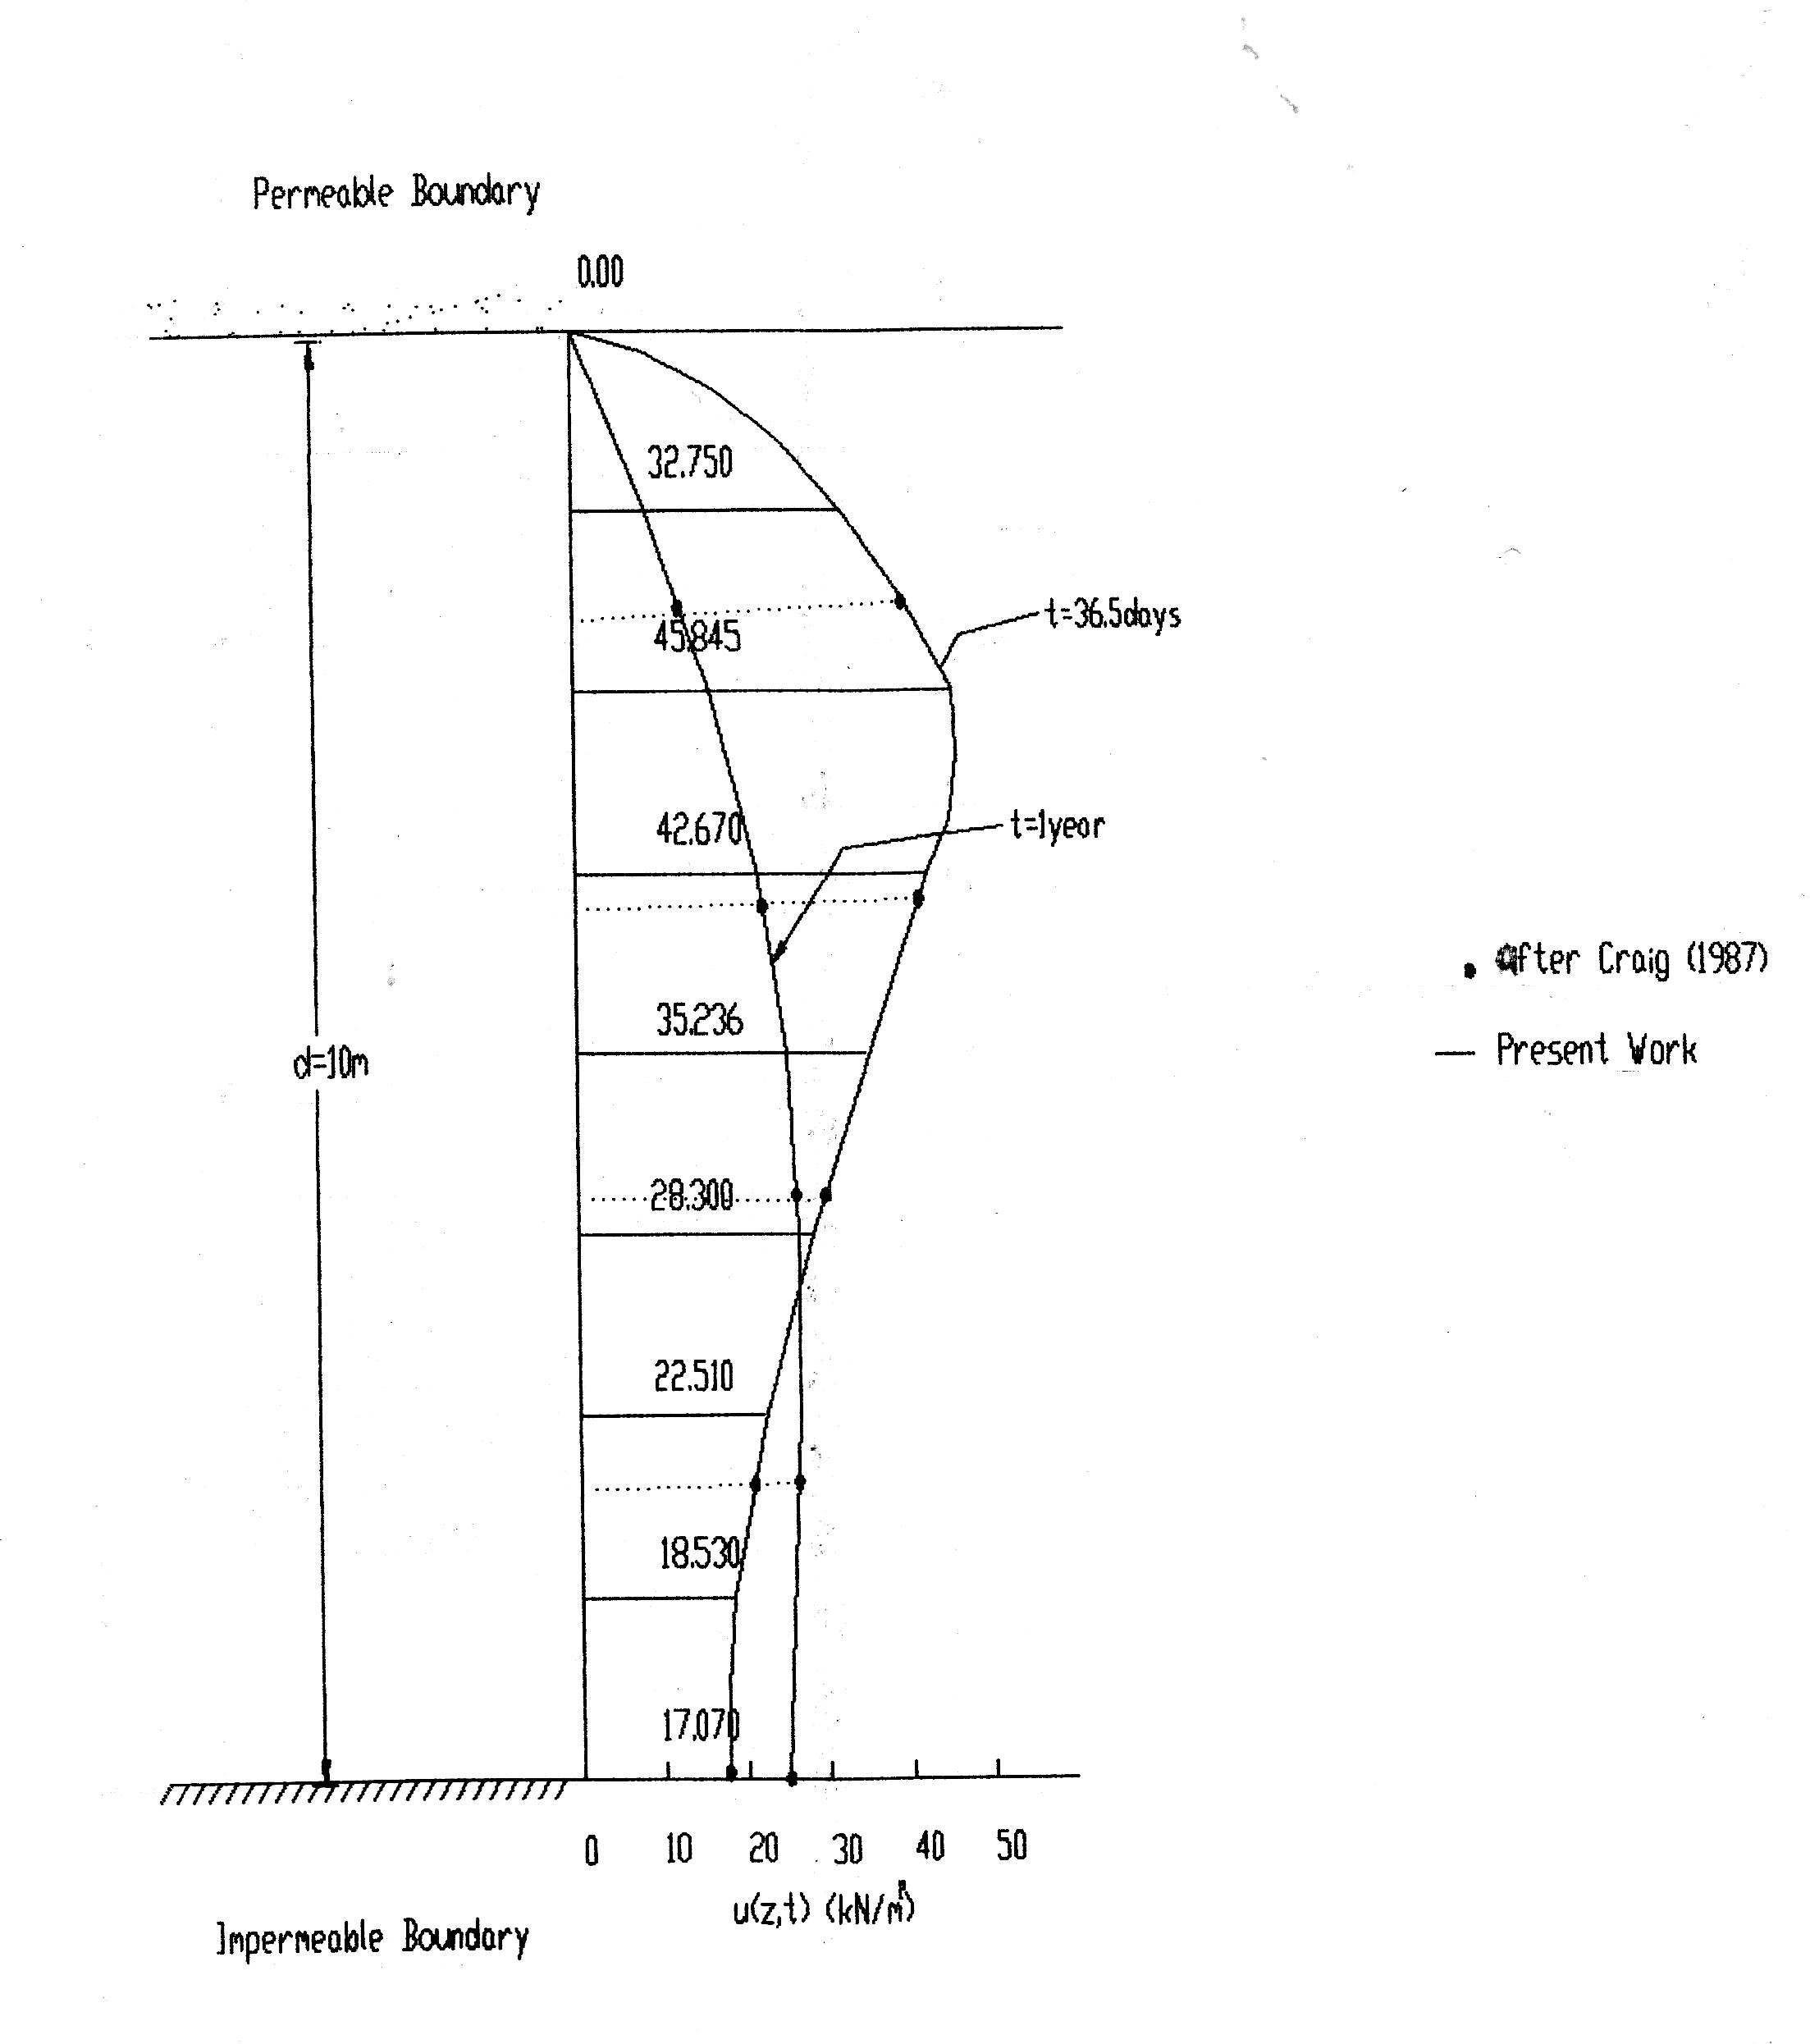

Figure. (6) Excess Pore Water Pressure at The End of The 2nd and 20th Time Steps
It is quite obvious from Figure (6) that there is excellent agreement between the results of this work with those after Craig(2007).
Table (3): The Average Degree of Consolidation at All Time Steps
Time step | Time (t) years | Time factor $T_{v}=\frac{C_{v}t}{d^{2}}$ | Average degree of consolidation U_{av} (%)
1 | 0.05 | 0.00395 | 13.64
2 | 0.10 | 0.00790 | 17.64
3 | 0.15 | 0.01185 | 20.74
4 | 0.20 | 0.01580 | 23.27
5 | 0.25 | 0.01975 | 25.56
6 | 0.30 | 0.02370 | 27.80
7 | 0.35 | 0.02765 | 27.57
8 | 0.40 | 0.03160 | 29.21
9 | 0.45 | 0.03555 | 30.70
10 | 0.50 | 0.03950 | 32.17
11 | 0.55 | 0.04345 | 33.38
12 | 0.60 | 0.04740 | 34.57
13 | 0.655 | 0.05135 | 35.92
14 | 0.70 | 0.05530 | 36.81
15 | 0.75 | 0.05925 | 37.86
16 | 0.80 | 0.06320 | 38.85
17 | 0.85 | 0.06715 | 39.87
18 | 0.90 | 0.07110 | 40.73
19 | 0.95 | 0.07505 | 41.62
20 | 1.00 | 0.07900 | 42.43

Figure (7) shows the average degree of consolidation with time.
0.0
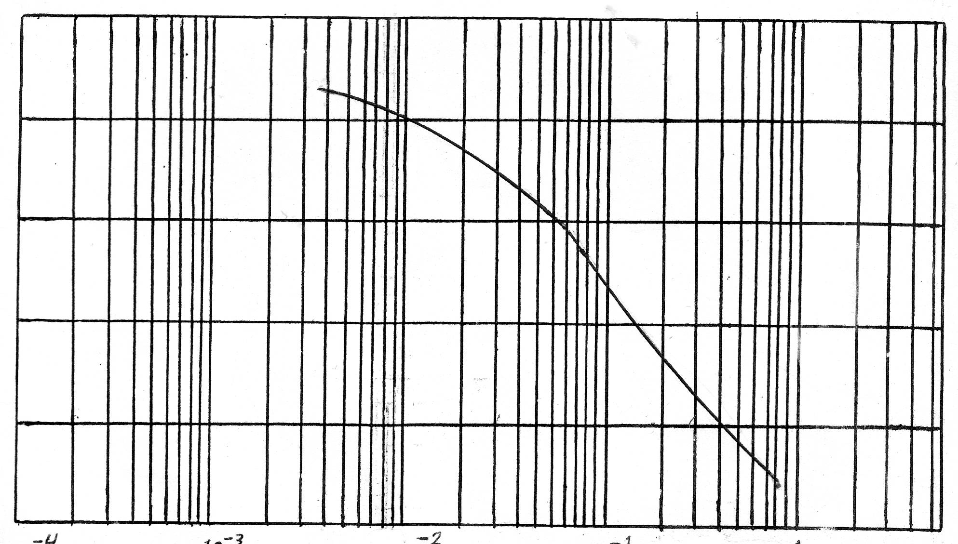
0.2
0.4
0.6
0.8
1.0
U
10⁻⁴
10⁻³
10⁻²
10⁻¹
1
Time Factor T_{v}

Figure (7), One Dimensional Consolidation of Homogeneous Clay Layer.
13-Conclusions
The following main conclusions can be drawn from this work
1-the computer program developed for finite difference technique of one –dimensional consolidation of a single layer subjected to non uniform. Initial excess pore water pressure distribution gives excellent agreement of it's result with Craig (2007)
2- the degree of consolidation of any clay layer at a curtain time depends upon the initial excess pore water pressure .
3- the degree of consolidation a long time depends upon the boundary conditions of the layer .
4- excellent results could be gained by increasing the mesh refinement for both the time and the depth .
5- the degree of consolidation and excess pore water pressure depend widely upon the characteristics of clay layer , like coefficient of consolidation and layer thickness .

14- Recommendation
1- it's recommended to study the one- dimensional consolidation of malty- layer clay .
2- the time – dependent loading could be covered for the study of one dimensional consolidation .
3-it's important to study the one dimensional consolidation using finite element method of analytical method and compare the result .
4-economical studies find the most appropriate and economical method for studying one dimensional consolidation layered clays .
5-it is recommended to extent the study to two or three – dimensional consolidation of layered clays .
15-References
Craig R.F.)2007(, “Soil Mechanics” , Van Nostrand Reinhold(UK), Co.Ltd. Sixth Edition.
Das B. M.S. & Herbich J.B. (1991), “principles of Geotechnical Engineering” Coastal Engineering Handbook.
Das B.M. (2008), “Advanced Soil Mechanics”, Washington, New York, London.
Lambe T. W. and Whitman V. R. (2008) “Soil Mechanics”, with the assistance of H.G. Poules, Jone Wiley and Sons, New York.
Murthy V. N. S. (1988), “Soil Mechanics and Foundation Engineering”, Phanpat Rai and Sons.
Raymond G.P. (1997), “Geotechnical Engineering”.
Rajarman V. (2009), “Computer Programming in Fortran 90 and 95” Indian Institute of Science, Bangalore, New Delhi.
Razauki, S. S. (1989), “A Combined Explicit-Implicit Technique for One-Dimensional Consolidation Analysis of Layered Clays” Al-Muhandis, Vol.98, No.1, pp.3-17.
Robert, W. D. (2006), “Foundation Engineering Handbook” McGRAW-Hill, American Geotechnical, San Diego, California.
Scott, R. F., “Principles of Soil Mechanics”, California Institute of Technology, Addition-Weslway Publishing Company, INC.
Serge L., Ph.D. thesis , “embankment of soft clays” ,Department of Civil Engineering & Laral UN , Quebec , Canada.
Terzaghi K. and Peck R.B. (1967), “Soil Mechanics in Engineering Practice” Jone Wiley and Sons, New York.

