Implementation of suggests GSM/GPRS system in governmental service departments
Raad G. Hameed Al-Azawi.

Abstract
The research aims to design and implement a system helps the service departments to send and receive messages short for the problems of citizens about the particular service (water, electricity, municipal), using a Computer and a GSM / GPRS. Does not require a user to the system possess considerable experience in the field of telecommunications to use the system.
The designed system gives the ability to saving thousands of SMS send and received in a external database. This database has been built in collaboration with a group of domain experts. And has been applied in practice of serve the water department.
The System can communicate with the user through the simple and easy interfaces through the use of a simple model of the windows. System provides a number of statistics and reports required to help the beneficiaries to identify problems, the most frequent and worst-hit areas, in addition to graphic organizers available, which vary according to the modernization to the data.
The system provides some flexibility in the update on the possibility of some procedures, especially the procedure for interaction with the user system, which gives him the possibility of future expansion to keep pace with the rapid development and large to include all service departments.
The system is written using Visual Basic 6 with Microsoft Access. And works on the operating system Vista, Xp sp2, Windows Server 2008.

الخلاصة
يهدف البحث الى تصميم وتنفيذ نظام يساعد الدوائر الخدمية على ارسال واستلام الرسائل القصير الخاصة بمشاكل المواطنين حول خدمة معينة(الماء, الكهرباء, البلدية), باستخدام الحاسبة وجهاز GSM/GPRS.ولا يشترط لمستخدم النظام امتلاك خبرة كبيرة في مجال الاتصالات لاستخدام النظام .
يوفر النظام المصمم امكانية حفظ الاف الرسائل المرسلة والمستلمة في قاعدة بيانات خارجية , وقد بنيت هذه القاعدة بالتعاون مع مجموعة من خبراء المجال وقد تم تطبيق النظام المولد في الحياة العملية على خدمة الماء.
يستطيع النظام المولد التخاطب مع المستخدم من خلال واجهات سهلة وبسيطة وذلك من خلال استخدامها لنموذج بسيط من النوافذ.ويوفر النظام عدد من الاحصائيات والتقارير المطلوبة التي تساعد الجهات المستفيدة على تحديد المشاكل الاكثر حدوثا والمناطق الاكثر تضررا, اضافة الى المخططات الرسومية المتوفرة والتي تتغير حسب عمليات التحديث على البيانات.
يوفر النظام بعض المرونة في امكانية التحديث على بعض اجراءاته وخصوصا الاجراء الخاص بتفاعل النظام مع المستخدم مما يعطيه من امكانية التوسع المستقبلي لمواكبة التطور السريع والكبير ليشمل جميع الدوائر الخدمية.
تمت كتابة النظام بلغة , Visual Basic 6 مع قاعدة بيانات Access MS يحتاج النظام الى حاسبة مايكروية متوافقة مع حاسبات IBM, ويعمل على نظام التشغيل Vista,Xp sp2, Windows Server 2008 .
1- Introduction
There are many different kinds of SMS applications in the market today and many others are being developed. Applications in which SMS messaging can be utilized are virtually unlimited. Some common examples of SMS applications are given below: [Syeda Anila (2010)]
- Person-to-person text messaging is the most commonly used SMS application and it is what the SMS technology was originally designed for.
- Many content providers make use of SMS text messages to send information such as news, weather report and financial data to their subscribers.
- SMS messages can carry binary data and so SMS can be used as the transport medium of wireless downloads. Objects such as ringtones, wallpapers, pictures and operator logos can be encoded in SMS messages.
- SMS is a very suitable technology for delivering alerts and notifications of important events.
- SMS messaging can be used as a marketing tool.
In general, there are two ways to send SMS messages from a computer / PC to a mobile phone: [Syeda Anila (2010)]
- Connect a mobile phone or GSM/GPRS modem to a computer / PC. Then use the computer / PC and AT commands to instruct the mobile phone or GSM/GPRS modem to send SMS messages.
- Connect the computer / PC to the SMS center (SMSC) or SMS gateway of a wireless carrier or SMS service provider. Then send SMS messages using a protocol / interface supported by the SMSC or SMS gateway.
2- GSM Modem
A GSM modem(Global System for Mobile) is a wireless modem that works with a GSM wireless network. A wireless modem behaves like a dial-up modem. The main difference between them is that a dial-up modem sends and receives data through a fixed telephone line while a wireless modem sends and receives data through radio waves.[ SMS Tutorial September 11, 2011]
GSM modem can be an external device or a PC Card / PCMCIA Card. Typically, an external GSM modem is connected to a computer through a serial cable or a USB cable. A GSM modem in the form of a PC Card / PCMCIA Card is designed for use with a laptop computer. It should be inserted into one of the PC Card / PCMCIA Card slots of a laptop computer.[ Scott B. Guthery and Mary J. Cronin(2002)]
Like a GSM mobile phone, a GSM modem requires a SIM card from a wireless carrier in order to operate.
Computers use AT commands to control modems. Both GSM modems and dial-up modems support a common set of standard AT commands. You can use a GSM modem just like a dial-up modem.
In addition to the standard AT commands, GSM modems support an extended set of AT commands. These extended AT commands are defined in the GSM standards. With the extended AT commands, you can do things like.[ SMS Tutorial September 11, 2011]
- Reading, writing and deleting SMS messages.
- Sending SMS messages.
- Monitoring the signal strength.
- Monitoring the charging status and charge level of the battery.
Reading, writing and searching phone book entries.
The number of SMS messages that can be processed by a GSM modem per minute is very low -- only about six to ten SMS messages per minute.[ SMS Tutorial September 11, 2011]
3- GPRS Modem
A GPRS modem (general packet radio service) is a GSM modem that additionally supports the GPRS technology for data transmission. GPRS stands for General Packet Radio Service. It is a packet-switched technology that is an extension of GSM. (GSM is a circuit-switched technology.) Packet switching is where data is split into packets that are transmitted separately and then reassembled at the receiving end.A key advantage of GPRS over GSM is that GPRS has a higher data transmission speed. .[Brahim G. and Luigil.,(2000)]
GPRS can be used as the bearer of SMS. If SMS over GPRS is used, an SMS transmission speed of about 30 SMS messages per minute may be achieved. This is much faster than using the ordinary SMS over GSM, whose SMS transmission speed is about 6 to 10 SMS messages per minute. A GPRS modem is needed to send and receive SMS over GPRS. Note that some wireless carriers do not support the sending and receiving of SMS over GPRS.[ SMS Tutorial September 11, 2011]
GPRS provides mobile operators with an opportunity to offer higher- margin data access services to subscribers in return, subscribers benefit from GPRS by being able to use higher bandwidth mobile. [Alan Bavosa(2004)] .

4-Which is Better: Mobile Phone or GSM / GPRS Modem?
In general, a GSM/GPRS modem is recommended for use with a computer to send and receive messages. This is because some mobile phones have certain limitations comparing to GSM/GPRS modems. Some of the limitations are described below: [ Scott B. Guthery and Mary J. Cronin(2002)]
- Some mobile phone models (example: Ericsson R380) cannot be used with a computer to receive concatenated SMS messages. What is a concatenated SMS message?
A concatenated SMS message is a message that contains more than 140 bytes. (A normal SMS message can only contain at most 140 bytes.) Concatenated SMS works like this: the sender's mobile device breaks a message longer than 140 bytes into smaller parts. Each of these parts are then fitted in a single SMS message and sent to the recipient. When these SMS messages reach the destination, the recipient's mobile device will combine them back to one message. What is the cause of the problem?
When the mobile phone receives the SMS messages that are parts of a concatenated SMS message, it combines them to one message automatically. The correct behavior should be: when the mobile phone receives the SMS messages that are parts of a concatenated SMS message, it forwards them to the computer without combining them.
- Many mobile phone models cannot be used with a computer to receive MMS messages. Because when they receive a MMS notification, they handle it automatically instead of forwarding it to the computer.
- A mobile phone may not support some AT commands, command parameters and parameter values. For example, some mobile phones do not support the sending and receiving of SMS messages in text mode. So, the AT command "AT+CMGF=1" (it instructs the mobile phone to use text mode) will cause an error message to be returned. Usually GSM/GPRS modems support a more complete set of AT commands than mobile phones.
- Most SMS messaging applications have to be available 24 hours a day. (For example, an SMS messaging application that provides ringtone downloading service should be running all the time so that a user can download ringtones any time he/she wants.) If such SMS messaging applications use mobile phones to send and receive SMS messages, the mobile phones have to be switched on all the time. However, some mobile phone models cannot operate with the battery removed even when an AC adaptor is connected, which means the battery will be charged 24 hours a day. .[Brahim G. and Luigil.,(2000)].
Besides the above issues, mobile phones and GSM/GPRS modems are more or less the same for sending and receiving SMS messages from a computer. Actually, you can consider an AT-command-enabled mobile phone as "GSM/GPRS modem + keypad + display + .[Brahim G. and Luigil.,(2000)].
There is not much difference between mobile phones and GSM/GPRS modems in terms of SMS transmission rate, since the determining factor for the SMS transmission rate is the wireless network.[Brahim G. and Luigil.,(2000)].

5- Technological Considerations
SMS (Short Message Service) is originally available on digital GSM (Global System for Mobile Communications) networks allowing text messages of up to 160 characters to be sent or received. The concatenation mechanism of SMS permits messages longer than 140 bytes. If the phone is powered off or out of range, messages can be conveniently stored in the mobile network operators and are delivered at the next opportunity. SMS is the most reliable and popular message communication on mobile phones today. According to ITU (International Telecommunication Union), in China alone, SMS usage totaled to 250 billions in 2005. The significance of this technology leads to many applications developed for different areas including teaching and learning. .[Simon so 2009].
Typically, the exchange of SMS messages requires a SMSC (Short Message Service Center) to store and forward the messages and interact with the mobile network. Applications receive the messages directly from SMSC
and send messages out to the SMSC. For a large operation of sending and receiving SMS messages, SMS messages can be sent to the mobile network operator using SMPP (Short Message Peer-to-Peer Protocol). SMPP is an open industry standard messaging protocol designed to simplify integration of data applications with wireless mobile networks as shown in Figure 1.
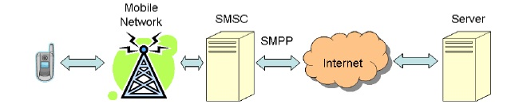

Figure1. SMS service API with SMPP
For medium to small operations, there are a number of options available. Some companies, for example, provide SMS services through HTTP, XML, or SMTP. Clients do not have to know the SMS technologies behind this system too much. For example, Telstra Mobile Online SMS Business Service in Australia allows clients to send and receive SMS messages. .[Simon so 2009].
Conveniently from their desktop computers using a Web interface or from a proprietary desktop SMS software. But the most direct method is to use a group of GPRS/GSM modems to send and receive SMS messages. Figure 2 illustrates the infrastructure of our SMS-based teaching and learning system using GPRS/GSM modems[Simon so 2009].

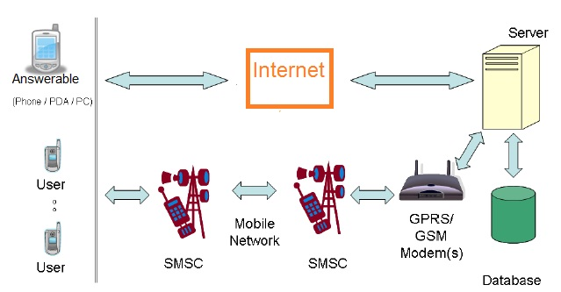

Figure2. The Infrastructure Of The System Using GSM Modems.
If GSM modems are used, there are a number of different modems or devices to choose from. Many of them are compatible to the popular Wavecom’s GSM modems. These modems are programmed using AT commands to send and receive SMS messages.[Simon so 2009].

5- AT Commands
AT commands are instructions used to control a modem. AT is the abbreviation of Attention. Every command line starts with "AT" or "at". That's why modem commands are called AT commands. There are two types of AT commands.
- Basic commands are AT commands that do not start with "+". For example, D (Dial), A (Answer), H (Hook control) and O (Return to online data state) are basic commands. [Syeda Anila 2010].
- Extended commands are AT commands that start with "+". All GSM AT commands are extended commands. For example, +CMGS (Send SMS message), +CMGL (List SMS messages) and +CMGR (Read SMS messages) are extended commands. [Syeda Anila 2010].
5-1 types of AT command operations:
- Test operation. A test operation is used to check whether a certain AT command is supported by the GSM/GPRS modem or mobile phone.
- Set operation. A set operation is used to change the settings used by the GSM/GPRS modem or mobile phone for certain tasks.
- Read operation. A read operation is used to retrieve the current settings used by the GSM/GPRS modem or mobile phone for certain tasks.
- Execution operation. An execution operation is used to perform an action or retrieve information/status about the GSM/GPRS modem or mobile phone.[ Chris Cockings 2001]
5-1-1Test Command
A test operation is used to check whether a certain AT command is supported by the GSM/GPRS modem or mobile phone. The syntax is:
command=?
Example: The AT command +CGMI (Request Manufacturer Identification) is used to get the manufacturer name of the GSM/GPRS modem or mobile phone. To test whether +CGMI is supported, you can make use of the test command "+CGMI=?". The complete command line that should be entered is:
AT+CGMI=?
If the GSM/GPRS modem or mobile phone supports the AT command +CGMI, the result code "OK" will be returned, like this:
AT+CGMI=?
OK
If the GSM/GPRS modem or mobile phone does not support the AT command +CGMI, the result code "ERROR" will be returned, like this:
AT+CGMI=?
ERROR
5-1-2Set Command
A set operation changes the settings used by the GSM/GPRS modem or mobile phone for certain tasks. The syntax is:
command=value1,value2,...valueN
Example. The AT command +CSCA (Service Centre Address) is used to set the SMSC (SMS center) address for sending SMS messages. It takes two parameters that specify the SMSC address and type of address. To set the SMSC address to +85291234567, enter the following command line:
AT+CSCA="+85291234567",145
If the set command runs successfully, the result code "OK" will be returned:
AT+CSCA="+85291234567",145
OK
5-1-3 Read Command

A read operation retrieves the current settings used by the GSM/GPRS modem or mobile phone for certain tasks. The syntax is:
command?
Example that illustrates how to use a read command. The AT command +CSCA (Service Centre Address) is used to set the SMSC (SMS center) address for sending SMS messages. It takes two parameters that specify the SMSC address and type of address. Suppose you set the SMSC address to +85291234567, like this:
AT+CSCA="+85291234567",145
OK
After that, if you enter the read command "+CSCA?", the GSM/GPRS modem or mobile phone will return the SMSC address and type of address that you set in the previous step:
AT+CSCA?
+CSCA: "+85291234567",145
OK

5-1-4 Execution Command

An execution operation is used to perform an action (for example, send or read an SMS message) or retrieve information/status about the GSM/GPRS modem or mobile phone (for example, retrieve the current battery charge level, battery charging status or radio signal strength of the mobile network). The syntax is:
command=value1,value2,...valueN
Example illustrating the use of an execution command. The AT command +CMSS (Send Message from Storage) can be used to perform an execution operation to send an SMS message stored in message storage. It has three parameters. They specify the index of the memory location that stores the SMS message, the destination phone number and the type of the phone number respectively. To send the SMS message at index 1 to the phone number +85291234567, the following command line can be used:
AT+CMSS=1,"+85291234567",145
Unlike set commands, execution commands do not store the parameter values assigned to them. So, no read command is available for retrieving the last parameter values assigned to an execution command. For example, if you send the command line "AT+CMSS?" to your GSM/GPRS modem or mobile phone, the ERROR result code will be returned:

AT+CMSS?
ERROR
5-2 Testing the Communication between the PC and GSM/GPRS Modem or Mobile Phone

Suppose you have connected your GSM/GPRS modem or mobile phone to your PC / computer and started a terminal program (such as HyperTerminal on Microsoft Windows). Now you are ready to enter your first command. The first thing that is usually done is to test the communication between the PC and GSM/GPRS modem/mobile phone to confirm that everything is working properly so far. Simply enter "AT" in the terminal program to perform the test. When the GSM/GPRS modem or mobile phone receives "AT", it will send back the final result code "OK" to indicate that it has received your command successfully, like this:[ Jawarkar, N. P., Ahmed, V., Ladhake, S. A. & Thakare, R. D. (2008)]
AT
OK

5-3 AT Commands for SMS
There are certain AT Commands that can be used through HyperTerminal to send and receive SMS messages. Some SMS related commands are as follows:[ Sony Ericsson Mobile Communications International, 2004].
AT+CSMS Select Message Service
AT+CPMS Preferred Message Storage
AT+CMGF Message Format
AT+CSCA Service Centre Address
AT+CSMP Set Text Mode Parameters
AT+CSDH Show Text Mode Parameters
AT+CSCB Select Cell Broadcast Message Types
AT+CSAS Save Settings
AT+CRES Restore Settings
AT+CNMI New Message Indications to TE
AT+CMGL List Messages
AT+CMGR Read Message
AT+CMGS Send Message
AT+CMSS Send Message from Storage
AT+CMGW Write Message to Memory
AT+CMGD Delete Message

6- Major Stages for Building Expert System
The system builder proceeds through five stages before producing an expert system. These stages can be characterized as problem identification, conceptualization, formulation, implementation, and testing.
8- Architecture of the System and Implementation-
The architecture consists of four main parts see Figure (3):
  - Database to Reserve SMS.
  - Interface admin to create users.
  - Manipulating Data (Classifying, Charting, and Reporting).
  - Sending Problems Related Department

Figure. (3) Architecture of the Proposed System.
Database.
The Database in that systems are used to save all SMS that received from client and contained an admin (Permissions), classification, and details SMS tables.

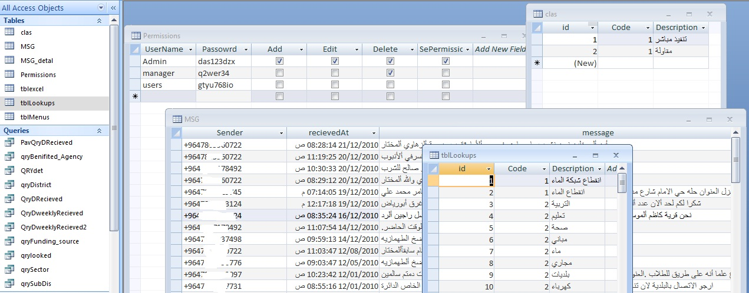

Figure. (4) Database in The proposed System.
The responsible interface for connect and Patronize with this Database called Main Interface: through this interface the user can manipulating received SMS by classified and preparing (update, delete and insert class to received SMS based on a classification list). After filtering the received according to district and quarter.
Through this interface the user can add a new classification based on the received SMS.
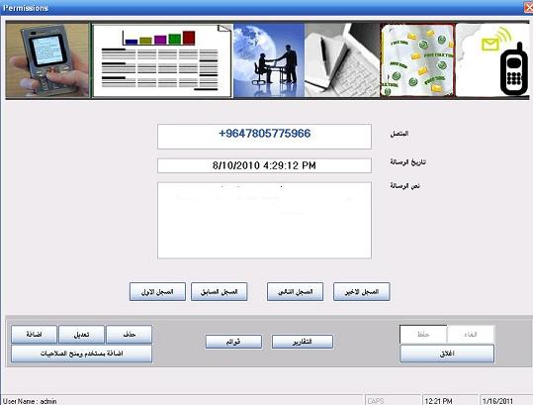

Figure.(5) Main window in The proposed System.
Throw this main Interface the users cane entered to list interface for select classified the SMS and can you edit this list by add new classified or delete another.
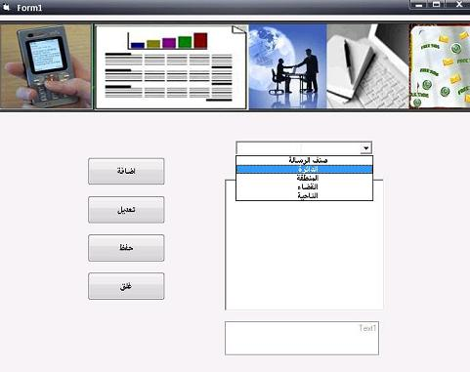

Figure. (6) Simple Window of classified the SMS.
In above interface where responsible about manipulate stored SMS in database, but there are another option in this program it’s the interface report, that give a user more flexibility to display your data as graphic or document to providence council or related department to make decision for this problem or proposal that contained in this collection SMS .

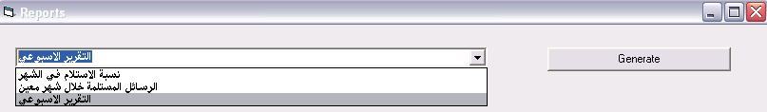

Figure. (7) Reports Window in The proposed System.

The last interface in the system is a login and user admin, where the user must login to the system through a user name and password giving them a system administrator and grant the permissions of use.

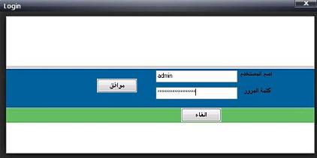

Figure. (8) Login Window in The proposed System.
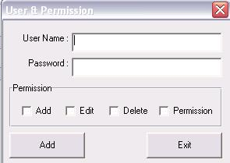

Figure. (9) Admin Window in The proposed System.

9- Conclusions.
Several concluding remarks have been drawn from the process of designing expert system. The main ones are stated below:-
- The software is a very useful tool for communication and principle of transparency between the senior official and citizens for solving problems by using the most common way and easy the Short Messages Service (SMS).
- The system provides charts method to display citizens SMS about a specific problem, which helps a councils providence to take overview of the size of these problems.
- GSM / GPRS Wireless Modems promises to benefit mobile data users greatly by providing always on higher bandwidth connections than are widely available today. In order to be successful, data connections must be secure and be available anytime and from anywhere.
- Using a simple menu from us an interface with the user makes the system more acceptable and more friendly.
- We have found that using Microsoft Activex Data Object(ADO) in connection and dealing with the database is appropriate to our system because, the reducing in use of objects(RecordSet,Command,Connection,Database,Parameter,Property,Error,…etc) can be accessed for database records using a single object(RecordSet),the independence of object, each object is independent of the other when the built and this feature enables us to use objects that we need only without having to open an object to have no need, and finally the ADO support for the(Heretical RecordSet) and (Stored Procedure).
- We use Visual Basic6(VB6) language with database Microsoft Access(MS Access) for building our system because easy application language and easy connected with database, especially Microsoft Access and the large number of language resources, on the other hand the VB6 and MS Access is free() and can used without copyright through internet web sites. Addition to the reasons above the limited use system on dome department services in province and service on a special type of problems.

References
Brahim G.and Luigil.,(2000), “Understanding GPRS: The GSM Packet Radio Service”, Computer Networks Journal, 34.5, pp. 763-779.
Chris Cockings. (2001)” GSM AT Command Set”, Cambridge Technology Centre Melbourn.
Haider Ali, November (2008)" Creating SMS-based Applications", Department of Computer Science University ofPeshawar, Pakistan.
Jawarkar, N. P., Ahmed, V., Ladhake, S. A. & Thakare, R. D. (2008). Micro-controller based Remote Monitoring using Mobile through Spoken Commands. Journal Of Networks, 3(2), 58-63. Retrieved
Recommendations " Juniper Networks, Inc.1194 North Mathilda Avenue Sunnyvale, CA 94089 USA 408 745 2000 or 888 JUNIPER.
Retrieved fromhttp://www.developershome.com/sms/
Scott B. Guthery and Mary J. Cronin(2002)" Mobile Application Development with SMS and the SIM Toolkit" Copyright © 2002 by McGraw-Hill Companies, Inc. Printed in the United States of America.
Simon So,PhD. ( 2009) ” The Development of a SMS- based teaching and learning system ‘,Hong Kong Institute of Education .
Sony Ericsson Mobile Communications International, 2004, " AT Commands Manual "Publication number: LZT 123 8022 R1A, Printed in UK. SMS Tutorial September 11, 2011" Short Message Service "

Syeda Anila (2010) ” Send and Read SMS through a GSM Modem using AT Commands" National University of Computer and Emerging Sciences.
White paper by Alan Bavosa(2004)" GPRS Security Threats and Solution
White paper by Usha Communications Technology (2000) "GPRS General Packet Radio Service".

