Electronic Structure of Cubic-Aluminum Nitride

Hamad Rahman Jappor , Magged Ali Hapeep
Babylon university, College of Education, Department of Physics

Abstract
A large unit cell (LUC) formalism of eight atoms within intermediate neglect of differential overlap (INDO) is used to study some properties of cubic aluminum nitride, and to study the effect of pressure on these properties. Cohesive energy, direct and indirect band gap, valence bandwidth, conduction bandwidth and hybridized orbitals of crystal are obtained from the band structure calculations. All the aforementioned properties are obtained by selecting empirical parameter sets for LUC-INDO model. It is found that the result are in good agreement with experimental results, cohesive energy, direct and indirect band gap, valence bandwidth increase with increasing the pressure, while the conduction bandwidth decreases.
الخلاصة
خلية وحدة كبيرة ( (LUC مكونه من ثمان ذرات ضمن الإهمال المتوسط للتداخل التفاضلي (INDO) استعملت لدراسة بعض خصائص نتريد الألمنيوم ذو الشبيكة المكعبة ولدراسة تأثير الضغط على هذه الخصائص. طاقة الترابط و فجوة الطاقة المباشرة وغير المباشرة و عرض حزمتي التكافؤ والتوصيل وتهجين المدارات فقد تم الحصول عليها من حسابات التركيب الحزمي. جميع الخواص المذكورة أعلاه قد تم الحصول عليها باختيار مجموعة مُعلمات تجريبية لأنموذج وحدة الخلية الكبيرة للإهمال المتوسط للتداخل التفاضلي. وجد أن النتائج في تطابق جيد مع النتائج العملية، طاقة الترابط و فجوة الطاقة المباشرة وغير المباشرة و عرض حزمة التكافؤ تزداد مع زيادة الضغط بينما يتناقص عرض حزمة التوصيل.
1 Introduction

Aluminum nitride (AlN) is the largest-bandgap nitride semiconductor that usually crystallizes in the wurtzite lattice (also known as hexagonal or α-AlN). The growing of AlN is still a difficult task [Jain et al., 2000] particularly for zinc - blende (ZB) phase. Nevertheless, under nonequilibrium conditions the growth of the zinc-blende (3C) has achieved [As et al., 1997] also; successful growth [Lei et al., 1991] by epitaxial techniques has been reported for AlN modification in zinc-blende structure. The ZB cubic form has been theoretically reported to be metastable [Petrov et al., 1992], under high pressure, AlN lattice structure and there nitrides experience a phase transition to the rocksalt [Petrov et al., 1992]. AlN is characterized by excellent thermal conductivity, high coefficient, short bond length, and low compressibility. All these properties are desirable for utilization in a variety of applications involving high temperature electronics, high-power operation [Morkoc et al., 1994] and high frequency opto-electronics (LED and LASER) [Ambacher et al., 1998]. C-AlN is a subject of extensive theoretical studies ranging from the semiempirical to the first principles methods [Vogel et al., 1997] within the density functional theory (DFT) framework [Stampfl and Van de Walle, 1999] using both pseudopotential [Pandey et al., 1993], and all-electron approaches. For the bulk phase of AlN, theoretical calculations based on the Hartree-Fock [Ruiz et al., 1994], and density functional method [ Kim et al., 1996] have obtained a very good description of its structural and electronic properties.
Over the last few years, study of materials under high pressure has become an extremely important subject displaying explosive growth. This is primarily due to both theoretical and experimental developments which have at last facilitated such work. The effect of pressure on the electronic properties on III-V compounds can be investigated in many ways [Menoni et al., 1986].
In the work we carry out only valence electron to determine band structure and some physical properties of cubic binary AlN under pressure with large unit cell within intermediate neglect of differential overlap (LUC-INDO) method [Radi et al., 2007]. This method has been chosen in the present work than rather other methods because this can be used to give reliable and precise results with relatively short time.

2 Calculations

We use large unit cell within intermediate neglect of differential overlap (LUC-INDO) method in the linear combination of atomic orbital (LCAO) approximation [Radi et al., 2007] to obtain a self-consistent solution for the valence electron. The iteration process was repeated until the calculated total energy of crystal converged to less than 1meV. A total of seven iteration was necessary to achieve self-consistency. The calculations are carried out, on the 8-atom LUC. The positions of atoms that constitute this LUC are calculated in the program according to zinc-blende structure for a given lattice constant. There are four electrons in average per each atom. Hence we have (32) eigenstates, two electrons per state, half are filled (valence band) leaving the other half empty (conduction band) in the ground state.
The electronic configuration of AlN is Al: Ne 3s²3p¹ and N: He 2s² 2p³. In the following calculations, we have treated the orbitals of Al (3s²3p¹) and N (2s²2p³) as valence electrons. In ZB, the Al and N atoms are in fcc positions as follows: Al (0, 0, 0); N (1/4, 1/4, 1/4). In the calculations, the N atom has been chosen to be at the origin and the Al atom at the position (1/4, 1/4, 1/4) in units of the lattice constant.

3 Results and Discussion

3.1 Choice of parameters
The number of parameters in the LUC – INDO method is four. These are the orbital exponent (ζ), the bonding parameter (β), the electronegativity of s- orbital (E_{s}), and the electronegativity of p-orbital (E_{p}). The value of the orbital exponent determines the change distribution of electrons around the nucleus or in the solid
These parameters are varied firstly to give nearly the exact value of the equilibrium lattice constant, cohesive energy, indirect bandgap and valence bandwidth. The remaining of the output data of the programs is a result of the theory that is used in the present work. We found that the investigated properties were sensitive to the aforementioned parameters. Our parameters used for AlN in the present work are summarized in Table (1).

Table (1) The adjusted parameters for AlN in the zinc-blende structure.

Parameter | Al | N
ζ (a.u)⁻¹ | 1.4 | 1.8
β (eV) | -6.0 | -8.0
E_{s} (eV) | 9.75 | 13.46
E_{p} (eV) | 8.68 | 10.37

3.2 The electronic and structural properties
The second step after the choice of parameters is to examine the structural properties of cubic AlN at the equilibrium lattice constant in order to test the accuracy of the cohesive energy, direct and indirect bandgap, and valence bandwidth.
Based on the total energy results, we obtained the cohesive energy (E_{coh}) as follows:

-E_{coh}=E_{tot}/8-E_{free}-E₀ (1)
Where E_{tot} is the total energy, E_{free} is the free atom sp shell energy, and E₀ is the zero –point vibration energy. In this work E_{free} =160.106 eV, and this value is taken from ionization potential of AlN, E₀= 0.185 eV, is calculated by the formula E₀= (9/8)k_{В}Ө_{D} (per atom) with Ө_{D} is the Debye temperature [Born and Huang, 1954], which is equals 950 K [Pässler, 1999]. The cohesive energy value of the present work is in good agreement with experimental results as shown in Table (2).
Figure (1) displays the cohesive energy versus the relative volume for AlN. The curve is fitted to the equation of state of Murnaghan [Ziambaras and Schröder, 2003] from which we obtained the equilibrium lattice parameter (a₀), the bulk modulus B, its derivative$B_{0}^{'}$, and the cohesive energy.
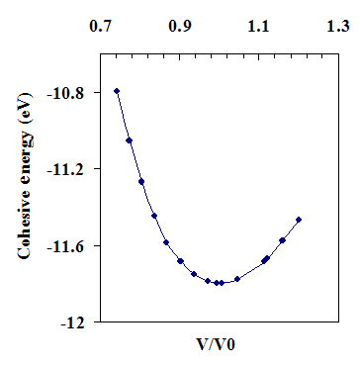
Figure (1) The cohesive energy as a function of relative volume V/V₀ (V₀ is the equilibrium volume of the zinc-blende structure) for AlN.
The calculated structural properties of AlN are summarized in Table (2), in comparison with other computational and experimental results. We notice that the lattice parameter for the ZB structure of AlN is 4.359Å in good agreement with the experimental value of 4.37 Å [Edgar, 1994] with accuracy of 0.252%. For the bulk modulus and the cohesive energy, the accuracies are about 6.93 % and 2.03%, respectively. Table (2) shows = 4.1 for AlN, which is consistent with previous results [Wang and Ye, 2002].

Table (2) Structural properties of C-AlN at zero pressure determined by LUC-INDO compared to other theoretical calculations and experimental data

Property | Present | Other results | Experimental
a₀ (Å) | 4.359 | 4.323  [Wang and Ye, 2002] | 4.37  [Edgar,1994]
E_{coh}(eV) | -11.78 | -13.242  [Stampfl et al., 1999] | 11.54  [Lambercht &Segal,1991]
B (GPa) | 216 | 203  [Kim et al., 1996] | 202  [Sherwin & Drummond,1991]
$$B_{0}^{'}$$ | 4.1 | 4.182  [Wang and Ye, 2002] | ----

Hybridization states illustrated in Table (3) show an increasing of the s-state occupation and p-state occupation with the increasing the valence electron of the compound where the occupation of s and p orbitals of nitrogen is larger than that for aluminum. This reflects the weakness of the directional characters of these bonds represented by the sp³ hybridized orbitals with increasing the valence electron.

Table (3) Hybridization states of AlN in the LUC-INDO calculation.
p-orbital | s-orbital | Element
2.0706 | 0.7435 | Aluminum
4.2966 | 0.9667 | Nitrogen

To visualize the nature of the bond character and to explain the charge transfer and the bonding properties of c-AlN, we calculate the total charge density. The total valence charge densities for AlN are displayed along the Al-N bonds in the (100), (110), (200), and (400) planes in (figure 2). From this figure we noticed that the nitrogen ions are larger than the aluminum ions. This figure also shows the charge density associated with the dangling bond lab at the N site.

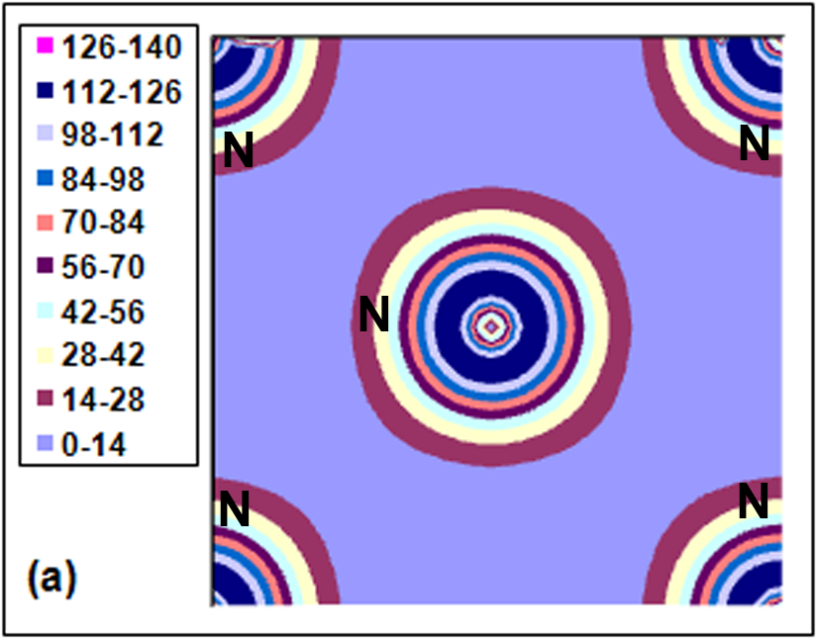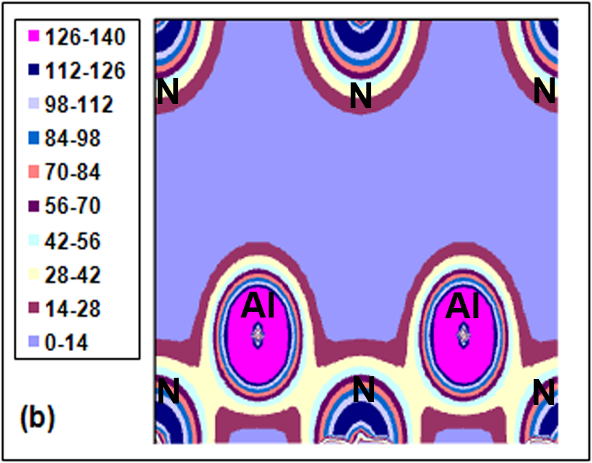

Figure (2) The valence charge density for C-AlN at zero pressure in (a) (100) plane, (b) (110) plane, (c) (200) plane, and (d) (400) plane.

Figure 2(a) shows the charge density for the (100) surface. Where a build up of charge density along the AlN bond length on the surface is clearly visible. This figure also shows the charge density associated with dangling bond lobe at the N site.

3.3 The band structure and energy eigenvalues

We will start our calculations on the band structure by the energy eigenvalues for AlN crystal at various high symmetry points of the Brillouin zone and the results are listed in Table (4). For folding reasons the electronic structure is only studied at the Г and Χ points of the fcc Brillouin zone. The most important band states are considered. They are the valence bands Г1v, Г_{15v}, X_{1v}, and X_{5v}. and the conduction bands states X_{1c}, X_{5c}, Г_{15c}, and Г_{1c}.
The predicted direct bandgaps at the Γ-point (E_{g}^{Γ}) and X-point (E_{g}^{X}) for AlN semiconductor are shown in Table (5). These values are compared with the available experimental data [Aulbur et al., 2000; Wang and Ye, 2002] and LDA and EXX pseudopotential calculations [Aulbur et al., 2000; Qteish et al., 2005]. The results of other approaches beyond the LDA, Hartree-Fock [Guadalupe et al., 2000], and self-interaction and relaxation correction pseudopotential (SIRC-PP) [Vogel et al., 1997] calculations are also listed for comparison. We find that the difference between the predicted and experimental bandgap are acceptable, our predicted value of E_{g}^{Γ} (7.355 eV) is larger than the experimental value of 5.94 eV [Wang and Ye, 2002] so that the value of E_{g}^{X} (8.746) is much larger the previous experimental value of 5.11 eV [Aulbur et al., 2000].

Table (4) Eigenvalues (in electron volts) at Γ and Χ high-symmetry points of Brillouin zone.

LUC–INDO method | Symmetry point
-14.502 | Г_{1v}
0.0 | Г_{15v}
7.355 | Г_{1c}
13.707 | Γ_{15c}
-11.338 | X_{1v}
-2.025 | X_{5v}
6.721 | X_{1c}
14.446 | X_{4c}

The direct bandgap E_{g}^{Γ} (Γ_{1c}-Γ_{15v}) in the ZB structures of AlN is due to the Al 3s and N 2s orbital interaction which forms the lower-energy bonding state (Γ_{15v}) and the antibonding state (Γ_{1c}). The bonding and antibonding states are lowered and pushed respectively, relative to the N 2s and Al 3s orbital energies, by same amount of s-s interaction energy in AlN. Results on some high symmetry points are reported in Table (5).
In c-AlN the conduction-band minimum (CBM) is located away from the Γ point, at the X point. AlN has an indirect minimum gap with the CBM at X, Thus, we obtain an indirect bandgap (E_{g}^{ind}) of 6.721 eV which is larger than the other results [Remediakis and Kaxiras, 1999; Vurgaftman et al., 2001] (see Table (5) for comparison).
The total valence bandwidth (VBW) or the difference between the top of the valence bands (Γ_{15v}) and the lowest energy valence band (Γ_{1v}) is 14.502 eV for C-AlN. The obtained total valence bandwidth is in good agreement with previous results as shown in Table (5). The maximum level of the valence band is splitted only by spin-orbit interaction Δ_{so} giving rise to two states at the Brillouin zone centre: Γ_{8v} and Γ_{7v.} in the absence of spin orbit splitting, these levels become a triply degenerated Γ15v.The spin-orbit interaction Δ_{so} is not taken into account in this paper because its value is very small, averaging the theoretical results from different Refs. = 0.019eV [Suzuki and Uenoyama, 1996]. Our work gives a value of the conduction bandwidth (CBW) to be 7.725 eV (Table 5), but experimental results are not available to CBW of the ZB of AlN.

Table (5) Calculated LUC-INDO, direct and indirect band gaps, valence bandwidth, and conduction bandwidth for AlN compared to other theoretical calculations and experiments. All energies are in eV.

Experimental | Other results | Present | Property
5.94  [ Wang and Ye, 2002] | 6.00, 5.66, 5.98  [Aulbur et al, 2000]  4.27, 5.99, 5.76  [ Qteish et al., 2005] | 7.355 | E_{g}^{Γ}
5.11  [ Aulbur et al., 2000] | 3.16, 5.08 , 5.18  [ Qteish et al., 2005] | 8.746 | E_{g}^{X}
5.4  [Vurgaftman et al., 2001] | 6.01, 6.077  [Remediakis et al.,999] | 6.721 | E_{g}^{ind}
---- | 15.01, 15.41  [Guadalupe et al., 2000] | 14.502 | VBW
---- | ---- | 7.725 | CBW

4 The effect of pressure on the properties
The effect of pressure on the electronic structure and other properties can be calculated from the present theory and computational procedure. By the use of our calculated values of the bulk modulus B, and its derivative, the volume change (V₀) with applied pressure was calculated using the following equation [Edgar, 1994]:
$P=\frac{B_{0}}{B_{0}^{'}}\left[{\left(\frac{V_{0}}{V}\right)}^{B_{0}^{'}}−1\right]$ (2)
Where P is pressure and V is the equilibrium volume at zero pressure. We applied a pressure up to 28 GPa, because this structure transforms to another phase, rock salt (NaCl), when pressure exceeds nearly 30 GPa [Perlin et al., 1992]. The calculated lattice constant as a function of pressure is shown in Figure (3).
The pressure dependence of the bulk modulus and the cohesive energy is illustrated in figure (4) and figure (5). It is shown that the bulk modulus increases linearly with pressure. On the other hand, the absolute value of the cohesive energy decreases as the pressure increases.
The effect of pressure on the high symmetry points (Г_{1v}, Г_{15v}, X_{1v}, X_{5v,} X_{1c}, X_{5c}, Г_{15c}, and Г_{1c}) is shown in figure (6). From this figure one can see that the eigenvalues at conduction band (X_{5c}, Г1_{5c}, Г_{1c}, X_{1c}) are increase with pressure, whereas eigenvalues at valence band (X_{5v}, X_{1v}, Г_{1v} ) decrease with pressure, However, the decrease of X_{5v}, X_{1v}, and Г_{1v} with pressure is small.
. 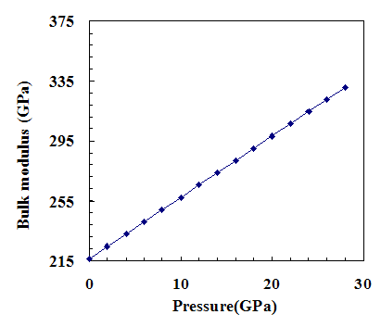
Figure (3) The effect of pressure on the lattice constant of AlN.
Figure (4) the bulk modulus as a function of pressure for AlN.

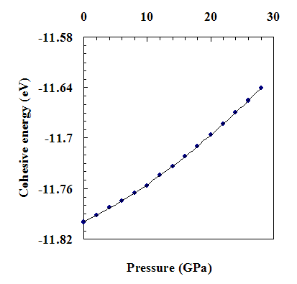
Figure (5) The effect of pressure on the cohesive energy of AlN.
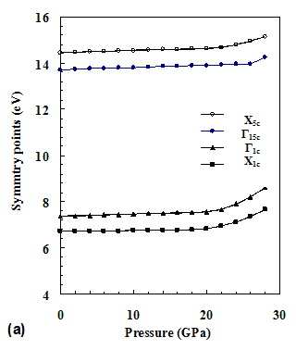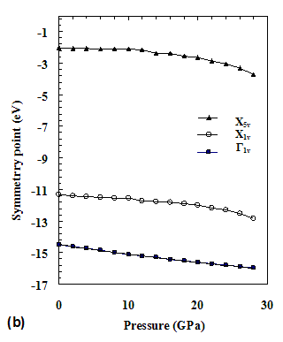
Figure (6) The effect of pressure on the high symmetry points in (a) conduction band (X_{5c}, Г_{15c} , Г_{1c} , X_{1c}) and (b) valence band (X_{5v} , X_{1v} , Г_{1v} ).
Figure (7) shows the pressure dependence of E_{g} at the Γ and X points of the energy band for the ZB phase from the present energy band structure calculations. It is shown that the fundamental band gap increases with pressure, so, keeping in mind for the fabrication of blue emitting-light devices, it is necessary to diminish stress. Application of pressure tends to broaden the electron bands and hence increasing the bandgap: in most cases the first pressure-induced phase transition corresponds to the closing of the bandgap and metallization of the sample.
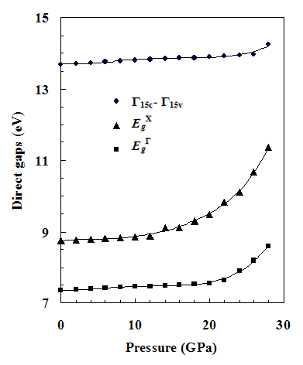
Figure (7) Variation of various band gap at the Γ and X versus pressure for AlN

The pressure derivative of the direct band gaps at the Γ and X point, E_{g} ^{Γ} and E_{g}^{X}, respectively, is between (31-65) meV/GPa. In general this result is in a good agreement with the plane wave pseudopotential (PWPP) calculation of Kim et al., 1996, which gave a corresponding value of 45 meV/GPa, and the calculations of Christensen and Gorezyca, 1994, using LMTO who reported a value of 42 meV.GPa. The direct gap does not show a linear dependence as in the previous calculation [Pandey et al., 1993].
The predicted effect of pressure on the indirect bandgap, valence bandwidth, and conduction bandwidth is illustrated in figure (8). The indirect bandgap and the valence bandwidth increase with the increase of pressure, while the conduction bandwidth decreases with the increase of pressure. In the present work, the pressure derivative of the indirect bandgap is computed to be 31.2 meV/GPa, for the valence bandwidth and conduction bandwidth our calculation give pressure derivative 29 meV/GPa for the valence bandwidth, and ~ -11 meV/GPa conduction bandwidth.
We found that the s- state occupation for Al and N decreases with the increase of pressure, whereas the p states occupation for Al and N increases in this case. The occupation of s and p states for Al and N with pressure is shown in figure (9). The increase of pressure causes an increase of the probability of electron transition from s-orbital to p-orbital. This phenomenon is known and leads to a phase transition due to the change of electronic distribution such as the s-d transition in alkali metals [Takemura and Syassen, 1983].
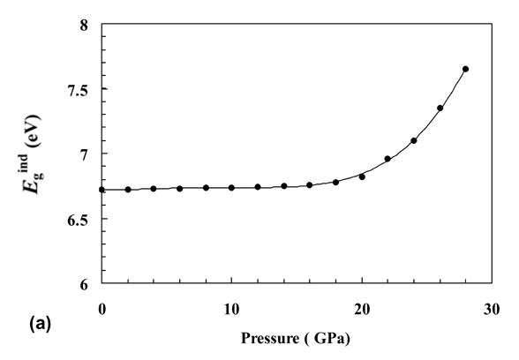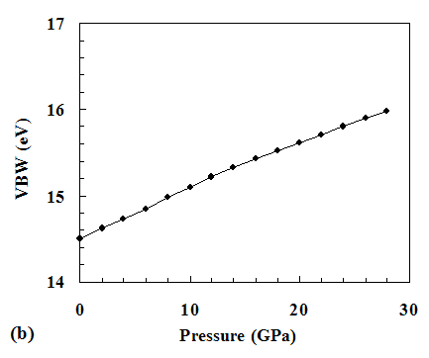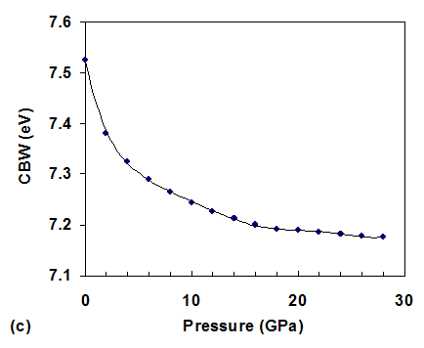
Figure (8) Effect of pressure on the (a) indirect band gap, (b) valence bandwidth, and (c) conduction bandwidth.

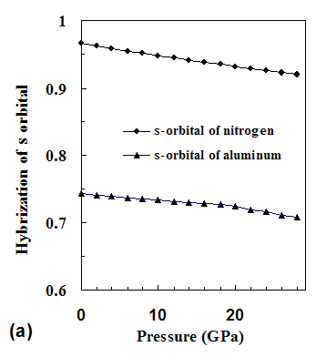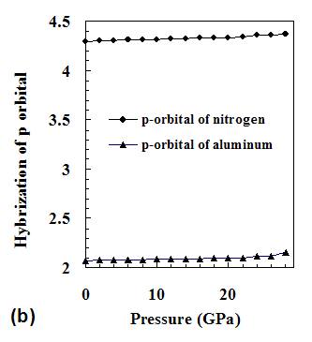
Figure (9) The effect of pressure on the hybridization of (a) s- state and (b) p- state.

The valence charge densities in the planes (100), (110), (200), and (400) at (28 GPa) are shown in figure (10). It can be noted that the increase of pressure causes, in general, an increase of the valence charge density around the nuclei and a decrease of this density at the intermediate distance between the nuclei. This can be seen in comparison figure (10) this with figure (2).

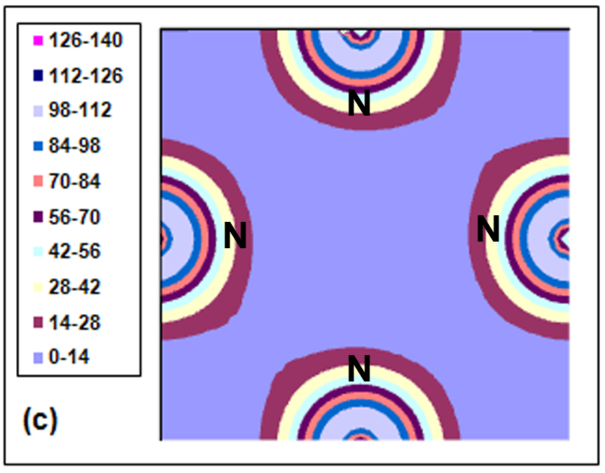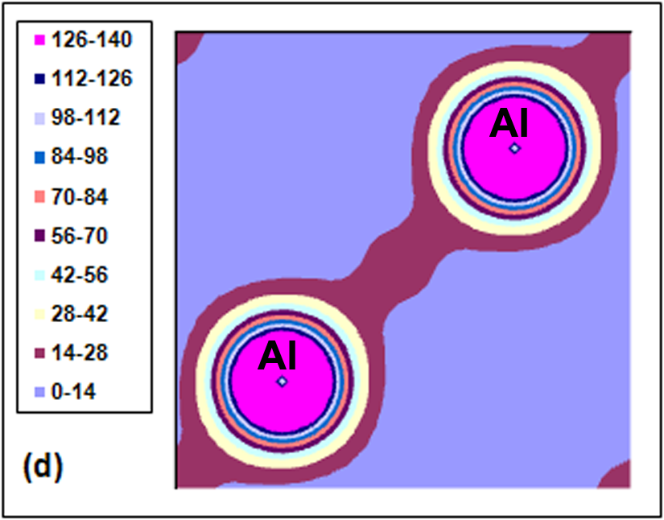

Figure (10) Valence charge density (in electron/Å³) of AlN under the effect of the pressure (28 GPa) in the planes (a) (100), (b) (110), (c) (200), and (d) (400).

- Conclusions

In this paper, the study of some properties of C-AlN is presented. Cohesive energy, lattice constant, bulk modulus, and their pressure derivative have been calculated by (LUC-INDO) method. The calculated results indicate that this model gives results in good agreement with the corresponding experimental results, and this shows the possibility of using this model in qualitative of study some materials. A reasonable agreement for the valence bandwidth and band gaps is shown in comparison with available theoretical results even when these values are not in a good agreement with the corresponding experimental values. The effect of pressure on these properties is investigated. It is found that the conduction bandwidth decreases with increasing the pressure, whereas the direct and indirect bandgap, valence bandwidth, and cohesive energy increase with the increase of pressure. The maximum value of pressure is taken to be 28 GPa, because beyond this value of pressure, the phase of AlN transforms from ZB to rock salt phase. Relativistic effect is added to the calculation of the band gap, also zero point energy is added to the calculation of the cohesive energy. Finally, this model is shown to give good description to the hybridization state and charge density of AlN and it is expected that this method could give reliable description for other materials that has zinc-blende and cubic structure.

References
Ambacher, O., 1998," Growth and applications of Group III-nitrides", J. Phys. D: Appl. Phys. Vol. 31, pp 2653-2710.
As, D. J., Schmilgus, F., Wang, C., Schöttker, B., Schikora, D., and Lischka, K., 1997,"The near band edge photoluminescence of cubic GaN epilayers",Appl. Phys. Lett. Vol.70, pp 1311-1313.
Aulbur, W.G., Städele, M., and Görling, A., 2000,"Exact-exchange-based quasipart-icle calculations ", Phys. Rev. B Vol.62, pp 7121-7132
Born, M., and Huang, K., 1954,"Dynamical Theory of Crystal Lattices", (Oxford, London) p 43.
Christensen, N. E., and Gorezyca, I., 1994,"Optical and structural properties of III-V nitrides under pressure", Phys. Rev. B Vol.50, pp 4397- 4415.
Edgar, J. H., 1994,"Properties of Group III Nitrides (Electronic Materials Information Service Datareviews Series)"(London: Institution of Electrical Engineers).
Guadalupe, M., Armenta, M., Serrato, A. R., and Borja, M. A., 2000,"Ab initio determineation of the electronic structure of beryllium-, aluminum-, and magnesium-nitrides: A comparative study", Phys. Rev. B Vol.62, pp 4890-4898.
Jain, S. C., Willander, M., Narayan, J., and Van Overstraeten, R. J., 2000,"III–nitrides: Growth, characterization, and properties",Appl. Phys.Vol.87, pp 965-1006.
Kim,K., Lambrecht, W. R. L, and Segall, B.,1996,"Elastic constants and related properties of tetrahedrally bonded BN, AlN, GaN, and InN", Phys. Rev. B Vol.53, pp 16310 -16326.
Lambrecht, W. R. L., and Segal, B., 1991,"Electronic structure and bonding at SiC/AlN and SiC/BP interfaces", Phys. Rev. B Vol.43, pp 7070- 7085.
Lei, T., Fanciulli, M., Molnar, R. J., Moustakas, T. D., Graham, R. J., and Scanlon, J., 1991,"Epitaxial growth of zinc blende and wurtzitic gallium nitride thin films on (001) silicon" Appl. Phys. Lett. Vol.59, pp 944-946.
Menoni, C., Hochheimer, H., and Spain, I.,1986,"High-pressure study of photolumin-escence in indium phosphide at low temperature", Phys. Rev. B Vol. 33, pp 5896 -5898.
Morkoc, H., Strite, S., Gao, G. B., Lin, M. E., Sverdlov, B., and Burns, M., 1994," Large-band-gap SiC, III-V nitride, and II-VI ZnSe-based semiconductor device technologies", Appl. Phys. Vol.76, pp 1363-1398.
Pandey, R., Sutijianto, A., Seel, M., and Jaffe, J. E., 1993,"Electronic structure of high pressure phase of A1N", J. Mater. Res. Vol.8, pp 1922-1927.
Pässler, R., 1999," Parameter Sets Due to Fittings of the Temperature Dependencies of Fundamental Bandgaps in Semiconductors", phys.stat.sol. (b) Vol.216, pp 975-1007.
Perlin, P., Jauberthic-Carillon, C., Itie, J. P., San Mieguel, A., Grzegorg, I., and Polian, A., 1992,"Raman scattering and x-ray-absorption spectroscopy in gallium nitride under high pressure", Phys. Rev. B Vol.45, pp 83-89.
Petrov, I., Mojab, E., Powell, R. C., Greene, J. E., Hultman, L., and Sundgren, J. E., 1992,"Synthesis of metastable epitaxial zinc-blende-structure AlN by solid-state reaction", Appl. Phys. Lett. Vol. 60, pp 2491- 2493.
Qteish, A. , Al-Sharif, A. I., Fuchs, M., Scheffler, M., Boeck, S., and Neugebauer, J., 2005,"Role of semicore states in the electronic structure of group-III nitrides: An exact-exchange study", Phys. Rev. B Vol. 72, pp 155317-1 -155317-8.
Radi, I. O., Abdulsattar, M. A., and Abdul-Lettif, A. M., 2007,"Semiempirical LUC-INDO calculations on the effect of pressure on the electronic structure of diamond", phys. stat. sol. (b) Vol. 244, pp 1304 -1317.
Remediakis, I. N., and Kaxiras, E., 1999,"Band-structure calculations for semicon-ductors within generalized-density-functional theory", Phys. Rev. B Vol. 59, pp 5536 -5543.
Ruiz, E., Alvarez, S., and Alemany, P., 1994,"Electronic structure and properties of AlN", Phys. Rev. B Vol.49, pp 7115- 7123.
Sherwin, M. E. and Drummond, T. J., 1991, "Predicted elastic constants and critical layer thicknesses for cubic phase AlN, GaN, and InN on β -SiC", J. Appl. Phys. Vol.69, pp 8423-8425.
Stampfl, C., and Van de Walle, C. G., 1999,"Density-functional calculations for III-V nitrides using the local-density approximation and the generalized gradient approximation ", Phys. Rev. B Vol. 59, pp 5521-5535.
Suzuki, M., and Uenoyama, T., 1996,"Optical gain and crystal symmetry in III–V nitride lasers", Appl. Phys. Lett. Vol.69, pp 3378-3380.
Takemura, K., and Syassen, K., 1983,"High-pressure phase transitions in potassium and phase relations among heavy alkali metals",Phys. Rev. B Vol.28, pp1193-1196.
Vogel, D., Krüger, P., and Pollmann, J., 1997,"Structural and electronic properties of group-III nitrides", Phys. Rev. B Vol.55, pp 12836-12839.
Vurgaftman, I., Meyer, J. R., and Ram-Mohan, L. R., 2001,"Band parameters for III–V compound semiconductors and their alloys",J. Appl. Phys. Vol.89, pp 5815 -5875
Wang, S. Q. and Ye, H. Q.,2002,"A plane-wave pseudopotential study on III–V zinc-blende and wurtzite semiconductors under pressure", J. Phys.: Condens. Matter Vol.14, pp 9579- 9587.
Wright, A. F., Nelson, J. S., 1995,"Consistent structural properties for AlN, GaN, and InN", Phys. Rev. B Vol. 51, pp 7866-7869.
Ziambaras, E., Schröder, E., 2003,"Theory for structure and bulk modulus determination", Phys. Rev. B Vol. 68, pp 064112-1 - 064112-7.

