Detection of the perfect condition to produce the tannase from Aspergillus niger at different medium
Myes E. Ahmed Hind J.Abdal Rhman
Dept. of Biology/ College of Science/ Baghdad University

Abstract
Three samples were collected to the test ability of tannase production from these isolates was studied semi quantitative and quantitative screening appeared that Aspergillus niger A2 was the highest tannase producer.
Aspergillus niger A2 was grow in liquid medium under different available condition for tannase production were inoculation with 2.2x10⁴ cell/ml of fungus in medium containing 1% (W/V) tannic acid at 25 C for 5 days.
Tannase production reached 4 U/mg proteins in these conditions; tannase was precipitation from production media by 80% saturation of Ammonium sulphate with 4.2 U/mg protein. The enzyme obtained from this step was particularly purified with 1.3 fold of purification and 62.6 yield.

الخلاصة
تم الحصول على ثلاثة عزلات من فطر Aspergillus niger ودرست قدرتها على انتاج انزيم التانييز حيث اظهرت نتائج الغربله الكميه والشبه الكميه ان العزله Aspergillus niger A2 هي الاغزر انتاجا للانزيم
زرعت في اوساط تخمر سائله وصلبه وتحتوي على مصادر نتروجينيه مختلفه بالاضافه على احتوائه على الاملاح وحامض تانك اسد 1% بعد 5 ايام من الحضانه عند درجه 25مْ وبينت النتائج ان الوسط خلاصه الخميره هو الاغزر انتاجا وبلغت 4 وحده/ملغم بروتين اما وسط نخاله الحنطه فكان اعلى الاوساط الصلبه انتاجا للانزيم وبلغت 3.5 وحده/ملغم بروتين
تمت دراسه الظروف المثلى لانتاج الانزيم وبلغت اعلى فعاليه نوعيه عند درجه الحراره 40مْ والرقم الهيدروجيني 8 عند مده حضانه 48 ساعه . نقي التانييز من فطر Aspergillus niger A2 بعد خطوات تضمنت الترسيب بكبريتات الامونيوم بنسبة اشباع 80% ثم التخلص من الملح بعمليه الفرز الغشائي وكانت عدد مرات التنقيه 1.3 مره بحصيله انزيمية مقدارها .62.6%

Introduction:
Tannase or tannin acyl hydrolysis is an inducible enzyme, produce mainly by fungus but also can be produce by bacteria and plant (Sabu et.al,2006 ). Tannase hydrolysis tannins and catalysis the hydrolysis of estear bonds in tannic acid releasing glucose and Gallic acid (Mahapartra,et.al,2005) ). Tannase is used for a variety of purpose including the manufacturing of coffee, instant tea and flavor soft drink and clarification of beer and fruit juice (Batra and Saxena,2005 ). Another potential use for tannase is in the treatment of west water contaminated with the polyphenolic compounds such as tannis (Agullar, 2001). Tannase are wide spread in the plant kingdom and can be found in the seeds, fruits, leafs, bark and wood (Vaquero and Muhoz 2004). Substrate used for the production of tannase in solid substrate fermentation (SSF) include natural tannin rich substrate such as myrobalan fruits and gel set cover (Lokeswar and Raju 2007 ). Wheat bran, janun leaves, aml leaves and ber leaves (Kumar and Singh, 2007). The major commercial applications of tannase are in the manifucture of instant tea and reqired for the synthesis of an antifolic antibacterial drugs, trimethebrium used in the pharmaceutical industries (Sittig, M .1988). The first step in the developed of microbial enzyme production is the lineage selection extracellular enzyme were preferred because they are extracted and do not require extensive extraction method (Van, et.al 2001).
Purification and characterization of tannase has been attempted early owing to its wide application in the various food, feed, leather and pharmaceutical industry. Various media preparation can be used with the tannic acid as the sole carbon source for production of microbial tannase but biotransformation of tannin rich agro reduced is cost effective (Mukher et.al, 2006). Tannins are polyphenolic compound of varying molecular weight and widely occur in the plant kingdom, also tannin are the 4th most abundant plant constant after cellulose hemicelluloses and lignin. Generally tannase are accumulated as secondary metabolites in the bark, leave and stem but do not play any direct role in the plant metabolism and role in plant immunity and protect them from microbial attack (Aguilar, et.al, 2001).
Material and methods:
Three samples collected from the department of biology\college of science inoculated were prepared by transferring the spores to Potato Dextrose agar (PDA) and incubated for 4 days at 30 ˚C.
The growing colonies were purified by sub culturing on nutrient agar for many time units pure culture was obtained, the morphology, size, shape and margin of fungal isolated on PDA.
Culture media of Aspergellus niger isolation and produce tannase:
- Liquid media for isolation and production tannase (Aguilar and Sanchez, 2001).
NaNo3 ……………. 3 gm
Kcl ………………… 0.05 gm
MgSo4…………….. 0.05 gm
K2Hpo4 …………… 0.1 gm
Tannic acid ……….. 1 gm
All component were dissolved in 90 ml, PH was adjusted to 8 and then volume was completed to 100 ml and sterilize by autoclaving at 121 C for 15 minutes.

- Solid culture media: (Sharma and Dawra, 2000)
This medium was prepared with different carbon sources as fallowing:
Wheat barn……………….10gm
Tan flour…………….. 10 gm
Burglar……………….10 gm
Whey…………………10 gm
Each one of source dissolved in 50 ml of D.W. with 1% tannic acid and adjusts to PH 8 and sterilize by autoclave 121 C for 15 minutes.

- Tannase medium for semi quantitative method (Ramirez, M. 2000):
Potato dextrose agar……………..6.5 gm
Tannic acid………………………1%
All dissolved in 100 ml D.W PH was 8 and sterilized by autoclave 121 C for 15 minutes.
Qualitative method with modification (Yamada et.al, 1968):
10 ml of Potato dextrose broth with 1% tannic acid were inoculated with 0.1 (2.2x104 cell/ml) fungus for 48 hrs, the enzyme was collected by centrifugation for 15 minutes and enzyme activity was measured in the supernatant.
Semi quantitative method (Mondal et .al, 2001):
The activated fungal were cultured on tannic acid and inoculated at 37 C for 48 hrs. the plate zone clearness around fungal and colonies inoculated tannase production, the diameter of colonies was obtained which represented as semi quantitative assay of tannase.
Solution for measurement tannase activity:
- Sodium acetate puffer 0.2 M: was prepeared by dissolving 1.2 gm of sodium acetate in 100 ml D.W. adjeste pH=8
- STS (sodium didosalsulphate) 1%.
- Fecl3 reagent.
Estimation of tannase activity (16):
0.5 enzyme with 0.1 ml of tannic acid (0.5%) dissolved in 0.2 M Sodium acetate puffer (PH 8) and incubated at 60 C for 10 minuets, the tube were centrifuged at 5000 rpm for 10 minutes, the pellet down the tannic reduced. Pellet was dissolved in 3 ml SDS. Absorbance was measured at 530 nm against blank after the addition of 1 ml of FeCl3 reagent, a control reaction was done sid by - sid with heat denaturated enzyme.
One unit of tannase activity was defended as the amount of enzyme that hydrolyzed 1 ml of substrate tannic acid in 1 minute under the assay condition.

Protein assay: According to Lowry et al. (1951)
Precipitation of tannase by ammonium sulphate (Sabu et.al, 2005):
The crude tannase solution was precipitated with different concentration of ammonium sulphate (40, 50, 60, 70 and 80%), saturation under cooling condition. The precipitant were separated by cooling centrifuge at 8000 rpm for 30 minutes and dissolved in small amount of phosphate buffer. The solution was dialyzed against D.W. of 4 C for 24 hrs. with many changes of water 2 hrs. The activity of enzyme, protein concentration and specific activity were determined.

Determination of conditions for tannase production:
- Effect of incubation period:
100 ml of PDA with 2 ml of activated fungal and incubated at 28 C for different time (24, 48, 72, 96 hrs.) supernatant were assayed for enzyme activity, protein concentration and specific activity.
- Effect of temperature of incubation:
100 ml of PDA with 2 ml of activated fungal and incubated at different temperature (30, 35, 40 and 45 C) for 48 hrs. supernatant were assayed for enzyme activity, protein concentration and specific activity.
- Effect of pH:
100 ml of PDA with 2 ml of activated fungal at different pH values (5, 6, 7 and 8) adjested with the 1 N Hcl or NaOH, the medium was inoculated with 2 ml of activated fungal suspension and incubated at 30 C for 48 hrs. Supernatant were assayed for enzyme activity, protein concentration and specific activity.

Results and discussion:
Three sample were obtained and identification as A.niger according to morphology and growth color on the PDA medium. The result shows that the activity of tannase in a liquid medium between 1.3-4 U\mg protein (Fig. 1), was cultivated media containing various nitrogen source, result showed that the present of yeast extract nitrogen source in medium was the best one tannase produce with the specific activity 3.1 U\mg protein.
The organic nitrogen compound support the growth and biosynthesis of protein, nucleic acid, energy (Gupta and Lorenz ,2002 ). Enzyme production from Aspergellus niger was more efficient medium containing nitrogen source yeast extract compared with other (Romero-Gomez et.al,2000). The effect of yeast extract production tannase from Paecilomyces varotii with specific activity 2.8 U\mg protein (Mahendran et.al, 2006).

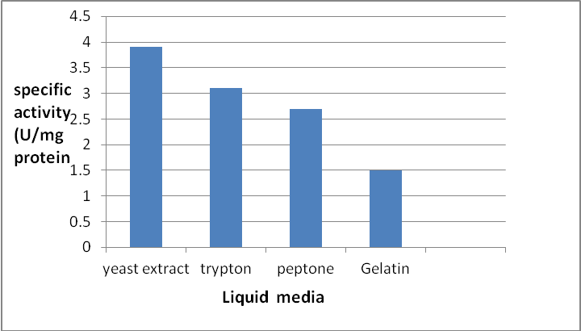
Figure 1: tannase production by Aspergillus niger A2 medium pH 8 contining 1% tannaic acid of different nitrogen sources and incubated at 40c for 5 days

Production tannase in solid media:
The results showed that the activity of tannase in solid medium range between 2-3.6 U\mg protein (Fig. 2) was cultivated in media containing various carbohydrate and protein. Result showed that rice was the best one of tannase production with specific activity 3.6 U\mg protein, while another source like bulgur were less effective with specific activity 2 U\mg protein. The carbohydrate compounds support the growth of bacteria to produce tannase (Seth and Chand ,2000). The desired and produce of SSF include biomass, enzyme, organic acid and specific secondary metabolic such as mycotoxins (VanAahen et.al, 2002).
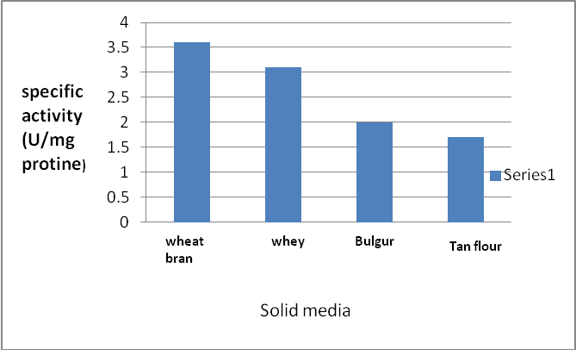
Figure 2: tannase production by Aspergillus niger A2 medium pH 6 contining 1% tannic acid of different carbohydrate sources and incubated at 40c for 5day
Screening for tannase production Aspergellus niger:
- Semi quantitative screening: PDA medium containing 1% as tannaic acid was used for screening the tannase production. The results showed that 3 isolates were able to produce tannase with deffrent zone at 37 ˚C incubation. The ratio (diameter of the clear zone\diameter of colony) range between (1-3.2) for isolates grow at 37 ˚C as shown in table 1.
Table 1:- Aspergellus niger isolates and their in tannic acid agar media incubation at 37 ˚C for 72 hrs.
Isolation number | Zone of hydrolysis/ cm
A1 | 1
A2 | 3.2
A3 | 2.6
- Quantitative screening: three isolates (A1, A2 and A3) which have largest tannic acid hydrolysis zone were selected for quantitative screening of tannase production. The results showed that the activity of tannase production by these isolates range between (1.1-3.1) U/mg protein (Table 2).
These different in the production of enzyme a many isolates may be due to different source of the isolate or the variation in the gene coded tannase synthesis (Pinto et.al,2001). Bacillus subtilis produced high levels of thermostable amylase with the characterized suitable for application the starch processing and other food industrial.

Table 2: production of tannase by Aspergillus niger isolation in PDB isolation with 1% tannic acid after incubation 28 ˚C for 72 ˚C.
Number of isolates | Specific activity U\mg protein
A1 | 1.1
A2 | 3.1
A3 | 2

Precipitation of tannase by Ammonium sulphate is one of the classical methods in protein chemistry. It was widely used for fraction of protein. It is rather used as an inexpensive way of concentrating a protein extract (Silva lopes ,et.al,2002), cell free extract of A. niger was subjected to ammonium sulphate precipitation with different ratio saturation (40, 50, 60, 70, 80) the results indicate that 80% saturation give specific activity 3.1 U\mg protein (Fig. 3). The results of (Sabu,et.al,205) show that the precipitation of tannase from Lactobacillus plantarun was carried out with the 75% saturation of (NH4)2So4, while (Monda et.al,2001) reported that fraction of 60% (NH4)2So4 were contiant highe tannse activity 2.3 U\mg protein produced by Serrtia Spp.

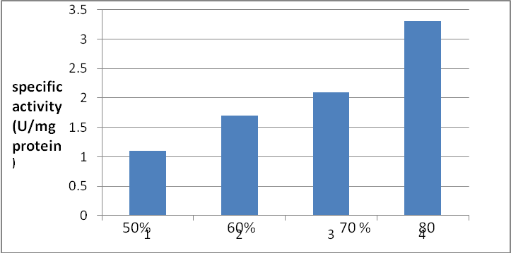
Figure 3: Specific activity of Aspergillus niger A2 tannase after perciptation with ammonium sulphate

Determination of optimal condition for tannase production:
- Effect of incubation period: the tannase production by Aspergellus niger was observed after (24, 48, 72, 96 hrs) of incubation period. The result in (Fig.4) showed that the production of tannase started for 24 hrs of the growth reached its maximum in 48 hrs. 3.2 U\mg protein and then decreases with the increasing incubation time its might be that tannase is produce during Log. Pahse and reach it maximum value at stationary phase, the maximum activity of Enterobacteria Spp. tannase is reached after incubation for 72 hrs (Selwal et.al, 2010).
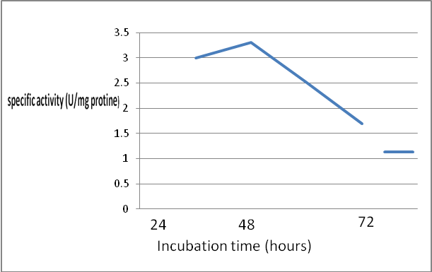
96
Figure 4: tannase production by Aspergillus niger A2 cultur liqud medium and incubation at 40 c for different time
- Effected of temperature of incubation: tannase activity was assyed at various incubation temperature (30, 35, 40, 45 ˚C) the result showed that optimal temperature for tannase production by Aspergellus niger was 40 ˚C with specific activity 4 U\ mg protein. The decrease of increasing in the incubation temperature leas to decrease of the enzyme production (Fig.5) the reduction of specific activity at other temperatures may relate to the growth of the organism and therefore the production of the enzymes studies (Yamada and Tanaka 1972). A Pseudomonas fluoresceas which tannase at temperature around 45 ˚C and number produce at temperature lower than 40 ˚C, the result of (Mahapatra et.al,,2008) showed that the optimal temperature of the production of tannse from Aspergellus awamon was 30 ˚C.
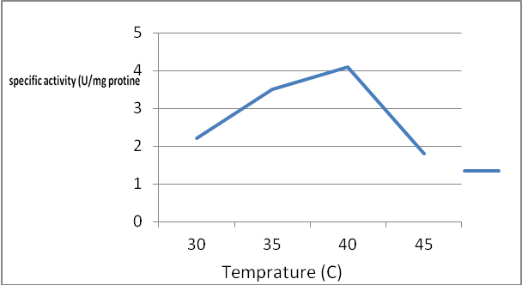

Figure 5: tannase production by Aspergillus niger A2 cultured in liquid medium and incubated at different temperatures for 5days

- Effected of PH: to investigated the effect of initial pH medium on tannase production Aspergellus niger was grow on PDA medium with the different PH value. The results show that the enzyme production is produce over PH range 6-8 with the maximum value with the specific activity 3.5 U\mg protein (Fig.6) showed that optimal pH for the production tannse of Klebsella spp. was 7 (Munmum and Purohit ,2008 ).
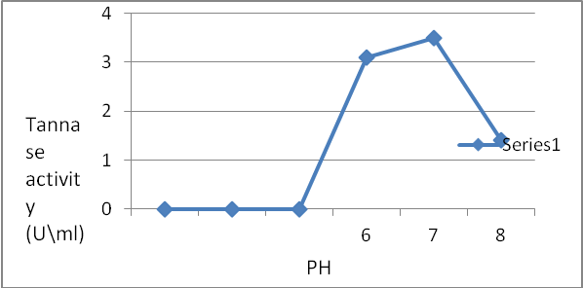
Figuer 6: tannase production by Aspergillus niger A2 culture in liquid medium prepared at different PH and incubated at 40 c for 5day.
References:
Agullar CN, Augur C, Favela-Torres E, Yiniegra-Gonzalez G (2001) Production of tannase by Aspergillus niger and solid state fermentation: influence of glucose and tannic acid. J. Ind. Microbiol-Biotechnol. 26:296-302.
Agullar C N, Augur C, Favela-Torres E, Yiniegra-Gonzalez G (2001) introduction and reposition pattern of fungal tannase in solid and submerged culture. Process. Biochem. 36:565-570.
Aguilar CN, Gutierrez-Sanchez G (2001). Review sources, properties, and application and potential uses of tannin acyl hydrolase. Food Sci. Technol. Int. 7:373-382.
Batra A, Saxena R K (2005). Potential tannase producers from the genera Aspergillus and Penallium. Process Biochem. 40:1553-1557.
Gupta R, Bego K and Lorenz P (2002). Bacterial alkaline protease molecular approached and industrial application. Applied microbiology and Biotechnology. Vol.59, no.1, P 15-32.
Kumar R. Shama J, Singh R (2007). Production al Aspergillus niger under solid state fermentation using jamun leaves. Microbiol. Res. 162:384-390.
Lokeswar N, Jaya Raju K (2007). Tannse producton by Aspergillus niger E. J. Chem. 4:192-198.
Lowry OH, Roseberoush N, Tofarr AL and Randall RJC (1951). Protein measurement with the fold phenal reagent. J. Biol: 276: 356-366.
Mahapartra, k., nanda R K, Bag S S, Banerijee R, Panueley A, Szakacs G (2005) Purificaiton characterization and some studies on secondary structure of tannase from Aspergillus awamori. Process Biochem. 40:321-3254.
Mahendran B, Raman N and Kim DJ. (2006). Purification and characterization of tannase from Paealomyces vqriotis: hydrolysis of tannic acid using immobilized tannase. Applied Microbiology and Biotechnology,. 70(4): 444-450.
Mondal KC, Banerjee D, Jana M, Pati BR (2001). Colormetric assay method for determination of tannin acyl hydrolase. Anal, Biochem. 295: 168-181.
Mondal K, Baherges D, Banerjee R, Pati B (2001) production and characterization of tannase from Bacillus cereus. J. Gen. Appl. Microbiol. 47:263-267.
Mahapatra K, Nada, RK, BAG SS, Banerjee R, Panoey A, Scakacs G,. Purification, characterization and some studies on secondary structure of tannase from Aspergillus awamon nakazawa. (2005) Process Biochemistry. 40(10): 3251-3254.
Munmum S, Atya K, Purohit H (2008) Study of biodiversity of Klebsiella Sp. World J. Microbiolo. Biotechnol. 24:203-207.
Mukher Jee, Gargiand Baner Jee, Rintu. (2006) Effedts of temperature, PH and additives on the activity of tannase produced by a co-culture of Rizopus oryzae and Aspergillus foetidus. World Journal of Microbiology and Biotechnology. 22( 3):207-212.
Pinto G, Leite S, Tarzi S, Couri S (2001) Selection of Tannase producing Aspergillus niger strains. Braz. J. Microbiolo. 32:24-26.
Ramirez-Coronel MA (2000) Purification characterization tannase Aspergillus niger produced poor fermentation medio. 45, 1555-1560.
Romero-Gomez S, Augur C and Viniegra-Gonzalez G (2000) invertase production by Aspergillus niger in submerged and solid stat fermentation. Biotechnol. Lott 22:1255-1258.
Sabu A, Augur C; Swat C; Pandey A (2006) Tannase production by Lactobacillus Spp. under solid stat fermentation. Process. Biochem. 41:675-580.
Sittig M (1988) trimethoprim. I pharmaceutical manufacturing encyclopedia. New Jersey: Noyes publication 282-284.
Sharma S, Bhat TK, Dawra RK (2000). A spectrophotometric method for assay of tannase rhodanin. Anal. Biochem. 279(1): 85-89.
Sabu, abdulhameed; Kiran, G. Shegal and Pandey A shok. (2005). Purification and characterization of tannin acyl hydrolate from Aspergillus niger. Food Technology and Biotechnology. 43(2):133-138.
Seth M and Chand S (2000). Biosynthesis of tannase and hydrolysis of tanase to gallic acid by Aspergillus awamori optimization of proxess parameters. Process Biochem. 36:39-44.
Sabu, abdulhameed; Kiran, G. Shegal and Pandey A shok. Purification and characterization of tannin acyl hydrolate from Aspergillus niger. Food Technology and Biotechnology, April, June 2005, Vo l.43, no.2, P. 133-138.
Selwal MK, Yadav A, Selwal K, Aggarual N, Gupta R, Gautam S (2010). Optimizaiton of cultural condition for TAnnase production by Pseudomonas aerugeniosa. World J. Biotechnolo. 26:599-605.
Silva lopes M., Leitao A, Regalla M, Fgueiredo Marques J, Texeiracrroudo M. and Barretocrespo M. characterization of highly thermostable extracellular lipase from Lactobacillus plantarum. International Journal of food Microbology. June 2002, Vol. 76, no. 1-2, P. 107-115.
Van D E, Lagemaat J and Pyle DL. Solid-state fermentation and bioremediation development of a continuous process for the production of fungal tannase. Chemical Engineering Journal. October 2001, Vol. 84, n 2 p. 115-123.
Vaquero I, Marcobal A, Muhoz R (2004) Tannase activity by lactic acid bacteria isolated from grapsmusst anelwine. Int. J. Food Microbial. 96: 199-204.
VanAahen D, Synstad M, Brurbeg B, Hough E, Rilse B, Eijsink V and Wierehg RK (2002). Mstructure of two domam chitotyosidas from Serratia marcescens.
Yamada H, Adachi O, Watanbe, Mand Sato N. Studies on fungal tannase. Part I: formation, Purification and Catalutic properties of tannase of Aspergillus flavus. Agricultural and Biological Chemistry. February 1968, Vol. 32, no 9, P 1070-1078.
Yamada, D and Tanaka T (1972) Wine malcin using tannase in fermentation process. Patent. Offen. 2.224 Japanese patent Application no. 7133, 151.

