3D Visualization GIS Vector Layer Using Texture Mapping
Tawfiq A. Abbas
Babylon University , Dean of Computer Technology College
Elaf Ali Baiey
Babylon University, College of Science ,Computer Department
Abstract
This study aims to visualized 3D GIS vector data and build system operate through creating a new tool added to ArcMap Geographic Information System (GIS). This new tool automatically visualizes 3D GIS vector layer of an agricultural lands extracted from integrating GIS databases resources without needed to raster layer or any 3D drivers such as DirectX or OpenGL Dll libraries. This paper introduce a new usage for the surface flattening method that by applying it on GIS vector layer and it database. surface flattening used fast marching and classical MSD techniques to find texture coordinates. The scene is rendered using ray casting rendering. Moreover, barycentric coordinates is used as an interpolation method in texture mapping process. Some techniques like lighting, rotation and anti-aliasing, are applied to accomplish the proposed system task. The 3D scene resulted from the texture mapping method in proposed system are have minimum distortion for the textured surface compared with the scene resulted from ArcScene software and obtained a fine look. The system is developed using Visual Studio. Net C# which linked with ArcMap GIS to allowing for the system application to access to the GIS database resources.
الخلاصة
تهدف هذه الدراسة إلى بناء نظام يعرض رؤيا ثلاثية الأبعاد أوتوماتيكيا للبيانات المتجهة لنظم المعلومات الجغرافية من خلال إضافة أداة جديدة إلى التطبيق (ArcMap) . تستخلص البيانات التي يعمل عليها النظام من تكامل مصادر نظم المعلومات الجغرافية ومن قاعدة بيانات إضافية تمثل مجموعة صور النسيج. هذا النظام لا يحتاج إلى صورة الأقمار الصناعية للمنطقة المدروسة ولا يحتاج إلى محرك ثلاثي الأبعاد مثل (DirectX, OpenGL) . تستخدم طريقة تسقيط الأشعة لتطبيق الرسم الثلاثي والتي تتبنى إظهار معلومات نظام المعلومات الجغرافية كمشهد ثلاثي الأبعاد. كما وتستخدم تقنية تسطيح السطح طريقة الزحف السريع لإيجاد البعد الجيوديسي بين كل زوج من النقاط على السطح وطريقة التقييس المتعدد الأبعاد لتقليص أبعاد هذه المصفوفة لتشير إلى إحداثيات النسيج للسطح. تحفظ طريقة تسطيح السطح الخواص الوضعية والعامة صورة. المشهد ثلاثي البعاد الناتج هو أكثر تصورا واقل تشوها مقارنة بطريقة مطابقة النسيج الموجودة في برنامج نظم المعلومات الجغرافية الـ ArcScene ولنفس المنطقة الزراعية. يستخدم النظام مقاييس ذاتية و موضوعية كمقياس الـ SNR لمقارنة نتائج النظام.
1. Introduction
Geographic Information System (GIS) can be defined as an incorporated system of computer hardware and software with procedures and a human analyst that collectively maintain the capture, management, manipulation, analysis, modeling, and display of spatial referenced data [David99]. GIS stores two types of data that are found on a map definitions of earth surface features and the attributes or qualities of these features. These types are vector and raster [J.Ronald94][ Drew02].
Visualization is one of the most important functionality of GIS and have a major role in realistic the 3D scene and increase their visibility [Niro11]. 3D Visualization GIS is a emerging advanced study fields in recent years. Application of 3D GIS is increasingly widespread, covering the battlefield simulation, digital city, resource management, environmental assessment, regional planning, public facilities management and many other fields. Compared with the 2D GIS, 3D GIS can analysis and display objects from the perspective of spatial, and can achieve visual look and various analysis of virtual 3D space [Q.Zhiy11]. One additional data model that used in 3D GIS is the Triangulated Irregular Network (TIN) patches as drawing primitives in place of triangles [B.Tony10]. TIN can represent the surface by set of contiguous, non-overlapped triangles and can be created in GIS using 3D Analyst tool [ESRI02].
Rendering is method for display and visualize a realistic looking 3D object as real as possible on a 2D output screen [Salomon11]. Rendering process have sequence of techniques to accomplished its task including transformation ,lighting, viewing, projection, clipping, culling, and texture mapping. There are many rendering methods such as z-buffer , radiosity , ray tracing and ray casting methods [K.Frank08, D.Hearn98, Max05].
Texture mapping is a popular tool in the computer graphics and rendering system because it is an easy way to achieve a high degree of realism in computer-generated imagery with very little effort. A simplest classes of texture mapping are linear ( affine ), bilinear and perspective (projective) texture mapping [P.S.Hechbert89, Paul86]. Surface flattening is one method to find texture coordinates by mapping the 3D surface to the 2D planar [C.Zhon07]. It’s a simple and general structure preserving texture mapping approach that introduced a minimum distortion compared with linear and projected methods. Moreover, in this method its unnecessary to apply fixed boundary conditions [K.Dong03, Patel10]. Barycentric coordinates are used in computer graphics applications to generalize a set of given data values. Barycentric coordinates are used in a wide range of applications from shading, interpolation, and parameterization. In particular, all real barycentric coordinates reproduce linear transformations. Therefore, its used in texture mapping process by interpolate each pixel in texture image to a point in 3D triangular surface [W.Ofir09].
In this paper, the works that related to the proposed system's idea are introduced in section (2). Ray casting that used in this system as a method of rendering the 3D scene is described in section (3). Texture mapping process described in section (4). Surface flattening using fast marching and classical multidimensional scaling methods are defined in section (5) and barycentric coordinate interpolation in section (6). The proposed system is described in section (7). Finally, the results of this work are illustrated in section (8), as well as the conclusions and future works section (9).
2. Related Works
Q. Zhiyuan et al. 2011 [Q.Zhiy11]: They introduced visualization method of GIS vector data on 3D terrain using geometry-based method. Including the organization of 3D vector data based on a quad-tree structure and adopts the idea of levels of detail (LOD) geometry. Also, they described a way to spatial 2D vector data with terrain matching and methods to improve 3D rendering for a large amount of vector objects in a 3D scene and supporting spatial analysis. Their system focus on the visualization of polyline vector data. Vector objects are cached and managed by an object pool to realize rapid visualization. To verify the effectiveness of visualization method, C# and the DirectX API are used in a test environment.
B. Tony et al. (2010) [B.Tony10]: present an interactive, real-time mapping system for digital elevation maps (DEMs) to visualizes the surface of the Earth as a 3D surface generated from a DEM, with a color texture generated from a registered multispectral image and vector-based mapping elements draped over it. The system use a quad-tree based multi-resolution and adopt the combination of interactive rendering and interactive mapping directly onto the 3D surface, with the ability to navigate the terrain and to change viewpoints arbitrarily during mapping. The vertex positions and texture coordinates are generated by creating a planar regular grid where (x, y) points are elevated using the appropriate pixel value of the height quad. Vertex texture coordinates are calculated by linearly mapping (x, y) coordinates into the associated texture quad’s texture rectangle, which is identical for each texture node. This system compared with available mapping software and improves mapping accuracy and efficiency, and also enables different observations that are not possible to make with existing systems.
J. Hailiang et al. 2009 [J.Hail09], introduce visualization and analysis 3D GIS terrain using remote sensing image and digital elevation model (DEM) through virtual reality technology, multimedia technology and 3D graphics technology, with OpenGL as the underlying graphics driver and VC ++ 6.0 as development tool. The raw data of the system is vector contour data. System uses Kriging plane interpolation method to rasterized vector and obtains grid DEM data, then executes 3D terrain visualization using DEM data. The system uses pick up and feedback mechanism of OpenGL to achieve rendering different types ground objects of the scene.
3. Ray Casting Rendering
Ray casting considered as a basic idea of ray tracing. It is a fundamental task that is the core of a large number of algorithms. Other applications use this approach for example to simulate propagation of radio waves, neutron transport, and diffusion [W.Ingo01]. Instead of ray tracing, ray casting used as rendering process to visualization and illumination the earth surface database such as the terrain and GIS information, because in these fields the secondary rays for reflection and/or refraction are not generally spawned [R.Stefan02, M.W.Frederick97]. Figure (1) illustrated ray casting rendering process.
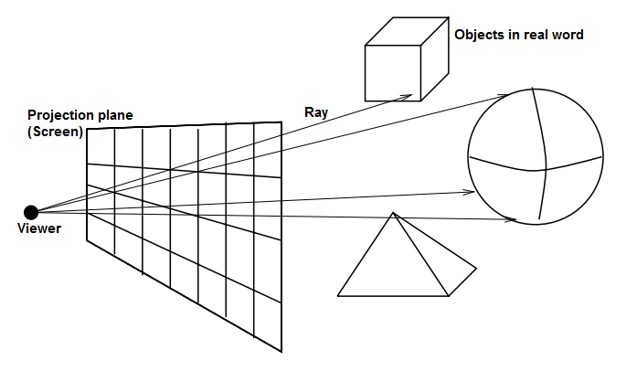
Figure (1) ray casting rendering
In ray casting, ray is formed and intersected with the objects in a specific triangle and have the two following steps:
1. Finding the intersection point [K.Frank08, A.Edw09, H.Jiri08]: The parametric equation R(t) of such a ray is:
$R(t)=V+tα$………………….(1)
Where α is a vector denoted the distance from the viewer V to pixel P ($α=P−V$ ), and t can computed as:
$t=\frac{N⋅β}{N⋅α}$…...………………...…. (2)
Where N is the normal vector of the current surface triangle, and ß is the distance vector between V and any point on the current triangle. For each triangle the intersection is found, and the value of t is compared with the previous t value and save smallest t with it's IntPoint. The smallest value of t is used to select the nearest triangle.
2. Decide whether the intersection point lies inside the edges of current triangle using barycentric coordinate's properties. Finally, compute the intensity color of the intersection point by applying lighting, texture mapping shadowing and other rendering processes for the current pixel [Salomon11, M.Tomas97].

4. Texture Mapping
Texture Mapping is of the necessary step in rendering process where it add realism to the 3D scene and increases it's visualization without more complex or change on the geometry of it's primitives [K.Dong03] . Basically, texture mapping is the process of mapping the image (texture ) on the object in the 3D scene by modified color of each pixel in that object with the corresponding color from the image and sum it with the light and shadow value for that pixel [Salomon11, H.Paul93]. Texture mapping is performed by map texture on the object, this done by assignment a texture coordinates for all the points on the object's geometry. Texture coordinate should be given to all point on the geometry. In this paper, a method for assignment texture coordinates for the object vertices called surface flattening using multidimensional scaling method is used (section (5)). One method of interpolation adopted to finding the texture coordinate for the interior points in the triangle that called barycentric coordinate interpolation method (section (6)).
5. Surface Flattening
Surface flattening is the method of mapping a surface in 3D space into 2D space such that the distance between each pair of points in 2D space is as close as possible to the corresponding geodesic distance between the points on the 3D space. Namely, first flattening the 3D surface for the case of triangulated surfaces onto 2D plane. Then mapping the 2D texture image onto the flattening surface and assigned texture coordinate for the triangulated surface's vertices, and followed by mapping back the textured flattened surface onto the surface in 3D space [H.Steven99, G.Ruth02]. Figure (2) illustrated flattening process.
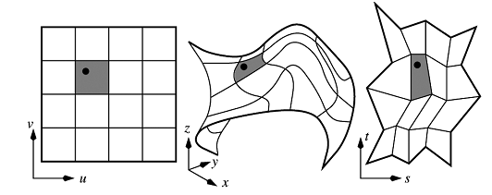
Figure (2) Surface Flattening process

This paper uses a flattening method based on area preserving mapping and free boundary that introduced in [Gil02]. Figure (3) illustrated some examples of 3D surfaces and its 2D flattened map [S.Olga02, Gil02]. This method of flattening minimized distortions by preserving the local and global structure of the texture by preserve the distance between close points and between the distant points on the surface. This method have two steps: First, fact marching method and second classical multidimensional scaling method. Fast marching used to find the geodesic distances between each point and other points on the surface. This method is first introduced by Kimmel and Sethian [J.A.Sethian00] . Whereas, the triangulated surface is consist of number of vertices N, the output of this procedure is N×N matrix. This method is one type of the classical Dijkstra graph search method that used to find the shortest path on the graph.
Multidimensional Scaling (MDS) is a set of mathematical techniques widely used as standard dimensionality reduction method for flattening a general distance matrix into a low dimensional distance space [Arvind10]. Classical MDS is scalable dimensionality reduction algorithm used to create 2D map of 3D objects that is used in texture mapping process. The input to the MDS is N×N symmetric matrix that resulted from fast marching method. MDS methods are based on reducing the input matrix with N×N dimension to matrix with k dimension. The interesting here will be with k is 2, that mean the resulted matrix X will be N×2 represent 2D texture coordinates and defines square Euclidean distances between surface points [S.Vin04]. Classical MDS described in [Patel10]:
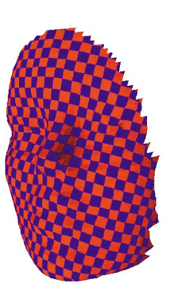
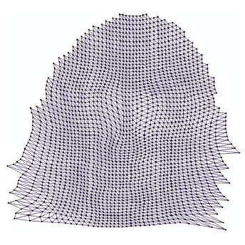
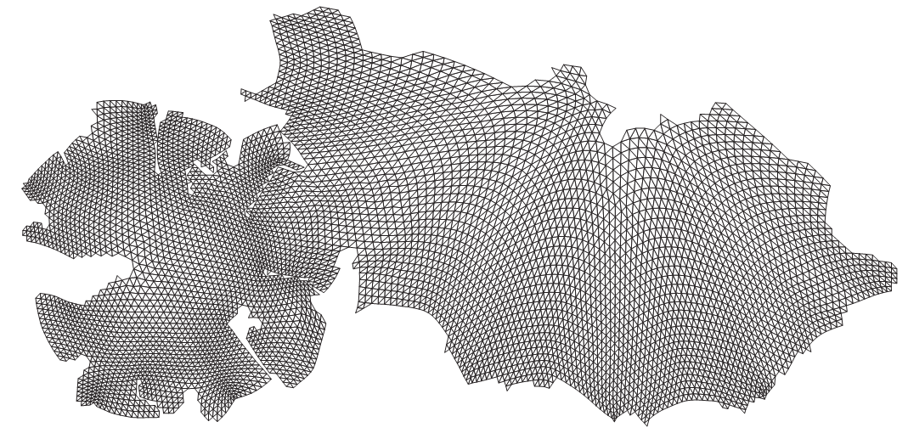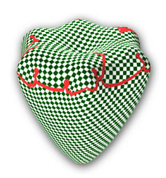

Figure (3) examples of 3D surfaces and 2D flattened map

6. Barycentric Coordinate Interpolation
The term of barycentric coordinates provide a powerful tool of analyzing problems in plane geometry. Also, there are considered as a fundamental tool for dealing with triangles [Paul00]. Barycentric coordinate used to test if the point in triangle and in linear interpolation over a triangle such as color, light , and color from texture image (texture mapping process) [Max05]. A triangle is given by three points, p₁, p₂, p₃, refer to values in it's vertices. This values can be 2D or 3D coordinates, colors, texture coordinates of the vertices [H.Dianne07]: if p₁, p₂, p₃ denote the texture coordinates (2D plan) of three vertices of triangle, then the texture coordinate of point p in triangle can be find using: p_{x} = u p_{1x} + v p_{2x} + w p_{3x}, p_{y} = u p_{1y} + v p_{2y} + w p_{3y}…………(3)
where u + v + w = 1......…(4)
Thus, u , v , w can be defined as the barycentric coordinates of the point p.
If there is a triangle ∆ ( p₁, p₂, p₃ ) and sub triangles ∆1= p, p₂, p₃, ∆2= p₁, p, p₃, ∆3= p₁, p₂, p within main triangle, then barycentric coordinates u , v , w can defined as [H.Dianne07]: $u=\frac{N⋅N1}{||N||^{2}}$, $v=\frac{N⋅N1}{||N||^{2}}$ , $w=\frac{N⋅N1}{||N||^{2}}$……………………..(5)
where N, N1, N2, N3 are the normals vector of ∆, ∆1, ∆2, ∆3 respectively and (•) is denoted dot product process. In texture mapping process, if there is a triangle in 3D space with known vertices a, b, c and its corresponding triangle in 2D texture image space with known vertices ta, tb, tc, then the point p in 3D triangle have corresponding with a point p' in 2D texture image triangle with the same barycentric coordinates. Therefore, there is possible to use the barycentric coordinate of p to find the coordinate of p' although the two points are in a different space [Max05].
7. The proposed System
In Geographic Information System (GIS ), it is very useful to build 3D map for regions as a layer for 2D vector layer, that will provided a visualization for more realistic scene. Users can build 3D maps manually by using ArcScene which is ArcGIS Desktop package, that can be done by applying attendant tools to build the 3D model with its triangulated mesh. Then apply texture mapping process manually by choosing the appropriate texture image and applying it on model by calling FillPictureSimple instruction. Most recently work applied a combined display of vector data and raster data to find new 3D visualized scene using different techniques. The proposed visualization system Built a 3D vector layer in Geographic Information System (GIS ) by integrating three parts of data: vector data that represented by more than one type of geometry vector layer, GIS database represented by an additive information about these geometries and the third is the external
database represent selected texture images that will be used on mapping on 3D model.

Selecting appropriate texture image

Texture Image Database
Texture Image for each object
Importing GIS information
Triangle Layer
Vertices Layer
Object Layer
Imported GIS information
Surface flattening
Rendering and Texture Mapping
Texture Coordinates
New 3D visualized vector layer

Figure (4) Block Diagram of The Proposed System
This system will be useful when we don’t have the original remote sensing imagery or the raster layer. The proposed system will be approximated visual and realism 3D scene for agricultural regions. The block diagram in figure (4) illustrates the proposed system.

7.1 Prepared the GIS Database and Import it to the Proposed System's Environment
The proposed system choose case study represent a specific regions of agricultural land has been chosen from Al-Hilla city. Each region in these agricultural land is named object and it's information have entered by using ArcMap GIS software as a vector layer. Drawing the agricultural regions (objects) will be as obtained from users paper maps in directorate of agricultural in Babylon conservative. The proposed system is in needed to add new fields to attribute table of object layer file described the objects and the most important types of vegetations such as the area of it. In the case study, three fields represented the vegetated area of three types for vegetations which are corn, wheat and barley are added to attribute table of object layer. Fourth field represent area of unused lands in each object. The fifth field represent texture image that will selected and mapped onto object's region. We need to define number of points that distributed on agricultural land which represent the elevation of these points over surface sea level. These points will spread around the objects and inside them and represent the vertices of triangles which formed the triangulated mesh. The X,Y coordinates of vertices will be the coordinates of GIS system, and Z coordinate will be entered as the elevation of surface. To build a triangulated mesh for these points, 3D Analyst tools should be used from Arctoolbox in ArcScene GIS software. This done by create Triangulated Irregular Network (TIN ) layer from vertices layer. Figure (5) illustrates overlaying the three layers object layer, vertices layer and triangular mesh layer with each other represented in ArcMap software. A table of images is represent additional database inputs of the proposed system. These Images refer to type of vegetations in the case study. The table have three fields: ID, Vegetation type and the bath name of images storing location. Building this table will be done manually by the user and can increase the number of vegetations as needed. In ArcGIS 10 there is a new Add-ins model that makes it easier to customize and develop the ArcGIS Desktop applications. Add-ins model used to create elements of custom user interface (UI) that can be configured within ArcGIS Desktop packages.
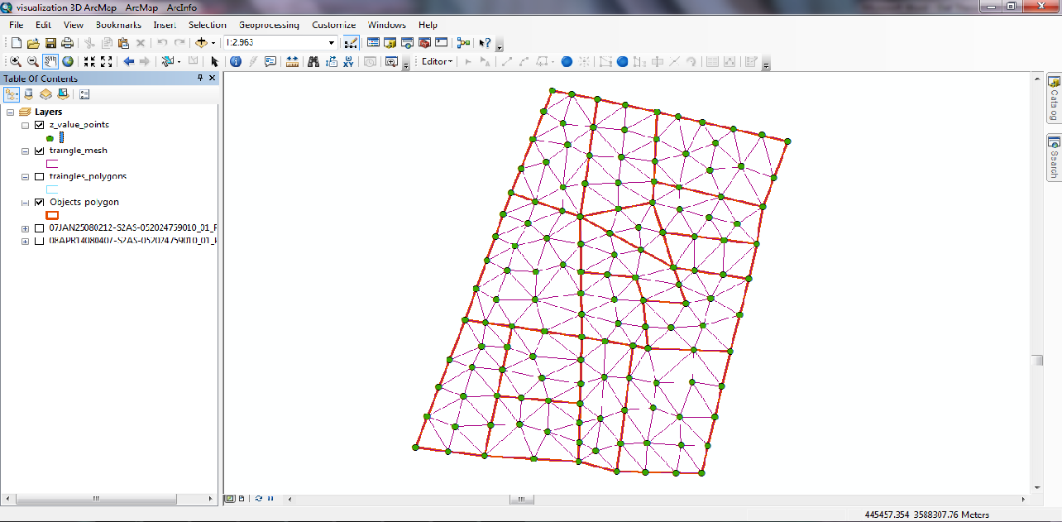
Figure (5) overlaying of the three layers object, vertices and triangular mesh layers
The proposed system select one texture image for each object in agricultural land. Selection mechanism of the vegetation's texture depends on the vegetation that has the largest area in the object attribute table. After that, update the Texture_image field in object attribute table with the path name of the selected vegetation's texture image. In this case study, there are four type of vegetations in the agricultural land's case study.
After preparing all inputs of the proposed system in GIS layers. The proposed system import all these information from ArcDesktop GIS environment to the Visual studio C#.Net environment . Figure (6) illustrated this stage.

GIS Environment
Object Attribute Table
Triangle Attribute Table
Vertices Attribute Table
Extracting triangles indexes
Importing Texture Image Field
Triangle record
Normalization
X,Y,Z Extracting
Vertices X,Y,Z coordinates
vertexArray (Normalized Vertices X,Y,Z coordinates)
ElementArray
Add triangle record
proposed system environment
Texture path va vb vc other fields
figure (6) Block diagram of importing the object information from GIS
7.2 Finding Texture Coordinate by Using Surface Flattening Technique
For each object there is one texture image will be fit on it. One of the important challenges of texture mapping process is how can we spreading texture image on 3D surface and divided within triangles with preserved minimum distortion. For that, each vertex in object must have 2D texture coordinate determine which a right pace of texture image will mapped on it's triangles. The texture coordinates of each vertex is pair of float numbers (x, y) ranged between (0-1). For that these coordinates must be multiplied by image's width and height to be the truth part of that image. These texture coordinates will be one of the inputs of texture mapping procedure. This task adopted by surface flattening technique described in section (5). This technique mainly based on two steps:
First: fact marching method which used to calculate the geodesic distances between vertices of the object and processes for each object in our case study as alone. The input of this procedure is the imported GIS database. The output will be N×N symmetric matrix M, where N is number of vertices in object. The M_{ij} element in matrix M is squared geodesic distance between points i and j. Second: classical MDS method that used for embedding a general distance matrix into a low dimensional Euclidean space. This used the output of previous method (N×N symmetric matrix of geodesic distances) as an input and calculate the N×2 texture coordinates of vertices as output that represents the flattening map of the curved surface. Since, the resulted N×2 matrix represented the texture coordinates, its must ranged between 0 and 1 using normalization method. Figure (7) illustrated the flattening surface process in our proposed system.

Finding Geodesic distance array by Fast Marching Method
vertexArray of 3D points
ElementArray
Geodesic distance N×N matrix
Applying classical MDS approach
N×2 Texture flatted coordinates
Figure (7) Block Diagram of Surface Flattening Approach
7.3 Rendering and Texture Mapping process
To visualize a 3D scene on the screen, a simple ray casting approach is used as a rendering process in order to implement texture mapping process. Ray casting is have the following steps as applied in proposed system:
1. Finding the normal vector of triangle.
2. Cast the ray from the user eyes (camera location ) to each pixel in the screen.
3. Convert pixel coordinate from screen space to it's corresponding part in the virtual 3D scene that determined by the virtual size of 3D scene using normalization equation.
4. Find the closest intersection point for the ray with the surfaces in 3D scene by finding the minimum distance between the ray and all the triangles that faced the ray through current pixel.
6. Test if the intersection point in triangle by some barycentric coordinates' properties.
7. Applying Texture mapping using barycentric coordinate interpolation to find the corresponding texture color for intersection point using the barycentric coordinate that find in previous step. These coordinates are applied on 2D texture triangle that selected for 3D triangle using surface flattening approach.
8. Applying lighting process for the light source and anti-aliasing filtering to minimum the distortion caused by texture mapping process.
9. Finally, display the final color for the intersection point on the screen in the current pixel. Figure (8) illustrated the rendering and texture mapping process.

Object list
( GIS Database)

Rotation
Rotation angles
Finding Closest triangle
Ray
Find Ray
Viewer position
Pixel in virtual space

Convert each pixel in screen to virtual space
Screen
Rotated database

Intersection Point
Closest triangle
Barycentric coordinate
Texture Mapping
Lighting
Light effect
Map color for pixel
Combining Light effect with Map color
Final color
Saving color in bitmap image
Bitmap image
Display bitmap image on screen

3D Scene

Figure (8) The rendering and texture mapping process
8. Results
The main aim of this paper is 3D visualization of GIS vector data depending on GIS database represented in vector layer and additional related database and depending on Texture image database. Also, this paper include using for surface flattening on GIS information. 3D resulted visualization scene will compared with the results of mapping texture image on 3D model manually using ArcScene. To explain the comparison between the two resulted 3D scene, small sample of the GIS data will treated as alone. One object with three triangles, this object taken from the case study and scaled to be clear for the reader the deference between the proposed system and ArcScene GIS texture mapping results. Figure (9) have 3D sample explain the comparison between the proposed system result and ArcScene result. In ArcScene GIS software, there is a different in distribution of the texture map image on the surface. That because the difference in height of the elevation points. Since, the ArcScene applied the texture from the top of 3D surface, a small sub images parameterized to triangle with a wide area. Therefore, the scene appeared stretched in some regions (triangles). Whereas, the proposed system prevent or decrease this type of distortion by applying surface flattening that attempted to distributed the texture image in a right way, and preserving the local and the global feature of the texture on the surface as well as adopt free boundaries of the texture that minimized the distortion. The proposed system used root-mean-square signal-to-noise-ratio SNR_{rms} objective distortion measure to compare the sample results in figure (9.a) and (9.b) when applied ArcScene software and the proposed system respectively. The SNR_{rms} between the original texture image and the proposed system's result is 2.445 and with ArcScene software result SNR_{rms} is 2.407. Since the larger number of SNR metric implies a better image, the result of the proposed system is less distortion than the ArcScene result. The results of the proposed system for 3D scene for the case study from different view illustrated in figure (10).
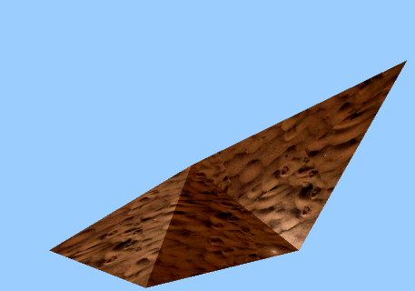
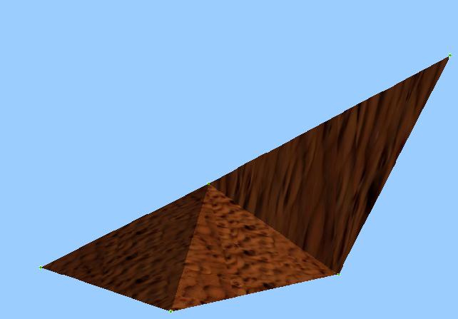
a
b

Figure (9) comparison between the proposed system result with ArcScene (a) Sample from case study as resulted in ArcScene, explained the different in distribution of texture on the three triangles (b) Sample from case study as display in the proposed system, explained accessible distribution for texture on the three triangles

9. Conclusions and Future Works
The proposed system introduce new implementation for texture mapping using surface flattening when it applied on terrains data represented in ArcMap GIS software. Texture mapping using surface flattening can be sufficiently visualized 3D GIS vector layer compared with ArcScene, because this method preserve the local and global area and, consequently, minimized the distortion caused by mapping, specially, with a higher lands while ArcScene GIS software use traditional projection in parameterization process. The system Added a new tool in ArcMap GIS software adopted approximate 3D visualization of GIS vector layer depend on using multiple sources of data such as vector layer, GIS database and additional texture images database, instead of, depending on only vector and/or raster GIS layers and solve the practical problem of automatic 3D visualization, instead of manually method using more than one software such as ArcMap with ArcScene. To improve the ability of proposed system, and raising the efficiency of the visualization system, we can suggest to importing the images that used as textures from any image classification methods. Moreover, developing the system to draw 3D maps to visualized information for the lands such as population information or the elevation of the lands, rather than use images. For texture mapping, researchers can applied another approach for texture mapping such as bump mapping to represent trees in more realism, as well as, using texture mapping build in 3D hardware drivers such as DirectX or OpenGL Dll libraries. Also, researchers can applying another method of rendering such as z-buffer approach and compared with proposed system results.

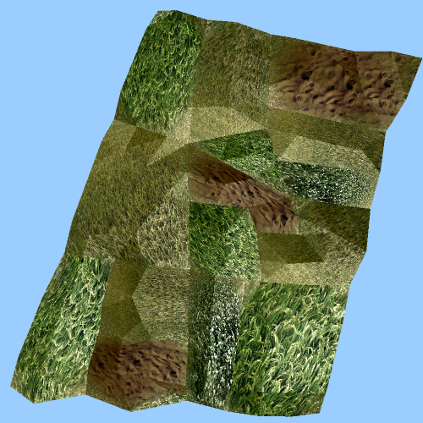
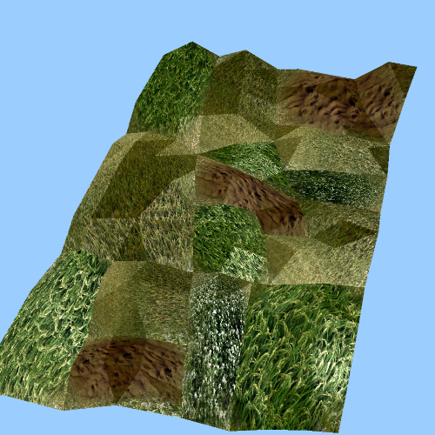
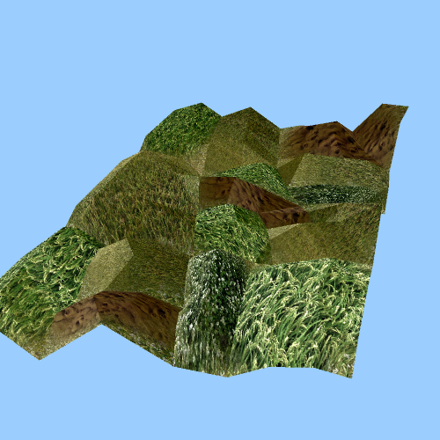
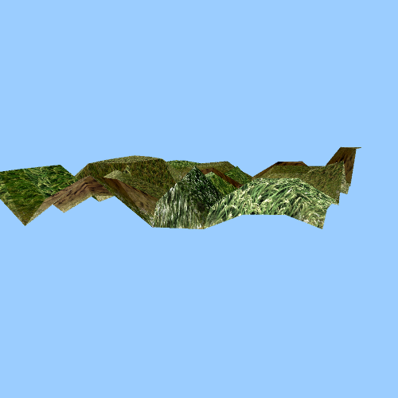

Figure (10) The results of 3D scene for the case study from different view.
References
[A.Edw09] A. Edward , 2009, "Interactive Computer Graphics: A Top-Down Approach Using OpenGL" , 5th Edition , Pearson.
[Arvind10] Arvind et al. , 2010, "Universal Multi-Dimensional Scaling" , ACM.
[B.Tony10] B.Tony , 2010, "Real-time Terrain Mapping" , Dagstuhl Publishing.
[C.Zhon07] C. Zhonggui et al. , 2007, "Surface Parameterization via Aligning Optimal Local Flattening", Association for Computing Machinery, Inc.
[D.Hearn98] D. Hearn and M. P. Baker, 1998, "Computer Graphics " C Version, 2nd Edition, Prentice Hall, Inc., Upper Saddle River, p. 226.
[David99] David P. Lusch, 1999, " Fundamentals of GIS" , Basic Science and Remote Sensing Initiative.
[Drew02] Drew Decker, 2001, "GIS Data Sources", John Wiley & Sons , INC.
[ESRI02] Environmental Systems Research Institute, White paper, 2002 , "ArcGIS 3D Analyst: Three-Dimensional Visualization, topographic Analysis, and Surface Creation".
[G.Ruth02] G. Ruth et al. , 2002, " Computational Surface Flattening: A Voxel-based Approach" , IEEE.
[Gil02] Gil Zigelman et al. , 2002. , " Texture mapping using surface flattening via multidimensional scaling" , IEEE Transactions on Visualization and Computer Graphics, 8(2)
[H.Dianne07] H. Dianne , 2007, "Barycentric Coordinates Introduction to Computer Graphics " , Arizona State University.
[H.Jiri08] H. Jiri and H. Adam , 2008, "Yet Faster Ray-Triangle Intersection (Using SSE4)" , IEEE TRANSACTIONS ON VISUALIZATION AND COMPUTER GRAPHICS.
[H.Paul93] H. Paul and S. Mark , 1993, "Texture Mapping as a Fundamental Drawing Primitive " , proceeded in the Fourth Eurographics Workshop on Rendering.
[H.Steven99] H. Steven, et al. , 1999, "Conformal surface parameterization for texture mapping", Institute of Mathematics and its Applications.
[J.A.Sethian00] J.A. Sethian , 2000, "Evolution, Implementation, and Application of Level Set and Fast Marching Methods for Advancing Fronts" , California, Berkeley .
[J.Ronald94] J. Ronald Eastman et al. , 1994 , "The GIS Handbook" , The United States Agency for International Development USAID / ARTS / FARA , Washington, D. C., Technical Paper No. 11.
[J.Hail09] J. Hailiang and L. Huijie, 2009 , "Terrain Visualization and Application Based on 3D GIS", The 1st International Conference on Information Science and Engineering (ICISE).
[K.Frank08] K. Frank , 2008, "Introduction to Computer Graphics Using Java 2D and 3D" , Springer.
[K.Dong03] K. Dongho , 2003, "Nonlinear Texture Mapping Techniques for General Purpose Graphics Hardware" , Ph. D. Thesis , The School of Engineering and Applied Science of the George Washington University.
[Max05] Max K. Agoston, 2005 , "Computer Graphics and Geometric Modeling" , Springer.
[M.W.Frederick97] M. W. Frederick and D. Venkat , 1997, "Texture Mapping 3D Models of Real-World Scenes" , ACM Computing Surveys, Vol. 29, No. 4.
[M.Tomas97] M. Tomas and T. Ben , 1997, "Fast Minimum Storage Ray Triangle Intersection" , Journal of graphics, gpu, and game tools , Vol. 2 , No. 1 , pp. 21-28.
[Niro11] Niroumand-Jadidi M. et al. , 2011 , "Optimal Visualization of Satellite Imagery and Superimposed Vector Data ; A new Trend to the Conceptual Visualization of Land-use Maps" , Proceedings of the 25th International Cartographic Conference.
[Paul00] Paul Yiu , 2000, "The uses of homogeneous barycentric coordinates in plane euclidean geometry" , Int. J. Math. Educ. Sci. Technol. , 31 , pp. 569 -578.
[Paul86] Paul S. Heckbert , 1986, "Survey of Texture Mapping" , IEEE Computer Graphics and Applications, pp. 56-67.
[P.S.Hechbert89] P. S. Hechbert , 1989, Fundamentals of texture Mapping and image warping" , Masters Thesis , Computer Science Division, University of California , Report No. UCB/CSD 89/516.
[Patel10] Patel and W. A. P. Smith , 2010, "Automated Construction of Low Resolution, Texture-Mapped, Class-Optimal Meshes" , IEEE.
[Q.Zhiy11]Q. Zhiyuan et al. , 2011, "A Rapid Visualization Method of Vector Data over 3D Terrain", IEEE .
[R.Stefan02] R. Stefan and F. Ingo , 2002, "The Terrain Rendering Pipeline ", In Proc. EWV '02, pp. 195-199 .
[Salomon11] Salomon D. , 2011, "The Computer Graphics Manual" , Volume 1 , Springer.
[S.Olga02] S. Olga et al. , 2002, "Bounded-distortion Piecewise Mesh Parameterization" , IEEE Computer Society Washington, pp. 355 – 362.
[S.Vin04] S. Vin de and B. T. Joshua , 2004, "Sparse multidimensional scaling using landmark points" .
[W.Ingo01] W. Ingo et al. , 2001, "Interactive Rendering with Coherent Ray Tracing" , EUROGRAPHICS Vol. 20, No. 3.
[W.Ofir09] W. Ofir et al. , 2009 , "Complex Barycentric Coordinates with Applications to Planar Shape Deformation" , The Eurographics Association and Blackwell Publishing Ltd, Vol. 28 , No. 2.

